IST 687: Introduction to Data Science
Title: Project Update #3, Federal Aviation Administration (FAA) Wildlife strike Database.
Date: 09/16/2026
Adis Delanovic


Key achievements
- Created a cleaner dataset using methods discussed in Project Update #2.
- Developed an SVM damage-prediction model and a confusion-matrix chart to evaluate its performance.
- Developed an rpart damage-prediction model and an accompanying decision-tree graph.
- Used reported incident times and approximate monthly sunrise/sunset times to fill 38,189 missing time-of-day values. Missing values decreased from 153,368 to 115,179, resolving approximately 25% of the original missing values. Overall missingness declined from 43.6% to 32.7%, an improvement of 10.9 percentage points. Remaining records lacked sufficient time information.
- Consolidated 974 distinct species entries into 17 broader groups, including unknown categories. This reduced the number of species indicators needed for the SVM and rpart models and made their results easier to interpret.
  - Note: Given the dataset’s size and variety of wildlife entries, I used the GPT-6 Astra large language model (LLM) to assist with developing keyword-based rules that organized 974 distinct species entries into 17 broader categories.
- Created the detailed PHASE_OF_FLIGHT categories into four broader groups, Ground, Departure, Arrival, and En route, and stored them in a new PHASE_GROUP column to simplify model interpretation as shown in Table 1 - Phase groupings.
- Used HEIGHT to estimate some missing phases in a separate PHASE_GROUP_FILLED column. However, approximately 50% of height values and 69% of speed values were missing in the original dataset.
Table 1 - Phase groupings
Group | Original Phases
Ground | Parked, Taxi
Departure | Take-off Run, Climb, Departure
Arrival | Approach, Descent, Landing Roll, Arrival
En route | En Route, Local

- When flight phase was missing, both speed and height were also missing in approximately 99.7% of records. SPEED was not used in the filling rule since we couldn’t make a distinction in phase groups based on speed alone.
- Other cleaning achievements include:
  - Grouping INDICATED_DAMAGE into DAMAGED with a binary yes/no outcome.
  - Removed question marks from damage-level codes and assigned N to missing damage levels only when INDICATED_DAMAGE = 0
  - Added MONTH_NAME and SEASON
  - Standardized missing values from N/A, NA and UNKNOWN
  - Removed extra spaces
  - Converted numeric fields to numbers and incident dates to dates
- Answered the airport-risk business question: aggregated 351,859 strike records into risk scores for 2,786 airports, mapped by state and FAA region. Built an airport-level risk profile scoring 2,786 airports on damage rate and recent strike activity, with state and FAA-region risk maps.
  - Risk scores equally weight the percentile ranks of damage rate and reported strike counts during the latest five-year window.
    - Risk score = 100 * (0.50 * damage-rate percentile + 0.50 * recent-strike-count percentile)
    - Damage-rate percentiles rank each FAA region’s proportion of damaging strikes relative to the other regions. The lowest rate receives a value of 0 and the highest receives 1, with the remaining regions ranked between them. This puts damage rate on the same scale as recent strike activity, allowing both measures to contribute equally to the risk score
  - High score is defined as greater than or equal to 67
  - Moderate score greater than or equal to 33 but less than 67
  - Low score is defined as being less than 33
  - FAA-region scores were calculated from combined airport records within each region, rather than averaging airport scores.
  - Scores represent relative reported-strike risk, not the probability of a strike or damage, and do not account for differences in flight volume or voluntary reporting.

Airport and FAA Region Risk Profiles

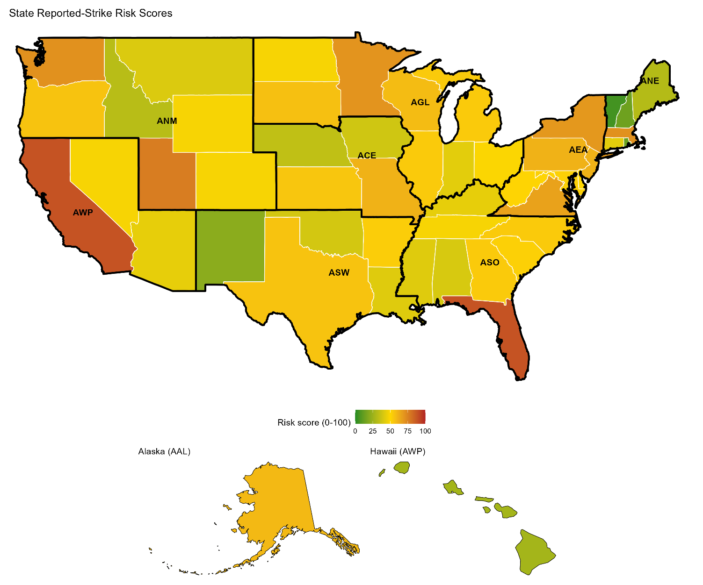
Figure 1 - State level average risk scores
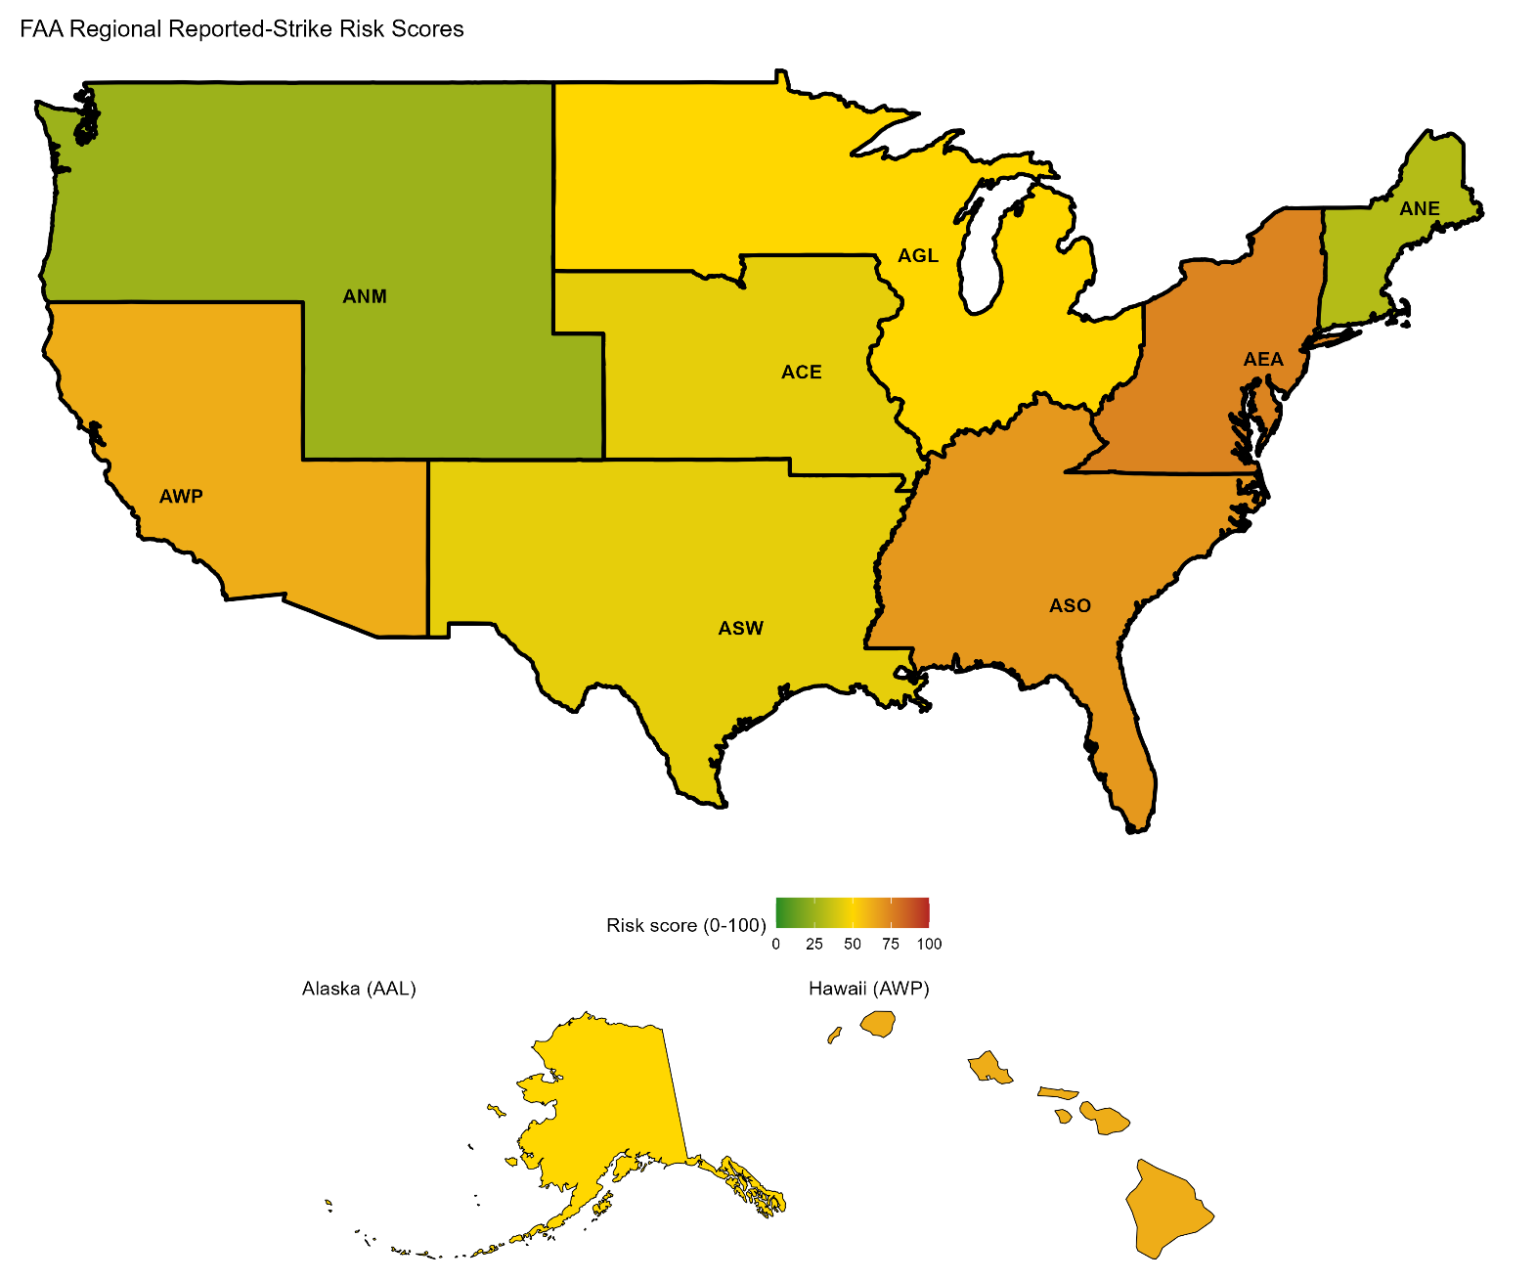

Figure 2 - FAA Regional Reported-strike Risk Scores
As shown in Figure 2, AEA and ASO tied for the highest risk score, followed by AWP, while ANE and ANM scored lowest. AEA had a higher damage rate than ASO, ASO had the most recent strike reports, and AWP had the highest damage rate overall. These scores compare reported-strike patterns without accounting for flight volume or reporting differences. In Figure 1, Florida and California both carry the highest risk score.

SVM and rpart models
The data was separated by year. Both models were trained on a random sample of 12,000 strikes reported through 2020 and tested on 46,829 strikes from 2024–2025. Records from 2021–2023 were used in separate experiments to compare training sizes and missing-value handling methods.
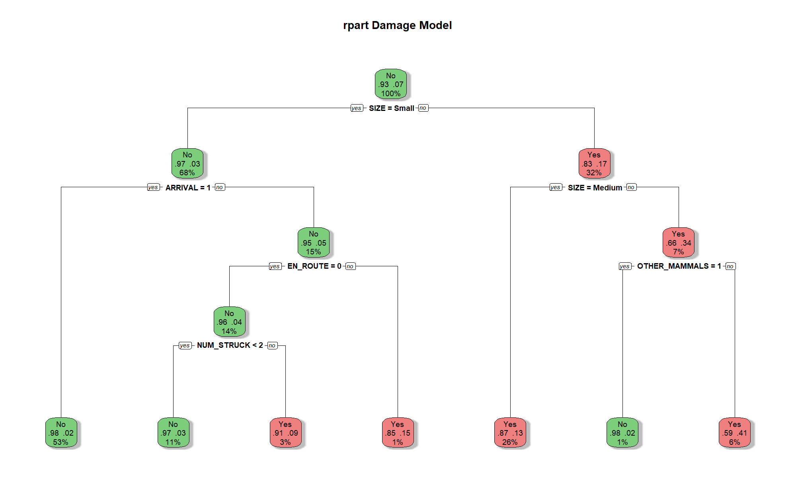
Figure 3 - rpart Damage Model
Our rpart damage model is shown in Figure 3. Wildlife size was selected as the tree’s first split, with strikes involving medium or large animals generally associated with a higher likelihood of aircraft damage than those involving small animals.

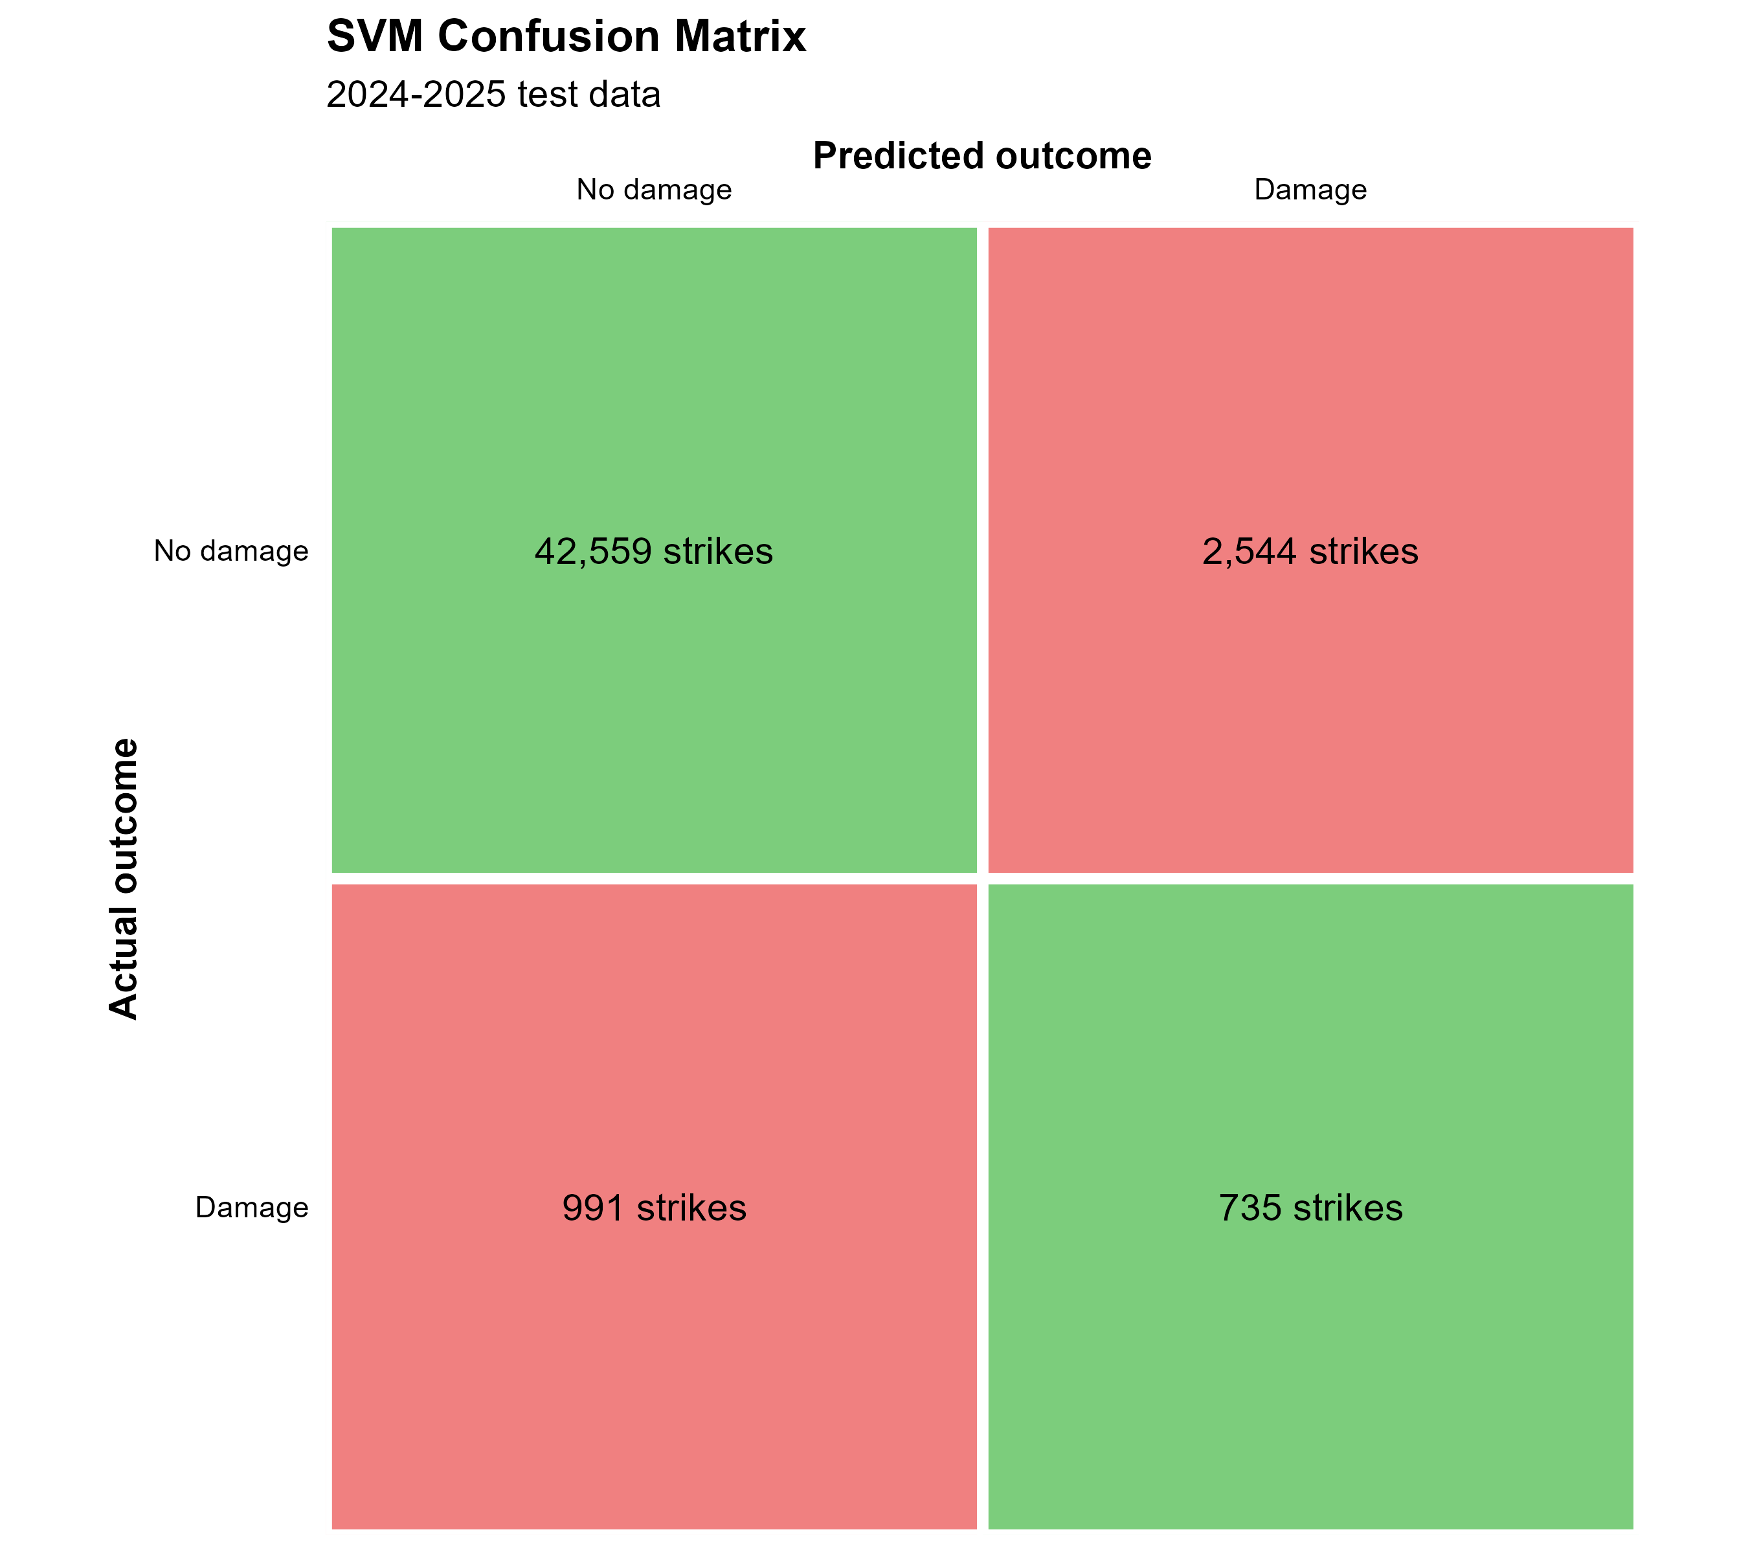
Figure 4 - SVM Confusion Matrix

Our SVM Confusion Matrix is shown in Figure 4. On the 2024–2025 test data, the model correctly identified 735 damaging strikes and 42,559 non-damaging strikes. However, it missed 991 damaging strikes and incorrectly classified 2,544 non-damaging strikes as damaging. Overall accuracy was approximately 92.5%, but the model detected only 42.6% of damaging strikes.

Challenges
- Species grouping: Developing meaningful groups for 974 distinct species entries required keyword matching and decisions about which animals belonged together.
- Missing airport and FAA-region information: Although AIRPORT_ID contained no missing values, 47,669 strike records used ZZZZ, indicating an unknown airport. These records could not support airport-based recovery of missing FAA regions.
- Handling unresolved missing values: Choosing between imputation and exclusion depended on the analysis. Unknown airports were excluded from airport summaries, while missing model predictors were filled using training-derived medians or modes. These replacements allowed modeling but introduced uncertainty because they did not recover the actual observations.
- Overall, this was a large dataset, 351,859 records across more than 100 variables, with substantial missing data in most of the fields we needed for our initial business questions. This made data analysis and cleaning the most time-consuming part of the project. In hindsight, I would narrow the scope earlier so more of the schedule went to modeling instead of cleaning.

Next steps
- Finalize scripts, graphs, and output tables
- Combine results into a 10–15-minute presentation and create a recording
- Complete the final project report

Business Questions Review
There are the business questions and columns I’ve identified to be relevant to them. These questions may change or continue to evolve as I explore the dataset.
- Do strikes cluster seasonally, and does the seasonal pattern differ by species group or region? Relevant variables: INCIDENT_MONTH, INCIDENT_YEAR, SPECIES, STATE, FAAREGION
- Can we segment airports into risk profiles based on their strike patterns? Relevant variables: AIRPORT_ID, Strike Total, % damaging Strikes, % occurring at night, Seasonality
- Which combination of species, phases of flight, and time of day carry the highest damage risk? Relevant variables: SPECIES, SIZE, PHASE_OF_FLIGHT, TIME_OF_DAY, DAMAGE_LEVEL

- Given conditions known before or at impact, can we predict whether a strike will cause damage? Relevant variables: INDICATED_DAMAGE, SIZE, SPECIES, PHASE_OF_FLIGHT, HEIGHT, SPEED, TIME_OF_DAY, AC_MASS, NUM_ENGS, TYPE_ENG, NUM_STRUC

Image Credit: Aviation Bird Strikes - Precise Flight

