Manual

Project Title: Spectrum Analysis GUI in MATLAB

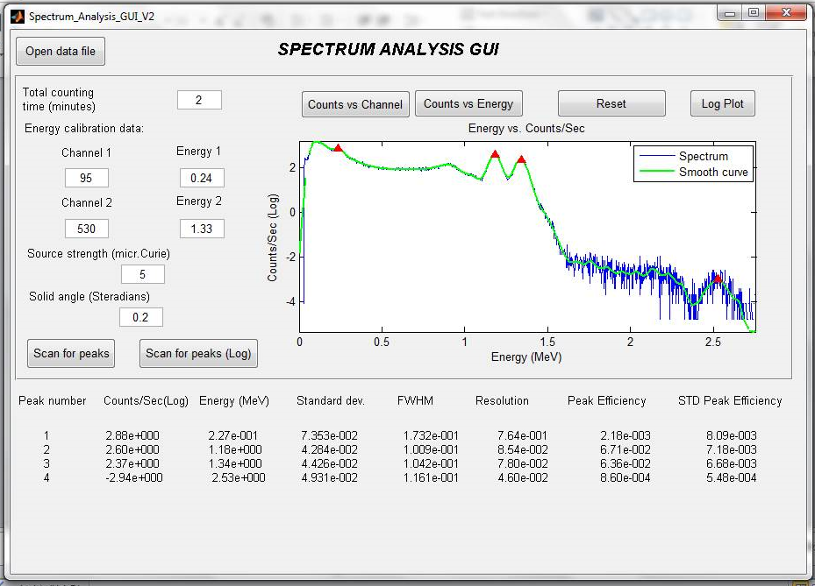

Abstract:
For “Spectrum Analysis”, MATLAB program has been developed with Graphical User Interface (GUI). The functionalities of this program are as follow:
- Load a spectrum data formatted in two columns, the first column is channel number and the second column is total counts per channel. The following file formats are acceptable as an input file: “.txt”, “.dat”, “.xls”, “xlsx”. In case different file format is selected, an error dialog box will appear.
- Can accept from user the following inputs: total time of the measurement and two data points of channel and corresponding energy (I.e. E1, ch1 and E2, ch2).
- Using this program, user can plot energy vs counts/sec, count vs channel, counts vs energy and energy vs counts/sec in logarithmic scale.
- This program can scan the plotted spectrum for peaks.
- The following information for each peak will be reported: energy, count rate, Full Width Half Maximum (FWHM), resolution, Peak efficiency and standard deviation of the peak efficiency.
- Summary file with the information reported above is produced (NOTE: The output file name is “Results” in a “.txt” format).

Introduction

When Spectrum Analysis GUI program starts, only “Open data file” button is enabled (Fig. 1).

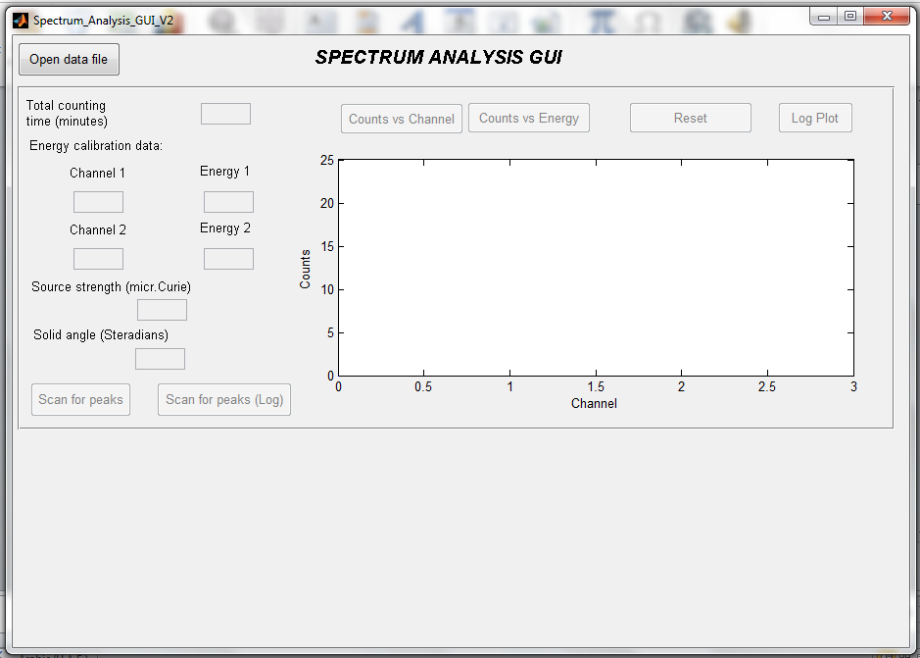

Figure 1 Opening

Pressing the button “Open data file” will result in showing a dialog which allows to choose input file from any location inside your PC (Fig.2). The following file formats for input file are allowed: “.txt”, “.dat”, “.xls”, “xlsx”. The input data must be formatted in two columns, the first column is channel number and the second column is total counts per channel and without any column names in the input file.
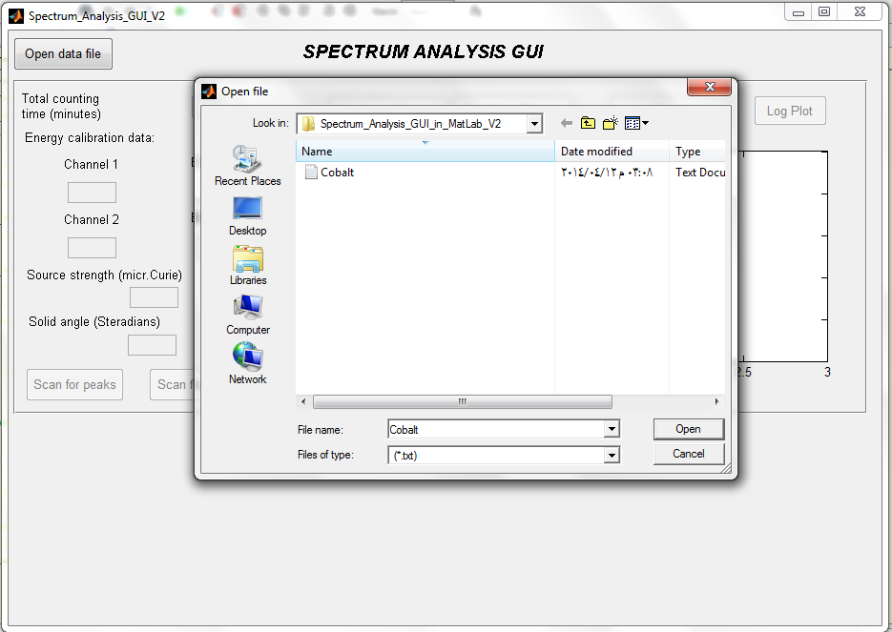

Figure 2 Open data file

After loading the input file. The user can input the total time of the measurement, two data points of channel and corresponding energy (I.e. E1, ch1 and E2, ch2) for energy calibration. The default values for these parameters (Data given for Cobalt) are set as follows:

Total time | 2 minutes
Channel 1 | 95
Channel 2 | 530
Energy 1 | 0.24 MeV
Energy 2 | 1.33 MeV
Source strength | 5 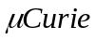
Solid angle | 0.2 steradians
These parameters can be changed. In case of inputting negative values for these parameters, an error dialog box appears and all buttons and fields become disabled (Fig. 3). User must input positive values for these parameters.
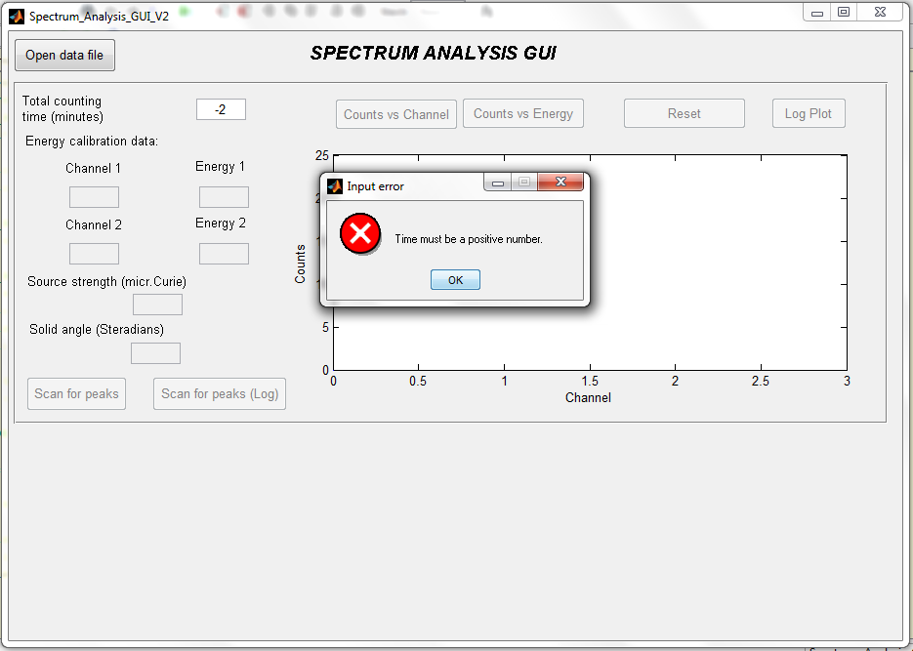

Figure 3 Error input
When the correct input parameters are set, all buttons become enabled. By pressing scan for peaks, the spectrum analysis is performed. In figure 4, energy vs. counts/sec is plotted. The positions of peaks are marked in the plot. When the peaks are found, informations about these peaks will appear in the bottom part of GUI (Fig. 4). Moreover, these informations are automatically saved in separate file (“Results.txt”) in the same directory where the input file is located.
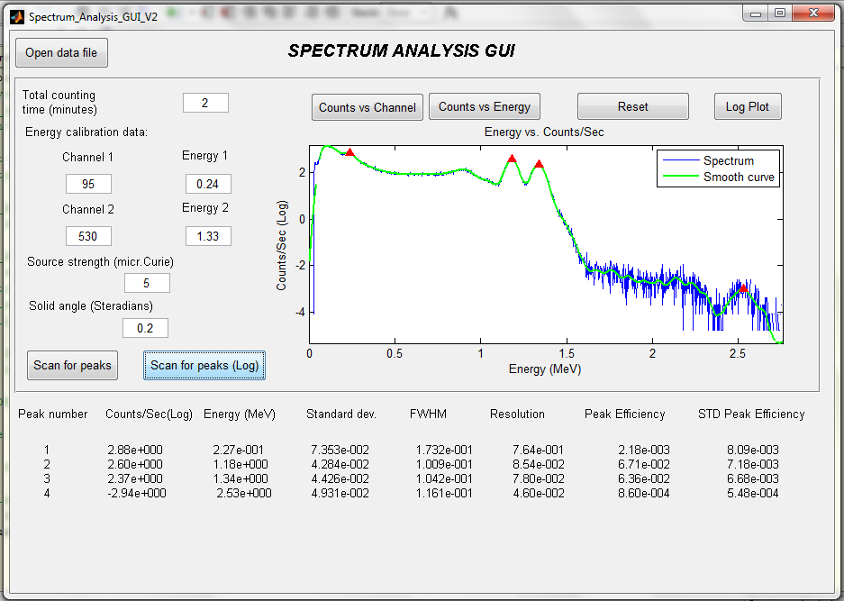

Figure 4 Scan result
The functionality of remaining buttons are the followings:
- Channel vs. Counts/channel – plot channel number versus counts per channel.
- Energy vs. Counts – plot energy versus counts.
- Log Plot - plot energy versus counts per sec in logarithmic scale.
- Reset - clear plot.
- Scan for peaks (Log) - plot energy vs. counts/sec in log scale with smoothed curves and targeted peaks.
- Scan for peaks - plot energy vs. counts/sec in normal scale with targeted peaks.

