**Longevity EEG protocol**

***Before the participant arrival***

Go to the EEG lab and prepare the room for testing:

* Ensure all necessary forms are printed and ready (consent form, privacy notice, safety screening, study information sheet, open brain consent from, participant log sheet – this is for experimenters’ use)
* Switch on the VPixx monitor inside the EEG booth (the switch is behind the monitor).
* Turn on the stimulation pc screen outside and the EEG recording pc (passwords on the wall). Open Matlab and prepare the task scripts:
  + go to “home” and select “Open”, then navigate to the experiment folder: *‘home/stim/Hanslmayr_lab/longevity_eeg/exp_scripts’*
  + Choose the folder “short_delay” or “long_delay” corresponding to the participant group allocation
  + Open the scripts contained in the chosen folder

This is the scripts order for the two groups (see the log sheet for details):

|  |  |
| --- | --- |
| *Short group:*   1. theta_short_rating_practice.m 2. theta_short_rating_practice_block1_8.m 3. theta_short_distractor.m 4. theta_short_test_practice.m 5. theta_short_test_sync.m | *Long group:*   1. theta_long_rating_practice.m 2. theta_long_rating_practice_block1_8.m 3. theta_long_distractor.m   after 24h (you can open them in the 2nd session):   1. theta_short_test_practice.m 2. theta_short_test_sync.m |

* Fill in the syringes with Signa conductive gel and screw a sterile cannula onto the tip of the syringe (do not fill them completely to the rim)
* Prepare the 4 electrode bundles (A,B,C and D) and CMS/DRL electrodes from the cupboard
* Mount the BioSemi battery under the amplifier using the 4 black clips on the sides and then plug the blue/grey connector (as shown in figure 5)
* Insert the yellow foam eartips (box on the desk) onto the tip of the sound tubes inside the EEG booth.
* Check that shampoo and clean towels are available. If necessary, refill the shampoo bottle at the wash hair station using the big shampoo tank in the towel drawer outside of the EEG lab on the right.
* Remember to fill in the EEG lab book (on the table near the entrance)

***Once the participant arrives:***

* Stage 1: Welcome the participant in the waiting room and guide them to the EEG lab.
* Stage 2: The participant reads and signs the relevant forms. The researcher should check the answers on the screening form, making sure all boxes are ticked No. Answer any questions the participants may have.
* Stage 3: ***EEG preparation***
  + Explain to the participant what is about to happen and ask them to remove any jewelry (earrings, necklace) or hair elastics that may interfere with fitting the cap. If the participant wear glasses, ask them to remove them, and put them back at the end of this stage.
  + Measure the participant’s head circumference and select the appropriate cap size (cm range is indicated on the label inside the cap).
  + Fit the cap ensuring correct orientation (C on the front, A on the back) and center it on the participant’s head.
  + Fasten the chinstrap snugly but not uncomfortably tight and make sure the ears and the label on the back stick out.
  + Gelling time. Warn the participant that the gel might feel cold and encourage them to communicate any discomfort during application.
    - Use your fingers to keep the electrode holder still during the process to prevent movement and gel spreading
    - Move the hair aside using the top of the cannula until the scalp is visible (avoid excessive pressure on the participant’s head and ask for feedback)
    - Once in contact with the scalp, apply a small amount of gel into each holder while moving the syringe upwards. Make sure you don’t put an excessive amount of gel, as it may lead to electric bridges and the lost of the participant.
    - Follow a shema to not lose track of the electrode already filled (e.g., you can follow the electrode numbers)

Always keep participant happy.

* Stage 4: ***Digitization***

(for details see: <https://neuroimage.usc.edu/brainstorm/Tutorials/TutDigitize>)

* Move with the participant to the tES lab (room 233).
* Make sure the wooden chair is in the center of the room away from any object (because the system is sensitive to magnetic distortions).
* Switch on the computer plug, make sure all the cables are un-looped/detangled, and access the pc (password is on the desk).
* Invite the participant to sit on the wooden chair in a comfortable position. Affix the glasses securely to their head, ensuring the cable does not interfere with the electrode holders.
* Ask the participants to avoid moving their head during the procedure (because it is important that the mounted receiver on the glasses does not move during the procedure).
* Launch Brainstorm software from the desktop icon (it can take a few minutes). Go to “File” and select “Digitize”. Enter the participant code (e.g., “subj01”).
* Verify the EEG montage settings, ensuring '128 electrodes' are selected. Adjust if necessary, by clicking on “Default (64)” and changing the value to 128.
* Take the stylus and collect the position of the reference points: Nasion, left pre-auricular point (LPA), and right pre-auricular point (RPA) (*figure 1*). Start with the nasion. Once you are in the correct position, instruct your partner to click “collect point” on the PC. Go on to the other reference points (the procedure is repeated twice).

|  |  |
| --- | --- |
| ***Nasion***    The nasion is the point where the top of the nose meets the ridge of the forehead | ***LPA and RPA***    We take as LPA and RPA the point where the tragus is more prominent |

***Figure 1****. Nasion and LPA/RPA positions*

* Then insert the stylus in each electrode holder starting from A to D and following the number order (don’t digitize CMS/DRL). Make sure the stylus is still inside the holder and touch the scalp before clicking.
* After completing the digitization of the electrode holders, draw the head shape. Draw a line above the eyebrows and slightly below the cap. Do the same under the eyes and the participant’s nose (figure 2).
* Save the files by participant, in the folder on the Desktop called “Simon”. You should save 3 files:
  + *Filename*: subj*.pos (with subject number replacing the *)

*Files of type*: EEG+Headshape: Polhemus (*.pos)

* + *Filename*: subj*_eeg.txt (with subject number replacing the *)

*Files of type*: EEG: ASCII: XYZ (*.txt)

* + *Filename*: subj*_headshape.txt
  + *Files of type*: Headshape: ASCII: XYZ (*.txt)
* Invite the participant to go back to the EEG lab.

***Figure 2****. Digitization of electrodes and head shape on Brainstorm*

* Stage 5: Insert the electrodes from each of the four bundles (figure 3) into the corresponding electrode holders (never manipulate from red part because it is fragile and can break). Make sure all cables are directed backwards. Insert the CMS/DRL as well. Once finished, explain the first task (Rating task – do not anticipate the other tasks). You can read the instructions to the participants from the log sheet. Ask the participants for any clarification and invite them to join the experiment booth.

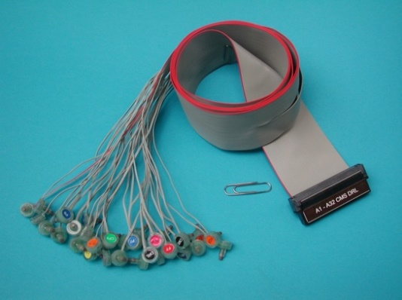

***Figure 3.*** *Electrode bundle*

* Stage 6: Once in the experimental room:
  + Check if the battery is plugged (blue cable) and mounted correctly under the amplifier (figure 4).

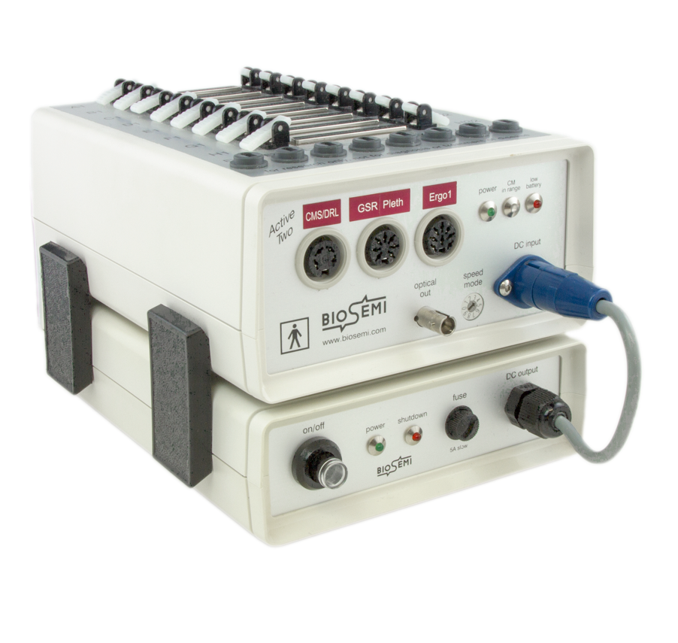

***Figure 4.*** *Biosemi amplifier (above) and battery (below)*

* + Turn the battery on using the power button on the right (you want to make sure that the green (power) and flickering blue (CM range) colors are on, on the left side of the amplifier)
  + Next, connect the 4 electrode bundles to the amplifier. Make sure each bundle connector is in the right place and with the right orientation and insert them gently without forcing.
  + Connect the CMS/DRL cable to the corresponding round slot on the front of the amplifier (again check the correct orientation and gentle handling to prevent damage).
  + Exit the experimental room and go to the computers.
* Stage 7:
  + Open the software “ActiView” on the EEG recording pc (Desktop) and press on “Decimation”, then select “1/2” (on the right)
  + Press “Start” to see the signal.
  + Check the battery status on the top right and replace it if it is running out of charge
  + Inspect EEG signal in the ActiView panel and identify noisy electrodes (manipulate, Lowpass, Channels on the left).
  + Check the electrode impedance by clicking on the Electrode Offset tab. Select the different electrode bundles on the left (“*Channel Selection*”) to clearly see which ones are problematic. Adjust the noisy electrodes by gently removing the electrode from the holder and inserting more gel (do not exaggerate). According to Biosemi, impedance between +/- 100 kΩ is enough to get good quality data but the lower the better (aim for +/- 20 kΩ). If all electrodes show high impedance values, adjust the CMS/DRL reference electrodes.
  + Take notes of the noisy channels or any other problems in the log sheet of the participant. Once happy with the electrode impedance, move to the next step.

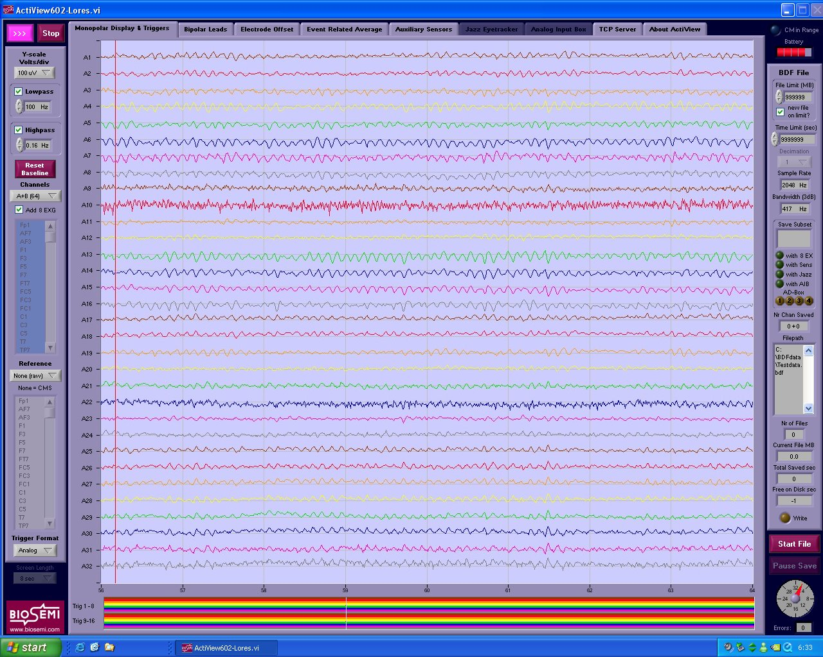

***Figure 5****. ActiView software*

* Stage 8:
  + Ask participant to find a comfortable position for the chin and adjust the chin support if necessary. It is important that the neck of the participant is not tense, because it can introduce noise into the EEG recording.
  + Explain to the participant the task following the instructions on the participant log sheet, and let them know about the practice session prior to experimental task.
  + Highlight the importance of remaining relaxed and still. Advise participants to minimize blinking during the task (when possible) and use breaks to stretch. Blinks, cough, swallow, grinding the teeth etc. can affect the EEG signal, so it is important that the participants are aware and try to minimize these movements during the task.
  + Ask participants to insert the earplugs well into their ears by rolling the foam tip to a size that fits the ear canal.
  + Once ready, leave the booth, turn off the lights and close the door.
* Stage 9: Go to stimulation pc and run the practice session from Matlab as outlined in the participant log sheet. Ensure the correct script is selected and initiate the session by pressing “Run”. At this point the participant should hear a “bip” sound through the earphones. If it doesn’t happen, try to disconnect and reconnect the earphones to the stim pc (you can find the earphones cable plugged into the front of the stim pc tower).

A dialog box will appear on the screen prompting for the participant number. Insert the participant number in both spaces (enter only the number, e.g., “1” figure 6):

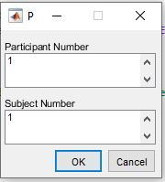

***Figure 6****. Matlab dialog box*

* During the practice session inspect EEG trace making sure it is not noisy and the practice runs smoothly.
* Stage 10: Once the practice session finishes, check in with the participant and announce that the experiment will now begin. The experiment consists of 8 blocks.
  + In ActiView select “Start File” and insert the name of the file followed by *“_ratings_raw”* (e.g. *subj01_ratings_raw.edf*). Check the appropriate fields: in “Save subset” choose A1-D32 (128) and deselect “add 8 EX electrodes” and “add displayed sensors” (figure 7).
  + Change the trigger view from “analog” to “decimal” (bottom left in ActiView – figure 5).
  + Start recording by pressing “Start File” and then “PAUSED” at the bottom right of ActiView. When data is being recorded, the paused button should light up in green and say “**SAVING**”.
  + Once the recording has started, start the rating task script in Matlab (see log sheet).
  + During the task, monitor the EEG activity of the participant and take notes of any unusual signals. It is also important to check if the triggers are displayed (bottom part of ActiView).
  + During breaks between experiment blocks, you can check up on the participant. Turn the lights on to ask them how they are doing and make sure they haven’t fallen asleep. Always keep them motivated and awake.
  + If the task needs to stop for any reason, click ESC to end the task, then CTRL C to reactivate keyboard on the stim pc (it is not preferable because this means that the participant will repeat the encoding, biasing the memorization.
  + At the end of the task, press J to exit the task.
  + When the rating task ends, stop the recording on ActiView (click “pause save” on the bottom right and then click stop on the top left) and ensure the files are saved (folder: actiview_files/hanslmayr_lab/longevity_eeg/subj*). Step into the experimental room and turn off the battery. Check in with the participant and encourage them to take advantage of the break to stretch and relax.

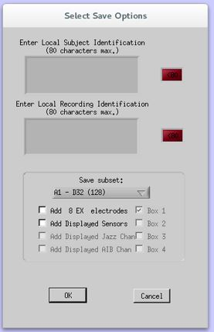

***Figure 7****. ActiView saving options*

* Stage 11: Once the break is over and the participant is happy to continue, explain the distractor task from the log sheet. Turn off the light and run the corresponding script from Matlab.
* Stage 12: At the end of the distractor task, if the participant is assigned to the short group proceed to stage 13; if the participant is assigned to the long group, moves to stage 14 (participants in the long group will leave and come back the day after for Stage 13).
* Stage 13: proceed by explaining the test task (read the log sheet). Also in this case there is a short practice block before the actual task. Address any questions, instruct the participant to re-insert their earplugs, dim the lights, and exit the booth. Run the practice, and then the real task on Matlab. We are recording the EEG only for the short group. If the participant belongs to the short group, in ActiView select “Start File” and insert the name of the file followed by “_*test_raw*” (e.g. *subj01_test_raw.edf*). Check the appropriate fields: in “Save subset” choose A1-D32 (128) and deselect “add 8 EX electrodes” and “add displayed sensors” and follow the same procedure described in stage 10 to start and stop the recording.

Continuously motivate and support the participants throughout the process.

* Stage 14:
  + Once the task is finished, ask the participant to remove the earplugs.
  + Turn off the battery and unplug the 4 electrode bundles from the amplifier by pressing the white release levers on each side. Place the plastic protector caps on the electrode plugs.
  + Pull out CMS/DRL cable from amplifier (always be gentle, do not force or twist anything and do not pull the cable itself).
  + Invite participant to step out of the experimental room. Slowly walk the participant holding the 4 electrode bundles to a chair and gently take the cap off their head. Leave the cap on a plastic tub placed on the desk and direct the participant to the hair washing station (room 230). Offer a clean towel and a hair dryer.
* Stage 15: Fill in the debriefing questionnaire at the end of the log file with the participant. Pay the participant and make them sign the receipt with the amount received. Goodbye greetings.
* Stage 16: Time to clean the EEG cap (you can find a useful “Electode handling” guide attached on the electrodes cupboard)
  + Take the EEG cap to the wash area in room 243 and gently detach the electrodes from the cap by pulling their head and not the cables.
  + Wash each electrode with water whilst ensuring that the other end of the bundle does not come into contact with any water. You should clean the electrodes by hand using warm water (do NOT use a toothbrush). Ensure that the electrodes do not touch any metal (e.g., of the sink).
  + After cleaning each electrode, gently wipe them with paper towels. Ensure that the water is not dripping from the electrodes and store them in the electrode cupboard. Remember to close the cupboard doors.
  + Make sure all electrodes are removed before washing the cap and remove the Velcro strap.
  + Reverse the cap to access the white electrode holders and rinse the gel residue away with water. Visual inspect the cap to ensure that all gel is removed. The cap is left to dry on a white towel on top of the EEG set-up cabinet.
  + Avoid drying the cap on radiators or hanging it up, as this could lead to stretching on misshaping the cap.
  + Syringes are reusable. Unscrew and discard the cannula. Return any remaining gel to the main gel tube. Clean the syringes by repeatedly drawing water in and out using the plunger. Leave the syringes with the plunger removed to air dry on a towel on top of the EEG set-up cabinet (under the cap support).
* Stage 17: Final housekeeping.
  + Remove the battery blue power connector from the amplifier and release the 4 black clips on the sides. Connect the battery to the charger by attaching the blue power connector to the charger output. Always keep the battery charging (it is not harming the battery).
  + Discard the yellow eartips
  + Sanitize each piece of equipment used in the experimental room and tidy up the area
  + Ensure the lab book is updated with the session’s end time
  + Backup the collected data and copy them on the project folder (Project0409)
  + Lock the PCs and power the VPixx off
  + Put the used towels in the dirty towels’ cupboard for laundering