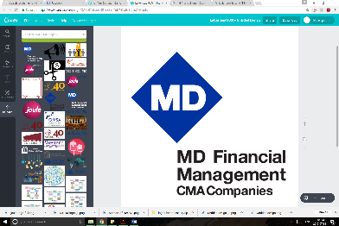

**CFMS 40th Annual General Meeting**

*Courtyard by Marriott Hotel, 350 Dalhousie St. Ottawa, ON*

|  |  |  |  |
| --- | --- | --- | --- |
|  | **Thursday, September 21, 2017** | | |
| 6:30pm - 8:00pm | **CFMS Executive Meeting**  *Cartier Room, Lower Level* | | |
| 8:00pm - 11:00pm | **Presidents’ Roundtable**  Cartier Room, Lower Level | **CFMS Representatives Forum**  MacDonald Room, Lower Level | **Global Health Program**  Laurier Room, Lower Level |

|  |  |
| --- | --- |
|  | **Friday, September 22, 2017 – 40th Anniversary Day**  *Lower Level, Main Ballroom* |
| 7:00 - 8:15am | **Continental Breakfast**  *Lower Level Ballroom Foyer* |
| 8:30 - 8:45am | **Introduction & Welcome Address**  *Dr. Robin Clouston, CFMS Past-President 2012-2013* |
| 8:45 - 10:00am | **Small Working Groups** |
| 10:00 - 10:10am | **Break #1** |
| 10:10 - 11:05am | **Panel 1:**  **Unmatched Canadian Medical Graduates**  *Panelists:* Dr. Genevieve Moineau (AFMC), Dr. Ian Bowmer (MCC), John Gallinger (CaRMS) |
| 11:05 - 12:15pm | **Panel 2: Entry Routes**  *Panelists:* Irving Gold (RDoC), Dr. Genevieve Moineau (AFMC), Dr. Ken Harris (RCPSC),  Dr. Paul Sawchuck (CFPC), Representative TBD (CMA) |
| 12:15 - 1:00pm | **LUNCH**  *Kindly sponsored by: Insurance Alliance for Provisional Medical Associations* |
| 1:00 - 2:30pm | **Dr. Brian Goldman - Keynote Address**  Disruptive Innovation in Medicine |
| 2:30 - 2:45pm | **Break #2** |
| 2:45 - 4:30pm | **Hack-a-thon**  Innovation in Medical Education |
| 4:30 - 4:45pm | ***Wrap-Up*** |
| 6:00 – 8:00pm  onward | **RECEPTION**  *Courtyard Restaurant, 21 George St, Byward Market*  **Cocktails & Buffet** |
| 10:00pm onward | **Social**  *Heart & Crown, 67 Clarence St, Byward Market* |

|  |  |  |  |
| --- | --- | --- | --- |
| **Saturday, September 23, 2017 – AGM Day 1** | | | |
| 7:00 - 8:30am | **Continental Breakfast**  *Lower Level Ballroom Foyer* | | |
| 7:00 - 8:30am | **Presidents’ Roundtable**  Cartier Room, Lower Level | | **Global Health Program**  Cartier Room, Lower Level |
| 9:00am | ***Indigenous Territorial Statement/Welcome*** | | |
| 9:10 - 9:30am | **Welcome to our 40th AGM!**  Shreya Jalali, AGM 2017 Chair | | |
| 9:30 - 10:00am | **President’s Update**  Dr. Franco Rizzuti, CFMS President | | |
| 10:00 - 10:30am | **MINC Overview**  Stephen Abhraham, MINC Chief Information Officer | | |
| 10:30 - 10:45am | **Break #1**  *Kindly sponsored by: The Department of National Defence* | | |
| 10:45 - 11:15am | **CMA/MDFM/Joule Panel & Presentation of MDFM Travel Awards**  Alison Forestell (MDFM), Allison Seymour (MDFM), CMA & Joule Reps TBD | | |
| 11:15 - 11:25am | **Resident Doctors of Canada**  Dr. Michael Arget | | |
| 11:25 - 12:00pm | **Finance Report**  Daniel Peretz, VP Finance | | |
| 12:00 - 12:30pm | **Strategic HR & Operations Plan**  Dr. Anthea LaFrienere, Past-President | | |
| 12:30 - 1:30pm | **LUNCH**  *Kindly sponsored by: The College of Family Physicians of Canada* | | |
| 1:30 - 3:00pm | **Elections Part I** | | |
| 3:00 - 3:15pm | **Break #2**  *Kindly sponsored by: Virtual Hospice* | | |
| 3:15 - 5:15pm | **Elections Part II** | | |
| 5:15 - 6:15pm | **Resolutions Committee Meeting**  *Members of Resolutions Committee only* | **Wellness Activity**  *Meet outside hotel* | |
| 7:15pm | ***Shuttles to Dinner*** | | |
| 7:30pm | **DINNER on Dow’s Lake**  *Mexi’s Restaurant*  *Kindly sponsored by: Resident Doctors of Canada* | | |
| 10:00-11:00pm | ***Shuttles to Social and Hotel*** | | |
| 11:00pm onward | **SOCIAL**  *Hooley’s, Elgin Street* | | |

|  |  |
| --- | --- |
| **Sunday, September 24, 2017 – AGM Day 2** | |
| 7:00am | **Continental Breakfast**  *Lower Level Ballroom Foyer* |
| 7:30 - 8:30am | **New Executive Handover Meeting**  *Laurier Room, Lower Level* |
| 9:00 - 9:15am | **Introduction & Robert’s Rules Review**  Shreya Jalali, AGM 2017 Chair |
| 9:15 - 9:30am | **Resolutions Working Group Update**  Sarah Silverberg, VP Government Affairs & Henry Annan, President-Elect |
| 9:30 - 10:00am | **Resolutions Marketplace & Gatorade Break***\**  *Main Ballroom, Lower Level*  *\*Kindly sponsored by: University of Ottawa Aesculapian Society* |
| 10:00 - 12:00pm | **Resolutions Part I** |
| 12:00 - 1:00pm | **LUNCH**  *Kindly sponsored by: CaRMS and OMSA* |
| 1:00 - 2:00pm | **Resolutions Part II** |
| 2:00 - 3:15pm | **Executive Q&A**  2016-2017 Exec Panel |
| 3:15 - 3:30pm | **Inaugural Address**  Henry Annan, President-Elect |
| 3:30pm | ***Adjourn Meeting*** |

The CFMS would like to thank the very generous sponsors of AGM 2017 including our title sponsor,  
 **MD Financial Management**!



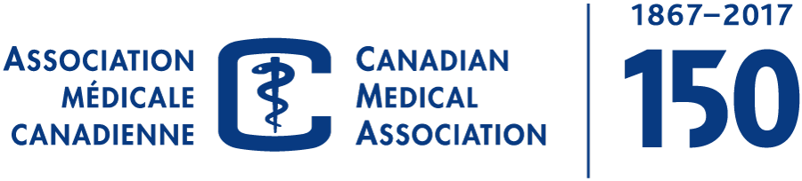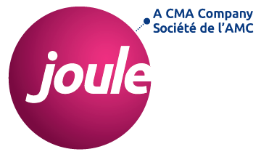

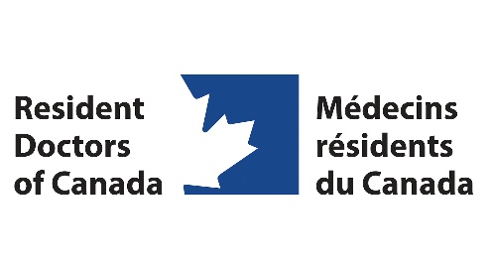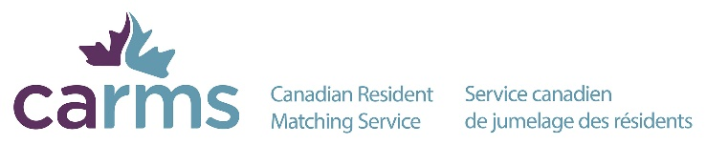

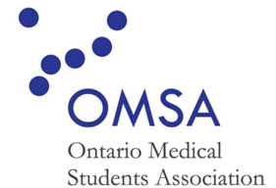

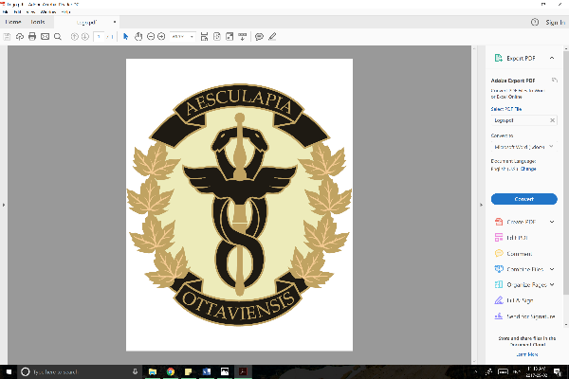



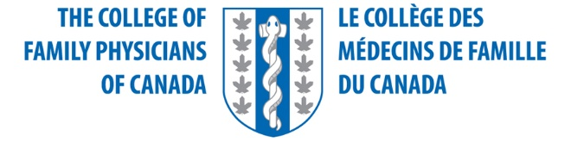





**AGM 2017 Sponsors**