**Supplementary Information**

Large-scale meta-analysis suggests low regional modularity in lateral frontal cortex.

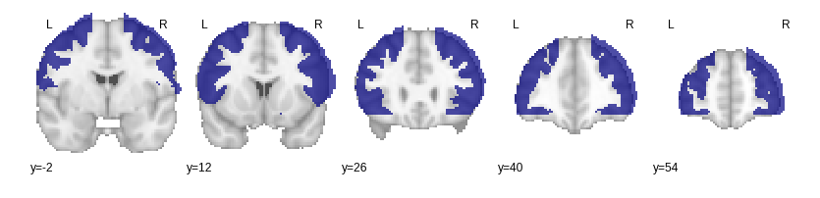

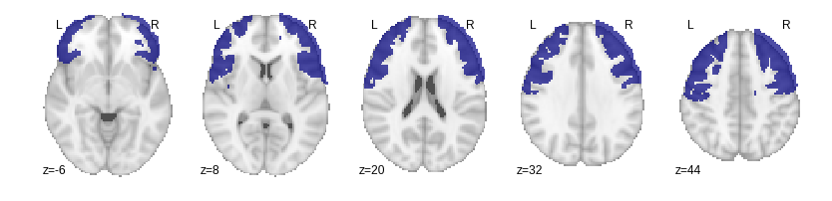

**Supplemental Figure 1**. Mask used to select lateral frontal cortex clusters from whole-brain hierarchical clustering results. Top) Axial. Bottom) Saggital.

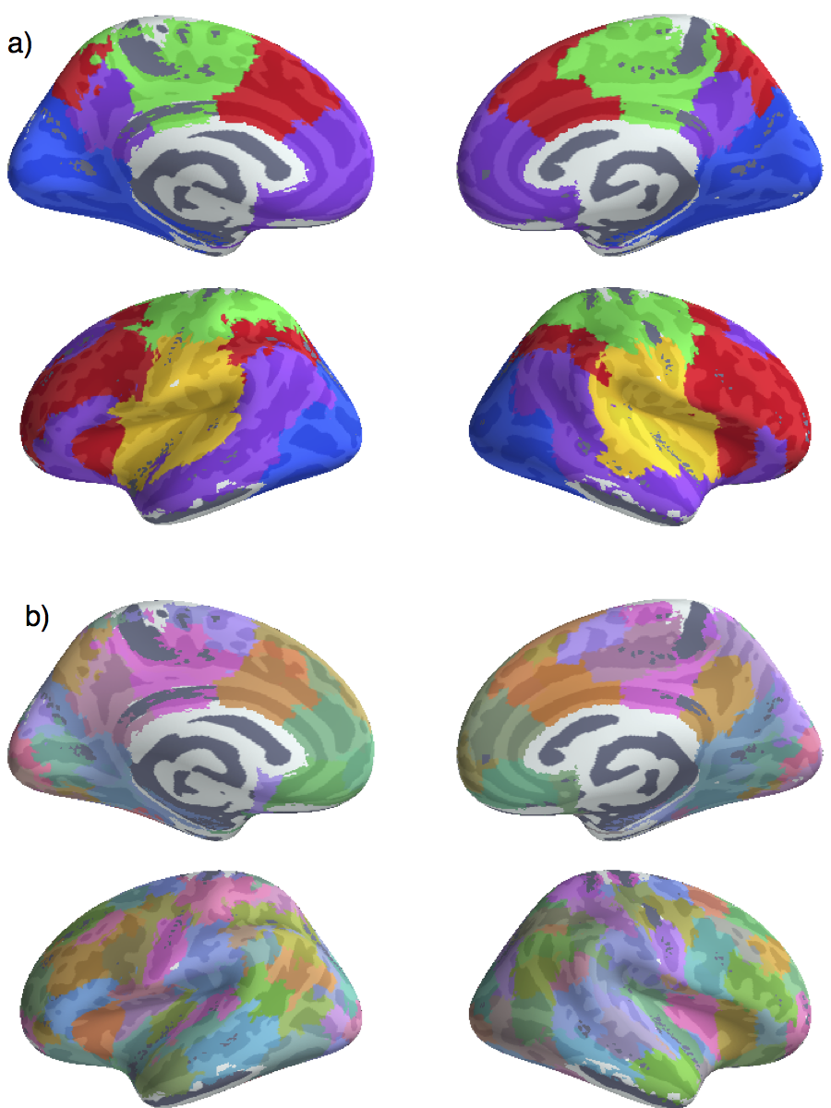

**Supplemental Figure 2**. Whole brain hierarchical clustering results at *k*=5 and *k*=70. In addition to the three clusters in LFC, we identified two clusters primarily outside of LFC, which we refer to as the “ventral attention” network (yellow), and the “visual” network (blue).

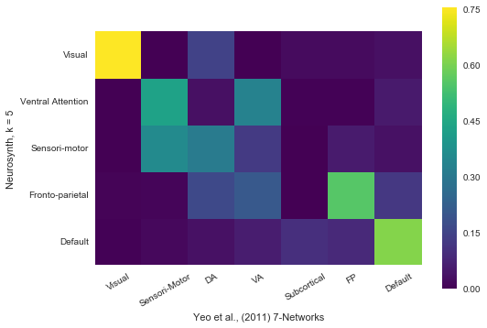

**Supplemental Figure 3**. Cross-reference of the Dice coefficient overlap between our clusters at *k* = 5 and Yeo et al., (2011)’s 7-Network solution (liberal). Greater dice coefficients indicate greater spatial overlap. Overall, there was substantial overlap between the two sets of clusters. Due to the lower dimensionality of our parcellation, some clusters (e.g. sensori-motor) showed moderated to more than one of Yeo’s networks.

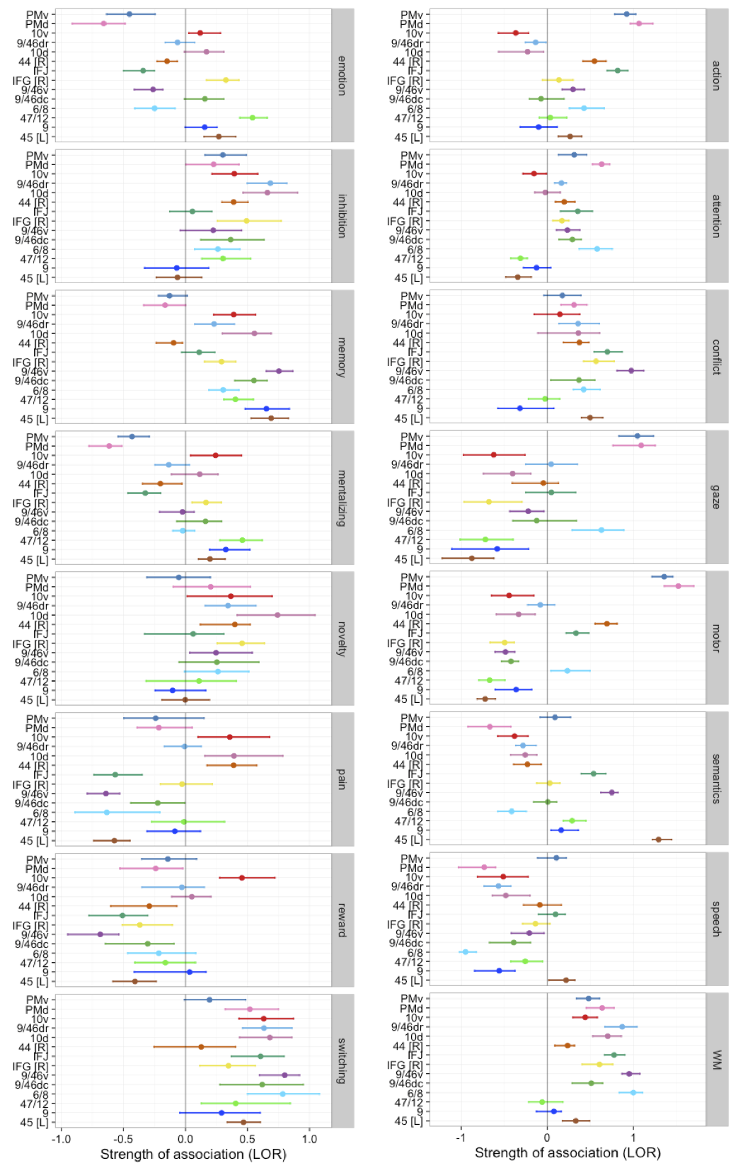

**Supplemental Figure 4**. Strength of association between the 16 topics analyzed throughout the manuscript and individual LFC sub-regions, measured as log odds ratio (LOR). 95% confidence intervals for LORs were generated by bootstrapping the full set of studies 1000 times. Colors for each region correspond to those used throughout the main text.