A major strength of our meta-analytic approach is that it allowed us to quantify the relative specificity of brain-cognition associations. A trenchant problem for both individual fMRI studies and conventional meta-analyses is that they typically estimate the probability of observing brain activity conditional on a given mental state, rather than the probability of a mental state conditional on observed brain activity (Poldrack, 2006). To demonstrate the insidious nature of this *reverse inference* problem in the present context, we recreated, using Neurosynth, a meta-analysis conducted by Shackman et al., (2011) that reported a high degree of overlap between negative affect, pain and cognitive control in regions of the dACC. First, we performed a ‘forward inference’ analysis that identified all voxels consistently activated in studies involving negative affect, pain or conflict (Figure 5a); this analysis is akin to performing a standard fMRI meta-analysis, in which one selects studies purporting to engage these processes. Similar to Shackman et al., (2011), we found a marked overlap between pain, conflict and affect in dACC. Strikingly, however, we also obtained nearly identical results when assessing the overlap between three cognitive functions that are not typically associated with dACC activity: social cognition, vision and memory retrieval (Figure 5b). In contrast, when we conducted a ‘reverse inference’ analysis -- which displays voxels that predict a high probability of the presence of each of these cognitive functions given their activation-- we found unique spatial patterns for negative affect, pain and cognitive control (Figure 5c; cf. Yarkoni et al, 2011). The limited degree of overlap observed in the latter analysis suggests that the putative role of dACC in affect, pain, and cognitive control likely derives from a more general function, whereas other subregions of MFC may subserve more domain-specific roles in cognition.

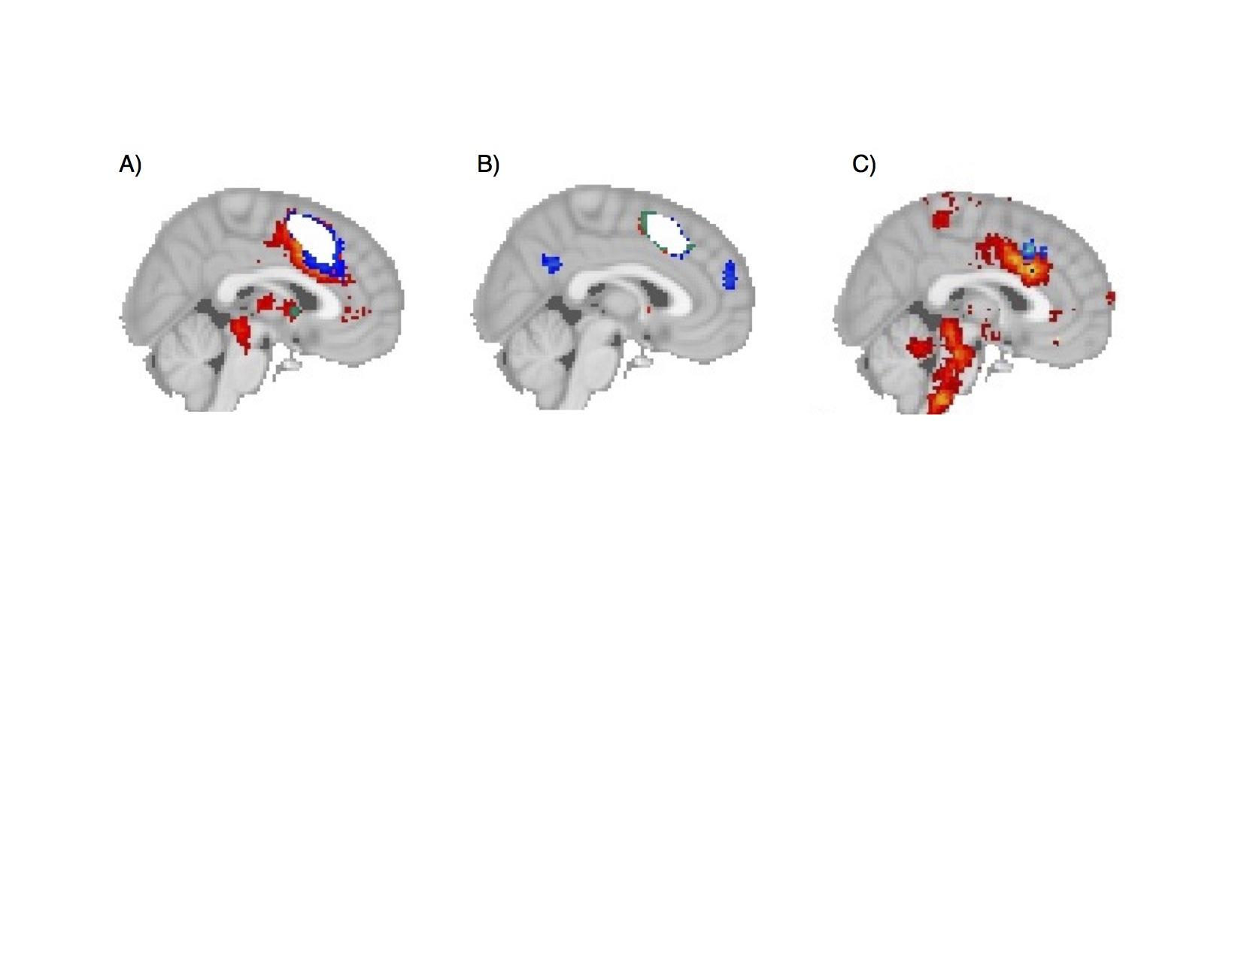

**Figure 1**. *.* Reverse-inference is necessary to determine neural correlates of cognitive functions. A) Forward inference of pain (red), cognitive control (blue) and emotion (yellow), showing overlap in in white. B) Forward inference of social cognition (blue), vision (red) and memory retrieval (red) also showing overlap in white. C) Reverse inference map of pain (red), cognitive control (blue) and emotion (yellow) shows distinct neural correlates of these domains, with no overlap between these three cognitive states in dACC.