Title: Large-scale meta-analysis of human medial frontal cortex reveals tripartite functional organization

Abbreviated title: Large-scale meta-analysis of medial frontal cortex

Alejandro de la Vega1,2, Luke J. Chang3, Marie T. Banich1,2, Tor D. Wager1,2 and Tal Yarkoni4

1 Department of Psychology and Neuroscience, University of Colorado Boulder, 80309 2 Institute of Cognitive Science, University of Colorado Boulder, 80309 3 Department of Psychological and Brain Sciences, Dartmouth College, 03755 4 Department of Psychology, University of Texas at Austin, 78712

Corresponding Author: Alejandro de la Vega, Department of Psychology and Neuroscience, University of Colorado Boulder, Muenzinger D244, 345 UCB, Boulder, CO 80309-0345, 650-315-9536, email: delavega@colorado.edu

Number of pages: 37

Number of figures: 4

Number of words for abstract: 209

Number of words for introduction: 649

Number of words for discussion: 1491

Conflicts of Interest: The authors declare no competing financial interests.

Acknowledgments: R01MH096906 National Institutes of Health.

**Abstract**

The functional organization of human medial frontal cortex (MFC) is a subject of intense study. Using functional magnetic resonance imaging (fMRI), the MFC has been associated with diverse psychological processes including motor function, cognitive control, affect, and social cognition. However, there have been few large-scale efforts to comprehensively map specific psychological functions to sub-regions of medial frontal anatomy. Here we applied a meta-analytic data-driven approach to nearly 10,000 fMRI studies to identify putatively separable regions of MFC and determine which psychological states preferentially recruit their activation. We identified regions at several spatial scales on the basis of meta-analytic co-activation, revealing three broad functional zones along a rostro-caudal axis composed of 2-4 smaller sub-regions each. Multivariate classification analyses aimed at identifying the psychological functions most strongly predictive of activity in each region revealed a tripartite division within MFC, with each zone displaying a relatively distinct functional signature. The posterior zone was associated preferentially with motor function, the middle zone with cognitive control, pain, and affect, and the anterior with reward, social processing and episodic memory. Within each zone, the more fine-grained sub-regions showed distinct, but subtler, variations in psychological function. These results provide hypotheses about the functional organization of medial prefrontal cortex that can be tested explicitly in future studies.

**Significance Statement**

Activation of medial frontal cortex in fMRI studies is associated with a wide range of psychological states ranging from cognitive control to pain. However, this high rate of activation makes it challenging to determine how these various processes are topologically organized across medial frontal anatomy. We conducted a meta-analysis across nearly 10,000 studies to comprehensively map psychological states to discrete sub-regions in medial frontal cortex using relatively unbiased data-driven methods. This approach revealed three distinct zones that differed substantially in function, each of which were further subdivided into 2-4 smaller subregions that showed additional functional variation. Each individual region was recruited by multiple psychological states, suggesting sub-regions of medial frontal cortex are functionally heterogeneous.

**Introduction**

The medial frontal cortex (MFC) is purported to play a key role in a number of psychological processes, including motor function, cognitive control, emotion, pain and social cognition. However, the precise correspondence of psychological states onto discrete medial frontal anatomy remains elusive. Several recent attempts to define distinct functional sub-regions of MFC have been based on morphology (Palomero-Gallagher et al., 2013; Vogt, 2016) in-vivo structural connectivity (Johansen-Berg et al., 2004; Beckmann et al., 2009; Sallet et al., 2013; Neubert et al., 2014) and functional connectivity (Andrews Hanna et al., 2010). Although such studies map key properties which constrain information processing in MFC, it’s unclear if these boundaries correspond to patterns of brain activity observed during behavioral performance (Eickhoff et al., 2007; Amunts and Zilles, 2015; Mattar et al., 2015). Moreover, as these methods do not measure the brain’s response to various psychological challenges, they cannot directly identify the (potentially separable) functional associates of MFC sub-regions.

To this end, task-based functional MRI (fMRI) has suggested that distinct foci of MFC activation may be associated with specific psychological manipulations. For example, the supplementary motor area (SMA) and pre-SMA have been associated with the planning and initiation of movements (Roland et al., 1980; Kennerley et al., 2004; Leek and Johnston, 2009), while midcingulate cortex (MCC) has been implicated in various aspects of cognitive control (Botvinick et al., 1999; Milham et al., 2001; Holroyd et al., 2004; Brown and Braver, 2005; Shenhav et al., 2013), fear (Vogt and Vogt, 2003; Milad et al., 2007; Etkin et al., 2011), and pain processing (Rolls et al., 2003; Wager et al., 2013; Vogt, 2016). Further anterior, medial prefrontal cortex (mPFC) and the rostral anterior cingulate cortex (rACC) have been associated with a affective processes, including emotion (Etkin et al., 2011; Lindquist et al., 2012), autonomic function (Critchley et al., 2003), and valuation (Hare et al., 2009), as well as internally oriented processes, such as mentalizing (Baumgartner et al., 2012) and autobiographical memory (Spreng and Grady, 2010) .

Despite the large number of neuroimaging studies, there have been few large-scale efforts to comprehensively map the full range of psychological functions onto medial frontal anatomy. Most meta-analyses are restricted to a subset of empirical findings relevant to candidate cognitive states hypothesized to be important (e.g. negative affect, pain, cognitive control; Shackman et al., 2011) or a specific anatomical region of interest (e.g., Palomero-Gallagher et al., 2015). This relatively narrow scope limits the ability to address the specificity of activation of psychological states across the MFC more broadly. That is, without considering a wide representative range of psychological states, it is difficult to determine whether particular psychological processes preferentially recruit specific subdivisions of MFC. This limitation, widely known as the reverse inference problem (Poldrack, 2006), is particularly acute for portions of MFC which commonly activate in a large proportion of fMRI studies, raising questions about whether these regions are selectively involved in specific mental functions (Nelson et al., 2010; Yarkoni et al., 2011).

Here we address these issues by creating a comprehensive mapping between psychological states and MFC anatomy using Neurosynth (Yarkoni et al., 2011), a framework for large-scale fMRI meta-analysis composed of nearly 10,000 studies. We first clustered MFC voxels into functionally separable regions at several spatial scales based on their co-activation across studies with the rest of the brain (Kober et al., 2008; Toro et al., 2008; Smith et al., 2009; Robinson et al., 2010). In contrast to cytoarchitechtonic and connectivity based parcellations, the present analysis identified clusters with distinct signatures of activation across a wide range of psychological manipulations. This procedure revealed three zones along the rostro-caudal axis that further fractionated into nine sub-regions. We then characterized each cluster’s functional profiles using multivariate classification, revealing broad functional shifts between the three zones, and subtler variations between their corresponding sub-regions. Collectively, our results provide a comprehensive functional map of the human MFC using relatively unbiased data-driven methods.

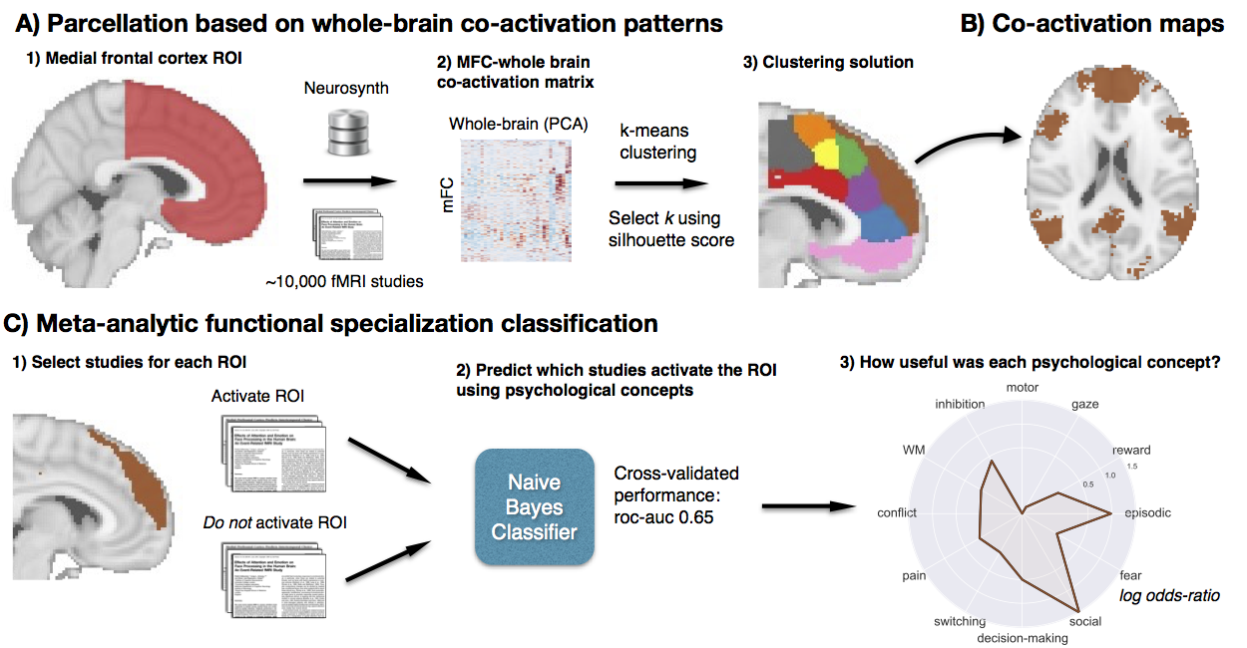**Figure 1. Methods overview.** A) Whole brain co-activation of MFC voxels was calculated and k-means clustering was applied resulting in spatially distinct clusters. B) For each cluster, thresholded whole-brain co-activation maps were generated. C) We generated functional preference profiles for each cluster by determining which psychological topics best predicted their activation.

**Materials & Methods**

We analyzed version 0.4 of the Neurosynth database, (Yarkoni et al., 2011), a repository of 9,721 fMRI studies and over 350,000 activation peaks that span the full range of the published literature. The studies included human subjects of either sex. Each observation contains the peak activations for all contrasts reported in a study’s table as well as the frequency of all of the words in the article abstract. A heuristic but relatively accurate approach is used to detect and convert reported coordinates to the standard MNI space (see: Yarkoni et al., 2011). As such, all activations and subsequent analyses are in MNI152 coordinate space. The scikit-learn

Python package (Pedregosa et al., 2011) was used for all machine learning analyses. Analyses were performed using the core Neurosynth python tools (https://github.com/neurosynth/neurosynth); code and data to replicate these analyses on any given brain region at any desired spatial granularity are available as a set of IPython Notebooks (https://github.com/adelavega/neurosynth-mfc).

### Co-activation-based clustering

We clustered individual voxels inside of a MFC mask based on their meta-analytic co-activation with voxels in the rest of the brain (Figure 1A). First, we defined a MFC mask excluding voxels further than 10mm from the midline of the brain, posterior to the central sulcus (Y < -22mm) and ventral to vmPFC (Z < -32mm). Next, we removed voxels with low grey matter signal by excluding voxels with either fewer than 30% probability of grey matter cortex according to the Harvard-Oxford anatomical atlas, or very low activation rates in the database (less than 80 studies per voxel). In general, Neurosynth’s activation mask (derived from the standard MNI152 template distributed with FSL) corresponded highly with probabilistic locations of cerebral cortex, with the exception of portions of precentral gyrus and far ventromedial prefrontal cortex– which showed low activation although they were more than 50% likely to be in cerebral cortex.

Next, we calculated the co-activation of each MFC voxel with the rest of the brain by correlating the target voxel’s activation pattern across studies with the rest of the brain. Activation in each voxel is represented as a binary vector of length 9,721 (the number of studies). A value of 1 indicated that the voxel fell within 10 mm of an activation focus reported in a particular study, and a value of 0 indicated that it did not. Because correlating the activation of every MFC voxel with every other voxel in the brain would result in a very large matrix (15,259 MFC voxels x 228,453 whole-brain voxels) that would be computationally costly to cluster, we reduced the dimensionality of the whole brain to 100 components using principal components analysis (PCA; the precise choice of number of components does not materially affect the reported results). Next, we computed the Pearson correlation distance between every voxel in the MFC mask with each whole-brain PCA component. We applied k-means clustering to this matrix (15,259 MFC voxels x 100 whole-brain PCA components) to group the MFC voxels into 2-15 clusters. K-means was used for clustering as this algorithm is computationally efficient, widely used, and shows reasonably high goodness-of-fit characteristics (Thirion et al., 2014). We used the k-means++ initialization procedure, ran the algorithm 10 times on different centroid seeds and selected the output of these consecutive runs with the lowest inertia to avoid local minima.

Since the optimality of a given clustering depends in large part on investigators’ goals, the preferred level of analysis, and the nature and dimensionality of the available data, identifying the ‘correct’ number of clusters is arguably an intractable problem (Varoquaux and Thirion, 2014; Eickhoff et al., 2015; Poldrack and Yarkoni, 2016). However, in the interest of pragmatism, we attempted to objectively select the number of clusters using the silhouette score, a measure of within-cluster cohesion. The silhouette coefficient was defined as (b – a) / max(a, b), where a is the mean intra-cluster distance and b is the distance between a sample and the nearest cluster of which the sample is not a part. Solutions that minimized the average distance between voxels within each cluster received a greater score. To estimate the uncertainty around silhouette scores, we used a permutation procedure previously employed by our group (Wager et al., 2008).

To understand the anatomical correspondence of the resulting clusters, we calculated the probability of voxels in each cluster of occurring in probabilistic regions from the Harvard-Oxford atlas (H-O). We refer to H-O’s Juxapositional Lobule Cortex as Supplementary Motor Area (SMA) for consistency. We also compared the location of clusters to regions from cytoarchitechtonic atlases of medial motor areas (Picard and Strick, 1996), mid-cingulate cortex (Vogt, 2016) and vmPFC (Mackey and Petrides, 2014). To be precise, sub-regions in the nine-cluster solution were given alphanumeric labels in addition to descriptive names.

### Co-activation profiles

Next, we analyzed the differences in whole brain co-activation between the resulting clusters (Figure 1B). To highlight differences between clusters, we contrasted related sets of clusters. For the three-cluster solution, we contrasted the co-activation of each cluster (e.g. ‘posterior zone’) with the other two clusters (e.g. ‘middle’ and ‘anterior’ zones). For the nine-cluster solution, we contrasted the co-activation of each cluster (e.g. ‘SMA’) with spatially adjacent clusters that fell within the same zone of the three-cluster solution (e.g. ‘pre-SMA’). To do so, we performed a meta-analytic contrast between studies that activated a given cluster and studies that activated control clusters. The resulting images identify voxels with a greater probability of co-activating with the cluster of interest than with control clusters. For example, voxels in grey in the first panel of Figure 3B indicate voxels that are active more frequently in studies in which SMA [P1] is active than in studies in which pre-SMA [P2] is active. We calculated p-values for each voxel using a two-way chi-square test between the two sets of studies and thresholded the co-activation images using the False Discovery Rate (q < 0.01). The resulting images were binarized for display purposes and visualized using the NiLearn library for Python.

### Topic modeling

Although term-based meta-analysis maps in Neurosynth closely resemble the results of manual meta-analyses of the same concepts, there is a high degree of redundancy between terms (e.g. ‘episodes’ and ‘episodic’), as well as potential ambiguity as to the meaning of an individual word out of context (e.g. ‘memory’ can indicate working memory or episodic memory). To remedy this problem, we employed a reduced semantic representation of the latent conceptual structure underlying the neuroimaging literature: a set of 60 topics derived using latent dirichlet allocation (LDA) topic-modeling (Blei et al., 2003). This procedure was identical to that used in a previous study (Poldrack et al., 2012a), except for the use of a smaller number of topics and a much larger version of the Neurosynth database. The generative topic model derives 60 independent topics from the co-occurrence across studies of all words in the abstracts fMRI studies in the database. Each topic loads onto individual words to a varying extent, facilitating the interpretation of topics; for example, a working memory topic loads highest on the words 'memory, WM, load', while an episodic memory topic loads on 'memory, retrieval, events'. Note that both topics highly load on the word “memory”, but the meaning of this word is disambiguated because it is contextualized by other words that strongly load onto that topic. Out of the 60 generated topics, we excluded 25 topics representing non-psychological phenomena– such as the nature of the subject population (e.g. gender, special populations) and methods (e.g., words such as “images”, “voxels”)— resulting in 35 psychological topics. See Table 1 for a list of topics most associated with MFC.

### Meta-analytic functional preference profiles

We generated functional preference profiles by determining which psychological topics best predicted each MFC cluster’s activity across fMRI studies (Figure 1C). First, we selected two sets of studies: studies that activated a given cluster—defined as activating at least 5% of voxels in the cluster­– and studies that did not– defined as activating no voxels in the cluster. For each cluster, we trained a naive Bayes classifier to discriminate these two sets of studies based on psychological topics herein. We chose naive Bayes because (i) we have previously had success applying this algorithm to Neurosynth data (Yarkoni et al., 2011); (ii) these algorithms perform well on many types of data (Androutsopoulos et al., 2000); (iii) they require almost no tuning of parameters to achieve a high level of performance; and (iv) they produce highly interpretable solutions, in contrast to many other machine learning approaches (e.g., support vector machines or decision tree forests).

We trained models to predict whether or not fMRI studies activated each cluster, given the semantic content of the studies. In other words, if we know which psychological topics are mentioned in a study how well can we predict whether the study activates a specific region? We used 4-fold cross-validation for testing and calculated the mean score across all folds as the final measure of performance. We scored our models using the area under the curve of the receiver operating characteristic (AUC-ROC) –a summary metric of classification performance that takes into account both sensitivity and specificity. AUC-ROC was chosen because this measure is not detrimentally affected by unbalanced data (Jeni et al., 2013), which was important because each region varied in the ratio of studies that activated it to the studies that did not.

To generate functional preference profiles, we extracted from the naive Bayes models the log odds-ratio (LOR) of a topic being present in active studies versus inactive studies. The LOR was defined as the log of the ratio between the probability of a given topic in active studies and the probability of the topic in inactive studies, for each region individually. LOR values above 0 indicate that a psychological topic is predictive of activation of a given region. To determine the statistical significance of these associations, we permuted the class labels and extracted the LOR for each topic 1000 times. This resulted in a null distribution of LOR for each topic and each cluster. Using this null distribution, we calculated p-values for each pairwise relationship between psychological concepts and regions, and reported associations significant at the p<0.001 threshold. Finally, to determine if certain topics showed greater preference for one cluster versus another, we conducted exploratory, post-hoc comparisons by determining if the 95% confidence intervals (CI) of the LOR of a specific topic for a one region overlapped with the 95% CI of the same topic for another region. We generated CIs using bootstrapping, sampling with replacement and recalculating log-odds ratios for each region 1000 times.

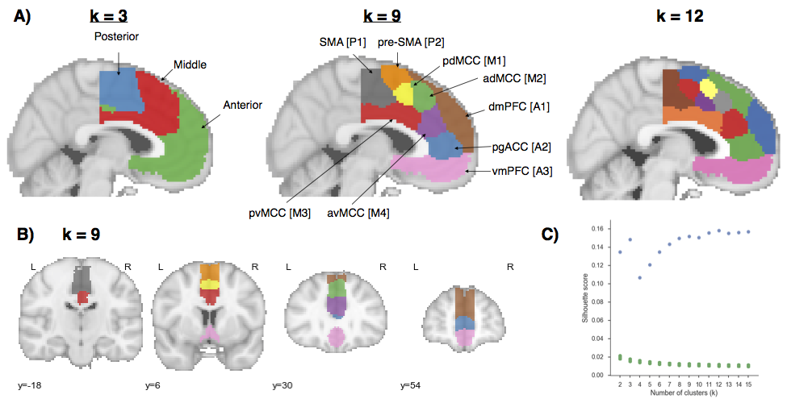

**Figure 2. Co-activation-based clustering of MFC results.** A) Mid-sagittal view at three levels at granularity: three broad zones, nine and twelve sub-regions. Clusters in nine sub-region solution are given both descriptive and alphanumeric names for reference. SMA: supplementary motor area. pre-SMA: pre-supplementary motor area; MCC: midcingulate cortex. pgACC: pre-genual anterior cingulate cortex; dmPFC: dorsal medial PFC; vmPFC: ventromedial PFC. B) Axial view of nine sub-regions. C) Silhouette scores of real (green) and permuted (blue) clustering solutions. Clustering was performed on permuted data 1000 times for each k to compute a null distribution (*p*-values for all clusters < .001). Silhouette scores reached local maxima at 3 regions and plateaued after 9.

**Results**

## Functionally separable regions of medial frontal cortex

We identified spatially dissociable regions on the basis of shared co-activation profiles with the rest of the brain (Kober et al., 2008; Toro et al., 2008; Smith et al., 2009; Chang et al., 2013), an approach that exploits the likelihood of a voxel co-activating with another voxel across studies in the meta-analytic database (Figure 2). Because structure-to-function mappings can be identified at multiple spatial scales, we iteratively extracted 2- through 15-cluster solutions and assessed their validity using the silhouette score—a commonly used measure of inter-cluster coherence. Permutation analyses indicated that the null hypothesis of random clustering could be rejected for all solutions, with silhouette scores reaching local maxima at 3 clusters (Figure 2C). The plateauing of silhouette scores suggests that there is little objective basis for selecting one solution over another past around 9 clusters (Thirion et al., 2014). We have therefore opted to focus on the 3-cluster and 9- cluster solutions because they provide greater theoretical parsimony than more fine-grained solutions.

At the coarsest level, MFC divided into three broad bilateral clusters organized along the rostral-caudal axis. The nine-cluster solution revealed additional fine-grained topographical organization, with each of the three major zones fractionating into 2-4 smaller regions (84% of all voxels within each zone overlapped with its putative sub-regions). We henceforth refer to the clusters from the 3-cluster solution as “zones” to differentiate them from clusters in the 9-cluster solution, which we refer to as “sub-regions”.

To better understand the anatomical location of our clusters, we compared them to previously defined sub-regions from the Harvard-Oxford (H-O) probabilistic structural atlas and well-known cytoarchitechtonic studies. Although we did not necessarily expect our clusters to conform precisely to morphologically derived regions, we nonetheless observed moderate correspondence– suggesting morphological properties constrain, but not determine function. Within the posterior zone, we identified two clusters (Figure 2A; SMA [P1] & pre-SMA[P2]) with a high probability of occurring in SMA according to H-O. The two clusters were approximately delineated by the vertical commissure anterior (VCA), consistent with cytoarchitechtonic delineations (Picard and Strick, 1996). However, SMA [P1] spanned multiple cytoarchitechtonic areas– extending ventrally to include portions of Picard & Strick’s cingulate zones– suggesting these morphologically distinct areas co-activate similarly across tasks.

In the middle zone, we identified four clusters consistent with midcingulate cortex (MCC). In particular, two anterior and two posterior clusters delineated from each other a few millimeters anterior to the VCA, consistent with Vogt’s definition of anterior and posterior midcingulate cortex (Vogt, 2016). The two dorsal clusters (pdMCC [M1] & adMCC [M2]) showed a high probability of falling within H-O’s paracingulate gyrus, whereas the two ventral clusters (pvMCC [M3] & avMCC [M4]) showed a high probability of falling in the cingulate gyrus proper. Unlike some cytoarchitechtonic studies, we did not identify any regions exclusively located in the cingulate sulcus, such as the rostral cingulate zone.

In the anterior zone, the most dorsal cluster (dmPFC [A1]) included medial aspects of H-O’s frontal pole and superior frontal gyrus, and was entirely outside of the anterior cingulate gyrus. Ventrally, we identified a second cluster (pgACC [A2]) which was primarily located within pregenual aspects of the anterior cingulate gyrus, but also included pregenual portions of paracingulate gyrus. Finally, the most ventral cluster (vmPFC [A3]) encompassed both pregenual aspects of the ACC and medial OFC, similar to the vmPFC area of interest used in cytoarchtechtonic studies (Mackey and Petrides, 2014).

Next, to provide direct insight into the functions of the clusters we identified, we applied two approaches. First, we determined which other brain regions co-activate with each cluster, in order to reveal their functional networks. Second, we used semantic data from Neurosynth to determine which psychological states predict the activation of each cluster.

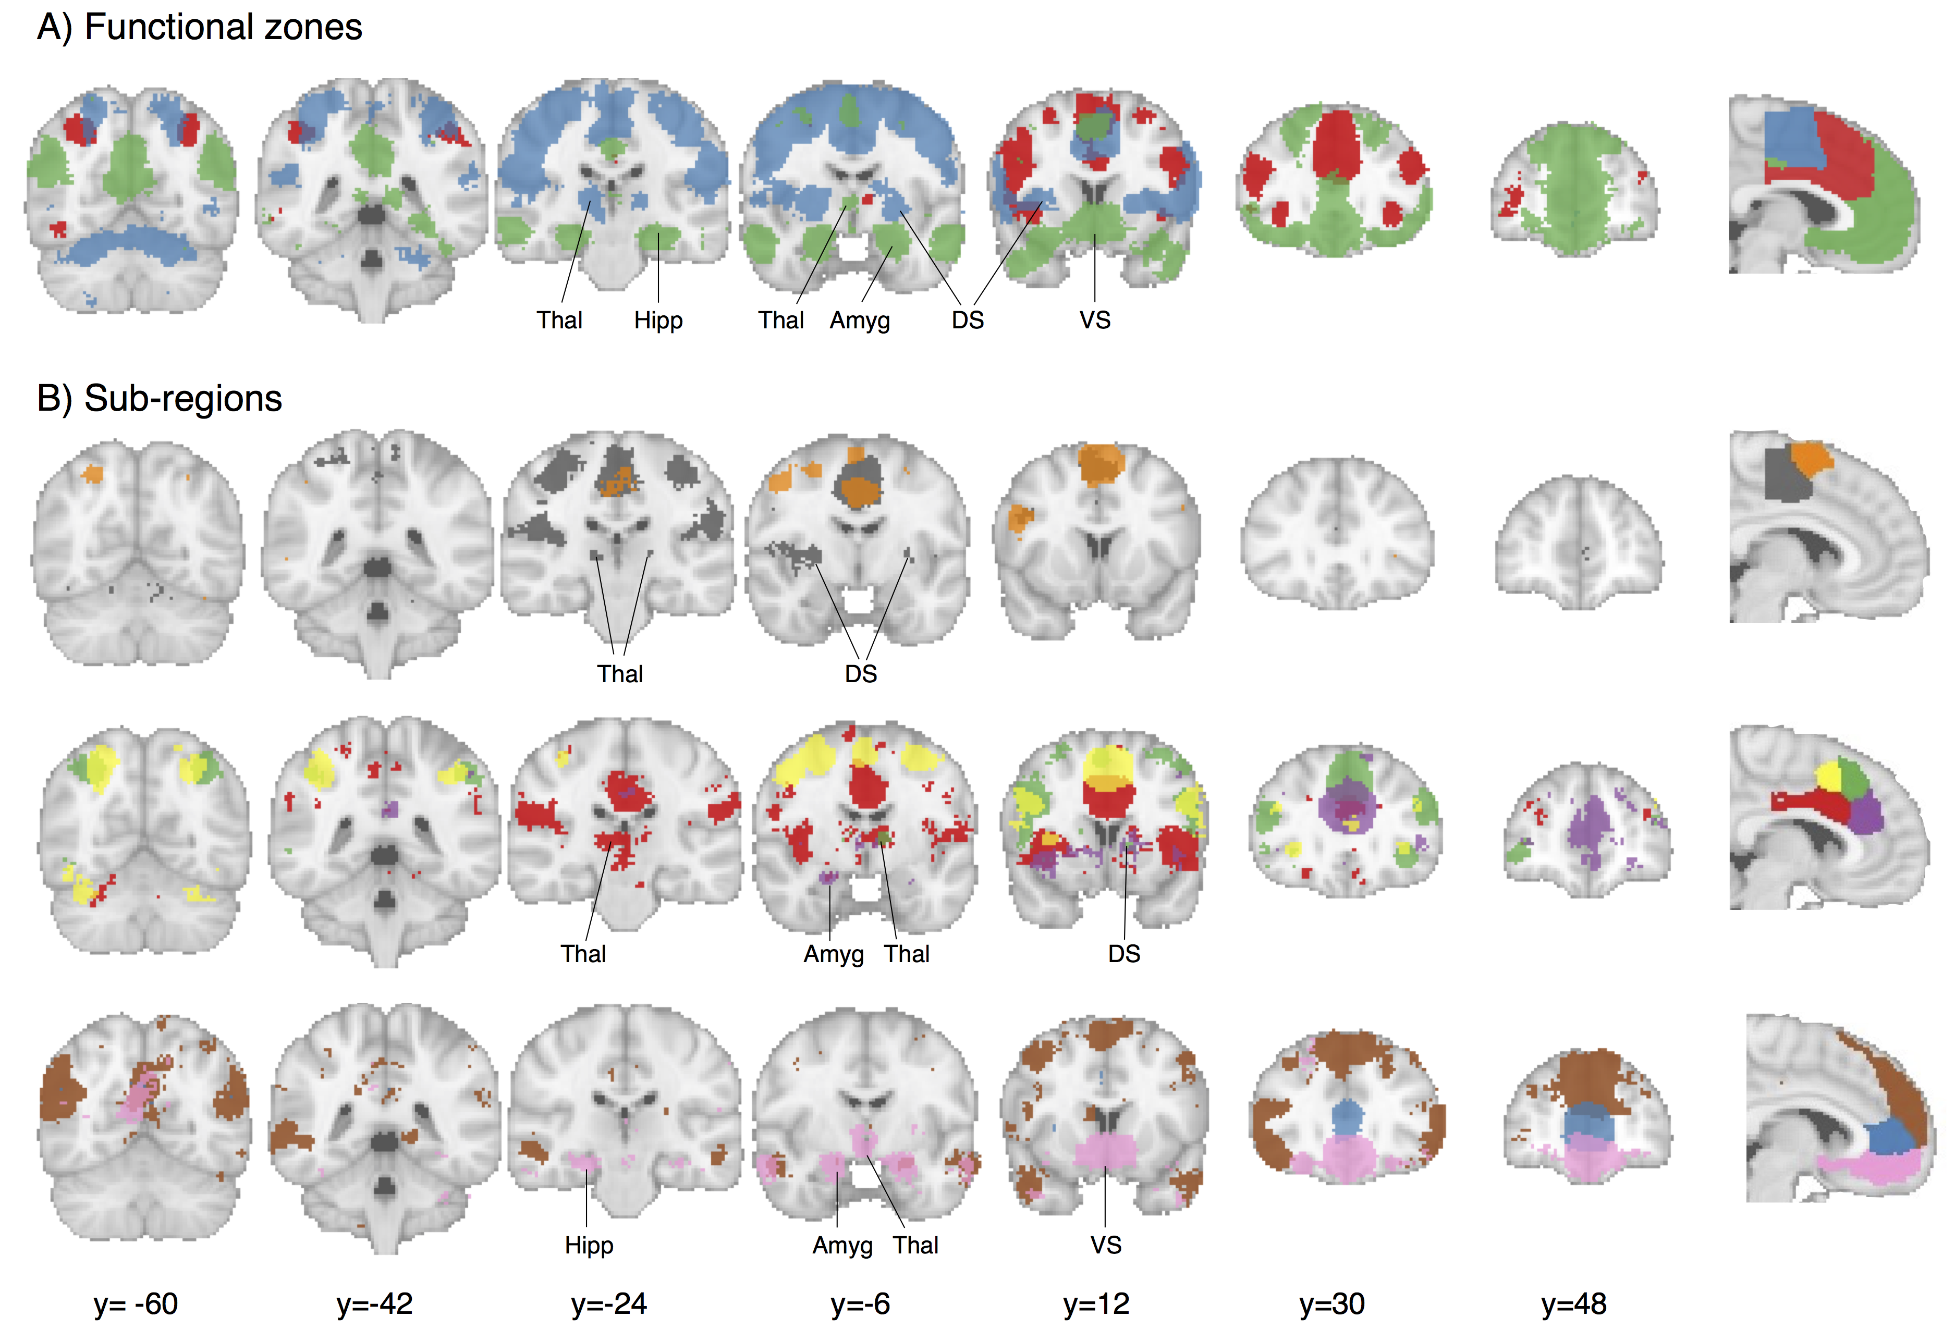

Figure 3. Meta-analytic co-activation contrasts for (A) three zones and B) nine sub-regions. Colored voxels indicate significantly greater co-activation with the seed region of the same color (at right) than control regions in the same row. The three zones showed distinct co-activation patterns, while sub-regions within each zone showed fine-grained co-activation differences. Images are presented using neurological convention and were whole-brain corrected using a false discovery rate (FDR) of q = 0.01. Major subcortical structures are labeled; Thal: thalamus, Hipp: hippocampus; Amyg: amygdala; DS: dorsal striatum; VS: ventral striatum.

## Meta-analytic co-activation profiles

We directly contrasted co-activation patterns of the three functional zones– i.e., we sought to identify voxels that co-activated to a stronger degree with each zone than with the other two (Figure 3A). The posterior zone showed greater bilateral co-activation with primary motor cortex (PMC) and superior parietal cortex (SPC), anterior cerebellum, and posterior insula (pIns) as well subcortical regions such as the thalamus and dorsal striatum (DS)—a co-activation pattern consistent with motoric function. The middle zone co-activated with anterior aspects of the thalamus as well as regions in the frontoparietal control network such as dorsolateral prefrontal cortex (DLPFC), anterior insula (aIns) and SPC. Finally, the anterior zone showed a qualitatively different pattern, co-activating to a greater extent with default network regions such as angular gyrus, hippocampus and posterior cingulate cortex (PCC) (Andrews-Hanna, 2012). The anterior zone also showed greater co-activation with subcortical regions important for affect– the amygdala and ventral striatum (VS).

To understand the differences in co-activation found within each zone, we directly contrasted the co-activation patterns of each zone’s sub-regions (Figure 3B). In the posterior zone, SMA [P1] showed greater co-activation with somatosensory cortices and pIns while pre-SMA [P2] showed greater co-activation with posterior DLPFC, including the inferior frontal junction (IFJ), as well as aIns— regions associated with goal-directed cognition (Nelson et al., 2010; Chang et al., 2013). Within the middle zone, we found that all four sub-regions strongly co-activated with various aspects of the insula. However, pvMCC [M3] was more strongly co-activated with pIns, SII and the brain stem—important regions for pain processing (Vogt, 2005; Wager et al., 2013). In contrast, avMCC [M4] co-activated more strongly with ventral aIns and lateral OFC—regions previously associated with reward-driven learning (Stalnaker et al., 2015). In contrast, both dorsal MCC [M1 & M2] clusters were more strongly associated with dorsal aIns and frontoparietal control regions (e.g DLPFC, SPC). However, adMCC [M2]’s co-activation extended anteriorly into the frontal pole, whereas pdMCC [M1] more strongly co-activated with motor cortices. Subcortically, pvMCC [M3] showed greater co-activation with the thalamus and dorsal striatum while avMCC showed greater co-activation with the left amygdala. However, daMCC [M2] also showed robust co-activation with portions of thalamus and dorsal striatum.

Within the anterior zone, pgACC [A2] did not show many co-activation differences from its neighbors. Surprisingly, both dmPFC [A1] and vmPFC [V3] showed greater co-activation with PCC – a key default network region. In addition, dmPFC [A1] robustly co-activated with portions of the so-called ‘mentalizing’ network, such as the tempo-parietal junction (TPJ) (Carter and Huettel, 2013) and the superior temporal sulcus (STS) (Zilbovicius et al., 2006), as well as lateral PFC, including inferior and middle frontal gyri. Finally, vmPFC [A3] showed strong co-activation with subcortical regions, including VS and the amygdala, extending into the hippocampus. As a whole, these co-activation patterns demonstrate that the regions we identified are involved with distinct functional networks, and suggest that there are likely broad functional differences across MFC zones, accompanied by fine-grained differences within each sub-region.

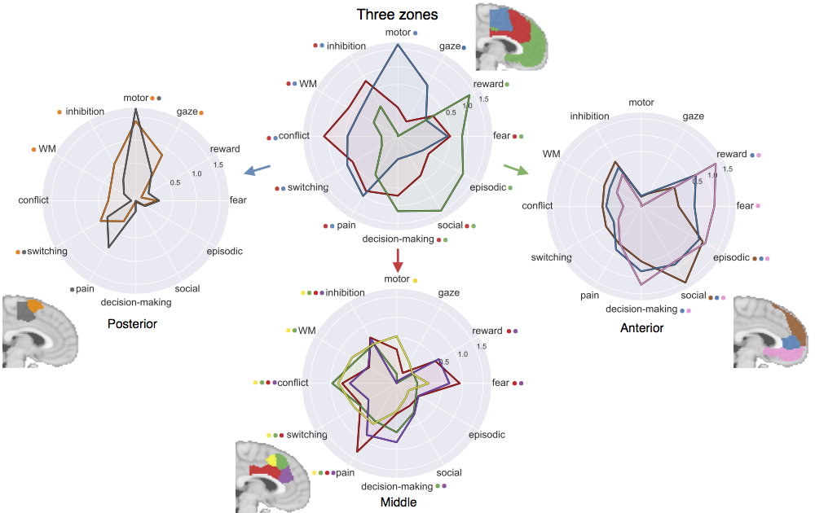

**Figure 4. Functional preference profiles of MFC clusters.** Each cluster was profiled to determine which psychological concepts best predicted its activation. Top) Each of the three functional zones we identified showed distinct functional profiles with broad shifts across cognitive domains Bottom) Within each zone, sub-regions showed fine-grained shifts in function. Strength of association is measured in log odds-ratio (LOR), and permutation-based significance (p<0.001) is indicated next to each psychological concept by color-coded dots corresponding to each region.

## Meta-analytic functional preference profiles

Next, we used a data-driven approach that surveyed a broad range of psychological states to determine if MFC clusters are differentially recruited by psychological states. For each cluster, we trained a multivariate classifier to predict which studies activated the cluster using a set of 35 psychological topics derived by applying a standard topic modeling approach to the abstracts of articles in the database (Poldrack et al., 2012b) (Table 1). From the resulting fitted classifiers, we calculated a measure of how strongly each topic indicated that a study activated a given cluster (measured as the log odds-ratio [LOR] of the probability of a each topic in studies that activated a given cluster to the probability of the same topic in studies that did not activate the cluster). LOR values over 0 indicate that the presence of that topic in a study predicts activity in a given region. We restricted interpretation to significant associations (p<0.001) and additionally report 95% confidence intervals of LORs whenever we comparatively discuss sets of regions. As the latter comparisons are post-hoc and exploratory, caution in interpretation is warranted.

Although the following results demonstrate relatively high loadings between specific topics and regions (e.g. ‘motor’ and SMA), classification using all 35 topics yielded much better performance (mean AUC-ROC: 0.61) than when using only the most predictive topic of each region (mean AUC-ROC: 0.54). The relatively poor performance when using only one topic suggests low selectivity between psychological states and any one region.

Across the three broad MFC zones, we observed distinct functional patterns, consistent with their divergent patterns of functional co-activation (Figure 3). The posterior zone was primarily involved with motor function (including gaze), consistent with its co-activation with motor regions. The middle zone was primarily associated with various facets of cognitive control, but was also implicated in negative affect—pain and fear– as well as decision-making. Consistent with its distinct pattern of co-activation, the anterior zone showed a robust shift away from goal-directed cognition and was strongly associated with affective processes such as reward, fear and decision-making, as well as internally oriented processes such as episodic memory and social processing.

Inspection at a finer spatial scale revealed that sub-regions within each zone showed more subtle patterns of psychological function, similar to the fine-grained variations in co-activation previously observed for each sub-region. In the posterior zone (Figure 4, bottom left), activity in both clusters was similarly predicted by motor function and switching. However, exploratory post-hoc tests suggested that SMA [P1] was more strongly associated with pain, while pre-SMA [P2] was more strongly associated with working memory (WM) (95% CI LOR. ‘pain’: SMA [0.6, 1.1], pre-SMA [-0.1, 0.4]; ‘WM’, SMA [-0.2, 0.1], pre-SMA [0.2, 0.4]).

In the middle zone (Figure 4, bottom middle), activity in all four sub-regions was significantly predicted by aspects of cognitive control (i.e. conflict and inhibition) and pain. However, post-hoc exploratory tests indicated dorsal MCC (M1 & M2) was more strongly associated with WM than ventral MCC (M3 & M4) (95% CI LOR. ‘pdMCC [0.5, 0.8], adMCC [0.4, 0.6], pvMCC [0, 0.15], avMCC [0, 0.3]) whereas ventral MCC showed a stronger association with affect (95% CI LOR. ‘fear’: pdMCC [-0.1, 0.4], adMCC [-0.4, 0.2], pvMCC [0.7, 1.2], avMCC [0.4, 0.9]; ‘reward: pdMCC [-0.4, 0.1], adMCC [-0.4, 0.1], pvMCC [0.3, 0.7], avMCC [0.3, 0.8]; ‘pain’: pdMCC [0.3, 0.8], adMCC [0.2, 0.7], pvMCC [1.1, 1.5], avMCC [0.6, 1.1]). Finally, both anterior clusters showed a greater association with decision-making than their posterior counterparts (95% CI LOR. pdMCC [-0.2, 0.3], adMCC [0.3, 0.8], pvMCC [-0.2, 0.4], avMCC [0.6, 1.1])

In the anterior zone (Figure 4, bottom right), activity across all three sub-regions was significantly predicted by episodic memory and social processing; however, the association with social processing was maximal for dmPFC [A3] (95% CI LOR. dmPFC [1.3, 1.7], pgACC [0.7, 1], vmPFC [0.6, 1]). In contrast, the reverse was true for reward and decision-making; we observed a gradient such that the association with reward and fear was greatest going ventrally, reaching a maximum in vmPFC (95% CI LOR. ‘reward’: dmPFC [-0.4, 0.3], pgACC [0.5, 1], vmPFC [1.2, 1.7]; ‘fear’: dmPFC [-0.4, 0.3], pgACC [0.2, 0.7], vmPFC [0.8, 1.3]).

**Topic definitions**

|  |  |
| --- | --- |
| **Topic name** | **Highest loading words** |
| gaze | eye gaze movements eyes visual saccades saccade target fixation direction |
| decision-making | decision choice risk decisions choices uncertainty outcomes risky taking outcome |
| episodic | memory events imagery autobiographical retrieval episodic memories future mental semantic |
| motor | motor movement movements sensorimotor primary finger control imagery tasks force |
| social | social empathy moral person judgments mentalizing mental theory people mind |
| reward | reward anticipation monetary responses rewards motivation motivational loss incentive punishment |
| switching | cues target trials cue switching stimulus targets preparation switch selection |
| conflict | conflict interference control incongruent trials stroop congruent cognitive behavioral rt |
| inhibition | inhibition control inhibitory stop motor trials nogo cognitive suppression aggression |
| fear | fear anxiety threat responses conditioning cs extinction autonomic conditioned arousal |
| working memory | memory performance cognitive wm tasks verbal load executive test maintenance |
| pain | pain painful stimulation somatosensory intensity noxious heat nociceptive placebo chronic |

Table 1. Topics most strongly associated with MFC regions used in Figure 4. Ten strongest loading words for each topic are listed, in descending order of association strength.

# Discussion

In the current study, we identified and functionally characterized regions of the medial frontal cortex by applying a data-driven approach to a large-scale database of ~10,000 fMRI studies. We defined regions on the basis of differences in co-activation patterns across a wide variety of psychological manipulations– a more direct measure of function than morphology or connectivity. We identified three broad zones arranged along the rostral-caudal axis that further fractionated into 2-4 sub-regions. Finally, we used multivariate classification analyses to identify the psychological topics most strongly predictive of activity in each region, revealing broad shifts in function between the three broad zones and more fine-grained differences between sub-regions within each zone. In the following sections, we discuss theoretical implications for each zone as well as future challenges.

Posterior zone

Posterior MFC spanned various regions previously associated with motoric function–such as SMA, pre-SMA, and motor cingulate zones. This zone further fractioned into a posterior and anterior cluster similarly to cytoarchitectonic (Vorobiev et al., 1998) and connectivity parcellations (Johansen-Berg et al., 2004; Kim et al., 2010). As a whole, posterior MFC was primarily associated with motor function and co-activated with key motor regions such as primary motor cortex and thalamus. However, SMA [P1] showed a greater association with pain processing and greater co-activation with key pain regions such as SII and thalamus, suggesting this region may be important for initiating movements in response to pain. In contrast, pre-SMA [P2] showed a stronger association with cognitive control and co-activated with regions important for goal-directed cognition (e.g. DLPFC, aIns). These results are generally consistent with a large line of work suggesting that pre-SMA is responsible for more complex motor actions that presumably require cognitive control (Picard and Strick, 1996).

Middle zone

The middle MFC zone spanned portions of the cingulate and paracingulate gyri consistent with existing definitions of midcingulate cortex (MCC) (Vogt, 2016). In contrast to claims of pain-selectivity in MCC (Lieberman and Eisenberger, 2015), all four middle sub-regions were associated with pain and cognitive control. This finding is broadly consistent with adaptive control hypotheses, which postulates that MCC integrates negative affective signals with cognitive control in order to optimize actions in the face of action-outcome uncertainty (Shackman et al., 2011; Cavanagh and Shackman, 2015). However, the present results additionally suggest functional differences between sub-regions of MCC. Notably, both dorsal MCC clusters were more strongly associated with WM– and showed greater co-activation with other cognitive control regions— while ventral MCC was more strongly associated with affect and co-activated more strongly with subcortical regions, such as amygdala and striatum. Importantly, ventral MCC was associated not only with negative affect and pain, but also reward. Thus, the present results suggest that ventral aspects of MCC may incorporate low-level affective signals into cognitive control, whereas dorsal MCC may be more important for aspects of cognitive motor control that require working-memory or resolving interference. Finally, we also observed that both anterior MCC clusters were more strongly associated with decision-making than posterior clusters, consistent with theories that incorporate reward-driven decision-making processes into the optimization of cognitive control (Brown and Braver, 2005; Alexander and Brown, 2011).

Anterior zone

Anterior MFC exhibited a distinct functional profile with strong associations with affect, decision-making, social cognition, and episodic memory, accompanied by co-activation with the default network. Yet, our results suggest that anterior MFC zone is not a unitary area, and fractionated into functionally differentiable subregions. DmPFC [A1] was most strongly associated with social processing, consistent with studies linking dmPFC to social perception and self-referential thought (Mitchell et al., 2005) and consistent with its robust co-activation with TPJ– a region hypothesized to be important for mentalizing (Baumgartner et al., 2012; Denny et al., 2012). pgACC [A2] showed a less specific functional pattern, showing moderate associations with both affective processes and decision-making, perhaps consistent with descriptions of a default network ‘hub’ region in mPFC (Andrews Hanna et al., 2010; van den Heuvel and Sporns, 2013). Finally, vmPFC [A3] was primarily associated with affective processes, such as reward and fear, consistent with its robust sub-cortical co-activation. Although some have characterized vmPFC as a ‘valuation’ system (Lebreton et al., 2009), our results suggest that vmPFC is equally important for other affective processes, such as fear. Thus, vmPFC may play a more general role of incorporating sub-cortical affective signals into cortex, while more dorsal regions contextualize this affective information (Roy et al., 2012).

Future challenges

While the present results provide valuable insights into the functional neuroanatomy of MFC, a number of important challenges remain for future research. Although the present analyses revealed distinct functional profiles for each region in MFC, it is notable that no region was selectively activated by a single psychological concept. This functional diversity is evident in that at least two distinct topics were significantly associated with each cluster and our classifier’s poor ability to predict activation using only the single most strongly associated topic for each region. These results suggest a complex many-to-many mapping between brain regions and cognitive processes– in contrast to recent claims of functional selectivity in MFC (Lieberman and Eisenberger, 2015; c.f., Wager et al, in press). This heterogeneity is consistent with an enormous wealth of electrophysiological data demonstrating that virtually all areas of association cortex contain distinct, but overlapping, neuron populations with heterogeneous functional profiles (Shidara and Richmond, 2002; Sikes et al., 2008; Kvitsiani et al., 2013).

Although the present results provide a comprehensive snapshot MFC function, many have argued that brain regions dynamically assume different roles (Shackman et al., 2015) and modulate their connectivity as a function of task demands (Cole et al., 2014; Mattar et al., 2015). Moreover, MCC is likely to be among the most heterogeneous brain regions (Anderson et al., 2013) as evidenced by its very high activation rate (Nelson et al., 2010; Yarkoni et al., 2011). Thus, because the functional co-activation profiles presented here represent averages across tasks, they may mask task-dependent co-activation structure. For example, it’s possible that ventral MCC co-activates more strongly with the amygdala during ‘fear’, but co-activates with posterior insula during ‘pain’. An interesting avenue of future research will be to precisely characterize how co-activation and functional patterns of MFC change as a function of context through large-scale meta-analysis.

Moreover, although our parcellation was moderately consistent with boundaries based on cytoarchitecture and connectivity (e.g. the distinction between SMA and pre-SMA), we observed several discrepancies. For example, we did not identify separate cingulate motor zones (Picard & Strick, 1996), suggesting morphologically distinct regions can co-activate similarly to support high-level psychological function (e.g. ‘motor function’). Systematic modeling of the relationship between anatomy and task evoked activation– similarly to existing models linking resting state and anatomical connectivity (Goñi et al., 2014)– are needed to better understand the nature of such discrepancies.

The present report also provides the ability to generate hypotheses that can be more carefully tested in future studies using the candidate psychological functions discussed here. For example, our result suggests that ventral MCC had a higher association with affect than dorsal MCC. However, given the wide inter-subject variability in paracingulate anatomy (Paus et al., 1996) it would be prudent to explore this suggestion in a single sample with subject-level anatomical registration. This hypothesis might also be explored by large-scale meta-analyses that combine functional and anatomical data to more precisely localize activity to detailed anatomical variation. Moreover, the present findings can be improve the development of future multivariate classifiers by providing better prior information as to the regions that may specifically predict psychological states (e.g. Wager et al., 2013).

Finally, there are several limitations of Neurosynth that can be addressed in future research. First, the topic model we employ is data-derived from the semantic content of papers. Although these topics provide a substantial improvement over term based meta-analysis (Poldrack et al., 2012b), these topics are still based purely on the frequency with which terms appear in the abstracts of articles and are not able to capture more complex semantic structures. The adoption of a standardized ontology of psychological concepts and tasks, such as the cognitive atlas (Poldrack et al., 2011), will greatly improve the ability of future meta-analyses to discriminate more fine-grained theories. Second, the quality of activation data in Neurosynth is inherently limited due to its automatically generated nature. Although previous validation analyses have shown that these limitations are unlikely to contribute systematic biases (Yarkoni et al., 2011), coordinate based meta-analyses are generally limited in comparison to their image-based counterparts (Salimi-Khorshidi et al., 2009). Sharing of statistical images in databases such as NeuroVault (Gorgolewski et al., 2015) will greatly improve the fidelity of future meta-analyses.

Conclusion

In the present study, we provide a comprehensive functional map of the human medial frontal cortex using unbiased data-driven methods. Although the anatomy of this area has been extensively studied, the present study more directly identified putative sub-regions with distinct functional profiles across a wide-variety of psychological states. The present results can serve as a foundation to generate and test more fine-grained hypotheses in future studies.

**References**

Alexander WH, Brown JW (2011) Medial prefrontal cortex as an action-outcome predictor. Nat Neurosci 14:1338–1344.

Amunts K, Zilles K (2015) Architectonic Mapping of the Human Brain beyond Brodmann. Neuron 88:1086–1107.

Anderson ML, Kinnison J, Pessoa L (2013) Describing functional diversity of brain regions and brain networks. NeuroImage 73:50–58.

Andrews Hanna JR, Reidler JS, Sepulcre J, Poulin R, Buckner RL (2010) Functional-Anatomic Fractionation of the Brain's Default Network. Neuron 65:550–562.

Andrews-Hanna JR (2012) The Brain's Default Network and Its Adaptive Role in Internal Mentation. The Neuroscientist 18:251–270.

Androutsopoulos I, Koutsias J, Chandrinos KV (2000) An evaluation of naive bayesian anti-spam filtering Potamias G, Moustakis V, van Someren M, eds. Proceedings of the workshop on Machine Learning in the New Information Age:9–17.

Baumgartner T, Götte L, Gügler R, Fehr E (2012) The mentalizing network orchestrates the impact of parochial altruism on social norm enforcement. Hum Brain Mapp 33:1452–1469.

Beckmann M, Johansen-Berg H, Rushworth MFS (2009) Connectivity-Based Parcellation of Human Cingulate Cortex and Its Relation to Functional Specialization. Journal of Neuroscience 29:1175–1190.

Blei DM, Ng AY, Jordan MI (2003) Latent dirichlet allocation. The Journal of Machine Learning Research 3:993–1022.

Botvinick M, Nystrom LE, Fissell K, Carter CS, Cohen JD (1999) Conflict monitoring versus selection-for-action in anterior cingulate cortex. Nature 402:179–181.

Brown JW, Braver TS (2005) Learned Predictions of Error Likelihood in the Anterior Cingulate Cortex. Science 307:1118–1121.

Carter RM, Huettel SA (2013) A nexus model of the temporal–parietal junction. Trends in Cognitive Sciences 17:328–336.

Cavanagh JF, Shackman AJ (2015) Frontal midline theta reflects anxiety and cognitive control: Meta-analytic evidence. Journal of Physiology-Paris 109:3–15.

Chang LJ, Yarkoni T, Khaw MW, Sanfey AG (2013) Decoding the Role of the Insula in Human Cognition: Functional Parcellation and Large-Scale Reverse Inference. Cerebral Cortex 23:739–749.

Cole MW, Bassett DS, Power JD, Braver TS, Petersen SE (2014) Intrinsic and Task-Evoked Network Architectures of the Human Brain. Neuron 83:238–251.

Critchley HD, Mathias CJ, Josephs O, O’Doherty J, Zanini S, Dewar BK, Cipolotti L, Shallice T, Dolan RJ (2003) Human cingulate cortex and autonomic control: converging neuroimaging and clinical evidence. Brain 126:2139–2152.

Denny BT, Kober H, Wager TD, Ochsner KN (2012) A meta-analysis of functional neuroimaging studies of self- and other judgments reveals a spatial gradient for mentalizing in medial prefrontal cortex. Journal of Cognitive Neuroscience 24:1742–1752.

Eickhoff SB, Paus T, Caspers S, Grosbras M-H, Evans AC, Zilles K, Amunts K (2007) Assignment of functional activations to probabilistic cytoarchitectonic areas revisited. NeuroImage 36:511–521.

Eickhoff SB, Thirion B, Varoquaux G, Bzdok D (2015) Connectivity-based parcellation: Critique and implications. Hum Brain Mapp 36:4771–4792.

Etkin A, Egner T, Kalisch R (2011) Emotional processing in anterior cingulate and medial prefrontal cortex. Trends in Cognitive Sciences 15:85–93.

Goñi J, van den Heuvel MP, Avena-Koenigsberger A, Velez de Mendizabal N, Betzel RF, Griffa A, Hagmann P, Corominas-Murtra B, Thiran J-P, Sporns O (2014) Resting-brain functional connectivity predicted by analytic measures of network communication. PNAS 111:833–838.

Gorgolewski KJ, Varoquaux G, Rivera G, Schwarz Y, Ghosh SS, Maumet C, Sochat VV, Nichols TE, Poldrack RA, Poline J-B, Yarkoni T, Margulies DS (2015) NeuroVault.org: a web-based repository for collecting and sharing unthresholded statistical maps of the human brain. Front Neuroinform 9:8.

Hare TA, Camerer CF, Rangel A (2009) Self-Control in Decision-Making Involves Modulation of the vmPFC Valuation System. Science 324:646–648.

Holroyd CB, Nieuwenhuis S, Yeung N, Nystrom L, Mars RB, Coles MGH, Cohen JD (2004) Dorsal anterior cingulate cortex shows fMRI response to internal and external error signals. Nat Neurosci 7:497–498.

Jeni LA, Cohn JF, la Torre De F (2013) Facing Imbalanced Data Recommendations for the Use of Performance Metrics. Int Conf Affect Comput Intell Interact Workshops 2013:245–251.

Johansen-Berg H, Behrens TEJ, Robson MD, Drobnjak I, Rushworth MFS, Brady JM, Smith SM, Higham DJ, Matthews PM (2004) Changes in connectivity profiles define functionally distinct regions in human medial frontal cortex. PNAS 101:13335–13340.

Kennerley SW, Sakai K, Rushworth MFS (2004) Organization of action sequences and the role of the pre-SMA. Journal of Neurophysiology 91:978–993.

Kim J-H, Lee J-M, Jo HJ, Kim SH, Lee JH, Kim ST, Seo SW, Cox RW, Na DL, Kim SI, Saad ZS (2010) Defining functional SMA and pre-SMA subregions in human MFC using resting state fMRI: Functional connectivity-based parcellation method. NeuroImage 49:2375–2386.

Kober H, Barrett LF, Joseph J, Bliss-Moreau E, Lindquist K, Wager TD (2008) Functional grouping and cortical–subcortical interactions in emotion: A meta-analysis of neuroimaging studies. NeuroImage 42:998–1031.

Kvitsiani D, Ranade S, Hangya B, Taniguchi H, Huang JZ, Kepecs A (2013) Distinct behavioural and network correlates of two interneuron types in prefrontal cortex. Nature 498:363–366.

Lebreton M, Jorge S, Michel V, Thirion B, Pessiglione M (2009) An Automatic Valuation System in the Human Brain: Evidence from Functional Neuroimaging. Neuron 64:431–439.

Leek EC, Johnston SJ (2009) Functional specialization in the supplementary motor complex. Nat Rev Neurosci 10:78–authorreply78.

Lieberman MD, Eisenberger NI (2015) The dorsal anterior cingulate cortex is selective for pain: Results from large-scale reverse inference. PNAS 112:15250–15255.

Lindquist KA, Wager TD, Kober H, Bliss-Moreau E, Barrett LF (2012) The brain basis of emotion: A meta-analytic review. Behavioral and Brain Sciences 35:121–143.

Mackey S, Petrides M (2014) Architecture and morphology of the human ventromedial prefrontal cortex. European Journal of Neuroscience 40:2777–2796.

Mattar MG, Cole MW, Thompson-Schill SL, Bassett DS (2015) A Functional Cartography of Cognitive Systems. PLoS Comput Biol 11:e1004533.

Milad MR, Quirk GJ, Pitman RK, Orr SP, Fischl B, Rauch SL (2007) A Role for the Human Dorsal Anterior Cingulate Cortex in Fear Expression. Biological Psychiatry 62:1191–1194.

Milham MP, Banich MT, Webb A, Barad V, Cohen NJ, Wszalek T, Kramer AF (2001) The relative involvement of anterior cingulate and prefrontal cortex in attentional control depends on nature of conflict. Cognitive Brain Research 12:467–473.

Mitchell JP, Banaji MR, Macrae CN (2005) The link between social cognition and self-referential thought in the medial prefrontal cortex. Journal of Cognitive Neuroscience 17:1306–1315.

Nelson SM, Dosenbach NUF, Cohen AL, Wheeler ME, Schlaggar BL, Petersen SE (2010a) Role of the anterior insula in task-level control and focal attention. Brain Structure and Function 214:669–680.

Neubert F-X, Mars RB, Thomas AG, Sallet J, Rushworth MFS (2014) Comparison of Human Ventral Frontal Cortex Areas for Cognitive Control and Language with Areas in Monkey Frontal Cortex. Neuron 81:700–713.

Palomero-Gallagher N, Eickhoff SB, Hoffstaedter F, Schleicher A, Mohlberg H, Vogt BA, Amunts K, Zilles K (2015) Functional organization of human subgenual cortical areas: Relationship between architectonical segregation and connectional heterogeneity. NeuroImage 115:177–190.

Palomero-Gallagher N, Zilles K, Schleicher A, Vogt BA (2013) Cyto- and receptor architecture of area 32 in human and macaque brains. J Comp Neurol 521:3272–3286.

Paus T, Tomaiuolo F, Otaky N, MacDonald D, Petrides M, Atlas J, Morris R, Evans AC (1996) Human cingulate and paracingulate sulci: pattern, variability, asymmetry, and probabilistic map. Cerebral Cortex 6:207–214.

Pedregosa F, Varoquaux G, Gamfort A, Michel V, Thirion B, Grisel O, Blondel M, Prettenhofer P (2011) Scikit-learn: Machine Learning in Python. Journal of Machine Learning Research 12:2825–2830.

Picard N, Strick PL (1996) Motor Areas of the Medial Wall: A Review of Their Location and Functional Activation. Cerebral Cortex 6:342–353.

Poldrack RA (2006) Can cognitive processes be inferred from neuroimaging data? Trends in Cognitive Sciences 10:59–63.

Poldrack RA, Kittur A, Kalar D, Miller E, Seppa C, Gil Y, Parker DS, Sabb FW, Bilder RM (2011) The cognitive atlas: toward a knowledge foundation for cognitive neuroscience. Front Neuroinform 5:17.

Poldrack RA, Mumford JA, Schonberg T, Kalar D, Barman B, Yarkoni T (2012a) Discovering relations between mind, brain, and mental disorders using topic mapping. PLoS Comput Biol 8:e1002707.

Poldrack RA, Mumford JA, Schonberg T, Kalar D, Barman B, Yarkoni T (2012b) Discovering Relations Between Mind, Brain, and Mental Disorders Using Topic Mapping Sporns O, ed. PLoS Comput Biol 8:e1002707.

Poldrack RA, Yarkoni T (2016) From Brain Maps to Cognitive Ontologies: Informatics and the Search for Mental Structure. Annual Review of Psychology 67:587–612.

Robinson JL, Laird AR, Glahn DC, Lovallo WR, Fox PT (2010) Metaanalytic connectivity modeling: Delineating the functional connectivity of the human amygdala. Hum Brain Mapp 31:173–184.

Roland PE, Larsen B, Lassen NA, Skinhøj E (1980) Supplementary motor area and other cortical areas in organization of voluntary movements in man. Journal of Neurophysiology 43:118–136.

Rolls ET, O'Doherty J, Kringelbach ML, Francis S, Bowtell R, McGlone F (2003) Representations of Pleasant and Painful Touch in the Human Orbitofrontal and Cingulate Cortices. Cerebral Cortex 13:308–317.

Roy M, Shohamy D, Wager TD (2012) Ventromedial prefrontal-subcortical systems and the generation of affective meaning. Trends in Cognitive Sciences 16:147–156.

Salimi-Khorshidi G, Smith SM, Keltner JR, Wager TD, Nichols TE (2009) Meta-analysis of neuroimaging data: A comparison of image-based and coordinate-based pooling of studies. NeuroImage 45:810–823.

Sallet J, Mars RB, Noonan MP, Neubert FX, Jbabdi S, O'Reilly JX, Filippini N, Thomas AG, Rushworth MF (2013) The Organization of Dorsal Frontal Cortex in Humans and Macaques. Journal of Neuroscience 33:12255–12274.

Shackman AJ, Fox AS, Seminowicz DA (2015) The cognitive-emotional brain: Opportunitvnies and challenges for understanding neuropsychiatric disorders. Behavioral and Brain Sciences 38:e86.

Shackman AJ, Salomons TV, Slagter HA, Fox AS, Winter JJ, Davidson RJ (2011) The integration of negative affect, pain and cognitive control in the cingulate cortex. Nat Rev Neurosci 12:154–167.

Shenhav A, Botvinick MM, Cohen JD (2013) The Expected Value of Control: An Integrative Theory of Anterior Cingulate Cortex Function. Neuron 79:217–240.

Shidara M, Richmond BJ (2002) Anterior Cingulate: Single Neuronal Signals Related to Degree of Reward Expectancy. Science 296:1709–1711.

Sikes RW, Vogt LJ, Vogt BA (2008) Distribution and properties of visceral nociceptive neurons in rabbit cingulate cortex. Pain 135:160–174.

Smith SM, Fox PT, Miller KL, Glahn DC, Fox PM, Mackay CE, Filippini N, Watkins KE, Toro R, Laird AR, Beckmann CF (2009) Correspondence of the brain's functional architecture during activation and rest. PNAS 106:13040–13045.

Spreng RN, Grady CL (2010) Patterns of brain activity supporting autobiographical memory, prospection, and theory of mind, and their relationship to the default mode network. Journal of Cognitive Neuroscience 22:1112–1123.

Stalnaker TA, Cooch NK, Schoenbaum G (2015) What the orbitofrontal cortex does not do. Nat Neurosci 18:620–627.

Thirion B, Varoquaux G, Dohmatob E, Poline J-B (2014) Which fMRI clustering gives good brain parcellations? Front Neurosci 8:167.

Toro R, Fox PT, Paus T (2008) Functional Coactivation Map of the Human Brain. Cerebral Cortex 18:2553–2559.

van den Heuvel MP, Sporns O (2013) Network hubs in the human brain. Trends in Cognitive Sciences 17:683–696.

Varoquaux G, Thirion B (2014) How machine learning is shaping cognitive neuroimaging. Gigascience 3:28.

Vogt BA (2005) Pain and emotion interactions in subregions of the cingulate gyrus. Nat Rev Neurosci 6:533–544.

Vogt BA (2016) Midcingulate cortex: Structure, connections, homologies, functions and diseases. Journal of Chemical Neuroanatomy.

Vogt BA, Vogt L (2003) Cytology of human dorsal midcingulate and supplementary motor cortices. Journal of Chemical Neuroanatomy 26:301–309.

Vorobiev V, Govoni P, Rizzolatti G, Matelli M, Luppino G (1998) Parcellation of human mesial area 6: cytoarchitectonic evidence for three separate areas. European Journal of Neuroscience 10:2199–2203.

Wager TD, Atlas LY, Lindquist MA, Roy M, Woo C-W, Kross E (2013) An fMRI-Based Neurologic Signature of Physical Pain. N Engl J Med 368:1388–1397.

Wager TD, Davidson ML, Hughes BL, Lindquist MA, Ochsner KN (2008) Prefrontal-Subcortical Pathways Mediating Successful Emotion Regulation. Neuron 59:1037–1050.

Yarkoni T, Poldrack RA, Nichols TE, Van Essen DC, Wager TD (2011) Large-scale automated synthesis of human functional neuroimaging data. Nat Meth 8:665–670.

Zilbovicius M, Meresse I, Chabane N, Brunelle F, Samson Y, Boddaert N (2006) Autism, the superior temporal sulcus and social perception. Trends in Neurosciences 29:359–366.