Functional specialization and complexity in medial frontal cortex

Alejandro de la Vega

The medial frontal cortex (mFC) has been associated with a wide variety of cognitive states ranging from motor function and cognitive control to affective processes such as reward-driven learning, negative affect, and pain processing, impeding efforts to determine its topographical organization. While several qualitative reviews and quantitative meta-analyses have sought to map a more limited set of cognitive processes onto mFC regions, there have been few large-scale efforts to comprehensively map cognitive states to medial frontal anatomy across the full range of cognitive and affective states.

The limitations of domain-specific reviews and meta-analyses are well exemplified in the case of dorsal anterior cingulate cortex (dACC). In an influential review, Bush and colleagues (2000) hypothesized that dorsal ACC is primarily specialized for cognitive processes such as conflict processing, while rostral ACC specializes in affective processing theories of dACC’s role in cognitive control subsequently flourished (Carter, Braver, Barch, Botvinick, Noll, & Cohen, 1998; Botvinick, Braver, Barch, Carter, & Cohen, 2001; Botvinick, Cohen, Carter, 2004; Banich, 2009), and dACC’s critical role in cognitive control was bolstered by several fMRI meta-analyses (...). However, a more recent meta-analysis (Shackman et al., 2011) eschewed the strict division between affective and cognitive processes by pointing out a burgeoning body of evidence which critically implicates overlapping portions of dACC in both pain processing (Vogt, 2005; Treede, Kenshalo, Gracely, & Jones, 1999; Rolls, O'Doherty, Kringelbach, Francis, Bowtell, & McGlone, 2003; Wager, Atlas, Lindquist, Roy, Woo, & Kross, 2013) and cognitive control. Shackman et al. (2011) argued that this overlap suggests dACC integrates negative reinforcers with motor centers to implement goal-directed behavior.

Despite the usefulness of such cross-domain meta-analyses of mFC function, several problems remain. First, since most researchers are intimately familiar with one particular domain of cognition, most meta-analyses are necessarily restricted to a small subset of empirical findings generally related to a particular emotional or cognitive process under investigation (Paus et al., 2001; Botvinick et al., 2005; Vogt et al., 2005; Wallis & Kennerley, 2010; Etkin, Egner, & Kalisch, 2011). Even those meta-analyses that attempt to take a broader look at mFC function only include a subset of cognitive processes (e.g. negative affect, pain and cognitive control; Shackman, 2011). Second, traditional meta-analyses have limited ability to draw conclusions about the relative specificity of brain activity to particular cognitive processes--a limitation widely known as the reverse inference problem (Poldrack, 2006). This concern is particularly acute in the case of mFC subregions such as pre-SMA and dACC, which show high rates of activation across a broad range of fMRI studies, suggesting low selectivity to a given domain (Yarkoni et al., 2011) [ALSO CITE NELSON ET AL, 2010].

In addition, the lack of agreement regarding clear dissociable regions in mFC further hampers the assignment of cognitive functions to specific subregions. While there have been substantial efforts to define mFC subregions on the basis of cytoarchitectonics (Vogt et al., 2005), resting-state functional fMRI connectivity (Kim, Lee, Jo, Kim, Lee, Kim, et al., 2010; Kahnt, Chang, Park, Heinzle, & Haynes, 2012), and diffusion tensor imaging (Yu, Zhou, Liu, Jiang, Dong, Zhang, et al. 2011; Liu, Qin, Li, Fan, Wang, Jiang, et al. 2013), such methods are unable to directly link anatomy with cognitive and affective states.to This lack ofan established topography has led to wide-variability in the usage of anatomical terms such as dACC, and ventromedial prefrontal cortex (vmPFC). (I don’t have a good citation for this)

To make a clearly connection between anatomy and function, Here, we use Neurosynth, a diverse large-scale functional neuroimaging database of over 10,000 studies (Yarkoni et al., 2011), to systematically create a comprehensive functional-anatomical mapping of medial frontal cortex. We used a data-driven approach to cluster mFC voxels into functionally homogeneous subregions at different spatial scales based on their meta-analytic coactivation with other brain regions (Toro, Fox, & Paus, 2008; Robinson, Laird, Glahn, Lovallo, & Fox, 2010; Smith et al., 2011). We then characterized the cognitive profiles of these clusters using multivariate classification analyses and quantified the degree of functional heterogeneity displayed by each cluster.

# 

# Results

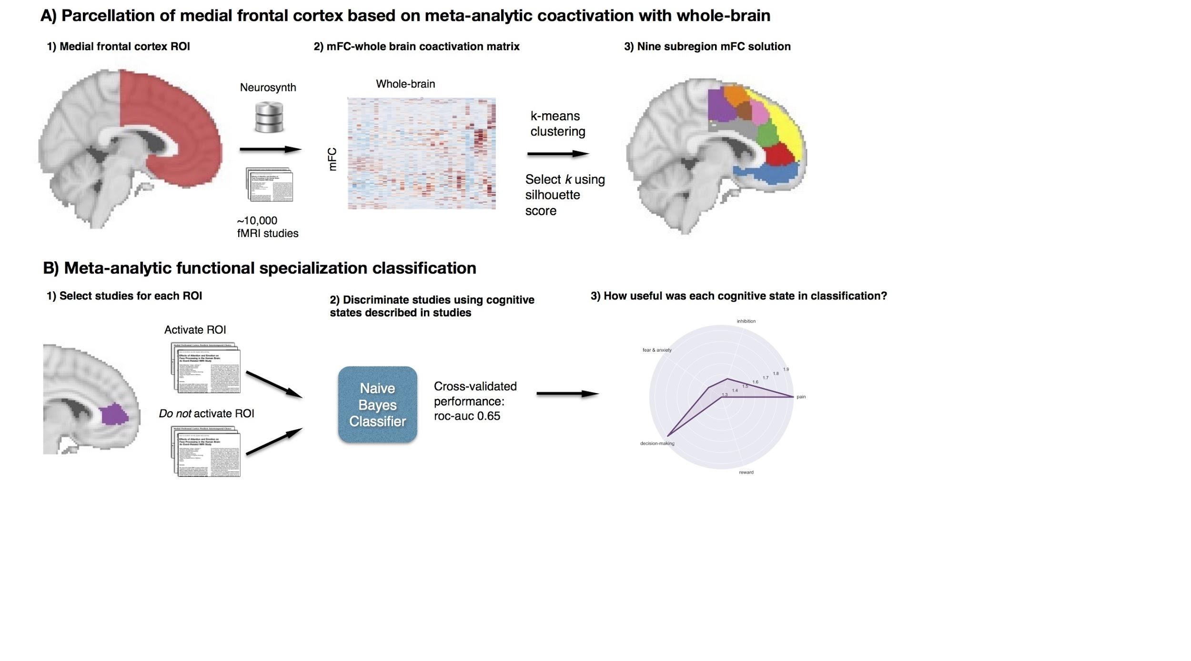

*Figure 1. Methods overview. A) Coactivation with the rest of the brain for each voxel in medial frontal cortex ROI was calculated and used to create a distance matrix of mFC voxels; k-means clustering was applied to distance matrix resulting in spatially distinct clusters. We functionally characterized each cluster by determining which cognitive functions best differentiated studies that activated each cluster, from those that did not.*

### Functionally separable components of medial frontal cortex

Our first goal was to identify functionally dissociable spatial regions in the human medial frontal cortex (Figure 1A). Our mFC region of interest (ROI) spanned the entire medial surface of frontal cortex bilaterally, including the entirety of the supplementary motor area (SMA), pre-SMA, anterior cingulate cortex, medial prefrontal cortex, and medial aspects of the frontopolar and orbitofrontal cortex. We identified putatively functionally separable units of medial frontal cortex on the basis of shared coactivation profiles with the rest of the brain (cf. Chang et al, 2013). This approach is akin to using resting state functional connectivity MRI (rs-fMRI) to determine how tightly coupled voxels are to each other. We determined the pattern of coactivation between each mFC voxel to the rest of the brain and generated a distance matrix representing how similarly mFC voxels coactivate with the rest of the brain. We then used k-means clustering, an unsupervised clustering algorithm, to group voxels with similar coactivation profiles into homogenous clusters. Following recent work comparing the performance of multiple clustering algorithms, we used k-means clustering, as this algorithm is computationally efficient, commonly used, and shows high goodness of fit and reproducibility (Thirion, Varoquaux, Dohmatob, & Poline, 2014). Because structure-to-function mappings can be identified at multiple scales, with potentially different (but equally valid) results, we conducted our analyses at multiple levels of spatial resolution, identifying 2 through 15 parcels. 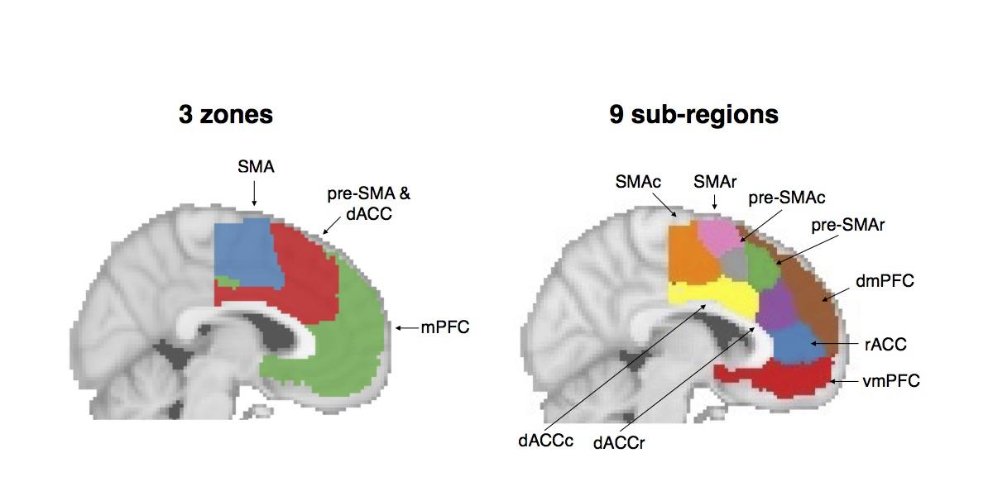

*Figure 2. Coactivation-based k-means clustering of the medial frontal cortex at two levels of granularity. Voxels in the mFC were grouped together based on similarity of coactivation with all other voxels in the brain. SMA: supplementary motor area; SMAr: SMA rostral; SMAc: SMA caudal; pre-SMAc: caudal pre-SMA; pre-SMAr: rostral pre-SMA; dACC: dorsal anterior cingulate cortex; dACCc: dACC caudal; dACCr: dACC rostral; rACC: rostral anterior cingulate cortex; mPFC: medial prefrontal cortex; dmPFC: dorsal medial PFC; vmPFC: ventromedial PFC.*

Identifying the ‘correct’ number of clusters is arguably an intractable problem, since the optimality of a given clustering depends in large part on investigators’ goals, the preferred level of analysis, and the nature and dimensionality of the available data (for discussion, see Poldrack and Yarkoni, in press). However, in the interest of pragmatism, we attempted to guide our selection of the number of clusters using the silhouette score, a measure of within-cluster cohesion. We used permutation analysis to test whether clustering solutions were better than chance, and rejected the null hypothesis for all clustering solutions (p < .001). SIlhouette scores reached local maxima at 3, 9 and 12 clusters (SI Figure 1). We focus here on the 3- and 9-cluster solutions, which provide insight into the functional topography of mFC at two different scales: broad zones and more fine-grained regions. Figures for 6, 12, and 15 clusters are available in the supplemental material (SI Figure 2).

At the coarsest level, medial medial frontal cortex divided into three broad bilateral zones (Figure 2A). The most posterior zone exclusively encompassed the supplementary motor area (SMA). Dorsally, the SMA zone delineated from the next cluster around 6 mm rostral to the vertical line traversing the anterior commissure (VCA line; y=0 in MNI and Talairach coordinates), consistent with cytoarchitectonic and resting-state functional connectivity (Picard and Strick, 1996; Rizzolatti, Fadiga, Matelli, Bettinardi, Paulesu, Perani, & Fazio, 1996; Kim et al., 2011), suggesting dorsal aspects of the second cluster encompassed pre-SMA. This middle cluster also included most of the dorsal anterior cingulate (dACC) running dorsal to the corpus callosum. The final cluster encompassed the rostral portion of medial prefrontal cortex, rostral and subgenual aspects of anterior cingulate cortex, and medial aspects of orbitofrontal cortex and the frontal pole. A few non-contiguous voxels located in the posterior portions of the ROI were also included in this zone, but this did not persist at more fine-grained levels of analysis.

The nine-parcel solution revealed additional topographical organization (Figure 2B). SMA separated into rostral and caudal subdivisions, consistent with previous cytoarchitectonic evidence (Vorobiev & Luppino, 1998; Luppino, 1993). The pre-SMA/dACC cluster separated into four regions, two lying dorsal of the cingulate sulcus, and two lying neatly in the anterior cingulate cortex proper. Notably, the two clusters lying in ACC did not extend dorsally into the paracingulate gyrus or superior frontal gyrus, consistent with cytoarchitectonic definitions of the cingulate (CITE). We termed the clusters lying dorsal to the cingulate sulcus pre-SMA, caudal and rostral, respectively. The two dorsal ACC clusters were consistent with prior cytoarchitechtonic evidence suggesting that dACC (also known as midcingulate cortex) differentiates into caudal and rostral subdivisions (Vogt et al., 2005). Further anterior, we found that medial prefrontal cortex broke down into clusters encompassing rostral aspects of the anterior cingulate cluster (rACC), and dorsal and ventral subdivisions of mPFC. dmPFC included medial aspects of the frontal pole as well as medial aspects of the superior frontal gyrus more dorsally. Finally, vmPFC included subgenual aspects of anterior cingulate cluster as well as medial aspects of orbitofrontal cortex.

**Meta-analytic coactivation profiles**

Our next goal was to visualize the common coactivation pattern of the resulting zones and regions we identified in our parcellation analysis. At a broad scale, the SMA zone and pre-SMA/dACC zone showed similar coactivation with the rest of the brain, while mPFC showed a different pattern of coactivation (Figure 3). Both SMA and pre-SMA/dACC coactivated with the insula, precuneus, large sections of parietal cortex, and lateral prefrontal cortex, while mPFC primarily coactivated with other members of the ‘default mode network’, including posterior cingulate cortex and the hippocampus. Although both pre-SMA/dACC coactivate with the thalamus and the basal ganglia, SMA did so to a greater extent while pre-SMA/dACC coactivated with more anterior aspects of both the insula and lateral prefrontal cortex.

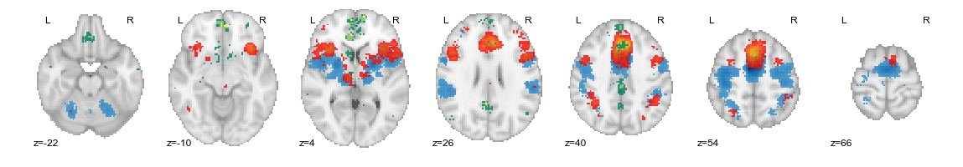

*Figure 3. Coactivation of the three mFC zones with the rest of the brain. SMA (blue) coactivated primarly with lateral motor cortices. but also showed strong coactivation with posterior insula and operculum as well as the cerebellum; pre-SMA/dACC (red) coactivated with the frontoparietal control network; and mPFC (green) showed a distinctly different pattern, coactivating with regions in default network, such as posterior cingulate and temporal cortices.*

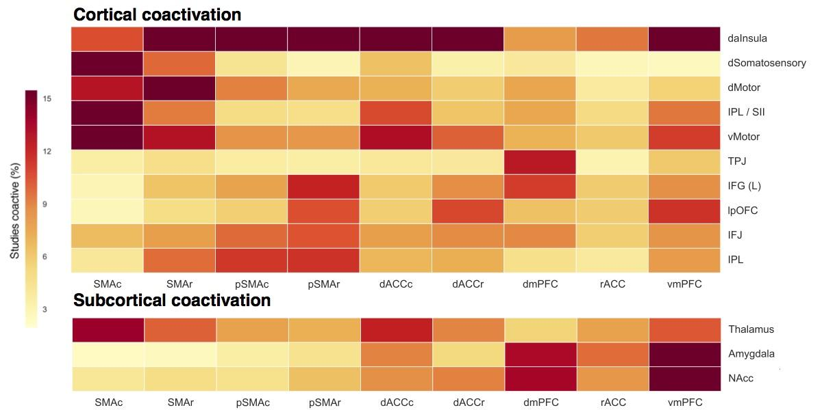*Figure 4. Coactivation of nine mFC clusters to selected regions across the rest of the brain. Coactivation between each mFC cluster and 34 regions across the brain was calculated and the 3 whole-brain ROIs with highest coactivation were selected for each region. Darker colors represent greater coactivation between a pair of regions. daInsula: dorsal anterior Insula; dSomatosensory: dorsal somatosensory cortex; dMotor: dorsal motor cortex; vMotor: ventral motor strip; TPJ: tempo-parietal junction; IFG (L): left inferior frontal gyrus; lpOFC: lateral posterior OFC; IFJ: inferior frontal junction; IPL: Inferior parietal lobule. All regions except IFG are bilateral, and the center of mass reflects the right side of the brain.*

At a more fine-grained scale, there were clear differences in coactivation within regions sameof a broad functional zone. In Figure 4, we plot the strength of coactivation between each of the nine regions we identified and key ROIs from the rest of the brain. Within the first broad zone, the SMA zone, the two sub-regions showed largely similar coactivation patterns although the caudal SMA regionshowed greater coactivation with somatosensory cortex while the rostral SMA regionshowed greater coactivation with motor cortex. InWithin the second broad zone, the pre-SMA / dACC zone, both pre-SMA regions showed markedly lower coactivation with motoric regions than the SMA zone and greater coactivation with regions in the frontoparietal control network (e.g. inferior parietal lobule (IPL) and inferior frontal junction (IFJ)), consistent with the hypothesis that pre-SMA does not directly implement motoric plans. The rostral pre-SMAregion had particularly strong coactivation with the regions important for cognitive control, such as the left inferior frontal gyrus (IFG). Both dorsal ACC subregions showed markedly lower coactivation with regions in the frontoparietal network than the neighboring region within the braod pre-SMA/dACC, but they showed greater coactivation with subcortical regions, in particular the thalamus, and to a lesser extent the nucleus accumbens (NAcc) and amygdala. In addition, dACC region, and in particular its caudal subdivision, showed greater coactivationthan adjacent regions with motor related regions, consistent with work highlighting the importance of this region--also known as the cingulate motor zone-- in precise movement (xxx, xxx). Finally, rostral pre-SMA and dorsal dACC showed greater coactivation with regions important for reward-driven learning, such as lateral orbitofrontal cortex (lOFC) and to a lesser extent, NAcc, than neighboring regions within the same broad zone.

Regions within the final zone, the medial prefrontal cortex were characterized by robust coactivation with subcortical regions, in particular the amygdala and nucleus accumbens. dmPFC and especially vmPFC showed particularly strong coactivation with these subcortical regions. dmPFC also showed a unique pattern of strong coactivation with the tempo-parietal junction, a region hypothesized to be important for social processing (citeCite McKell’s review paper here) and cross-modal sensory integration (cite), as well as the middle temporal gyrus, an important region for semantic memory and language (cite). Surprisingly, rACC showed fairly low coactivation with the rest of the brain, suggesting this region may be important for local processing of information. Unlike the rest of mPFC, vmPFC showed robust coactivation with dorsal-anterior insula, mirroring the strong coactivation of this area with pre-SMA and dACC. In addition, vmPFC coactivated with lateral OFC, an important region for the processing of affect (cite).

### Meta-analytic functional specialization

Next, we sought to functionally characterize the regions that we identified in medial frontal cortex. As opposed to traditional meta-analyses that investigate the whole-brain neural correlates of theoretically motivated cognitive functions selected *a priori* (e.g. pain and cognitive control in dorsal ACC), we employed a method that determined to what extent a large set of cognitive functions predicted the activation of each of our nine individual regions of interest. We used a set of 34 cognitive functions derived by applying a standard topic modeling approach to the text of articles in the database (Poldrack et al., 2012), allowing us to also sidestep the difficult problem of manually defining a cognitive ontology and ensuring our analysis was as data-driven as possible (See Supplemental Table 1 for full list of derived topics).

In this analysis, we were careful to account for the reverse-inference problem that hampers the ability to infer cognitive processes from neuroimaging data (Poldrack, 2006). The selectivity of activation of a particular region severely influences the ability to determine if brain activity; this issue is particularly problematic for brain regions with a high base rate of activation such as dACC. To demonstrate the insidious nature of the reverse inference problem, we recreate, using Neurosynth, the meta-analysis from Shackman et al., (2011) that claims to find overlap between negative affect, pain and cognitive control in regions of the dACC. First, we performed a ‘forward inference’ analysis which returned all voxels active given the presence of a negative affect, pain and conflict (Figure 5a); this analysis is akin to performing a standard fMRI meta-analysis, in which one selects studies purported to engage these processes. Similar to Shackman et al., (2011), we find a striking overlap between pain, conflict and affect in the dACC/pre-SMA zone. However, as a comparison we conducted the same analysis using three cognitive functions that would not be predicted *apriori* to be integrated in dACC *i*: social cognition, vision and memory retrieval (Figure 5b). These three processes also showed distinct overlap in dACC/pre-SMA. In contrast, we conducted a ‘reverse inference’ analysis -- which displays voxels that predict a high probability of the presence of each of these cognitive functions given their activation-- and found unique spatial patterns for negative affect, pain and cognitive control (Figure 5c). Although this analysis reveals some overlap between conflict, pain and negative affect, this overlap is limited, suggesting that mFC has greater amount of spatial functional specialization, consistent with our clustering analysis finding four subregions in this area.

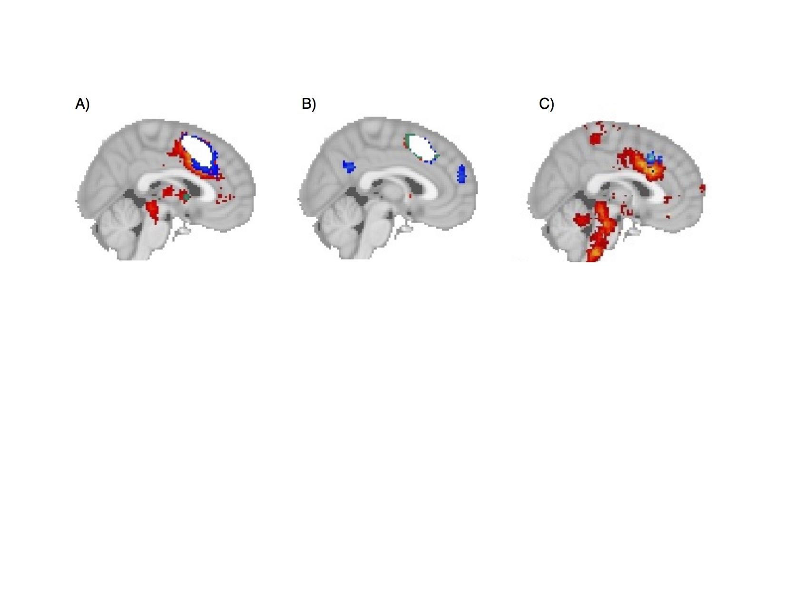

*Figure 5. Reverse-inference is necessary to determine neural correlates of cognitive functions. A) Forward inference of pain (red), cognitive control (blue) and emotion (yellow), showing overlap in in white. B) Forward inference of social cognition (blue), vision (red) and memory retrieval (red) also showing overlap in white. C) Reverse inference map of pain (red), cognitive control (blue) and emotion (yellow) shows distinct neural correlates of these domains, with no overlap between these three cognitive states in dACC.*

To characterize the functional specialization of medial frontal cortex, we used a method to identify which cognitive functions best predicted the activation of each individual cluster. For each cluster individually, we selected two sets of fMRI studies: those that showed activation within the cluster (average N = ) and those that did not (average N = ). Then, for each set of studies we calculated their average loading on the 34 cognitive functions in our ontology, derived from (\*\*\*\*give your reader a bit of a hint here so they can at least follow a bit without jumping to the methods) and subtracted the weights of the studies that did not activate the region from those that did. Thus, we were able to determine the extent to which each cognitive function differentiates studies that activated a region from those that did not.

At a broad scale, each of the three functional zones in medial frontal cortex show distinct patterns of functional specialization (Figure 6A). SMA was strongly and primarily involved with motor function, although this region was also involved to some extent with pain and cognitive control processes (in particular switching). pre-SMA/dACC showed a distinct shift away from motor function and towards cognitive and affective processes. This zone was primarily involved with various facets of cognitive control (e.g. conflict, working memory, switching, inhibition), but also showed specialization to more affective processes such as pain, emotion and decision-making. Consistent with mPFC’s distinct coactivation with the rest of the brain, this zone showed a distinct pattern, being primarily involved with social cognition, emotion, reward and decision-making.

To take a closer look, we performed the same analysis on each of the nine subregions we identified, and plotted the results grouped by the functional zone they belonged to (Figure 6). Overall, subregions within each cluster showed similar profiles to each other, with subtleyet important distinctions in their functional specialization. Both SMA subregions were similarly involved in motor function, but caudal SMA was more strongly associated with pain, while rostral SMA showed some associations with language.

. 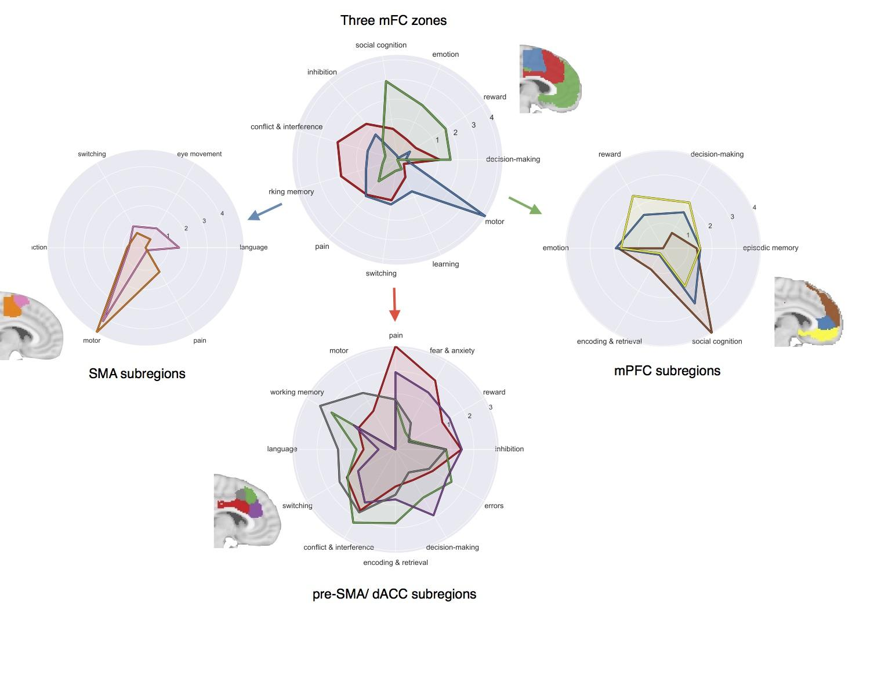

*Figure 6. Functional specialization profile of each of the mFC clusters. Each cluster was individually profiled to determine which cognitive functions best predicted its activation in a study. A) Each of the three broad zones we identified showed distinct functional profiles. B) Within each zone, each subregion showed subtle differences in functional specialization.*

All four subregions of dACC/pre-SMA we identified were involved with cognitive control to varying extents, although on average, pre-SMA was more strongly associated with cognitive control. Working memory in particular was strongly associated with pre-SMA--peaking in caudal pre-SMA-- while switching and conflict were more evenly associated with all four subregions in this zone. The sole exception was inhibition, which was more strongly associated with dACC than pre-SMA. Both dACC clusters were further characterized by a strong association with negative affect. In particular, pain and fear were very strongly associated with caudal aspects of dACC; unlike cognitive control, negative affect was fairly specifically associated with dACC and showed very weak associations with pre-SMA. We also found some rostro-caudal functional distinctions in this zone. Only caudal pre-SMA and dACC showed associations with motor function, while the two rostral clusters showed virtually no association. In contrast, rostral pre-SMA and dACC were more involved with decision-making and learning related processes. Finally, all four clusters were also associated with memory encoding and retrieval processes, although this association peaked in rostral pre-SMA.

Medial prefrontal cortex showed a distinct shift away from externally oriented processes, such as cognitive control, motor function and pain, and towards internal, self-oriented processes, such as decision-making, social processing, and episodic memory, and emotion. Again, the three subregions of this zone showed rather similar functional specialization patterns; in particular all three regions were similarly involved in emotion and episodic-memory processes. However, dmPFC was much more strongly associated with social cognition then rACC and even more so than vmPFC. We observed a reverse pattern for reward and decision-making, as these processes were more strongly associated with vmPFC, and least associated with dmPFC. Finally, memory encoding and retrieval was associated with dmPFC, although not as strongly as the association we found in rostral pre-SMA.

### Functional complexity

Finally, in addition to functionally characterizing regions, we sought to quantify how predictive these functional profiles of a given region’s activity can be. That is, given a region’s functional profile, how accurately can we predict if a study will activate that region, and how much information do we need in order to make an accurate prediction? To do so, we trained naive Bayesian classifiers for each region to discriminate studies that activated a region from studies that did not. In order to determine how many psychological topics were necessary to accurately predict activation of each region, we began by training the classifier using only a single cognitive function, and progressively added functions in order to observe how much the accuracy would increase as a function of the complexity of our predictive model (Figure 7A). Not surprisingly, activation of all regions was better predicted as the number of cognitive functions in the model increased, reaching peak performance on average with 27 functions (receiver operating characteristic area under the curve (ROC-AUC) of 0.612). Eventually, accuracy decreased when too many uninformative features were added to the model.

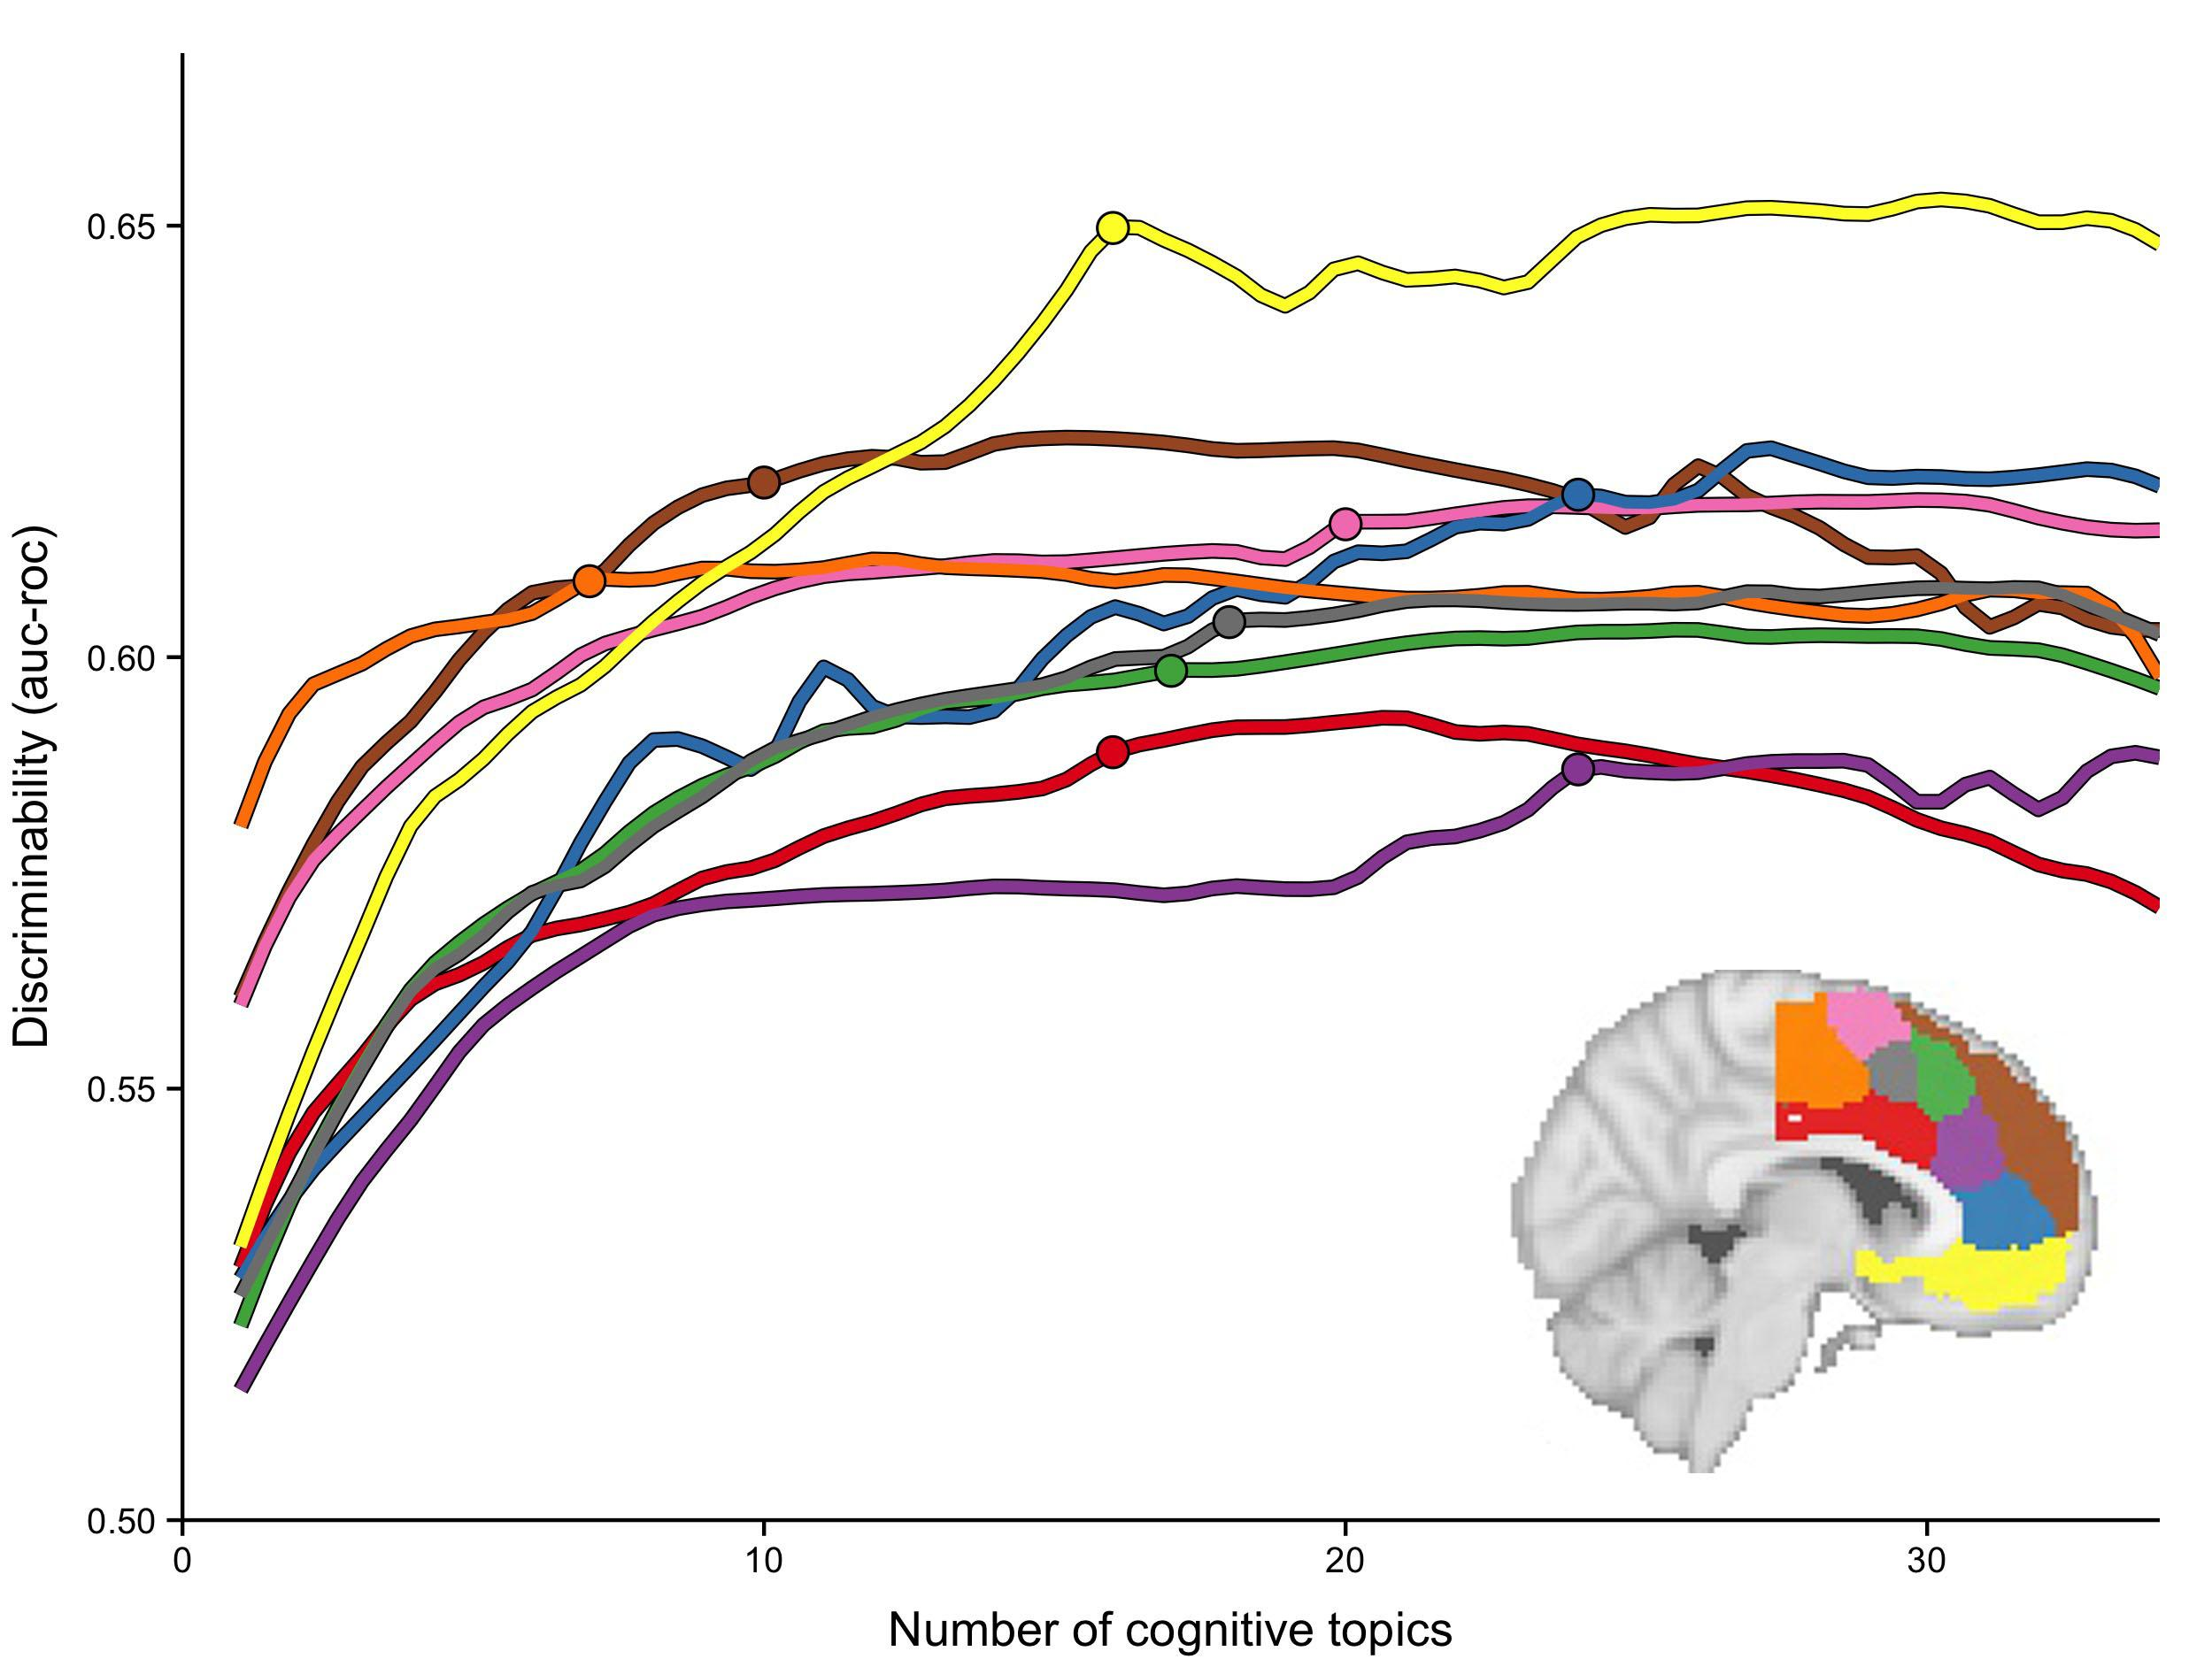

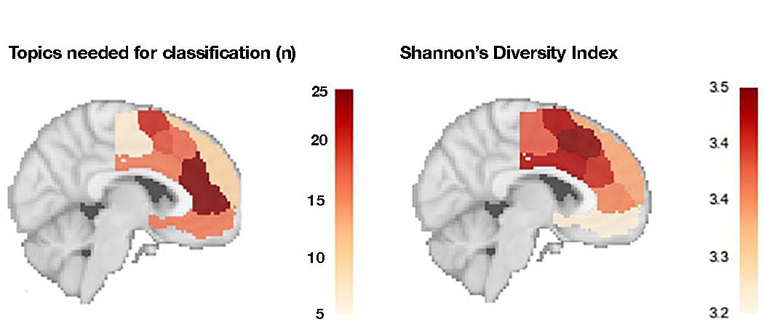

*Figure 7. Regions of mFC varied widely in functional complexity. (Top) As the number of cognitive functions in the model were increased (x-axis) the amount of variance in activity that could be explained (y-axis) also increased for all regions. However, regions varied in the number of topics required to reach maximum discriminability. The circles on each line represent……(Bottom Left) Number of topics to reach near-maximum discriminability plotted on a sagittal brain slice for each region. (Bottom Right) Shannon's’ diversity index was applied to each region's functional profiles as a comparison, resulting in a different approximation of functional complexity.*

However, mFC regions varied in two key aspects of these metrics: maximum discriminabilityr, and the number of topics required to reach this maximum. The maximum discriminability reflects how well overall a region’s function is explained by the cognitive ontology we employed, while the number of topics required to reach this maximum reflects the complexity of function observed in each region. Regions in pre-SMA and in particular dACC reached generally lower discriminability, perhaps indicating that the current cognitive ontology does not accurately describe their function. Caudal SMA also failed to reach very high level of discriminability, perhaps because motoric function is inherent to many tasks, yet often not discussed as a key aspect of the task. Conversely, regions in mPFC, and in particular vmPFC, reached greater level of discriminability, suggesting that our cognitive ontology better explains the functions supported by each of these regions.

Regions in mFC varied greatly in the number of topics required to reach the maximum discriminability level, a property we termed ‘functional complexity’ (Figure 7B). Caudal SMA required the fewest number of topics to reach its modest maximum discriminability level; in fact, we are able to discriminate activity in SMAc well above chance using only a single topic: motor function. At the other end of the spectrum, rACC and rostral dACC required a greater number of topics to reach maximum discriminability, suggesting a complex model of cognitive function is required to accurately predict if these two regions are likely activeto be activated in any given study.

Next, we compared our results to a measure of functional diversity previously applied to meta-analytic functional profiles, Shannon’s Diversity Index (SDI) (Anderson et al., 20xx). We applied SDI to our functional specialization profiles and found that pre-SMA showed the greatest diversity, while vmPFC showed low diversity, consistent with previous findings (Anderson et al., 20xx). SDI differed from functional complexity dramatically across many regions. All clusters in mPFC, including rACC and dmPFC, showed low diversity indexes; however, rACC was found to have the greatest amount of functional complexity in our previous analysis. Caudal SMA also showed surprisingly high SDI, despite only requiring very few cognitive functions to predict its activity. Finally, caudal dACC showed very high SDI, although we were able to predict its activity with relatively few cognitive functions.

# Discussion

In the current study, we applied a data-driven approach to a large-scale database of ~10,000 fMRI studies to identify and functionally characterize separable regions inof medial frontal cortex. On the basis of coactivation patterns with the rest of the brain, we identified three distinct zones in mFC: supplementary motor area (SMA), pre-SMA / dorsal anterior cingulate (dACC), and medial prefrontal cortex (mPFC). These zones further broke down into nine subregions corresponding to divisions observed in previous cytoarchitectonic work. We then performed an analysis to find which cognitive functions best discriminate activity in each of these clusters, and found that the three broad zones we identified corresponded with large shifts in functional specialization, and that the nine subregions revealed distinct, but subtle fine-grained specialization. Finally, we quantified the heterogeneity of function found in each of these regions, and found wide variability in this measure of functional complexity. Below, we discuss the results for each functional zone separately, and conclude with limitations and future directions of large-scale meta-analysis.

***Supplementary Motor Area***

Consistent with prior cytoarchitectonic (Vogt et al., 2005, Vorobiev et al., 1998; Luppino, 1993), tractography (Klein et al )and parcellations based on resting-state functional connectivity (Kim et et al.,), SMA cluster delineated from pre-SMA a few millimeters rostral of the VCA line. Moreover, consistent with more fine-grained cytoarchitectonic evidence, we find that SMA breaks down into rostral and caudal subdivisions, both of which show strong coactivation with regions important for motoric output (e.g. thalamus, somatosensory and primary motor cortex). Functionally, both rostral and caudal SMA are strongly implicated in motoric processing--consistent with direct corticospinal connections observed in tracing studies (Hutchins, Martino, & Strick, 1988)-- and show scant associations with higher-level cognitive processes. This functional zone shows strong coactivation with lateral motor cortices, consistent with its central role in motor function. Motor functions strongly characterize studies that active Caudal SMA, as this region shows low functional complexity and coactivation that is relatively restricted to other motor regions. Rostral SMA, on the other hand, shows greater coactivation with regions supporting high-level cognitive processes, such as parietal cortex. It also exhibited greater functional complexity as its activates morewhen studies are tapping cognitive processes such as ‘language’. These findings suggest that whilecaudal SMA is relatively specifically engaged with motoric processing, rostral aspects of SMA may be important for supporting some aspects of higher-level cognitive processes.

**pre-SMA and dorsal ACC**

Our results are consistent with the idea that the broadpre-SMA / dorsal ACC zone is involved in both cognitive as well as affective processes. Nonetheless, our analysis provides evidence that these disparate processes are supported by different subregions within this functional zone. As a whole, this zone is primarily associated with various aspects of cognitive control processes, including working memory, conflict, and to a lesser extent switching and inhibition. These findings are consistent with this zone’s strong coactivation with regions in the frontoparietal control network, such a lateral prefrontal cortex and superior parietal cortex (cite). This zone also showed very strong coactivation with dorsal anterior insula, consistent with previous claims that this region is part of a cingulo-opercular network that supports aspects of cognitive control (cite). On the other hand, pre-SMA / dACC was also associated withaffective processes, in particular pain, and decision-making processes that are more often attributed to more anterior portions of medial frontal cortex.

However, our results indicate that this broad functional pre-SMA/dACC zone is composed of at least four subregions with distinct patterns of functional coactivation and specialization: caudal and rostral pre-SMA and caudal and rostral dACC. These subdivisions are consistent with extensive cytoarchitectonic work in monkeys and humans (cite, cite cite) indicating that caudal dACC and rostral dACC (also known as anterior and posterior midcingulate cortex) show distinct cellular organization and demarcate from pre-SMA along the cingulate sulcus. Our functional specialization analysis indicates that although all four regions support cognitive control to some extent, pre-SMA is much more strongly associated with most aspects cognitive control-- in particular working memory and conflict. This pattern is consistent with our finding that both pre-SMA clusters--but in particular rostral pre-SMA-- shows greater coactivation with regions in the frontoparietal control network (e.g. IFG, IFJ, and IPL). On the contrary, activity in dACC is much more strongly associated with affective processes (e.g. fear, reward, and in particular, pain). Caudal dACC in particular is activated by studies that examine pain and fear, consistent with its robust coactivation with subcortical regions--in particular the thalamus-- and other cortical regions known to be important for pain processing, such as SII (cite cite).

The dissociation between pre-SMA and dACC found in our data suggests that existing models of cognitive control underspecify the functional topography dACC, andof the medial prefrontal cortexin cases may misattribute functions to dACC, when in fact they are likely supported by pre-SMA proper. For example, many influential theories of cognitive motoric control consider dACC to be the region primarily responsible for the integration of affective signals with motoric control to detect conflict (Botvnick et al., 2001, 2004) and define pre-SMA as primarily responsible for the modulation of motoric plans (cite). However, concerns have previously been raised that macaques primarily show conflict related activity in pre-SMA and not dACC, unlike humans (Nakamura, Roesch & Olson, 2005; Rushworth, Walton, Kennerley, Bannerman et al., 2004; Cole, Yeung, Freiwald, & Botvinick, 2009). Our results suggest that human conflict-related activity is also most associated pre-SMA proper, not dACC; rostral pre-SMA is the region we found to be most strongly co-activated with the rest of the frontoparietal control network andis the region that specifically become actives in studies of conflict processing. In fact, we also find that that rostral pre-SMA shows activation in studies examining decision-making, and showed no particular association with studies examining motor function, suggesting this region’s function may be best characterized as related to non-motor decision conflict.

Furthermore, while our findings support the idea that the larger pre-SMA / dACC zone activates during studies examining negative affect and cognitive control (Shackman et al., 2012), the overlap between these processes is not as neat as previously thought. In fact, rostral pre-SMA, the region most strongly activated specifically in studies examining conflict, is very weakly associated with studies related to negative affect. While our data cannot directly speak to the integration of disparate signals in the brain, one possibility is that the integration of negative affect and cognitive control occurs exclusively in dACC proper. Under that hypothesis, pre-SMA receives a non-affective conflict signal, which is then integrated with high-level goals represented in lateral prefrontal cortex.

**Medial prefrontal cortex**

At the most anterior portion of medial frontal cortex, we identified a medial prefrontal cortex zone characterized by strong coactivation with subcortical regions, such as the amygdala and nucleus accumbens. This zone showed a fairly distinct pattern of functional specialization, being primarily associated with studies involving social cognition, emotion, reward, and decision-making. This medial prefrontal zone broke down further into three subregions: a dorsal parcel (dmPFC), a middle cluster primarily situation in rostral anterior cingulate cortex (rACC), and a ventral cluster (vmPFC). The three regions were similarly associated with both emotion and episodic memory, suggesting these two processes rely on the entire medial prefrontal cortex. However, studies involving social cognition were associated far more strongly with dmPFC, consistent with a long line of studies (cite cite). This finding was also consistent with dmPFC’s strong coactivation with temporoparietal junction, another key region implicated in social cognition. However, activation associated with studies that examined social cognition were not isolated to dmPFC, as activity in rACC, and to a lesser extent, vmPFC were also predicted by studies involving social cognition, suggesting this process is distributed throughout mPFC. In contrast, studies involving affective processes, such as reward, fear and decision-making were primarily associated with ventral mPFC and to a lesser extent rACC. Consistent with this finding, vmPFC showed strong coactivation with subcortical regions known to be important in affect-- nucleus accumbens, amygdala (cite, cite, cite).

Across all three of mPFC subregions, we were able to predict their activation relatively accurately based on the cognitive functions described in fMRI studies. In fact, we reached the highest maximum accuracy in these three regions, suggesting the cognitive ontology we employed explains activity in these regions quite well. However, these regions varied substantially in the number of topics required to reach high classification accuracy. On one end, dmPFC required among the lowest number of topics (N=x\_to reach maximum accuracy, suggesting this region is involved with a fairly circumscribed set of cognitive functions. vmPFC required a greater but still limited number to reach high accuracy, (N=y\_ perhaps suggesting vmPFC is involved in a variety of affective processes, but is restricted to that domain of cognition. rACC was on the extreme, requiring the most number of topics (N=z\_ to reach high accuracy. rACC was not strongly associated with any one cognitive function, suggesting that rACC may be involved in numerous core processes that are tapped during the performance of many tasks and processes. This rACC region we identified, located in the middle of medial prefrontal cortex, may be the same region that has been previously identified as a “hub” or “rich club” in the default network, and is hypothesised to perform domain-general information integration (Andrews-Hanna et al., 2010; van den Huevel & Sprons, 2011). Further cross-modal research with meta-analytic data and resting state fMRI is necessary to better pin down the dynamics that result in a region with high functional complexity.

***Limitations***

While our large-scale meta-analytic approach to revealing mFC function allows us to comprehensively synthesize a plethora of fMRI findings, there are several limitations. Primarily, the quality of the data in Neurosynth is inherently limited due to its automatically generated nature. Since activation coordinates are automatically mined from papers, errors are likely to occur. Moreover, the cognitive ontology we employ is data-derived from the semantic content of papers, and thus is not driven by theoretical models that may be critical in discriminating the activity of certain regions. Nonetheless, our coactivation-based parcellations are surprisingly consistent with neuroscientific knowledge and detailed studies from other modalities (e.g. resting-state fMRI, cytology), suggesting that the sheer number of studies in the database is able to ameliorate some of these concerns. Future application of more sophisticated data-mining techniques on both the activation estimates and semantic information may further improve this situation.

Second, the cognitive ontology that we derived using topic modeling is relatively simple, as it is based purely on the frequency of terms-- and is unable to distill more nuanced differences between cognitive processes. Creating a more fine-grained ontology, of course, is very difficult and will take targeted efforts to improve. Similarly, due to the lack of data sharing found in the fMRI literature, we’ve had to rely on only the peak reported coordinates in fMRI papers. While many of these limitations are overcome by the sheer number of studies in the database--many more than what is found in hand-curated databases-- large-scale data mining efforts such as these will be greatly helped by the future proliferation of data-sharing in our community. Large-scale hand-curated meta-analyses that encompass a wider range of domains may also help in the ability to more accurately categorize the processes present in studies (e.g. Lindquist, Wager, Kober, Bliss-Moreau, & Barrett, 2012).

Moreover, as with any meta-analysis of fMRI data, our approach is limited by the low spatial resolution of fMRI and the inability to disentangle individual differences in anatomy across subjects. In particular, it is difficult to precisely localize each of our clusters onto gyri and sulci; this is particularly problematic in dorsal ACC, where BA 32’ lies only a few millimeters dorsal of BA 24, and shows particularly large anatomical variation across humans (Paus et al., 2011, Cole t al., XXX). While only advances in radiology will improve the spatial resolution of fMRI, the open sharing of fMRI accompanied with useful metadata (e.g. expert knowledge) will certainly have a large impact on the quality of large-scale meta-analyses that can be conducted. We suggest that given the levels of classification we are able to achieve with relatively noisy data, applying similar approaches to higher quality data will result in precise estimates of functional specialization in the future. Moreover, if these data include individual subject anatomical information, it will be possible to better understand the organization of medial frontal cortex, and in particular those regions with variable anatomy such as pre-SMA/dACC.

CONCLUSION

### 

## Methods

### Neuroimaging Database

We analyzed the Neurosynth database (neurosynth.org; Yarkoni et al., 2011), a repository of 9,721 fMRI studies and over 350,000 activations. Each observation in the database contains the peak activations for all contrasts reported in a study’s table as well as the frequency of all of the words in the article abstract. Activations were smoothed using a 6mm Gaussian kernel.

### Medial frontal cortex coactivation clustering

To find separable regions in medial frontal cortex, we clustered individual voxels inside of a medial frontal cortex mask based on their coactivation with voxels in the rest of the brain. First, we defined a medial frontal cortex volume of interest mask in standard Montreal Neurological Institute (MNI) to select the appropriate voxels. We used FSLView to create a mask of voxels with greater than 30% probability of being grey matter according to the Harvard-Oxford anatomical atlas. Next, we excluded all voxels that were more than 10mm from the midline of the brain in the X dimension, as a way to exclude grey matter voxels on the lateral surface of the brain. We also excluded voxels that were posterior to central sulcus (Y < -22) and voxels that were ventral to vmPFC (Z < -32), such as temporal cortices, resulting in a somewhat liberal mask of medial frontal cortex. Next, we took this somewhat liberal mask and excluded voxels that showed very low activation in the database (less than 80 studies per voxel).

Next, we calculated the correlation between each medial frontal cortex voxel with the rest of the brain across studies. As this would result in a very large matrix which would be computationally difficult to cluster, we first reduced the dimensionality of the rest of the brain using principal components analysis. We applied principal component analysis using randomized singular value decomposition to the matrix containing activation of every voxel in the brain across all studies (228453 voxels x 9721 studies) to reduce it to 100 components (100 voxels x 9721 studies). Then, for each voxel in the mFC mask, we computed the correlation distance of every voxel in mFC with each PCA component defined as 1 - \frac{(u - \bar{u}) \cdot (v - \bar{v})}         {{||(u - \bar{u})||}_2 {||(v - \bar{v})||}_2}, where *u* is a mFC voxels and *v* is a whole-brain PCA component, resulting in a mFC distance matrix.

We used k-means clustering to group mFC voxels, as this algorithm is computationally efficient, commonly used, and shows high goodness of fit and reproducibility (Thirion, Varoquaux, Dohmatob, & Poline, 2014). We then used scit-kit learn’s implementation of k-means clustering to the mFC distance matrix using the k-means++ initialization procedure. The k-means algorithm was run 10 times on different centroid seeds and the best output of these consecutive runs was selected in terms of inertia to avoid local minima.

Because structure-to-function mappings can be identified at multiple scales, with potentially different (but equally valid) results, we conducted our analyses at multiple levels of spatial resolution. We parcellated the mFC into 2 through 15 regions. Identifying the ‘correct’ number of clusters is arguably an intractable problem, since the optimality of a given clustering depends in large part on investigators’ goals, the preferred level of analysis, and the nature and dimensionality of the available data (for discussion, see Poldrack and Yarkoni, in press). However, in the interest of pragmatism, we attempted to objectively select the number of clusters using the silhouette score, a measure of within-cluster cohesion. Solutions that minimized the average distance between voxels within each cluster received a greater score. The silhouette coefficient was defined as (b - a) / max(a, b), where a is the mean intra-cluster distance and b is the distance between a sample and the nearest cluster that the sample is not a part of. Higher scores indicate tighter clustering of the data.

However, because it is unclear what should be considered a significant silhouette score, we used a permutation procedure previously employed by our group (cite TOR) to infer if a given clustering solution was warranted. For each possible solution between 2 and 15 clusters, we permuted the columns of the whole-brain x studies matrix as well as the mFC VOI voxels x studies matrix. We then re-applied the clustering algorithm, and re-calculated the silhouette score. This was repeated **XX** times for each number of clusters, resulting in a null-hypothesis distribution of silhouette scores for each *k*. Estimating the null distribution of silhouette scores allowed us to calculate a Z-score for the silhouette score based on our observed data clustering solutions. Figure S1 shows the silhouette score for each clustering solution and below it the silhouette scores of the null-distribution. All clustering solutions were very significant (all z-scores were greater than XX), and the null-distribution stayed relatively stationary as the number of clusters increased.

Given the high statistical significance of all clustering solutions, we qualitatively assessed the silhouette scores of our real clustering solutions. Silhouette scores reached a local maxima with three clusters, suggesting that this simple organizational scheme explained a surprisingly high amount of the data. Silhouette scores then dipped and reached another local maxima using nine clusters. Beyond nine clusters, silhouette scores marginally increased, but in our estimation not sufficiently so to warrant the increase in complexity in the clustering solutions. Thus, we selected three and nine regions as the most useful clustering solutions, but note that solutions with 12 and 14 regions also showed high silhouette scores, and sensible solutions, thus we include them as a supplement (Figure SII).

### Coactivation profiles of mFC clusters

To calculate coactivation profiles of each cluster, we performed a whole-brain meta-analysis of studies that activated each mFC parcel. This analysis resulted in a whole-brain map indicated the extent to which voxels activated in the studies that activated each mFC parcel. We selected studies that activated at least 25% of voxels in a given parcel and then performed a forward-inference meta-analysis. See the section below on meta-analysis for more details on the procedure.

For the three-cluster solution, we visualized whole-brain coactivation across the brain using axial slices. To reduce the complexity of this map, we thresholded the coactivation maps using the false discovery rate. For the nine-cluster solution, it was challenging to visualize many clusters across the entire brain. Instead, we employed a ROI based approach, in which we calculated the mean coactivation for ROIs across the brain with each mFC parcel, and visually represented the coactivation in a heat map (Figure 4). First, we generated 40 whole-brain ROIs the same k-means clustering approach outlined above applied to a whole-brain MNI mask; 40 regions were used because they struck a balance between anatomical specificity and interpretability, approximating the number of regions in Brodmann’s classic anatomical divisions. mFC clusters were removed from the whole brain ROIs, so as to examine connectivity of the mFC specifically with the rest of the brain. This process resulted in 34 regions, and the mean coactivation between mFC regions and each ROI was calculated by masking the whole-brain coactivation matrix we calculated above.

### Topic modeling

Although the term-based meta-analysis maps in Neurosynth closely resemble the results of manual meta-analyses of the same concepts (e.g. Yarkoni et al., 2011; Bartra, McGuire & Kable 2013), there is a high degree of redundancy between terms (e.g. ‘episodes’ and ‘episodic’) and potential ambiguity as to the meaning of an individual word out of context (e.g. ‘memory’ can indicate working memory or episodic memory). To remedy this dilemma, we employed a reduced semantic representation of the latent conceptual structure underlying the neuroimaging literature: a set of 60 topics derived using latent dirichlet allocation topic-modeling. This procedure was identical to that used in a previous paper (Poldrack, Mumford, Schonberg, Kalar, Barman, & Yarkoni, 2012), except for the use of a smaller number of topics and a much larger version of the Neurosynth database. The generative topic model derives 60 independent topics from the co-occurrence across studies of all words occurring in the abstracts of studies in the Neurosynth database. Each resulting topic loads onto individual words to a varying extent, facilitating the interpretation of topics; for example, a working memory topic loads highest on the words 'memory, WM, load', while an episodic memory topic loads on 'memory, retrieval, events'. Note that both topics highly load on the word “memory”, but the meaning of this word is disambiguated because it is contextualized by other word that strongly load onto that topic. Likewise, as each topic maps onto individual studies to a varying extent, the topic model facilitates the categorization of the cognitive phenomena studied across fMRI studies; for example, a study that maps highly onto a topic described by the words 'control, inhibition, conflict’ is likely to be examining cognitive control. Out of the 60 generated topics, 25 represented non-cognitive semantic topics, such as the nature of the subject population (e.g. gender, special populations) and methods (e.g., words such as “images”, “voxels”. In order to focus on the cognitive predictors of brain activity, we identified these topics and excluded them from all analyses (see Appendix for a list of included and excluded topics).

### Reverse and forward inference meta-analysis

To demonstrate the importance of appropriately controlling for variation in activation specificity, we conducted topic-based meta-analyses using forward and reverse inference. To perform a reverse inference.

### Meta-analytic functional specialization

For each cluster, we built a linear model to predict whether activity in that region would be reported by an fMRI study based on the semantic content of the words used to describe the focus of that fMRI study. This procedure allowed us to generate functional profiles that describe which cognitive functions best predicted the activity of each region, and how well fMRI activity can be explained by the cognitive ontology present in the body of fMRI studies at the meta-analytic level. Below, we describe each step of our approach.

*Predictive modeling of activity using cognitive functions.* We generated functional profiles of mFC regions by determining which cognitive functions best predicted each mFC region’s activity across fMRI studies. First, we selected two sets of studies: studies that activated a given parcel--defined as activating at least 5% of voxels in the parcel-- and studies that did not--defined as activating absolutely no voxels in the parcel. For each parcel, we trained a naive Bayes classifier to discriminate these two sets of studies based on the semantic content of the studies herein. We chose naive Bayes because we have previously had success applying this algorithm to Neurosynth data in the past (Yarkoni et al., 2011), and has been shown to perform well on many types of data (cite cite). In addition, naive Bayes classifiers require almost no tuning of parameters to achieve a high level of performance, decreasing the likelihood of an overfit of the model to the data.

We assessed our models’ ability to predict if an unseen study activated a region, given the content of the study. In other words, if we know what cognitive topic a study is about, how well can we predict if it activates a specific region? We employed 4-fold cross validation to test the generalization of our models. Models were fitted on 3/4ths of studies and tested on the remaining studies. This procedure was repeated four times, circulating over the studies so that the model was trained and tested on the entire dataset. The mean score across the 4-fold tests were used as the final measure of performance. We scored the models by calculating the area under the receiver operating characteristic, (AUC-ROC) a summary metric of classification performance that take into account both sensitivity and specificity. Furthermore, AUC-ROC is not detrimentally affected by unbalanced data, that is the number of observations in each class. This was particularly important because each region varied in the ratio of studies that activated it to the studies that did not, and we wanted to ensure that our measure of performance was not driven by this variation.

To generate functional specialization profiles, we extracted from the naive Bayes models a critical piece of information the model uses for classification: the average loading of each cognitive function to each class. That is, we extracted the average loading of each cognitive topic to the set of studies that activated each region, and the average loading to studies that did not activate each region. We then subtracted the mean loading for the ‘active’ class from the ‘inactive’ class, how yieldinga measure of the expression of a given cognitive function for a given parcel. We zZ-scored this measure across regions to make the magnitude of this difference more easily interpretable, and used these ‘weights’ to generate the plots in figure 5.

*Functional complexity.* We quantified the complexity of function in order to determine if mFC regions are involved in a diverse range of cognitive functions. We operationalized regions with heterogenous function as those that required a larger number of topics to accurately predict their activity, while regions with more homogenous function are those that would require fewer topics to correctly classify. We started by fitting the simplest possible model and attempting to predict activity for each region only using the topic that had the greatest weight in the complete model. We then assessed the benefit of including additional topics by sequentially adding topics as predictors (up to 35) to the model in order of their importance in the full model.

*Machine learning algorithms*. Scikit-learn (CITE CITE), a python machine learning module, was used for all machine learning analyses in this study (PCA, k-means clustering, naive Bayes classification).

Supplemental Information

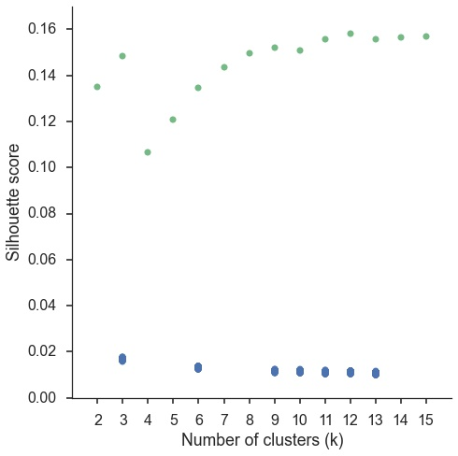

Supplemental Figure 1. Silhouette scores of clustering solutions. Silhouette scores of clusters derived from observed data are shown in green. Permuted silhouette scores (XX permutations) are shown in blue and represent the null-hypothesis.

## Supplemental Table 1. Topics derived from topic modeling.

## Cognitive Topics

Name of topics as given by authors in left columns. Topics used in primary figures are italicized.

|  |  |  |  |  |  |
| --- | --- | --- | --- | --- | --- |
| **Topic Name** | **Five highest loading words** | | | | |
| stress | stress | awareness | experience | conscious | cortisol |
| *eye movements* | eye | gaze | movements | eyes | visual |
| *decision-making* | decision | choice | risk | decisions | choices |
| reasoning | reasoning | rule | rules | intelligence | complexity |
| sensory | visual | auditory | sensory | modality | integration |
| spatial | spatial | location | mental | space | virtual |
| repetition priming | repetition | priming | hearing | repeated | suppression |
| feature detection | visual | category | adaptation | color | features |
| *episodic memory* | memory | events | imagery | autobiographical | retrieval |
| object recognition | object | objects | visual | recognition | familiar |
| *motor function* | motor | movement | movements | sensorimotor | primary |
| attention | attention | attentional | visual | spatial | target |
| learning | learning | training | performance | practice | sequence |
| *social cognition* | social | empathy | moral | person | judgments |
| tms/stimulation | stimulation | somatosensory | tms | primary | tactile |
| mathematics | arithmetic | numerical | mental | magnitude | calculation |
| sentence comprehension | sentences | comprehension | sentence | language | syntactic |
| *reward* | reward | anticipation | monetary | responses | rewards |
| error processing | feedback | error | learning | errors | prediction |
| *switching* | cues | target | trials | cue | switching |
| audition | auditory | speech | sounds | music | sound |
| *emotion* | emotional | emotion | negative | neutral | facial |
| language | language | speech | production | fluency | asymmetry |
| reading | reading | word | words | phonological | chinese |
| *conflict & interference* | conflict | interference | control | incongruent | trials |
| semantic | semantic | words | word | lexical | knowledge |
| *inhibition* | inhibition | control | inhibitory | stop | motor |
| *encoding & retrieval* | memory | encoding | retrieval | recognition | episodic |
| motor action | action | actions | motor | observation | mirror |
| *fear & anxiety* | fear | anxiety | threat | responses | conditioning |
| food | food | taste | body | weight | eating |
| *working memory* | memory | performance | cognitive | wm | tasks |
| motion perception | motion | visual | perception | body | human |
| *pain* | pain | painful | stimulation | somatosensory | intensity |

## Non-Cognitive Topics Non-cognitive topics were not named, and are instead numbered.

|  |  |  |  |  |  |
| --- | --- | --- | --- | --- | --- |
| **Topic #** | **Top five loading words** | | | | |
| 35 | women | sex | gender | females | males |
| 36 | placebo | pet | tomography | emission | dopamine |
| 37 | schizophrenia | controls | risk | reduced | deficits |
| 38 | condition | conditions | tasks | control | performance |
| 39 | ad | disease | mci | alzheimer | atrophy |
| 40 | individuals | cognitive | individual | control | behavioral |
| 41 | wm | fractional | integrity | tracts | diffusivity |
| 42 | lesions | controls | patient | lesion | stroke |
| 43 | human | humans | organization | located | primates |
| 44 | network | role | evidence | human | distinct |
| 45 | network | resting | default | mode | rest |
| 46 | frequency | source | alpha | amplitude | beta |
| 47 | pd | controls | disease | clinical | motor |
| 48 | disorder | adhd | bipolar | controls | ocd |
| 49 | depression | mdd | depressed | disorder | depressive |
| 50 | images | standard | time | voxel | image |
| 51 | time | sustained | delay | phase | period |
| 52 | alcohol | acupuncture | cocaine | users | drug |
| 53 | volume | gray | voxel | gm | morphometry |
| 54 | effective | causal | network | dynamic | modeling |
| 55 | carriers | allele | gene | genotype | genetic |
| 56 | ptsd | social | game | attachment | trauma |
| 57 | asd | autism | social | reho | controls |
| 58 | age | adults | children | adolescents | sleep |
| 59 | features | free | sensitivity | classifier | feature |
| 60 | responses | stimulus | effect | design | neuronal |

**References**

Alexander, W. H., & Brown, J. W. (2011). Medial prefrontal cortex as an action-outcome predictor. Nature neuroscience, 14(10), 1338-1344.

Amunts, K., Schleicher, A., Bürgel, U., Mohlberg, H., Uylings, H., & Zilles, K. (1999). Broca's region revisited: cytoarchitecture and intersubject variability. Journal of Comparative Neurology, 412(2), 319-341.

Andrews-Hanna, Jessica R. "The brain’s default network and its adaptive role in internal mentation." The Neuroscientist 18.3 (2012): 251-270.

Andrews-Hanna, J.R., Reidler, J.S., Sepulcre, J., Poulin, R. & Buckner, R.L. (2010). Functional-anatomic fractionation of the brain’s default network. Neuron, 65: 550-562.

Banich, M. T. (2009). Executive function the search for an integrated account. Current Directions in Psychological Science, 18(2), 89-94.

Bartra, O., McGuire, J. T., & Kable, J. W. (2013). The valuation system: A coordinate-based meta-analysis of BOLD fMRI experiments examining neural correlates of subjective value. NeuroImage, 76, 412–427. doi:10.1016/j.neuroimage.2013.02.063

Beckmann, M., Johansen-Berg, H., & Rushworth, M. F. (2009). Connectivity-based parcellation of human cingulate cortex and its relation to functional specialization. The Journal of Neuroscience, 29(4), 1175-1190.

Behrens, T. E., Woolrich, M. W., Walton, M. E., & Rushworth, M. F. (2007). Learning the value of information in an uncertain world. Nature neuroscience, 10(9), 1214-1221.

Buckner, Randy L, Jessica R Andrews‐Hanna, and Daniel L Schacter. "The brain's default network." *Annals of the New York Academy of Sciences* 1124.1 (2008): 1-38.

Botvinick, M. M., Braver, T. S., Barch, D. M., Carter, C. S., & Cohen, J. D. (2001). Conflict monitoring and cognitive control. Psychological review, 108(3), 624.

Botvinick, M. M., Cohen, J. D., & Carter, C. S. (2004). Conflict monitoring and anterior cingulate cortex: an update. Trends in cognitive sciences, 8(12), 539-546.

Buckner, R. L., Andrews Hanna, J. R., & Schacter, D. L. (2008). The Brain's Default Network. Annals of the New York Academy of Sciences, 1124(1), 1–38. doi:10.1196/annals.1440.011

Bush, G., Luu, P., & Posner, M. I. (2000). Cognitive and emotional influences in anterior cingulate cortex. Trends in Cognitive Sciences, 4(6), 215–222. doi:10.1016/S1364-6613(00)01483-2

Carter, C. S., Braver, T. S., Barch, D. M., Botvinick, M. M., Noll, D., & Cohen, J. D. (1998). Anterior cingulate cortex, error detection, and the online monitoring of performance. Science, 280(5364), 747-749.

Chang, L. J., Yarkoni, T., Khaw, M. W., & Sanfey, A. G. (2012). Decoding the role of the insula in human cognition: functional parcellation and large-scale reverse inference. Cerebral Cortex, bhs065.

Etkin, A., Egner, T., & Kalisch, R. (2011). Emotional processing in anterior cingulate and medial prefrontal cortex. Trends in Cognitive Sciences, 15(2), 85–93. doi:10.1016/j.tics.2010.11.004

Fair, Damien A et al. "Development of distinct control networks through segregation and integration." *Proceedings of the National Academy of Sciences* 104.33 (2007): 13507-13512.

Feja, Malte, and Michael Koch. "Frontostriatal systems comprising connections between ventral medial prefrontal cortex and nucleus accumbens subregions differentially regulate motor impulse control in rats." Psychopharmacology (2014): 1-12.

Fox PT, Laird AR, Fox SP, Fox PM, Uecker AM, Crank M, Koenig SF, Lancaster JL. BrainMap taxonomy of experimental design: Description and evaluation. Hum Brain Mapp 25, 185-198, 2005.

Ghazizadeh, Ali et al. "Prefrontal cortex mediates extinction of responding by two distinct neural mechanisms in accumbens shell." The Journal of Neuroscience 32.2 (2012): 726-737.

Honey, Christopher J, Jean-Philippe Thivierge, and Olaf Sporns. "Can structure predict function in the human brain?." *Neuroimage* 52.3 (2010): 766-776.

Hutchins, K. D., Martino, A. M., & Strick, P. L. (1988). Corticospinal projections from the medial wall of the hemisphere. Experimental Brain Research, 71(3), 667–672. doi:10.1007/BF00248761

Kahnt, T., Chang, L. J., Park, S. Q., Heinzle, J., & Haynes, J.-D. (2012). Connectivity-Based Parcellation of the Human Orbitofrontal Cortex. Journal of Neuroscience, 32(18), 6240–6250. doi:10.1523/JNEUROSCI.0257-12.2012

Kim, J.-H., Lee, J.-M., Jo, H. J., Kim, S. H., Lee, J. H., Kim, S. T., et al. (2010). Defining functional SMA and pre-SMA subregions in human MFC using resting state fMRI: Functional connectivity-based parcellation method. NeuroImage, 49(3), 2375–2386. doi:10.1016/j.neuroimage.2009.10.016

Liu, H., Qin, W., Li, W., Fan, L., Wang, J., Jiang, T., & Yu, C. (2013). Connectivity-Based Parcellation of the Human Frontal Pole with Diffusion Tensor Imaging. Journal of Neuroscience, 33(16), 6782–6790. doi:10.1523/JNEUROSCI.4882-12.2013

Lindquist, K. A., Wager, T. D., Kober, H., Bliss-Moreau, E., & Barrett, L. F. (2012). The brain basis of emotion: A meta-analytic review. Behavioral and Brain Sciences, 35(03), 121–143. doi:10.1017/S0140525X11000446

Luppino, G. (1993). Corticocortical connections of area F3 (SMA-proper) and area F6 (pre-SMA) in the macaque monkey, 1–27.

McDonald, A. J., Mascagni, F., & Guo, L. (1996). Projections of the medial and lateral prefrontal cortices to the amygdala: a Phaseolus vulgaris leucoagglutinin study in the rat. Neuroscience, 71(1), 55–75. doi:10.1016/0306-4522(95)00417-3

Mohanty, A., Engels, A. S., Herrington, J. D., Heller, W., Ringo Ho, M.-H., Banich, M. T., et al. (2007). Differential engagement of anterior cingulate cortex subdivisions for cognitive and emotional function. Psychophysiology, 44(3), 343–351. doi:10.1111/j.1469-8986.2007.00515.x

Nakamura, K., & Roesch, M. R. (2005). Neuronal activity in macaque SEF and ACC during performance of tasks involving conflict. Journal of …..

McDonald, A. J., Mascagni, F., & Guo, L. (1996). Projections of the medial and lateral prefrontal cortices to the amygdala: a Phaseolus vulgaris leucoagglutinin study in the rat. Neuroscience, 71(1), 55–75. doi:10.1016/0306-4522(95)00417-3

Mennes, M., Kelly, C., Zuo, X.-N., Di Martino, A., Biswal, B. B., Castellanos, F. X., & Milham, M. P. (2010). Inter-individual differences in resting-state functional connectivity predict task-induced BOLD activity. NeuroImage, 50(4), 1690–1701. doi:10.1016/j.neuroimage.2010.01.002

Paus, T. (2001). Primate anterior cingulate cortex: where motor control, drive and cognition interface. Nature Reviews Neuroscience.

Phan, K. L., Wager, T., Taylor, S. F., & Liberzon, I. (2002). Functional Neuroanatomy of Emotion: A Meta-Analysis of Emotion Activation Studies in PET and fMRI. NeuroImage, 16(2), 331–348. doi:10.1006/nimg.2002.1087

Picard, N., & Strick, P. L. (1996). Motor Areas of the Medial Wall: A Review of Their Location and Functional Activation. Cerebral Cortex, 6(3), 342–353. doi:10.1093/cercor/6.3.342

Poldrack, R. A., Mumford, J. A., Schonberg, T., Kalar, D., Barman, B., & Yarkoni, T. (2012). Discovering relations between mind, brain, and mental disorders using topic mapping. PLoS computational biology, 8(10), e1002707.

Power, J. D., & Petersen, S. E. (2013). Control-related systems in the human brain. Current opinion in neurobiology, 23(2), 223-228.

Power, J. D., Cohen, A. L., Nelson, S. M., Wig, G. S., Barnes, K. A., Church, J. A., et al. (2011). Functional network organization of the human brain. Neuron, 72(4), 665-678.

Rizzolatti, G., Fadiga, L., Matelli, M., Bettinardi, V., Paulesu, E., Perani, D., & Fazio, F. (1996). Localization of grasp representations in humans by PET: 1. Observation versus execution. Experimental Brain Research, 111(2), 246–252. doi:10.1007/BF00227301

Robinson, J. L., Laird, A. R., Glahn, D. C., Lovallo, W. R., & Fox, P. T. (2010). Metaanalytic connectivity modeling: Delineating the functional connectivity of the human amygdala. Human Brain Mapping, 31(2), 173–184. doi:10.1002/hbm.20854

Rolls, E. T., O'Doherty, J., Kringelbach, M. L., Francis, S., Bowtell, R., & McGlone, F. (2003). Representations of Pleasant and Painful Touch in the Human Orbitofrontal and Cingulate Cortices. Cerebral Cortex, 13(3), 308–317. doi:10.1093/cercor/13.3.308

Rizzolatti, G., Fadiga, L., Matelli, M., Bettinardi, V., Paulesu, E., Perani, D., & Fazio, F. (1996). Localization of grasp representations in humans by PET: 1. Observation versus execution. Experimental Brain Research, 111(2), 246–252. doi:10.1007/BF00227301

Rushworth, M., Walton, M. E., & Kennerley, S. W. (2004). Action sets and decisions in the medial frontal cortex. Trends in Cognitive …. doi:10.1016/j.tics.2004.07.009

Rushworth, M. F., & Behrens, T. E. (2008). Choice, uncertainty and value in prefrontal and cingulate cortex. Nature neuroscience, 11(4), 389-397.

Seeley, W. W., Menon, V., Schatzberg, A. F., Keller, J., Glover, G. H., Kenna, H., et al. (2007). Dissociable intrinsic connectivity networks for salience processing and executive control. The Journal of neuroscience, 27(9), 2349-2356.

Sesack, Susan R, and Virginia M Pickel. "Prefrontal cortical efferents in the rat synapse on unlabeled neuronal targets of catecholamine terminals in the nucleus accumbens septi and on dopamine neurons in the ventral tegmental area." *Journal of Comparative Neurology* 320.2 (1992): 145-160.

Shackman, A. J., Salomons, T. V., Slagter, H. A., Fox, A. S., Winter, J. J., & Davidson, R. J. (2011). The integration of negative affect, pain and cognitive control in the cingulate cortex. Nature Reviews Neuroscience, 12(3), 154-167.

Smith, S. M., Fox, P. T., Miller, K. L., Glahn, D. C., Fox, P. M., Mackay, C. E., et al. (2009). Correspondence of the brain's functional architecture during activation and rest. Proceedings of the National Academy of Sciences, 106(31), 13040-13045.

Toro, R., Fox, P. T., & Paus, T. (2008). Functional Coactivation Map of the Human Brain. Cerebral Cortex, 18(11), 2553–2559. doi:10.1093/cercor/bhn014

Thirion, B., Varoquaux, G., Dohmatob, E., & Poline, J. (2014). Which fMRI clustering gives good brain parcellations?. Frontiers in Neuroscience, 8, 167.

Treede, R.-D., Kenshalo, D. R., Gracely, R. H., & Jones, A. K. P. (1999). The cortical representation of pain. Pain, 79(2), 105–111. doi:10.1016/S0304-3959(98)00184-5

Vorobiev, V., & Luppino, G. (1998). Parcellation of human mesial area 6: cytoarchitectonic evidence for three separate areas, 1–5.

Wager, T. D., Lindquist, M., & Kaplan, L. (2007). Meta-analysis of functional neuroimaging data: current and future directions. Social Cognitive and Affective Neuroscience, 2(2), 150–158. doi:10.1093/scan/nsm015

Wager, T. D., Atlas, L. Y., Lindquist, M. A., Roy, M., Woo, C.-W., & Kross, E. (2013). An fMRI-Based Neurologic Signature of Physical Pain. New England Journal of Medicine, 368(15), 1388–1397. doi:10.1056/NEJMoa1204471

Wallis, J. D., & Kennerley, S. W. (2010). Heterogeneous reward signals in prefrontal cortex. Current Opinion in Neurobiology, 20(2), 191–198. doi:10.1016/j.conb.2010.02.009

Yarkoni, T., Poldrack, R. A., Nichols, T. E., Van Essen, D. C., & Wager, T. D. (2011). Large-scale automated synthesis of human functional neuroimaging data. Nature methods, 8(8), 665-670.

Yu, C., Zhou, Y., Liu, Y., Jiang, T., Dong, H., Zhang, Y., et al. (2011). Functional segregation of the human cingulate cortex is confirmed by functional connectivity based neuroanatomical parcellation. Neuroimage, 54(4), 2571-2581.

# 

## 