Functional specialization and complexity in medial frontal cortex

Alejandro de la Vega

The medial frontal cortex (MFC) is a broad area of the brain encompassing many functionally distinct foci that have been associated with a wide variety of cognitive states using functional neuroimaging. For example, the supplementary motor area (SMA) and pre-SMA, have been associated with the planning and initiation of movements (Ball, Schreiber, Feige, Wagner, & Lücking, 1999; Kennerley & Sakai, 2004; Lee, Chang, & Roh, 1999; Leek & Johnston, 2009; Roland, Larsen, & Lassen, 1980), while nearby dorsal anterior cingulate cortex (ACC) has been implicated in various aspects of cognitive control, such as conflict (Botvinick, Nystrom, Fissell, Carter, & Cohen, 1999; Milham et al., 2001; Rushworth, Walton, & Kennerley, 2004) and error processing (Brown & Braver, 2005; C. S. Carter et al., 1998; Holroyd, Nieuwenhuis, & Yeung, 2004), and is thought to be important region for pain processing (Rolls et al., 2003; Treede, Kenshalo, Gracely, & Jones, 1999; Vogt, 2005; Wager et al., 2013). Further anterior, medial prefrontal cortex (mPFC) and subgenual ACC have been shown to be important for a variety of affective processes, including emotion (Bush, Luu, & Posner, 2000; Lindquist, Wager, Kober, Bliss-Moreau, & Barrett, 2012; Winecoff et al., 2013), autonomic function (Critchley et al., 2003), and valuation (Bartra, McGuire, & Kable, 2013; Hare, Camerer, & Rangel, 2009; Rogers et al., 2004). Furthermore, portions of mPFC have also been associated with a variety of stimulus-independent internally oriented processes, such as mentalizing (Baumgartner, Götte, Gügler, & Fehr, 2012; Denny, Kober, Wager, & Ochsner, 2012) and autobiographical memory (Spreng & Grady, 2010; Summerfield, Hassabis, & Maguire, 2009).

Despite the enormous amount of neuroimaging research on focal regions of MFC, there have been few large-scale efforts to comprehensively map function to medial frontal anatomy across the full range of cognitive and affective states. Since most researchers are intimately familiar with one particular domain of cognition, most meta-analyses are necessarily restricted to a small subset of empirical findings relevant to the cognitive states or region under investigation. Even those meta-analyses that attempt to take a inter-disciplinary look at MFC typically only include a subset of cognitive states hypothesized to be important (e.g. Bush et al., 2000; Shackman et al., 2011). The constrained scope of such meta-analyses is further hampered by the limited ability to draw conclusions about the relative specificity of brain activity to particular cognitive processes— a limitation widely known as the reverse inference problem (Poldrack, 2006). This concern is particularly acute in the case of pre-SMA and dACC, suggesting low selectivity to a given domain (Nelson et al., 2010; Yarkoni, Poldrack, Nichols, Van Essen, & Wager, 2011).

Here we attempt systematically create a comprehensive functional-anatomical mapping of medial frontal cortex using Neurosynth, a diverse large-scale functional neuroimaging database of over 10,000 studies (Yarkoni et al., 2011). We first clustered MFC voxels into functionally homogeneous clusters at different spatial scales based on their meta-analytic co-activation with the rest of the brain (Robinson, Laird, Glahn, Lovallo, & Fox, 2010; Smith et al., 2009; Toro, Fox, & Paus, 2008), revealing three distinct zones along the rostro-caudal axis which further fractionated into nine sub-regions. We characterized the cognitive profiles of these clusters using multivariate classification analyses and found that the three functional zones accounted for a large portion of functional variation; however, we also found fine-grained variation in functional specialization between sub-regions within a functional zone. Collectively, our results reveal considerable diversity in the functional roles of discrete MFC subregions, provide insight into the spatial topography of MFC at several different scales, and suggest that previous studies may have overstated the case for the convergence of different processes in MFC.

# Results

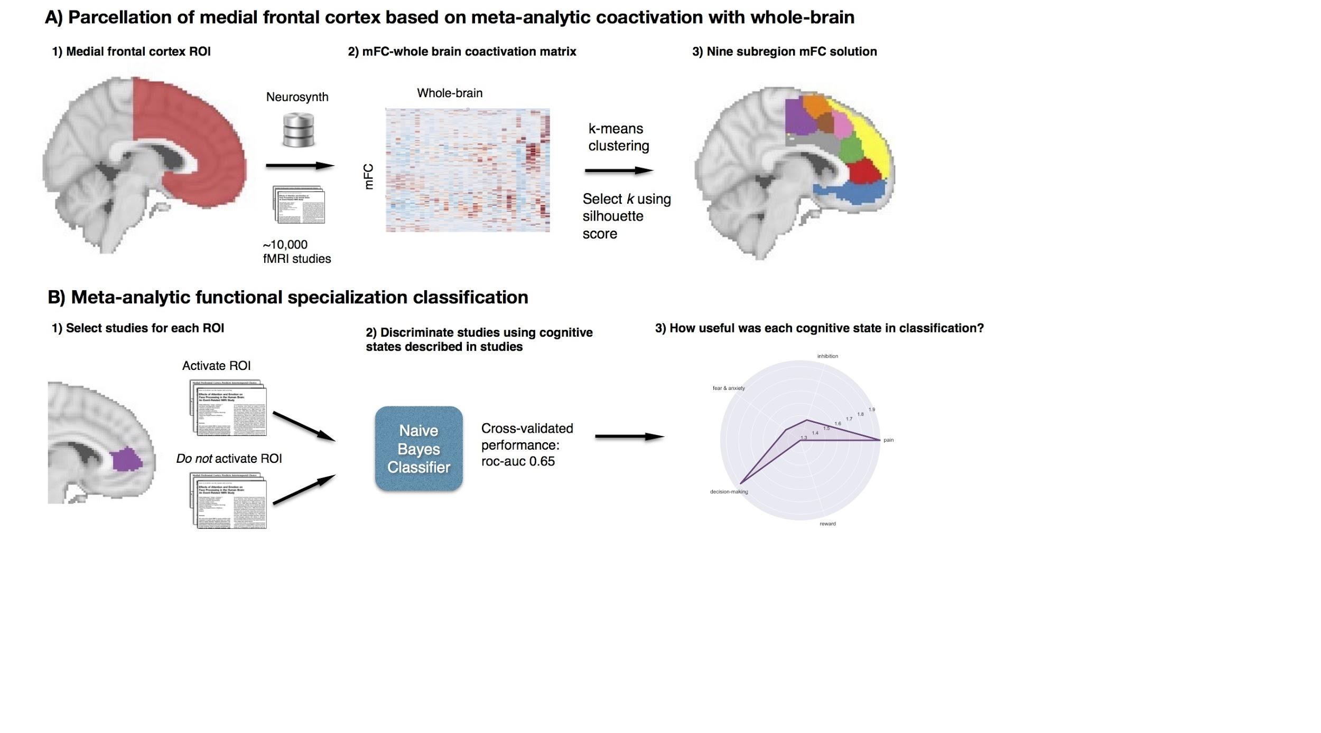

Figure . Methods overview. A) Co-activation with the rest of the brain for each voxel in medial frontal cortex ROI was calculated and used to create a distance matrix of MFC voxels; k-means clustering was applied to distance matrix resulting in spatially distinct clusters. B) We functionally characterized each cluster by determining which cognitive functions best differentiated studies that activated each cluster, from those that did not.

## Functionally separable components of medial frontal cortex

Our first goal was to identify functionally dissociable spatial regions in the human medial frontal cortex (Figure 1A). Our MFC region of interest (ROI) spanned the entire medial surface of frontal cortex bilaterally, including the entirety of the supplementary motor area (SMA), pre-SMA, anterior cingulate cortex, medial prefrontal cortex, and medial aspects of the frontopolar and orbitofrontal cortex. We identified putatively separable divisions of medial frontal cortex on the basis of shared co-activation profiles with the rest of the brain (Toro et al., 2008; Smith et al., 2010; Chang et al, 2013). This approach exploits the likelihood of a voxel co-activating with another voxel across studies in the meta-analytic database, analogous to the functional coupling of individual voxels across time in resting state functional connectivity MRI (rs-fMRI) analyses. Because structure-to-function mappings can be identified at multiple spatial scales, we iteratively extracted 2- through 15-cluster solutions. We asses the validity of these different solutions by calculating the silhouette score—a commonly use measure of inter-cluster coherence. Permutation analyses indicated that the null hypothesis of random clustering could be rejected for all solutions (p < .001), with silhouette scores reaching local maxima at 3 and 9 clusters; silhouette scores plateaued after 9 clusters, reaching an absolute maximum at 12 clusters (SI Figure 1). We focus here on the 3- and 9-cluster solutions, which provide insight into the functional topography of MFC at two different scales: broad functional zones and fine-grained regions. Figures for 6, 12, and 15 clusters are available in the supplemental material (SI Figure 2).



Figure . Co-activation-based k-means clustering of the medial frontal cortex at two levels of granularity. Voxels in the MFC were grouped together based on similarity of co-activation with all other voxels in the brain. A) At a coarse level, we identified three functional zones along a rostral-caudal axis. B) At a more fine-grained level, nine regions sub-regions were identified. SMA: supplementary motor area; SMAr: SMA rostral; SMAc: SMA caudal; pre-SMAc: caudal pre-SMA; pre-SMAr: rostral pre-SMA; dACC: dorsal anterior cingulate cortex; dACCc: dACC caudal; dACCr: dACC rostral; rACC: rostral anterior cingulate cortex; mPFC: medial prefrontal cortex; dmPFC: dorsal medial PFC; vmPFC: ventromedial PFC

At the coarsest level, medial frontal cortex divided into three broad bilateral zones (Figure 2A). Although the k-means clustering algorithm imposed no spatial constrains, we observed an orderly parcellation of MFC into three distinction zones along the rostral-caudal axis. We refer to these as the posterior, middle and anterior zones. The posterior zone encompassed regions which have been previous associated with sensorimotor function, such as the paracentral lobule, SMA, and dorsal posterior midcingulate cortex. The posterior and middle zones delineated from each other around 6 mm rostral to the vertical commissure anterior (VCA) line, consistent with definitions of pre-SMA (Picard and Strick, 1996; Rizzolatti, Fadiga, Matelli, Bettinardi, Paulesu, Perani, & Fazio, 1996; Kim et al., 2011). The middle zone also included much of dorsal anterior cingulate (dACC) running along the corpus callosum (Vogt et al., 2005). The anterior zone encompassed a large portion of medial prefrontal cortex, including rostral and subgenual aspects of anterior cingulate cortex, and medial aspects of orbitofrontal cortex and the frontal pole.

The nine-cluster solution revealed additional fine-grained topographical organization and qualitatively mapped onto the three functional zones (Figure 2B). Lying roughly within the posterior zone, we found two clusters consistent with cytoarchitectonic-based rostral and caudal subdivisions of SMA (Vorobiev & Luppino, 1998; Luppino, 1993). Within the middle functional zone, we found four subregions: two lying dorsal of the cingulate sulcus, and two lying neatly in the anterior cingulate cortex proper. We refer to the two dorsal clusters pre-SMA, caudal and rostral, as they are positioned at least 6mm rostral of the VCA line, consistent with cytoarchitechtonic definitions of pre-SMA (Picard and Strick, 1996; Rizzolatti, Fadiga, Matelli, Bettinardi, Paulesu, Perani, & Fazio, 1996; Kim et al., 2011). The two dorsal clusters were consistent with prior cytoarchitechtonic evidence suggesting that dorsal ACC (also known as midcingulate cortex) fractionates into caudal and rostral subdivisions and does not extend dorsally past the paracingulate sulcus (Vogt et al., 2005). The anterior functional zone fractionated into clusters encompassing rostral anterior cingulate cluster (rACC), and dorsal and ventral subdivisions of mPFC. rACC delineated from vmPFC in a manner consistent with cytoarchtechtonic parcellations (Vogt et al., 2015), although at this level of resolution subgenual ACC did not form its own cluster and instead was grouped with medial orbitofrontal cortex into a ventral mPFC (vmPFC) cluster (but see 12-region solution: SI Figure 1). Finally, dorsal mPFC (dmPFC) included medial aspects of the frontal pole and superior frontal gyrus. Thus, the boundaries of the clusters we identified using a strict functional co-activation based approach converged with many distinctions previously drawn on the basis of anatomical criteria.

Qualitatively, we observed that subregions in the nine-clustering solution mapped hierarchically onto the three functional zones. In particular, the two most posterior subregions, caudal and rostral SMA, overlapped with the posterior zone; pre-SMA and dACC subregions overlapped with the middle zone and rACC, vmPFC and dmPFC overlapped with the anterior functional zone. To test this assertion, we calculated the average percentage of voxels that overlapped between groups of regions in the nine-cluster solution and the three functional zones. On average, 84% of voxels within a functional zone overlapped with its corresponding subregions, while only 8% of voxels in a zone overlapped with other regions not hypothesized to map to a functional zone. Although we derived clustering solutions at different granularities independently using a non-hierarchical clustering algorithm, these results suggest that subregions within MFC are organized into three broad functional zones.

## Meta-analytic co-activation profiles

Thus far, we have demonstrated that MFC can be parcellated into robust and anatomically sensible subregions on the basis of meta-analytic co-activation. To better understand the nature of these divisions, we extracted brain-wide co-activation networks for each cluster, providing insight into which functional networks each of these subdivisions reliably participated in.

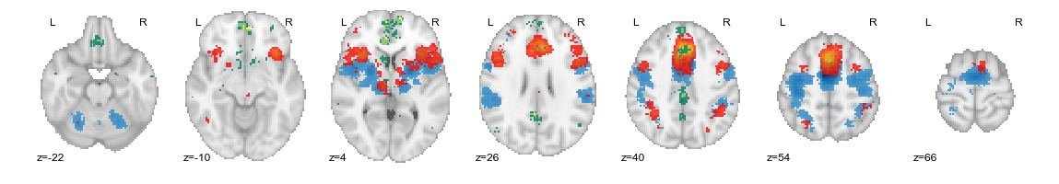

Figure . Whole-brain co-activation patterns for the three MFC functional zones. The posterior zone (blue) co-activated primarily with lateral motor cortices but also showed strong co-activation with posterior insula and operculum as well as the cerebellum; the middle zone (red) co-activated with the frontoparietal control network, including dorsolateral prefrontal cortex, superior parietal cortex, and dorsoanterior portions of the insula. The anterior zone (green) showed a distinct pattern, co-activating with regions in default network, such as posterior cingulate and temporal cortices. Images were whole-brain corrected using false detection rate (FDR) at p <0.01.

First, we mapped the whole-brain co-activation patterns for of the three functional zones and identified distinct patterns for each zone (Figure 3; *p* < 0.01, FDR whole-brain corrected). The posterior zone showed robust co-activation with lateral motor regions, lateral parietal cortex, the anterior lobe of the cerebellum, the thalamus and the basal ganglia, consistent with an important role in motor function. The posterior zone also co-activated with posterior insula, an important region for sensorimotor, somatosensory and pain processing (Chang et al., 2012). The co-activation pattern for the middle zone resembled an anteriorly shifted version of the posterior zone’s co-activation pattern, robustly co-activating with lateral prefrontal cortex, anterior aspects of the insula, more anterior aspects of the thalamus—regions known to be important for high-level cognitive processes, including cognitive control (Chang et al., 2012, cite, cite). The middle zone also showed co-activation with subcortical regions known to be important for reward processing such as the caudate and to some extent the nucleus accumbens. Moreover, the posterior and middle regions showed areas of overlap in lateral parietal cortex, lateral frontal cortex and the thalamus-- suggesting that these regions may not be entirely functionally distinct. Finally, the anterior functional zone showed a qualitatively different pattern of co-activation, suggesting this region is involved with a different class of cognitive processes as the former regions. The anterior zone primarily co-activate with in the default network hypothesized to support internal mentation, such as posterior cingulate cortex, precuneus, and the left hippocampus (Andrews-Hanna, 2012). The anterior zone also showed robust co-activation with subcortical regions, such as the amygdala and nucleus accumbens.

Next, to better understand the nature of functional co-activation within each functional zone, we calculated the co-activation between each sub-region and a set of 34 whole-brain ROIs derived using the same parcellation methodology that we previously applied to only the MFC. In Figure 4, we plot the strength of co-activation between each sub-region within a functional zone to the whole-brain ROIs that showed the strongest co-activation within a functional zone. Within the posterior zone, both sub-regions showed similar co-activation with key motor areas, such as the ventral motor strip and the putamen. However, caudal SMA showed greater co-activation with regions important for sensation and pain, such as the dorsal somatosensory cortex, SII, and the thalamus whereas rostral SMA showed greater co-activation with dorso-anterior insula, superior parietal cortex, and primary motor cortex-- regions thoughts to be important for motor function and attention (Corbetta, Shulman, Miezin, & Petersen, 1995; Posner, Walker, Friedrich, & Rafal, 1984), and goal-directed cognition (Chang et al., 2012; ).

Within the middle zone, we found that all four sub-regions strongly co-activated with dorso-anterior insula, consistent with previous studies suggesting the dorsal ACC and anterior insula are tightly coupled as part of the so-called “salience network”. However, there were subtle variations in co-activation that differentiated these sub-regions. The two more dorsal pre-SMA subregions co-activated more strongly with regions in the frontoparietal control network, such as the inferior frontal junction (IFJ) and the inferior parietal lobule (IPL). Rostral pre-SMA also co-activated strongly with left inferior frontal gyrus (IFG), suggesting this portion of pre-SMA is most critical for cognitive control processes. The two sub-regions in dorsal ACC—and in particular caudal dACC-- showed lower co-activation with regions in the frontoparietal control network. Caudal dACC showed the greatest co-activation with regions important for motor movement and pain sensation, such as the ventrolateral motor cortex (vMotor), SII and the thalamus, consistent with work highlighting the importance of this region--also known as the cingulate motor zone-- in precise movement {Picard:1996ea}{Paus:2001tx} and work implicating dACC in pain processing {Vogt:2005gm}{Wager:2013ff}. Rostral dACC, on the other hand, showed the greatest co-activation within the middle functional zone with lateral posterior OFC (lpOFC) and the nucleus accumbens (NAcc)—regions known to be important for decision-making and reward-driven learning {Day:2007fq}{Knutson:2001vi}{Ikemoto:1999eo}{Schoenbaum:2005dc}{Elliott:2000hj}. Rostral pre-SMA also showed robust co-activation with lpOFC, suggesting both of these sub-regions may be important for driving learning of behavior enacted by more posterior regions.

Figure . Co-activation of MFC sub-regions. Within each functional zone separately, we display the co-activation between each MFC sub-regions and the whole-brain ROIs with which they most strongly co-activate. Within each functional zone, each sub-region displays a distinct pattern of co-activation that also reflects the overall functional co-activation of its corresponding zone. Co-activation strengths were normalized within reach region (z-scored).

Within the anterior functional zone, we found that rACC and vmPFC showed similar patterns of co-activation while dmPFC showed a more distinct pattern. dmPFC showed strong co-activation with regions in the so called ‘mentalizing’ network known to be important for social processing , such as the tempo-parietal junction (TPJ) (Carter & Huettel, 2013) and the superior temporal sulcus (STS) (Zilbovicius et al., 2006). dmPFC also showed robust co-activation with left inferior frontal gyrus (IFG), a region important for language processing and inhibition. rACC and vmPFC, on the other hand showed a qualitatively different pattern with robust co-activation with dorso-anterior Insula—mirroring the pattern observed in the middle functional zone. Both of these regions also co-activated with lpOFC, consistent with their hypothesized role in valuation. All three regions in this zone showed strong co-activation with subcortical regions; in particular, all three regions co-activation to a similar extent with the amygdala. However, rACC showed the greatest co-activation with the thalamus while vmPFC showed the strongest co-activation in all MFC with NAcc. The strong co-activation of these sub-regions with a variety of subcortical sites, is consistent with the hypothesis that medial PFC is generally important for the contextualization of lower-level affective signals (Roy, Shohamy, & Wager, 2012). As a whole, these functional co-activation patterns suggest the three broad functional zones in MFC are likely to exhibit substantial functional differences whereas sub-regions within each zone are likely to show more fine-grained differences in functional specialization.

## Meta-analytic functional specialization

Next, we sought to determine if the putatively functionally separable MFC regions we identified using co-activation data exhibited differences across the wide-variety of cognitive states represented in the Neurosynth database. In contrast to traditional meta-analyses that investigate the whole-brain neural correlates of theoretically motivated cognitive functions selected *a priori* (e.g. pain and cognitive control in dorsal ACC), we used a data-driven approach that surveyed a broad range of cognitive states and identified those most strongly predictive of MFC cluster activity. We used a set of 34 cognitive concepts derived by applying a standard topic modeling approach to the text of articles in the database (Poldrack et al., 2012), allowing us to also sidestep the difficult problem of manually defining a cognitive ontology and ensuring our analysis was as data-driven as possible (See Supplemental Table 1 for full list of derived topics).

A major strength of our meta-analytic approach is that it allowed us to quantify the relative specificity of brain-cognition associations. A trenchant problem for both individual fMRI studies and conventional meta-analyses is that they typically estimate the probability of observing brain activity conditional on a given mental state, rather than the probability of a mental state conditional on observed brain activity (Poldrack, 2006). To demonstrate the insidious nature of this *reverse inference* problem in the present context, we recreated, using Neurosynth, a meta-analysis conducted by Shackman et al., (2011) that reported a high degree of overlap between negative affect, pain and cognitive control in regions of the dACC. First, we performed a ‘forward inference’ analysis that identified all voxels consistently activated in studies involving negative affect, pain or conflict (Figure 5a); this analysis is akin to performing a standard fMRI meta-analysis, in which one selects studies purporting to engage these processes. Similar to Shackman et al., (2011), we found a marked overlap between pain, conflict and affect in dACC. Strikingly, however, we also obtained nearly identical results when assessing the overlap between three cognitive functions that are not typically associated with dACC activity: social cognition, vision and memory retrieval (Figure 5b). In contrast, when we conducted a ‘reverse inference’ analysis -- which displays voxels that predict a high probability of the presence of each of these cognitive functions given their activation-- we found unique spatial patterns for negative affect, pain and cognitive control (Figure 5c; cf. Yarkoni et al, 2011). The limited degree of overlap observed in the latter analysis suggests that the putative role of dACC in affect, pain, and cognitive control likely derives from a more general function, whereas other subregions of MFC may subserve more domain-specific roles in cognition.

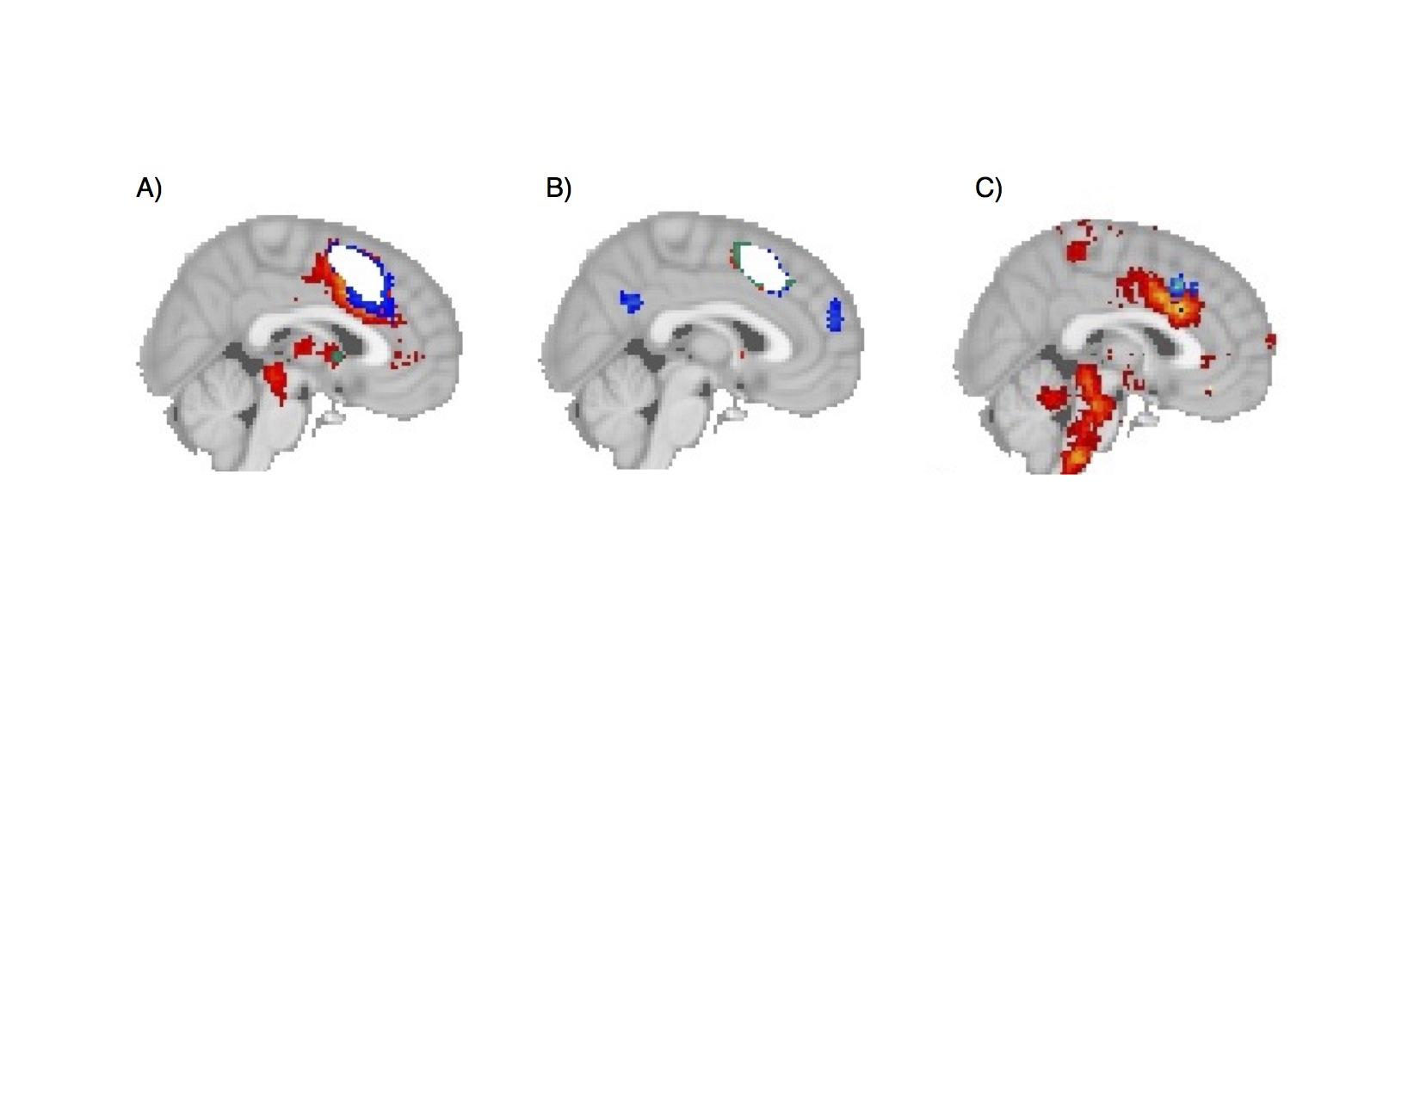

**Figure 5**. *.* Reverse-inference is necessary to determine neural correlates of cognitive functions. A) Forward inference of pain (red), cognitive control (blue) and emotion (yellow), showing overlap in in white. B) Forward inference of social cognition (blue), vision (red) and memory retrieval (red) also showing overlap in white. C) Reverse inference map of pain (red), cognitive control (blue) and emotion (yellow) shows distinct neural correlates of these domains, with no overlap between these three cognitive states in dACC.

To characterize the functional specialization of different MFC clusters, we used a machine learning classifier to identify the cognitive states that best predicted the activation of each individual cluster. For each cluster individually, we selected two sets of studies: studies that activated the cluster and studies that did not; we then trained a naïve Bayes classifier to differentiate the two sets of studies on the basis of the cognitive concepts discussed within each study. From the resulting fitted models, we extracted the log-odds ratio of each cognitive concept given activation of that cluster, revealing the cognitive concepts that best predicted activity for each individual MFC region.

Across the three coarse functional zones we identified in MFC, we observed distinct patterns of functional specialization, consistent with their divergent patterns of functional co-activation (Figure 6A). The posterior zone was strongly and primarily involved with motor function, including gaze and eye movements, consistent with its robust co-activation with primary motor cortex. However, activation this region was also predicted by pain processing and cognitive control processes, suggesting this region is not entirely focus on motoric function. The middle zone showed a distinct shift away from motor function. This zone was primarily associated with various facets of cognitive control (e.g. conflict, working memory, inhibition), but was also predicted by affective processes such as pain, reward and decision-making. Overall, the middle zone seemed to be involved with a wide range of cognitive concepts. The anterior functional zone showed a distinct shift away from externally oriented processes such as motor function and cognitive control and was strongly associated with affective processes, such as reward and decision-making, as well as social processing. This qualitative difference in functional specialization is consistent with the distinct pattern of functional co-activation we observed for the anterior zone in our previous analysis.



**Figure 6**. Functional specialization profile of each of the MFC clusters. Each cluster was individually profiled to determine which cognitive functions that best predicted its activation. Top) Each of the three functional zones we identified showed distinct functional profiles with broad shifts across cognitive domains Bottom three) Within each zone, each sub-region showed fine grained shifts in functional specialization. Strength of association of each cognitive concept with each region is measures in log-odds ratio. In each subplot, we selected relevant cognitive concepts to display by selecting the three most predictive topics for each individual region, and display the total set of topics for that group of regions. Due to overlap between some similar regions, the number of topics displayed varies in each subplot.

Next, we investigated the functional specialization of within each of these functional zones at a more fine-grained level of analysis by profiling the functional specialization of each of nine subregions we identified and comparing the functional specialization of sub-regions within a functional zone (Figure 6). Overall, subregions within each cluster showed similar profiles to each other, with subtle yet important distinctions in their functional specialization. Both subregions in the posterior zone were similarly involved in motor function, but caudal SMA was more strongly associated with pain, while rostral SMA showed some associations with language.

All four subregions of middle functional zone we identified were involved with cognitive control to varying extents, although on average, pre-SMA was more strongly associated with cognitive control. Working memory in particular was strongly associated with pre-SMA--peaking in caudal pre-SMA-- while switching and conflict were more evenly associated with all four subregions in this zone. The sole exception was inhibition, which was more strongly associated with dACC than pre-SMA. Both dACC clusters were further characterized by a strong association with negative affect. In particular, pain and fear were very strongly associated with caudal aspects of dACC; unlike cognitive control, negative affect was fairly specifically associated with dACC and showed very weak associations with pre-SMA. We also found some rostro-caudal functional distinctions in this zone. Only caudal pre-SMA and dACC showed associations with motor function, while the two rostral clusters showed virtually no association. In contrast, rostral pre-SMA and dACC were more involved with decision-making and learning related processes. Finally, all four clusters were also associated with memory encoding and retrieval processes, although this association peaked in rostral pre-SMA.

Regions within the anterior functional zone showed a distinct shift away from externally oriented processes, such as cognitive control, motor function and pain, and towards internal, self-oriented processes, such as decision-making, social processing, and episodic memory, and emotion. Again, the three subregions of this zone showed rather similar functional specialization patterns; in particular all three regions were similarly involved in emotion and episodic-memory processes. However, dmPFC was much more strongly associated with social cognition then rACC and even more so than vmPFC. We observed a reverse pattern for reward and decision-making, as these processes were more strongly associated with vmPFC, and least associated with dmPFC. Finally, memory encoding and retrieval was associated with dmPFC, although not as strongly as the association we found in rostral pre-SMA.

### Functional complexity

Thus far, we have functionally characterized MFC subregions by determine which cognitive concepts are most predictive. That is, given a region’s functional profile, how accurately can we predict if a study will activate that region, and how much information do we need in order to make an accurate prediction? To do so, we trained naive Bayesian classifiers for each region to discriminate studies that activated a region from studies that did not. In order to determine how many psychological topics were necessary to accurately predict activation of each region, we began by training the classifier using only a single cognitive function, and progressively added functions in order to observe how much the accuracy would increase as a function of the complexity of our predictive model (Figure 7A). Not surprisingly, activation of all regions was better predicted as the number of cognitive functions in the model increased, reaching peak performance on average with 27 functions (receiver operating characteristic area under the curve (ROC-AUC) of 0.612). Eventually, accuracy decreased when too many uninformative features were added to the model.

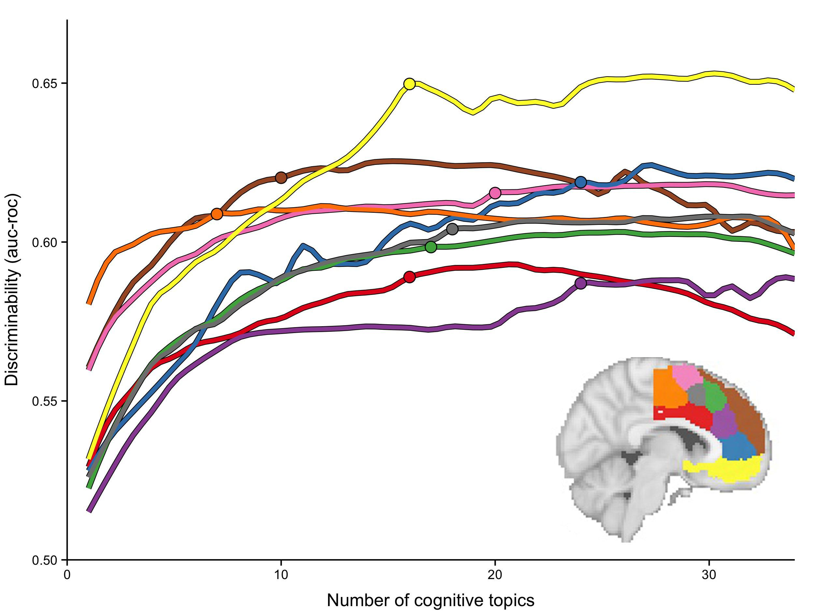

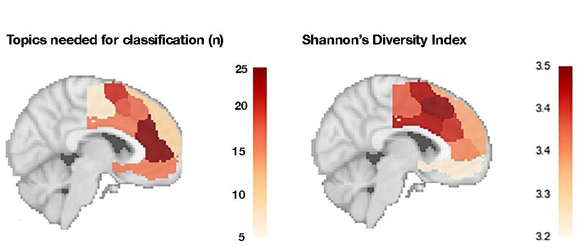

*Figure 7. Regions of MFC varied widely in functional complexity. (Top) As the number of cognitive functions in the model were increased (x-axis) the amount of variance in activity that could be explained (y-axis) also increased for all regions. However, regions varied in the number of topics required to reach maximum discriminability. The circles on each line represent……(Bottom Left) Number of topics to reach near-maximum discriminability plotted on a sagittal brain slice for each region. (Bottom Right) Shannon's’ diversity index was applied to each region's functional profiles as a comparison, resulting in a different approximation of functional complexity.*

However, MFC regions varied in two key aspects of these metrics: maximum discriminabilityr, and the number of topics required to reach this maximum. The maximum discriminability reflects how well overall a region’s function is explained by the cognitive ontology we employed, while the number of topics required to reach this maximum reflects the complexity of function observed in each region. Regions in pre-SMA and in particular dACC reached generally lower discriminability, perhaps indicating that the current cognitive ontology does not accurately describe their function. Caudal SMA also failed to reach very high level of discriminability, perhaps because motoric function is inherent to many tasks, yet often not discussed as a key aspect of the task. Conversely, regions in mPFC, and in particular vmPFC, reached greater level of discriminability, suggesting that our cognitive ontology better explains the functions supported by each of these regions.

Regions in MFC varied greatly in the number of topics required to reach the maximum discriminability level, a property we termed ‘functional complexity’ (Figure 7B). Caudal SMA required the fewest number of topics to reach its modest maximum discriminability level; in fact, we are able to discriminate activity in SMAc well above chance using only a single topic: motor function. At the other end of the spectrum, rACC and rostral dACC required a greater number of topics to reach maximum discriminability, suggesting a complex model of cognitive function is required to accurately predict if these two regions are likely activeto be activated in any given study.

Next, we compared our results to a measure of functional diversity previously applied to meta-analytic functional profiles, Shannon’s Diversity Index (SDI) (Anderson et al., 20xx). We applied SDI to our functional specialization profiles and found that pre-SMA showed the greatest diversity, while vmPFC showed low diversity, consistent with previous findings (Anderson et al., 20xx). SDI differed from functional complexity dramatically across many regions. All clusters in mPFC, including rACC and dmPFC, showed low diversity indexes; however, rACC was found to have the greatest amount of functional complexity in our previous analysis. Caudal SMA also showed surprisingly high SDI, despite only requiring very few cognitive functions to predict its activity. Finally, caudal dACC showed very high SDI, although we were able to predict its activity with relatively few cognitive functions.

# Discussion

In the current study, we identified and functionally characterized separable regions of the medial frontal cortex by applying a data-driven approach to a large-scale database of ~10,000 fMRI studies. On the basis of meta-analytic co-activation with the rest of the brain, we identified three distinct functional zones along a rostra-caudal axis. We discovered that MFC further fractionated into nine subregions which spatially corresponded with the three zones and were anatomically consistent with cytoarchitectonic studies (Vogt et al., 2005; etc). Next, we used machine-learning classification to identify the cognitive concepts which best predicted activation for each of these MFC parcels, revealing broad distinctions in function across the three functional zones and finer-grained shifts in specialization between sub-regions within each zone. Finally, we quantified the heterogeneity of function found in each of these regions, and found wide variability in this measure of functional complexity. Below, we discuss the results for each functional zone separately, and conclude with limitations and future directions of large-scale meta-analysis.

***Posterior functional zone***

The posterior functional zone of MFC was robustly associated with the relatively specific role of motor function. This posterior zone spanned portions of MFC previously associated with motoric function, such as SMA, and delineated from more anterior regions thought to support more high-level cognitive processes, such as pre-SMA, in a manner consistent with cytoarchitechtonic (Vogt et al., 2005, Vorobiev et al., 1998; Luppino, 1993), tractography (Klein et al.) and resting-state functional connectivity (Kim et et al.,). The whole-brain co-activation of this zone supported a strong role in motoric function, primarily co-activating with lateral motor cortices and sub-cortical regions such as the thalamus. The functional characterization of this zone was consistent with this co-activation pattern as activation in this zone was primarily predicted by general motor function and eye gaze, and to a lesser extent pain processing.

Posterior MFC further fractionated into a caudal and rostral subdivisions consistent with cytoarchtechtonic evidence suggesting SMA is composed of at least two functionally separable regions (Vorobiev et al., 1998; Luppino, 1993). While a strong association with motoric function primarily characterized both sub-regions, our results suggest that caudal SMA is also involved in pain processing while rostral SMA is more involved with goal-directed cognition and inhibitory processes. In particular, caudal SMA showed stronger co-activation with the thalamus, SII and dorsal somatosensory cortex—regions previously identified to be important for pain (cite). Consistent with this pattern, activity in caudal SMA was also predicted by pain processing. Importantly, caudal SMA showed relatively low functional complexity, suggesting this region is fairly specifically involved with motor and pain processing. Given that pain signals often indicate that motor action must be taken to avoid inflicting damage to an organism, this region may be particularly important for taking quick action in response to harmful, painful stimuli.

In contrast, our results suggested rostral SMA is likely to be important for goal-directed motor function. Rostral SMA co-activated with dorsal motor cortex and daInsula—a region hypothesized to be important for effortful, controlled action (Peterson cites). In addition, SMA was associated with eye gaze function and several aspects of cognitive control, most notably inhibition. Moreover, rostral SMA showed greater functional complexity, suggesting this region is involved with a wider variety of functions in addition to it’s core function of motor action. These results are consistent with long-standing notion that the supplementary eye fields (SEF), which are located within our rostral SMA parcel, are important for high-level control of eye movements, in tasks such as anti-saccade {Corbetta:1998kg}{Everling:2000wj}. Thus, while rostral SMA is unlikely to be involved in the resolution of cognitive control processes, the known direct corticospinal connections possessed by this region suggest it is well situated to send direct inhibitory motor signals.

***Middle functional zone***

The middle functional zone of MFC—encompassing pre-SMA and dACC—was characterized by its involvement with a variety of cognitive control processes as well affective processes. At a coarse scale, these findings seem consistent with recent hypotheses suggesting that “dorsal ACC” is important for the integration of negative affect into cognitive control processes (Shackman et al., 2011). However, upon closer inspection, our results suggests that there is substantial functional-anatomical specificity that has thus far been underappreciated due to this region’s very high activation rate (Yarkoni et al., 2011). These distinctions are only appreciable when this broad zone is divided into smaller functional regions and analytical methods that appropriately control for base rate of activation are used to characterize their functions.

In particular, we identified four sub-regions with dissociable patterns of co-activation within the middle MFC zone: caudal and rostral pre-SMA and caudal and rostral dACC. These subdivisions are consistent with extensive cytoarchitectonic work in monkeys and humans (Vogt et al., 2005) indicating that caudal dACC and rostral dACC (also known as anterior and posterior midcingulate cortex) show distinct cellular organization and demarcate from pre-SMA along the cingulate sulcus. Our functional specialization analysis indicates that although all four regions co-activate with regions important for goal-driven cognition, such as daInsula, the two pre-SMA subregions show much stronger associations with most aspects cognitive control-- in particular working memory and conflict. These functional differences are supported by the fact that both pre-SMA clusters showed greater co-activation with regions in the frontoparietal control network (e.g. IFG, IFJ, and IPL). In contrast, activity in the dACC clusters is much more strongly associated with affective processes-- such as fear, reward and pain.

The present results suggest that existing accounts of integration between negative affect and cognitive control in MFC have been overstated. We tested this explicitly by recreating Shackman et al., 2011’s meta-analysis of negative pain, reward, and conflict in Neurosynth using a “reverse-inference” analysis that controlled for differences in activation rate across the brain, revealing almost no overlap between these three processes in MFC (Figure 5c). Our results highlight the need to properly control for base-rate activation differences, especially in high-base rate regions such as pre-SMA and dACC. Moreover, our results suggest a division of labor between dorsal ACC proper—lying ventral to the cingulate sulcus—and pre-SMA. dACC, with its stronger subcortical co-activation patterns, is likely the entry point of affective signals into MFC, whereas pre-SMA is more important for integrating this information into higher-level goals and action plans.

The dissociation between pre-SMA and dACC found in our data suggests that existing models of cognitive control underspecify the functional topography this middle zone of MFC and may misattribute functions to dACC, when in fact they are likely supported by pre-SMA proper. Some influential theories of cognitive motoric control consider dACC to be the region primarily responsible for conflict processing (Botvnick et al., 2001, 2004){Carter:1998fs}. However, concerns have previously been raised that macaques primarily show conflict related activity in pre-SMA and not dACC, unlike humans (Nakamura, Roesch & Olson, 2005; Rushworth, Walton, Kennerley, Bannerman et al., 2004; Cole, Yeung, Freiwald, & Botvinick, 2009). Our results suggest that human conflict-related activity is also most associated pre-SMA proper, not dACC. In particular, rostral pre-SMA was most strongly associated with the cognitive concepts of “conflict” and “errors” and strongly co-activated with regions in the fronto-parietal control network. In contrast, caudal pre-SMA was more strongly associated with working memory, suggesting that different aspects of pre-SMA are more important for different aspects of cognitive control.

Finally, we also found evidence that the two sub-regions of dACC proper specialized in different types of affective processes. Caudal dACC was much more strong associated with pain than any other regions, consistent with its strong co-activated with the thalamus—an important region in pain perception (Aziz et al., 2006; Wager et al., 2013). In contrast, rostral dACC was more strongly associated with decision-making and reward, consistent with its stronger co-activation with the nucleus accumbens and lpOFC—regions important for reward processing {Day:2007fq}{Knutson:2001vi}{Ikemoto:1999eo}{Schoenbaum:2005dc}{Elliott:2000hj}. Interestingly, rostral pre-SMA was also associated with decision-making and co-activated with lpOFC, consistent with theories suggesting that conflict is better described as the process of learning how to avoid future negative outcomes. Our results suggest that rostral pre-SMA and dACC are more important for interacting with other brain-system important for learning, whereas caudal pre-SMA and dACC may be more important for integrating negative affective signals into conflict processing.

**Anterior functional zone**

Finally, at the most anterior portions of MFC, we identified a functional zone composed of three subregions: vmPFC, rACC and dmPFC. This zone showed a fairly distinct pattern of functional specialization, showing very low associations with motor and executive functions and strong associations with affective processes, decision-making, and social cognition. This distinct pattern of functional was accompanied by a distinct pattern of whole-brain co-activation, primarily co-activating with regions of the default network, such as posterior cingulate, the precuneus, the hippocampus and sub-cortical regions such as the amygdala and nucleus accumbens. These results are consistent with extensive evidence suggesting medial prefrontal cortex is a key region in the ‘default network’ {AndrewsHanna:2012jc} that is relatively removed from the processing of external stimuli and actions.

The Anterior MFC broke down further into three subregions: a dorsal parcel (dmPFC), a middle cluster primarily situated in rostral anterior cingulate cortex (rACC), and a ventral cluster (vmPFC) encompassing medial OFC and subgenual ACC. The three regions were similarly associated with both emotion and episodic memory, suggesting these two processes rely on the entire medial prefrontal cortex. However, dmPFC was much more strongly associated with social processing, consistent with several studies linking dmPFC to social perception and self-referential thought {Mitchell:2006ce}{Iacoboni:2004eq}. Moreover, dmPFC showed strong co-activation with TPJ, a region thought to also be important for mentalizing {Baumgartner:2012ip}{Denny:2012hc}. Importantly, dmPFC showed no association with reward processing, suggesting that higher-level mentalizing processes occur separately from low-level affective processing.

Ventral to dmPFC, rACC showed a less specific functional pattern, showing moderating associations with a variety of process, including low-level affective processes such as fear, reward and emotion as well as higher-level processes such as decision-making, episodic memory. This was consistent with the high functional complexity we observed in this region—a model with many cognitive concepts we required to accurately predict activity in this region. These findings are consistent with descriptions of the existence of a default network ‘hub’ region in mPFC {vandenHeuvel:2013ge}{AndrewsHanna:2010gl}. As a hub of the default network, rACC is likely to be involved in many of the processes supported by this network, but not be specialized in any given process.

Finally our results suggest that vmPFC, the most ventral region in MFC, is primarily associated processes directly related to affective signals. Activity in vmPFC was very strongly predicted by affective processes, such as reward and fear. This function is consistent with its strong co-activation with subcortical regions known to be important for these processes, such as the nucleus accumbens {Knutson:2001vi} and amygdala {FANSELOW:2003ib}{Phillips:1992ji} , respectively. However, vmPFC was also associated with higher-level cognitive processes that are known to depend on these affective signals, such as decision-making {Salamone:2006il}{Matthews:2004vv} and memory {Hamann:1999ui}{Agren:2012vn}. Importantly, although some have characterized vmPFC as being a ‘valuation’ system {Lebreton:2009gn}, these results suggest that this region is equally important for processes more closely related with the amygdala and related negative emotions. Our results suggest that vmPFC may more generally be involved in the integration of various affective signals into cortex, while more dorsal regions, such as rACC may be important for integrating or contextualizing these signals into higher-level processes {Roy:2012fd}.

***Limitations***

While our large-scale meta-analytic approach allowed us to comprehensively synthesize a plethora of fMRI findings, there are several limitations. First, the cognitive ontology we employ is data-derived from the semantic content of papers, and thus is not driven by theoretical models that may be critical in discriminating the activity of certain regions. Although this topic based ontology provides a substantial improvement over term based meta-analysis {Poldrack:2012ew}, these topics are still based purely on the frequency that terms appear in the body of fMRI studies and are not able to capture more complex syntactic structures such as sentences which may denote more fine-grained differences in function. Nonetheless, topic-modeling based ontologies are surprisingly consistent with neuroscientific knowledge suggesting that the current approach provides a useful, if coarse, functional-anatomical mapping. Second, the quality of activation data in Neurosynth is inherently limited due to its automatically generated nature. The automated coordinate parser is unable to differentiate between MNI and Talarach coordinates, and thus collapses over them. Moreover, the parser does not distinguish between activations and deactivations nor does it distinguish different tables within an article that may report different contrasts. However, previous validation analyses have shown that these limitations are unlikely to contribute systematic biases to the data and instead primarily reduce the overall spatial fidelity of the database (Yarkoni et al., 2011). Thus, the large nature of the current meta-analysis (N= 9,721) help ameliorate the additional noise introduced by this approach. Future application of more sophisticated data-mining techniques on both the activation estimates and semantic information may further improve this situation.

Moreover, as with any meta-analysis of fMRI data, our approach is limited by the low spatial resolution of fMRI and the inability to disentangle individual differences in anatomy across subjects. In particular, it is difficult to precisely localize each of our clusters onto gyri and sulci; this is particularly problematic in dorsal ACC, where BA 32’ lies only a few millimeters dorsal of BA 24, and shows particularly large anatomical variation across humans {Paus:2001txa}{Cole:2009eo}. While only advances in radiology will improve the spatial resolution of fMRI, the open sharing of full fMRI data may improve this situation by enabling research to perform large-scale meta-analysis with higher quality data, including perhaps individualize registration to anatomy on a subject-by-subject basis. The benfit of open data sharing will be compounded if these datasets are accompanied by high-quality ontological metadata (e.g. expert knowledge) that is otherwise difficult to ascertain. We suggest that the functional-anatomical mappings and modest classification performance we are able to achieve with this relatively noisy data suggest that applying similar data-driven methods to higher quality data will result in precise estimates of functional specialization in the future.

# Conclusion

In the present study, we used meta-analytic co-activation to identify three broad functional zones along a rostro-caudal axis in MFC that functionally mapped on to distinct cognitive domains. The most posterior zone is distinctly involved motor function, the middle zone is important for both negative affect and cognitive control processes while anterior MFC likely integrates affective signals into higher-level internally oriented processes. Within each of these zones, we identified component sub-regions with distinct patterns of whole-brain co-activation and discovered appreciable amount of fine-grained functional specialization. Our analyses suggest that integrative accounts of MFC function may be overstated and result from not controlling for variation in activation base rate across the brain.

## Methods

### Neuroimaging Database

We analyzed the Neurosynth database (neurosynth.org; Yarkoni et al., 2011), a repository of 9,721 fMRI studies and over 350,000 activations. Each observation in the database contains the peak activations for all contrasts reported in a study’s table as well as the frequency of all of the words in the article abstract. Activations were smoothed using a 6mm Gaussian kernel.

### Medial frontal cortex coactivation clustering

To find separable regions in medial frontal cortex, we clustered individual voxels inside of a medial frontal cortex mask based on their coactivation with voxels in the rest of the brain. First, we defined a medial frontal cortex volume of interest mask in standard Montreal Neurological Institute (MNI) to select the appropriate voxels. We used FSLView to create a mask of voxels with greater than 30% probability of being grey matter according to the Harvard-Oxford anatomical atlas. Next, we excluded all voxels that were more than 10mm from the midline of the brain in the X dimension, as a way to exclude grey matter voxels on the lateral surface of the brain. We also excluded voxels that were posterior to central sulcus (Y < -22) and voxels that were ventral to vmPFC (Z < -32), such as temporal cortices, resulting in a somewhat liberal mask of medial frontal cortex. Next, we took this somewhat liberal mask and excluded voxels that showed very low activation in the database (less than 80 studies per voxel).

Next, we calculated the correlation between each medial frontal cortex voxel with the rest of the brain across studies. As this would result in a very large matrix which would be computationally difficult to cluster, we first reduced the dimensionality of the rest of the brain using principal components analysis. We applied principal component analysis using randomized singular value decomposition to the matrix containing activation of every voxel in the brain across all studies (228453 voxels x 9721 studies) to reduce it to 100 components (100 voxels x 9721 studies). Then, for each voxel in the MFC mask, we computed the correlation distance of every voxel in MFC with each PCA component defined as 1 - \frac{(u - \bar{u}) \cdot (v - \bar{v})}         {{||(u - \bar{u})||}_2 {||(v - \bar{v})||}_2}, where *u* is a MFC voxels and *v* is a whole-brain PCA component, resulting in a MFC distance matrix.

We used k-means clustering to group MFC voxels, as this algorithm is computationally efficient, commonly used, and shows high goodness of fit and reproducibility (Thirion, Varoquaux, Dohmatob, & Poline, 2014). We then used scit-kit learn’s implementation of k-means clustering to the MFC distance matrix using the k-means++ initialization procedure. The k-means algorithm was run 10 times on different centroid seeds and the best output of these consecutive runs was selected in terms of inertia to avoid local minima.

Because structure-to-function mappings can be identified at multiple scales, with potentially different (but equally valid) results, we conducted our analyses at multiple levels of spatial resolution. We parcellated the MFC into 2 through 15 regions. Identifying the ‘correct’ number of clusters is arguably an intractable problem, since the optimality of a given clustering depends in large part on investigators’ goals, the preferred level of analysis, and the nature and dimensionality of the available data (for discussion, see Poldrack and Yarkoni, in press). However, in the interest of pragmatism, we attempted to objectively select the number of clusters using the silhouette score, a measure of within-cluster cohesion. Solutions that minimized the average distance between voxels within each cluster received a greater score. The silhouette coefficient was defined as (b - a) / max(a, b), where a is the mean intra-cluster distance and b is the distance between a sample and the nearest cluster that the sample is not a part of. Higher scores indicate tighter clustering of the data.

However, because it is unclear what should be considered a significant silhouette score, we used a permutation procedure previously employed by our group (cite TOR) to infer if a given clustering solution was warranted. For each possible solution between 2 and 15 clusters, we permuted the columns of the whole-brain x studies matrix as well as the MFC VOI voxels x studies matrix. We then re-applied the clustering algorithm, and re-calculated the silhouette score. This was repeated **XX** times for each number of clusters, resulting in a null-hypothesis distribution of silhouette scores for each *k*. Estimating the null distribution of silhouette scores allowed us to calculate a Z-score for the silhouette score based on our observed data clustering solutions. Figure S1 shows the silhouette score for each clustering solution and below it the silhouette scores of the null-distribution. All clustering solutions were very significant (all z-scores were greater than XX), and the null-distribution stayed relatively stationary as the number of clusters increased.

Given the high statistical significance of all clustering solutions, we qualitatively assessed the silhouette scores of our real clustering solutions. Silhouette scores reached a local maxima with three clusters, suggesting that this simple organizational scheme explained a surprisingly high amount of the data. Silhouette scores then dipped and reached another local maxima using nine clusters. Beyond nine clusters, silhouette scores marginally increased, but in our estimation not sufficiently so to warrant the increase in complexity in the clustering solutions. Thus, we selected three and nine regions as the most useful clustering solutions, but note that solutions with 12 and 14 regions also showed high silhouette scores, and sensible solutions, thus we include them as a supplement (Figure SII).

### Coactivation profiles of MFC clusters

To calculate coactivation profiles of each cluster, we performed a whole-brain meta-analysis of studies that activated each MFC parcel. This analysis resulted in a whole-brain map indicated the extent to which voxels activated in the studies that activated each MFC parcel. We selected studies that activated at least 25% of voxels in a given parcel and then performed a forward-inference meta-analysis. See the section below on meta-analysis for more details on the procedure.

For the three-cluster solution, we visualized whole-brain coactivation across the brain using axial slices. To reduce the complexity of this map, we thresholded the coactivation maps using the false discovery rate. For the nine-cluster solution, it was challenging to visualize many clusters across the entire brain. Instead, we employed a ROI based approach, in which we calculated the mean coactivation for ROIs across the brain with each MFC parcel, and visually represented the coactivation in a heat map (Figure 4). First, we generated 40 whole-brain ROIs the same k-means clustering approach outlined above applied to a whole-brain MNI mask; 40 regions were used because they struck a balance between anatomical specificity and interpretability, approximating the number of regions in Brodmann’s classic anatomical divisions. MFC clusters were removed from the whole brain ROIs, so as to examine connectivity of the MFC specifically with the rest of the brain. This process resulted in 34 regions, and the mean coactivation between MFC regions and each ROI was calculated by masking the whole-brain coactivation matrix we calculated above.

### Topic modeling

Although the term-based meta-analysis maps in Neurosynth closely resemble the results of manual meta-analyses of the same concepts (e.g. Yarkoni et al., 2011; Bartra, McGuire & Kable 2013), there is a high degree of redundancy between terms (e.g. ‘episodes’ and ‘episodic’) and potential ambiguity as to the meaning of an individual word out of context (e.g. ‘memory’ can indicate working memory or episodic memory). To remedy this dilemma, we employed a reduced semantic representation of the latent conceptual structure underlying the neuroimaging literature: a set of 60 topics derived using latent dirichlet allocation topic-modeling. This procedure was identical to that used in a previous paper (Poldrack, Mumford, Schonberg, Kalar, Barman, & Yarkoni, 2012), except for the use of a smaller number of topics and a much larger version of the Neurosynth database. The generative topic model derives 60 independent topics from the co-occurrence across studies of all words occurring in the abstracts of studies in the Neurosynth database. Each resulting topic loads onto individual words to a varying extent, facilitating the interpretation of topics; for example, a working memory topic loads highest on the words 'memory, WM, load', while an episodic memory topic loads on 'memory, retrieval, events'. Note that both topics highly load on the word “memory”, but the meaning of this word is disambiguated because it is contextualized by other words that strongly load onto that topic. Likewise, as each topic maps onto individual studies to a varying extent, the topic model facilitates the categorization of the cognitive phenomena studied across fMRI studies; for example, a study that maps highly onto a topic described by the words 'control, inhibition, conflict’ is likely to be examining cognitive control. Out of the 60 generated topics, 25 represented non-cognitive semantic topics, such as the nature of the subject population (e.g. gender, special populations) and methods (e.g., words such as “images”, “voxels”. In order to focus on the cognitive predictors of brain activity, we identified these topics and excluded them from all analyses (see Appendix for a list of included and excluded topics).

### Reverse and forward inference meta-analysis

To demonstrate the importance of appropriately controlling for variation in activation specificity, we conducted topic-based meta-analyses using forward and reverse inference. To perform a reverse inference.

### Meta-analytic functional specialization

For each cluster, we built a linear model to predict whether activity in that region would be reported by an fMRI study based on the semantic content of the words used to describe the focus of that fMRI study. This procedure allowed us to generate functional profiles that describe which cognitive functions best predicted the activity of each region, and how well fMRI activity can be explained by the cognitive ontology present in the body of fMRI studies at the meta-analytic level. Below, we describe each step of our approach.

*Predictive modeling of activity using cognitive functions.* We generated functional profiles of MFC regions by determining which cognitive functions best predicted each MFC region’s activity across fMRI studies. First, we selected two sets of studies: studies that activated a given parcel--defined as activating at least 5% of voxels in the parcel-- and studies that did not--defined as activating absolutely no voxels in the parcel. For each parcel, we trained a naive Bayes classifier to discriminate these two sets of studies based on the semantic content of the studies herein. We chose naive Bayes because we have previously had success applying this algorithm to Neurosynth data in the past (Yarkoni et al., 2011), and has been shown to perform well on many types of data (cite cite). In addition, naive Bayes classifiers require almost no tuning of parameters to achieve a high level of performance, decreasing the likelihood of an overfit of the model to the data.

We assessed our models’ ability to predict if an unseen study activated a region, given the content of the study. In other words, if we know what cognitive topic a study is about, how well can we predict if it activates a specific region? We employed 4-fold cross validation to test the generalization of our models. Models were fitted on 3/4ths of studies and tested on the remaining studies. This procedure was repeated four times, circulating over the studies so that the model was trained and tested on the entire dataset. The mean score across the 4-fold tests were used as the final measure of performance. We scored the models by calculating the area under the receiver operating characteristic, (AUC-ROC) a summary metric of classification performance that take into account both sensitivity and specificity. Furthermore, AUC-ROC is not detrimentally affected by unbalanced data, that is the number of observations in each class. This was particularly important because each region varied in the ratio of studies that activated it to the studies that did not, and we wanted to ensure that our measure of performance was not driven by this variation.

To generate functional specialization profiles, we extracted from the naive Bayes models a critical piece of information the model uses for classification: the average loading of each cognitive function to each class. That is, we extracted the average loading of each cognitive topic to the set of studies that activated each region, and the average loading to studies that did not activate each region. We then subtracted the mean loading for the ‘active’ class from the ‘inactive’ class, how yieldinga measure of the expression of a given cognitive function for a given parcel. We zZ-scored this measure across regions to make the magnitude of this difference more easily interpretable, and used these ‘weights’ to generate the plots in figure 5.

*Functional complexity.* We quantified the complexity of function in order to determine if MFC regions are involved in a diverse range of cognitive functions. We operationalized regions with heterogenous function as those that required a larger number of topics to accurately predict their activity, while regions with more homogenous function are those that would require fewer topics to correctly classify. We started by fitting the simplest possible model and attempting to predict activity for each region only using the topic that had the greatest weight in the complete model. We then assessed the benefit of including additional topics by sequentially adding topics as predictors (up to 35) to the model in order of their importance in the full model.

*Machine learning algorithms*. Scikit-learn (CITE CITE), a python machine learning module, was used for all machine learning analyses in this study (PCA, k-means clustering, naive Bayes classification).

Supplemental Information

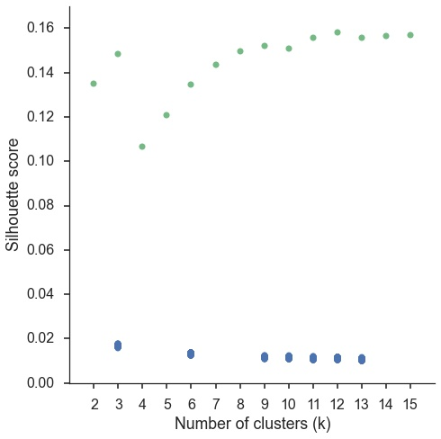

Supplemental Figure 1. Silhouette scores of real (green) and permuted (green) clustering solutions (green). Clustering was performed on permuted data 500 times for each k to compute a null distribution. We z-scored real clustering scores and determined they were all significantly greater than chance (p<.0001). Silhouette scores reached local maxima at 3, 9 and 12 regions, although silhouette scores only increased slightly after 9 clusters.

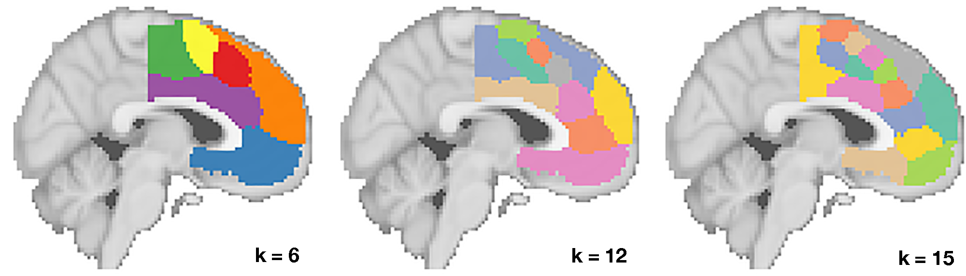

Supplemental Figure 2. Clustering solutions for 6, 12, and 15 clusters.

## Supplemental Table 1. Topics derived from topic modeling.

## Cognitive Topics

Name of topics as given by authors in left columns. Topics used in primary figures are italicized.

|  |  |  |  |  |  |
| --- | --- | --- | --- | --- | --- |
| **Topic Name** | **Five highest loading words** | | | | |
| stress | stress | awareness | experience | conscious | cortisol |
| *eye movements* | eye | gaze | movements | eyes | visual |
| *decision-making* | decision | choice | risk | decisions | choices |
| reasoning | reasoning | rule | rules | intelligence | complexity |
| sensory | visual | auditory | sensory | modality | integration |
| spatial | spatial | location | mental | space | virtual |
| repetition priming | repetition | priming | hearing | repeated | suppression |
| feature detection | visual | category | adaptation | color | features |
| *episodic memory* | memory | events | imagery | autobiographical | retrieval |
| object recognition | object | objects | visual | recognition | familiar |
| *motor function* | motor | movement | movements | sensorimotor | primary |
| attention | attention | attentional | visual | spatial | target |
| learning | learning | training | performance | practice | sequence |
| *social cognition* | social | empathy | moral | person | judgments |
| tms/stimulation | stimulation | somatosensory | tms | primary | tactile |
| mathematics | arithmetic | numerical | mental | magnitude | calculation |
| sentence comprehension | sentences | comprehension | sentence | language | syntactic |
| *reward* | reward | anticipation | monetary | responses | rewards |
| error processing | feedback | error | learning | errors | prediction |
| *switching* | cues | target | trials | cue | switching |
| audition | auditory | speech | sounds | music | sound |
| *emotion* | emotional | emotion | negative | neutral | facial |
| language | language | speech | production | fluency | asymmetry |
| reading | reading | word | words | phonological | chinese |
| *conflict & interference* | conflict | interference | control | incongruent | trials |
| semantic | semantic | words | word | lexical | knowledge |
| *inhibition* | inhibition | control | inhibitory | stop | motor |
| *encoding & retrieval* | memory | encoding | retrieval | recognition | episodic |
| motor action | action | actions | motor | observation | mirror |
| *fear & anxiety* | fear | anxiety | threat | responses | conditioning |
| food | food | taste | body | weight | eating |
| *working memory* | memory | performance | cognitive | wm | tasks |
| motion perception | motion | visual | perception | body | human |
| *pain* | pain | painful | stimulation | somatosensory | intensity |

## Non-Cognitive Topics Non-cognitive topics were not named, and are instead numbered.

|  |  |  |  |  |  |
| --- | --- | --- | --- | --- | --- |
| **Topic #** | **Top five loading words** | | | | |
| 35 | women | sex | gender | females | males |
| 36 | placebo | pet | tomography | emission | dopamine |
| 37 | schizophrenia | controls | risk | reduced | deficits |
| 38 | condition | conditions | tasks | control | performance |
| 39 | ad | disease | mci | alzheimer | atrophy |
| 40 | individuals | cognitive | individual | control | behavioral |
| 41 | wm | fractional | integrity | tracts | diffusivity |
| 42 | lesions | controls | patient | lesion | stroke |
| 43 | human | humans | organization | located | primates |
| 44 | network | role | evidence | human | distinct |
| 45 | network | resting | default | mode | rest |
| 46 | frequency | source | alpha | amplitude | beta |
| 47 | pd | controls | disease | clinical | motor |
| 48 | disorder | adhd | bipolar | controls | ocd |
| 49 | depression | mdd | depressed | disorder | depressive |
| 50 | images | standard | time | voxel | image |
| 51 | time | sustained | delay | phase | period |
| 52 | alcohol | acupuncture | cocaine | users | drug |
| 53 | volume | gray | voxel | gm | morphometry |
| 54 | effective | causal | network | dynamic | modeling |
| 55 | carriers | allele | gene | genotype | genetic |
| 56 | ptsd | social | game | attachment | trauma |
| 57 | asd | autism | social | reho | controls |
| 58 | age | adults | children | adolescents | sleep |
| 59 | features | free | sensitivity | classifier | feature |
| 60 | responses | stimulus | effect | design | neuronal |

**References**

Alexander, W. H., & Brown, J. W. (2011). Medial prefrontal cortex as an action-outcome predictor. Nature neuroscience, 14(10), 1338-1344.

Amunts, K., Schleicher, A., Bürgel, U., Mohlberg, H., Uylings, H., & Zilles, K. (1999). Broca's region revisited: cytoarchitecture and intersubject variability. Journal of Comparative Neurology, 412(2), 319-341.

Andrews-Hanna, Jessica R. "The brain’s default network and its adaptive role in internal mentation." The Neuroscientist 18.3 (2012): 251-270.

Andrews-Hanna, J.R., Reidler, J.S., Sepulcre, J., Poulin, R. & Buckner, R.L. (2010). Functional-anatomic fractionation of the brain’s default network. Neuron, 65: 550-562.

Banich, M. T. (2009). Executive function the search for an integrated account. Current Directions in Psychological Science, 18(2), 89-94.

Bartra, O., McGuire, J. T., & Kable, J. W. (2013). The valuation system: A coordinate-based meta-analysis of BOLD fMRI experiments examining neural correlates of subjective value. NeuroImage, 76, 412–427. doi:10.1016/j.neuroimage.2013.02.063

Beckmann, M., Johansen-Berg, H., & Rushworth, M. F. (2009). Connectivity-based parcellation of human cingulate cortex and its relation to functional specialization. The Journal of Neuroscience, 29(4), 1175-1190.

Behrens, T. E., Woolrich, M. W., Walton, M. E., & Rushworth, M. F. (2007). Learning the value of information in an uncertain world. Nature neuroscience, 10(9), 1214-1221.

Buckner, Randy L, Jessica R Andrews‐Hanna, and Daniel L Schacter. "The brain's default network." *Annals of the New York Academy of Sciences* 1124.1 (2008): 1-38.

Botvinick, M. M., Braver, T. S., Barch, D. M., Carter, C. S., & Cohen, J. D. (2001). Conflict monitoring and cognitive control. Psychological review, 108(3), 624.

Botvinick, M. M., Cohen, J. D., & Carter, C. S. (2004). Conflict monitoring and anterior cingulate cortex: an update. Trends in cognitive sciences, 8(12), 539-546.

Buckner, R. L., Andrews Hanna, J. R., & Schacter, D. L. (2008). The Brain's Default Network. Annals of the New York Academy of Sciences, 1124(1), 1–38. doi:10.1196/annals.1440.011

Bush, G., Luu, P., & Posner, M. I. (2000). Cognitive and emotional influences in anterior cingulate cortex. Trends in Cognitive Sciences, 4(6), 215–222. doi:10.1016/S1364-6613(00)01483-2

Carter, C. S., Braver, T. S., Barch, D. M., Botvinick, M. M., Noll, D., & Cohen, J. D. (1998). Anterior cingulate cortex, error detection, and the online monitoring of performance. Science, 280(5364), 747-749.

Chang, L. J., Yarkoni, T., Khaw, M. W., & Sanfey, A. G. (2012). Decoding the role of the insula in human cognition: functional parcellation and large-scale reverse inference. Cerebral Cortex, bhs065.

Etkin, A., Egner, T., & Kalisch, R. (2011). Emotional processing in anterior cingulate and medial prefrontal cortex. Trends in Cognitive Sciences, 15(2), 85–93. doi:10.1016/j.tics.2010.11.004

Fair, Damien A et al. "Development of distinct control networks through segregation and integration." *Proceedings of the National Academy of Sciences* 104.33 (2007): 13507-13512.

Feja, Malte, and Michael Koch. "Frontostriatal systems comprising connections between ventral medial prefrontal cortex and nucleus accumbens subregions differentially regulate motor impulse control in rats." Psychopharmacology (2014): 1-12.

Fox PT, Laird AR, Fox SP, Fox PM, Uecker AM, Crank M, Koenig SF, Lancaster JL. BrainMap taxonomy of experimental design: Description and evaluation. Hum Brain Mapp 25, 185-198, 2005.

Ghazizadeh, Ali et al. "Prefrontal cortex mediates extinction of responding by two distinct neural mechanisms in accumbens shell." The Journal of Neuroscience 32.2 (2012): 726-737.

Honey, Christopher J, Jean-Philippe Thivierge, and Olaf Sporns. "Can structure predict function in the human brain?." *Neuroimage* 52.3 (2010): 766-776.

Hutchins, K. D., Martino, A. M., & Strick, P. L. (1988). Corticospinal projections from the medial wall of the hemisphere. Experimental Brain Research, 71(3), 667–672. doi:10.1007/BF00248761

Kahnt, T., Chang, L. J., Park, S. Q., Heinzle, J., & Haynes, J.-D. (2012). Connectivity-Based Parcellation of the Human Orbitofrontal Cortex. Journal of Neuroscience, 32(18), 6240–6250. doi:10.1523/JNEUROSCI.0257-12.2012

Kim, J.-H., Lee, J.-M., Jo, H. J., Kim, S. H., Lee, J. H., Kim, S. T., et al. (2010). Defining functional SMA and pre-SMA subregions in human MFC using resting state fMRI: Functional connectivity-based parcellation method. NeuroImage, 49(3), 2375–2386. doi:10.1016/j.neuroimage.2009.10.016

Liu, H., Qin, W., Li, W., Fan, L., Wang, J., Jiang, T., & Yu, C. (2013). Connectivity-Based Parcellation of the Human Frontal Pole with Diffusion Tensor Imaging. Journal of Neuroscience, 33(16), 6782–6790. doi:10.1523/JNEUROSCI.4882-12.2013

Lindquist, K. A., Wager, T. D., Kober, H., Bliss-Moreau, E., & Barrett, L. F. (2012). The brain basis of emotion: A meta-analytic review. Behavioral and Brain Sciences, 35(03), 121–143. doi:10.1017/S0140525X11000446

Luppino, G. (1993). Corticocortical connections of area F3 (SMA-proper) and area F6 (pre-SMA) in the macaque monkey, 1–27.

McDonald, A. J., Mascagni, F., & Guo, L. (1996). Projections of the medial and lateral prefrontal cortices to the amygdala: a Phaseolus vulgaris leucoagglutinin study in the rat. Neuroscience, 71(1), 55–75. doi:10.1016/0306-4522(95)00417-3

Mohanty, A., Engels, A. S., Herrington, J. D., Heller, W., Ringo Ho, M.-H., Banich, M. T., et al. (2007). Differential engagement of anterior cingulate cortex subdivisions for cognitive and emotional function. Psychophysiology, 44(3), 343–351. doi:10.1111/j.1469-8986.2007.00515.x

Nakamura, K., & Roesch, M. R. (2005). Neuronal activity in macaque SEF and ACC during performance of tasks involving conflict. Journal of …..

McDonald, A. J., Mascagni, F., & Guo, L. (1996). Projections of the medial and lateral prefrontal cortices to the amygdala: a Phaseolus vulgaris leucoagglutinin study in the rat. Neuroscience, 71(1), 55–75. doi:10.1016/0306-4522(95)00417-3

Mennes, M., Kelly, C., Zuo, X.-N., Di Martino, A., Biswal, B. B., Castellanos, F. X., & Milham, M. P. (2010). Inter-individual differences in resting-state functional connectivity predict task-induced BOLD activity. NeuroImage, 50(4), 1690–1701. doi:10.1016/j.neuroimage.2010.01.002

Paus, T. (2001). Primate anterior cingulate cortex: where motor control, drive and cognition interface. Nature Reviews Neuroscience.

Phan, K. L., Wager, T., Taylor, S. F., & Liberzon, I. (2002). Functional Neuroanatomy of Emotion: A Meta-Analysis of Emotion Activation Studies in PET and fMRI. NeuroImage, 16(2), 331–348. doi:10.1006/nimg.2002.1087

Picard, N., & Strick, P. L. (1996). Motor Areas of the Medial Wall: A Review of Their Location and Functional Activation. Cerebral Cortex, 6(3), 342–353. doi:10.1093/cercor/6.3.342

Poldrack, R. A., Mumford, J. A., Schonberg, T., Kalar, D., Barman, B., & Yarkoni, T. (2012). Discovering relations between mind, brain, and mental disorders using topic mapping. PLoS computational biology, 8(10), e1002707.

Power, J. D., & Petersen, S. E. (2013). Control-related systems in the human brain. Current opinion in neurobiology, 23(2), 223-228.

Power, J. D., Cohen, A. L., Nelson, S. M., Wig, G. S., Barnes, K. A., Church, J. A., et al. (2011). Functional network organization of the human brain. Neuron, 72(4), 665-678.

Rizzolatti, G., Fadiga, L., Matelli, M., Bettinardi, V., Paulesu, E., Perani, D., & Fazio, F. (1996). Localization of grasp representations in humans by PET: 1. Observation versus execution. Experimental Brain Research, 111(2), 246–252. doi:10.1007/BF00227301

Robinson, J. L., Laird, A. R., Glahn, D. C., Lovallo, W. R., & Fox, P. T. (2010). Metaanalytic connectivity modeling: Delineating the functional connectivity of the human amygdala. Human Brain Mapping, 31(2), 173–184. doi:10.1002/hbm.20854

Rolls, E. T., O'Doherty, J., Kringelbach, M. L., Francis, S., Bowtell, R., & McGlone, F. (2003). Representations of Pleasant and Painful Touch in the Human Orbitofrontal and Cingulate Cortices. Cerebral Cortex, 13(3), 308–317. doi:10.1093/cercor/13.3.308

Rizzolatti, G., Fadiga, L., Matelli, M., Bettinardi, V., Paulesu, E., Perani, D., & Fazio, F. (1996). Localization of grasp representations in humans by PET: 1. Observation versus execution. Experimental Brain Research, 111(2), 246–252. doi:10.1007/BF00227301

Rushworth, M., Walton, M. E., & Kennerley, S. W. (2004). Action sets and decisions in the medial frontal cortex. Trends in Cognitive …. doi:10.1016/j.tics.2004.07.009

Rushworth, M. F., & Behrens, T. E. (2008). Choice, uncertainty and value in prefrontal and cingulate cortex. Nature neuroscience, 11(4), 389-397.

Seeley, W. W., Menon, V., Schatzberg, A. F., Keller, J., Glover, G. H., Kenna, H., et al. (2007). Dissociable intrinsic connectivity networks for salience processing and executive control. The Journal of neuroscience, 27(9), 2349-2356.

Sesack, Susan R, and Virginia M Pickel. "Prefrontal cortical efferents in the rat synapse on unlabeled neuronal targets of catecholamine terminals in the nucleus accumbens septi and on dopamine neurons in the ventral tegmental area." *Journal of Comparative Neurology* 320.2 (1992): 145-160.

Shackman, A. J., Salomons, T. V., Slagter, H. A., Fox, A. S., Winter, J. J., & Davidson, R. J. (2011). The integration of negative affect, pain and cognitive control in the cingulate cortex. Nature Reviews Neuroscience, 12(3), 154-167.

Smith, S. M., Fox, P. T., Miller, K. L., Glahn, D. C., Fox, P. M., Mackay, C. E., et al. (2009). Correspondence of the brain's functional architecture during activation and rest. Proceedings of the National Academy of Sciences, 106(31), 13040-13045.

Toro, R., Fox, P. T., & Paus, T. (2008). Functional Coactivation Map of the Human Brain. Cerebral Cortex, 18(11), 2553–2559. doi:10.1093/cercor/bhn014

Thirion, B., Varoquaux, G., Dohmatob, E., & Poline, J. (2014). Which fMRI clustering gives good brain parcellations?. Frontiers in Neuroscience, 8, 167.

Treede, R.-D., Kenshalo, D. R., Gracely, R. H., & Jones, A. K. P. (1999). The cortical representation of pain. Pain, 79(2), 105–111. doi:10.1016/S0304-3959(98)00184-5

Vorobiev, V., & Luppino, G. (1998). Parcellation of human mesial area 6: cytoarchitectonic evidence for three separate areas, 1–5.

Wager, T. D., Lindquist, M., & Kaplan, L. (2007). Meta-analysis of functional neuroimaging data: current and future directions. Social Cognitive and Affective Neuroscience, 2(2), 150–158. doi:10.1093/scan/nsm015

Wager, T. D., Atlas, L. Y., Lindquist, M. A., Roy, M., Woo, C.-W., & Kross, E. (2013). An fMRI-Based Neurologic Signature of Physical Pain. New England Journal of Medicine, 368(15), 1388–1397. doi:10.1056/NEJMoa1204471

Wallis, J. D., & Kennerley, S. W. (2010). Heterogeneous reward signals in prefrontal cortex. Current Opinion in Neurobiology, 20(2), 191–198. doi:10.1016/j.conb.2010.02.009

Yarkoni, T., Poldrack, R. A., Nichols, T. E., Van Essen, D. C., & Wager, T. D. (2011). Large-scale automated synthesis of human functional neuroimaging data. Nature methods, 8(8), 665-670.

Yu, C., Zhou, Y., Liu, Y., Jiang, T., Dong, H., Zhang, Y., et al. (2011). Functional segregation of the human cingulate cortex is confirmed by functional connectivity based neuroanatomical parcellation. Neuroimage, 54(4), 2571-2581.

# 

## 

Andrews-Hanna, J. R. (2012). The Brain's Default Network and Its Adaptive Role in Internal Mentation. *The Neuroscientist*, *18*(3), 251–270. http://doi.org/10.1177/1073858411403316

Ball, T., Schreiber, A., Feige, B., Wagner, M., & Lücking, C. H. (1999). The role of higher-order motor areas in voluntary movement as revealed by high-resolution EEG and fMRI. *NeuroImage*, *10*(6), 682–694. http://doi.org/10.1006/nimg.1999.0507

Bartra, O., McGuire, J. T., & Kable, J. W. (2013). The valuation system: A coordinate-based meta-analysis of BOLD fMRI experiments examining neural correlates of subjective value. *NeuroImage*, *76*, 412–427. http://doi.org/10.1016/j.neuroimage.2013.02.063

Baumgartner, T., Götte, L., Gügler, R., & Fehr, E. (2012). The mentalizing network orchestrates the impact of parochial altruism on social norm enforcement. *Human Brain Mapping*, *33*(6), 1452–1469. http://doi.org/10.1002/hbm.21298

Botvinick, M., Nystrom, L. E., Fissell, K., Carter, C. S., & Cohen, J. D. (1999). Conflict monitoring versus selection-for-action in anterior cingulate cortex. *Nature*, *402*(6758), 179–181. http://doi.org/10.1038/46035

Brown, J. W., & Braver, T. S. (2005). Learned Predictions of Error Likelihood in the Anterior Cingulate Cortex. *Science*, *307*(5712), 1118–1121. http://doi.org/10.1126/science.1105783

Bush, G., Luu, P., & Posner, M. I. (2000). Cognitive and emotional influences in anterior cingulate cortex. *Trends in Cognitive Sciences*, *4*(6), 215–222. http://doi.org/10.1016/S1364-6613(00)01483-2

Carter, C. S., Braver, T. S., Barch, D. M., Botvinick, M. M., Noll, D., & Cohen, J. D. (1998). Anterior Cingulate Cortex, Error Detection, and the Online Monitoring of Performance. *Science*, *280*(5364), 747–749. http://doi.org/10.1126/science.280.5364.747

Carter, R. M., & Huettel, S. A. (2013). A nexus model of the temporal–parietal junction. *Trends in Cognitive Sciences*, *17*(7), 328–336. http://doi.org/10.1016/j.tics.2013.05.007

Corbetta, M., Shulman, G. L., Miezin, F. M., & Petersen, S. E. (1995). Superior Parietal Cortex Activation During Spatial Attention Shifts and Visual Feature Conjunction. *Science*, *270*(5237), 802–805. http://doi.org/10.1126/science.270.5237.802

Critchley, H. D., Mathias, C. J., Josephs, O., O’Doherty, J., Zanini, S., Dewar, B. K., et al. (2003). Human cingulate cortex and autonomic control: converging neuroimaging and clinical evidence. *Brain*, *126*(10), 2139–2152. http://doi.org/10.1093/brain/awg216

Denny, B. T., Kober, H., Wager, T. D., & Ochsner, K. N. (2012). A Meta-analysis of Functional Neuroimaging Studies of Self- and Other Judgments Reveals a Spatial Gradient for Mentalizing in Medial Prefrontal Cortex. *Dx.Doi.org*, *24*(8), 1742–1752. http://doi.org/10.1162/jocn\_a\_00233

Hare, T. A., Camerer, C. F., & Rangel, A. (2009). Self-Control in Decision-Making Involves Modulation of the vmPFC Valuation System. *Science*, *324*(5927), 646–648. http://doi.org/10.1126/science.1168450

Holroyd, C. B., Nieuwenhuis, S., & Yeung, N. (2004). Dorsal anterior cingulate cortex shows fMRI response to internal and external error signals. *Nature*.

Kennerley, S. W., & Sakai, K. (2004). Organization of action sequences and the role of the pre-SMA. *Journal of …*. http://doi.org/10.1152/jn.00651.2003

Lee, K. M., Chang, K. H., & Roh, J. K. (1999). Subregions within the supplementary motor area activated at different stages of movement preparation and execution. *NeuroImage*, *9*(1), 117–123. http://doi.org/10.1006/nimg.1998.0393

Leek, E. C., & Johnston, S. J. (2009). Functional specialization in the supplementary motor complex. *Nature Reviews Neuroscience*.

Lindquist, K. A., Wager, T. D., Kober, H., Bliss-Moreau, E., & Barrett, L. F. (2012). The brain basis of emotion: A meta-analytic review. *Behavioral and Brain Sciences*, *35*(03), 121–143. http://doi.org/10.1017/S0140525X11000446

Milham, M. P., Banich, M. T., Webb, A., Barad, V., Cohen, N. J., Wszalek, T., & Kramer, A. F. (2001). The relative involvement of anterior cingulate and prefrontal cortex in attentional control depends on nature of conflict. *Cognitive Brain Research*, *12*(3), 467–473. http://doi.org/10.1016/S0926-6410(01)00076-3

Nelson, S. M., Dosenbach, N. U. F., Cohen, A. L., Wheeler, M. E., Schlaggar, B. L., & Petersen, S. E. (2010). Role of the anterior insula in task-level control and focal attention. *Brain Structure and Function*, *214*(5-6), 669–680. http://doi.org/10.1007/s00429-010-0260-2

Poldrack, R. A. (2006). Can cognitive processes be inferred from neuroimaging data? *Trends in Cognitive Sciences*. http://doi.org/10.1016/j.tics.2005.12.004

Posner, M. I., Walker, J. A., Friedrich, F. J., & Rafal, R. D. (1984). Effects of parietal injury on covert orienting of attention. *Journal of Neuroscience*, *4*(7), 1863–1874.

Robinson, J. L., Laird, A. R., Glahn, D. C., Lovallo, W. R., & Fox, P. T. (2010). Metaanalytic connectivity modeling: Delineating the functional connectivity of the human amygdala. *Human Brain Mapping*, *31*(2), 173–184. http://doi.org/10.1002/hbm.20854

Rogers, R. D., Ramnani, N., Mackay, C., Wilson, J. L., Jezzard, P., Carter, C. S., & Smith, S. M. (2004). Distinct portions of anterior cingulate cortex and medial prefrontal cortex are activated by reward processing in separable phases of decision-making cognition. *Biological Psychiatry*, *55*(6), 594–602. http://doi.org/10.1016/j.biopsych.2003.11.012

Roland, P. E., Larsen, B., & Lassen, N. A. (1980). Supplementary motor area and other cortical areas in organization of voluntary movements in man. *Journal of …*.

Rolls, E. T., O'Doherty, J., Kringelbach, M. L., Francis, S., Bowtell, R., & McGlone, F. (2003). Representations of Pleasant and Painful Touch in the Human Orbitofrontal and Cingulate Cortices. *Cerebral Cortex*, *13*(3), 308–317. http://doi.org/10.1093/cercor/13.3.308

Roy, M., Shohamy, D., & Wager, T. D. (2012). Ventromedial prefrontal-subcortical systems and the generation of affective meaning. *Trends in Cognitive Sciences*, *16*(3), 147–156. http://doi.org/10.1016/j.tics.2012.01.005

Rushworth, M., Walton, M. E., & Kennerley, S. W. (2004). Action sets and decisions in the medial frontal cortex. *Trends in Cognitive …*. http://doi.org/10.1016/j.tics.2004.07.009

Shackman, A. J., Salomons, T. V., Slagter, H. A., Fox, A. S., Winter, J. J., & Davidson, R. J. (2011). The integration of negative affect, pain and cognitive control in the cingulate cortex. *Nature Reviews Neuroscience*, *12*(3), 154–167. http://doi.org/10.1038/nrn2994

Smith, S. M., Fox, P. T., Miller, K. L., Glahn, D. C., Fox, P. M., Mackay, C. E., et al. (2009). Correspondence of the brain's functional architecture during activation and rest. *Proceedings of the National Academy of Sciences of the United States of America*, *106*(31), 13040–13045. http://doi.org/10.1073/pnas.0905267106

Spreng, R. N., & Grady, C. L. (2010). Patterns of Brain Activity Supporting Autobiographical Memory, Prospection, and Theory of Mind, and Their Relationship to the Default Mode Network. *Dx.Doi.org*, *22*(6), 1112–1123. http://doi.org/10.1162/jocn.2009.21282

Summerfield, J. J., Hassabis, D., & Maguire, E. A. (2009). Cortical midline involvement in autobiographical memory. *NeuroImage*, *44*(3), 1188–1200. http://doi.org/10.1016/j.neuroimage.2008.09.033

Toro, R., Fox, P. T., & Paus, T. (2008). Functional Coactivation Map of the Human Brain. *Cerebral Cortex*, *18*(11), 2553–2559. http://doi.org/10.1093/cercor/bhn014

Treede, R.-D., Kenshalo, D. R., Gracely, R. H., & Jones, A. K. P. (1999). The cortical representation of pain. *Pain*, *79*(2), 105–111. http://doi.org/10.1016/S0304-3959(98)00184-5

Vogt, B. A. (2005). Pain and emotion interactions in subregions of the cingulate gyrus. *Nature Reviews Neuroscience*, *6*(7), 533–544. http://doi.org/10.1038/nrn1704

Wager, T. D., Atlas, L. Y., Lindquist, M. A., Roy, M., Woo, C.-W., & Kross, E. (2013). An fMRI-Based Neurologic Signature of Physical Pain. *New England Journal of Medicine*, *368*(15), 1388–1397. http://doi.org/10.1056/NEJMoa1204471

Winecoff, A., Clithero, J. A., Carter, R. M., Bergman, S. R., Wang, L., & Huettel, S. A. (2013). Ventromedial Prefrontal Cortex Encodes Emotional Value. *Journal of Neuroscience*, *33*(27), 11032–11039. http://doi.org/10.1523/JNEUROSCI.4317-12.2013

Yarkoni, T., Poldrack, R. A., Nichols, T. E., Van Essen, D. C., & Wager, T. D. (2011). Large-scale automated synthesis of human functional neuroimaging data. *Nature Methods*, *8*(8), 665–670. http://doi.org/10.1038/nmeth.1635

Zilbovicius, M., Meresse, I., Chabane, N., Brunelle, F., Samson, Y., & Boddaert, N. (2006). Autism, the superior temporal sulcus and social perception. *Trends in Neurosciences*, *29*(7), 359–366. http://doi.org/10.1016/j.tins.2006.06.004