Classification: Biological Sciences; Neuroscience

Title: Large-scale meta-analysis of human medial frontal cortex reveals tripartite functional organization

Alejandro de la Vega1,2, Luke J. Chang3, Marie T. Banich1,2, Tor D. Wager1,2 and Tal Yarkoni4

1 Department of Psychology and Neuroscience, University of Colorado Boulder, Muenzinger D244, 345 UCB, Boulder, CO 80309-0345 2 Institute of Cognitive Science, University of Colorado Boulder, 345 UCB, Boulder, CO 80309-0345 3 Department of Psychological and Brain Sciences, Dartmouth College, 6207 Moore Hall. Hanover, NH 03755 4 Department of Psychology, University of Texas at Austin, SEA 4.20, 108 E. Dean Keeton Stop A8000, Austin, TX 78712-1043

Corresponding Author: Alejandro de la Vega, Department of Psychology and Neuroscience, University of Colorado Boulder, Muenzinger D244, 345 UCB, Boulder, CO 80309-0345, 650-315-9536, delavega@colorado.edu

Keywords: medial frontal cortex, neuroimaging, cognitive control, affect, meta-analysis

**Abstract**

The human medial frontal cortex (MFC) has been the subject of intense study, having been associated with a wide-range of psychological processes. Here, we comprehensively map these diverse psychological processes onto functionally separable sub-regions across nearly 10,000 fMRI studies. We identified three broad zones along a rostro-caudal axis that co-activated with distinct whole-brain networks and were composed of 3-4 smaller sub-regions that more subtly varied in co-activation. Multivariate classification analyses aimed at identifying the psychological concepts most predictive of activity in each region also supported a tripartite division within MFC, with each zone displaying distinct functional signatures; the posterior zone was associated primarily with motor function, the middle zone with cognitive control and negative affect and the anterior with internal mentation and affect. Upon closer inspection, we also identified fine-grained shifts in function within each zone, revealing greater functional diversity than previous “unifying” accounts might suggest.

The medial frontal cortex (MFC) encompasses many functionally distinct foci that have been associated with a wide variety of cognitive states using functional neuroimaging. For example, the supplementary motor area (SMA) and pre-SMA have been associated with the planning and initiation of movements 1-3, while nearby dorsal anterior cingulate cortex (ACC) has been implicated in various aspects of cognitive control, such as conflict 4-6 and error processing 7,8, in addition to pain processing 9-11. Further anterior, medial prefrontal cortex (mPFC) and subgenual ACC have been shown to be important for a variety of affective processes, including emotion 12,13, autonomic function 14, and valuation 15,16. Furthermore, portions of mPFC have also been associated with internally oriented processes, such as mentalizing 17,18 and autobiographical memory 19. Moreover, the functional organization supporting these diverse processes has been investigated using a wide range of methods, including cytoarchitecture 9,20, computational models 21, and network and region level descriptions of intrinsic organization at rest 22-24.

Despite the enormous amount of research on focal regions of MFC, there have been few large-scale efforts to comprehensively map function to medial frontal anatomy across the full range of psychological concepts. Since most researchers are intimately familiar with one particular domain of cognition, most meta-analyses are necessarily restricted to a relatively small subset of empirical findings. Even those meta-analyses that attempt to take a broader look at organization of the MFC typically only include a subset of cognitive states hypothesized to be important (e.g. negative affect and cognitive control 12,25) or restrict themselves to a small region of interest (e.g. subgenual ACC 26). Such meta-analyses are further hampered by the limited ability to draw conclusions about the relative specificity of brain activity to particular cognitive processes— a limitation widely known as the reverse inference problem 27. This concern is particularly acute in the case of pre-SMA and dACC, which are activated in a large proportion of fMRI studies, raising questions about their functional selectivity 28,29.

Here we attempt to systematically create a comprehensive mapping of psychological function onto MFC neuroanatomy using Neurosynth, a diverse large-scale database of over 10,000 fMRI studies 29. First, we clustered MFC voxels into functionally separable regions at several spatial scales based on their meta-analytic co-activation with the rest of the brain 30-32, revealing three zones along the rostro-caudal axis that further fractionated into nine sub-regions. In contrast to cytoarchitechtonic 9,33,34 and connectivity based parcellations 35,36 – which delineate regions on the basis of static anatomical properties— the present analysis identified clusters with distinct functional signatures across a wide range of psychological manipulations. We then determined each cluster’s psychological profile using multivariate classification and found that the three zones accounted for a large portion of functional variation; however, we also found appreciable fine-grained variation between sub-regions within each zone. Collectively, our results provide insight into the topography and function of MFC at multiple anatomical scales and suggest that previous studies may have overstated the case for the convergence of different processes in MFC.

**Results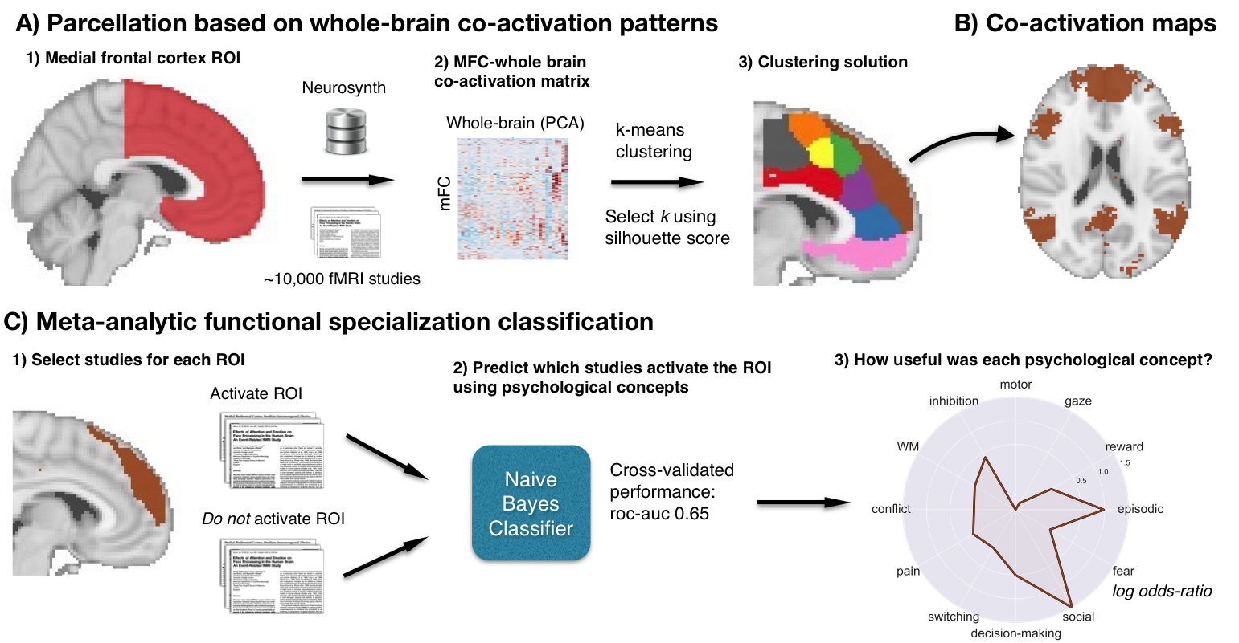**Figure 1. Methods overview. A) Whole brain co-activation of MFC voxels was calculated and k-means clustering was applied resulting in spatially distinct clusters. B) For each cluster, thresholded whole-brain co-activation maps were generated. C) We functionally characterized each cluster by determining which cognitive functions best predicted their activation.

## Functionally separable components of medial frontal cortex

We identified spatially dissociable regions on the basis of shared co-activation profiles with the rest of the brain 30,32,37, an approach that exploits the likelihood of a voxel co-activating with another voxel across studies in the meta-analytic database. Because structure-to-function mappings can be identified at multiple spatial scales, we iteratively extracted 2- through 15-cluster solutions and assessed their validity using the silhouette score—a commonly used measure of inter-cluster coherence. Permutation analyses indicated that the null hypothesis of random clustering could be rejected for all solutions, with silhouette scores reaching local maxima at 3 and 9 clusters (See Supplementary Fig. 1). We focus on these solutions as they provide insight into the functional topography of MFC at two different scales (Fig. 2). Solutions for 12 and 15 regions are available in Supplementary Figure 2.

Figure 2. Co-activation-based clustering of MFC at two levels of granularity. A) Three broad functional zones along a rostral-caudal axis. B) Nine-subregions hierarchically organized within the zones. SMA: supplementary motor area; dACC: dorsal anterior cingulate cortex; rACC: rostral anterior cingulate cortex; mPFC: medial prefrontal cortex; dmPFC: dorsal medial PFC; vmPFC: ventromedial PFC. r and c indicate rostral and caudal.

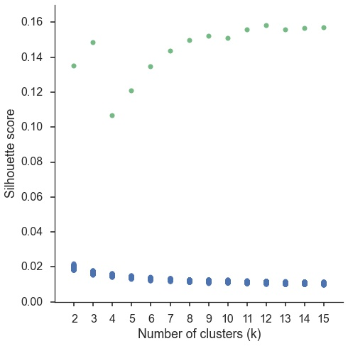

Supplementary Figure 1. Silhouette scores of real (green) and permuted (blue) clustering solutions. Clustering was performed on permuted data 500 times for each k to compute a null distribution. We z-scored real clustering scores and determined they were all significantly greater than chance (p<.0001). Silhouette scores reached local maxima at 3, 9 and 12 regions, although silhouette scores only increased slightly after 9 clusters.

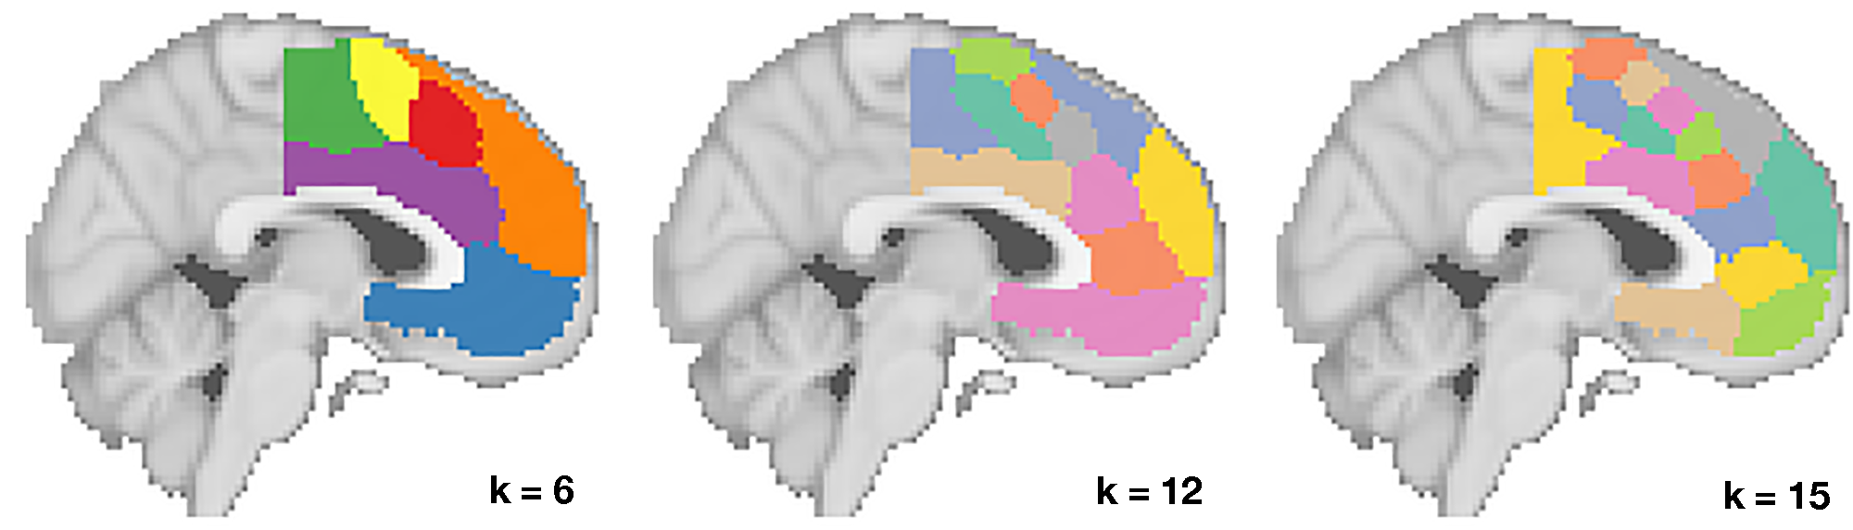

Supplementary Figure 2. Clustering solutions for 6, 12, and 15 clusters.

At the coarsest level, MFC divided into three broad bilateral zones organized along the rostral-caudal axis. We refer to these as the posterior, middle and anterior zones. The posterior zone encompassed the paracentral lobule, SMA, and dorsal posterior midcingulate cortex; the middle zone included portions of pre-SMA as well as much of dorsal anterior cingulate (dACC) running along the corpus callosum 9; and the anterior zone encompassed much of medial prefrontal cortex, including rostral and subgenual ACC, and medial orbitofrontal cortex (OFC).

The nine-cluster solution revealed additional fine-grained topographical organization, with each of the three major zones fractionating into 2-4 smaller regions (84% of all voxels within each zone overlapped with its putative subregions). The resulting sub-regions were generally consistent with extensive cytoarchitechtonic work. Within the posterior zone, we identified two clusters consistent with rostral and caudal SMA 33. Within the middle functional zone, we identified two clusters dorsal to the cingulate sulcus consistent with pre-SMA 38 and two ventral clusters consistent caudal and rostral dACC 9. Within the anterior zone, we identified a rostral ACC cluster that delineated from ventral mPFC (vmPFC) 9 and a dorsal mPFC (dmPFC) cluster which included medial aspects of the frontal pole and superior frontal gyrus. Thus, the boundaries of the clusters we identified exclusively using a functional co-activation based approach converged with many distinctions previously drawn on the basis of anatomical criteria.

## Meta-analytic co-activation profiles

Thus far, we have demonstrated that MFC can be parcellated into robust, anatomically sensible subregions on the basis of meta-analytic co-activation. To better understand the differences that led to these divisions, we directly contrasted co-activation patterns of the three functional zones---i.e., we sought to identify voxels that co-activated to a stronger degree with each zone than with the other two (Fig. 3A). The posterior zone showed greater bilateral co-activation with primary motor cortex (PMC) and superior parietal cortex (SPC), anterior cerebellum, and posterior insula (pIns) as well subcortical regions such as the thalamus and putamen—a co-activation pattern consistent with motoric function. The co-activation pattern for the middle zone resembled an anterior-shifted version of the posterior zone’s pattern, co-activating with more anterior aspects of the thalamus as well as regions in the frontoparietal control network such as dorsolateral prefrontal cortex (DLPFC), anterior insula (aIns) and SPC. Finally, the anterior zone showed a qualitatively different pattern, co-activating to a greater extent with default network regions such as angular gyrus, hippocampus and posterior cingulate cortex (PCC) 39. The anterior zone also showed greater co-activation with subcortical regions important for affect-- the amygdala and ventral striatum (VS).

Figure 3. Functional co-activation networks of MFC zones (A) and sub-regions within each zone (B). Colored voxels indicate significantly greater co-activation with the seed region of the same color (at right) than other regions in the same map. The three zones showed distinct co-activation patterns, while sub-regions within each zone showed fine-grained co-activation differences. Images are presented using neurological convention and were whole-brain corrected using a false discovery rate (FDR) of q = 0.01.

To understand the differences in co-activation found within each zone, we directly contrasted co-activation patterns of each zone’s sub-regions (Fig. 3B). In the posterior zone, caudal SMA showed greater co-activation with somatosensory cortices and pIns while rostral SMA showed greater co-activation with posterior DLPFC, including the inferior frontal junction (IFJ), as well as aIns— regions associated with goal-directed cognition 37,40. Within the middle zone, we found that all four sub-regions strongly co-activated with various aspects of the insula. However, caudal dACC was more strongly co-activated with pIns as well as SII and the brain stem—important regions for pain processing 9,11. In contrast, rostral dACC co-activated more strongly with ventral aIns as well as lateral OFC—regions previously associated with chemosensory processing 41,42 and reward-driven learning 43. In contrast, both caudal and rostral pre-SMA were strongly associated with dorsal aIns, in addition to frontoparietal control regions (e.g DLPFC, SPC). However, rostral pre-SMA’s co-activation extended anteriorly into the frontal pole, whereas caudal pre-SMA more strongly co-activated with motor cortices, suggesting that these regions are involved in cognitive control at different levels of abstraction.

Within the anterior zone, rACC did not show many co-activation differences from its neighbors. Surprisingly, both dmPFC and vmPFC showed greater co-activation with PCC – a key default network region. In addition, dmPFC robustly co-activated with portions of the so-called ‘mentalizing’ network, such as the tempo-parietal junction (TPJ) 44 and the superior temporal sulcus (STS) 45, as well as lateral PFC, including inferior and middle frontal gyri. Finally, vmPFC showed strong co-activation with subcortical regions, including VS and the amygdala, extending into the hippocampus. As a whole, these co-activation patterns demonstrate that the regions we identified are involved with distinct functional networks, and suggest that there are likely broad functional differences across MFC zones, accompanied by fine-grained differences within each zone.

## Meta-analytic functional specialization

To test if MFC zones and sub-regions exhibited distinct functional specialization, we used a data-driven approach that surveyed a broad range of psychological states to identify those maximally predictive of activation in each MFC region. For each cluster, we trained a multivariate classifier to predict which studies activated the cluster using a set of 35 psychological concepts derived by applying a standard topic modeling approach to the text of articles in the database 46 (See Supplementary Table 1 for a list of topics). From the resulting fitted classifiers, we calculated the extent to which each psychological concept predicted activity in each cluster and restricted interpretation to significant associations (p<0.001) using permutation testing.

Across the three broad MFC zones, we observed distinct functional patterns, consistent with their divergent patterns of functional co-activation (Fig. 4). The posterior zone was primarily involved with motor function (including gaze) consistent with its co-activation with motor regions. The middle zone was primarily associated with various facets of cognitive control, but was also implicated in negative affect—pain and fear – as well as decision-making. Consistent with its distinct pattern of co-activation, the anterior zone showed a robust shift away from goal-directed cognition and was strongly associated with affective processes, such as reward, fear and decision-making, as well as internally oriented processes such as episodic memory and social processing.

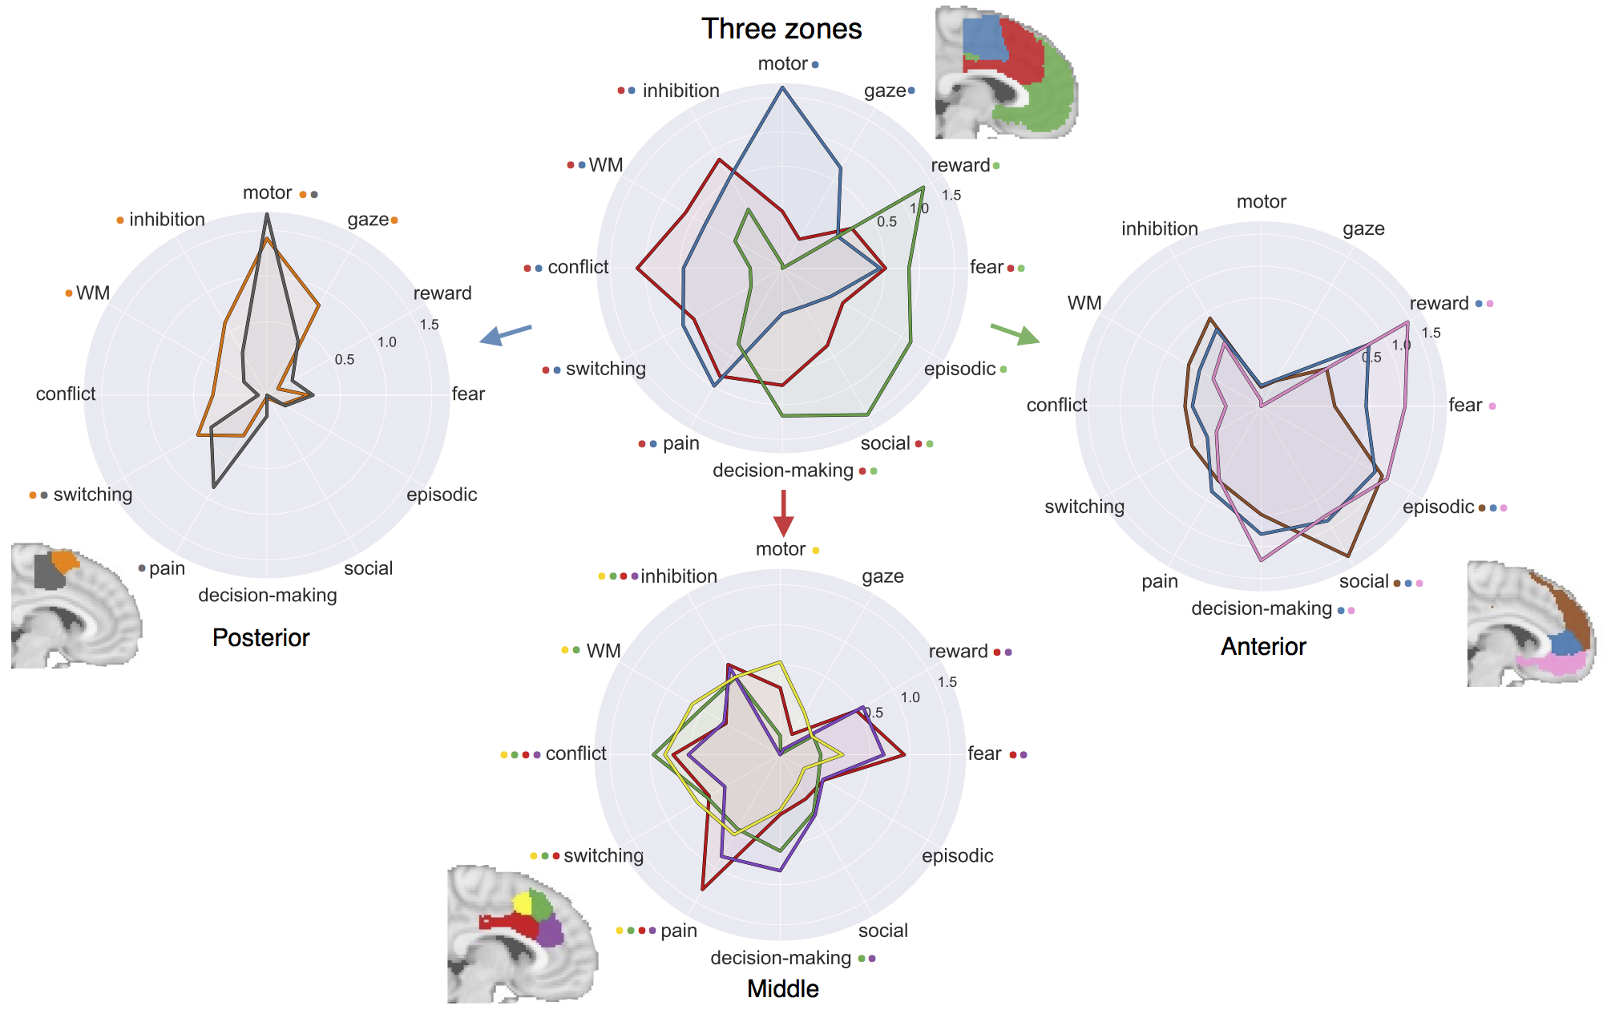Figure 4. Functional specialization profile of MFC clusters. Each cluster was profiled to determine which psychological concepts best predicted its activation. Top) Each of the three functional zones we identified showed distinct functional profiles with broad shifts across cognitive domains Bottom) Within each zone, sub-regions showed fine-grained shifts in functional profile. Strength of associations is measured in log-odds ratio, and permutation-based significance (p<0.001) is indicated next to each psychological concept by color-coded dots corresponding to each region.

Inspection at a finer spatial scale revealed that sub-regions within each zone showed more subtle shifts in function, similar to the fine-grained shifts in co-activation previously observed. In the posterior zone, activity in both clusters was similarly predicted by motor function and switching. However, only caudal SMA was significantly associated with pain, while rostral SMA showed significant associations with working memory (WM), inhibition and gaze function. In the middle zone, activity in all four sub-regions was predicted by aspects of cognitive control (i.e. conflict and inhibition) and pain, although only activity in pre-SMA was significantly predicted by WM. dACC clusters were further characterized by a strong association with affect-- including fear and reward. In addition to differences between pre-SMA and dACC, we found that only activity in caudal pre-SMA was significantly predicted by motor function, while activity in rostral pre-SMA and dACC was significantly predicted by decision-making.

In the anterior zone, activity across all three sub-regions was significantly predicted by episodic memory and social processing; however, the association with social processing peaked in dmPFC, consistent with a previous meta-analysis 18. In contrast, the reverse was true for reward and decision-making: only activity in rACC and vmPFC was significantly predicted by these processes. Moreover, fear was maximally associated with vmPFC, consistent with its strong co-activation with the amygdala. Interestingly, however, no region in the anterior zone was significantly associated with pain processing, suggesting fear and pain have dissociable associations in MFC.

# Discussion

In the current study, we identified and characterized and functionally characterized regions of the medial frontal cortex by applying a data-driven approach to a large-scale database of ~10,000 fMRI studies. We identified three broad zones arranged along the rostra-caudal axis with distinct patterns of whole-brain co-activation and

Posterior zone

The posterior MFC zone spanned regions previously associated with motoric function--such as SMA-- and delineated from pre-SMA, in a manner consistent with cytoarchitectonics 9,33 and rs-fMRI connectivity 47. Thus, it follows that this zone was primarily associated with motor function, and co-activated with key motor regions such as primary motor cortex and thalamus. Moreover, our results suggest that posterior MFC can be further fractionated into caudal and rostral sub-regions that specialize in different aspects of motor function. Caudal SMA—which includes (CCZ)-- showed a greater association with pain processing and greater co-activation with key pain regions such as SII and thalamus11. Given that pain signals often indicate the need for motor action to avoid damage to the organism, caudal SMA may be particularly specialized in initiating reflexive movements in response to pain. In contrast, in addition to motor function, rostral SMA was implicated in cognitive control and co-activated with regions in the fronto-parietal control system such as DLPFC and aIns. These results are consistent with the hypothesis that the supplementary eye fields (located in our rostral SMA cluster) are important for high-level control of eye movements 48,49. While rostral SMA is unlikely to be involved in the resolution of conflict or direct maintenance of WM, the direct cortico-spinal connections in this region 50 suggest it is well situated to modify motor action to support goal-directed cognition.

Middle zone

The middle MFC zone was associated with several aspects of cognitive control in addition to negative affect. While these findings seem consistent with hypotheses suggesting that “dorsal ACC” is important for the integration of negative affect into cognitive control 25, our findings suggest that middle MFC further fractionates into sub-regions with substantial functional-anatomical specificity. These sub-regions are consistent with evidence suggesting dACC shows distinct cellular organization and demarcates from pre-SMA along the cingulate sulcus 9. Although all four sub-regions co-activated with regions important for goal-driven cognition, such as aIns and DLPFC, the two pre-SMA subregions showed greater co-activation with these regions and stronger associations with cognitive control-- in particular WM. In contrast, dACC sub-regions were more strongly associated with affect (e.g. fear, reward and pain). These distinctions may only be appreciable using analytical methods that appropriately control for the high base rate of activation of this region 29.

These functional dissociations suggest that existing models of cognitive control may underspecify the functional topography of middle MFC. Some influential theories of cognitive motoric control consider dACC to be the region primarily responsible for conflict processing. However, our results suggest that the more dorsal pre-SMA is more strongly associated with cognitive control. Our findings are consistent with previously raised concerns that macaques primarily show conflict related activity in pre-SMA and not dACC 51,52. Our results support an alternate hypothesis in which negative affective signals that indicate conflict may be initially processed in dACC and are integrated with high-level goals –likely represented in DLPFC-- in pre-SMA.

We also found evidence suggesting that two sub-regions of dACC are focused on different types of affective processes. Caudal dACC was more strongly associated with pain, consistent with it’s co-activation with pain processing regions, while rostral dACC was more strongly associated with decision-making and reward, consistent with greater co-activation with reward processing regions, such as the VS and lateral OFC. Notably, rostral pre-SMA was also associated with decision-making and co-activated with lateral OFC, consistent with existing theories suggesting that cognitive motoric control depending on dopaminergic to avoid future negative outcomes 8.

Anterior zone

Anterior MFC exhibited a distinct functional signature from the rest of MFC with strong associations with affect, decision-making, social cognition, and episodic memory. This was accompanied by co-activation with regions of the default network, such as PCC, hippocampus, and sub-cortical regions such as amygdala and VS. However, our results suggest that anterior MFC is not a unitary area, and fractionated into three subregions: dmPFC, rACC and vmPFC. DmPFC was the most strongly associated with social processing, consistent with several studies linking dmPFC to social perception and self-referential thought 53 and it’s strong co-activation with TPJ, a region hypothesized to be important for mentalizing 17,18. Notably, dmPFC was weakly associated with reward processing, suggesting mentalizing may be a higher-level process distinct from low-level affect. Rostral ACC showed a relatively less specific functional pattern, moderately associating with both low-level affective processes as well as higher-level processes, such as decision-making. These findings are consistent with descriptions of the existence of a default network ‘hub’ region in mPFC 54,55 Finally, vmPFC was primarily associated with low-level affective processes, such as reward and fear, consistent with its robust sub-cortical co-activation. Although some have characterized vmPFC as a ‘valuation’ system 56, these results suggest that this region is equally important for processes more closely related with the amygdala and related negative emotions, such as fear. vmPFC may play a general role incorporating a variety of affective signals into cortex, while more dorsal regions may integrate these signals with the rest of the default network 57.

While our large-scale meta-analytic approach allowed us to comprehensively synthesize a plethora of fMRI findings, there are several limitations. First, the topic modeling approach we employ is data-derived from the semantic content of papers, and thus is not driven by theoretical models that may be critical for discriminating the activity distinct regions. Although this topic model provides a substantial improvement over term based meta-analysis 46, these topics are still based purely on the frequency with which terms appear in the abstracts describing fMRI articles, and are not able to capture more complex semantic structures. Second, the quality of activation data in Neurosynth is inherently limited due to its automatically generated nature; for example, the Neurosynth parser does not distinguish between activations and deactivations, nor does it distinguish different tables within an article that may report different contrasts. However, previous validation analyses have shown that these limitations are unlikely to contribute systematic biases to the data,29; as such, the large-scale nature of our approach (N= 9,721) ameliorates these concerns. Moreover, as with any meta-analysis of fMRI data, our approach is limited by the low spatial resolution of fMRI and the inability to disentangle individual differences in anatomy across subjects. In particular, it is difficult to precisely localize each of our clusters onto gyri and sulci; this is particularly problematic in dACC, where BA 32’ lies only a few millimeters dorsal of BA 24, and shows large anatomical variation across humans 52,58. While only advances in MR technology will improve spatial resolution, the open sharing of low-level fMRI data will enable large-scale meta-analyses with subject-specific anatomical registration 59.

The present results provide a unique viewpoint into the functional organization of medial frontal cortex by leveraging the wealth of experimental fMRI studies linking psychological functions to structure. Although the anatomical organization of this area has been extensively studied using a variety of methods—such as cytoarchitechtonics20,33,34, DTI35,36 and rs-fMRI47—such approaches lack the ability to directly link hypothesized sub-regions to psychological function. Here we focus on identifying regions that show differential co-activation and functional patterns across the variety of psychological states elicited by the tasks in the Neurosynth database. Importantly, as each of these approaches attempts to optimize different criteria in search for organizational units, we should not necessarily expect these different parcellations to perfectly align. However, future studies that formally integrate across modalities may provide additional insights to the organization of medial frontal cortex, as well as the rest of the brain.

In conclusion, we used meta-analytic co-activation to identify three broad functional zones along a rostro-caudal axis in MFC that functionally mapped on to distinct cognitive domains. Within each of these zones, we identified component sub-regions with distinct patterns of whole-brain co-activation and discovered appreciable amount of fine-grained functional specialization. Our analyses suggest that there is greater functional diversity within MFC regions than previous “unifying” accounts might suggest.

**Online Methods**

We analyzed the Neurosynth database 29, a repository of 9,721 fMRI studies and over 350,000 activations. Each observation contains the peak activations for all contrasts reported in a study’s table as well as the frequency of all of the words in the article abstract. Activations are smoothed using a 6mm Gaussian kernel. Scikit-learn 60, a Python module, was used for all machine learning analyses in this study. Code and tutorials to replicate this analysis on any given region are available as part of the Neurosynth code base (https://github.com/neurosynth/neurosynth).

### Co-activation clustering

We clustered individual voxels inside of a MFC mask based on their co-activation with voxels in the rest of the brain. First, we defined a ROI in Montreal Neurological Institute (MNI) space using FSLView, by excluding all voxels further than 10mm from the midline of the brain, voxels posterior to central sulcus (Y < -22) and voxels ventral to vmPFC (Z < -32). Next, we removed voxels with low grey matter signal by excluding voxels with less than 30% probability of being grey matter according to the Harvard-Oxford anatomical atlas and very low activation in the database (less than 80 studies per voxel). We then calculated the correlation between each MFC voxel with the rest of the brain across all studies in the Neurosynth dataset. As this would result in a very large matrix that would be computationally intractable to cluster, we reduced the dimensionality of the rest of the brain using principal components analysis (PCA). We applied PCA to the matrix containing activation of every voxel in the brain across all studies (228453 voxels x 9721 studies) to reduce it to 100 components (100 voxels x 9721 studies). Then, we computed the correlation distance between every voxel in the MFC ROI with each PCA component, resulting in a 15259 x 100 feature matrix (where each row is an MFC voxel, and each column is a loading on a single PCA component). We applied k-means clustering to this matrix, as this algorithm is computationally efficient, widely used, and shows high goodness of fit and reproducibility 61. We used the k-means++ initialization procedure, ran the algorithm 10 times on different centroid seeds and selected the best output of these consecutive runs in terms of inertia to avoid local minima. The algorithm was run on different k values, resulting in solutions for 2 to 15 regions.

Since the optimality of a given clustering depends in large part on investigators’ goals, the preferred level of analysis, and the nature and dimensionality of the available data, identifying the ‘correct’ number of clusters is arguably an intractable problem 62. However, in the interest of pragmatism, we attempted to objectively select the number of clusters using the silhouette score, a measure of within-cluster cohesion. The silhouette coefficient was defined as (b - a) / max(a, b), where a is the mean intra-cluster distance and b is the distance between a sample and the nearest cluster that the sample is not a part of. Solutions that minimized the average distance between voxels within each cluster received a greater score. Because it is unclear what should be considered a significant silhouette score, we used a permutation procedure previously employed by our group 63 in order to estimate the uncertainty around scores. For each possible solution between 2 and 15 clusters, we permuted the data matrix generating a new permuted data set with no relationship between voxels. We then re-applied the clustering algorithm, and re-calculated the silhouette score 1000 times resulting in a null-hypothesis distribution of silhouette scores for each *k*. We used this null distribution to calculate z-scores for each solution and select solutions for further analysis.

### Co-activation profiles

To determine which voxels across the brain co-activated with each MFC parcel, we performed a meta-analysis resulting in whole-brain maps that indicate which voxels across the brain are active in the studies that activated each parcel. To display the unique co-activation of each region, we directly contrast co-activation patterns between zones and sub-regions within each zone by performing a meta-analysis that contrasted studies that uniquely activated each ROI to studies that activated other parcels in the same analysis (e.g. studies that activated anterior MFC vs studies that activated middle and posterior MFC). For each voxel across the brain, we calculated the conditional probability of activation across the selected set of studies and calculated p-values for each voxel using a two-way chi-square test (see 29 for more details). Next, we thresholded significant voxels using False Discovery Rate correction at p < 0.01 and binarized the resulting maps for display. We created co-activation maps using the NiLearn library for Python.

### Topic modeling

Although term-based meta-analysis maps in Neurosynth closely resemble the results of manual meta-analyses of the same concepts, there is a high degree of redundancy between terms (e.g. ‘episodes’ and ‘episodic’), as well as potential ambiguity as to the meaning of an individual word out of context (e.g. ‘memory’ can indicate working memory or episodic memory). To remedy this, we employed a reduced semantic representation of the latent conceptual structure underlying the neuroimaging literature: a set of 60 topics derived using latent dirichlet allocation (LDA) topic-modeling. This procedure was identical to that used in a previous study 64, except for the use of a smaller number of topics and a much larger version of the Neurosynth database. The generative topic model derives 60 independent topics from the co-occurrence across studies of all words in the abstracts fMRI studies in the database. Each topic loads onto individual words to a varying extent, facilitating the interpretation of topics; for example, a working memory topic loads highest on the words 'memory, WM, load', while an episodic memory topic loads on 'memory, retrieval, events'. Note that both topics highly load on the word “memory”, but the meaning of this word is disambiguated because it is contextualized by other words that strongly load onto that topic. Out of the 60 generated topics, we excluded 25 topics representing non-psychological phenomena-- such as the nature of the subject population (e.g. gender, special populations) and methods (e.g., words such as “images”, “voxels”)—resulting in 35 psychological concepts.

### Meta-analytic functional specialization

We generated functional profiles of MFC regions by determining which psychological topics best predicted each MFC region’s activity across fMRI studies. First, we selected two sets of studies: studies that activated a given parcel--defined as activating at least 5% of voxels in the parcel-- and studies that did not--defined as activating no voxels in the parcel. For each parcel, we trained a naive Bayes classifier to discriminate these two sets of studies based on psychological concepts herein. We chose naive Bayes because (i) we have previously had success applying this algorithm to Neurosynth data 29; (iii) these algorithms perform well on many types of data 65, (iii) they require almost no tuning of parameters to achieve a high level of performance; and (iv) they produce highly interpretable solutions, in contrast to many other machine learning approaches (e.g., support vector machines or decision tree forests).

We assessed our models’ ability to predict if an unseen study activated a region, given the content of the study. In other words, if we know what cognitive topic a study is about, how well can we predict if it activates a specific region? We used 4-fold cross validation for testing and calculated the mean score across all folds as the final measure of performance. We scored our models using the area under the curve of the receiver operating characteristic (AUC-ROC) --a summary metric of classification performance that take into account both sensitivity and specificity – because this measure is not detrimentally affected by unbalanced data 66. This was important because each region varied in the ratio of studies that activated it to the studies that did not. For all regions, we were able to predict activity at moderately accurate levels, averaging an AUC-ROC of 0.63 (range: 0.609 – 0.663) for the three zone parcellation and AUC-ROC of 0.6 for the nine-region parcellation (range: 0.567 – 0.643).

To generate functional specialization profiles, we extracted from the naive Bayes models the log odds-ratio of a feature being present in active studies versus inactive studies, defined as the log of the ratio between the mean loading of each cognitive concept in studies that activated a given region to the mean loading in studies that did not activate he ratio. Log odds-ratio values above 0 indicate that a cognitive concept is predictive of activation of a given region. To determine the significance of these associations, we permuted the class labels indicating if a study activated a region and extracting the log odds-ratio for each cognitive concept, 1000 times. This resulted in a null distribution of log odds-ratio for each cognitive concept and each region. Using this null distribution, we calculated p-values for each pairwise relationship between psychological concepts and regions, and reported associations significant at the p<0.001 threshold.

# Author Contribution Statement

AD and TY conceived the study. AD, LC, and TY analyzed the data and M.T. and T.W. provided feedback on the analyses. All authors wrote the manuscript.

# Acknowledgments

R01MH096906 National Institutes of Health.

**References**

1. Leek, E. C. & Johnston, S. J. Functional specialization in the supplementary motor complex. *Nat Rev Neurosci* (2009).

2. Roland, P. E., Larsen, B. & Lassen, N. A. Supplementary motor area and other cortical areas in organization of voluntary movements in man. *Journal of …* (1980).

3. Kennerley, S. W. & Sakai, K. Organization of action sequences and the role of the pre-SMA. *Journal of …* (2004). doi:10.1152/jn.00651.2003

4. Botvinick, M., Nystrom, L. E., Fissell, K., Carter, C. S. & Cohen, J. D. Conflict monitoring versus selection-for-action in anterior cingulate cortex. *Nature* **402,** 179–181 (1999).

5. Milham, M. P. *et al.* The relative involvement of anterior cingulate and prefrontal cortex in attentional control depends on nature of conflict. *Cognitive Brain Research* **12,** 467–473 (2001).

6. Rushworth, M., Walton, M. E. & Kennerley, S. W. Action sets and decisions in the medial frontal cortex. *Trends in cognitive …* (2004). doi:10.1016/j.tics.2004.07.009

7. Holroyd, C. B., Nieuwenhuis, S. & Yeung, N. Dorsal anterior cingulate cortex shows fMRI response to internal and external error signals. *Nature* (2004).

8. Brown, J. W. & Braver, T. S. Learned Predictions of Error Likelihood in the Anterior Cingulate Cortex. *Science* **307,** 1118–1121 (2005).

9. Vogt, B. A. Pain and emotion interactions in subregions of the cingulate gyrus. *Nat Rev Neurosci* **6,** 533–544 (2005).

10. Rolls, E. T. *et al.* Representations of Pleasant and Painful Touch in the Human Orbitofrontal and Cingulate Cortices. *Cerebral Cortex* **13,** 308–317 (2003).

11. Wager, T. D. *et al.* An fMRI-Based Neurologic Signature of Physical Pain. *N Engl J Med* **368,** 1388–1397 (2013).

12. Bush, G., Luu, P. & Posner, M. I. Cognitive and emotional influences in anterior cingulate cortex. *Trends in Cognitive Sciences* **4,** 215–222 (2000).

13. Lindquist, K. A., Wager, T. D., Kober, H., Bliss-Moreau, E. & Barrett, L. F. The brain basis of emotion: A meta-analytic review. *Behavioral and Brain Sciences* **35,** 121–143 (2012).

14. Critchley, H. D. *et al.* Human cingulate cortex and autonomic control: converging neuroimaging and clinical evidence. *Brain* **126,** 2139–2152 (2003).

15. Rogers, R. D. *et al.* Distinct portions of anterior cingulate cortex and medial prefrontal cortex are activated by reward processing in separable phases of decision-making cognition. *Biological Psychiatry* **55,** 594–602 (2004).

16. Hare, T. A., Camerer, C. F. & Rangel, A. Self-Control in Decision-Making Involves Modulation of the vmPFC Valuation System. *Science* **324,** 646–648 (2009).

17. Baumgartner, T., Götte, L., Gügler, R. & Fehr, E. The mentalizing network orchestrates the impact of parochial altruism on social norm enforcement. *Hum. Brain Mapp.* **33,** 1452–1469 (2012).

18. Denny, B. T., Kober, H., Wager, T. D. & Ochsner, K. N. A Meta-analysis of Functional Neuroimaging Studies of Self- and Other Judgments Reveals a Spatial Gradient for Mentalizing in Medial Prefrontal Cortex. *http://dx.doi.org/10.1162/jocn_a_00233* **24,** 1742–1752 (2012).

19. Spreng, R. N. & Grady, C. L. Patterns of Brain Activity Supporting Autobiographical Memory, Prospection, and Theory of Mind, and Their Relationship to the Default Mode Network. *http://dx.doi.org/10.1162/jocn.2009.21282* **22,** 1112–1123 (2010).

20. Ongur, D. & Price, J. L. The Organization of Networks within the Orbital and Medial Prefrontal Cortex of Rats, Monkeys and Humans. 1–14 (2000).

21. Alexander, W. H. & Brown, J. W. Medial prefrontal cortex as an action-outcome predictor. *Nat. Neurosci.* **14,** 1338–1344 (2011).

22. Buckner, R. L., Andrews Hanna, J. R. & Schacter, D. L. The Brain's Default Network. *Ann. N.Y. Acad. Sci.* **1124,** 1–38 (2008).

23. Power, J. D. *et al.* Functional Network Organization of the Human Brain. *Neuron* **72,** 665–678 (2011).

24. Craddock, R. C., James, G. A., Holtzheimer, P. E., Hu, X. P. & Mayberg, H. S. A whole brain fMRI atlas generated via spatially constrained spectral clustering. *Hum. Brain Mapp.* **33,** 1914–1928 (2012).

25. Shackman, A. J. *et al.* The integration of negative affect, pain and cognitive control in the cingulate cortex. *Nat Rev Neurosci* **12,** 154–167 (2011).

26. Palomero-Gallagher, N. *et al.* Functional organization of human subgenual cortical areas: Relationship between architectonical segregation and connectional heterogeneity. *NeuroImage* **115,** 177–190 (2015).

27. Poldrack, R. A. Can cognitive processes be inferred from neuroimaging data? *Trends in Cognitive Sciences* (2006). doi:10.1016/j.tics.2005.12.004

28. Nelson, S. M. *et al.* Role of the anterior insula in task-level control and focal attention. *Brain Structure and Function* **214,** 669–680 (2010).

29. Yarkoni, T., Poldrack, R. A., Nichols, T. E., Van Essen, D. C. & Wager, T. D. Large-scale automated synthesis of human functional neuroimaging data. *Nat Meth* **8,** 665–670 (2011).

30. Toro, R., Fox, P. T. & Paus, T. Functional Coactivation Map of the Human Brain. *Cerebral Cortex* **18,** 2553–2559 (2008).

31. Robinson, J. L., Laird, A. R., Glahn, D. C., Lovallo, W. R. & Fox, P. T. Metaanalytic connectivity modeling: Delineating the functional connectivity of the human amygdala. *Hum. Brain Mapp.* **31,** 173–184 (2010).

32. Smith, S. M. *et al.* Correspondence of the brain's functional architecture during activation and rest. *PNAS* **106,** 13040–13045 (2009).

33. Vorobiev, V. & Luppino, G. Parcellation of human mesial area 6: cytoarchitectonic evidence for three separate areas. 1–5 (1998).

34. Palomero-Gallagher, N., Zilles, K., Schleicher, A. & Vogt, B. A. Cyto- and receptor architecture of area 32 in human and macaque brains. *J. Comp. Neurol.* **521,** 3272–3286 (2013).

35. Beckmann, M., Johansen-Berg, H. & Rushworth, M. F. S. Connectivity-Based Parcellation of Human Cingulate Cortex and Its Relation to Functional Specialization. *Journal of Neuroscience* **29,** 1175–1190 (2009).

36. Neubert, F.-X., Mars, R. B., Sallet, J. & Rushworth, M. F. S. Connectivity reveals relationship of brain areas for reward-guided learning and decision making in human and monkey frontal cortex. *PNAS* 201410767–10 (2015). doi:10.1073/pnas.1410767112

37. Chang, L. J., Yarkoni, T., Khaw, M. W. & Sanfey, A. G. Decoding the Role of the Insula in Human Cognition: Functional Parcellation and Large-Scale Reverse Inference. *Cerebral Cortex* **23,** 739–749 (2013).

38. Picard, N. & Strick, P. L. Motor Areas of the Medial Wall: A Review of Their Location and Functional Activation. *Cerebral Cortex* **6,** 342–353 (1996).

39. Andrews-Hanna, J. R. The Brain's Default Network and Its Adaptive Role in Internal Mentation. *The Neuroscientist* **18,** 251–270 (2012).

40. Nelson, S. M. *et al.* Role of the anterior insula in task-level control and focal attention. *Brain Structure and Function* **214,** 669–680 (2010).

41. Yaxley, S., Rolls, E. T. & Sienkiewicz, Z. J. Gustatory responses of single neurons in the insula of the macaque monkey. *Journal of Neurophysiology* **63,** 689–700 (1990).

42. Rolls, E. T., Yaxley, S. & Sienkiewicz, Z. J. Gustatory responses of single neurons in the caudolateral orbitofrontal cortex of the macaque monkey. *Journal of Neurophysiology* **64,** 1055–1066 (1990).

43. Schoenbaum, G. & Roesch, M. Orbitofrontal Cortex, Associative Learning, and Expectancies. *Neuron* **47,** 633–636 (2005).

44. Carter, R. M. & Huettel, S. A. A nexus model of the temporal–parietal junction. *Trends in Cognitive Sciences* **17,** 328–336 (2013).

45. Zilbovicius, M. *et al.* Autism, the superior temporal sulcus and social perception. *Trends in Neurosciences* **29,** 359–366 (2006).

46. Poldrack, R. A. *et al.* Discovering Relations Between Mind, Brain, and Mental Disorders Using Topic Mapping. *PLoS Comput Biol* **8,** e1002707 (2012).

47. Kim, J.-H. *et al.* Defining functional SMA and pre-SMA subregions in human MFC using resting state fMRI: Functional connectivity-based parcellation method. *NeuroImage* **49,** 2375–2386 (2010).

48. Corbetta, M., Akbudak, E., Conturo, T. E. & Snyder, A. Z. A common network of functional areas for attention and eye movements. *Neuron* **21,** 761–773 (1998).

49. Everling, S. & Munoz, D. P. Neuronal Correlates for Preparatory Set Associated with Pro-Saccades and Anti-Saccades in the Primate Frontal Eye Field. *Journal of Neuroscience* **20,** 387–400 (2000).

50. Luppino, G. Corticocortical connections of area F3 (SMA-proper) and area F6 (pre-SMA) in the macaque monkey. 1–27 (1993).

51. Nakamura, K. & Roesch, M. R. Neuronal activity in macaque SEF and ACC during performance of tasks involving conflict. *Journal of …* (2005).

52. Cole, M. W., Yeung, N., Freiwald, W. A. & Botvinick, M. Cingulate cortex: Diverging data from humans and monkeys. *Trends in Neurosciences* **32,** 566–574 (2009).

53. Mitchell, J. P., Banaji, M. R. & Macrae, C. N. The Link between Social Cognition and Self-referential Thought in the Medial Prefrontal Cortex. *http://dx.doi.org/10.1162/0898929055002418* **17,** 1306–1315 (2006).

54. van den Heuvel, M. P. & Sporns, O. Network hubs in the human brain. *Trends in Cognitive Sciences* **17,** 683–696 (2013).

55. Andrews Hanna, J. R., Reidler, J. S., Sepulcre, J., Poulin, R. & Buckner, R. L. Functional-Anatomic Fractionation of the Brain's Default Network. *Neuron* **65,** 550–562 (2010).

56. Lebreton, M., Jorge, S., Michel, V., Thirion, B. & Pessiglione, M. An Automatic Valuation System in the Human Brain: Evidence from Functional Neuroimaging. *Neuron* **64,** 431–439 (2009).

57. Roy, M., Shohamy, D. & Wager, T. D. Ventromedial prefrontal-subcortical systems and the generation of affective meaning. *Trends in Cognitive Sciences* **16,** 147–156 (2012).

58. Paus, T. Primate anterior cingulate cortex: where motor control, drive and cognition interface. 1–8 (2001).

59. Gorgolewski, K. J. *et al.* NeuroVault.org: a web-based repository for collecting and sharing unthresholded statistical maps of the human brain. *Frontiers in Neuroinformatics* **9,** (2015).

60. Pedregosa, F. *et al.* Scikit-learn: Machine Learning in Python. *Journal of Machine Learning Research* **12,** 2825–2830 (2011).

61. Thirion, B., Varoquaux, G., Dohmatob, E. & Poline, J.-B. Which fMRI clustering gives good brain parcellations? *Frontiers in Neuroscience* **8,** (2014).

62. Poldrack, R. A.Tal Yarkoni. **From Brain Maps to Cognitive Ontologies: Informatics and the Search for Mental Structure**. *Annual Review of Psychology* (2016).

63. Wager, T. D., Davidson, M. L., Hughes, B. L., Lindquist, M. A. & Ochsner, K. N. Prefrontal-Subcortical Pathways Mediating Successful Emotion Regulation. *Neuron* **59,** 1037–1050 (2008).

64. Poldrack, R. A. *et al.* Discovering Relations Between Mind, Brain, and Mental Disorders Using Topic Mapping. *PLoS Comput Biol* **8,** e1002707 (2012).

65. Androutsopoulos, I., Koutsias, J., Chandrinos, K. V., Paliouras, G. & Spyropoulos, C. D. An evaluation of Naive Bayesian anti-spam filtering. (2000).

66. Jeni, L. A., Cohn, J. F. & la Torre, De, F. Facing Imbalanced Data--Recommendations for the Use of Performance Metrics. *2013 Humaine Association Conference on Affective Computing and Intelligent Interaction (ACII)* 245–251 (2013). doi:10.1109/ACII.2013.47

**Supplemental Information**

## Supplementary Table 1. Topics derived from topic modeling.

## Cognitive Concept Topics

Name of topics as given by authors in left columns.

|  |  |  |  |  |  |
| --- | --- | --- | --- | --- | --- |
| **Topic Name** | **Five highest loading words** | | | | |
| stress | stress | awareness | experience | conscious | cortisol |
| gaze | eye | gaze | movements | eyes | visual |
| decision-making | decision | choice | risk | decisions | choices |
| reasoning | reasoning | rule | rules | intelligence | complexity |
| sensory | visual | auditory | sensory | modality | integration |
| spatial | spatial | location | mental | space | virtual |
| repetition priming | repetition | priming | hearing | repeated | suppression |
| feature detection | visual | category | adaptation | color | features |
| episodic memory | memory | events | imagery | autobiographical | retrieval |
| object recognition | object | objects | visual | recognition | familiar |
| motor function | motor | movement | movements | sensorimotor | primary |
| attention | attention | attentional | visual | spatial | target |
| learning | learning | training | performance | practice | sequence |
| social cognition | social | empathy | moral | person | judgments |
| tms/stimulation | stimulation | somatosensory | tms | primary | tactile |
| mathematics | arithmetic | numerical | mental | magnitude | calculation |
| sentence comprehension | sentences | comprehension | sentence | language | syntactic |
| reward | reward | anticipation | monetary | responses | rewards |
| error processing | feedback | error | learning | errors | prediction |
| switching | cues | target | trials | cue | switching |
| audition | auditory | speech | sounds | music | sound |
| emotion | emotional | emotion | negative | neutral | facial |
| language | language | speech | production | fluency | asymmetry |
| reading | reading | word | words | phonological | chinese |
| conflict & interference | conflict | interference | control | incongruent | trials |
| semantic | semantic | words | word | lexical | knowledge |
| inhibition | inhibition | control | inhibitory | stop | motor |
| encoding & retrieval | memory | encoding | retrieval | recognition | episodic |
| motor action | action | actions | motor | observation | mirror |
| fear & anxiety | fear | anxiety | threat | responses | conditioning |
| food | food | taste | body | weight | eating |
| working memory | memory | performance | cognitive | wm | tasks |
| motion perception | motion | visual | perception | body | human |
| pain | pain | painful | stimulation | somatosensory | intensity |

## Non-Cognitive Topics Non-cognitive topics were not named, and are instead numbered.

|  |  |  |  |  |  |
| --- | --- | --- | --- | --- | --- |
| **Topic** | **Top five loading words** | | | | |
| 35 | women | sex | gender | females | males |
| 36 | placebo | pet | tomography | emission | dopamine |
| 37 | schizophrenia | controls | risk | reduced | deficits |
| 38 | condition | conditions | tasks | control | performance |
| 39 | ad | disease | mci | alzheimer | atrophy |
| 40 | individuals | cognitive | individual | control | behavioral |
| 41 | wm | fractional | integrity | tracts | diffusivity |
| 42 | lesions | controls | patient | lesion | stroke |
| 43 | human | humans | organization | located | primates |
| 44 | network | role | evidence | human | distinct |
| 45 | network | resting | default | mode | rest |
| 46 | frequency | source | alpha | amplitude | beta |
| 47 | pd | controls | disease | clinical | motor |
| 48 | disorder | adhd | bipolar | controls | ocd |
| 49 | depression | mdd | depressed | disorder | depressive |
| 50 | images | standard | time | voxel | image |
| 51 | time | sustained | delay | phase | period |
| 52 | alcohol | acupuncture | cocaine | users | drug |
| 53 | volume | gray | voxel | gm | morphometry |
| 54 | effective | causal | network | dynamic | modeling |
| 55 | carriers | allele | gene | genotype | genetic |
| 56 | ptsd | social | game | attachment | trauma |
| 57 | asd | autism | social | reho | controls |
| 58 | age | adults | children | adolescents | sleep |
| 59 | features | free | sensitivity | classifier | feature |
| 60 | responses | stimulus | effect | design | neuronal |