Functional specialization and complexity in medial frontal cortex

Alejandro de la Vega

Comprehensive Exam - Post-Defense Revision

May 5, 2014

The anterior cingulate cortex (ACC), the frontal part of the cingulate gyrus and sulcus, belies its seemingly coherent anatomical structure with the diversity of cognitive processes that it supports. As part of the limbic system, the ACC was thought initially to be exclusively involved in affective and motivational processes, consistent with its dense connections with subcortical structures such as the amygdala and nucleus accumbens. However, neuroimaging studies have implicated the ACC in a range of processes, from firmly cognitive processes, such as cognitive control and conflict adaptation, to various affective processes, notably pain. Supporting this observed diversity, a recent large-scale meta-analysis revealed that dorsal portions of the ACC (dACC) are amongst the most commonly activated regions in the brain (Yarkoni, Poldrack, Nichols, Van Essen, & Wager, 2011).

Early theories suggested a topographical organization in anterior cingulate that separated it into distinct cognitive and affective portions. Pulling together fMRI, EGG and anatomical evidence, Bush et al., (2000) put forth the influential hypotheses that dorsal ACC as part of a distributed attention network, is primarily specialized in cognitive processes, such as conflict processing, while rostral ACC, in concert with affective subcortical regions such as nucleus accumbens (NAcc) and the amygdala, is specialized for affective processing. Subsequent fMRI studies (e.g., Mohanty, Engels, Herrington, Heller, Ringo, Banich, et al. 2007) lent support to this broad distinction and theories of dACC function matured and evolved despite a burgeoning body of evidence indicating dACC’s critical role in pain (Vogt, 2005; Treede, Kenshalo, Gracely, & Jones, 1999; Rolls, O'Doherty, Kringelbach, Francis, Bowtell, & McGlone, 2003; Wager, Atlas, Lindquist, Roy, Woo, & Kross, 2013).

Much research focused on the role that ACC plays in cognitive processes. In particular, a prominent theory claims that the dACC signals error and conflict (Carter, Braver, Barch, Botvinick, Noll, & Cohen, 1998; Botvinick, Braver, Barch, Carter, & Cohen, 2001; Botvinick, Cohen, Carter, 2004) during information processing-- a necessary process for modulating motoric behavior. When errors are made in a task or task difficulty leads to conflicts during processing, dACC is proposed to trigger compensatory top-down cognitive control in lateral prefrontal cortex in order to improve subsequent performance. Others have argued that dACC itself is responsible for directly implementing end-stage action selection to modulate downstream motoric plans when upstream cognitive control in dorsolateral prefrontal cortex (DLPFC) is insufficient (Banich, 2009).

However, more recent theories have come full circle and argued that the divide between affective and cognitive divisions in anterior cingulate is untenable (Shackman, Salomons, Slagter, Fox, Winter & Davidson, 2011; Paus, 2001). Noting that negative affect, pain and cognitive control activate overlapping portions of dACC, such theories suggest a fundamentally different hypothesis in which dACC plays a key role in integrating cognitive motoric control with aversive affective signals. Negative affective signals are thought to occur when incorrect behavior leads to an error, signaling the need to correct future behavior to avoid possible punishment. Others have taken this idea a step further to argue that these affective signals not only trigger cognitive control but that dACC’s primary function is to use these signals is to predict the uncertainty, value, and outcome of possible actions in order to learn which future behaviors to execute (Alexander & Brown, 2012; Behrens, Woolrich, Walton & Rushworth 2007; Rushworth & Behrens, 2008). While the specifics of these nascent theories vastly diverge, a key underlying tenet is that dACC function is far from monolithic; in contrary, the integration of affective and cognitive processes seems to be a defining feature of this region.

However, several roadblocks have hampered progress in selecting from amongst these competing hypotheses and further refining the spatial topography of dACC, as many of the above theories speak about ACC function generally without more focused anatomical specificity. First, most meta-analyses (e.g. Shackman et al., 2011) and qualitative reviews (Paus et al., 2001; Botvinick et al., 2005; Vogt et al., 2005; Wallis & Kennerley, 2010; Etkin, Egner, & Kalisch, 2011) have necessarily focused on a restricted subset of empirical findings presumably due to dACC’s overwhelming functional diversity. For example, Shackman et al., (2011) restricted his meta-analysis to pain, cognitive control, and negative affect, finding that these processes overlap in the regions of dACC that they activate. However, recent large scale meta-analyses have shown that it is necessary to take into account the base rate of activation of a region in order to determine which cognitive processes are present given a pattern of brain activity (e.g. ‘reverse inference’; see Yarkoni et al., 2012). This is particularly problematic for the dACC, as it is active across a wide range of cognitive tasks; dACC’s overwhelming functional diversity can potentially lead to erroneous or overly specific claims about it’s functional specialization.

To demonstrate this, we recreated Shackman’s (2011) meta-analysis using forward inference (e.g. probability of activation given a cognitive function) using Neurosynth, a large-scale database of fMRI studies (Figure 1a), finding a similar overlap between pain, negative affect and cognitive control (overlap shown in yellow). However, when taking into account the base rate of activation of this region using reverse inference (Figure 1b), there is almost no overlap between these three domains, suggesting that dACC may have more fine-grained functional topography than previously claimed.

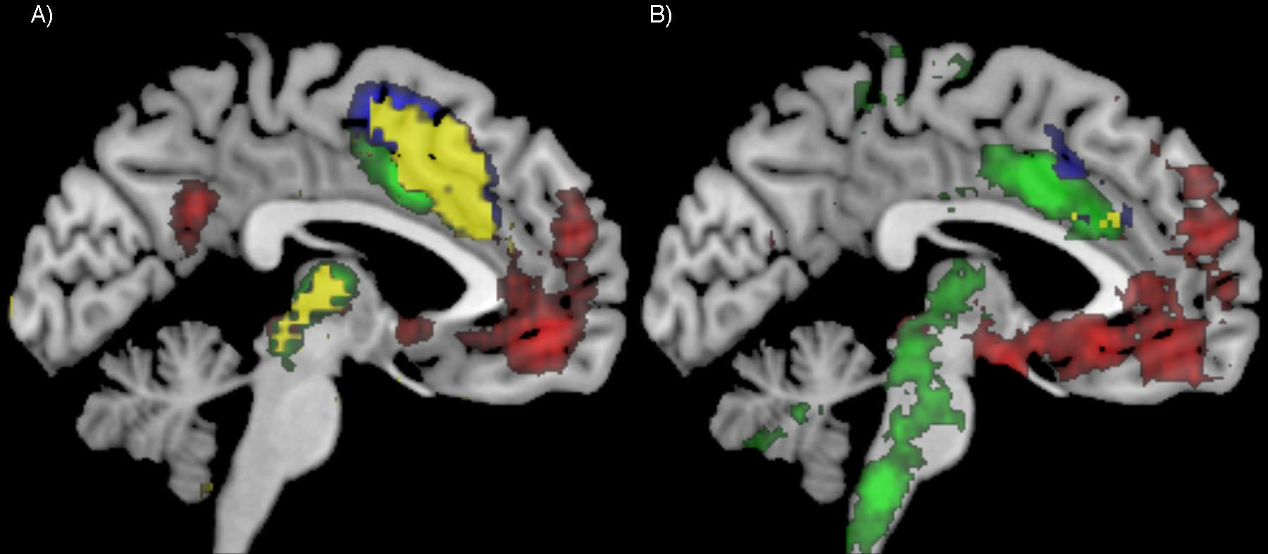

*Figure 1. Meta-analysis of pain (green), cognitive control (blue) and negative affect (red). Overlap shown in yellow. A) Forward inference (probability of activation given term) shows a large region of overlap between these processes. B) Reverse inference (probability of term given activation) shows much less overlap, suggesting these dACC shows additional topographical heterogeneity.*

An additional roadblock in is the lack of established means of investigating for functionally separable regions across dACC and medial frontal cortex more broadly. While there have been several efforts to define subregions on the basis of cytoarchitectonics (Vogt et al., 2005), resting-state functional fMRI connectivity (Kim, Lee, Jo, Kim, Lee, Kim, et al., 2010; Kahnt, Chang, Park, Heinzle, & Haynes, 2012), and diffusion tensor imaging (Yu, Zhou, Liu, Jiang, Dong, Zhang, et al. 2011Liu, Qin, Li, Fan, Wang, Jiang, et al. 2013), these measures are limited in their ability to directly link regions to cognitive functions. While these measures have been shown to predict functional dissociations during tasks (Beckman, Johansen-Berg, & Rushworth, 2009; Honey, Thivierge & Sporns, 2010; Mennesa, Zuoa, Di Martinoa, Biswala, Castellanosa, & Milhama, 2010), and can be suggestive of a region’s function-- for example, a region connected to the amygdala is likely to be involved in affective processes-- such measures are nonetheless indirect proxies of cognitive function.

Fortunately the recent development of large-scale neuroimaging databases, such as Neurosynth (Yarkoni et al., 2011) and BrainMap (Fox, Laird, Fox, Fox, Uecker, Crank, Koenig, & Lancaster, 2005) and allow scientists to take advantage of the wealth of functional MRI studies our field has amassed to systematically map cognitive functions onto anatomy-- without focusing on a narrow subset of phenomena. However, existing efforts to generate structure to function mappings have typically focused either on network level characterizations of the whole brain (Smith, Fox, Miller, Glahn, Fox, Mackay et al., 2009) or have focused on other regions (e.g. the insula; see Chang, Yarkoni, Khaw, & Sanfer, 2012).

Here, we applied applied machine-learning algorithms to Neurosynth, a diverse database of nearly 10,000 fMRI studies, in order to explore whether it is possible to define and characterize separable units in dACC that support different mental functions. In order to avoid casting too narrow of a net, we avoided defining dACC *apriori*, and instead applied the following methods to the entire medial frontal cortex (mFC) including SMA, pre-SMA, mPFC, and the entire anterior cingulate gyrus. First, we profiled individual mFC voxels on the basis of their meta-analytic functional coactivation with the rest of the brain-- a meta-analytic measure shown to reflect instinct organization akin to resting-state functional connectivity (Toro, Fox, & Paus, 2008; Robinson, Laird, Glahn, Lovallo, & Fox, 2010). Next, we grouped voxels with similar meta-analytic coactivation patterns into putatively functionally homogenous regions using k-means clustering, arriving at a stable solution of nine mFC regions. We then functionally characterized the resulting clusters using predictive modeling by determining which cognitive functions best predicted activity in each individual cluster, finding a large amount of functional specialization in dACC and mFC more generally. Finally, we quantified functional diversity across mFC clusters by determining how many cognitive functions were necessary to accurately predict brain activity, finding that regions ranged from very low to very high complexity.

Together, our analyses suggest that existing theoretical models underspecify the functional topography of dACC, confounding the cingulate cortex proper with regions dorsal to it better characterized as pre-SMA. While our results support the view that dACC is well situated for the integration of affective signals with cognitive motoric control, we suggest a division of labor such that dACC proper is specialized in the monitoring and initial cortical processing of affective signals, while rostral pre-SMA-- often referred to as dACC-- modifies high-level behavioral plans and goals, to reduce conflict. We also find evidence that caudal portions of dACC and pre-SMA specialize in actually implementing motoric plans, consistent with classic cytoarchitectonic and tracing work in primates. Finally, we also find evidence for specialization of affect within dACC, with caudal dACC specializing in the integration of negative affect, especially pain, and rostral dACC specializing in appetitive affect.

# Methods

### Neuroimaging Database

We analyzed the Neurosynth database (neurosynth.org), a repository of 9,721 fMRI studies and over 350,000 activations. Each observation in the database contains the peak activations for all contrasts reported in a study’s table as well as the frequency of all of the words in the article abstract.

### Medial frontal cortex coactivation clustering

We clustered voxels in the medial frontal cortex based on their coactivation with other voxels in the brain. We calculated how frequently each mFC voxel coactivated across neuroimaging studies with all other voxels in the entire brain. Voxels that across a large number of studies were found to consistently coactivate received high coactivation coefficients while those voxels that did not consistently activate in the same studies -- and are presumably involved in a different tasks and cognitive functions -- received low coactivation coefficients. We then applied an unsupervised clustering algorithm to group voxels with similar coactivation profiles into regions. Following recent work comparing the performance of multiple clustering algorithms, we used k-means clustering as this algorithm is computationally efficient, commonly used, and shows high goodness of fit and reproducibility (Thirion, Varoquaux, Dohmatob, & Poline, 2014).

Because structure-to-function mappings can be identified at multiple scales, with potentially different (but equally valid) results, we conducted our analyses at multiple levels of spatial resolution. We parcellated the mFC into into 2 through 10 regions. Selecting a ‘correct’ number of clusters can be difficult because equally valid groupings of units can occur across different spatial resolutions. However, we attempted to objectively select the number of clusters using the silhouette score, a measure of within-cluster cohesion. Solutions that minimized the average distance between voxels within each cluster recieved a greater score.

### Coactivation profiles of mFC clusters

Because whole-brain coactivation was difficult to visualize for many clusters (e.g. more than 5), we calculated the coactivation between mFC seed regions and whole-brain ROIs. We employed a set of ROIs from a 40-region whole-brain coactivation clustering using the approach laid out above; 40 regions were used because they struck a balance between anatomical specificity and interpretability, approximating the number of regions in Brodmann’s classic anatomical divisions. mFC clusters were removed from the whole brain ROIs, so as to examine connectivity of the mFC specifically with the rest of the brain. This process resulting in 34 regions, and the mean coactivation between mFC regions and each ROI was calculated.

### Functional profiles of mFC clusters

For each cluster, we built a linear model to predict if that region would be activated by an fMRI study based on the semantic content of the words used to describe the focus of that fMRI study. This procedure allowed us to generate functional profiles that describe which cognitive functions best predicted the activity of each region, and how well fMRI activity can be explained by the cognitive ontology present in the body of fMRI studies at the meta-analytic level.

*Topic modeling.* Although the term-based meta-analysis maps in Neurosynth closely resemble the results of manual meta-analyses of the same concepts (e.g. Yarkoni et al., 2011; Bartra, McGuire & Kable 2013), there is a high degree of redundancy between terms (e.g. ‘episodes’ and ‘episodic’) and potential ambiguity as to the meaning of an individual word out of context (e.g. ‘memory’ can indicate working memory or episodic memory). To remedy this dilemma, we employed a reduced semantic representation of the latent conceptual structure underlying the neuroimaging literature: a set of 60 topics derived using latent dirichlet allocation topic-modeling (see Poldrack, Mumford, Schonberg, Kalar, Barman, & Yarkoni, 2012). The generative topic model derives 60 independent topics from the co-occurrence across studies of the 8067 terms in Neurosynth. Each resulting topic loads onto individual words to a varying extent, facilitating the interpretation of topics; for example, a working memory topic loads highest on the words 'memory, WM, load', while an episodic memory topic loads on 'memory, retrieval, events'. Note that both topics highly load on the word “memory”, but the meaning of this word is disambiguated because it is contextualized by other word that strongly load onto that topic. Likewise, as each topic maps onto individual studies to a varying extent, the topic model facilitates the categorization of the cognitive phenomena studied across fMRI studies; for example, a study that maps highly onto a topic described by the words 'control, inhibition, conflict’ is likely to be examining cognitive control. Out of the 60 generated topics, 25 represented non-cognitive semantic topics, such as the nature of the subject population (e.g. gender, special populations) and methods (e.g., words such as “images”, “voxels”. In order to focus on the cognitive predictors of brain activity, we identified these topics and excluded them from following analyses (see Appendix for a list of included and excluded topics).

*Predictive modeling of activity using cognitive functions.* We generated functional profiles of mFC regions by determining which cognitive functions best predicted their activity across fMRI studies. First, we determined whether or not each study in the database activated each mFC region. Activations were represented as 0s (not active) and 1s (active). For each region, we trained a regularized linear regression with an L2-penalty--or ridge regression--to predict if that region was activated (or not) based on the cognitive topics describing the fMRI studies. We chose ridge regression as it is well suited for multivariate regression with many, potentially collinear predictor (large predictor coefficients are penalized, resulting in a more generalizable and stable solution than using ordinary least squares). We used the weight in the regression for each topic as a measure of how predictive different cognitive functions were of activity for each region. Positive weights indicate that the presence of that topic in a study increases the likelihood a study activated that region, while negative weights indicate a decreased likelihood of that region being active.

In addition, we assessed our model’s ability to predict if a study activated a region, given the content of the study. In other words, if we know what cognitive topic a study is about, how well can we predict if it activates a specific region? We employed 4-fold cross validation to test the generalization of our models. Models were fitted on 3/4ths of studies and tested on the remaining studies. This procedure was repeated four times, circulating over the studies so that the model was trained and tested on the entire dataset. The mean score across the 4-fold tests were used as the final measure of performance. We scored the models by calculating r-squared-- or how much variance in activity was explained by the cognitive functions described in fMRI studies.

*Functional complexity.* We quantified the complexity of function in order to determine if mFC regions are involved in a diverse range of cognitive functions. We operationalized regions with heterogenous function as those that required a larger number of topics to accurately predict their activity, while regions with more homogenous function are those that would require fewer topics to correctly classify. We started by fitting the simplest possible model and attempting to predict activity for each region only using the topic that had the greatest weight in the complete model. We then assessed the benefit of including additional topics by sequentially adding topics as predictors (up to 35) to the model in order of their importance in the full model.

# Results

### Clusteringk_3_12_newlabls.jpg

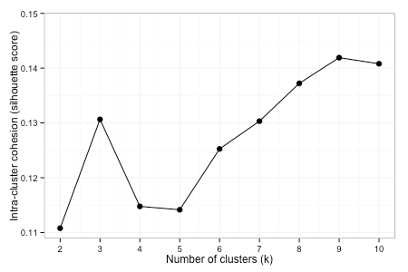

*Figure 1. (top) Coactivation based k-means clustering of the medial frontal cortex . Voxels of the mFC were grouped together into clusters based on their coactivation coefficients with all other voxels in the brain; voxels that activated in similar studies with similar voxels across the brain grouped into regions. (bottom) mFC was clustered into 2-10 regions. On average, intra-cluster cohesion increased with the number of clusters and showed either a substantial increase or a local peak using 3, 6, and 9 clusters. SMA: supplementary motor area; SMAr: SMA rostral; SMAc: SMA caudal; pSMAc: caudal pre-SMA; pSMAr: rostral pre-SMA; dACC: dorsal anterior cingulate cortex; dACCc: dACC caudal; dACCr: dACC rostral; mPFC: medial prefrontal cortex; rmPFC: rostromedial PFC; vmPFC: ventromedial PFC.*

Clustering mFC resulted in distinct, spatially contiguous regions despite that no spatial constraints were imposed on the algorithm (Figure 1a). In order to determine an appropriate number of clusters, we used the silhouette score to quantify intra-cluster cohesion. Silhouette scores peaked using 9 clusters, but also reached a local maxima with 3 regions. To explore how the clustering evolved as the number of clusters increased, we also discuss the results using 6 regions.

At the coarsest level using 3 clusters, the medial frontal cortex divided into three large clusters: a posterior cluster encompassing the supplementary motor area (SMA), a middle cluster composed of dorsal ACC and pre-SMA, as well as an anterior cluster encompassing medial prefrontal cortex. Using 6 clusters, we found that SMA separated into rostral and caudal subdivisions, consistent with cytoarchitectonic evidence (Vorobiev & Luppino, 1998; Luppino, 1993). SMA delineated from a more rostral cluster, presumably pre-SMA, around 4mm rostral to the vertical line transversing the anterior commissure (VCA line; y=0 in MNI and Talairach coordinates). This delineation between SMA and pre-SMA is anatomically consistent with cytoarchitectonic and resting-state functional connectivity (Picard and Strick, 1996; Rizzolatti, Fadiga, Matelli, Bettinardi, Paulesu, Perani, & Fazio, 1996; Kim et al., 2011) based parcellations, which separate these regions a few millimeters rostral of the VCA. This pre-SMA cluster cleanly separated from a ventral parcel which was neatly located in the posterior portion of the ACC proper-- often referred to as dorsal ACC or midcingulate cortex (Vogt et al., 2005). Notably, while dACC spanned most of the cingulate sulcus, it did not extend dorsally into the paracingulate gyrus or superior frontal gyrus, consistent with cytoarchitectonic definitions of the cingulate. Using 9 clusters, we found additional fine-grained topographical organization. Most notably, both pre-SMA and dACC broke down into rostral and caudal subregions. dACC’s caudal and rostral subdivisions showed high spatial correspondence with Vogt’s anterior and posterior midcingulate subregions (Vogt et al., 2005).

Dorsal to pre-SMA and, we found an additional parcel that separated from rmPFC and largely encompassed the medial aspects of the the superior frontal gyrus. In both rmPFC and vmPFC we did not find evidence for a dissociation between the anterior cingulate proper (pre- and sub-genual) and medial prefrontal cortex, suggesting they show largely similar coactivation patterns with the rest of the brain.

**Meta-analytic coactivation profiles**

*Figure 3. Coactivation of nine mFC clusters to selected regions across the rest of the brain. Coactivation between each mFC cluster and 34 regions across the brain was calculated and the 8 regions that varied the most in their coactivation across mFC regions were selected for display. Darker colors represent greater coactivation between two regions. NAcc: Nucleus Accumbens; pCC/AG: posterior cingulate cortex & angular gyrus; daInsula: dorsal anterior Insula; IFG: inferior frontal gyrus; IPL: Inferior Parietal Lobule; dSomatosensory: dorsal somatosensory cortex; dMotor: dorsal motor cortex; vMotor: ventral motor cortex. All regions are bilateral. See appendix II for coordinates of whole-brain ROIs.*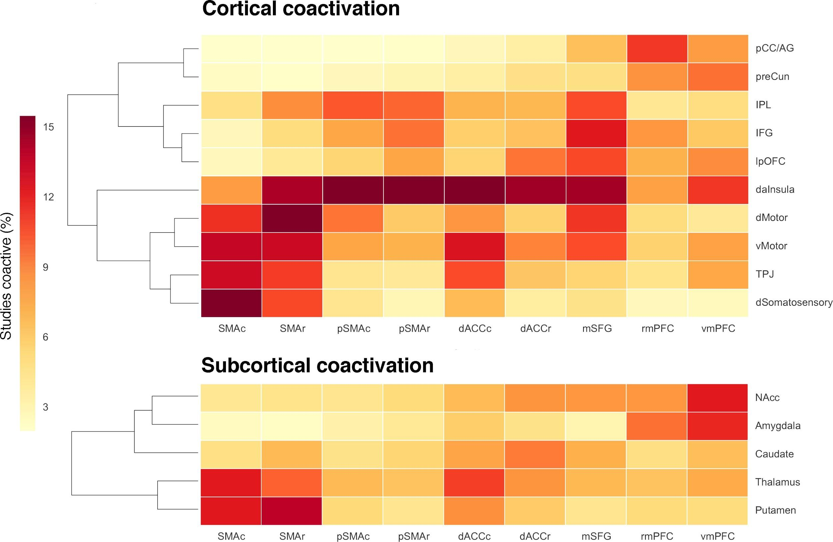

We analyzed the coactivation pattern of each mFC parcel with the rest of the brain, demonstrating that each of these subregions is associated with distinct functional networks. In Figure 3, we plot the strength of coactivation between each of the nine clusters we identified and key ROIs from the rest of the brain. It can be clearly observed that at a broad scale, SMA shows a distinct pattern with strong coactivation with regions important for motor function, including cortical regions such as motor and somatosensory cortices, and subcortical regions important for sensation and action such as the thalamus and caudate. We also observed subtle differences between caudal and rostral SMA; notably caudal SMA showed greater coactivation with somatosensory cortex while rostral SMA showed greater coactivation with motor cortex.

Anterior to SMA, pre-SMA showed markedly lower coactivation with motoric regions and greater coactivation with regions in the frontoparietal control network (e.g. inferior parietal lobule (IPL) and inferior frontal gyrus (IFG)), consistent with the long-held hypothesis that pre-SMA does not directly implement motoric plans, but is important for modulating high-level motor goals, in concert with lateral frontal regions. Dorsal ACC showed a similar overall coactivation pattern, but with distinctly lower coactivation with frontoparietal regions. However, dACC shows much greater coactivation with subcortical regions, in particular the thalamus and portions of the basal ganglia, and to a lesser extent the nucleus accumbens (NAcc) and amygdala. We also found differences between the caudal and rostral subregion of pre-SMA and dACC. Both caudal pre-SMA and caudal dACC showed greater coactivation with regions important for motor function, such as motor cortex. Caudal dACC in particular showed much greater coactivation with motor cortex and the thalamus, consistent with work highlighting the importance of this region--also known as the cingulate motor zone-- in precise movement (xxx, xxx). Finally, rostral pre-SMA and dorsal dACC showed greater coactivation with regions important for reward-driven learning, such as lateral orbitofrontal cortex (lOFC) and to a lesser extent, NAcc.

Further anterior, mPFC showed a drastically different pattern, coactivating with regions of the default network, such as posterior cingulate cortex, angular gyrus, and medial temporal cortex (Buckner, Andrews-Hanna, Schacter, 2008; Andrews-Hanna, 2012) and subcortical regions, such as NAcc and amygdala. rmPFC in particular strongly coactivated with default network regions, supporting with its role as a local hub in this network.. vmPFC on the other hand showed the highest coactivation in all of mFC with NAcc and amygdala, consistent with previous findings of direct projections from to vmPFC to these subcortical regions (McDonald & Guo, 1996). Finally, lying dorsal to pre-SMA and posterior to rmPFC, mSFG showed a pattern of coactivation that resembled a mixture between pre-SMA/MCC and mPFC. mSFG showed moderate with default network regions and nucleus accumbens, while also showing robust coactivation with motor cortex and IFG.

### 

### 

### Meta-analytic functional specialization

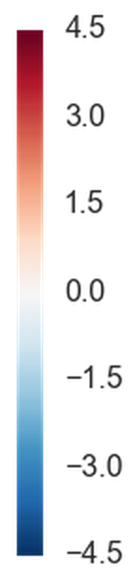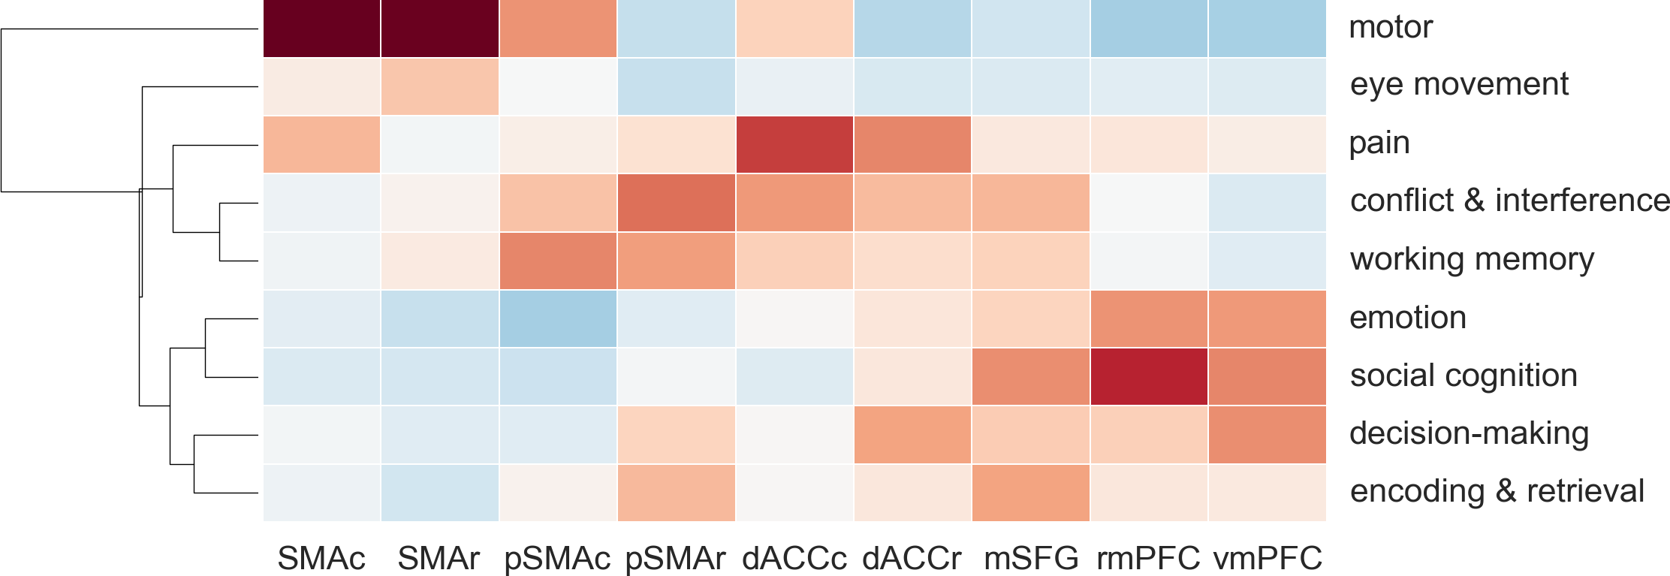

*Figure 4. Regions in medial prefrontal cortex were predicted by a wide range of cognitive functions. Positive values (in red) indicate that a function was predictive of activity in a given region, while negative values indicate that a function was anti-correlated with activity. Model weights were z-scored across all observations for interpretability. For display purposes, we only included two most predictive topics for each region, resulting in 9 topics, overall.*

Next, we took advantage of the diverse range of cognitive functions represented in Neurosynth to determine which cognitive functions best predicted activity in each mFC parcel. To do this, we examined which cognitive topics differentiated studies that activated a region from those that didn’t for each individual parcel. In Figure 4, we display the abbreviated functional profiles for these regions, selecting only the set of topics that best predicted activity for each parcel. Mirroring the pattern of functional connectivity discussed above, both SMA parcels were involved in motoric processing to a much greater extent than even the nearest region, caudal pre-SMA. Activity in SMA was also predicted by gaze movements, consistent with the finding that SMA coactivates with the frontal eye fields.

Anterior to SMA, we observed a distinct shift in functional specialization away from motor function and towards higher level cognitive processes. To take a closer look at the functional differences between pre-SMA and dACC, we display a more detailed functional profile for just for these regions in Figure 5. Activity across all four regions was predicted by aspects of cognitive control--working memory, switching, and conflict/interference--suggesting that these regions all play an important role in executive function. However, certain aspects of cognitive control, namely switching and working memory, were more strongly associated with pre-SMA whereas conflict was robustly associated with both pre-SMA and dACC, peaking in rostral pre-SMA and caudal dACC. Affective processes, however, were much more selectively predictive of dACC activity, showing very weak associations with pre-SMA.

We also found evidence for rostrocaudal functional distinctions in both pre-SMA and dACC. Both caudal dACC and caudal pre-SMA were more strongly associated with motor function than their rostral counterparts, consistent with their strong coactivation with other motoric regions. In addition, both rostral dACC and caudal pre-SMA were more strongly associated with decision-making than the other two regions, while rostral dACC was more strongly associated with reward processing than the other three regions. These findings suggest that rostral aspects of dACC and pre-SMA may be important for integrating reward driven learning into conflict adaptation. Also notable was the distinction that while dACC activates during both cognitive and affective processes, pre-SMA, and most especially caudal pre-SMA is not associated with affective processes.

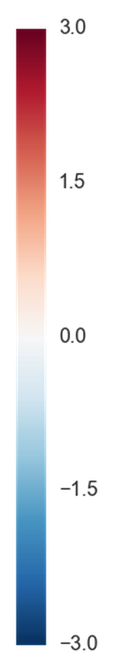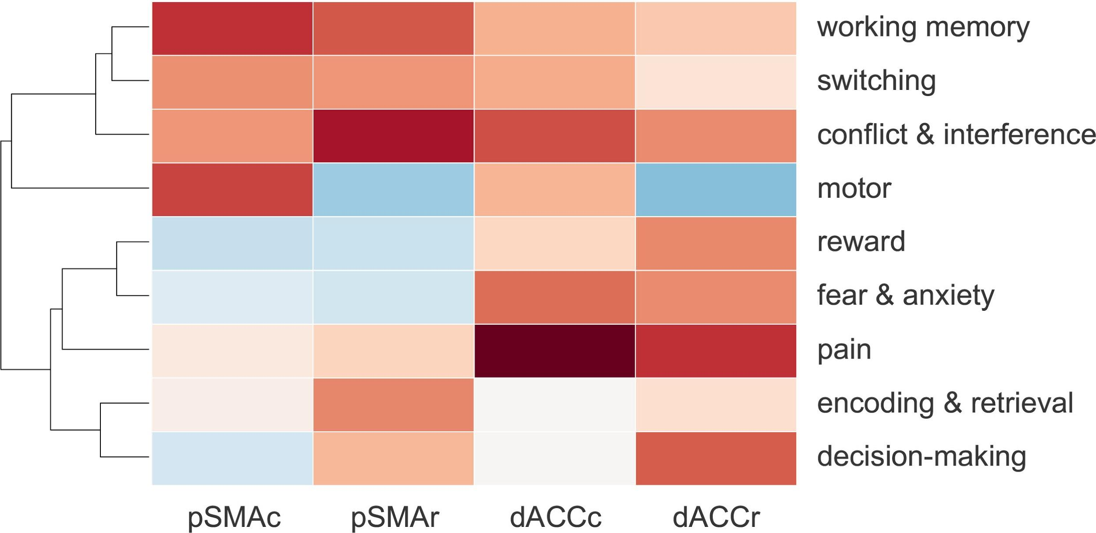

*Figure 5. To look at the functional specialization of pre-SMA and MCC in more detail, we selected the 4 topics most strongly associated with each of these regions, resulting in 9 total topics. Affective processes are mostly encountered in MCC, while pre-SMA is more strongly associated with high-level executive function processes. Caudal MCC and pre-SMA are more strongly associated with motor processes while rostral MCC and pre-SMA are associated with decision-making. Positive values (in red) indicate that a function was predictive of activity in a given region, while negative values indicate that a function was anti-correlated with activity.*

Further anterior, mPFC showed a distinct shift away from externally oriented processes, such as cognitive control, motor function and pain, and towards internal, self-oriented processes, such as decision-making, social processing, and episodic memory, as well as emotion. Within mPFC we found evidence for functional specialization. rmPFC was primarily predicted by social processing and to some extent episodic memory, consistent with its role as a primary region of the default network. Activity in vmPFC was even more strongly predicted by episodic memory, and additional decision-making and fear processing, suggesting this region was more involved in emotion-related processes. Finally, the mSFG the showed a unique pattern, as activity in this region was predicted by both external and internal processes, perhaps serving as a link between these fundamentally different cognitive domains. Surprisingly, mSFG was weakly associated with motor function despite its strong coactivation with motor cortex.

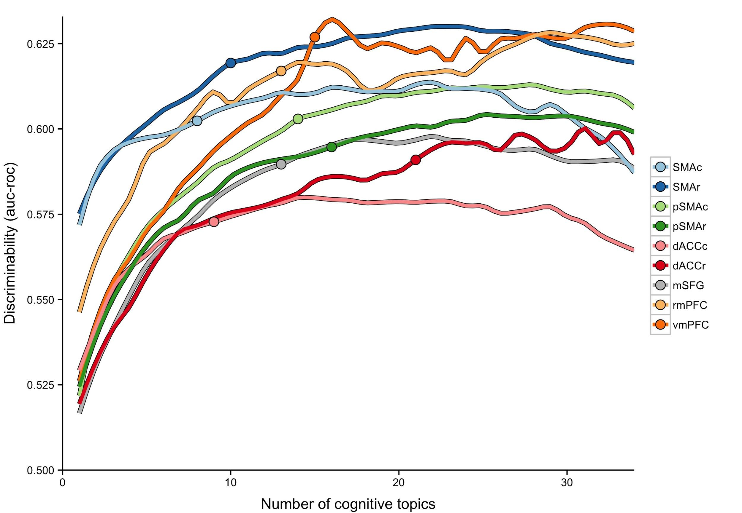

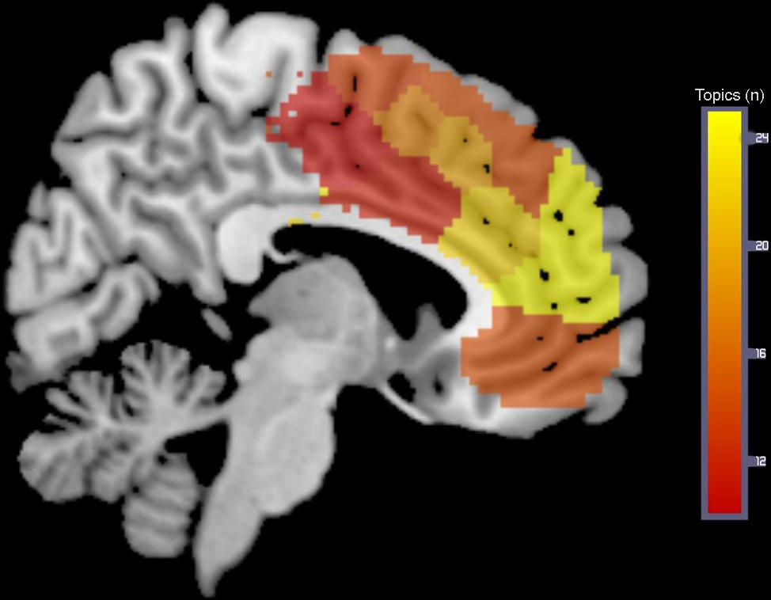

*Figure 4. Regions of mFC varied widely in functional complexity. (Top) As the number of cognitive functions in the model were increased (x-axis) the amount of variance in activity that could be explained (y-axis) also increased for all regions. However, regions varied in the number of topics required to reach maximum discriminability; the point at which ‘near-maximum’ discriminability (within 5%) is reached is indicated by a point for each region. (Bottom) Number of topics to reach near-maximum discriminability plotted on a sagittal brain slice for each region.*

### Functional complexity

Next, we quantified the diversity of function observed across mFC by determining how complex our predictive models needed to be in order to predict activity for each region (Figure 4). Not surprisingly, activity in all regions was predicted with greater accuracy as the number of cognitive functions in the model increased, reaching peak performance on average with 20 functions. However, mFC regions varied in two key aspects: maximum discriminability, and the number of topics required to reach this maximum. The maximum discriminability reached reflects how well overall a region’s function is explained by the cognitive ontology we employed while the number of topics required to reach this maximum reflects the complexity of function observed in each region.

The most posterior regions in mFC showed the lowest functional complexity; this was perhaps not surprising for regions such as SMA which are fairly specifically focused on motor function. Both SMA parcels also reached very high level of discriminability with just a few topics; in fact, we are able to discriminate activity in SMAc 40% near its maximum using only a single topic: motor function. We observed wide variability in complexity between pre-SMA and dACC. Caudal dACC showed both low complexity and low maximum discriminability, suggesting this region is involved in a relatively circumscribed set of functions. Both pre-SMA and rostral dACC in particular showed markedly greater complexity, suggesting these regions may be key sites of multimodal integration. Further anterior, rmPFC showed the greatest functional complexity, consistent with its role as a hub in the default network (Buckner et al., Andrews-Hanna et al., 2010, 2012)

# Discussion

In the current study, we identified three broad functional areas in medial frontal cortex on the basis of their functional coactivation with other regions in the brain, and found that these areas support distinct cognitive processes. The most posterior area, SMA, was found to be fairly specifically focused on motoric processes; the middle area, pre-SMA/dACC, showed a diverse functional pattern integrating affective signals with cognitive control and higher-level motoric planning; while the most anterior area, anterior medial frontal cortex, supported internally oriented processes--such as memory and social processing-- and their integration with affective signals, such as fear and reward. Importantly, we found evidence for fine-grained functional topography within each of these areas--especially so in pre-SMA and dACC-- that is supported by each region's unique coactivation with the rest of the brain.

***SMA, pre-SMA and dACC***

Our meta-analytic coactivation parcellation is generally consistent with prior cytoarchitectonic (Vogt et al., 2005, Vorobiev et al., 1998; Luppino, 1993), tractography (Klein et la.,), and resting-state functional connectivity (Kim et al.,) based parcellations which find a clear distinction between SMA and pre-SMA a few millimeters rostral of the VCA line. Moreover, consistent with more fine grained cytoarchitectonic evidence, we find that SMA breaks down into rostral and caudal subdivisions, both of which show strong coactivation with regions important for motoric output (e.g. thalamus, somatosensory and primary motor cortex). Functionally, both rostral and caudal SMA are strongly implicated in motoric processing--consistent with direct corticospinal connections observed in tracing studies (Hutchins, Martino, & Strick, 1988) -- and show scant associations with higher level cognitive processes.

Anterior to SMA, we find strong evidence for a functional dissociation between pre-SMA, located in the paracingulate gyrus, and dACC, located in cingulate cortex proper. While pre-SMA and dACC showed somewhat similar coactivation patterns--leading to their grouping at low clustering resolutions (e.g. k = 3)-- these regions readily formed their own parcels when the number of clusters was increased. Consistent with cytoarchitectonic studies, we find that caudal dACC demarcates from caudal pre-SMA along the cingulate sulcus, while rostral portions of dACC and pre-SMA separate more dorsally, closer to the paracingulate sulcus (Vogt et al., 2005). While both regions were moderately involved with executive and affective processes, activity in dACC was much more strongly predicted by affective processes (e.g. fear, reward, and in particular, pain) whereas activity in pre-SMA was more strongly predicted by high-level cognitive processes (e.g. conflict, working memory, and memory encoding). The functional specialization of these regions is consistent with their coactivation patterns: dACC robustly coactives with regions known to be efferents of affective signals (e.g. thalamus, basal ganglia), while pre-SMA coactives with regions in the frontoparietal network known to support executive function (e.g. superior parietal lobule, inferior frontal gyrus).

The dissociation between pre-SMA and dACC found in our data suggests that current models of cognitive motoric control underspecify the functional topography in pre-SMA and dACC, and misattribute many observed functions to dACC, when in fact they are likely supported by pre-SMA. The majority of influential theories of cognitive motoric control, such as the conflict monitoring hypotheses, consider dACC to be the region primarily responsible for the integration of affective signals with motoric control to detect conflict (Botvnick et al., 2001, 2004; Shackman et al. 2012) and strictly define pre-SMA as the region immediately anterior to SMA, primarily responsible for the modulation of behavior. However, concerns have previously been raised that macaques primarily show conflict related activity in pre-SMA and not dACC, unlike humans (Nakamura, Roesch & Olson, 2005; Rushworth, Walton, Kennerley, Bannerman et al., 2004; Cole, Yeung, Freiwald, & Botvinick, 2009). Our results suggest that this is true of humans as well. The ventral parcels we identified located in the cingulate proper are much more weakly associated with conflict and cognitive control in general, and instead seem primarily focused on the cortical integration of affective signals.

These results are consistent with a hypotheses put forth by Cole et al., (2009), suggesting that humans have a unique portion of anterior cingulate (BA 32’) not seen in monkeys that uniquely detects non-motor decision conflict. However, the parcels we identified as pre-SMA are likely too far dorsal to be considered as part of the the cingulate proper and considering them dACC would leave no candidate regions that appear to be pre-SMA. One may argue that the far dorsal parcel, mSFG, may reflect pre-SMA while the parcels we identified as pre-SMA are in fact dACC. However, mSFG has a negative association with motoric processing, seemingly at odds with pre-SMA presupposed role in motoric function. Our results suggest that BA 32’ is more akin to pre-SMA, consistent with its strong resting state functional connectivity with frontoparietal control regions, such as DLPFC and posterior parietal cortex (Fair, Dosenbach, Church , Cohen, Brahmbhat, Miezin, Barch, Petersen & Schlaggar, 2007; Seeley, Menon, Schatzberg, Keller, Glover, Kenna, Reiss & 2007). However, the anatomy of BA 32’ is widely variable in humans; 30-50% of humans have a double cingulate in at least one hemisphere (Paus, 2001); thus more detailed investigations with higher spatial resolution, such as high-resolution resting state connectivity, are needed to determine if BA 32’ is best characterized as a rostral extension of pre-SMA, or a dorsal extension of ACC.

Our results also suggest that rostral and caudal portions of pre-SMA and MCC specialize in integrating different types of affective signals into cognitive motoric control. Caudal MCC, with its strong association with pain and well-documented noxious efferents from subcortical regions, is well situated to integrate these negative signals into behavioral adaptations. Given caudal MCC’s strong associations with motoric processing, it is possible this region is able to directly implement motoric action if the noxious stimulus is strong enough to warrant it. On the other hand, rostral MCC, with its robust association with reward processing and coactivation with NAcc and lateral OFC, likely serves as the entry point of positive reinforcers to support the learning of appetitive behaviors that previously resulted in reward. Importantly, rostral pre-SMA’s association with decision-making and similar coactivation with lOFC (but not NAcc) implicates it in the contextualization of the low-level reward signals present in rostral MCC. Neither rostral pre-SMA or MCC are likely to directly implement these changes to behavior directly, as they show low association with motoric processes and lack the direct corticospinal connections required. Thus, its likely that rostral pre-SMA implements behavioral adaptations at a high level while caudal portions implement more fine-grained motoric plans. SMA, with its direct corticospinal connections, is likely to then directly implement these plans into actual movement.

**Anterior medial prefrontal cortex**

Further anterior we found that mFC broke down into three regions important for different aspects of internal mentation. The two most anterior of these, vmPFC and dmPFC, were only associated with internal processes, such as social cognition, and episodic memory. However, only vmPFC showed a robust association with affective processes-- decision-making, fear and negative emotion-- consistent with previous more fine grained meta-analyses (e.g. Phan, Wager, Taylor, & Liberzon, 2002). These affective processes were supported by strong coactivation with subcortical efferents of these signals-- nucleus accumbens and amygdala respectively. vmPFC’s exceptionally high functional diversity suggests that this region is important for integrating raw affective signals with higher-level internally-oriented information. On the other hand, dmPFC showed relatively specific associations with internal mentations and the default network, consistent with findings that this area serves as a local, not global, hub in the default network.

The most dorsal of the three, mSFG, showed functional and coactivation patterns suggesting that this region serves to link internal and external cognition. Activity in mSFG was predicted by both internal (e.g. social cognition) and external (e.g. cognitive control) cognitive functions and coactivated with both the default network and cognitive control regions, such as IFG and dorsal anterior insula. This unique mixture functional properties of two distinct, and typically anticorrelated, domains suggests the novel hypothesis that this far dorsal mPFC is important for adjusting external behavior with respect to internally oriented goals and processes. Given that this region’s activity was the most poorly predicted by our cognitive ontology, there is reason to believe that more research is needed to generate fine grained theories of this region’s function.

***Limitations***

While our large-scale meta-analytic approach to revealing mFC function allows us to comprehensively synthesize a plethora of fMRI findings, there are several limitations. First, our approach is limited by the low spatial resolution in fMRI and the inability to disentangle individual differences in anatomy across subjects. In particular, it is difficult to precisely localize each of our clusters onto gyri and sulci; this is particularly problematic in dorsal ACC, where BA 32’ lies only a few millimeters dorsal of BA 24. Thus, while our results suggest this region, important for resolving conflict, is better characterized as a rostral subdivision of pre-SMA on the basis of its coactivation with the rest of the brain, high-resolution studies, such as high-resolution resting-state imaging or single cell recordings, may find that this region is anatomically better characterized as lying in cingulate cortex proper. Nonetheless, regardless of where this region lies, its clear that there is a strong functional distinction between ventral and dorsal portions of pre-SMA / dACC.

Second, the cognitive ontology that we derived using topic modeling is relatively simple-- based purely on term frequencies-- and is unable to distill more nuanced differences between cognitive processes. Creating a more fine-grained ontology, of course, is very difficult and will take targeted efforts to improve. Similarly, due to the lack of data sharing found in the fMRI literature, we’ve had to rely on only the peak reported coordinates in fMRI papers. While many of these limitations are overcome by the sheer number of studies in the database--many more than what is found in hand-curated databases-- large-scale data mining efforts such as these will be greatly helped by the future proliferation of data-sharing in our community. Large scale hand curated meta-analyses that encompass a wider range of domains may also help in the ability to more accurately categorize the processes present in studies (e.g. Lindquist, Wager, Kober, Bliss-Moreau, & Barrett, 2012).

Finally, while our approach is designed to find a common functional pattern across many studies for individual regions, if there is little agreement about the function of a region-- as can be the case for regions with debated functions-- our approach will fail to find a consistent pattern. In this case, it will be unclear if a region shows low specialization because it is truly functionally diverse and supports a basic process underlying many functions, or because scientists use many different words to describe a similar phenomena. This may explain why activity in regions with well-characterized and circumscribed functions, such as SMA, is much better predicted by the cognitive topics than in regions such as ACC. However, future studies can explicitly quantify the semantic ambiguity found across the brain in order to determine which regions are characterized worse by a cognitive ontology in order to target them for future study using novel fMRI tasks. The functions that are predictive can also provide hints as to what the functional specialization of these regions is.

**References**

Alexander, W. H., & Brown, J. W. (2011). Medial prefrontal cortex as an action-outcome predictor. Nature neuroscience, 14(10), 1338-1344.

Amunts, K., Schleicher, A., Bürgel, U., Mohlberg, H., Uylings, H., & Zilles, K. (1999). Broca's region revisited: cytoarchitecture and intersubject variability. Journal of Comparative Neurology, 412(2), 319-341.

Andrews-Hanna, Jessica R. "The brain’s default network and its adaptive role in internal mentation." The Neuroscientist 18.3 (2012): 251-270.

Andrews-Hanna, J.R., Reidler, J.S., Sepulcre, J., Poulin, R. & Buckner, R.L. (2010). Functional-anatomic fractionation of the brain’s default network. Neuron, 65: 550-562.

Banich, M. T. (2009). Executive function the search for an integrated account. Current Directions in Psychological Science, 18(2), 89-94.

Bartra, O., McGuire, J. T., & Kable, J. W. (2013). The valuation system: A coordinate-based meta-analysis of BOLD fMRI experiments examining neural correlates of subjective value. NeuroImage, 76, 412–427. doi:10.1016/j.neuroimage.2013.02.063

Beckmann, M., Johansen-Berg, H., & Rushworth, M. F. (2009). Connectivity-based parcellation of human cingulate cortex and its relation to functional specialization. The Journal of Neuroscience, 29(4), 1175-1190.

Behrens, T. E., Woolrich, M. W., Walton, M. E., & Rushworth, M. F. (2007). Learning the value of information in an uncertain world. Nature neuroscience, 10(9), 1214-1221.

Buckner, Randy L, Jessica R Andrews‐Hanna, and Daniel L Schacter. "The brain's default network." *Annals of the New York Academy of Sciences* 1124.1 (2008): 1-38.

Botvinick, M. M., Braver, T. S., Barch, D. M., Carter, C. S., & Cohen, J. D. (2001). Conflict monitoring and cognitive control. Psychological review, 108(3), 624.

Botvinick, M. M., Cohen, J. D., & Carter, C. S. (2004). Conflict monitoring and anterior cingulate cortex: an update. Trends in cognitive sciences, 8(12), 539-546.

Buckner, R. L., Andrews Hanna, J. R., & Schacter, D. L. (2008). The Brain's Default Network. Annals of the New York Academy of Sciences, 1124(1), 1–38. doi:10.1196/annals.1440.011

Bush, G., Luu, P., & Posner, M. I. (2000). Cognitive and emotional influences in anterior cingulate cortex. Trends in Cognitive Sciences, 4(6), 215–222. doi:10.1016/S1364-6613(00)01483-2

Carter, C. S., Braver, T. S., Barch, D. M., Botvinick, M. M., Noll, D., & Cohen, J. D. (1998). Anterior cingulate cortex, error detection, and the online monitoring of performance. Science, 280(5364), 747-749.

Chang, L. J., Yarkoni, T., Khaw, M. W., & Sanfey, A. G. (2012). Decoding the role of the insula in human cognition: functional parcellation and large-scale reverse inference. Cerebral Cortex, bhs065.

Etkin, A., Egner, T., & Kalisch, R. (2011). Emotional processing in anterior cingulate and medial prefrontal cortex. Trends in Cognitive Sciences, 15(2), 85–93. doi:10.1016/j.tics.2010.11.004

Fair, Damien A et al. "Development of distinct control networks through segregation and integration." *Proceedings of the National Academy of Sciences* 104.33 (2007): 13507-13512.

Feja, Malte, and Michael Koch. "Frontostriatal systems comprising connections between ventral medial prefrontal cortex and nucleus accumbens subregions differentially regulate motor impulse control in rats." Psychopharmacology (2014): 1-12.

Fox PT, Laird AR, Fox SP, Fox PM, Uecker AM, Crank M, Koenig SF, Lancaster JL. BrainMap taxonomy of experimental design: Description and evaluation. Hum Brain Mapp 25, 185-198, 2005.

Ghazizadeh, Ali et al. "Prefrontal cortex mediates extinction of responding by two distinct neural mechanisms in accumbens shell." The Journal of Neuroscience 32.2 (2012): 726-737.

Honey, Christopher J, Jean-Philippe Thivierge, and Olaf Sporns. "Can structure predict function in the human brain?." *Neuroimage* 52.3 (2010): 766-776.

Hutchins, K. D., Martino, A. M., & Strick, P. L. (1988). Corticospinal projections from the medial wall of the hemisphere. Experimental Brain Research, 71(3), 667–672. doi:10.1007/BF00248761

Kahnt, T., Chang, L. J., Park, S. Q., Heinzle, J., & Haynes, J.-D. (2012). Connectivity-Based Parcellation of the Human Orbitofrontal Cortex. Journal of Neuroscience, 32(18), 6240–6250. doi:10.1523/JNEUROSCI.0257-12.2012

Kim, J.-H., Lee, J.-M., Jo, H. J., Kim, S. H., Lee, J. H., Kim, S. T., et al. (2010). Defining functional SMA and pre-SMA subregions in human MFC using resting state fMRI: Functional connectivity-based parcellation method. NeuroImage, 49(3), 2375–2386. doi:10.1016/j.neuroimage.2009.10.016

Liu, H., Qin, W., Li, W., Fan, L., Wang, J., Jiang, T., & Yu, C. (2013). Connectivity-Based Parcellation of the Human Frontal Pole with Diffusion Tensor Imaging. Journal of Neuroscience, 33(16), 6782–6790. doi:10.1523/JNEUROSCI.4882-12.2013

Lindquist, K. A., Wager, T. D., Kober, H., Bliss-Moreau, E., & Barrett, L. F. (2012). The brain basis of emotion: A meta-analytic review. Behavioral and Brain Sciences, 35(03), 121–143. doi:10.1017/S0140525X11000446

Luppino, G. (1993). Corticocortical connections of area F3 (SMA-proper) and area F6 (pre-SMA) in the macaque monkey, 1–27.

McDonald, A. J., Mascagni, F., & Guo, L. (1996). Projections of the medial and lateral prefrontal cortices to the amygdala: a Phaseolus vulgaris leucoagglutinin study in the rat. Neuroscience, 71(1), 55–75. doi:10.1016/0306-4522(95)00417-3

Mohanty, A., Engels, A. S., Herrington, J. D., Heller, W., Ringo Ho, M.-H., Banich, M. T., et al. (2007). Differential engagement of anterior cingulate cortex subdivisions for cognitive and emotional function. Psychophysiology, 44(3), 343–351. doi:10.1111/j.1469-8986.2007.00515.x

Nakamura, K., & Roesch, M. R. (2005). Neuronal activity in macaque SEF and ACC during performance of tasks involving conflict. Journal of …..

McDonald, A. J., Mascagni, F., & Guo, L. (1996). Projections of the medial and lateral prefrontal cortices to the amygdala: a Phaseolus vulgaris leucoagglutinin study in the rat. Neuroscience, 71(1), 55–75. doi:10.1016/0306-4522(95)00417-3

Mennes, M., Kelly, C., Zuo, X.-N., Di Martino, A., Biswal, B. B., Castellanos, F. X., & Milham, M. P. (2010). Inter-individual differences in resting-state functional connectivity predict task-induced BOLD activity. NeuroImage, 50(4), 1690–1701. doi:10.1016/j.neuroimage.2010.01.002

Paus, T. (2001). Primate anterior cingulate cortex: where motor control, drive and cognition interface. Nature Reviews Neuroscience.

Phan, K. L., Wager, T., Taylor, S. F., & Liberzon, I. (2002). Functional Neuroanatomy of Emotion: A Meta-Analysis of Emotion Activation Studies in PET and fMRI. NeuroImage, 16(2), 331–348. doi:10.1006/nimg.2002.1087

Picard, N., & Strick, P. L. (1996). Motor Areas of the Medial Wall: A Review of Their Location and Functional Activation. Cerebral Cortex, 6(3), 342–353. doi:10.1093/cercor/6.3.342

Poldrack, R. A., Mumford, J. A., Schonberg, T., Kalar, D., Barman, B., & Yarkoni, T. (2012). Discovering relations between mind, brain, and mental disorders using topic mapping. PLoS computational biology, 8(10), e1002707.

Power, J. D., & Petersen, S. E. (2013). Control-related systems in the human brain. Current opinion in neurobiology, 23(2), 223-228.

Power, J. D., Cohen, A. L., Nelson, S. M., Wig, G. S., Barnes, K. A., Church, J. A., et al. (2011). Functional network organization of the human brain. Neuron, 72(4), 665-678.

Rizzolatti, G., Fadiga, L., Matelli, M., Bettinardi, V., Paulesu, E., Perani, D., & Fazio, F. (1996). Localization of grasp representations in humans by PET: 1. Observation versus execution. Experimental Brain Research, 111(2), 246–252. doi:10.1007/BF00227301

Robinson, J. L., Laird, A. R., Glahn, D. C., Lovallo, W. R., & Fox, P. T. (2010). Metaanalytic connectivity modeling: Delineating the functional connectivity of the human amygdala. Human Brain Mapping, 31(2), 173–184. doi:10.1002/hbm.20854

Rolls, E. T., O'Doherty, J., Kringelbach, M. L., Francis, S., Bowtell, R., & McGlone, F. (2003). Representations of Pleasant and Painful Touch in the Human Orbitofrontal and Cingulate Cortices. Cerebral Cortex, 13(3), 308–317. doi:10.1093/cercor/13.3.308

Rizzolatti, G., Fadiga, L., Matelli, M., Bettinardi, V., Paulesu, E., Perani, D., & Fazio, F. (1996). Localization of grasp representations in humans by PET: 1. Observation versus execution. Experimental Brain Research, 111(2), 246–252. doi:10.1007/BF00227301

Rushworth, M., Walton, M. E., & Kennerley, S. W. (2004). Action sets and decisions in the medial frontal cortex. Trends in Cognitive …. doi:10.1016/j.tics.2004.07.009

Rushworth, M. F., & Behrens, T. E. (2008). Choice, uncertainty and value in prefrontal and cingulate cortex. Nature neuroscience, 11(4), 389-397.

Seeley, W. W., Menon, V., Schatzberg, A. F., Keller, J., Glover, G. H., Kenna, H., et al. (2007). Dissociable intrinsic connectivity networks for salience processing and executive control. The Journal of neuroscience, 27(9), 2349-2356.

Sesack, Susan R, and Virginia M Pickel. "Prefrontal cortical efferents in the rat synapse on unlabeled neuronal targets of catecholamine terminals in the nucleus accumbens septi and on dopamine neurons in the ventral tegmental area." *Journal of Comparative Neurology* 320.2 (1992): 145-160.

Shackman, A. J., Salomons, T. V., Slagter, H. A., Fox, A. S., Winter, J. J., & Davidson, R. J. (2011). The integration of negative affect, pain and cognitive control in the cingulate cortex. Nature Reviews Neuroscience, 12(3), 154-167.

Smith, S. M., Fox, P. T., Miller, K. L., Glahn, D. C., Fox, P. M., Mackay, C. E., et al. (2009). Correspondence of the brain's functional architecture during activation and rest. Proceedings of the National Academy of Sciences, 106(31), 13040-13045.

Toro, R., Fox, P. T., & Paus, T. (2008). Functional Coactivation Map of the Human Brain. Cerebral Cortex, 18(11), 2553–2559. doi:10.1093/cercor/bhn014

Thirion, B., Varoquaux, G., Dohmatob, E., & Poline, J. (2014). Which fMRI clustering gives good brain parcellations?. Frontiers in Neuroscience, 8, 167.

Treede, R.-D., Kenshalo, D. R., Gracely, R. H., & Jones, A. K. P. (1999). The cortical representation of pain. Pain, 79(2), 105–111. doi:10.1016/S0304-3959(98)00184-5

Vorobiev, V., & Luppino, G. (1998). Parcellation of human mesial area 6: cytoarchitectonic evidence for three separate areas, 1–5.

Wager, T. D., Lindquist, M., & Kaplan, L. (2007). Meta-analysis of functional neuroimaging data: current and future directions. Social Cognitive and Affective Neuroscience, 2(2), 150–158. doi:10.1093/scan/nsm015

Wager, T. D., Atlas, L. Y., Lindquist, M. A., Roy, M., Woo, C.-W., & Kross, E. (2013). An fMRI-Based Neurologic Signature of Physical Pain. New England Journal of Medicine, 368(15), 1388–1397. doi:10.1056/NEJMoa1204471

Wallis, J. D., & Kennerley, S. W. (2010). Heterogeneous reward signals in prefrontal cortex. Current Opinion in Neurobiology, 20(2), 191–198. doi:10.1016/j.conb.2010.02.009

Yarkoni, T., Poldrack, R. A., Nichols, T. E., Van Essen, D. C., & Wager, T. D. (2011). Large-scale automated synthesis of human functional neuroimaging data. Nature methods, 8(8), 665-670.

Yu, C., Zhou, Y., Liu, Y., Jiang, T., Dong, H., Zhang, Y., et al. (2011). Functional segregation of the human cingulate cortex is confirmed by functional connectivity based neuroanatomical parcellation. Neuroimage, 54(4), 2571-2581.

# 

# Appendix I

## Cognitive Topics

Name of topics as given by authors in left columns. Topics used in primary figures are italicized.

|  |  |  |  |  |  |
| --- | --- | --- | --- | --- | --- |
| **Topic Name** | **Five highest loading words** | | | | |
| stress | stress | awareness | experience | conscious | cortisol |
| *eye movements* | eye | gaze | movements | eyes | visual |
| *decision-making* | decision | choice | risk | decisions | choices |
| reasoning | reasoning | rule | rules | intelligence | complexity |
| sensory | visual | auditory | sensory | modality | integration |
| spatial | spatial | location | mental | space | virtual |
| repetition priming | repetition | priming | hearing | repeated | suppression |
| feature detection | visual | category | adaptation | color | features |
| *episodic memory* | memory | events | imagery | autobiographical | retrieval |
| object recognition | object | objects | visual | recognition | familiar |
| *motor function* | motor | movement | movements | sensorimotor | primary |
| attention | attention | attentional | visual | spatial | target |
| learning | learning | training | performance | practice | sequence |
| *social cognition* | social | empathy | moral | person | judgments |
| tms/stimulation | stimulation | somatosensory | tms | primary | tactile |
| mathematics | arithmetic | numerical | mental | magnitude | calculation |
| sentence comprehension | sentences | comprehension | sentence | language | syntactic |
| *reward* | reward | anticipation | monetary | responses | rewards |
| error processing | feedback | error | learning | errors | prediction |
| *switching* | cues | target | trials | cue | switching |
| audition | auditory | speech | sounds | music | sound |
| *emotion* | emotional | emotion | negative | neutral | facial |
| language | language | speech | production | fluency | asymmetry |
| reading | reading | word | words | phonological | chinese |
| *conflict & interference* | conflict | interference | control | incongruent | trials |
| semantic | semantic | words | word | lexical | knowledge |
| *inhibition* | inhibition | control | inhibitory | stop | motor |
| *encoding & retrieval* | memory | encoding | retrieval | recognition | episodic |
| motor action | action | actions | motor | observation | mirror |
| *fear & anxiety* | fear | anxiety | threat | responses | conditioning |
| food | food | taste | body | weight | eating |
| *working memory* | memory | performance | cognitive | wm | tasks |
| motion perception | motion | visual | perception | body | human |
| *pain* | pain | painful | stimulation | somatosensory | intensity |

## Non-Cognitive Topics Non-cognitive topics were not named, and are instead numbered.

|  |  |  |  |  |  |
| --- | --- | --- | --- | --- | --- |
| **Topic #** | **Top five loading words** | | | | |
| 35 | women | sex | gender | females | males |
| 36 | placebo | pet | tomography | emission | dopamine |
| 37 | schizophrenia | controls | risk | reduced | deficits |
| 38 | condition | conditions | tasks | control | performance |
| 39 | ad | disease | mci | alzheimer | atrophy |
| 40 | individuals | cognitive | individual | control | behavioral |
| 41 | wm | fractional | integrity | tracts | diffusivity |
| 42 | lesions | controls | patient | lesion | stroke |
| 43 | human | humans | organization | located | primates |
| 44 | network | role | evidence | human | distinct |
| 45 | network | resting | default | mode | rest |
| 46 | frequency | source | alpha | amplitude | beta |
| 47 | pd | controls | disease | clinical | motor |
| 48 | disorder | adhd | bipolar | controls | ocd |
| 49 | depression | mdd | depressed | disorder | depressive |
| 50 | images | standard | time | voxel | image |
| 51 | time | sustained | delay | phase | period |
| 52 | alcohol | acupuncture | cocaine | users | drug |
| 53 | volume | gray | voxel | gm | morphometry |
| 54 | effective | causal | network | dynamic | modeling |
| 55 | carriers | allele | gene | genotype | genetic |
| 56 | ptsd | social | game | attachment | trauma |
| 57 | asd | autism | social | reho | controls |
| 58 | age | adults | children | adolescents | sleep |
| 59 | features | free | sensitivity | classifier | feature |
| 60 | responses | stimulus | effect | design | neuronal |