Functional specialization in the medial prefrontal cortex

Alejandro de la Vega

The functional specialization of medial prefrontal cortex is greatly debated in part due to the wide variety of cognitive functions that active this region. Medial prefrontal cortex (mPFC) has been found to activate in fMRI for processes ranging from motoric function, cognitive control, a wide range of emotions such as pain and fear, reward processing, social cognition and memory. Medial prefrontal cortex is so widely involved across cognition that some portions are among the most commonly activated regions in the brain (Yarkoni et al., 2011). In particular, regions anterior of the supplementary motor area (SMA), such as pre-SMA, anterior midcingulate cortex (aMCC) and pregenual sections of anterior cingulate cortex (ACC) are activate in a large portion of neuroimaging tasks-- as high as in 10% of all studies.

This great functional diversity has naturally resulted in a plethora of theories, many of which propose that these regions implement core processes underlying many tasks. For example, a prominent set of related theories claim that portions of the cingulate are involved in signaling errors (Carter et al., 1998) and conflict (Botvinick et al., 2004) during information processing which trigger compensatory cognitive control in order to improve subsequent performance. More recently it has also been argued that emotional processes observed in nearby tissue are not functionally segregated from cognitive control processes; on the contrary, aMCC is thought integrate afferent reinforcers from subcortical areas to modulate cognitive control (Shackman et al., 2011). Emotional signals indicating behavioral failures , such as pain and negative emotions, trigger increased cognitive control, which in turn guides changes in motor plans in future behavior. A possible explanation for aMCC’s high activation frequency is that integrating modulatory signals to control motoric behavior is a very common demand of many tasks, leading to its involvement across a wide range of tasks.

However, evidence from network analyses of resting state functional connectivity data suggest that anterior MCC divides into two regions that are part of distinct networks: a posterior region which groups with a cingulo-opercular control network, with connections to other cognitive control regions, and a posterior region that groups with a saliency network, with robust connectivity to limbic and subcortical structures. (Seeley et al., Power et al., ). The posterior portion is presumably more involved in implementing cognitive motor control whereas the anterior portion is involved in autonomic arousal that can promote overall reactivity to stimuli. Under this theory, the portions of aMCC in the saliency network are likely to be involved across many tasks, not those implementing cognitive motoric control.

Complicating the specification of aMCC’s function is the lack of established functional units. Unlike sensory processing areas of the brain, such as visual cortex, there is no consensus division into functionally separable regions. There have been efforts made to define mPFC subregions on the basis of anatomical landmarks, such as gyri and sulci, as well as changes in cytoarchitectonics across cortex; however, there is not a clear correspondence between these boundaries and cognitive functions (Amunts et al., 1999). As an alternative, MRI methods measuring structural connectivity (diffusion tensor imaging) and functional connectivity (resting state fMRI), have been used to profile voxels and segregate them into distinct regions or networks. While these approaches are useful for understanding mPFC’s connectivity to the rest of the brain, regions with similar connectivity profiles may diverge in functions. Moreover, while connectivity patterns can hint at a regions function-- a region highly connected to the amygdala is likely involved in emotion-- connectivity is an indirect proxy of function.

In this present paper, we set out to create an atlas of functional separable regions of medial prefrontal cortex by using Neurosynth, a diverse database nearly 10,000 fMRI studies, to determine which cognitive functions best predict activity across voxels. We then used an unsupervised clustering algorithm to group voxels into regions based on their functional, not connectivity, profiles. Then for each mPFC region, we describe which functions best predict activity across studies to examine their functional specialization and test the hypothesis that aMCC breaks down into separate regions implementing cognitive motoric control and saliency arousal. Next, we calculate diversity of function by determining how many cognitive functions are necessary to accurately predict activity for each region, in order to determine which mPFC regions high functional diversity.

# Methods

*Database*. We analyzed the Neurosynth database (neurosynth.org), a repository of 9,721 fMRI studies and over 350,000 activations. Each observation in the database contains the peak activations for all contrasts reported in a study’s table as well as the frequency of all of the words in the article abstract. Activations are smoothed using an 8mm gaussian kernel.

*Topic modeling.* Although the term-based meta-analysis maps in Neurosynth closely resemble the results of manual meta-analyses of the same concepts (e.g. Yarkoni et al., 2011, Bartra et al., 2013), there is a high degree of redundancy between words (e.g. ‘memory’ and ‘episodic’) and potential ambiguity as to the meaning of an individual word out of context. Thus, we employed a set of 60 topics derived using latent dirichlet allocation topic-modeling (see Poldrack et al., 2012). The resulting topics reflect the underlying semantic structure of neuroimaging studies and produce more robust meta-analytic maps. Each topic loads onto the words in the database to a varying extent, and the words that load highest for a topic reflect the meaning of that topic; for example, a working memory topic loads highest on the words 'memory, WM, load', while an episodic memory topic loads on 'memory, retrieval, events' (see Appendix I for a full list of topics). In turn, every study loads to every topic to a varying degree, reflecting the semantic content of the paper; for example, a study about cognitive control would likely load highly to a topic described by the words 'control, inhibition, conflict'.

*Functional profile of voxels.* We used the following method to profile voxels across the entire brain on the basis of which functions best predict their activity using a cross-validated regularized linear regression. For each unit, we queried Neurosynth to determine which studies activated that voxel; since activations in the database are smoothed, values were continuous between 0 (not activate) and 1 (active). Next, we trained a regularized linear regression with an L2-penalty--or ridge regression--to predict if studies activated that voxel based on the semantic content of the study; ridge regression is well suited for classification with many co-linear features: large coefficients are penalized, resulting in a dense yet stable solution. We used the regression weights for each topic (‘Activation likelihood’) as a measure of how predictive each cognitive functions was of activity in a given voxel. Positive weights indicate that the presence of that topic in a study predicts the study activated that voxel, while negative weights indicate the the presence of that topic negatively predicts the study activating the voxel.

*Clustering analyses.* We used these functional profiles that described how strongly each cognitive function predicted each voxels activity to cluster voxels into regions; voxels with similar functional profiles would be grouped together into regions. Because structure-to-function mappings can be identified at multiple scales, with potentially different (but equally valid) results, we conducted our analyses at multiple levels of spatial resolution. Specifically, we parcellated the brain into into 20, 30 and 40 regions. Following recent work comparing the performance of multiple clustering algorithms (Thirion et al), we used the Ward algorithm for clustering. Consistent with the topology of the human brain, clusters consisted of contiguous voxels with very little “speckling”. Some clusters were composed of two distinct spatially contiguous regions (e.g. PCC and anterior mPFC) that showed similar functional profiles (see Appendix II for visualization of parcellations). We focused the rest of the analyses on clusters that contained voxels on the medial wall of frontal cortex.

*Predictive functional profiles of mPFC regions.* Once having grouped voxels with similar functional profiles together, we again used Ridge regression to describe the mean functional profile of each mPFC region. Similarly to before, we queried Neurosynth to give us a value of how strongly each region was activated by each study-- by taking the mean of all the voxels in each region-- and used Ridge regression to determine which cognitive functions best predict activity for each region.

In addition, we assessed our models’ ability to predict activity for each given voxel by testing their ability to predict activation for a region on unseen studies, given their semantics, using 4-fold cross validation. Regressions were fitted on 3/4ths of studies and tested on the remaining studies; this was repeated four times, circulating over the studies so that the model was trained and tested on the entire dataset (the mean score was used as the final measure of performance). We scored the models by calculating r-squared-- or how much activation variance for a given region was explained by the semantics (e.g. cognitive functions) across studies in the database

*Functional complexity.* We quantified the heterogeneity of function among mPFC regions in order to determine if mPFC regions are involved in a diverse range of cognitive functions. We estimated how well each region's activity could be predicted using a smaller set of functions, starting with only 1 topic and sequentially adding functions until we had a complete model using 60 topics. We then measured how many features were required to reach near maximum levels of predictive accuracy for each region; regions that required ,more cognitive functions to successfully predict their activity were presumably more heterogenous in function. We quantified the steepness of this curve by measuring the area under the curve of these heterogeneity functions; regions with greater areas reached near maximum performance with fewer features.

# Results

### Clustering

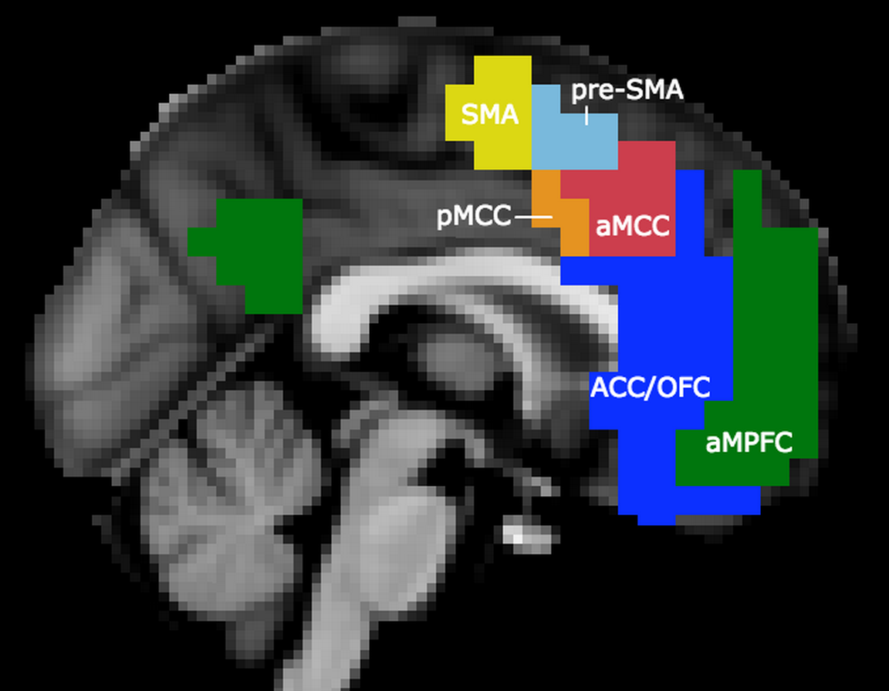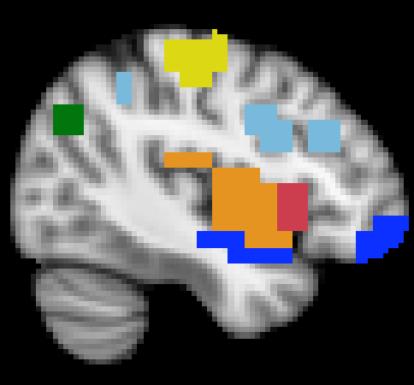

*Figure 1. (Left) Medial prefrontal cortex clusters from a 30-region whole brain parcellation based on voxels’ functional profiles. Clusters were labeled to be consistent with anatomical literature. Supplementary motor area (SMA), anterior SMA (pre-SMA), posterior and anterior mid cingulate cortex (MCC), anterior cingulate cortex / orbitofrontal cortex (ACC/OFC) and anterior medial prefrontal cortex (aMPFC). (Right) All clusters included voxels with similar functional profiles outside of the medial prefrontal cortex.*

Clustering voxels based on function into 30 regions across the brain resulted in 6 clusters that contained voxels on the surface of the medial prefrontal cortex (Figure 1). Within the medial prefrontal cortex, the resulting clusters were composed of contiguous voxels that did not bleed into neighboring clusters, despite that no spatial constraints were included in the clustering algorithm. However, many of these clusters also included voxels outside of the mPFC, indicating they shared similar functional profiles with regions outside of mPFC.

The most posterior cluster was positioned in the supplementary motor area (SMA), and also included voxels in the bilateral postcentral gyrus. The next cluster, pre-SMA, was positioned immediately anterior to SMA and included voxels in the left dorsolateral prefrontal cortex. Consistent with prior anatomical and resting-state definitions, neither SMA or pre-SMA included voxels ventral to the cingulate sulcus and the two regions were separated vertically by the anterior commissure line (separation at y = 3) (Kim, et al., 2011, [Picard and Strick, 1996](http://www.ncbi.nlm.nih.gov/pmc/articles/PMC2819173/#R38), [Rizzolatti et al., 1996](http://www.ncbi.nlm.nih.gov/pmc/articles/PMC2819173/#R43), [Zilles et al., 1996](http://www.ncbi.nlm.nih.gov/pmc/articles/PMC2819173/#R52)). The next two clusters, positioned inferior to the pre-SMA, encompassed much of the mid-cingulate cortex. Importantly, these two clusters separated despite being very close to each other and previously being grouped together in previous studies (Hoffstaedter et al., 2014). Despite being separated based on their functional profiles, these two midcingulate clusters included similar voxels outside of the medial prefrontal cortex; the posterior midcingulate cortex (pMCC) included voxels in posterior insula, going as far posterior as the parietal operculum whereas the anterior midcingulate cortex (aMCC), included more anterior aspects of the insula. The division of the midcingulate cortex into two clusters is consistent with previous distinctions between the cingulo-opercular and saliency networks made using graph theoretic resting state analyses (Power et al, ; other Petersen citations).

The two remaining clusters occupied much of ventromedial prefrontal cortex. The more posterior of the two (ACC/OFC) included most of anterior cingulate cortex, including subgenual aspects, much of the orbital surface of the orbitofrontal cortex, and extended ventrally into the temporal cortices, including parts of the parahippocampal gyrus. The most anterior cluster from our solution, anterior medial prefrontal cortex (aMPFC), extended into frontal pole, but stopped short of including the entire region, and included voxels of the posterior cingulate cortex and angular gyrus, consistent with previous observations that these regions are core members of the default network. However, few other regions of the default network, such as the hippocampus, clustered together with medial prefrontal regions, suggesting that they may be subcomponents that play different roles in a larger network.

### Functional profiles

Activity in different regions of the medial prefrontal cortex is predicted by a wide-range of cognitive processes (Figure 2). SMA activity, unsurprisingly, was strongly predicted by motor related processes, and only weakly predicted by other functions, such as pain, stimulation and sensory processes.

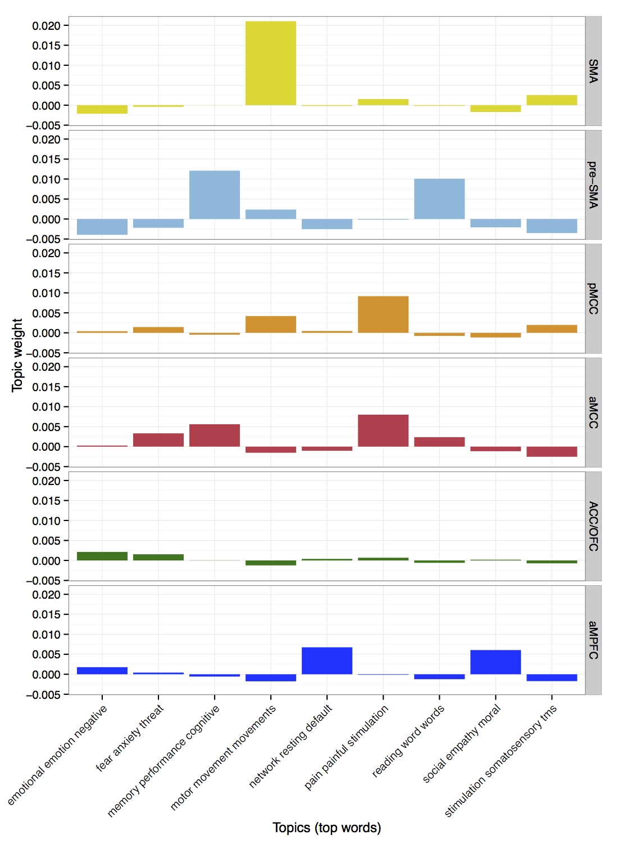

*Figure 2. Regions in medial prefrontal cortex showed vastly different functional profiles and varying amounts of associations with different cognitive functions. The x-axis represents how much a given cognitive function predicts activity for each mPFC region. Greater values indicate strong predictive ability, while negative values indicate that a function anti-predicts activity for that region. For each region, we display the two topics that best predict their activity, in addition to all other regions’ top two topics.*

In contrast, activity pre-SMA is only weakly predicted by motor processes but is strongly predicted by more cognitive topics such as executive function and language processes, such as reading and speech. Despite being slightly predicted by motor processing, pre-SMA was anti predicted-by a topic about stimulation and somatosensory, suggesting pre-SMA does not directly modulate any motoric processes. Similarly to SMA, pre-SMA was also anti-predicted by emotional and social processes (e.g. “emotional”, “negative”; “fear” “anxiety”), making them the only mPFC regions negatively associated with these processes.

The two midcingulate clusters showed limited commonalities in their functional patterns. Activity in both was strongly predicted by painful stimulation, consistent with MCC and insula’s known role in integrating sensory information and pain processing (citations). However, the similarities largely ended there. Posterior MCC activity was additionally predicted by motor processes and non-painful stimulation, whereas activity in anterior MCC was actually negatively predicted by both of those processes. Moreover, activity in anterior MCC was predicted by cognitive processes, such as reading and executive function, whereas posterior MCC wasn’t. These differences suggest anterior MCC is involved in higher level processing whereas posterior MCC is more involved in the integration of sensations and movements.

The two ventromedial prefrontal clusters also showed somewhat similar functional profiles. Activity in both regions was weakly predicted by emotional processes and negatively predicted by somatosensory and motoric processes. However, only activity in aMPFC was predicted by a default network network topic, social processes and episodic imagery whereas ACC/OFC wasn’t. Strikingly, ACC/OFC was not strongly predicted by any one process, suggesting this region may be involved in a wide variety of processes.

In addition to determining which functions best predicted activity in each region, we determined how well activity across regions of the mPFC could be predicted by the semantics in neuroimaging studies. In other words, across regions of mPFC, how well does our existing cognitive ontology allow us to predict if a region will activate? Activity in regions of mPFC more involved in motor functions, such as pMCC and SMA, was best explained by cognitive semantics; in fact, activity in SMA was the best explained across the entire brain. Despite its close spatial proximity, activity in pre-SMA/DLPFC was the most poorly explained by cognitive semantics, followed by activity in ACC/OFC. This likely reflects how semantically accessible the function of these regions is. In particular, pre-SMA/DLPFC are thought to be involved in instantiating high-level goals and exerting top-down control; this abstract process may be more difficult to explain using our existing ontology of cognitive processes as it is less grounded in specific tasks and elemental processes in contrast to SMA. The activity in the remaining MPFC regions was explained at average levels.

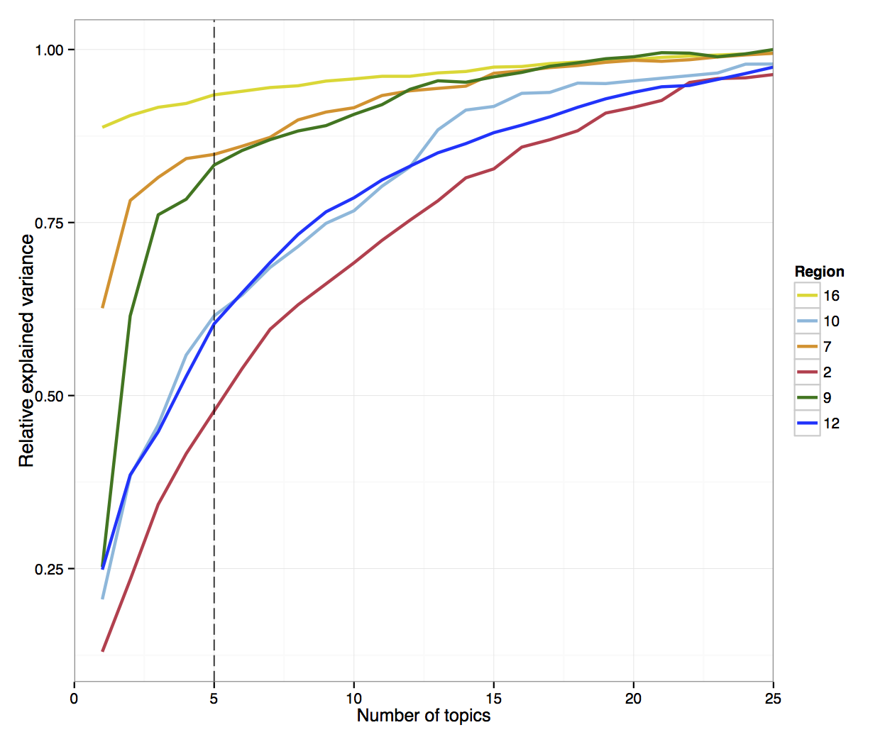

*Figure 3. Regions of mPFC varied widely in functional complexity. (Left) Functional complexity was determined by how many features (x-axis) were necessary for accurate for prediction of activity relative to each regions maximum explained variance (y-axis). Across all regions, activity was better predicted using more cognitive topics, but some regions (e.g. aMCC) required more functions to reach similar levels of prediction accuracy as others that required fewer (e.g. SMA). Darker colors indicate greater complexity. We summarized the rate that predictive accuracy increased as a function of number of functions using the area under the curve between 0 and 5 topics and plotted this value on the brain (Right).* Since regions reached near maximum predictions after 25 topics, plot is abridged for illustrative purposes.

**Functional complexity.** Next, we quantified the diversity of function observed across mPFC by determining how complex our predictive models needed to be in order to accurately predict activity for each region (Figure 3). As expected, activity in all regions was predicted with greater accuracy as the number of cognitive functions in the model increased, reaking peak performance with around 32 topics. However, the rate at which regions’ activity could be predicted near peak accuracy varied greatly. SMA showed among the lowest functional complexity across the whole brain; a single cognitive topic, motoric function, was responsible for explaining 87% of the possible variance in that region. The neighboring pMCC was also very homogenous; two topics, motoric function and pain, explained over 75% of the explainable activity in that region. More surprisingly, aMPFC showed relatively average heterogeneity, despite claims that this region is high in diversity and its purported role as a hub in the default network. In contrast, the remaining MPFC regions required relatively complex models to predict their activity accurately. In fact, aMCC (& Insula) showed the highest complexity across the entire brain, while pre-SMA and ACC/OFC were in the top 20 percentile of the brain.

Importantly, functional complexity was not simply driven by frequency of activation. Functional complexity did not correlate with activation frequency (proportion of studies active) across the whole brain (using 30 regions; r = .2, p = .28) or in the mPFC regions (r = .335, p = 0.5).

### Discussion

In the current study, we identified functionally separable regions of the medial prefrontal cortex by profiling voxels based on which cognitive functions best predict their activity, and grouping together voxels with similar functional profiles. By defining regions on the basis of function, rather than connectivity measures, we aimed to differentiate medial prefrontal regions that may often confused as a larger region. We then described the functions of these resulting regions and estimated their functional complexity-- or how many cognitive functions were necessary to describe their range of activity. Doing so allowed us to determine the degree of specialization in mPFC, and identify which regions were relatively heterogenous. Subregions of mPFC varied substantially in both their functional profiles and their overall complexity.

Generally, we found that more posterior regions of mPFC were more involved in motoric processes whereas more anterior regions were more involved in emotion and social processing. In particular, the supplementary motor area (SMA) was very narrowly focused on motoric function, with a large portion of its variance in activity being explained by this single cognitive function. We were also able to separate more anterior portions of the medial wall, dorsal and posterior of vmPFC, into three distinct regions: pre-SMA, and anterior and posterior mid cingulate cortex. pre-SMA showed a peculiar pattern because despite being spatially close to SMA, activity in pre-SMA was only slightly predicted by motoric function, and not at all predicted by emotional processes including pain. pre-SMA was strongly predicted by high level cognitive processes, such as executive function and reading, suggesting that this region primary role is to implement top down control. This is consistent with hypotheses that pre-SMA modules the motoric processes that are implemented by SMA. pre-SMA also showed very high functional complexity, suggesting that this region is involved a wide range of tasks and processes, consistent with its role in cognitive control and as part of the flexible frontoparietal control network.

We found that the midcingulate cortex broke down into two functionally separable subregions: a posterior and anterior division. Both regions grouped with voxels in the insula; pMCC grouped with the posterior insula and operculum while aMCC grouped with anterior insula. These divisions are consistent with prior resting state MRI graph networks that grouped pMCC with the operculum, as a part of the cingulo-opercular network, and aMCC with the insula, as a purported “salience network”. It was suggested that the cingulo-opercular network plays a role in cognitive control while the saliency network plays a role in autonomic arousal. However, our functions profiles suggest the opposite: we found that activity in the anterior MCC is robustly predicted by cognitive control while posterior MCC is not.

Instead, our findings suggest that the midcingulate cortex is composed of two functionally separable regions that play distinct roles in integrating negative signals-- in particular pain-- with cognitive control and motoric processes. Activity in both regions was robustly predicted by pain, while posterior MCC was also predicted by motoric processes and anterior MCC was predicted by cognitive control. Importantly, no single region was predicted by motor, cognitive control and pain, suggesting that no single portion of mPFC integrates all three sources of information. Instead, we propose that posterior portions of MCC provide a direct route to modulate motor actions while anterior portions indirectly modulate behavior by enacting additional cognitive control. This dual integration of pain signals may be important for reacting to potentially harmful stimuli at different time scales; posterior portions may be actuate immediate responses while anterior portions increase cognitive control for improved behavior in the future.

The two subregions of midcingulate cortex also showed markedly different levels of functional complexity: pMCC was relatively low while aMCC showed the highest functional complexity in the brain. These findings suggest that aMCC is involved in a wide variety of tasks and processes while pMCC has a relatively straight forward function. These findings are evidence against the hypothesis that pMCC is an important control region, as cognitive control regions would likely be involved in implementing and modulating a wide variety of tasks. It seems more likely that pMCC is involved in acute modulation of motor processes in the presence of intense sensory signals-- a process that is relatively specialized. aMCC, on the other hand, is likely involved in a plethora of processes, perhaps because integrating negative affective signals to modulate behavior through cognitive control is an ever-present task demand.

Further anterior we found two regions that spanned a large portion of cortex, including anterior cingulate cortex and ventromedial prefrontal cortex. The functional profile of these two regions is fairly consistent with prior work: activity in both regions is predicted by negative emotion and plays no role in cognitive control or motor processing. Additionally, activity in ACC/OFC was also predicted by fear and well as primary rewards, while activity in anterior mPFC was robustly predicted by social information, memory and default network. Notably, these only these two regions -- and not aMCC -- were associated with a topic about negative emotion, suggesting that this motivation signal does not directly influence cognitive control and motoric processes. ACC/OFC also showed relatively high functional complexity while aMPFC showed surprisingly *low* functional complexity. These findings suggest that despite claims that aMPFC, and the default network, are functionally diverse, these regions are specifically involved with internally focused processes, such as memory and social judgments. Conversely, ACC/OFC shows high diversity because processing primary rewards and negative emotion is fundamental to a wide range of processes, both internal and externally directed.