Estimating functional discriminability across the brain using large-scale classification
Introduction
Mapping cognitive functions to brain anatomy is central to understanding the functional organization of the human brain. Functional magnetic resonance imaging (fMRI) studies have had some success in discovering brain areas that seemingly specialize in certain processes – such as the fusiform face area for face perception. However, given that regions are likely to be involved in many processes, the limited scope of individual studies proves limiting. More recently, large-scale databases that span thousands of fMRI studies, such as Neurosynth, have been used to make robust inferences about which functions best describe activity across brain regions. These studies have harnessed the breadth of cognitive processes in these databases to describe the function in specific divisions of regions, such as the insula (Chang et al.,) as well as across the diversity of function across the brain (Anderson et al., )
While these analyses are useful in understanding the functions most strongly associated with specific regions, they don’t give us a measure of how well these functions account for brain activity. In other words, if we know what functions are most associated with a region, how accurately can we predict if a study will activate a region given that we know what a study was about? For example, given that ‘emotion’ is the most associated function of the amygdala, can we predict that a study about emotion will activate the amygdala?

In the present study, we amend these shortcomings by using multivariate classification to develop novel, prediction based metrics of function to brain anatomy mappings. For every region of the brain, we trained a linear classifier
to discriminate studies that activated that region from those that did not, using the semantic content of the studies as learning features. We tested the classifier’s ability to determine if unseen studies activated a region, terming performance ‘discriminability’; this novel metric is indicative of how well characterized activity in a region is by the existing cognitive ontology. Next, we determined how useful different cognitive functions were in predicting brain activity across the brain by examining the weights of the fitted classifiers. Finally, we determined the plurality of function exhibited in each region, as well as the utility of employing a multivariate approach, by analyzing how many cognitive functions were necessary to predict activity for each region.
[Pulling out differences, etc, etc, ]
Next, we used classification as a way to quantify differences between regions in their cognitive function by attempting to discriminate studies that activated one region, versus those that activated a different one. We hypothesized that regions that are closer in cognitive function would be more difficult to discriminate, and examined the models’ weights to infer which functions differentiate specific pairs of regions. Finally, we used this analysis to test if regions within networks defined externally using resting state functional connectivity would be more difficult to discriminate from pairs of regions from different networks. To our knowledge… using cognitive content rather than activation patterns, e tc, etc, etc….
Methods
Overall
discriminability across the brain. We analyzed the Neurosynth database (neurosynth.org), a repository of 9,721 fMRI studies and over 700,000 activations. Each observation in the database contains the peak activations for all contrasts reported in a study’s table as well as the frequency of all of the words in the body of the text. Although meta-analyses of cognitively relevant words yield activation maps consistent with neuroscientific knowledge, there is a high amount of redundancy between words (e.g. ‘memory’ and ‘episodic’) and potential ambiguity as to the meaning of an individual word out of context. Thus, we employed a set of 80 topics derived using latent dirichlet allocation topic-modeling (see Poldrack et al., 2012). The resulting topics reflect the underlying semantic structure of neuroimaging studies while simultaneously yielding more robust meta-analytic maps for individual features. Each study in the database has a load weight to each topic reflecting the semantics of the text.
To estimate discriminability for each region, we trained a classifier to discriminate between studies that activated that region versus studies that did not. We defined ‘active’ studies as those that activated at least 50 voxels in the ROI and ‘inactive’ as those that did not activate any voxels. Active studies were labeled as the positive class (coded as 1) and inactive studies were labeled as the negative class (coded as 0). Next, we trained a regularized linear regression with an L2-penalty, or ridge regression, to predict the label of each study in a region’s set. Ridge regression is well suited for classification with many co-linear features: large coefficients are penalized, resulting in a dense yet stable solution with class-leading predictive performance. We treated the regression as a binary classification problem by converting predictions for unseen data above 0.5 to 1 (‘positive’) and below 0.5 to 0 (‘negative’). To avoid overfitting, we tested our models using 4-fold cross validation. Each model was on trained 3/4ths of the data and asked to predict the class of the remaining 1/4th, circulating over the dataset such that the model was trained and tested on the entire dataset. The mean score across the four folds was used as the final measure of discriminability for each region. We scored the classifiers by taking area under the curve of the receiver operating characteristic (auc-roc). This common classification metric, ranging from 0.5 for chance to 1 for flawless predictions, is not biased by the balance of sample sizes between the two classes, which can vary between regions. (CITE) Finally, for each region, we extracted the regression weights for each topic (‘topic weights’); positive weights indicate the discussion of that topic in a study predict activity in the region, while negative weights indicate the topic is anti-predictive of activity.
We estimated discriminability for four parcellations of the brain that varied in resolution. We defined regions by clustering voxels together with similar coactivation profiles across studies in the database. We used Ward clustering to group voxels into 10, 20, 30, 40, 50 and 60 clusters. Consistent with the topology of the human brain, clusters consisted of contagious voxels or bilateral structures.
For each region we calculated how many features are necessary for successful classification. First, we took the absolute value of the topic weights for every region, to determine which regions were most useful in classification. Next, we reran the classification 80 times, starting with only the most useful feature as data, and progressively adding more features ordered by their absolute topic weight.
Discriminability between brain regions. To quantify how well we could differentiate different regions of the brain based on their function, we trained linear classifiers, as above, to discriminate between studies that activated either of two regions. We performed this analysis for all pairwise combinations of regions in each parcellation scheme (resulting in 1560 comparisons for 40 parcels). As before, we selected studies for each region that activated at least 50 voxels in the mask. For each pairwise comparison, we removed studies that activated both regions, as they are not discriminable, and trained a ridge classifier to discriminate the two sets of studies using the semantic topics as learning features. We assessed the classifiers exactly as before, resulting in a discriminability score for each pair of regions as well as the prediction weights for each topic. For each pair of regions, we trained two models – with each region being coded as the positive class (1) and negative class (0) in one model. The resulting feature weights indicated if the presence of that topic in the study predicted activity in either of the regions.
In order to account for variability in discriminability between regions, we calculated how often regions of the brain coactivate across studies. Within each region, we averaged the activation pattern of voxels across studies, and correlated the resulting regional activation patterns for every pairwise combination of regions. This resulted in a Pearson coefficient for every pair of regions reflecting their functional coactivation.

Results
Discriminability across the brain
Mean discriminability across the four parcellations was above chance (mean auc-roc = 0.57) and peaked when using 20 regions (Figure 1). The low accuracy using 10 regions suggests that at this resolution regions are too heterogeneous to be accurately discriminated, supported by the fact that the regions with most voxels in that parcellation were the most difficult to discriminate. However, increasing the resolution past 20 regions led to a slow decrease in discriminability. Fewer studies activated each region as the resolution increased, ranging from a mean of 4858 studies per region using 10 parcels to 1706 with 60 regions, suggesting that there was insufficient data to support training at high resolutions. Henceforth, we focus on the results using 40 regions as they strike a balance between resolution and performance of the model.
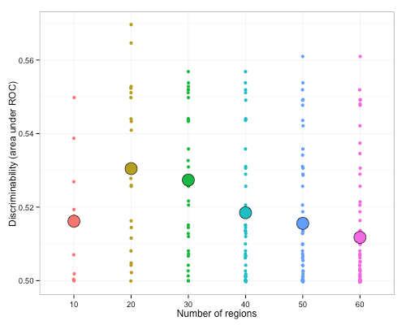
Figure 1. Discriminability as a function of the number of parcels. Mean discriminability for each parcellation resolution is represented by the large points; smaller points represent discriminability for individual regions. Discriminability peaked using 20 regions.
Regional discriminability showed wide variability across regions, ranging from near chance, for motor cortex, performance to robust classification, for the superior parietal lobule (Figure 2, auc-roc range: 0.51 - 0.65). Discriminability was slightly lower for larger regions (r = 0.12), but this effect is sufficiently small to allow for comparison across parcels of different size (see Supplemental Materials).
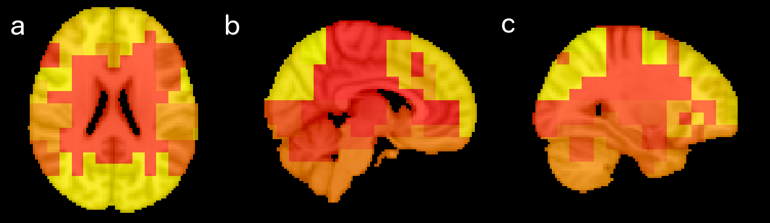
Figure 2. Discriminability varies across the brain. Lighter colors represent higher discriminability (max roc-auc: 0.65), while darker colors represent worst performance (minimum roc-auc: 0.51).
Regions also varied in the topics that were predictive of their activation. In Figure 3, we plot the topic weights for each region, arranged by the region’s discriminability. Predictive topics are consistent with existing knowledge about function to anatomy mappings. For example, for auditory cortex, a region that was highly discriminable, the most predictive topic was most associated with the words ’speech, auditory, and sounds’. Likewise, bilateral amygdala, a moderately discriminable region, was most predicted by a topic most associated with the word ‘emotional’. Even regions with low discriminability, such as right middle frontal gyrus, was most predicted by a topic about ‘inhibition, conflict, and control’, consistent with the role of lateral prefrontal cortex in cognitive control.
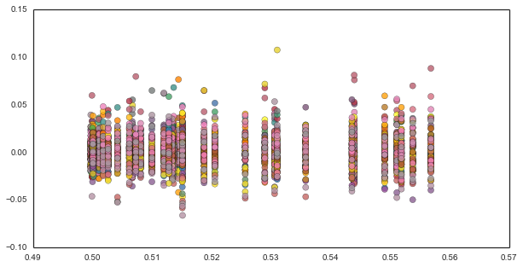
Figure 3. Topic weights for each region ordered by discriminability (roc-auc, x-axis). Regions on the right of the plot were easier to discriminate. Every dot represents the weight of a topic in discrimination. Positive values indicate the presence of that topic in a study predicts activity in that region, while negative values indicate that topic is anti-predictive of activity in that region.
While most regions seem to be most predicted by a topic related to its known cognitive function, we asked if the discriminability of a region affected the strength or distribution of the topic weights. In other words, do more discriminable regions have stronger relationships to specific cognitive phenomena? Discriminability did not correlate with overall topic weights, but did correlate with the absolute value of the weights. This suggests more discriminable regions have stronger associations with specific cognitive topics, in both positive and negative directions. For example, the parietal lobule is easily discriminable and is strongly anti-predicted by the topic described the words ‘wm’, ‘integrity’.
Next, we sought to determine for each region how many functions are necessary to successfully perform classification. We reran classification only using the most predictive features from the full model for each region, and progressively added features ordered by their topic weight. Regions varied in the number of features necessary to achieve classification near the levels obtained using the full model. For example, for a cluster including posterior and anterior cingulate many features were required to achieve maximum performance (Figure 4, left panel), whereas for right inferior frontal gyrus, performance close to the maximum was reached with only 15 features (Figure 4, right panel).
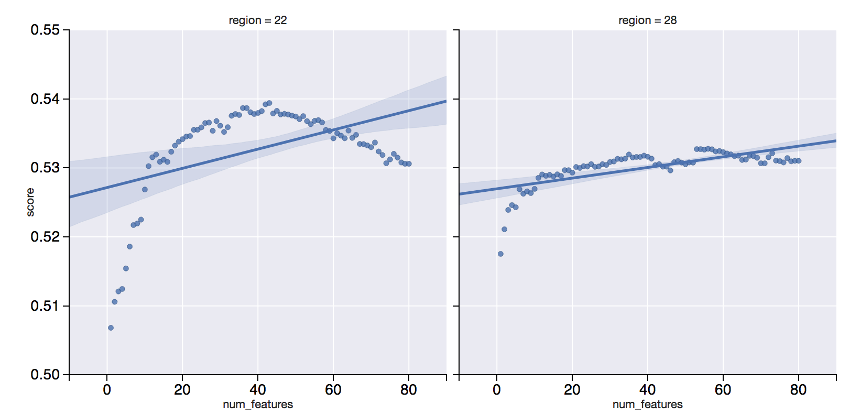
Figure 4. Discriminability for two regions, anterior/posterior cingular (left) and right inferior frontal gyrus (right), as a function of the number of features in the model. Features were added to the model progressively ordered by their topic weight in the full model, such that most useful features were added first. The region on the left required near 40 topics to reach maximum performance, while the region reached near maximum performance with only 15 topics.

Discriminability between regions. Having characterized the overall discriminability of regions, we wanted to understand how discriminable specific pairs of regions are from each other, and what cognitive functions differentiate them. We trained classifiers to discriminate all pair-wise combinations of regions from each other using 30 regions derived using Ward clustering. These analyses resulted in a discriminability score for each pair of region, and 29 discriminability scores for each region.

Discriminability between regions was above chance and comparable in performance to overall discriminability, averaging 0.59 roc-auc. Mean discriminability ranged from 0.54 for poorly discriminated regions to 0.65 for more discriminable regions. Regions were on average characterized similarly to the previous analysis; mean discriminability (r = 0.76), and mean feature importances (r = 0.75) across regions were robustly correlated between the two approaches.
However, discriminability varied substantially within regions depending on the comparison region (average sd of discriminability = 0.05 roc-auc), reflecting the distance in function between the two regions. For example, the medial hippocampus was discriminated very well from bilateral primary motor cortex (roc-auc = 0.73) but very poorly from a default network cluster spanning the temporal lobe, parahippocampus and areas of medial prefrontal cortex (Figure 5a). The cognitive functions that predict activity vary depending on the comparison region. Compared to primary motor cortex, topics about ‘emotion’ and ‘memory’ predicted activity in hippocampus, while topics about ‘motor’ and ‘language’ predicted activity in motor cortex. In contrast, compared to the default network cluster, topics about ‘spatial, location’ and ‘body, visual’, best predicted medial hippocampal activity while topics about ‘reward, decision’ and ‘speech, auditory’ predicted activity in default network.
The approach of discriminating pairs of regions shows its merits when differentiating regions that are close in function and difficult to discriminate. Topic weights for discriminating a pair of regions were most different from the mean topic weights for a region when the discrimination was difficult and yielded low performance (r = 0.4 – explain in methods). For example, on average, most useful in discriminating left inferior frontal gyrus (IFG) from the rest of the brain is a topic about sentences (‘sentences, ‘comprehension’) followed by one about reading (‘reading, words’) (Figure 5b). Both of these topics are also useful in differentiating the region from its contralateral homologue, the right inferior frontal gyrus, at a moderate level (roc-auc = 0.60). However, compared to the nearby left dorsolateral prefrontal cortex (roc-auc = 0.53), the most predictive topic is about ‘emotion’. On average this topic is not very useful in differentiating left IFG from other regions, suggesting left IFG is not very involed with emotion overall, but is more so than left DLPFC.

- Relationship between coactivation and pairwise performance. A large percentage of variance in pairwise analysis is explained by covariance. It is much harder to classify two regions that covary together. Highlight regions that go against this trend. 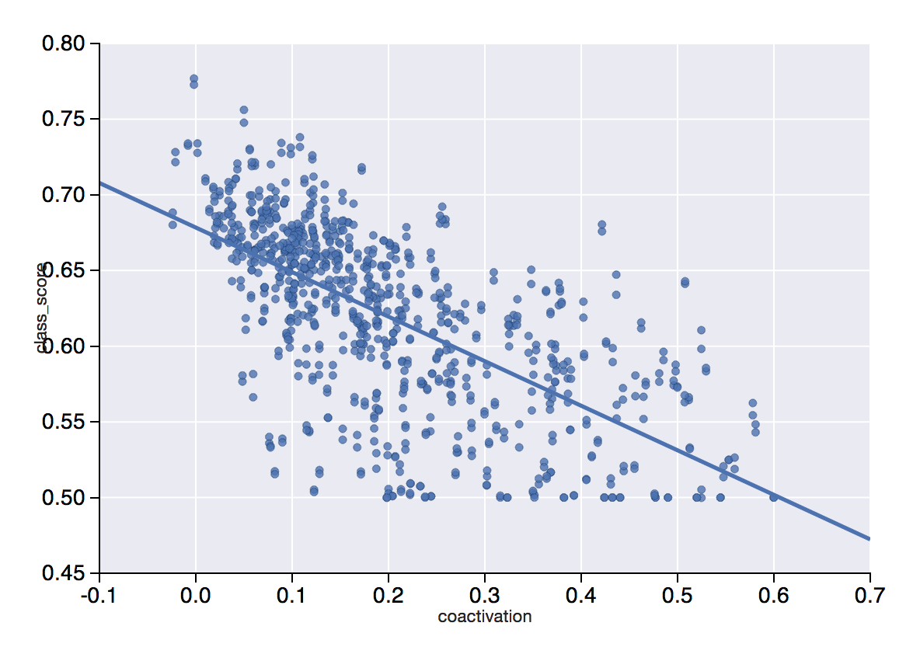
- Finally, conclude by showing that within-network classification is harder than between-network classification. This is likely due to regions within network coactivating more and also being more similar in cognitive function

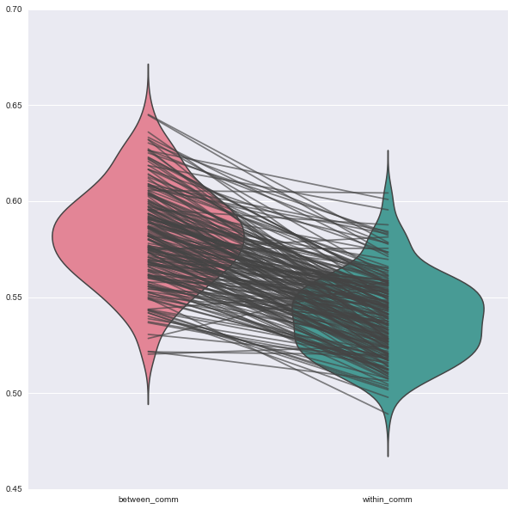

References
Anderson M, Kinnison J, Pessoa L (2013). Describing functional diversity of brain regions and brain networks. 73: 50-8.
Chang L, Yarkoni T, Khaw M, Sanfey A (2013). Decoding the role of the insula in human cognition: functional parcellation and large-scale reverse inference. 23: 739-49.
Poldrack R, Mumford J, Schonberg T, Kalar D, Barman B. (2012) Discovering relations between mind, brain, and mental disorders using topic mapping. 8: e1002707.
Yarkoni T, Poldrack R, Nichols T, Van ED, Wager T (2011) Large-scale automated synthesis of human functional neuroimaging data. 8: 665-70.

