**Installation steps:**

1. install java- JDK 1.7 or above

https://java.com/en/download/

2. download and install the Eclipse IDE for Java EE Developers

https://www.eclipse.org/downloads/packages/eclipse-ide-java-ee-developers/neon3

3. install maven- download the binary distribution:

https://maven.apache.org/download.cgi

3.1. unzip the archive:

Unix-based operating systems (Linux, Solaris and Mac OS X)

tar zxvf apache-maven-3.x.y.tar.gz

Windows

unzip apache-maven-3.x.y.zip

3.2. A directory called "apache-maven-3.x.y" will be created.

3.3. Add the bin directory to your PATH, eg:

Unix-based operating systems (Linux, Solaris and Mac OS X)

export PATH=/usr/local/apache-maven-3.x.y/bin:$PATH

Windows

set PATH="c:\program files\apache-maven-3.x.y\bin";%PATH%

3.4. Make sure JAVA_HOME is set to the location of your JDK

3.5. Run "mvn --version" to verify that it is correctly installed.

4. M2E plugin for Eclipse

install the latest M2Eclipse release by using the following update site from within Eclipse:

http://download.eclipse.org/technology/m2e/releases

**Accessing application:**

● Employee View:

-username: employee

-password: empl

● Admin View:

-username: admin

-password: adm

**Use cases screenshots:**

Login:

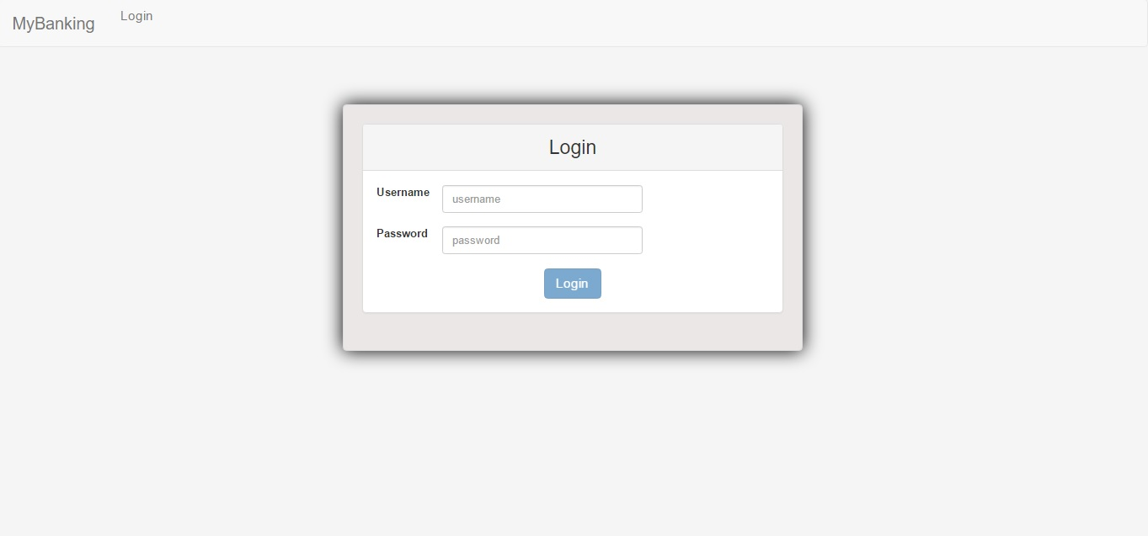

Login-employee:

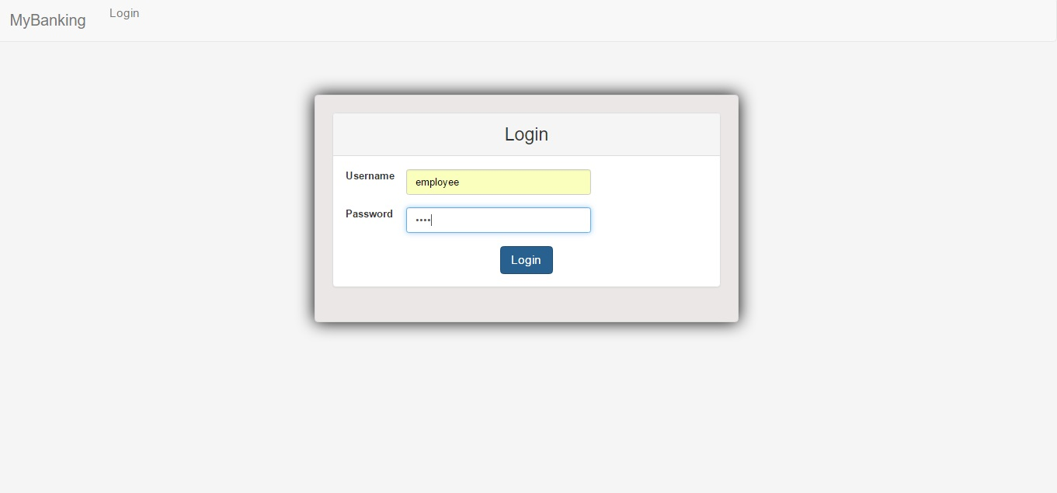

Login-admin:

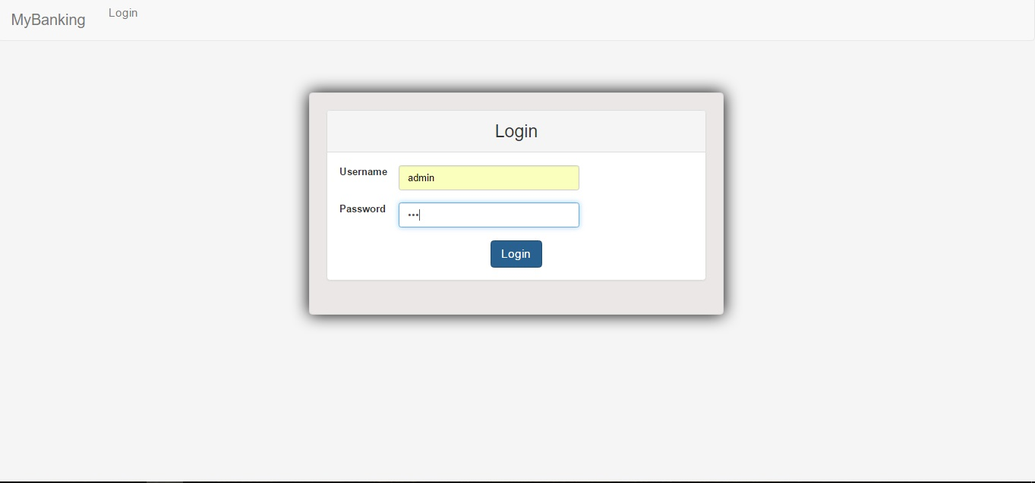

* Loged in as employee:

Employee page:

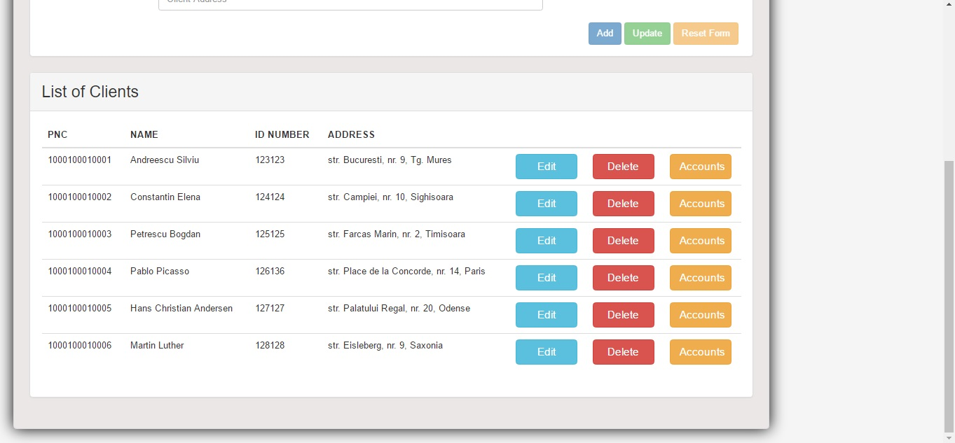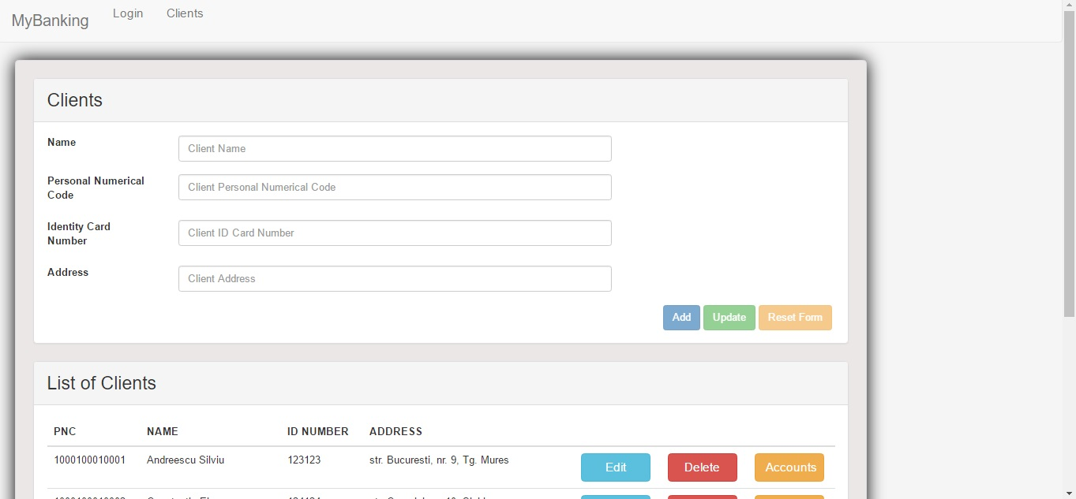

Adding Client-CNP exists:

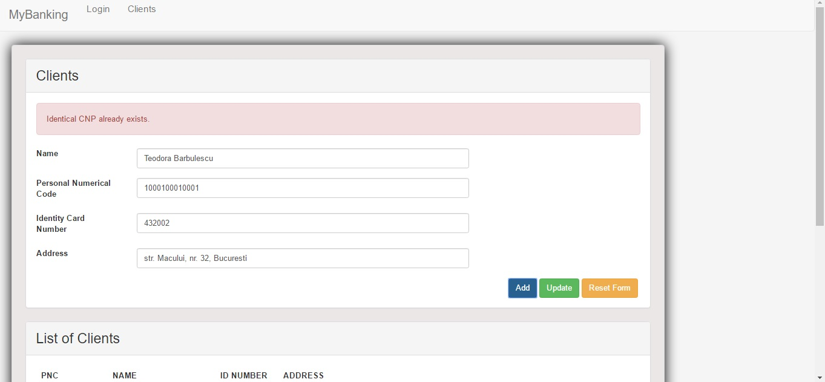

Adding Client (same details, correct CNP):

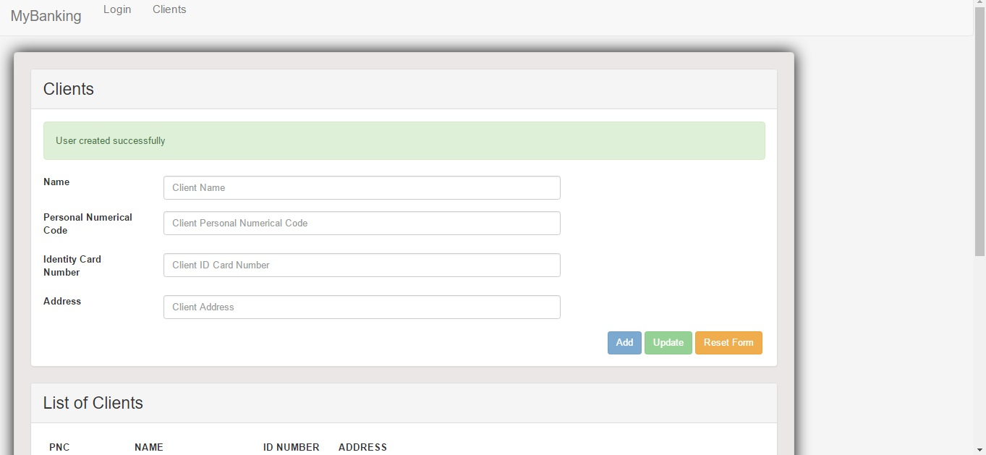

Delete Client (Teodora Barbulescu):

* before

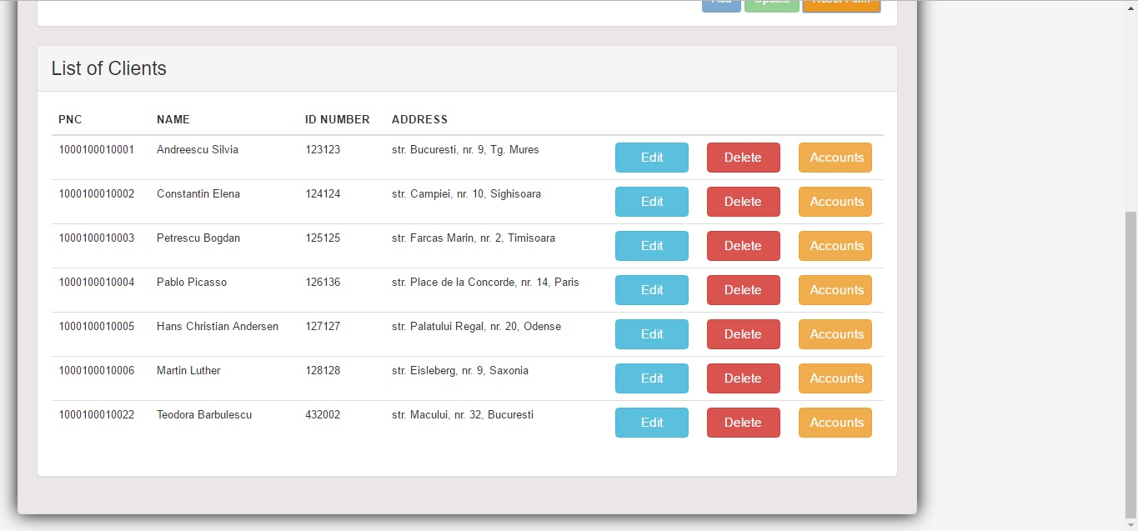

* after

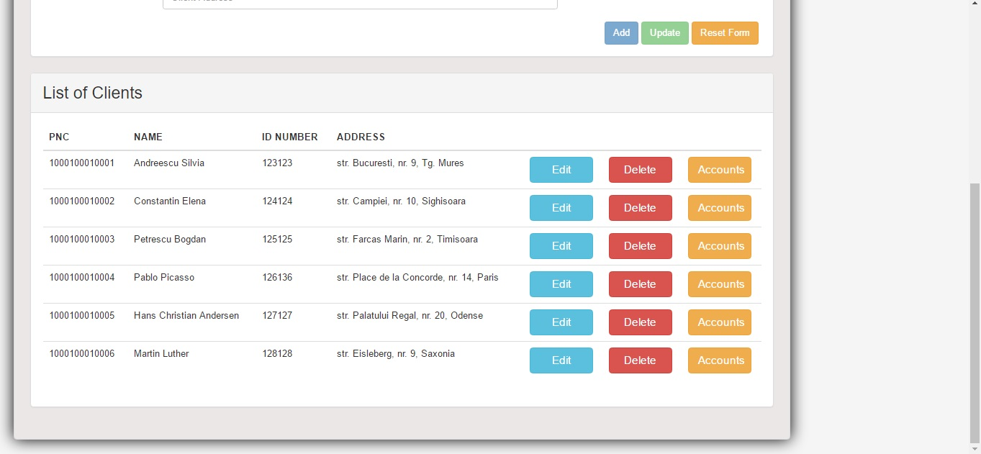

Update Client (Andreescu Silviu):

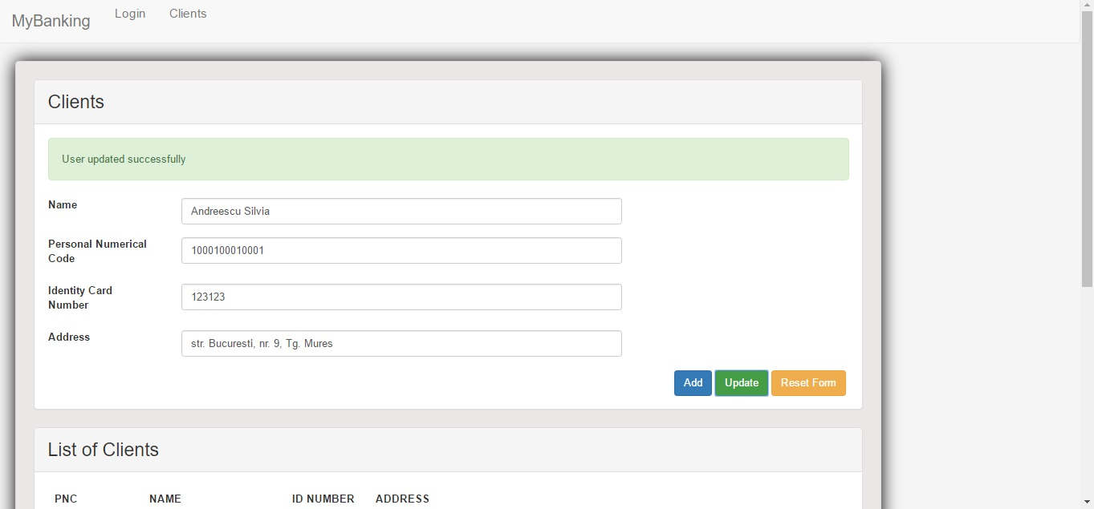

Reset Form:

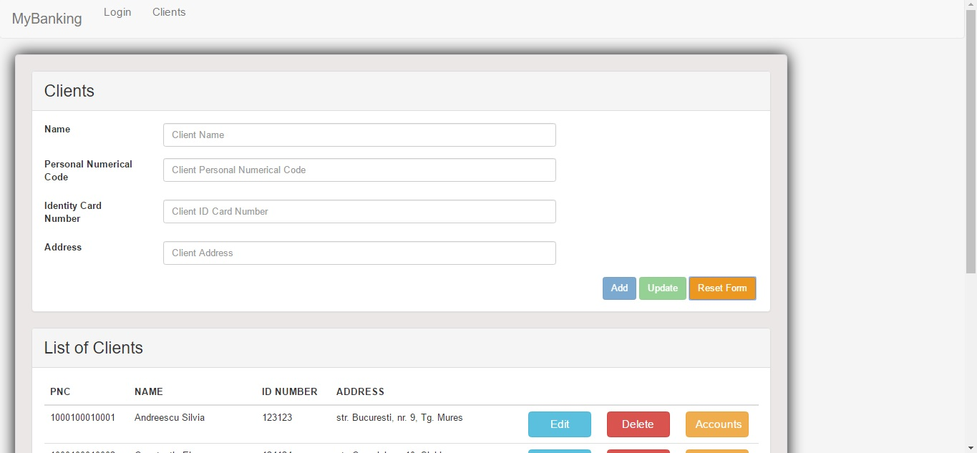

Select Client Accounts (Hans Chr. Andersen):

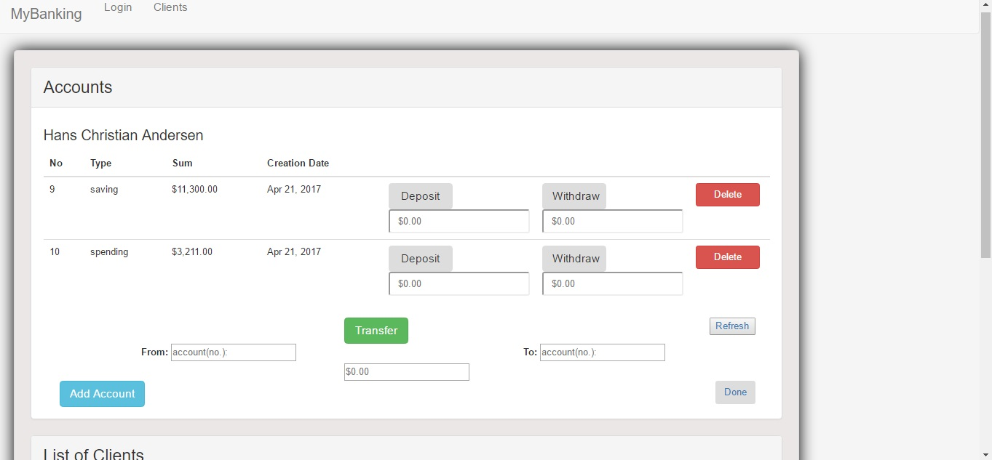

Deposit in account

* initially:

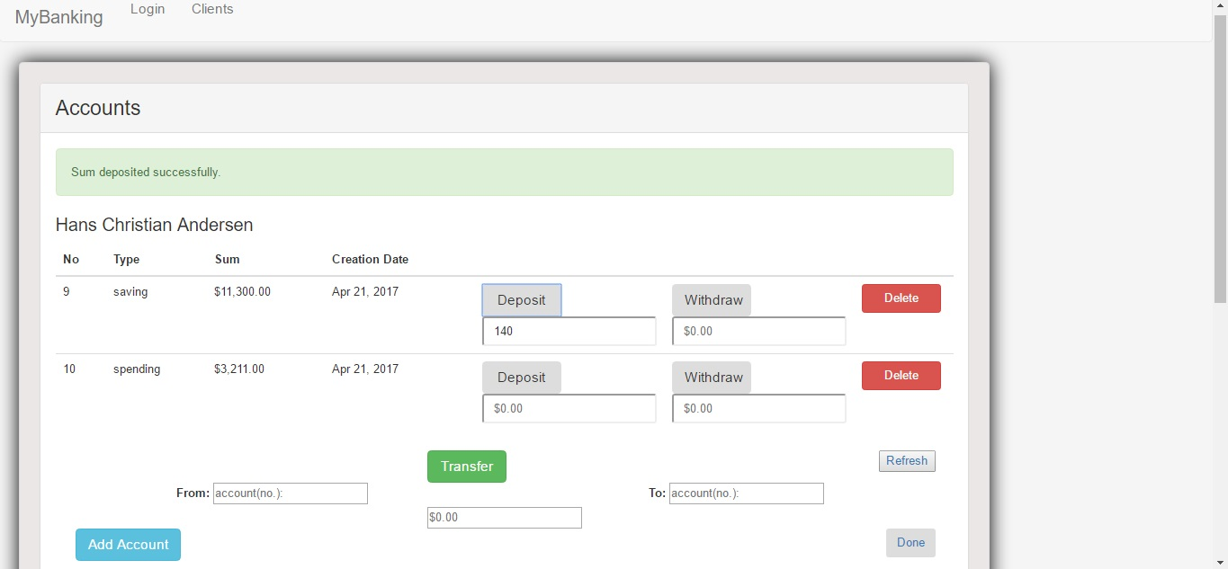

* after Refresh:

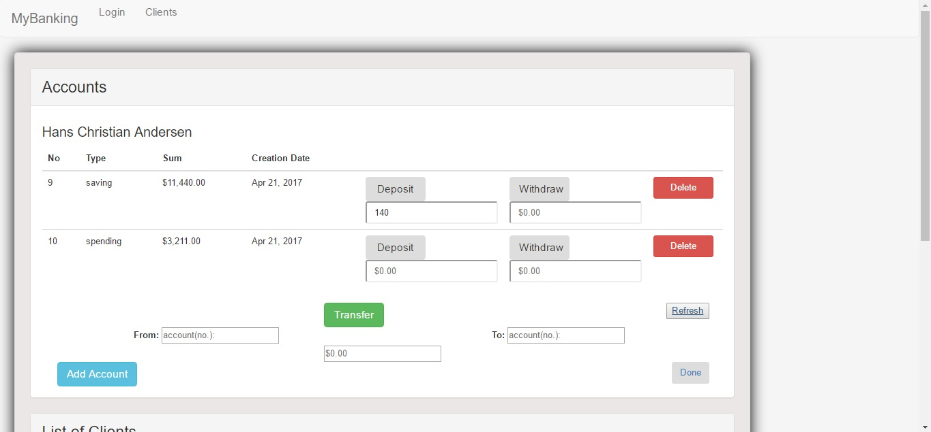

Withdraw from Account:

* initially:

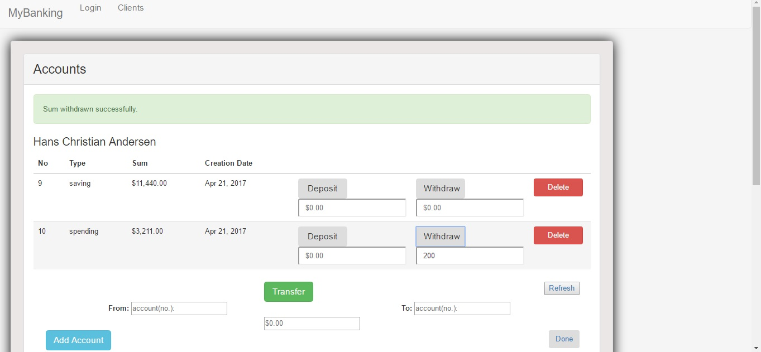

* after Refresh:

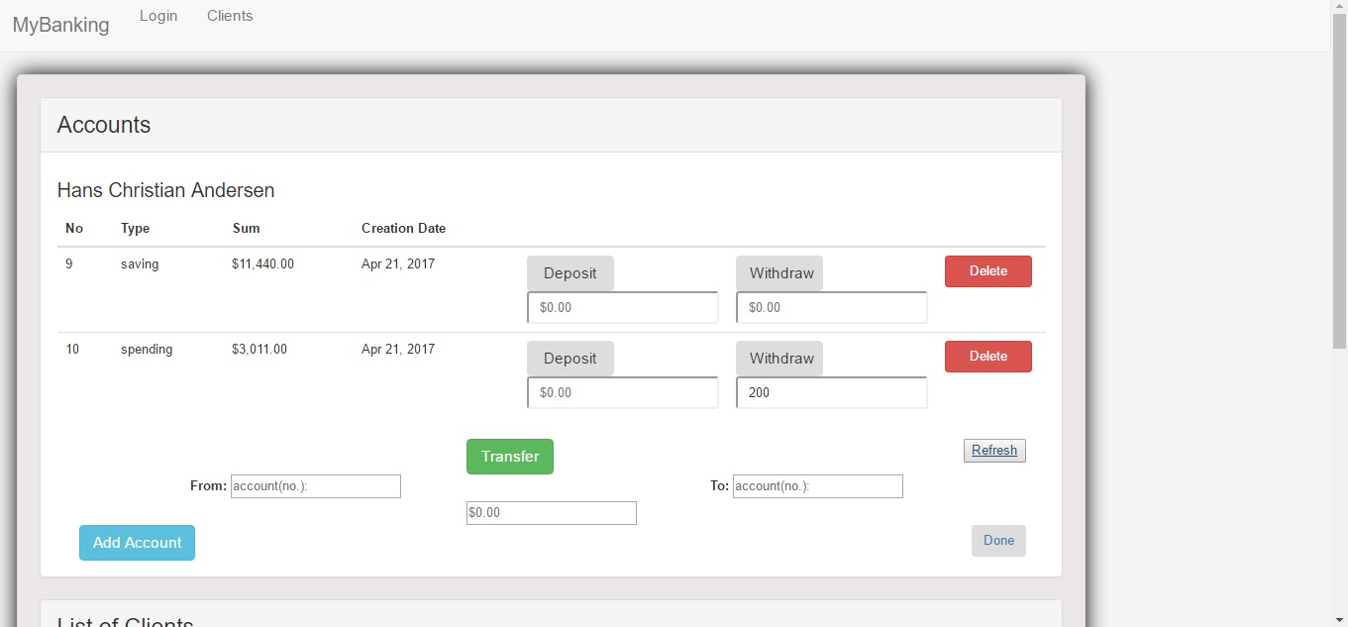

Transfer between accounts:

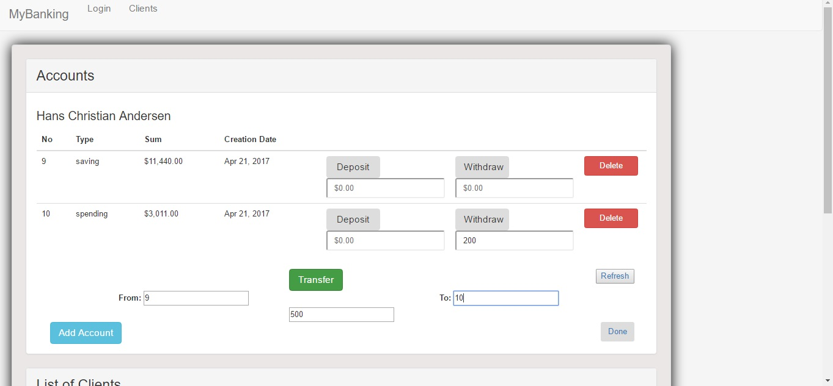

after Refresh:

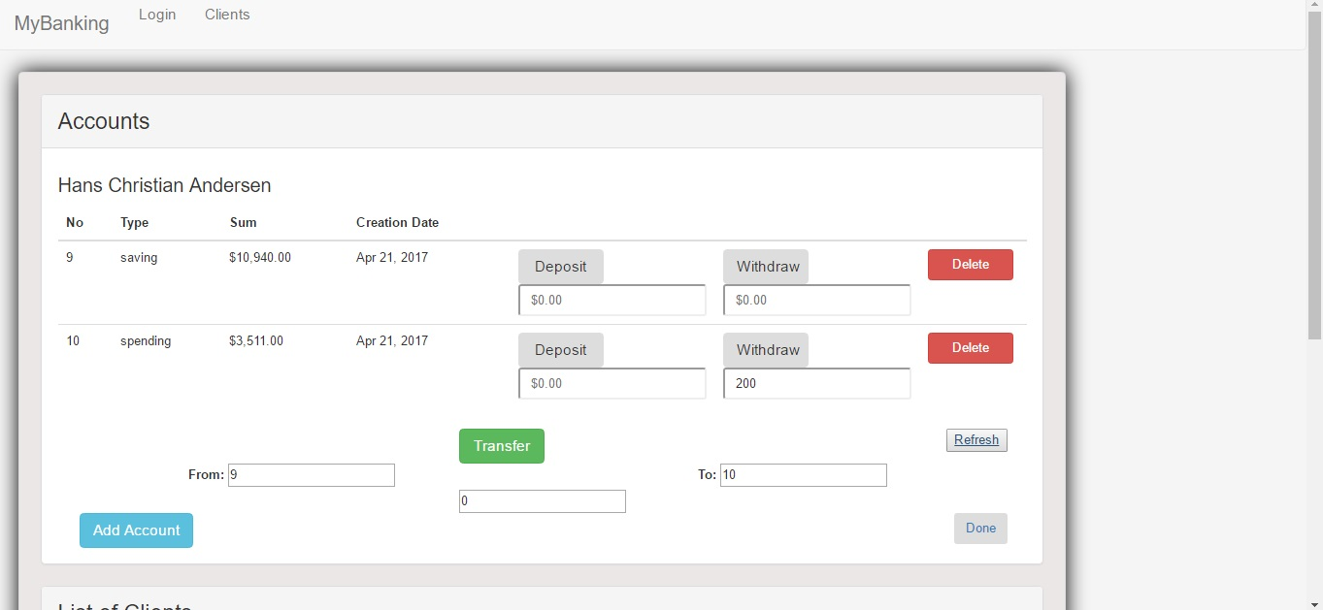

Add Client Account:

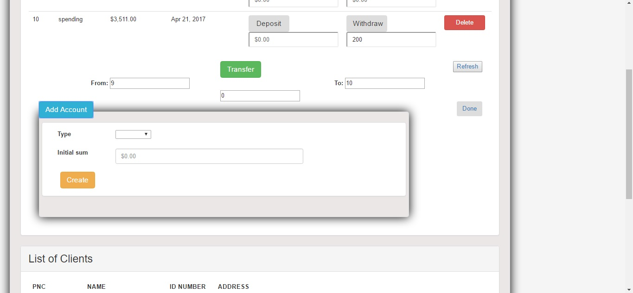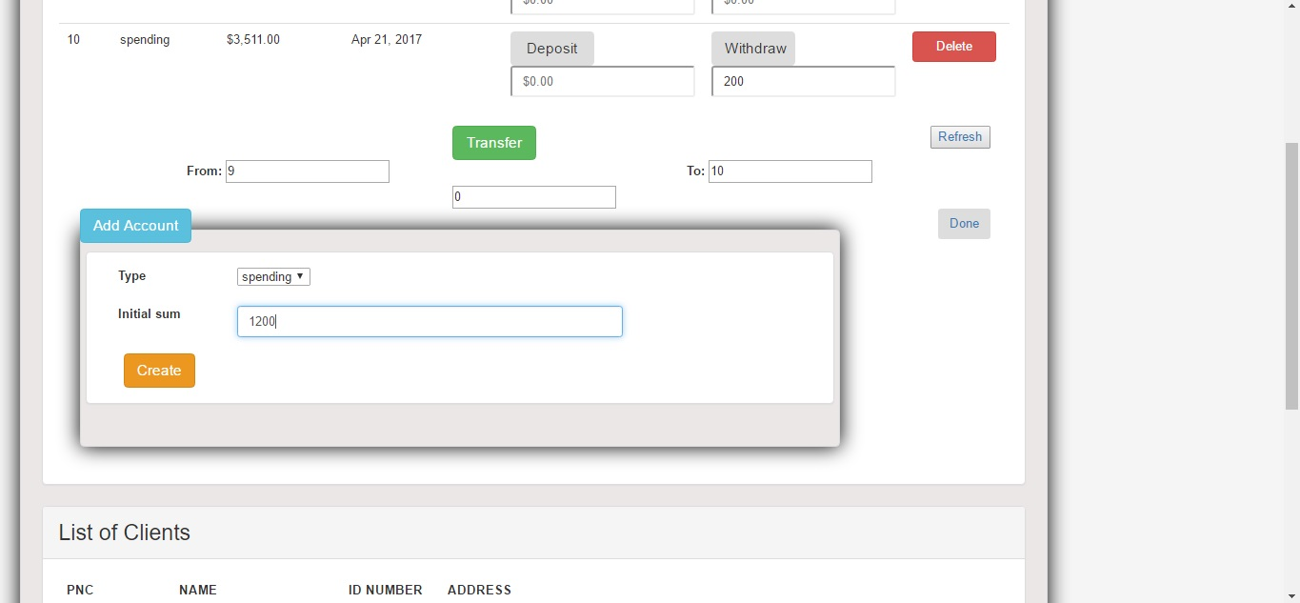

after Refresh:

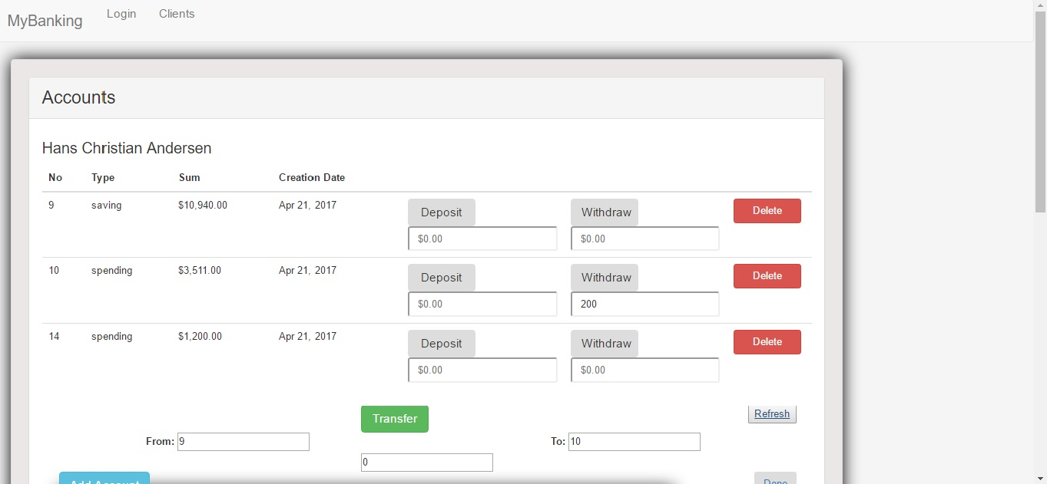

Delete Client Account:

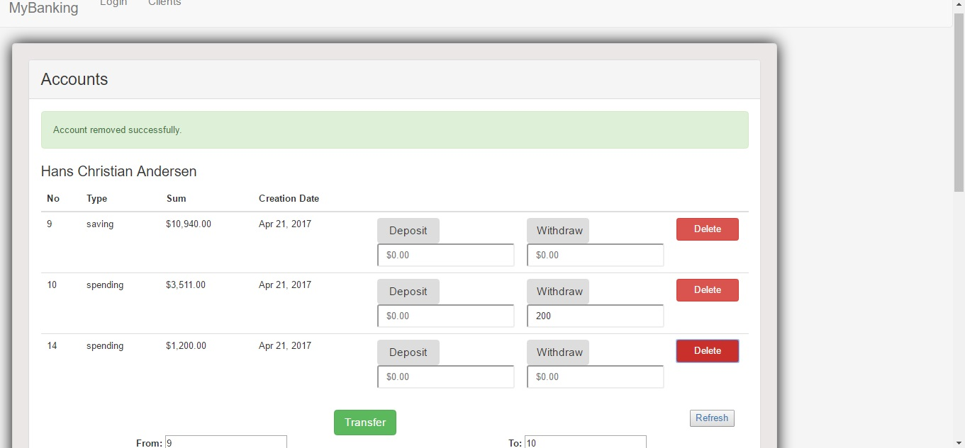

after Refresh:

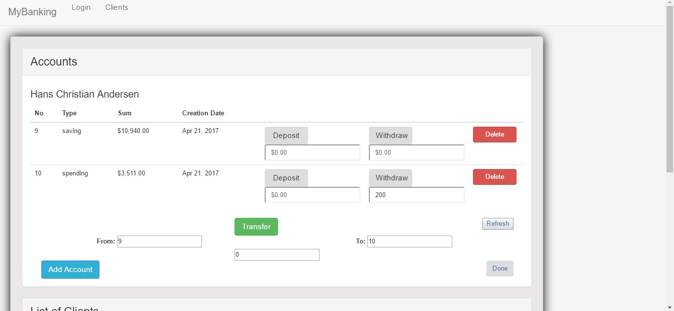

* Logged in as admin:

Admin page:

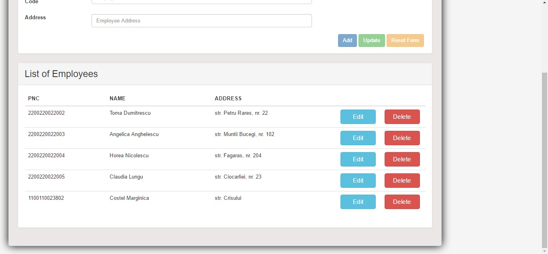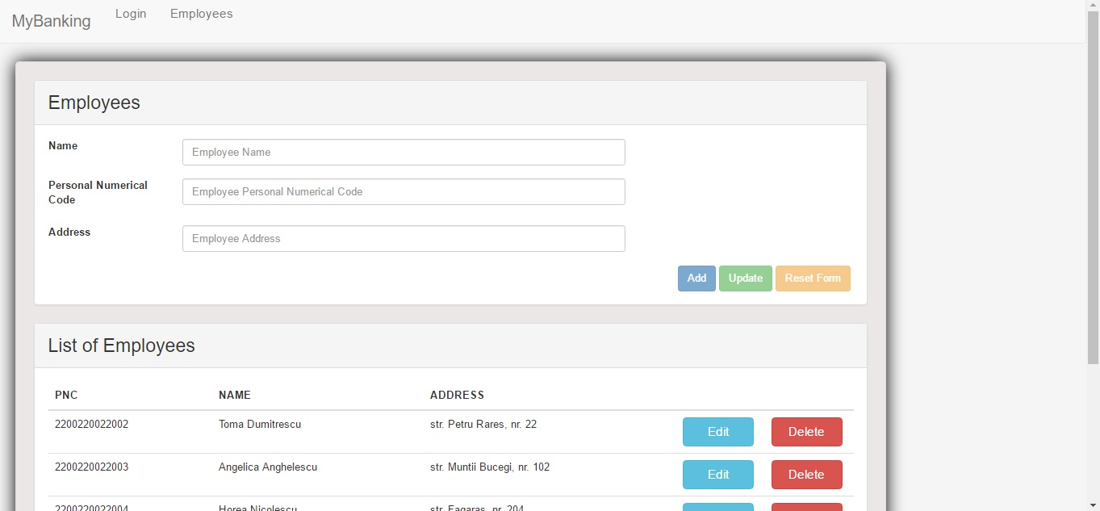

Add Employee:

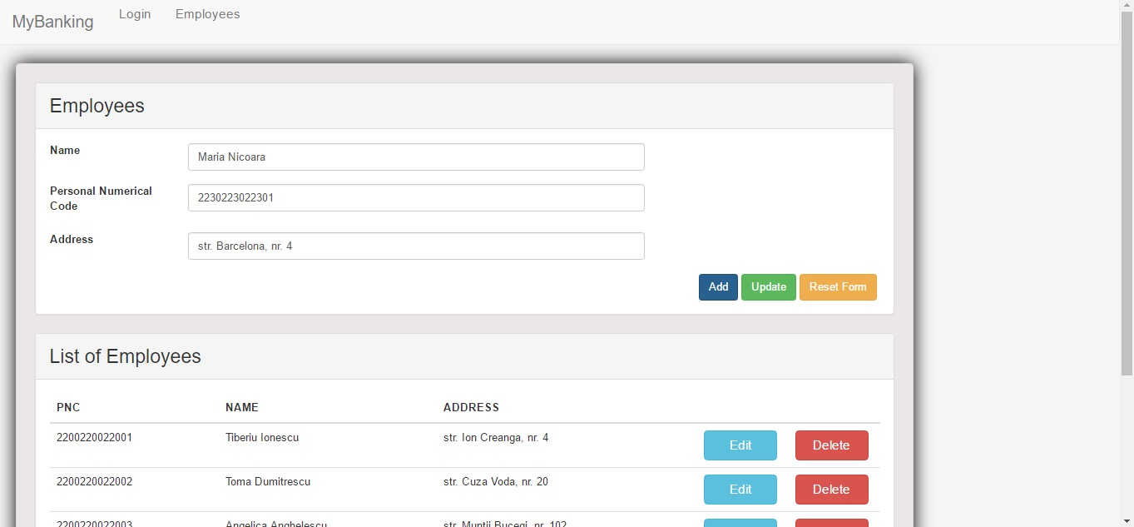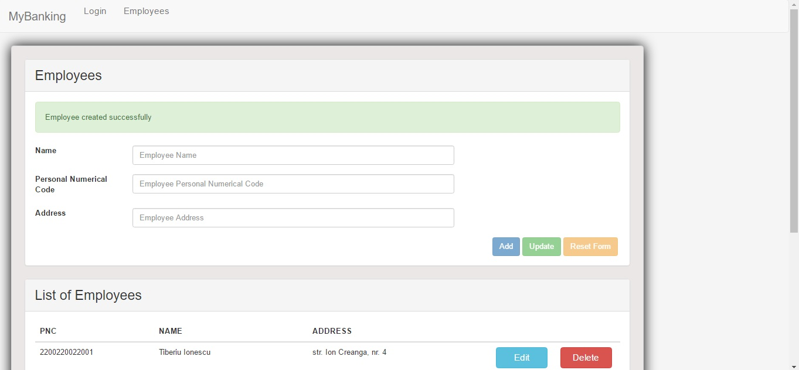

Add Employee with existing CNP:

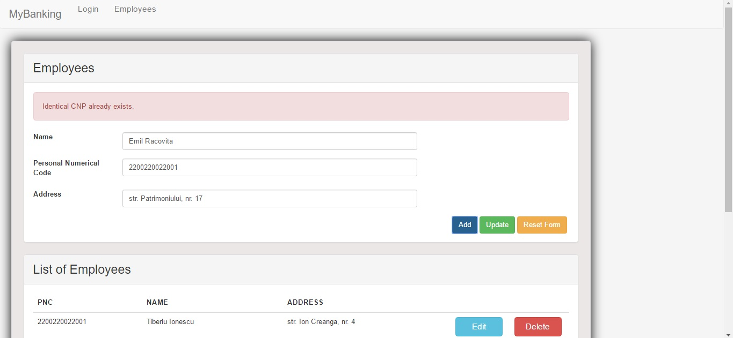

Delete Employee (Maria Nicoara):

* before:

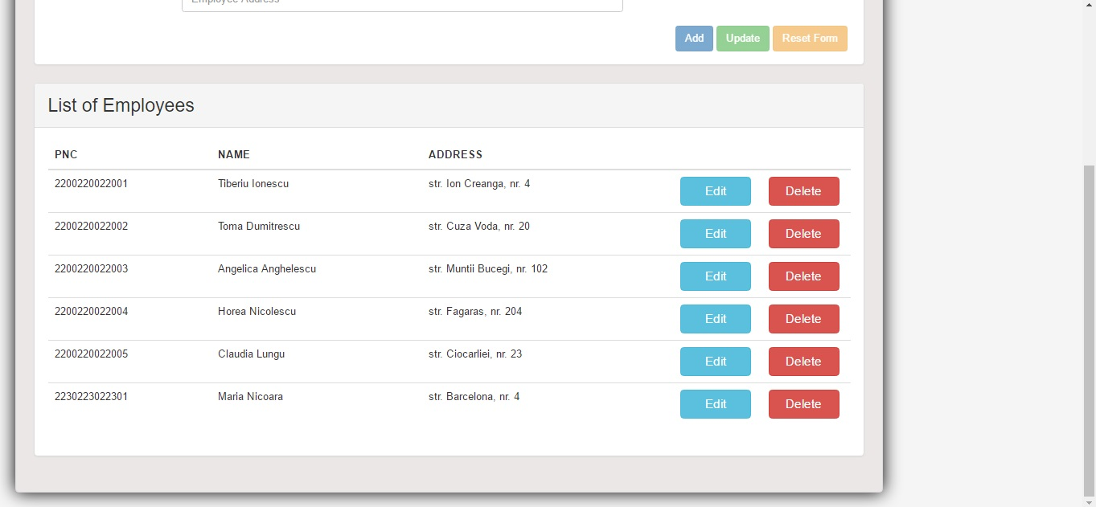

* after:

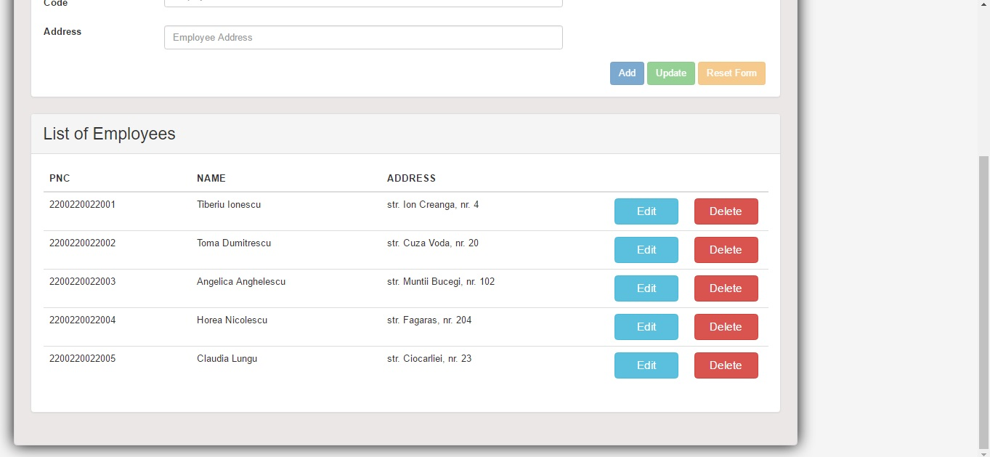

Update Employee:

