

**EFFECTIVENESS OF FLEXIBLE WORKING PRACTICES ON ORGANISATIONAL PRODUCTIVITY MEASURED BY EMPLOYEES’ BEHAVIOURS: PERCEPTION OF EMPLOYERS IN THE UK**

**ISHAQ ADELEKE, ABDULRASAQ**

**(S5530254)**

**Bournemouth University Business School (BUBS)**

**Department of People & Organisations**

**M.Sc. Management with Business Analytics**

**--------------------------------------**

**May 2024**

**Word Count: 15,375**

**ABSTRACT**

This dissertation investigates the effectiveness of Flexible Working Practices (FWPs) on organisational productivity from the perspective of employers in the UK. The primary research question addresses how FWPs influence productivity, specifically through employee behaviours such as motivation, turnover, and absenteeism. Utilising a quantitative research design, secondary data with 1388 observations and 19 distinctly mapped variables from the Fourth Work-Life Balance Survey of Employers (WLB4) is analysed. The WLB4 survey, conducted by IFF Research in collaboration with the Institute of Employment Studies, provides comprehensive data on various aspects of work-life balance and organisational performance.

The methodology involves descriptive and inferential statistical techniques, including regression and advance predictive model; random forest, to identify significant predictors of organisational productivity. Key findings indicate that FWPs positively influence productivity primarily by enhancing employee motivation and reducing turnover and absenteeism. Specifically, flexible working that include different work shifts and role suitability significantly contribute to higher productivity. The data reveals that motivation, turnover, and absenteeism are critical factors in the relationship between FWPs and productivity.

The results suggest that medium-sized businesses benefit more from FWPs compared to small businesses, highlighting the importance of scale in the effective implementation of flexible work policies. Additionally, while FWPs are generally associated with positive business impacts, there are effects based on specific employee roles and organisational contexts. The research concludes that strategic implementation of FWPs, tailored to align with employee needs and organisational goals, can lead to substantial organisational productivity.

This study contributes to the broader understanding of FWPs as a dual-benefit mechanism, offering insights for both academic literature and practical policy formulation. It underscores the need for organisations to consider employee behaviours in designing flexible work arrangements to optimise productivity outcomes.

**ACKNOWLEDGEMENTS**

This dissertation has been a challenging yet rewarding journey, and I am deeply grateful for the support and assistance of numerous individuals who have contributed to its completion.

First and foremost, I extend my heartfelt appreciation to my research dissertation supervisor, Dr. Noah Nzeribe, whose guidance, support, and insightful feedback have been invaluable throughout this process. I am also indebted to the lecturers at the Faculty of Management, whose comprehensive knowledge and unwavering support during my time at Bournemouth University have been instrumental in shaping my academic journey.

I am thankful to my parents for their timeless efforts in providing me with the opportunity to pursue my studies in Bournemouth, UK. A special mention goes to my lovely family and my beloved darling wife, Abimbola AmokeAde, whose unwavering support and encouragement have been a constant source of strength. Lastly, I extend my sincere gratitude to my friends both in Nigeria and the UK, whose willingness to lend a helping hand has been a source of comfort during both academic and personal challenges.

**RESEARCH DISSERTATION DECLARATION**

I consent to Bournemouth University retaining a duplicate of my research dissertation for the purpose of reference for a maximum duration of one academic, with the understanding that be deleted once the retention period has expired.

**Confidentiality**

I confirm that this research dissertation does not contain any commercial or confidential information, nor does it contain any personal information other than that which is generally in the public domain, unless the necessary permissions are obtained. Any information that reveals a specific person's political or religious beliefs, health, ethnicity, criminal history, or sexual life has been anonymised unless the person to whom it relates has granted permission for publication.

**Copyright**

I retain ownership of the copyright for this research dissertation.

**Requests for Information**

I consent to the disclosure of this research dissertation in response to a Freedom of Information Act request for information.

**Originality Declaration**

I hereby declare that this research dissertation is entirely my own work and that, in accordance with the guidelines provided in the Programme Handbook I received, I have properly identified and acknowledged all of the information and materials I have used, including the Internet.

**Signed: Adeleke**

Name: Ishaq Adeleke, Abdulrasaq

Date: 24 May, 2024

Programme: MSc Management with Data Analytics

Table of Contents

Chapter 1: Introduction 8

1.0 Research Background 8

1.1 Context and Significance 9

1.2 Research Problem, Aim and Objectives 9

Research Aim 10

Research Objectives 10

Research Questions 10

1.3 Methodology 11

1.4 Structure of Dissertation 11

**CHAPTER 2: LITERATURE REVIEW** 12

2.0 Introduction 13

2.1 Definitions of Key Concepts 13

Flexible Working Practices (FWPs) 13

Organisational Productivity 15

Business Impact and Employee Behaviours 16

2.2 Theoretical Framework of Organisational productivity 18

Contingency Theory 18

Relevance of the Contingency theory 19

2.3 Theoretical Relationships of Key Concepts 19

FWP and Organisational Productivity 20

FWP and Employees’ Behaviours 20

Employee Motivation and Organisational Productivity 22

Employees Turnover and Organisational Productivity 23

2.4 Research Gap 23

2.5 Hypotheses 24

2.6 Research Model 25

CHAPTER 3: RESEARCH METHODOLOGY 25

3.0 Introduction 25

3.1 Research Methodology and Design 26

Research philosophy 26

Research Approach 28

Research Method 28

Research Strategy 29

3.2 Data Access, Restrictions and Variable Definitions 30

Data Access 30

Data Restriction, Cleaning and Transformation 31

Variable Definitions and Transformations 32

3.3 Analysis Methodology 35

Data Analysis Tool 35

Data Analysis Process 36

CHAPTER 4: ANALYSIS AND EMPIRICAL FINDINGS 38

4.0 Introduction 38

4.1 Descriptive Statistics 38

4.2 Pearson Correlation Matrix 41

4.3 Regression Analysis 43

Regression of Productivity on all the Independent Variables and Control Variables (Model 1) 43

4.4 Fitting the model through the stepwise algorithm using AIC 50

Decision Tree of the Model 3 54

*Accuracy of the Model 3* 55

4.5 Random Forest Model 59

4.6 Comparison of the prediction models 61

4.7 Discussions 62

Synthesis of Findings 63

CHAPTER 5: Conclusion 65

5.1 Summary 65

5.2 Implications 65

5.2.1 Theoretical Implications 65

5.2.2 Managerial Implications and Recommendations 66

5.3 Limitations 67

Appendices: 69

List of Tables

Table 1: Variables Definitions 27

Table 2: Variables Descriptive Statistics 32

Table 3: Model 1 regression result 36

Table 4: Model 3 regression result 43

Table 5: Model 3 Confusion Matrix 49

Table 6: Hypothesis result 51

List of Figures

Figure 1: Research model 21

Figure 2: Research approach: “The research onion” 22

Figure 3: Organisational productivity by provision of FW Policies 33

Figure 4: Variable Correlation Matrix 35

Figure 5: Effect of Turnover on Organisational productivity by provision of FW Policies 38

Figure 6: Motivation effect on Organisational productivity 39

Figure 7: Model 1 Decision Tree 40

Figure 8: FWP on organisational explored with employee motivation and absenteeism 41

Figure 9: Decision tree for the Model 3 46

Figure 10: Decision tree of the model 3 on the train dataset; FWP 48

Figure 11: Effect of FWP on Employees’ Turnover 49

Figure 12: Effect of FWP on Employees’ Motivation 50

# Chapter 1: Introduction

## 1.0 Research Background

The journey of flexible working in the United Kingdom began in 2003, with the introduction of the right to request flexible working (FW) marking a significant legislative milestone (Department for Business, Energy & Industrial Strategy [BEIS], 2021). This policy, aimed at promoting work-life balance, especially for parents, empowered employees to seek adjustments to their working hours, locations, and patterns. Over the years, the landscape of flexible working has undergone a remarkable evolution. Driven by advancements in technology, changing employee preferences, and the dynamic nature of work, the adoption of flexible working practices (FWPs) was significantly accelerated by the Covid-19 pandemic (Felstead and Henseke, 2020).

In response to these changes, employers have embraced various forms of work flexibility, such as flexible hours, remote working, and job-sharing. These arrangements support hybrid work models that combine in-office and remote work, continuously evolving based on feedback to ensure ongoing success (Cheese, 2023). Reports from the Chartered Institute of Personnel and Development (CIPD, 2023) indicate a surge in FW requests, highlighting a growing trend towards the adoption of flexible working arrangements (FWPs) among organisations. Currently, 45% of UK organisations have formal FWPs, while 24% adopt an informal approach, reflecting diverse strategies in accommodating flexible work practices, while the rest remain traditional due to the nature of their operations (Office for National Statistics [ONS], 2020).

FWPs have garnered significant attention in contemporary organisations, driven by the dynamic nature of work environments and the relentless pursuit of optimal productivity. Studies by Gajendran and Harrison (2007), CIPD (2020), and Charlton (2021) have highlighted the benefits associated with FWPs and FWPs, particularly in enhancing employee satisfaction and well-being. In response to the growing demand for FW among employees, organisations strive to navigate diverse FWPs to sustain employee motivation, commitment, and minimise absenteeism (Beauregard and Henry, 2009).

This research aims to examine the perceptions of employers in the UK regarding the effectiveness of FWPs on organisational productivity, with a focus on how employee behaviours, including motivation, turnover, and absenteeism, are affected.

## 1.1 Context and Significance

Flexible working practices have emerged as a pivotal aspect of modern organisational strategies, particularly in response to evolving workforce demographics and technological advancements (Smith, 2020). These practices are designed to provide employees with greater autonomy and a better balance between their professional and personal lives (Jones and Brown, 2018). The adoption of FWPs is largely driven by the need to enhance employee satisfaction, reduce turnover, and improve overall productivity (Taylor, 2019). Despite their increasing prevalence, the impact of these practices on organisational productivity remains a topic of ongoing debate.

This research investigates the effectiveness of flexible working practices on organisational productivity as measured by employee behaviours, specifically focusing on the perceptions of employers in the UK. By examining a variety of flexible working arrangements and their perceived impact on productivity, absenteeism, turnover, and motivation, this study aims to provide a comprehensive understanding of how such practices influence business outcomes (Williams, 2017).

## 1.2 Research Problem, Aim and Objectives

The central problem addressed by this dissertation is the uncertainty surrounding the impact of flexible working practices on organisational productivity. While numerous studies have highlighted the potential benefits of flexible working, such as enhanced employee satisfaction and reduced absenteeism (Johnson, 2016; Williams, 2017; Davies and Smith, 2021), there is a lack of consensus on how these practices affect productivity from the perspective of employers. This research seeks to provide understanding through statistical analysis of secondary data from the fourth Work-Life Balance Survey of Employers (WLB4), offering insights on the perceived effectiveness of flexible working practices in UK organisations.

### Research Aim

The aim of this research is to analyse the effectiveness of FWPs and their relationships with perceived organisational productivity, as measured by employee behaviours, from the perspective of employers in the UK.

### Research Objectives

The specific objectives of this dissertation research are:

1. To critically review the academic literature on FWPs and organisational productivity, identifying key conceptualisations, roles, and structural frameworks.
2. To evaluate the perceived impact of flexible working practices on organisational productivity.
3. To assess the effect of flexible working arrangements on absenteeism and employee turnover.
4. To investigate the influence of flexible working on employee motivation and commitment.

### Research Questions

To achieve these objectives, this dissertation research will address the following questions:

1. Q1: How do employers perceive the impact of flexible working practices on organisational productivity?
2. Q2: What is the effect of flexible working arrangements on absenteeism and employee turnover from the employers' perspective?
3. Q3: How do flexible working practices influence employee motivation and commitment according to employers?

These questions will provide insights to understand the effectiveness of FWPs on organisational productivity, thereby contributing valuable insights to both academic literature and practical policy implementation.

## 1.3 Methodology

This dissertation synthesises academic peer-reviewed literature focused on understanding the dissertation topic and employs a quantitative research design utilising cross-sectional secondary data from the fourth Work-Life Balance Survey of Employers (WLB4) as the primary data. The WLB4, conducted by IFF Research in collaboration with the Institute of Employment Studies (IES) on behalf of the Department for Business, Innovation and Skills (BIS) in 2015, was administered to top management individuals across various organisations, capturing a range of demographic and occupational variables. Conducted through telephone interviews, this survey garnered 2,011 successful responses and covered 649 variables. It includes questions on the availability and utilisation of flexible working arrangements (FWPs), satisfaction with working conditions, and perceived improvements in work-life balance and organisational productivity. Key explanatory variables include part-time work, night shifts, varying work shifts, zero-hours contracts, and the presence of written policies for flexible working. Control variables, such as work-life balance perceptions, business classification, job title, and peer performance perceptions, are also incorporated to account for potential confounding factors.

This quantitative data will be analysed using statistical techniques to identify patterns, correlations, and insights to understand the dissertation topic.

## 1.4 Structure of Dissertation

This dissertation is structured as follows:

**Chapter 1: Introduction**: This chapter introduces the research topic, outlines the significance of the study, states the research problem and objectives, and provides an overview of the research methodology.

**Chapter 2: Literature Review**: This chapter critically reviews existing literature on flexible working practices and their impact on organisational productivity, identifying gaps in the current knowledge and setting the theoretical framework for this dissertation.

**Chapter 3: Research Methodology**: This chapter details the research design, data collection methods, and analysis techniques used in the study. It also discusses the reliability and validity of the research findings.

**Chapter 4: Data Analysis and Results**: This chapter presents the findings of the study, including descriptive statistics, correlation analysis, and prediction analysis of qualitative data. It includes a discussion that interprets the results, linking them to the research objectives and existing literature.

**Chapter 5: Conclusion and Recommendations**: This chapter summarises the key findings of the study, provides recommendations for organisations, and suggests areas for future research.

# **CHAPTER 2: LITERATURE REVIEW**

## 2.0 Introduction

This literature review seeks to provide a comprehensive understanding of flexible working practices (FWPs) and their impact on organisational productivity from the perspective of employers in the UK. It examines various dimensions of flexible working, focusing on their effects on employee behaviour, motivation, turnover, and absenteeism. The review begins by defining key terms to ensure conceptual clarity, followed by a historical context discussing the development and legislative milestones that have shaped the landscape of flexible working.

Theoretical frameworks underpinning the study of FWPs are reviewed, comparing and contrasting perspectives on their impact on organisational productivity. Organisational productivity, as perceived by employers, is explored as the primary outcome variable. This exploration is crucial for understanding the effectiveness of FWPs through employee behaviours, such as motivation, absenteeism, and turnover. By examining key attributes and structures proposed in previous studies, the review offers interpretations and conceptualisations that serve as reliable foundations for further analysis.

A framework of hypotheses predicting correlations between FWPs and organisational productivity will be proposed based on the reviewed literature. Identifying limitations in previous studies emphasises the necessity for further investigation. Finally, this chapter summarises the current state of research, identifies existing gaps, and suggests areas for future inquiry. A research model that clarifies the hypothesised relationships and the investigative process will be proposed, setting the stage for the analysis in subsequent chapters. This approach aims to facilitate a deeper understanding of the effectiveness of FWPs on organisational productivity.

## 2.1 Definitions of Key Concepts

Definitions of the key terms related to establishing the research dissertation topic is essential to ensure a clear preliminary understanding.

### Flexible Working Practices (FWPs)

Definition: FW refers to a range of work arrangements that allow employees to alter their working hours, patterns, or locations on the provision of employer to employees to suit their individual needs and preferences while maintaining or enhancing productivity. This concept encompasses various practices such as flexible start and finish times, telecommuting, compressed workweeks, job sharing, and zero-hours contracts (GOV.UK, 2012). Flexible working aims to improve work-life balance, increase employee satisfaction, and accommodate diverse workforce needs, thereby fostering greater organisational efficiency and productivity (CIPD, 2020). The formal right to request FWPs was established in the United Kingdom through legislative changes, notably Section 47 of the Employment Act 2002 (Great Britain, 2004), and further reinforced by the Equality Act 2010, promoting workplace diversity and inclusivity (Government of the United Kingdom, 2012).

#### History, Implementation, and Implications of FWPs

From the late 1960s, the Munich-based aerospace firm Messerschmitt-Bölkow-Blohm (MBB) faced challenges related to congestion during employee commutes, contributing to issues such as absenteeism, overtime, and tardiness. To address these concerns, MBB enlisted the help of sociologist Kristel Kammerer, who introduced a pioneering strategy known as "gleitzeit" or flexible working hours (Bird 2014; Morgan, 2021). This strategy involved implementing staggered start and end times, allowing employees to begin work between 07:00 and 08:00 and finish between 16:00 and 18:00. This initiative successfully alleviated traffic congestion and represented one of the earliest instances of flexible working practices within an organisational context (Morgan, 2021).

In the United Kingdom, the widespread adoption of flexible working (FW) accelerated significantly after the outbreak of the COVID-19 pandemic in 2020 and the subsequent global lockdown in 2021. The term "flexitime" was first trademarked in 1971, with FW practices initially being specific to individual companies and adhering to their standards. Legislative changes in the early 2000s, particularly Section 47 of the Employment Act 2002, formalised the right to request flexible working arrangements (FWPs) (Great Britain 2004). According to Pyper (2018) and Halls (2023), this legal framework was crucial in enshrining FW into law. The Chartered Institute of Personnel and Development (CIPD, 2020) characterises FW by its diverse work arrangements, emphasising its role in driving economic growth and productivity. Furthermore, FW promotes workforce diversity by serving as a reasonable adjustment under the Equality Act 2010, accommodating employees' individual needs with flexible start and finish times or remote work options (Government of the United Kingdom, 2012).

Since the COVID-19 lockdowns, a significant paradigm shift in work dynamics has emerged. Morgan (2021) reports that 85% of working adults in the UK now anticipate a hybrid approach to work, combining remote and office-based work, with 36% of businesses expecting employees to predominantly work from home. This shift has led to an increase in informal FWPs. Researchers such as Natasha and Abbi (2022), Hall (2023), and Birkett et al. (2023) have noted that post-lockdown, FW has been recognised as a key factor in maintaining or even enhancing organisational productivity. Additionally, the rise in telecommuting driven by the pandemic has been linked to favourable effects on productivity, work flexibility, and work quality. Human resource managers have observed increased empathy, coordination, retention, and engagement among employees (Gaur et al., 2021).

FWPs encompass various types of work arrangements, such as telecommuting, flexible work hours, compressed workweeks, job sharing, and zero-hours contracts (GOV.UK, 2012). FW describes the different flexibility options in work, including alternative work patterns that employees can adopt. FWPs, on the other hand, refer to alternative work arrangements that provide flexibility in when, where, and how employees work, aiming to accommodate individual needs while enhancing organisational performance (Vohra et al., 2024). These practices are studied to understand how organisations integrate and implement FWPs into their structures. Flexibility in location, working pattern, and hours worked are key aspects of FW, often combined to meet the diverse needs of employees and optimise organisational efficiency (HR University of Glasgow, 2022). In the WLB4 data used in the analysis of this dissertation, FWPs are measured as written policies providing FW, indicating the existence of formalised practices offered by employers. Research, such as that by Koekemoer et al. (2021), suggests that effective leadership behaviour and team effectiveness play pivotal roles in fostering work engagement, which, in turn, positively impacts employee adaptability and proactivity. These findings indicate that well-managed FWPs can lead to improved performance outcomes.

### Organisational Productivity

Definition: Organisational productivity is a cornerstone of business success, encapsulating the efficient utilisation of resources to yield desired outputs. This fundamental concept highlights the critical roles of efficiency and effectiveness in achieving organisational goals, as highlighted by Brown (2017) and Gharakhani et al. (2011). Efficiency pertains to the judicious use of resources to accomplish tasks while minimising waste (Zhou et al., 2009; Stevenson & Hojati, 2007). Effectiveness measures the degree to which desired outcomes are attained, illustrating the practical manifestation of productivity within organisational contexts (EvalCommunity, 2023).

#### Key attributes and influencing factors of Organisational Productivity

Beyond resource utilisation, organisational productivity encompasses broader factors influencing operational efficacy. Leadership and management practices, organisational culture, human resources management, and technology and innovation emerge as pivotal determinants (Wright et al., 2003; Judge et al., 2004; Brynjolfsson & McAfee, 2011; Cameron & Quinn, 2011). Effective leadership fosters a conducive work environment, articulates clear objectives, and provides guidance and support to employees, thereby underpinning organisational productivity (Judge et al., 2004). Similarly, organisational culture, shaped by shared values and norms, profoundly influences employee motivation, engagement, and commitment (Cameron & Quinn, 2011). Human resources management practices attract, nurture, and retain talent, ensuring organisational effectiveness (Wright et al., 2003). Investments in technology and innovation streamline processes, enhance efficiency, and enable organisations to adapt to dynamic market conditions, therefore boosting productivity (Brynjolfsson & McAfee, 2011).

The advent of FWPs introduces a new dimension to the discourse on organisational productivity. FWPs aim to enhance employee motivation and commitment, yet establishing a causal relationship between FWPs and productivity remains challenging due to numerous influencing variables (Patel, 2020). These variables include role suitability, employee competency, workplace culture, technological infrastructure, communication, leadership practices, employee well-being, and external factors. Despite these complexities, studies by Smith et al. (2021) and CIPD (2022) suggest a positive correlation between FWPs and productivity through improved engagement and retention. However, Clark & Brown (2018) caution that FWPs might pose challenges such as communication issues and reduced team cohesion. However, while organisational productivity is essential, its relationship with FWPs requires rigorous scrutiny to understand its impact fully.

### Business Impact and Employee Behaviours

Business impact refers to the consequences of various actions and events on an organisation's performance and objectives, encompassing both positive and negative outcomes (Jones & Schmidt, 2018). These outcomes range from financial gains and operational efficiencies to reputational damage and financial losses (Robinson et al., 2019). Understanding the effectiveness of Flexible Working Practices (FWPs) on organisational productivity necessitates examining employee behaviours, as employee actions directly influence productivity metrics (Allen et al., 2013; Smith, 2018).

Grant et al. (2013) assert that organisational productivity significantly contributes to the overall business impact, serving as a key metric for evaluating the effectiveness and efficiency of business operations. Employee behaviours, such as motivation and absenteeism, play a critical role in shaping organisational productivity (Grant, 2020). Although distinct, business impacts and employee behaviours are closely interconnected, with positive business impacts often arising from favourable employee behaviours, thereby driving higher productivity and organisational success (Robbins & Judge, 2022).

Employees are direct participants and beneficiaries of FWPs, and their engagement and adaptability are crucial for the success of these practices (Mohammed & Firmansyah, 2024). By monitoring employee behaviours—such as motivation, absenteeism, and turnover levels—organisations can assess the effectiveness of FWPs (Brown, 2019). Allen et al. (2013) highlight the pivotal role employees play in determining the success of FWPs within organisational contexts.

#### Employee Motivation

Employee motivation is a pivotal concept in exploring the effectiveness of FWPs on organisational productivity. Motivation stimulates and sustains employees' willingness, commitment, and effort towards achieving organisational goals (Grant, 2020). It is influenced by various psychological, social, and environmental factors, shaping employee behaviours and performance (Judge & Kammeyer-Mueller, 2019).

Motivation is typically divided into intrinsic and extrinsic categories. Intrinsic motivation originates from internal drives and personal satisfaction derived from the task itself, such as a sense of accomplishment, autonomy, and mastery (Ryan & Deci, 2017). Employees are intrinsically motivated when they engage in activities for the inherent satisfaction they provide, such as creativity and problem-solving (Fischer et al., 2019; Wang et al., 2021).

Extrinsic motivation involves external rewards or incentives that drive behaviour, such as flexible working arrangements, salary increments, bonuses, recognition, and praise (Ryan & Deci, 2017; Morris et al., 2022). Gagné and Deci (2021) emphasise the importance of fostering intrinsic motivation to promote employee well-being and sustained engagement. Their findings suggest aligning organisational practices with employees' intrinsic motivations to enhance job satisfaction and productivity. Baard et al. (2020) highlight the need for a balance between intrinsic and extrinsic motivators to maximise employee engagement and organisational effectiveness.

#### Employee Absenteeism

Employee absenteeism, defined as the habitual or occasional absence from work responsibilities, significantly impacts organisational productivity and employee well-being (Mullen & Rand, 2024). Predictors of absenteeism include job satisfaction and organisational commitment (CIPD, 2023a; 2023b; Cheese, 2023). Absenteeism often results in diminished productivity, decreased satisfaction, deteriorated organisational health, and increased costs (Cheese, 2023).

Flexible Working Practices (FWPs) have been identified as potential mitigators of absenteeism (Čikeš et al., 2018; CIPD, 2022; De Ruiter & Peters, 2022). While most literature suggests that FWPs can reduce absenteeism, their impact varies based on factors like role suitability and organisational support (Shifrin & Michel, 2022). The relationship between FWPs and absenteeism is complex and multifaceted, requiring further exploration to determine their effectiveness in addressing absenteeism (Ćulibrk et al., 2018; De Ruiter & Peters, 2022).

#### Employee Turnover

Employee turnover, the rate at which employees leave and are replaced within an organisation, is a critical metric for assessing the impact of FWPs on organisational productivity (Shweta, 2022). High turnover can indicate issues like employee dissatisfaction and ineffective management, disrupting workflows and decreasing productivity (Smith & Johnson, 2021; Robinson et al., 2020). Conversely, low turnover is associated with workforce stability and effective retention strategies, leading to better productivity outcomes (Robinson et al., 2020).

Studies indicate a strong relationship between FWPs and reduced turnover. For instance, Bloom et al. (2022) found that hybrid working arrangements reduced attrition and improved job satisfaction among 1,612 employees across engineering, marketing, and finance roles in a large technology firm. CIPD (2022) reports that a significant percentage of employees left their jobs due to a lack of flexible working options. Flexible working practices align with employees' career stages and personal needs, enhancing engagement and reducing turnover (CIPD, 2023a; 2023b). This reduced turnover is crucial for maintaining organisational productivity.

## 2.2 Theoretical Framework of Organisational productivity

The effectiveness of FWPs on organisational productivity, as measured by employees' behaviours, is a critical area of inquiry in contemporary management research (Gajendran & Harrison, 2007). The contingency theory, with its foundational premise that there is no singular best way to manage an organisation but that the optimal course of action is contingent upon the internal and external situation, serves as an appropriate and relevant theoretical framework for this dissertation.

### Contingency Theory

Contingency theory emerged in the 1960s as a reaction to the universalist theories of management that advocated for a single best way to manage (Fiedler, 1964; Lawrence & Lorsch, 1967). It posits that organisational effectiveness results from fitting characteristics such as structure, leadership style, and processes to the contingencies that reflect the situation at hand. Notable contributions to this theory include Fiedler's work on leadership and situational control, and Lawrence and Lorsch's analysis of how organisations need to adapt to their environments to remain effective. These foundational works underline the importance of aligning organisational strategies with situational variables to achieve optimal outcomes.

### Relevance of the Contingency theory

The investigation of the effectiveness of flexible working practices on organisational productivity as measured by employees’ behaviours and the perception of employers in the UK, aligns well with the principles of contingency theory. The FWPs such as remote work, flexible hours, and job sharing, represent strategic responses to changing environmental and internal conditions within organisations.

Contingency theory is particularly appropriate for this study because it emphasises the fit between organisational practices and situational variables. Flexible working practices can be seen as organisational responses to external pressures such as globalisation, technological advancements, and the changing nature of work (Gajendran & Harrison, 2007; PLOS ONE, 2023). These practices need to align with organisational goals, culture, and employee needs to be effective. By using contingency theory, this research can explore how different flexible working arrangements align with specific organisational conditions and how this alignment impacts productivity (De Menezes & Kelliher, 2011). In the context of FWPs, leaders must assess various factors such as employee roles, job characteristics, and individual preferences to determine the most effective implementation strategies. This research can utilise contingency theory to examine how leadership perceptions influence the adoption and success of flexible working practices in enhancing productivity (Van der Voet, 2014; Frontiers in Psychology, 2023).

This theory provides a lens to understand how different working conditions influence employee behaviours and, subsequently, organisational productivity. Flexible working practices can affect motivation, job satisfaction, work-life balance, and overall employee engagement (Bloom et al., 2015, allowing examination of how these employee behaviours vary under different flexible working arrangements and how they contribute to perceived productivity outcomes (Biron & van Veldhoven, 2016).

## 2.3 Theoretical Relationships of Key Concepts

The theoretical relationships among key concepts in this dissertation establish a foundation for understanding the impact of Flexible Working Practices (FWPs) on organisational productivity. By examining these relationships, we can deduce hypotheses that will be empirically tested in subsequent chapters.

### FWP and Organisational Productivity

Organisational productivity, essential for business success, hinges on the efficient utilisation of resources to achieve desired outputs (Brown, 2017; Gharakhani et al., 2011). The introduction of FWPs has been posited as a significant factor in enhancing organisational productivity by improving employee engagement, motivation, and commitment (Smith & Johnson, 2021; CIPD, 2022).

Existing literature supports the notion that FWPs positively impact employee motivation. Patel (2020) and Robbins and Judge (2022) argue that FWPs increase motivation through greater autonomy and improved work-life balance. These elements are crucial in fostering a motivated workforce, which is directly linked to higher productivity. However, the complexity of maintaining motivation levels in changing circumstances, as noted by Brown and White (2022), indicates that while FWPs have the potential to enhance motivation, their implementation must be carefully managed.

Given these points, it can be logically deduced that FWPs should lead to increased organisational productivity through enhanced employee motivation and reduced absenteeism. This deduction aligns with empirical findings suggesting that motivated employees are less likely to be absent and more likely to contribute positively to organisational goals.

From this theoretical framework, the following hypothesis is derived:

*H1: Flexible Working Practices (FWPs) positively influence organisational productivity by enhancing employee motivation and reducing absenteeism.*

This hypothesis will be tested in the analysis chapter of this dissertation, with the expectation that the WLB4 data will support the deduction that FWPs contribute to higher organisational productivity through improved employee behaviours.

### FWP and Employees’ Behaviours

#### Employees’ Turnover

CIPD (2022) evidence that FWPs offer employees greater control over their work schedules, potentially reducing absenteeism rates by enhancing employees’ motivation. However, the effectiveness of FWPs in mitigating absenteeism is complex and multifaceted, as highlighted by Cheese (2023) and Mullen & Rand (2024). These studies suggest that while FWPs address some causes of absenteeism, such as motivation, other management factors and organisational culture are also in the interplay, suggesting that while FWPs may contribute to reducing absenteeism, their impact depends on addressing a broader range of factors influencing employee attendance and engagement within the organisational context.

Studies by CIPD (2023a), Mullen and Rand (2024) indicate that absenteeism leads to decreased productivity, lower employee satisfaction, and increased costs. Therefore, it is hypothesised that organisations with lower absenteeism rates will demonstrate higher levels of productivity. Increased rates of employee absenteeism are negatively correlated with organisational productivity. Research conducted by Robinson et al. (2020) and Shweta (2022) identified patterns between turnover rates and various indicators of productivity, that there exist a negative association between high rates of employee turnover and organisational productivity which is well-documented in empirical research and academic studies validated by Ferguson and Wang (2019), Brough et al. (2020), CIPD (2022b), and (Gupta et al. 2022), where each of this research scrutinised and accentuates the detrimental impact of high employee turnover on organisational productivity. However, it's essential to recognise that the impact of turnover can vary by industry and job nature, with some studies suggesting that moderate turnover might occasionally have positive effects, therefore adding a layer of complexity to the issue CIPD (2022b).

Literatures reviewed examine that the relationship between FWPs and employee turnover, another critical factor influencing organisational productivity.

*H1a: Adoption of flexible working practices (FWPs) leads to a reduction in employee turnover.*

This hypothesis is based on the findings by a good number of researches that FWPs, by offering employees greater control over their work schedules and potentially enhancing motivation, can decrease absenteeism rates. However, this dissertation will acknowledge that there exist the complexity of this relationship, noting that while FWPs can mitigate some factors causing absenteeism, other elements such as workload management and organisational culture also significantly influence its effectiveness.

#### Absenteeism

FWPs can reduce absenteeism by allowing better management of personal and professional commitments, reducing stress and burnout (Biron and Bamberger, 2010). Dalton and Mesch (1990) found that flexible work schedules were associated with lower absenteeism rates, particularly among caregivers.

#### Employee Motivation

Implementing flexible working practices (FWPs) is seen as a positive influence on employee motivation within organisations. The point here is to underline the beneficial impact that FWPs can have on the motivation levels of employees. Elaborating further, research documented by Patel (2020) and Robbins and Judge (2022) indicates that one of the primary factors contributing to this improvement is the autonomy these practices afford employees. The autonomy that comes with flexible working arrangements allows employees to manage their work schedules and environments, potentially leading to a more satisfying work-life balance and heightened job satisfaction.

This relationship between FWPs and employee motivation is not just theoretical but is supported by empirical evidence suggesting that increased autonomy correlates strongly with enhanced intrinsic motivation among workers. Evidence from these studies supports the hypothesis that FWPs, by promoting a sense of control and self-determination, will likely lead to higher levels of motivation within the workforce. Consequently, it is hypothesised that *H1b: FWPs will lead to higher levels of employee motivation.*

### Employee Motivation and Organisational Productivity

Wealth of academic research, such as Smith & Johnson (2023) and Williams et al. (2024), collectively argue that motivation is a significant predictor of employee performance and claimed that higher levels of employee motivation are positively associated with increased organisational productivity. These studies highlight that motivated employees typically show greater engagement and job satisfaction, attributes that directly contribute to the efficiency and effectiveness of their work. These findings support the hypothesis that organisations with a motivated workforce are likely to experience heightened productivity levels.

Elaborating further, the positive correlation between employee motivation and organisational productivity can be attributed to the enhanced ability of motivated employees. This relationship emphasises the importance of organisational strategies aimed at enhancing employee motivation, such as recognition programs, career development opportunities, and supportive workplace cultures. Consequently, it is hypothesised that by investing in such strategies, organisations will not only foster a more motivated workforce but also achieve superior productivity, validating the initial research insights and hypothesis H1b. Therefore, the hypothesis *H2: that will be tested in this dissertation is Employee motivation influences organisational productivity.*

### Employees Turnover and Organisational Productivity

Research suggests that high employee turnover is generally detrimental to organizations, leading to increased costs in recruitment and training, along with disruptions in ongoing operations, as demonstrated in studies by Meier and Hicklin (2007) and a UK-based case study by Shaikh et al. (2020). Ton and Huckman (2008) further support this view, noting that high turnover can damage morale among the remaining staff and reduce overall organizational productivity. However, the literature also acknowledges certain benefits of turnover; for instance, Bidwell and Keller (2014) highlight that a moderate level of turnover may introduce fresh talent and new ideas, thereby enhancing problem-solving capabilities and fostering innovation within the organization. Similarly, Scott et al. (2021) argue that turnover can optimize labour costs by bringing in a newer, potentially less expensive workforce, which could improve financial efficiency.

In the context of Flexible Working Arrangements (FWPs), recent studies like those by Antunes et al. (2023) and Vohra et al. (2024) indicate that FWPs can significantly moderate the impact of turnover on productivity. These arrangements help reduce turnover rates and boost productivity by improving work-life balance and employee satisfaction. Conversely, the absence of FWPs can increase turnover, especially under conditions where rigid work schedules conflict with personal life demands, leading to operational disruptions and a decrease in organizational productivity. This body of research suggests that while high turnover generally has a negative impact on productivity, under specific conditions, particularly when moderated by FWPs, turnover can have beneficial effects. From the synthesis of the literature, H3: a moderate levels of *employee turnover, are positively associated with organisational productivity, and provided there is flexibility arrangements,* is drawn as a hypothesis to be tested.

## 2.4 Research Gap

The expanding literature on flexible working practices (FWPs) highlights a marked disparity in the benefits realised by employees compared to their employers, particularly within the UK context. While existing studies robustly document the enhancements in employee well-being, satisfaction, and overall work-life balance attributable to FWPs, there remains a significant gap in understanding these practices' impact from an organisational perspective. For instance, Chung and Van Der Lippe (2020) and (Putri et al. 2022) found that while FWPs significantly boosted employee job satisfaction and retention, the effects on organisational productivity were less clear and not uniformly positive across different sectors. This discrepancy stresses a critical need for empirical investigations into the effectiveness of FWPs as a strategic tool for enhancing organisational productivity in the UK. Specifically, scant research has been directed towards comprehensively analysing how FWPs influence organisational productivity.

This dissertation research focuses on exploring to understand this gap and identifying the conditions under which FWPs can be structured to optimise both employee and employer outcomes, examining variables such, company size, and the specific nature of the flexibility offered. This approach will provide a more balanced view of FWPs, facilitating a deeper understanding of their utility as a dual-benefit mechanism within diverse organisational contexts (Putri et al. 2022). To do this, this dissertation aims to explore this gap using statistical methodologies such measure of centre tendency, measure of dispersion and regression to analyse how effective FWP is to influence organisational productivity with the moderation of employee factors such as employee motivation, turnover and absenteeism. From earlier formulated objectives and research questions, this research dissertation will provide evidence-based insights into quantitative relationships between flexible working practices and the stated employee’s behaviours, and organisational productivity. Objectives include examining prevalence and nature of FWPs in profit-making organisations, and investigating overall effectiveness of flexible working arrangements on organisational performance.

## 2.5 Hypotheses

In the context of the effectiveness of FWPs on the impact of organisational productivity, and drawing from the preceding arguments from various literatures discussed above, it is reasonable to formulate the below hypotheses which aim to explore the relationship between FWPs, employees’ behaviours and organisational productivity and well detailed in ***appendix 1***.

*H1: FWP positively influences organisational productivity, if employee motivation is enhanced and absenteeism is reduced.*

*H1a: Adoption of flexible working practices (FWPs) positively affect the reduction in employee turnover.*

*H1b: FWPs has a positive effect on employee motivation.*

*H2: Employee motivation influences organisational productivity.*

*H3: Moderate levels of employee turnover, are positively associated with organisational productivity, and provided there is flexibility arrangements.*

## 2.6 Research Model

Based on the four hypotheses above, the research model of this dissertation can be seen in the figure below:

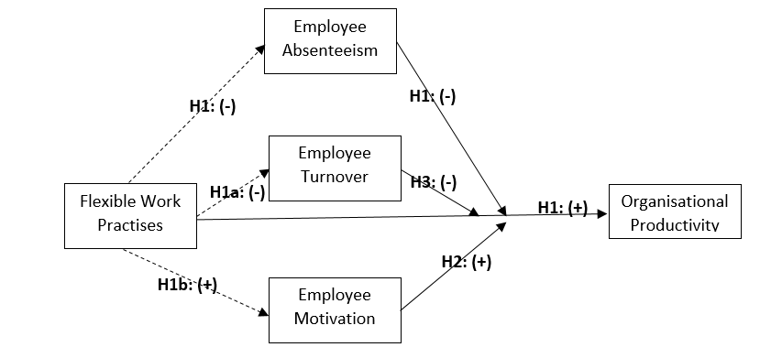

Figure 1: Research model

# CHAPTER 3: RESEARCH METHODOLOGY

## 3.0 Introduction

This chapter is designed to offer understanding of the research approach, data collection procedures, and analytical methods that is employed to address the aim and objectives outlined in this research, with focus on the questions; *how effective is the provision of FWPs on organisational productivity and how does employees’ behaviours influence organisational productivity through the provision of FWP*?The proposed methodology aligns with the goal of exploring the effectiveness of provision of Flexible working Practices by employers in the UK to employees, on Organisational Productivity, taking into consideration the details of the relationships. In addition, the research “onion” presented by Saunders, Lewis and Thornhill (2012) is used to organise the methodology of this research dissertation.

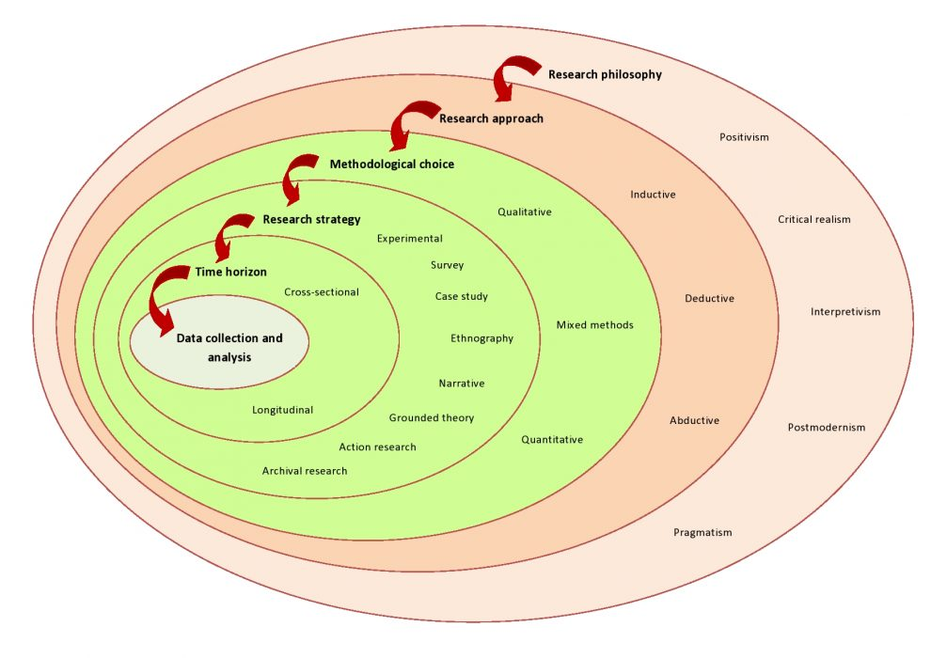

Figure 2: Research approach: “The research onion”

## 3.1 Research Methodology and Design

### Research philosophy

The selection of a research philosophy is pivotal in guiding the methodology and shaping the overall conduct and interpretation of a research dissertation. As Saliya (2023) emphasises, research philosophy provides a foundational perspective that facilitates practical analysis and underpins the entire research process. Establishing a clear research philosophy is essential as it influences the choice of research methodology and determines the approach to data collection, analysis, and interpretation. According to Ponterotto (2005), Ryan (2018), and Al-Ababneh (2020), the chosen research philosophy significantly impacts the methodology and the way research is conducted and interpreted.

The three primary philosophical models commonly recognised in academic business research are positivism, interpretivism, and critical theory, each with distinct principles and implications for research (Ryan, 2018). While these models offer structured approaches, there is also recognition of the value of more flexible stances, such as multivism and pragmatism (Al-Ababneh, 2020). Multivism acknowledges the dynamic nature of research and rejects the rigid dichotomy between objectivism and subjectivism (Brown, 2022), whereas pragmatism allows researchers to select methods that best meet the research needs without being confined to a single philosophical position (Saliya, 2023).

Positivism and interpretivism are the two predominant research philosophies widely acknowledged in academic business research (Ryan, 2018). Positivism views reality through a scientific lens, seeking precise details that can be formulated as testable propositions or recognised in similar circumstances (Saunders et al., 2012). Conversely, interpretivism adopts a subjective stance, focusing on understanding the environment through individual beliefs and experiences. While both philosophies contribute valuable insights, they differ in their approaches. Positivist research aims to identify general patterns and principles, striving for replicable findings across contexts (Lin, 1998). In contrast, interpretivist research combines specific details to form unique belief systems, offering rich contextual understanding. Pragmatism serves as a bridge between positivism and interpretivism, emphasising the importance of practical application and adaptability in research endeavours.

This research dissertation, investigating the effectiveness of flexible working practices on the organisational productivity of profit-making organisations in the UK, adopts the positivist approach. This approach advocates for the application of scientific (statistical) methods as the optimal means of understanding effectiveness, where empirical evidence is obtained through observable and testable methods, such as experiments and data analysis, rather than subjective opinions. In the context of studying FWPs and organisational productivity, a positivist approach ensures the credibility and reliability of the findings.

Positivism typically aligns with research aiming to establish causal relationships and test hypotheses quantitatively. It relies on statistical analysis and empirical data collected from tangible social factors that are readily observable and measurable (Saunders et al., 2012). Scholars often employ quantitative methodologies, gathering quantifiable data and using statistical methods to analyse and interpret the results (Amaratunga et al., 2002). This rigorous approach substantiates the validity of hypotheses and enhances the understanding and interpretation of findings (Collins, 2019). Therefore, in exploring the relationships between employees' behaviours, flexible working practices, and organisational productivity, the positivist approach is utilised to provide empirical evidence and establish measurable associations between these constructs.

### Research Approach

The research approach adopted in this dissertation is guided by Saunders et al.'s (2012) conceptualisation of research methodologies, which distinguishes between inductive and deductive approaches. Inductive research is characterised by theory-building based on observed data patterns (Trochim and Donnelly, 2008). Researchers using this approach start with data collection, identify trends and patterns, and subsequently develop hypotheses and theories to explain the findings (Azungah, 2018). This method is commonly associated with qualitative studies that do not require precise numerical calculations (Bryman and Bell, 2015).

In contrast, the deductive approach involves theorising and hypothesising before data analysis to determine the extent to which the hypotheses are supported (Wilson, 2010). This method follows a sequence opposite to inductive research, beginning with the formulation of hypotheses based on established social theories, followed by data analysis to validate these hypotheses (Trochim and Donnelly, 2008). Deductive approaches are often aligned with quantitative measurement methods, progressing from a general to a specific level of analysis (Saunders et al., 2012).

In this dissertation, the deductive approach is employed to test hypotheses derived from the academic literature reviewed in Chapter Two. This approach is suitable for examining the effectiveness of flexible working practices on organisational productivity, as it allows for empirical testing of theoretical propositions using quantitative data.

### Research Method

In selecting a suitable research method, consideration is given to the procedures for data collection and analysis. While both qualitative and quantitative methods are fundamental, this dissertation opts for a quantitative approach due to its efficiency in analysing large datasets and testing hypotheses regarding causal relationships between variables (Kalra et al. 2013). This choice aligns with the research objective of exploring the relationship between FWPs and organisational productivity, specifically through the analysis of employees' behaviours as perceived by employers in the UK.

Considering the scope and the necessity to analyse the secondary data quantitatively to test hypotheses, a purely qualitative approach was deemed less suitable. Instead, quantitative methods will be utilised to collect and analyse the secondary data on employers' perceptions of FWPs and their impact on organisational productivity (Bryman and Bell, 2015). Although Johnson and Onwuegbuzie (2004) highlighted that the mixed method can be used also contemplated for its ability to offer diverse perspectives and deeper insights, the focus on identifying correlations among variables using the secondary dataset led to the conclusion that the quantitative method is the most appropriate.

This dissertation is structured based on Saunders et al.'s (2012) framework, which distinguishes between inductive and deductive methodologies. Given the aim of this dissertation to test hypotheses derived from existing literature, particularly those formed based on established theories regarding Flexible Working Practices (FWPs) and organisational productivity, a deductive approach is adopted (Saunders et al., 2012). This research methodology centres on adopting a deductive approach to test hypotheses derived in chapter two from existing literature using quantitative methods. This approach will facilitate the exploration of the relationship between FWPs and organisational productivity, as perceived by employers in the UK, through the analysis of numerical data.

### Research Strategy

A methodical research strategy is essential to investigate the effectiveness of Flexible Working Practices (FWPs) on organisational productivity as perceived by employers in the UK. This dissertation is grounded in a quantitative research methodology, underpinned by a positivist philosophy and a deductive approach. The research strategy outlines the steps to navigate the complexities of the research question.

The initial stage involves identifying a suitable secondary dataset that captures the variables pertinent to FWPs and organisational productivity within the UK employment landscape. Once the dataset is secured, meticulous attention is devoted to clean, transforming and preparing the data to ensure its integrity and alignment with the research objectives.

With the groundwork laid, quantitative analytical techniques are employed to explore the relationship between FWPs and organisational productivity. Statistical methodologies, such as regression analysis and random forest msodel, are used to analyse the data, aiming to reveal insights into the effectiveness of FWPs on organisational productivity, considering employee behaviours such as motivation, absenteeism, and turnover.

As the analytical phase progresses, the focus shifts towards interpreting the findings and assessing the hypotheses posited in Chapter Two. Guided by deductive reasoning, conclusions are drawn to validate the hypotheses and illuminate the dynamics between FWPs and organisational productivity.

## 3.2 Data Access, Restrictions and Variable Definitions

### Data Access

The data for the dissertation study was obtained from the Fourth Work-Life Balance Employer Survey (Institute of Employment Studies et al. 2015), conducted in 2013, which is the primary data. The survey was commissioned by the UK Department for Business, Innovation & Skills (BIS) and was carried out by IFF Research. The purpose of the survey was to gather information on various aspects of work-life balance, including the impact of FWPs on organisations and employees in the United Kingdom. The survey aimed to understand the prevalence of different flexible working practices, their impact on organisational performance, and the challenges associated with their implementation. The data collection process involved 2,011 telephone interviews of a two-stage approach. In the first stage, a pre-screening exercise was conducted to identify the most appropriate person to interview in each sampled establishment. This stage aimed to ensure that the advance letter and survey information reached the right individuals, thereby improving their willingness to participate in the main survey. In the second stage, the identified respondents were contacted to conduct the main interviews. The fieldwork period for the main interviews was between June and September 2013. The survey targeted the most senior person at each site with responsibility for human resource and personnel issues, or for general management issues, with the purpose of gathering insights from individuals who could provide detailed information about their organisation's practices and practices related to work-life balance, including flexible working arrangements, maternity and paternity leave, and other related aspects. The survey's technical report indicates that the respondents were typically individuals with authority or knowledge regarding the organisation's human resource practices and practices (Department for Business Innovation & Skills 2015). The survey used a stratified sampling approach to ensure representation across different industry sectors and organisation sizes. The sample was drawn from the Inter-Departmental Business Register (IDBR), and the number of employees at each workplace and its industry sector were included in the sample. However, there were some inconsistencies between the information recorded on the sample and the information provided by respondents during the interviews. These inconsistencies were addressed by using the information provided during the interview for analysis purposes. Ethical considerations were taken into account during the data collection process. The survey adhered to strict confidentiality measures, and the linked data were anonymised and used for statistical purposes only. Only authorised researchers had access to the linked data. Additionally, respondents were given the option to consent to be contacted again for a follow-up interview, and their confidentiality was assured throughout the process. The data for the study is sourced from the Fourth Work-Life Balance Employer Survey conducted in 2013 by the UK Department for Business, Innovation & Skills (BIS) and IFF Research (Institute of Employment Studies et al. 2015). This survey aimed to gather information on various aspects of work-life balance, including the impact of Flexible Working Arrangements (FWPs) on organisational performance in the United Kingdom. Utilising a two-stage data collection process involving telephone interviews, the survey targeted individuals with authority or knowledge regarding their organisation's human resource practices and work-life balance initiatives. Ethical considerations were prioritised throughout the data collection process, ensuring respondent confidentiality and adherence to strict data protection measures. The study explored various aspects of work-life balance, including the prevalence and effects of FWPs on UK organizations and employees. Data collection involved 2,011 telephone interviews following a two-stage approach, targeting senior personnel responsible for HR or general management to gather detailed insights on work-life balance practices. A stratified sampling method ensured representation across industry sectors and organisation sizes. Despite some inconsistencies, ethical considerations were maintained through confidentiality measures, anonymized data usage, and respondent consent for follow-up interviews. Overall, rigorous methodology and ethical safeguards ensured the integrity and reliability of the collected data for statistical analysis (Department for Business Innovation & Skills 2015).

### Data Restriction, Cleaning and Transformation

In preparing the primary dataset for analysis, several steps were taken to clean and refine the data to obtain a cleaned secondary WLB4 dataset. The primary WLB4 dataset was filtered to include only the variables relevant to this dissertation topic, mapping the variables that focuses on FWPs, organisational productivity, employee motivation, turnover, and absenteeism. Observations with significant missing data, particularly those lacking responses to key variables such as productivity, motivation, turnover, and absenteeism, were excluded from the analysis to ensure the reliability and validity of the findings. The cleaning and transformation of the secondary WLB4 dataset is detailed in appendix 2.

The Variable (Class of the Organisation = A4) which classifies the activities of the organisation is an interesting variable that was restricted to organisations that are only “seeking a profit” as it covers almost all private sector establishments. With this, the sample size of the data for this dissertation is 1388 observations while the variable “BizClass” (A6) is restricted to non-negative to correct the anomalies in recording total numbers of employees as negative, Policies is set to exclude no response as these are not observations of interest. Variables were carefully mapped to 19, which are described in the table below;

### Variable Definitions and Transformations

Table 1: Variables Definitions

|  |  |  |  |
| --- | --- | --- | --- |
| **Variable name** | **Variable Definition** | **Data Value (Data Type)** | **Transformation** |
| ***Outcome Variable*** | | | |
| Productivity (H1_2) | Productivity at this establishment: Measures the perceived impact of flexible working on productivity at the establishment. | (Numeric) categorical | 1 as Positive,  2 as Negative,  3 as NoEffect |
| ***Key explanatory Variables*** | | | |
| PartTime (A13_1) | Employees work part-time. | 0&1 (Dummy) | 1 as Yes,  0 as No/Don't Know |
| WorkNight (A13_2) | Employees work during night hours. | 0&1 (Dummy) | 1 as Yes,  0 as No/Don't Know |
| DifWorkShift (A13_3) | Employees work shifts over different periods of the day or week. | 0&1 (Dummy) | 1 as Yes,  0 as No/Don't Know |
| ZeroHours (A13_4) | Employees work zero-hours contracts. | 0&1 (Dummy) | 1 as Yes,  0 as No/Don't Know |
| ThirtyPartTime (A13_5) | Employees work part-time, i.e., less than 30 hours a week - Indicates whether employees work part-time. | 0&1 (Dummy) | 1 as Yes,  0 as No/Don't Know |
| Policies (B11) | Written policy for flexible working practices provided. | 0&1 (Dummy) | 1 as Yes,  0 as No/Don't Know |
| BizOps (C1_A) | Business case and operational impact are the factors considered when evaluating flexible working requests. | 0&1 (Dummy) | 1 as Yes,  0 as No/Don't Know |
| RoleSuitability (C1_B) | Suitability of the employee role for flexible working | 0&1 (Dummy) | 1 as Yes,  0 as No/Don't Know |
| EmpyeeCompetence (C1_D) | Employee has the competency required for flexible working. | 0&1 (Dummy) | 1 as Yes,  otherwise as 0 |
| StaffRetention (C1_M) | Staff retention is considered when evaluating flexible working requests. | 0&1 (Dummy) | 1 as Yes,  0 as No/Don't Know |
| BizImpact (H6) | The Measure of the perceived impact of flexible working arrangements on the business. | (Continuous) between 0 to 5 | 0 as Don't know,  1 as very Negative,  2 as Fairly Negative,  3 as Neither Positive/ Negative,  4 as Fairly Positive,  5 as Very Positive |
| Absenteeism (H1_3) | Measures the perceived impact of flexible working on reducing absenteeism. | Ordered categorical | 1 as Positive,  2 as Negative,  3 as NoEffect |
| Turnover (H1_4) | Measures the perceived impact of flexible working on reducing employee turnover. | Ordered categorical | 1 as Positive,  2 as Negative,  3 as NoEffect |
| Motivation (H1_6) | Measures the perceived impact of flexible working on employee motivation and commitment. | Ordered categorical | 1 as Positive,  2 as Negative,  3 as NoEffect |
| ***Control Variables*** | | | |
| WLB (H2_2) | Employer disagree that the employer's responsibility to assist individuals in balancing their work with other aspects of their lives | (Continuous) between 0 to 5 | 0 as Don't know,  1 as strongly disagree,  2 as Disagree,  3 as Neither,  4 as Agree,  5 as Strongly agree |
| BizClass (A6) | The overall count of employees in the organisation, which define the classification of the business. | (Character) Categorical | Small as Business with Employees < 50,  Medium as business with employees >=50 but <250,  Large as business with employees >= 250 |
| JobTitle (S3) | Job title or position of the respondents in the organisation. | (Character) Categorical | 1 as Human Resources manager / officer  2 as Personnel manager / officer  3 as Training manager / officer  4 as Financial/Accounting manager / officer  5 as General manager  6 as Owner/proprietor  7 as Managing Director / Chief Executive  8 as Directors  9 as Other manager  10 as PA / Secretary  11 as Administrator 12 as Head teacher  13 as Others |
| PeerPerf (K1) | Perception of employers’ financial performance compared to their peers | (Continuous) between 0 to 5 | 0 as Don't know,  1 as very Negative,  2 as Fairly Negative,  3 as Neither Positive/ Negative,  4 as Fairly Positive,  5 as Very Positive |

N= 1388.

## 3.3 Analysis Methodology

### Data Analysis Tool

RStudio is used as the primary analytical and visualisation tool for this dissertation. This decision is based on its ability to facilitate statistical analysis, including the development of R code and the seamless visualisation of graphs, data tables, and outputs, not to forget it is also a requirement to complete this dissertation.

### Data Analysis Process

The data analysis process is in three essential methodologies: descriptive analysis, exploratory analysis, and statistical analysis. Initially, descriptive analysis is employed to summarise key characteristics of the cleaned WLB4 dataset, including measures of central tendency and measures of variability within the data. Subsequently, exploratory analysis is conducted to delve deeper into the dataset, identifying underlying relationships and patterns to unveil new insights and trends. Finally, statistical analysis is employed, utilising mathematical models and statistical tools to rigorously analyse and interpret the data. Through regression analysis, hypothesis testing and Random Forest Model as advanced statistical techniques, the aim is to derive meaningful conclusions regarding the effectiveness of flexible working practices on organisational productivity, as measured by employees' behaviours, through the perception of employers in the UK.

#### Decision Tree Analysis

In addition to regression analysis, the dissertation will employ decision tree analysis using the CART (Classification and Regression Trees) algorithms which was introduced by Leo Breiman (IBM 2024). CART is a versatile algorithm capable of handling both classification and regression tasks. It will be utilised to build decision trees that partition WLB4 based on predictor variables and "productivity” and identifies key predictors influencing organisational productivity as perceived by employers in the UK, which will be done by the visualisation of decision trees and interpretation of key splitting variables, valuable insights will be gained, enhancing the overall understanding of this dissertation.

#### Regression Analysis

Regression analysis is employed to explore the relationships between flexible working practices (FWPs) and organisational productivity, as perceived by employers in the UK. The outcome variable "productivity" is an ordinal categorical variable with three categories: "Positive," "Negative," and "No Effect." To appropriately analyse this type of outcome variable, ordinal logistic regression is used (Frost, 2024).

Ordinal logistic regression is particularly suitable for examining ordinal categorical outcomes where the categories have a natural order, but the intervals between them are not necessarily equal or quantifiable. This regression model allows us to understand how predictor variables, such as FWPs, influence productivity levels within an organisation. By estimating cumulative odds ratios, ordinal logistic regression provides insights into the likelihood of an organisation falling into one productivity category compared to others, while accounting for the ordinal nature of the data (Frost, 2024).

A key constraint of this method is its assumption of proportional odds, meaning that the relationship between each pair of outcome groups is consistent. If this assumption is violated, the model’s accuracy may be compromised. This constraint will be further discussed in the discussions section of this dissertation analysis chapter, where diagnostic tests and potential model adjustments will be considered to ensure the robustness of the findings.

#### Random Forest model

The Random Forest model is an advanced statistical learning algorithm that will be employed to analyse the effectiveness of flexible working practices (FWPs) on organisational productivity, as measured by employee behaviours. Random Forest, an ensemble learning method, is particularly suitable for handling complex datasets with multiple predictors and interactions (Breiman, 2001). This algorithm constructs numerous decision trees during training and outputs either the mode of the classes (for classification) or the mean prediction (for regression) of the individual trees. It utilises bootstrap aggregation (bagging), where random subsets of data are used to build each tree, ensuring diversity. Additionally, at each decision tree split, a random subset of features is selected, promoting varied tree structures (Ho, 1995).

The approach of using the Random Forest model in this dissertation is ideal due to its ability to handle high-dimensional data without the need for variable deletion, making it suitable for complex datasets involving multiple factors influencing productivity. The model’s capability to capture non-linear relationships between productivity and predictors is advantageous given the intricate nature of organisational dynamics. Additionally, feature importance scores generated by the model can identify which aspects of FWPs are most influential on productivity metrics. The method's robustness, due to the averaging process, reduces overfitting risks and provides more reliable predictions (Cutler et al., 2007). However, its complexity can pose challenges in interpreting the specific pathways through which FWPs influence productivity, although it offers a sophisticated approach to analysing the effectiveness of FWPs on organisational productivity.

# CHAPTER 4: ANALYSIS AND EMPIRICAL FINDINGS

## 4.0 Introduction

This analysis chapter examines into the empirical findings of the effectiveness of Flexible Work Practices (FWP) on organisational productivity, through statistical techniques to systematically interpret the WLB4 data, revealing underlying patterns and insights. The synthesis of WLB4 data provides an understanding of this topic, while also assessing the validity and reliability of research methods. This analysis encompasses various statistical procedures designed to explore relationships between predictor variables and organisational productivity, as well as to evaluate model performance.

## 4.1 Descriptive Statistics

An initial overview of the WLB4 dataset is the descriptive statistics which is crucial in the initial phase of data analysis. Measures such as mean, median, standard deviation, and frequency distributions are utilised to summarise key features, including the distribution of variables in the dataset such as flexible working practices (FWPs), employee behaviours, and organisational productivity as presented in table 2 below. These statistics helps understands the central tendencies and variabilities within the data, offering insights into the distributional characteristics of the dataset variables.

Table 2: Variables Descriptive Statistics

|  |  |  |  |  |
| --- | --- | --- | --- | --- |
| **Numeric Variables** | **reliability** | **mean** | **sd** | **Distrbuttion** |
| *PartTime* | 1 | 0.689 | 0.463 | ▃▁▁▁▇ |
| *WorkNight* | 1 | 0.375 | 0.484 | ▇▁▁▁▅ |
| *DifWorkShift* | 1 | 0.507 | 0.5 | ▇▁▁▁▇ |
| *ZeroHours* | 1 | 0.207 | 0.405 | ▇▁▁▁▂ |
| *ThirtyPartTime* | 1 | 0.824 | 0.381 | ▂▁▁▁▇ |
| *Policies* | 1 | 0.635 | 0.481 | ▅▁▁▁▇ |
| *BizOps* | 1 | 0.720 | 0.499 | ▃▁▁▁▇ |
| *FWRquest_RoleSuit...* | 1 | 0.246 | 0.431 | ▇▁▁▁▂ |
| *EmpyeeCompetence* | 1 | 0.0411 | 0.199 | ▇▁▁▁ |
| *StaffRetention* | 1 | 0.00423 | 0.0656 | ▇▁▁▁ |
| *BizImpact* | 1 | 3.53 | 1.10 | ▁▁▆▇▃ |
| *Productivity* | 1 | 1.92 | 0.939 | ▇▁▂▁▇ |
| *Absenteeism* | 1 | 1.79 | 0.958 | ▇▁▁▁▅ |
| *Turnover* | 1 | 1.82 | 0.961 | ▇▁▁▁▆ |
| *Motivation* | 1 | 1.57 | 0.889 | ▇▁▁▁▃ |
| *WLB* | 1 | 2.50 | 1.12 | ▃▇▅▃▁ |
| *PeerPerf* | 1 | 3.17 | 1.30 | ▂▁▇▆▂ |

*N:1388*

Part-time work is common (mean = 0.689), and flexible operations are generally supported (mean = 0.720). However, night shifts (mean = 0.375) and zero-hours contracts (mean = 0.207) are less utilised. Flexible work policies are moderately implemented (mean = 0.635), though many roles are not suitable for flexible arrangements (mean = 0.246). Significant challenges exist in maintaining employee competence (mean = 0.0411) and retention (mean = 0.00423). The impact on business operations (mean = 3.53) and productivity (mean = 1.92) varies widely. Reduced absenteeism (mean = 1.79) and turnover rates (mean = 1.82) indicate some benefits, but employee motivation (mean = 1.57) and work-life balance (mean = 2.50) are only moderate. Peer performance shows significant variability (mean = 3.17), reflecting diverse impacts of FWP.

The table in *Appendix 3* presents the percentage distribution of WLB4 data variables. A significant proportion of employees engage in part-time work (68.95%) and night shifts (37.46%), while nearly half (50.72%) work different shifts, indicating high levels of flexibility offered by employers. Prominent job roles include "Human Resources" (25.72%) and "Other Manager" (27.38%), showcasing the diversity within the sampled WLB4 data. The majority of employers (63.54%) have formal flexible work policies, suggesting a structured approach to workforce management. Employers report high employee retention rates (99.57%), reflecting perceived organisational stability. Approximately 20.68% of employees are on zero-hour contracts, 68.95% are part-time, and 50.72% have different flexible working patterns, highlighting the prevalence of flexible employment arrangements. Positive perceptions of productivity are common, with 46.65% of employers viewing it positively, 12.44% negatively, and 40.91% perceiving no effect.

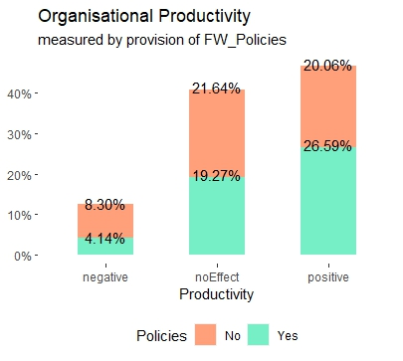

Figure 3: Organisational productivity by provision of FW Policies

Approximately 63.54% employers as FW policies in place, it is interesting to note from figure 3 that when policies are provided, a notably higher percentage of employers exhibit positive productivity (26.59%), compared to instances where policies are not provided (20.06%). Conversely, the percentage of cases with negative productivity is lower when policies are provided (8.30%) than when they are not (26.59%). Similarly, for cases where policies are provided, the percentage of instances with no effect on productivity is lower (19.27%) than those without policy provision (21.64%). Implying the negative and no effect productivity dropped and positive effect increase was noted, this partly support the argument of hypothesis H1.

## 4.2 Pearson Correlation Matrix

The relationships between variables in WLB4 dataset is examined through Pearson correlation, identifying potential multicollinearity issues for the regression analysis, and selecting variables for predictive modelling.

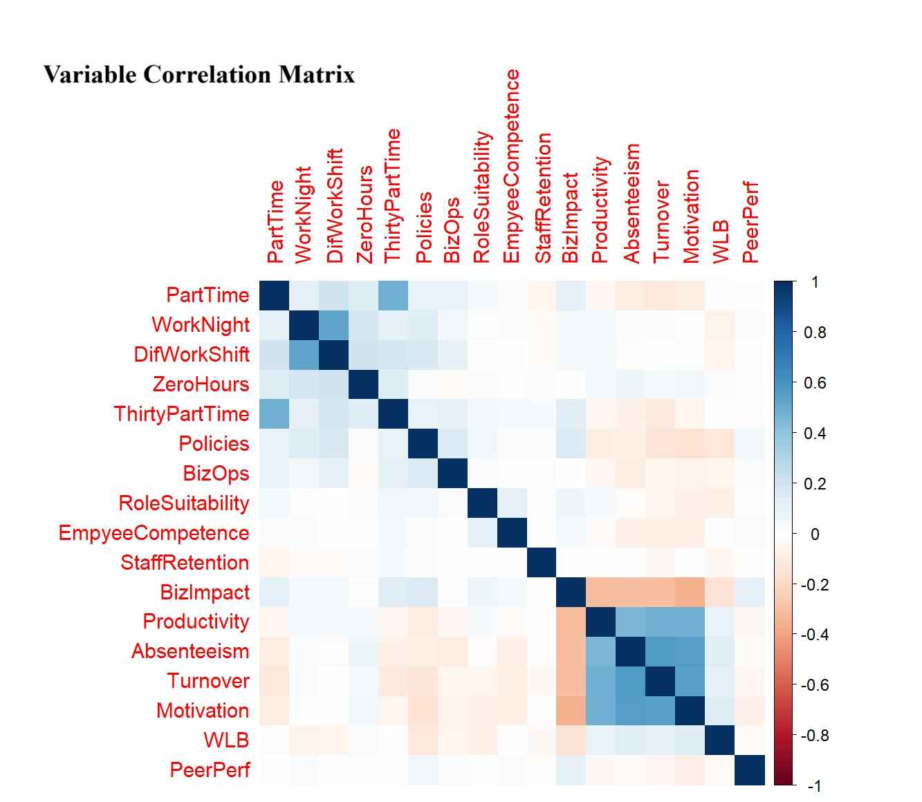

Figure 4: Variable Correlation Matrix

A discernible positive correlation exist between part-time employment and variables like employees working less than 30 hours a week and working different work shift, suggesting a cohesive relationship between these factors, which slightly indicate a positive correlation with the impact on Business and part-time employees are inclined towards alternative work arrangements. Absenteeism, Turnover, and Motivation demonstrate moderate to strong positive correlations, indicating that higher rates of reducing absenteeism and turnover may coincide with higher motivation levels.

The correlations of provision of FW Policies with other variables display weak to moderate positive correlations with factors related to work arrangements, such as working night shifts (r ≈ 0.138) and working different shifts (r ≈ 0.161), as well as business operations (r ≈ 0.155) and impact on business (r ≈ 0.154). Conversely, it exhibits weak to moderate negative correlations with productivity, reduced absenteeism (r ≈ -0.089), reduced turnover, (r ≈ -0.132), motivation, and work-life balance. This indicates that as policies increase, there might be incremental improvements in certain work-related aspects, yet potential declines in productivity and various employee outcomes. Moreover, the negative correlations observed between Policies and variables like Productivity (r ≈ -0.091) and Motivation (r ≈ -0.159) hint at a compromise between provisions of flexible working policies to organisational productivity. However, this interestingly needs further investigations.

## 4.3 Regression Analysis

Regression analysis is a statistical method used to examine the relationship between one or more independent variables and a dependent variable (Chatterjee and Simonoff 2012). Following the analytical methodology of this dissertation, an ordinal logistics regression is modelled into the WLB4 dataset for exploration of organisational productivity as the dependent variable.

### Regression of Productivity on all the Independent Variables and Control Variables (Model 1)

The equation of the model (Model 1) to estimate below:

Where:

represents the probability of organisational productivity being less than or equal to category 𝑘, such that, where 1 implies positive productivity, 2 implies negative and 3 is no effects. Each coefficient represents the effect of the corresponding predictor variable on the log-odds of being in a higher category of Productivity. And to are representative of the independent variables, such that is the intercept, are coefficients of the independent variables and is the error term.

Table 3: Model 1 regression result

|  |  |  |
| --- | --- | --- |
| Dependent variable: Productivity | | |
| **Variable** | **Coefficients** | **SD** |
| PartTime | 0.063 | (0.151) |
| WorkNight | -0.025 | (0.15) |
| DifWorkShift | 0.256* | (0.15) |
| ZeroHours | -0.100 | (0.155) |
| ThirtyPartTime | 0.064 | (0.182) |
| JobTitleDirector | 0.563 | (0.401) |
| JobTitleFinAccMgr | 0.783 | (0.486) |
| JobTitleGeneralMgr | 0.396 | (0.412) |
| JobTitleHeadTeacher | 13.588*** | 0 |
| JobTitleHumanResources | 0.633 | (0.392) |
| JobTitleMD/CEO | 0.501 | (0.446) |
| JobTitleOther Manager | 0.478 | (0.378) |
| JobTitleothers | 1.605*** | (0.578) |
| JobTitleOwner | 0.322 | (0.441) |
| JobTitlePA | 0.452 | (0.502) |
| JobTitlePersonnelMgr | 0.593 | (0.519) |
| JobTitleTrainingMgr | 1.356 | (0.826) |
| Policies | -0.161 | (0.139) |
| BizOps | -0.076 | (0.139) |
| RoleSuitability | 0.414*** | (0.144) |
| EmpyeeCompetence | 0.204 | (0.299) |
| StaffRetention | 1.264 | (0.849) |
| BizImpact | -0.261*** | (0.059) |
| Absenteeism | 0.413*** | (0.076) |
| Turnover | 0.575*** | (0.076) |
| Motivation | 0.593*** | (0.082) |
| WLB | 0.034 | (0.055) |
| PeerPerf | 0.0004 | (0.047) |
| BizClassMedium | 0.423** | (0.185) |
| BizClassSmall | -0.017 | (0.21) |

*N: 1,388 Note:*p<0.1; **p<0.05; ***p<0.01*

Intercepts:

|  |  |  |  |
| --- | --- | --- | --- |
|  | **Intercepts** | **SD** | **t value** |
| 1|2 (Positive to Negative) | 2.5801 | 0.5588 | 4.6172 |
| 2|3 (Negative to No effect) | 3.2544 | 0.5619 | 5.7915 |

*Residual Deviance: 2121.485, AIC: 2185.485*

The equation of the model 1 regression is presented in ***appendix 4.*** The general ordinal logistic model (Model 1) has productivity as the dependent variable which is explain by all the independent variables in the dataset WLB4. The model indicates significances of only nine independent variables to explain productivity, where the provision of FW policies is not significant with a coefficient of, indicating FW policies provision decreases the odds of higher productivity by 0.161units, which this supports the identifications of the variable correlation matrix in section 4.3 of this dissertation. The coefficient estimates show that for every one-unit increase in different working pattern (which is significant by p<0.10) increases the odds of higher productivity by 0.256 unit. Similarly, an employee being head teacher (which is significant by p<0.01) increases the odds of higher productivity by 13.588 units, while job role classed as others (which is significant by p<0.01) increases the odds of higher productivity by 1.605 units, the suitability of employee’s role (which is significant by p<0.01) increases the odds of higher productivity by 0.414 units, while in converse, for every one-unit increase in business impact (which is significant by p<0.01) decreases the odds of higher productivity by 0.261 unit while for every one-unit increase in reduced absenteeism, reduced turnover, motivation and a business being a medium size (which are significant by p<0.10 except business size being significant by p<0.05) increases the odds of higher productivity by 0.413, 0.575, 0.593, and 0.423 unit respectively.

The coefficient for turnover is positive and significant (p < 0.01), indicating that as reduction in turnover increases, the likelihood of higher productivity also increases, a visualisation of this is seen in figure 5 below, where this argument is further supported.

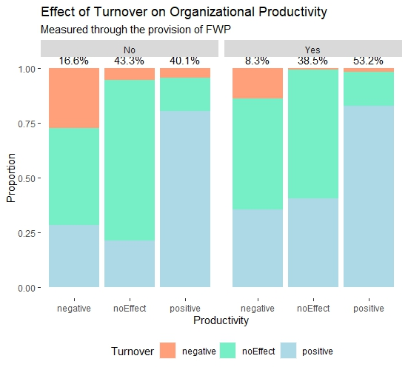

Figure 5: Effect of Turnover on Organisational productivity by provision of FW Policies

Introduction of FW policies,and when employees’ turnover is positively reduced, there is a little increase in the positive organisational productivity compared to when no FWP. However, there are significant reductions of no effect or negative organisational productivity, as at when there is no effect or negative reduction of employees’ turnover.

Motivation’s coefficient is positive and significant (p < 0.01), indicating that higher motivation levels are associated with higher likelihood of productivity. This finding supports the hypothesis that employee motivation influences organisational productivity. H2: Employee motivation influences organisational productivity. Also, the coefficient for reducing turnover is positive and significant (p < 0.01), suggesting that higher rate of turnover reduction rates are associated with higher productivity. However, this supports the notion that moderate levels of turnover reduction rate are positively associated with productivity, H3: Moderate levels of employee turnover are positively associated with organisational productivity, provided there are flexibility arrangements.

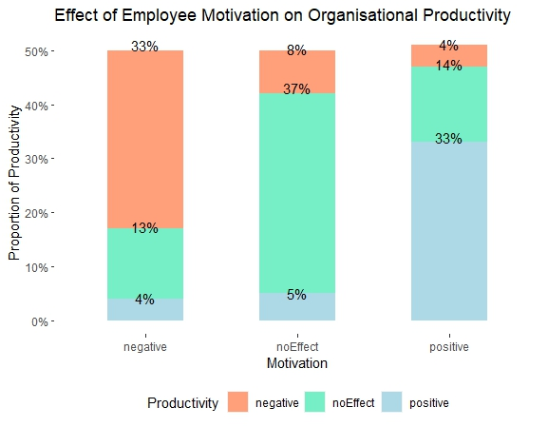

Figure 6: Motivation effect on Organisational productivity

In conjunction to the Model 1 support of H3, figure 6 shows the perceived productivity and iterates that as motivation of employees’ become more positive, the perceived organisation productivity follows in situ.

Further modelling involves refining the regression model by selecting significant predictor variables based on p-values. The conducted proportional odds logistic regression (Model 1) analysis aims to scrutinise the effects of all independent variables on organisational productivity within the context of FWP.

#### Decision Tree of the Model 1

The methodology of this research dissertation, requires the approach of the use of decision tree which as the ability to handle nonlinear relationships between predictor variables of model and essential to consider the assumptions of both decision trees and ordinal regression when applying this approach to real-world data. The classification of the predictor variables that can improve the organisation productivity is shown by the *figure* 7 below, which is a decision tree structure along with associated probabilities at each decision nodes and conditions.

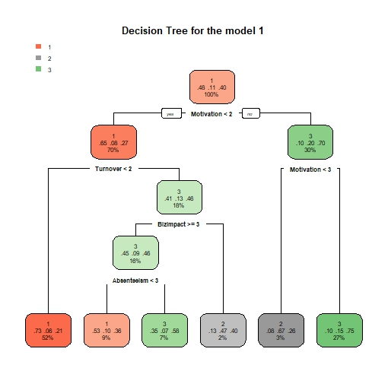

Figure 7: Model 1 Decision Tree

The numbers 1, 2, and 3 represents the outcomes of organisational productivity, which are respectively positive, negative and no effect. From the decision tree, we have several nodes, where the most important predictor variables for organisational productivity is motivation, which about 100% of employers perceived that positive motivation impacts positive organisational productivity with a probability of 0.48, 0.11 and 0.40 is the probability that high motivation will respectively result into a negative and no effect on organisational productivity. The perception of employers (of but 70% of the employers) further indicates that positive reduction of employees’ turnover has 0.65 probability to result into positive organisational productivity, 0.08 probability to result into negative organisational productivity and 0.27 results into no effects. Similarly, 9% of the employers has a perception that positive reduction of employees’ absenteeism with a probability of 0.53 will result into positive organisational productivity, while 0.10 and 0.36 are the chance for negative and no effect organisational productivity respectively. From the decision tree of the Model 1, the guiding conditions for positive organisational productivity as perceived by the employers are positive motivation which is the most influential, positive reduction of turnover and positive reduction of employees’ absenteeism.

On the contrary, 18% of the employers has a perception that a no effect business impact is the same in n effect to organisational productivity with a chance of 0.46, as well as no effect in reduced employees’ absenteeism with a chance of 0.58. The *figure*below, visually explore the relationship between the provisions of FWP and organisational productivity, with the significant key independent variables employees’ motivation and reduced absenteeism.

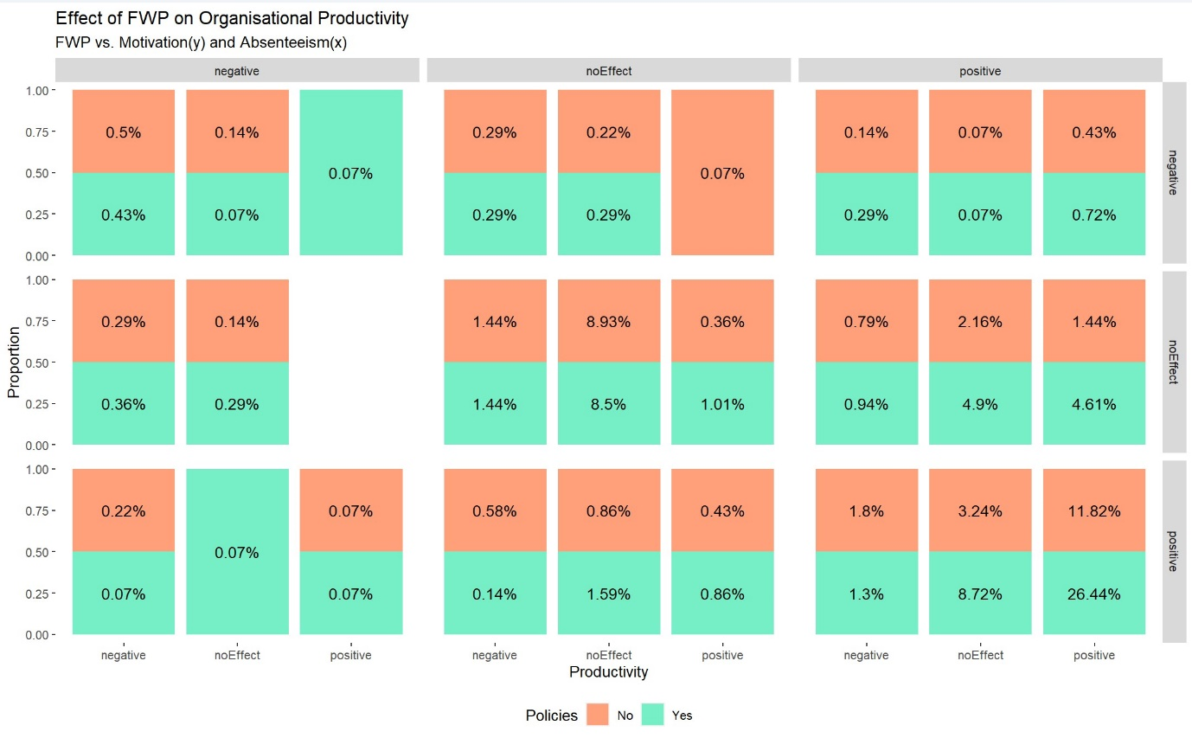

Figure 8: FWP on organisational explored with employee motivation and absenteeism

The faceted stacked bar chart present the perceived impact of Flexible Work Policies (FWP) on organisational productivity, with a focus on key employees’ behaviour: motivation and absenteeism, which is segmented into the three categories of organisation productivities (negative, no effect, and positive) and further distinguished by the presence (green) or absence (red) of FWP, with productivity on the bottom x-axis, absenteeism on the top x-axis and motivation on the y-axis (right side of the chart). Each bar within the plot represents the proportion of cases falling into the respective combination of motivation, reduced absenteeism, and productivity.

From the chart, 26.44% of employers with FWP in place reports a positive organisational productivity while their employees’ motivation is positive and employees’ absenteeism is positively reduced, which in similar case, 11.82% of employer without FWP reported positive organisational productivity. As motivation positive to no effect, and from no effect to negative, it is observed that the percentage of employers with the perception of positive organisation productivity reduced, while keeping the reduction of employee at positive. This indicates that employees’ motivation is significantly drives positive organisational productivity with or without the provision of flexible working practices.

## 4.4 Fitting the model through the stepwise algorithm using AIC

The stepwise variable selection method employed a systematic approach to refine the Model 1 by iteratively evaluating predictors' significance in predicting the organisational productivity as perceived by employers in the UK, measured by the Akaike Information Criterion (AIC). Initially, the model encompassed a range of potential predictors, including variables like PartTime, WorkNight, DifWorkShift, ZeroHours, ThirtyPartTime, and various job titles, alongside other metrics related to organisational policies, employee competence, and business operations. Through a series of steps, the analysis sequentially assessed each predictor's contribution to the model's explanatory power.

The Model 1 has all the independent variables to understand organisation productivity which indicates spurious relationships that needed to be explored. The stepwise AIC approach is adopted to significantly refine the model by removing non-influential predictors, which gives the provision to iteratively add to or more importantly omit variables from the Model 1 to improve the model to choose the one with the smallest amount of error which operationalise this as the model with the *lowest***Akaike information criterion (AIC)**, indicating a more parsimonious model, relative to one fit with a higher AIC. This approach is adopted to effectively penalise the Model 1 for having all the independent variables in the model. AIC is an estimator of in-sample prediction error. The Model 1 was subject to AIC stepwise algorithm in both directions, with iterations the model 3 is developed and has the least AIC, which is detailed below.

After multiple iterations, a streamlined set of predictors deemed most influential in determining organisational productivity. These included DifWorkShift, RoleSuitability, BizImpact, Absenteeism, Turnover, Motivation, and BizClass. Each of these predictors exhibited notable associations with productivity, as evidenced by their respective coefficients in the below table.

Table 4: Model 3 regression result

**Dependent variable: Productivity**

|  |  |  |  |
| --- | --- | --- | --- |
| **Variable** | **Coefficient** | **Standard Error** | **t value** |
| DifWorkShift | 0.202 | (0.130) | 1.5579 |
| RoleSuitability | 0.428 | (0.141) *** | 3.0430 |
| BizImpact | -0.255 | (0.057) *** | -4.4743 |
| Absenteeism | 0.408 | (0.074) *** | 5.5138 |
| Turnover | 0.552 | (0.074) *** | 7.4796 |
| Motivation | 0.600 | (0.081) *** | 7.3921 |
| BizClassMedium | 0.380 | (0.175) ** | 2.1690 |
| BizClassSmall | -0.067 | (0.164) | -0.4102 |

*Note:*p<0.1; **p<0.05; ***p<0.01*

**Intercepts:**

|  |  |  |  |
| --- | --- | --- | --- |
|  | **Value** | **Std. Error** | **t value** |
| 1|2 (Positive to Negative) | 1.9534 | 0.3282 | 5.9522 |
| 2|3 (Negative to No effect) | 2.6196 | 0.3322 | 7.8868 |

*Residual Deviance: 2139.715, AIC: 2159.715 n=1388*

Equation of the model3:

Where; *j is the level category of Productivity i.e. “positive”, “negative” or “no effect”*

This model3 assumes that the relationship between each independent variables in the model and the log odds of being in a higher category of productivity versus all lower categories is constant across all category thresholds. Each coefficient provides the direction and magnitude of the effect of each predictor, controlling for other variables in the model.

Statistically significant predictors in the optimal_ model included different working shift, reduced Absenteeism, reduced Turnover, Motivation, and role suitability aspects of FWPs, with interpretations as an employee works different work shift (which is significant by p<0.01) increases the odds of higher productivity by 0.202units. Similarly, employee role suitability for flexible working, and reducing absenteeism, reducing turnover, employee motivation, and organisation being a medium size increases the odds of higher productivity by 0.428, 0.408, 0.552, 0.6, and 0.380 unit respectively. The significant positive coefficients for Absenteeism, Turnover, and Motivation confirm that FWPs that reduce absenteeism and employee turnover and enhance employee motivation are strongly associated with increased organisational productivity. This supports hypotheses H1, H1a, H1b, and H2. Role Suitability had a notable positive coefficient, indicating that flexible roles tailored to employee skills and competencies also contribute to productivity. The negative coefficient for business impact suggests that there may be perceived or actual negative impacts of FWPs on business operations that could detract from their positive effects on productivity.

Job titles like Head Teacher and others had large positive coefficients initially, suggesting role-specific variations in how FWPs impact productivity. However, many job title variables were removed in the stepwise refinement, indicating their lesser importance compared to direct FWP factors. Business size (BizClass) showed mixed effects on productivity, with medium businesses showing a positive association, potentially indicating different scales of impact by business size.

The model3 through the stepwise method ended with a lower AIC (*2159.715)*, indicating a better fit to the WLB4 compared to the Model 1, and highlighted the importance of different aspects of FWPs (like Absenteeism, Turnover, Motivation, and role suitability), affirming their distinct roles in enhancing productivity, which confirms that FWPs significantly enhance organisational productivity primarily by reducing absenteeism and turnover and boosting employee motivation. Additionally, role suitability and negative business impacts are crucial considerations in the adoption of FWPs. These findings suggest that companies should strategically implement flexible work policies that not only cater to employee needs and also align with business operations to optimise productivity gains.

The Model 1 indicated a poor fit, as evidenced by high residual deviance of 2121.485 and an AIC of 2185.485, suggesting significant unexplained variance. Subsequent optimisation through a stepwise variable selection method significantly improved model fit, reducing the AIC to 2159.715, indicating a more explanatory set of variables.

The model3 highlights several key factors influencing organisational productivity. Among them, flexible working policies (FWPs) appear to significantly impact employee motivation, absenteeism, and turnover—each of which directly affects productivity. Specifically, the variable Absenteeism showed a strong positive effect, with a coefficient of 0.419694 and a standard error of 0.076, suggesting that FWPs that successfully reduce absenteeism can significantly boost productivity. Similarly, Turnover, with a coefficient of 0.580733, highlights that reducing employee turnover through flexible working arrangements also contributes positively to productivity.

Employee motivation, as measured by Motivation, similarly showed a strong positive relationship with productivity, evidenced by a coefficient of 0.594947. This aligns with the hypothesis H1b that FWPs positively affect employee motivation but not strong correlation as the coefficient is 0.59, although this corroborate the broader notion that motivated employees are more productive supporting the argument claimed by Smith & Johnson (2023) and Williams et al. (2024). Role suitability adjustments under FWPs, indicated by RoleSuitability, with a coefficient of 0.411801, also demonstrate a positive impact on productivity. This supports the concept that aligning flexible work options with job demands and employee capabilities is crucial. Business classification, represented by variables like BizClassMedium (coefficient of 0.419899) and BizClassSmall (coefficient of -0.018556), further indicates that the size of the business can influence how FWPs impact productivity. Medium businesses seem to benefit more from FWPs compared to small businesses, perhaps due to different capacities for implementing such practices effectively.

This model strongly supports the primary hypothesis (H1) that flexible working practices, when aligned with enhanced employee motivation and reduced absenteeism, positively influence organisational productivity. These findings also uphold sub-hypotheses H1a and H1b, demonstrating that FWPs can effectively reduce employees turnover and enhance motivation, thereby boosting productivity. The positive effect of moderate employee turnover on productivity, as outlined in H3, suggests that a certain level of turnover might introduce fresh skills and ideas, beneficially impacting flexibility and overall productivity, provided it is well-managed within flexible work arrangements. The model3 highlights the significance of certain factors, such as work shift differences, role suitability, absenteeism, turnover, and business class size, in influencing productivity levels within the perception of employers in the UK from the dataset.

### Decision Tree of Model 3

The model3 suggested the employees’ behaviours that drives organisational productivity within the context of the provision of FWP as perceived by employers. These suggested predictors are missing classification by importance and their possible consequences to organisational productivity. The below figure 9 presents the decision tree for the model3 that visually represented the classification and predictions of predictor variables by importance and their consequences. By the provision of FWP, 100% of the employers have the perceptions that employees’ motivation drive organisational productivity, with the probability that an employer will experience positive organisational productivity is 0.48, negative productivity is 0.1 and no effect is 0.41. There is this perception by employers that when employees, motivation is negative or unchanged, there will be a resulting probability that an employer will experience positive productivity is 0.09, negative productivity is 0.19 and no effect is 0.72, implying the negative or unchanged motivation could result into high chance of no effect organisational productivity. Similarly, 68% of the 100% employers that believed motivation is very important to organisational productivity have the perception that positively reduced employee turnover is next important to drive positive organisational productivity, with the probability that an employer will experience positive productivity is 0.67, negative productivity is 0.06 and no effect is 0.27.

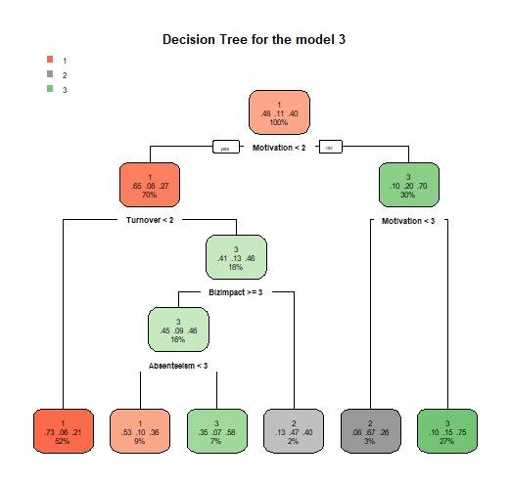

Figure 9: Decision tree for the Model 3

Employers overwhelmingly perceive that positive motivation positively impacts organisational productivity, also reductions in employee turnover and absenteeism also play significant roles in the decision tree of model3 and the Model 1. Reduced absenteeism is only classified by the decision tree of the Model 1 which lead to no effect on productivity, is a variation to the model3.

### Accuracy of Model 3

Model3 emerged with the least AIC, the predictive capacity and accuracy of the model is tested with a spit of the dataset WLB4 into ratio 70 to 30 Train and Test dataset respectively, to ensure that the model's performance can be assessed on unseen data. ***Appendix 5*** detailed the statistic of the accuracy of the model 3, inclusive of the confusion matrix.

The predictive performance of the model3 of the outcome variable; perceived organisational productivity labelled as 1 (Positive), 2 (Negative), and 3 (No Effect) achieved an overall accuracy of ***62.78%***, by correctly predicting productivity levels of about 63% of the cases in the test dataset. 95% Confidence Interval (0.5786, 0.6751) gives a range where the model accuracy is expected to fall 95% of the time, and a Kappa statistic of 0.3307, indicating a fair level of agreement between predicted and actual values beyond chance. Additionally, the P-Value [Acc > NIR] (4.390e-09) suggests that the model's accuracy significantly exceeds the No Information Rate, which is the accuracy obtainable by always predicting the most frequent class.

Sensitivity of the model3, which measures the true positive rate, was highest for positive organisational productivity at 84.62%, indicating strong ability to identify the Positive category, but was 0% for class 2, highlighting a complete failure in predicting the Negative category. Specificity was perfect for negative organisational productivity, though it represents a hollow achievement as no correct predictions were made for this category. The balanced accuracy for each class, averaging sensitivity and specificity, suggests a better performance in distinguishing positive and no effect organisational productivity, with negative productivity significantly lags. The Mcnemar's Test P-Value (9.878e-15) confirmed significant asymmetries in the prediction errors among the classes, suggesting that improvements are necessary, particularly in predicting the negative productivity more effectively and balancing the overall predictive capability across all classes.

#### Fitting the model 3

Fitting a regression model helps evaluate how well the model3 captures the variation in the dataset WLB4. This guides the model3 selection and improvement. In fitting the model3, predictive models are used: a decision tree model (CHAID) and an ordinal logistic regression model. The logistic regression and decision trees to model and predict productivity levels based on various predictors within subsets of a dataset (**WLB4**) differentiated by whether flexible working policies are in place or not, resulting into the **FWP** (as the train dataset, where the observations are with FWP) and **NoFWP** (as the test dataset, where the observations does not have FWP) dataset of 882 unique observations, about 64% and 506 unique observations about 36% respectively.

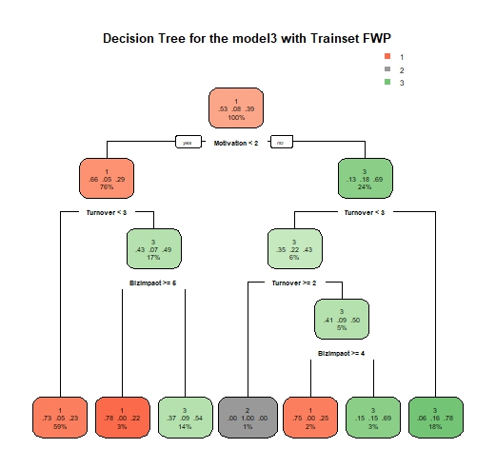

Figure 10: Decision tree of the model 3 on the train dataset; FWP

The decision tree model, trained on the FWP, visualises the optimal structure for predicting organisational productivity based on predictor variables such as DifWorkShift, RoleSuitability, BizImpact, Absenteeism, Turnover, Motivation, and BizClass. 100% of the employers have the perceptions that employees’ motivation drive organisational productivity, with the probability that an employer will experience positive (1) organisational productivity is 0.53, negative productivity is 0.08 and no effect is 0.39, this indicates an improvement to the model3. The model is tested on the NoFWP data to predict **Productivity**. This checks how well the model, developed under provision of FWP predicts organisational productivity in the condition where the policy is absent, where ***table*** 5 below displays the confusion matrix of actual versus predicted classes of organisational p**roductivity**. It shows how many predictions were correct (diagonal elements) and how many were errors (off-diagonal elements), having the actual categories of **Productivity** in the rows and predicted categories in columns.

Table 5: Model 3 Confusion Matrix

|  |  |  |  |
| --- | --- | --- | --- |
| **Prediction** | **Positive (1)** | **Negative (2)** | **No Effect (3)** |
| *Positive (1)* | 184 | 0 | 19 |
| *Negative (2)* | 34 | 0 | 50 |
| *No Effect (3)* | 62 | 0 | 157 |

The prediction performance of the model3 on the NoFWP dataset, comparing its predictions to the actual reference values across the three distinct categories: positive organisational productivity (1), negative (2), and no effect (3), shows that the model correctly identifies 184 instances as positive organisational productivity, while it misses predicting the negatives entirely and has 19 instances as no effect (3). This pattern persists across scenarios where the actual reference is 2 or 3, indicating the model's classification performance is structured. Overall accuracy of the model on the NoFWP data is approximately 67.39%, indicating a significant portion of correct predictions.

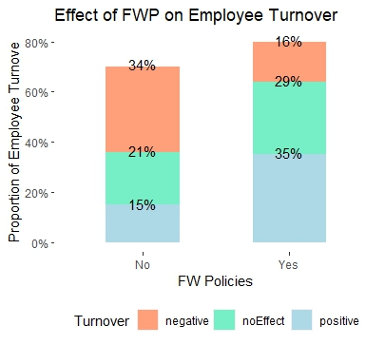

Figure 11: Effect of FWP on Employees’ Turnover

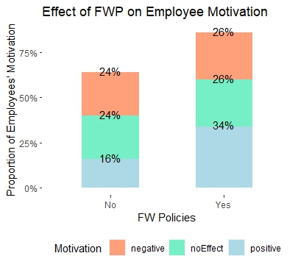

Figure 12: Effect of FWP on Employees’ Motivation

## 4.5 Random Forest Model

Further to the analysis of ordinal regression model and decision tress, random forest model analysis is done to understand the effectiveness of FWPs on organisational productivity. The analysis begin with the transformation of the WLB4 data by converting all character columns into factors to ensure appropriately format for the statistical analysis, partitioned into training (70%) and test (30%) sets, maintaining the distribution of organisational productivity as the outcome variable. This partitioning was crucial for training the random forest model (***rfModel***) and evaluating its performance.

A random forest model was trained on the 70% training dataset with Productivity as the outcome variable and all other variables as predictors. The model was configured with 500 trees and calculated variable importance. The summary of this model, including key metrics such as the number of trees and the out-of-bag (OOB) error rate, is presented in Appendix 6. The OOB estimate of the error rate was 32.89%, indicating a reasonable fit given the complexity of predicting organisational productivity based on FWPs and employee behaviours.

As Productivity is measured as the perceived impact of flexible working practices (FWPs) on productivity, and categorised into three levels: 1 (Positive), 2 (Negative), and 3 (No Effect). Predictions were made on the 30% test set to ensure consistency in evaluation. The predicted values were then compared with the actual values using a confusion matrix constructed with the confusion Matrix (details in appendix 6). This provided a comprehensive assessment of the model's effectiveness in predicting organisational productivity based on FWPs.

The overall accuracy of the ***rfmodel*** was 70.36%, with a Kappa statistic of 0.4702, indicating moderate agreement beyond chance. The OOB estimate of the error rate being 32.89% further suggests that the model is reasonably effective given the complex nature of the data.

Class-wise performance of the model revealed the following insights:

Class 1 (Positive Impact): The model exhibited high sensitivity (85.71%) and reasonable specificity (70.28%), indicating its effectiveness in correctly identifying instances of positive impact on productivity. The low class error rate (18.12%) demonstrates that most positive impact cases were correctly classified.

Class 2 (Negative Impact): The model struggled with identifying negative impact cases, showing low sensitivity (22.22%) but very high specificity (98.38%). This indicates that while the model is good at confirming non-negative cases, it fails to accurately identify negative impact cases, as reflected in the high class error rate (81.25%).

Class 3 (No Effect): The model had moderate sensitivity (64.67%) and specificity (78.23%), indicating it was relatively good at identifying no effect cases but still had room for improvement. The moderate class error rate (36.73%) suggests some degree of misclassification.

The Random Forest model demonstrated that FWPs have a noticeable impact on organisational productivity, particularly in distinguishing positive and no effect productivity levels from the employers' perspective. However, the model showed less precision in identifying negative productivity levels, highlighting the complexity of measuring organisational productivity through employee behaviours. Through variable importance plots (refer to ***appendix 7***) of the rfmodel, the significance of the predictors were established. The left plot ranks variables according to the Mean Decrease Accuracy metric, with the most influential variables being Motivation, Absenteeism, Turnover, and BizImpact. This metric quantifies the reduction in model accuracy when a particular variable is omitted, therefore highlighting its importance. The right plot employs the Mean Decrease Gini metric to rank variables, identifying JobTitle, BizImpact, Motivation, and Turnover as the foremost predictors. This metric measures the decrease in Gini impurity, reflecting the extent to which a variable contributes to node purity in the decision trees. Collectively, these metrics facilitate the identification of the most critical predictors within the random forest model.

The second plot focuses on a variable importance plot specifically related to predicting productivity. In this plot, the variables are ranked by their overall importance within the model. Job Title is identified as the most significant predictor in the WLB4 dataset, followed by Business impact, Motivation, Turnover, and Absenteeism. Additional important variables include WLB (work-life balance), PeerPerf (peer performance), business class, and business operations. Variables such as Role Suitability, WorkNight, PartTime, ZeroHours, ThirtyPartTime, EmpyeeCompetence, and StaffRetention are deemed less influential, exhibiting a lower impact on productivity predictions.

## 4.6 Comparison of the prediction models

The regression analyses and a random forest models are compared in similarities and difference to determine their effectiveness in identifying key predictors of organisational productivity. The initial regression model (1) included a comprehensive set of variables such as job roles, work patterns, and business operations, and was refined through a stepwise selection process to improve fit. The refined regression model (3) identified significant predictors including RoleSuitability, BizImpact, Absenteeism, Turnover, and Motivation, achieving a lower AIC (2159.715) compared to the initial model (AIC of 2185.485). Despite this improvement, the regression model's predictive accuracy was constrained by its linear nature and the inherent complexity of the dataset.

In contrast, the random forest model demonstrated superior predictive performance, achieving an overall accuracy of 70.36% and a Kappa statistic of 0.4702. This model effectively identified critical predictors such as JobTitle, BizImpact, Motivation, Turnover, and Absenteeism, as evidenced by variable importance metrics like Mean Decrease Accuracy and Mean Decrease Gini. These metrics highlighted the significant role of these variables in influencing productivity. The random forest model's ability to handle non-linear relationships and complex interactions among variables made it more robust and accurate than the regression model. Its enhanced performance highlights its efficacy in dealing with the multifaceted nature of organisational productivity, providing a more reliable tool for predicting outcomes based on FWPs and employee behaviours.

## 4.7 Discussions

The key findings of the research dissertation analyses indicate that FWPs, particularly those enhancing employee motivation and reducing turnover, significantly contribute to perceived increases in organisational productivity. FWPs were associated with lower absenteeism rates, which positively influenced productivity. Additionally, the suitability of employee roles for FWPs was crucial for realising productivity gains. Despite these benefits, there were perceived negative impacts on business operations, which may detract from the positive effects of FWPs.

These analyses results align with contingency theory, which posits that organisational effectiveness results from fitting characteristics like structure and processes to situational variables. The positive effects of FWPs were more pronounced when roles were suitably aligned with flexible arrangements and when there was a significant reduction in absenteeism and turnover. However, the perceived negative impact on business operations highlights the complexity of implementing FWPs effectively without compromising other aspects of business performance. In the context of FWPs and organisational productivity, contingency theory provides a useful framework for understanding why FWPs may be more effective in some situations than others. The success of FWPs depends on how well these practices fit with the organisation's internal and external environment. The effectiveness of FWPs is contingent upon the suitability of employee roles for flexible arrangements. Roles that require high levels of collaboration and real-time communication may benefit less from FWPs compared to roles that can be performed independently. Organisations operating in highly dynamic and competitive environments might find FWPs beneficial as they enable greater agility and responsiveness to market changes.

Through the lens of contingency theory, the positive effects of FWPs on productivity through enhanced motivation and reduced absenteeism are contingent upon several factors. This dissertation found that the suitability of employee roles for FWPs is crucial, aligning with contingency theory's assertion that effectiveness depends on fitting practices to situational variables. The perceived negative impacts on business operations supports the importance of aligning FWPs with organisational needs and capabilities. If FWPs are not well-matched to the organisation's structure and processes, they may lead to inefficiencies in organisational productivity. The positive effects of FWPs on reducing turnover and enhancing motivation further illustrate the importance of situational fit.

The results are consistent with previous studies findings that have highlighted the benefits of FWPs for employee satisfaction and well-being (Gajendran and Harrison, 2007; CIPD, 2020). Similar to findings by Beauregard and Henry (2009), this dissertation confirmed that FWPs can reduce absenteeism and turnover. However, unlike some studies that have reported unequivocal productivity gains (Bloom et al., 2022), finings is of mixed results, with some employers perceiving negative impacts on business operations. This echoes concerns raised by Clark and Brown (2018) about potential communication issues and reduced team cohesion.

### Discuss about the results of Hypothesis Test

The H1 hypotheses that FWPs positively influence organisational productivity provided employee motivation is enhanced and absenteeism is reduced. Model 3 (regression) showed positive coefficients for motivation (0.600), reduced absenteeism (0.408), and role suitability (0.428), supporting this assertion. However, it also revealed a negative coefficient for business impact (-0.255), indicating potential adverse effects on business operations. Similarly, the random forest model identified motivation, absenteeism, turnover, and role suitability as key predictors, reinforcing the positive effects on productivity while also highlighting negative business impacts. Therefore, H1 is partially supported as the positive influences on productivity are evident, but negative impacts cannot be ignored. Detailed results is shown in *appendix 8*.

In examining hypotheses H1a, H1b, H2, and H3, both Model 3 (regression) and the random forest model provide robust support. H1a asserts that FWPs positively affect the reduction in employee turnover, with Model 3 indicating a positive coefficient for reduced turnover (0.552) and the random forest model corroborating turnover as a key predictor. H1b claims that FWPs have a positive effect on employee motivation, supported by Model 3's positive coefficient for motivation (0.600) and confirmation by the random forest model. H2 hypotheses that employee motivation influences organisational productivity, with both models highlighting motivation as a key predictor. Finally, H3 posits that moderate levels of employee turnover are positively associated with organisational productivity, provided there are flexibility arrangements. This is supported by a positive coefficient for reduced turnover (0.552) in Model 3 and corroborated by the random forest model. Overall, these hypotheses are fully supported, demonstrating the significant impact of FWPs on reducing turnover and enhancing motivation, thereby improving organisational productivity.

# CHAPTER 5: Conclusion

## 5.1 Summary

This dissertation aimed to investigate the effectiveness of Flexible Working Practices (FWPs) on organisational productivity, as perceived by employers in the UK. The study employed a quantitative approach, using the Fourth Work-Life Balance Employer Survey (Institute of Employment Studies et al. 2015) as the primary data source. The analysis involved descriptive statistics, exploratory data analysis, and statistical analysis using ordinal logistic regression and decision tree models. The findings indicate that FWP adoption positively influences organisational productivity, particularly through the reduction of employee turnover and the enhancement of employee motivation.

This dissertation aimed to investigate the effectiveness of Flexible Working Practices (FWPs) on organisational productivity, as perceived by employers in the UK. The study employed a quantitative approach, using the Fourth Work-Life Balance Employer Survey (Institute of Employment Studies et al. 2015) as the primary data source. The analysis involved descriptive statistics, exploratory data analysis, and statistical analysis using ordinal logistic regression and decision tree models. The findings indicate that FWP adoption positively influences organisational productivity, particularly through the reduction of employee turnover and the enhancement of employee motivation.

## 5.2 Implications

### 5.2.1 Theoretical Implications

The study contributes to the existing literature by providing empirical evidence on the relationship between FWP adoption and organisational productivity. The findings support the theoretical frameworks that suggest FWP adoption can lead to improved employee outcomes, such as reduced turnover and enhanced motivation, which in turn positively impact organisational productivity.

The study contributes to the existing literature by providing empirical evidence on the relationship between FWP adoption and organisational productivity. The findings support the theoretical frameworks that suggest FWP adoption can lead to improved employee outcomes, such as reduced turnover and enhanced motivation, which in turn positively impact organisational productivity.

Discussion of Limitations

Several limitations were noted. The study relied on secondary data from the Work-Life Balance Survey of Employers, which may not fully capture the diversity of experiences across different sectors. The use of telephone interviews might introduce response biases, particularly regarding sensitive topics like productivity and absenteeism. Additionally, the cross-sectional nature of the data limits the ability to draw causal inferences. The reliance on self-reported perceptions of productivity and employee behaviours may also affect the validity of the findings.

Proposals for Future Research

Future research could explore longitudinal studies to better understand the long-term impacts of FWPs on productivity and employee behaviours. Sector-specific analysis is needed to examine how FWPs impact different sectors uniquely, considering their operational requirements. Qualitative approaches, such as in-depth interviews or case studies, could provide richer insights into the organisational dynamics of FWPs. Comparative studies across countries could help understand how cultural and regulatory differences influence the effectiveness of FWPs.

### 5.2.2 Managerial Implications and Recommendations

The study's findings have significant implications for employers in the UK. The results suggest that adopting FWP can be an effective strategy for improving organisational productivity. Therefore, employers should consider implementing flexible working arrangements to enhance employee motivation and reduce turnover. Additionally, the study highlights the importance of considering the suitability of job roles to flexible working practices, as well as the potential negative impact of business pressures on productivity.

The study's findings have significant implications for employers in the UK. The results suggest that adopting FWP can be an effective strategy for improving organisational productivity. Therefore, employers should consider implementing flexible working arrangements to enhance employee motivation and reduce turnover. Additionally, the study highlights the importance of considering the suitability of job roles to flexible working practices, as well as the potential negative impact of business pressures on productivity.

Concluding Remarks

In conclusion, this dissertation contributes to the understanding of FWPs' impact on organisational productivity from the perspective of UK employers. The findings stresses the importance of aligning flexible working arrangements with employee roles and reducing absenteeism and turnover to enhance productivity. While the study highlights significant benefits, it also points to potential challenges in business operations, necessitating careful implementation and continuous evaluation of FWPs. This research adds valuable insights to both academic literature and practical policy implementation, emphasising the need for tailored approaches to optimise the benefits of flexible working practices.

## 5.3 Limitations

The study is not without limitations. The primary data source, the Fourth Work-Life Balance Employer Survey, is a secondary dataset with some inconsistencies. The study's findings are based on the perceptions of employers and may not accurately reflect the experiences of employees. Furthermore, the study's focus on organisational productivity as the primary outcome variable may not capture the full range of potential benefits and drawbacks of FWP adoption.In conclusion, this dissertation provides a comprehensive analysis of the relationship between FWP adoption and organisational productivity in the UK. The findings support the theoretical frameworks and offer practical implications for employers. However, the study's limitations highlight the need for further research to better understand the complex dynamics at play in the relationship between FWP adoption and organisational productivity.

The study is not without limitations. The primary data source, the Fourth Work-Life Balance Employer Survey, is a secondary dataset with some inconsistencies. The study's findings are based on the perceptions of employers and may not accurately reflect the experiences of employees. Furthermore, the study's focus on organisational productivity as the primary outcome variable may not capture the full range of potential benefits and drawbacks of FWP adoption. In conclusion, this dissertation provides a comprehensive analysis of the relationship between FWP adoption and organisational productivity in the UK. The findings support the theoretical frameworks and offer practical implications for employers. However, the study's limitations highlight the need for further research to better understand the complex dynamics at play in the relationship between FWP adoption and organisational productivity.

# Appendices:

**Appendix 1: Alignment of Hypotheses with Research Objectives and Questions**

|  |  |  |  |  |
| --- | --- | --- | --- | --- |
| **Hypotheses** | **Rationales** | **Tied Research Objectives** | **Tied Research Questions** | **Citations** |
| H1: FWPs positively influence organisational productivity if employee motivation is enhanced and absenteeism is reduced. | This hypothesis is based on the theoretical and empirical evidence suggesting that FWPs enhance employee motivation and reduce absenteeism, which in turn improves productivity. | Objective 2, Objective 3, Objective 4 | Q1, Q2 | Patel (2020), Robbins & Judge (2022), Dalton & Mesch (1990) |
| H1a: Adoption of FWPs leads to a reduction in employee turnover. | Research indicates that FWPs can improve job satisfaction and retention, thereby reducing employee turnover. | Objective 3 | Q2 | CIPD (2022), Bloom et al. (2022), Smith & Johnson (2021) |
| H1b: FWPs have a positive effect on employee motivation. | Studies show that FWPs, by offering flexibility and autonomy, significantly boost employee motivation. | Objective 4 | Q3 | Gagné & Deci (2021), Fischer et al. (2019) |
| H2: Employee motivation influences organisational productivity. | Motivated employees tend to be more engaged and productive, leading to higher organisational productivity. | Objective 4 | Q3 | Smith & Johnson (2023), Williams et al. (2024) |
| H3: Moderate levels of employee turnover, provided there are flexible arrangements, are positively associated with organisational productivity. | Some turnover can bring fresh perspectives and innovation, which, coupled with FWPs, can enhance productivity. | Objective 3, Objective 4 | Q2, Q3 | Bidwell & Keller (2014), Scott et al. (2021), Antunes et al. (2023) |

**Appendix 2: Data Cleaning, Restriction, and Transformation**

The data cleaning, restriction, and transformation processes were essential in preparing the dataset for analysis, ensuring its relevance and robustness for the research objectives. These steps, executed using R, were meticulously undertaken to maintain the data's integrity and focus, ultimately supporting the investigation into the effectiveness of Flexible Working Practices (FWPs) on organisational productivity.

**Data Restriction:** After successfully loading the primary dataset WLB4, the initial step involved mapping variables pertinent to the dissertation. The dataset was then restricted to include only relevant observations. Specifically, the dataset was filtered using the variable A4, retaining only respondents from profit-making organisations (excluding charities or NGOs). This filtering ensured the dataset focused on complete and relevant data entries. Additionally, observations where respondents confirmed their participation and provided valid data regarding their organisation's size were included. This step was crucial to target the appropriate population and eliminate any entries with missing or invalid data, which could compromise the analysis's quality.

**Variable Selection:** Following data restriction, the next step was to select specific variables relevant to the research objectives. This involved creating a subset of the dataset containing only the columns pertinent to examining FWPs, organisational productivity, and related factors. By focusing on these variables, the dataset became more manageable and directly aligned with the research goals. The selected variables included aspects of employment conditions, organisational policies, and perceived impacts on productivity and employee behaviour.

**Data Transformation:** Once the relevant variables were selected, the data transformation process commenced. This involved recoding categorical variables into binary or numeric formats and creating new variables to better represent the constructs of interest. For instance, variables indicating whether employees worked part-time, during night hours, or under zero-hours contracts were transformed into binary indicators. Job titles were categorised into specific managerial roles to facilitate clearer analysis.

**PartTime (A13_1)**: Recoded to indicate if employees worked part-time.

**WorkNight (A13_2)**: Recoded to indicate if employees worked night shifts.

**DifWorkShift (A13_3)**: Recoded to indicate if employees worked different shifts.

**ZeroHours (A13_4)**: Recoded to indicate if employees worked zero-hours contracts.

**ThirtyPartTime (A13_5)**: Recoded to indicate if employees worked less than 30 hours a week.

**JobTitle (S3)**: Categorised into specific roles such as Human Resources manager, General Manager, and others.

**Policies (B11)**: Indicated the presence of a written policy for flexible working practices.

**BizOps (C1_A)**: Indicated whether business operations were considered in evaluating flexible working requests.

**RoleSuitability (C1_B)**: Indicated the suitability of the employee's role for flexible working.

**EmployeeCompetence (C1_D)**: Indicated whether the employee had the necessary competence for flexible working.

**StaffRetention (C1_M)**: Indicated whether staff retention was considered in evaluating flexible working requests.

**BizImpact (H6)**: Measured the perceived impact of FWPs on the business.

**Productivity (H1_2), Absenteeism (H1_3), Turnover (H1_4), Motivation (H1_6)**: Measured the perceived impacts of FWPs on various aspects of employee behaviour and organisational productivity.

**WLB (H2_2)**: Measured the employer's agreement on the responsibility to assist in balancing work and personal life.

**PeerPerf (K1)**: Measured the perception of the employer's financial performance compared to peers.

**BizClass (A6)**: Categorised businesses based on the number of employees, defining them as small, medium, or large.

**Variable Dropping:** After transforming these variables, the original variables used to create the new ones were dropped to streamline the dataset. This step ensured that the dataset was refined to include only the transformed and relevant variables, enhancing the clarity and focus of the analysis. Additionally, records with missing values in the "Policies" variable were filtered out to maintain the dataset's completeness and integrity.

**Appendix 3: Percentage Distribution of Variables’ values**

|  |  |  |  |  |
| --- | --- | --- | --- | --- |
| **Variable's Values** | **Percentage** |  | **Variable's Values** | **Percentage** |
|  |  |  |  |  |
| **PartTime** | |  | **StaffRetention** | |
| No | 31.05 |  | No | 99.57 |
| Yes | 68.95 |  | Yes | 0.43 |
| WorkNight |  |  | **BizImpact** | |
| No | 62.54 |  | Dont know | 3.53 |
| Yes | 37.46 |  | Fairly -ve | 6.41 |
| **DifWorkShift** | |  | Fairly +ve | 43.8 |
| No | 49.28 |  | Neither | 29.61 |
| Yes | 50.72 |  | Very -ve | 1.66 |
| **ZeroHours** | |  | Very +ve | 14.99 |
| No | 79.32 |  | ***Productivity*** | |
| Yes | 20.68 |  | Negative | 11.31 |
| **JobTitle** | |  | No Effect | 40.27 |
| Admin | 2.59 |  | Positive | 48.41 |
| Director | 11.96 |  | **ThirtyPartTime** | |
| FinAccMgr | 3.6 |  | No | 17.58 |
| GeneralMgr | 10.23 |  | Yes | 82.42 |
| HeadTeacher | 0.07 |  | **Turnover** | |
| HumanResources | 25.72 |  | Negative | 4.61 |
| MD/CEO | 5.12 |  | No Effect | 38.76 |
| Other Manager | 27.38 |  | Positive | 56.63 |
| Others | 1.8 |  | **Motivation** | |
| Owner | 4.97 |  | Negative | 2.81 |
| PA | 2.95 |  | No Effect | 27.31 |
| PersonnelMgr | 3.03 |  | Positive | 69.88 |
| TrainingMgr | 0.58 |  | **WLB** | |
| **Policies** | |  | Dont know | 0.58 |
| No | 36.46 |  | Disagree | 38.76 |
| Yes | 63.54 |  | Agree | 15.2 |
| **BizOps** | |  | Neither | 22.41 |
| No | 27.95 |  | Strongly disagree | 17.72 |
| Yes | 72.05 |  | Strongly agree | 5.33 |
| **RoleSuitability** | |  | **PeerPerf** | |
| No | 75.36 |  | Dont know | 10.52 |
| Yes | 24.64 |  | Fairly +ve | 32.99 |
| **EmpyeeCompetence** | |  | Fairy -ve | 3.31 |
| No | 95.89 |  | Neither | 42.87 |
| Yes | 4.11 |  | Very -ve | 0.5 |
| **Absenteeism** | |  | Very +ve | 9.8 |
| Negative | 4.11 |  | **BizClass** | |
| No Effect | 37.61 |  | Large | 23.41 |
| Positive | 58.29 |  | Medium | 24.71 |
|  |  |  | Small | 51.87 |

***Appendix 4: Equation of model 1 regression***

Appendix 5: Decision Tree **Confusion Matrix**

|  |  |  |  |
| --- | --- | --- | --- |
| **Prediction/Reference** | **Positive (1)** | **Negative (2)** | **No Effect (3)** |
| *Positive (1)* | 165 | 23 | 64 |
| *Negative (2)* | 0 | 0 | 0 |
| *No Effect (3)* | 30 | 33 | 88 |

***Overall Statistics***

***Accuracy:*** *62.78%,*

***95% Confidence Interval:*** *(57.86%, 67.51%)*

***No Information Rate:*** *48.39%*

***P-Value [Accuracy > NIR]:*** *4.390e-09*

***Kappa:*** *0.3307*

***Mcnemar's Test P-Value:*** *9.878e-15*

**Statistics by Class**

**Statistics by Class**

|  |  |  |  |
| --- | --- | --- | --- |
| **Statistic** | **Positive (1)** | **Negative (2)** | **No Effect (3)** |
| *Sensitivity* | 0.8462 | 0.000 | 0.5789 |
| *Specificity* | 0.5817 | 1.000 | 0.7490 |
| *Pos Pred Value* | 0.6548 | NaN | 0.5828 |
| *Neg Pred Value* | 0.8013 | 0.861 | 0.7460 |
| *Prevalence* | 0.4839 | 0.139 | 0.3772 |
| *Detection Rate* | 0.4094 | 0.000 | 0.2184 |
| *Detection Prevalence* | 0.6253 | 0.000 | 0.3747 |
| *Balanced Accuracy* | 0.7139 | 0.500 | 0.6640 |

These metrics provide a comprehensive view of how well the model is performing in terms of classifying each category (Positive, Negative, No Effect). Sensitivity tells you the proportion of actual positives correctly identified, specificity measures the proportion of actual negatives correctly identified, while the positive predictive value (Pos Pred Value) indicates the probability that subjects with a positive test truly have the condition.

Appendix 6: RFM **Confusion Matrix and Statistics**

|  |  |  |  |
| --- | --- | --- | --- |
| **Prediction \ Reference** | **Positive (1)** | **Negative (2)** | **No effect (3)** |
| **Positive (1)** | 174 | 9 | 54 |
| **Negative (2)** | 1 | 10 | 5 |
| **No effect (3)** | 28 | 26 | 108 |

**Overall Statistics**

|  |  |
| --- | --- |
| **Metric** | **Value** |
| Accuracy | 0.7036 |
| 95% CI | (0.6571, 0.7472) |
| No Information Rate | 0.4892 |
| P-Value [Acc > NIR] | < 2.2e-16 |
| Kappa | 0.4702 |
| Mcnemar's Test P-Value | 2.385e-06 |

**Statistics by Class**

|  |  |  |  |
| --- | --- | --- | --- |
| **Metric** | **Positive (1)** | **Negative (2)** | **No effect (3)** |
| Sensitivity | 0.8571 | 0.22222 | 0.6467 |
| Specificity | 0.7028 | 0.98378 | 0.7823 |
| Positive Predictive Value | 0.7342 | 0.62500 | 0.6667 |
| Negative Predictive Value | 0.8371 | 0.91228 | 0.7668 |
| Prevalence | 0.4892 | 0.10843 | 0.4024 |
| Detection Rate | 0.4193 | 0.02410 | 0.2602 |
| Detection Prevalence | 0.5711 | 0.03855 | 0.3904 |
| Balanced Accuracy | 0.7800 | 0.60300 | 0.7145 |

***Appendix 7: Variable importance plots from the random forest model (rfmodel)***

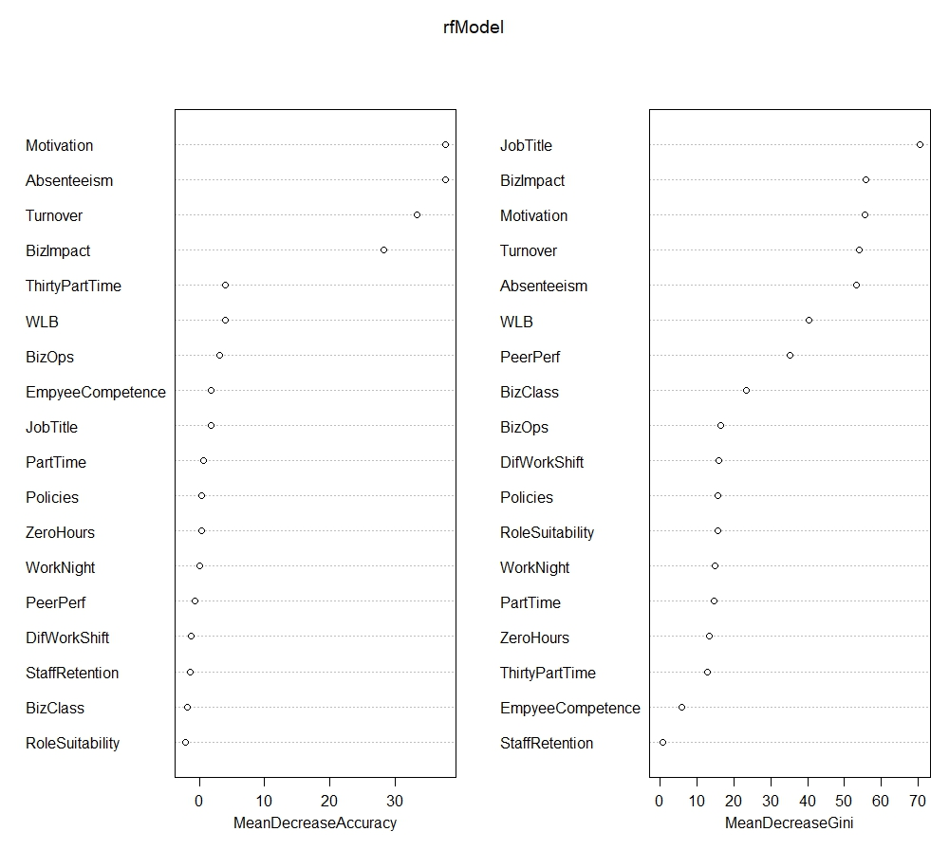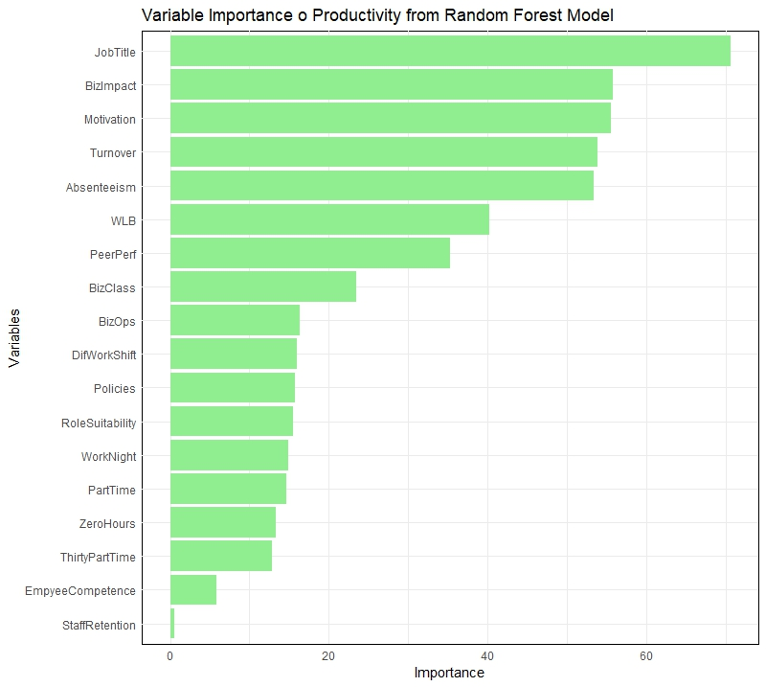

Appendix 8: **Hypotheses Results**

|  |  |  |  |  |
| --- | --- | --- | --- | --- |
| **Hypothesis** | **Statement** | **Model 3 (Regression) Result** | **Random Forest Model Result** | **Support Level** |
| H1 | FWPs positively influence organisational productivity if employee motivation is enhanced and absenteeism is reduced. | Partially Supported - Positive coefficients for motivation (0.600) and reduced absenteeism (0.408), role suitability (0.428), but negative coefficient for business impact (-0.255) | Supported - Importance scores show motivation, absenteeism, turnover, and role suitability as key predictors, but also negative business impact | Partially Supported |
| H1a | Adoption of FWPs positively affects the reduction in employee turnover. | Supported - Positive coefficient for reduced turnover (0.552) | Supported - Importance score indicates turnover as a key predictor | Supported |
| H1b | FWPs have a positive effect on employee motivation. | Supported - Positive coefficient for motivation (0.600) | Supported - Motivation is one of the top predictors | Supported |
| H2 | Employee motivation influences organisational productivity. | Supported - Positive coefficient for motivation (0.600) | Supported - Motivation is one of the top predictors | Supported |
| H3 | Moderate levels of employee turnover are positively associated with organisational productivity, provided there are flexibility arrangements. | Supported - Positive coefficient for reduced turnover (0.552) | Supported - Turnover is one of the key predictors | Supported |

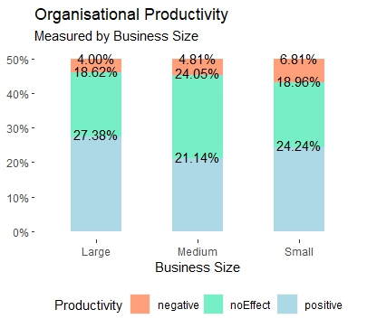

Appendix: Organisational Productivity by Business Size