**Course Statistics Manual**

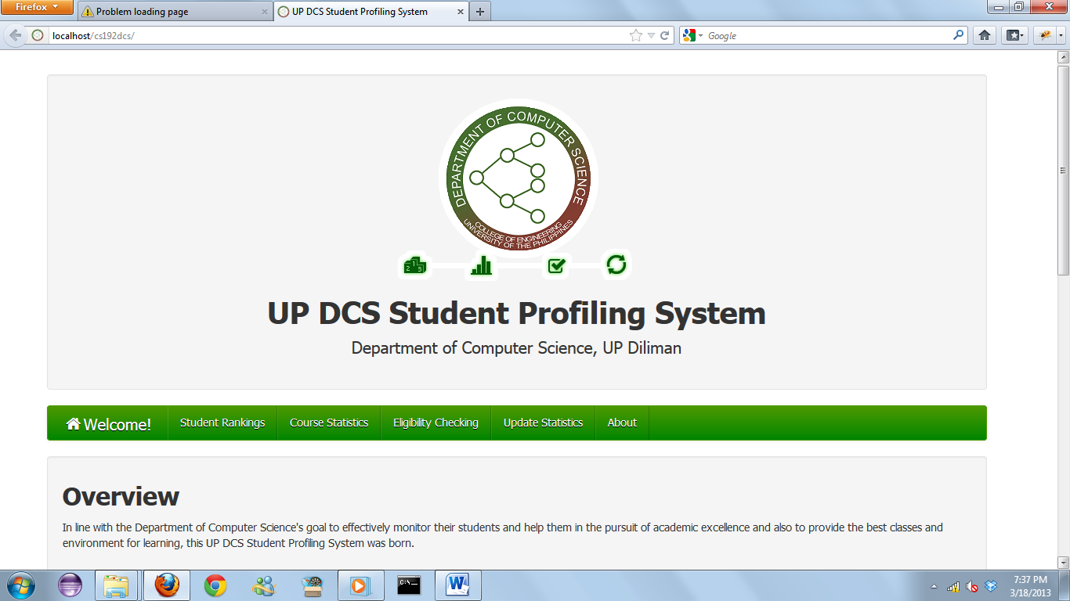

1. The Course Statistics module can be accessed by clicking the Course Statistics tab.

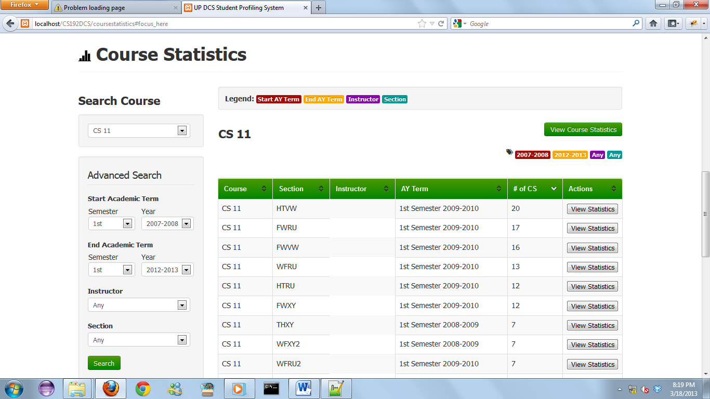

**c**

**a**

**d**

**b**

1. The Course Statistics main page looks like this.
   1. Search Pane
   2. Results Pane
   3. View Course Statistics Button
   4. Search Tags
2. **Search Pane**



1. Course Dropdown. This shows all the major subjects specified in the curriculum that are in the database.

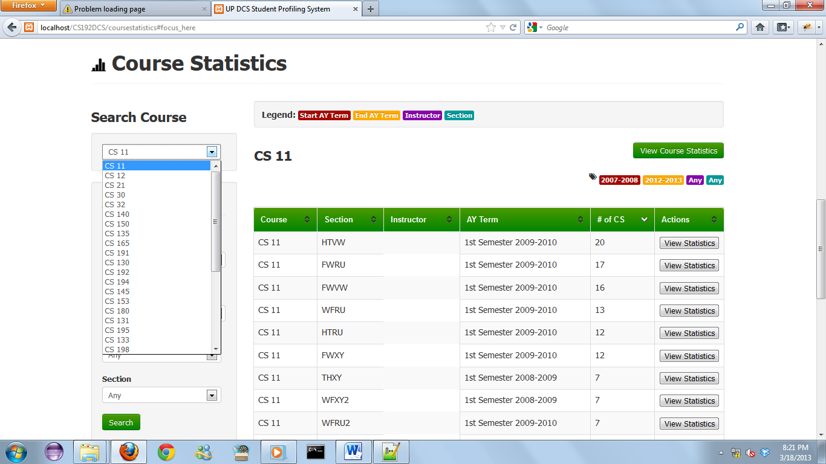

1. Start Academic Term and End Academic Term
   * The dropdowns show all the academic terms where there were courses offred.
   * Select start and ending academic terms to suit your preferred period of analysis.
   * Start and End Academic Terms boundaries are inclusive.

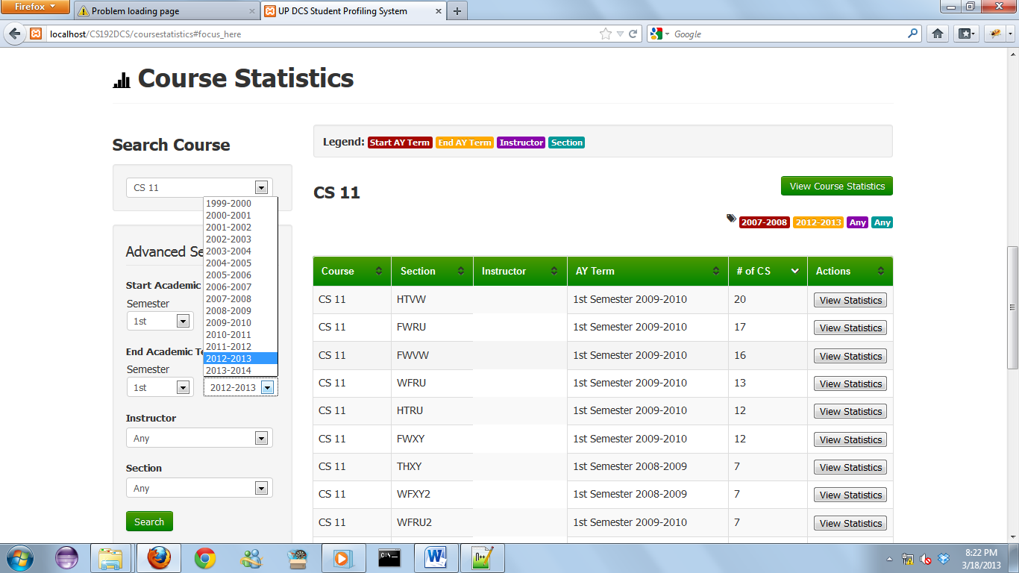

1. Instructor dropdown
   * This specialized dropdown shows only the instructors that have taught the course chosen at the Course dropdown.
   * 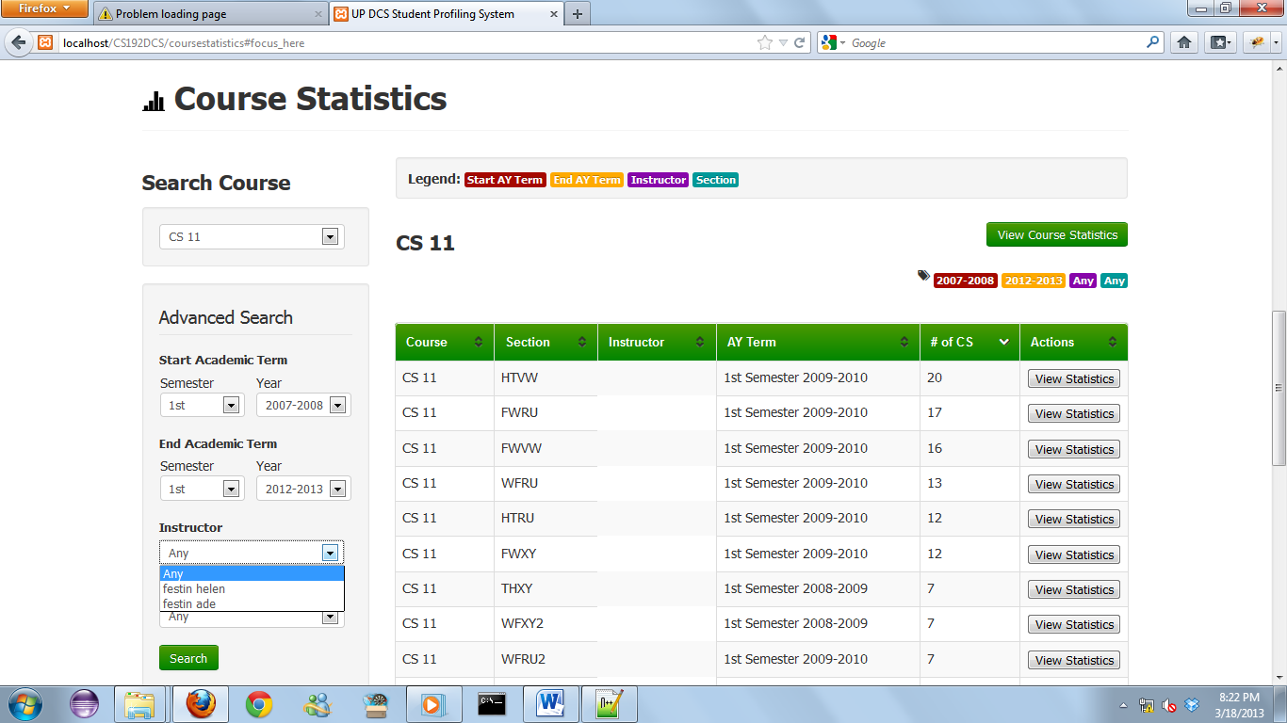Options include ‘Any’. Specifying ‘Any’ would disregard the instructors filter on the results.

1. Section dropdown.
   * This specialized dropdown shows only the sections under the course chosen above and under the instructor chosen.

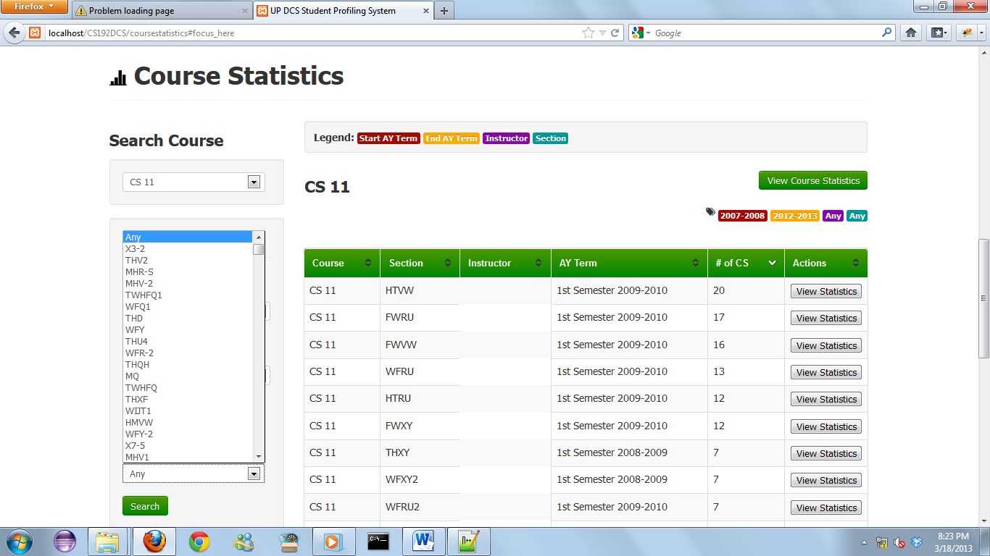

1. **Results Pane**
   * The Results Pane shows the course name, section, instructor(if information is available), AY term when it was offered and a View Statistics button.
   * Clicking the View Statistics button would lead to another page that contains specific pieces of information about the class.



**c) View Course Statistics Button**

Clicking the View Course Statistics button would lead to another page that contains specific pieces of information about the certain course. The course is viewed as a whole, no divisions into different classes or sections.

**d) Search Tags**

**(a)**

To aid one in remembering the search fields he entered, also to help in verifying the search tags entered, these tags show what the search tags were. Legends too may help to identify what the tag is for. Legends in (a).

**View Statistics Page**

**The same design goes for the View Course Statistics and View Statistics. The only difference are the data considered.**

* **View Course Statistics: Views the course as a whole.**
* **View Statistics: Analysis is local only to the class chosen.**

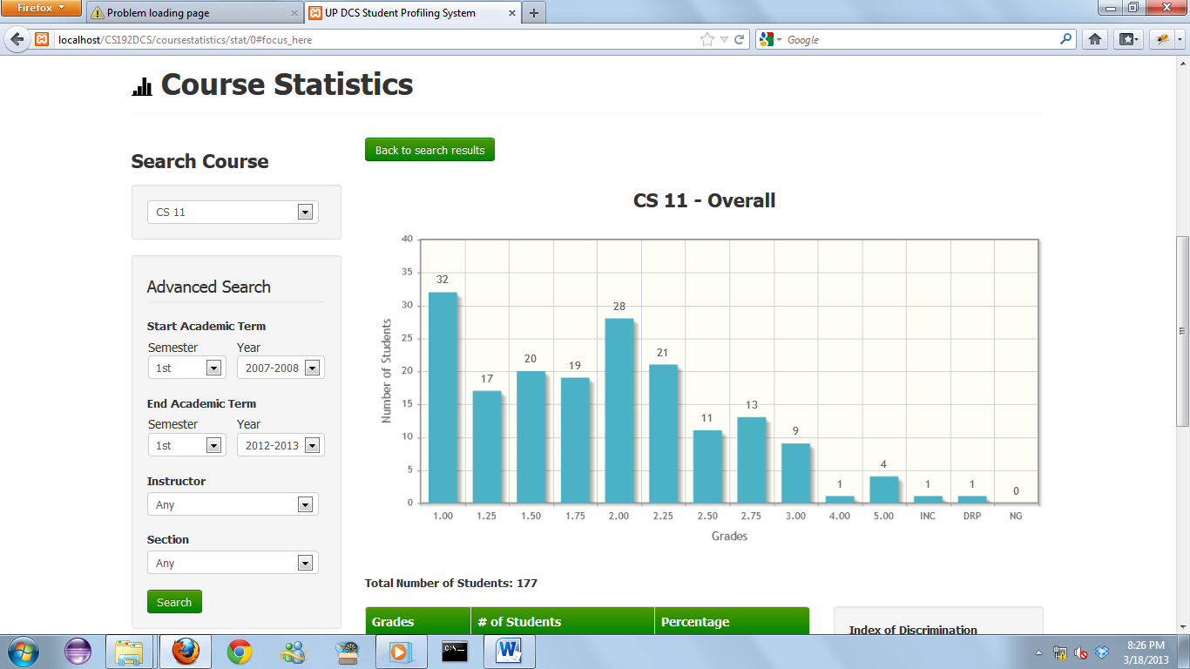

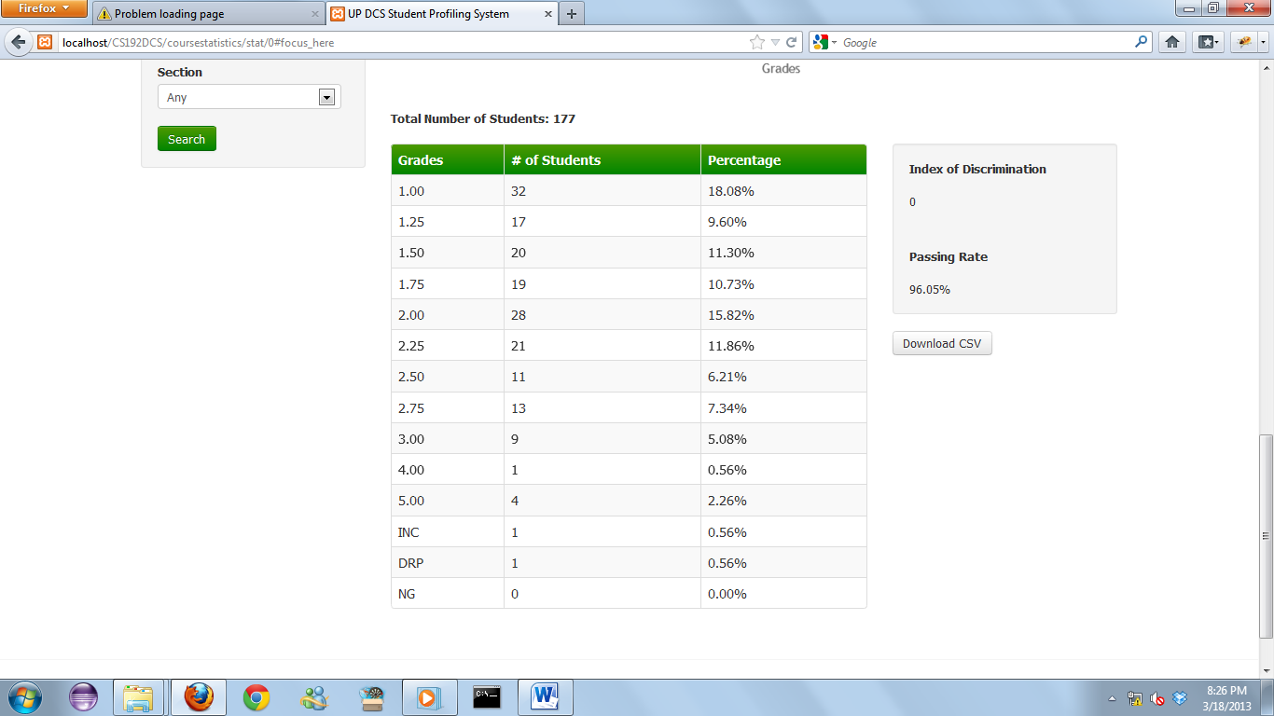

**View Course Statistics.**

**The chart shows a pictorial representation of how many students got what grade. On the X axis are the grades values of students and on the y are the number of students.**

**A Download CSV button is also present. Clicking this would download the CSV button to your ‘Downloads’ folder.**

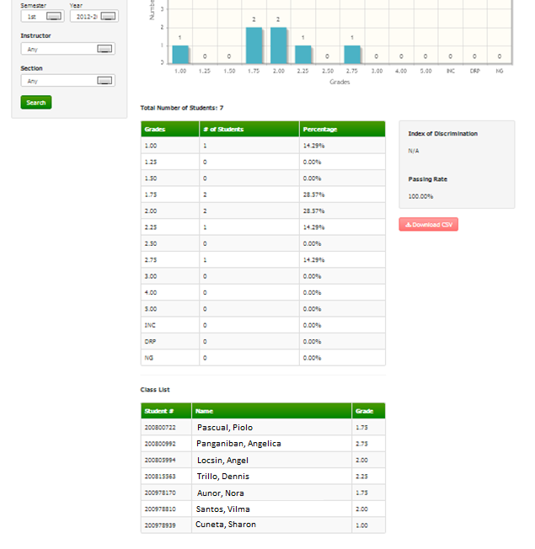

**View Statistics.**

**The chart shows a pictorial representation of how many students got what grade. On the X axis are the grades values of students and on the y are the number of students.**

**A Download CSV button is also present. Clicking this would download the CSV button to your ‘Downloads’ folder.**

**A class list is also included.**