Astrid Delestine

1/13/2023

ECE_372

Prof. Bechir Hamdaoui

Overview:

This lab is designed to introduce the concepts of how Wireshark works and how the student is expected to use it. In this lab the student primarily sets up Wireshark and analysis a HTTP protocol.

Content:

First the student installs Wireshark, then opens it. Once they have started Wireshark they must start capturing their network traffic, so the student makes sure they are connected to Wi-Fi or to Ethernet and uses the connection labeled as such. Next, while Wireshark is capturing, the student opens a particular webpage, this webpage then appears inside of the Wireshark program. The student then can stop the Wireshark capture and can analyze the HTTP protocol.

Requested Questions/Information:

1. List 3 different protocols that appear in the protocol column in the unfiltered packet-listing window in step 7 above.
   1. UDP, TCP, QUIC *
2. How long did it take from when the HTTP GET message was sent until the HTTP OK reply was received?
   1. 0.07981 seconds *
3. What is the Internet address of the gaia.cs.umass.edu (also known as www-net.cs.umass.edu)?
   1. The address of gaia.cs.umass.edu is 128.199.245.12
4. What is the Internet address of your computer?
   1. The address of my computer is 10.248.37.93
5. Print the two HTTP messages (GET and OK) referred to in question 2 above. To do so, select Print from the Wireshark File command menu, and select the “Selected Packet Only” and “Print as displayed” radial buttons, and then click OK.
   1. See appendix section

Appendix:

Different protocols seen:

Time Determined to receive message, source, and destination:

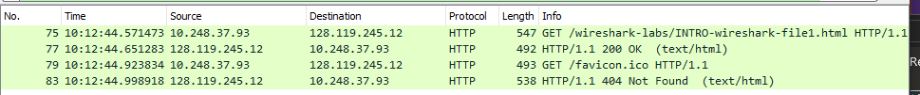

Screenshot of printed document:

