# Simulations Adele master thesis

## Output variables:

Extra aerosol output, no need to enable COSP.

Do we need anything in higher temporal resolution except emission files?

## COMPSET suggestion:

2000_CAM60%NORESM%NORPDDMSBC%SDYN_CLM50%BGC_CICE%PRES_DOCN%DOM_MOSART_SGLC_SWAV

I am thinking we want somehow constant present day emissions and climate for all simulations, right?

I’ve summarized below the way I understood the plan.

1. ~~Produce meteorology (1+6 yrs)→~~ **~~MET~~**

**CTRL simulation**

1. Present day compset nudged meteorology to ERA-Interrim (1+5 yrs?) → **CTRL**
   1. Output BVOC emissions in half hour resolution.

**Idealized veg shift:**

1. Simulation with new idealized vegetation nudged to ERA-Interrim (1+5 yrs) → **VEG_SHIFT_IDEAL**
   1. IF NEEDED: Use **VEG_SHIFT_IDEAL** init file as start for next simulation (1+5 yrs) → **VEG_SHIFT_IDEAL2**
2. Possibly: simulation with new vegetation nudged to ERA-Interrim but BVOCs from CTRL (1+5 yrs) → **VEG_SHIFT_IDEAL_PD_BVOC**

**Realistic scenario:**

1. Simulation with new realistic vegetation nudged to ERA-Interrim (1+5 yrs) → **VEG_SHIFT_REAL**
   1. IF NEEDED: Use **VEG_SHIFT_REAL** init file as starto for next simulation with same setup (1+5 yrs) → **VEG_SHIFT_REAL2**

**Future or past scenarios?**

1. We also briefly discussed the effect of temperature change etc on this whole picture. To be honest, I think that getting through all the stuff above is maybe plenty, but if we want to include future/past I would suggest actually we pick a cleaner and warmer future for maximum effect (cleaner means increases the impact of bsoa emission, warmer reduced (?) the albedo effect in terms of snow).

Illustration of simulation setup from Sporre et al (2019)

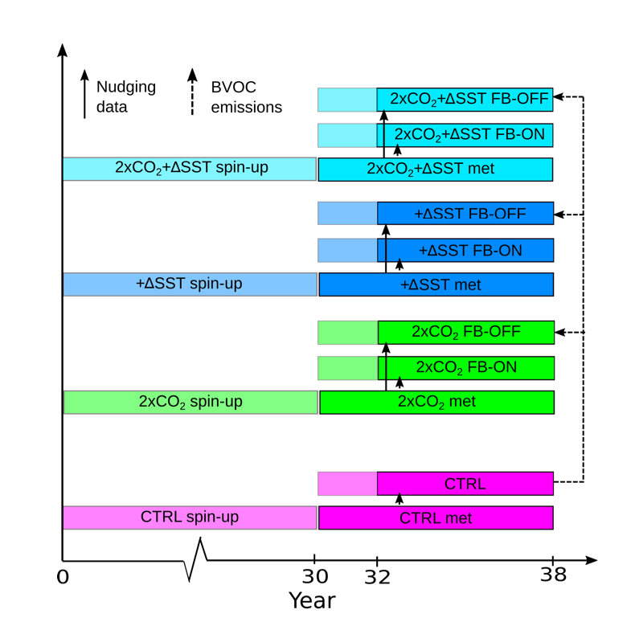

## Update on clm spinup:

The compset I2000Clm50BgcCruGs

Seems to be suited to spinup our new vegetation file. I suggest that we first spinup with this compset for a while (likely fast, so 50-100 yrs?) and then run some number of years with atmosphere just to check roughly stabilized.

## Details:

run

**Update after Hui**

Better with GWSP3 data atmosphere: I2000Clm50BgcCropGs

He gave 3 options to discuss… (<https://docs.google.com/document/d/1byqYZ4eV2vdLrKqQLE7iBy-hoDEc2mpk/>)

**Update 2 on CLM spinup after Terje+Kjetil**

Better the compset I1850BgcCropCmip6 → <https://noresm-docs.readthedocs.io/en/latest/configurations/clm.html>

**To sum up:**

**NITROGEN LIMITATION OFF:**

1. **CTRL_NLIMOFF:** [...] with N limitation off to match with the next step
2. **SPINUP_VEG_SHIFT_IDEAL_NLIMOFF:** part 1) run offline CLM with NorESM2 data atmosphere (careful at release!) for ~1000 years max, turning off N limitation to speed up, we should look at when N stabilizes (TOTPFTN, TOTSOMN_1m); part 2) run coupled for a decade. *

**NITROGEN LIMITATION ON:**

1. **CTRL:** [...]
2. **SPINUP_VEG_IDEAL**: [...]

* in case 3) is within 30 years we can just run it fully coupled instead of going through offline.

## Namlist settings to get BVOC output: user_nl_cam

<https://www.cesm.ucar.edu/models/ccsm4.0/ccsm_doc/x2500.html>

mfilt = 1, 48

nhtfrq = 0, 1

avgflag_pertape='A','I'

fincl1 =blablabla

fincl2='SFisoprene','SFmonoterp'

Fields to include:

fincl1 = 'FSNT','FLNT','FSNT_DRF','FLNT_DRF','FSNTCDRF','FLNTCDRF','FLNS','FSNS','FLNSC','FSNSC','FSDSCDRF','FSDS_DRF','FSUTADRF','FLUTC','FSUS_DRF','FLUS','CLOUD','FCTL','FCTI','NUCLRATE','FORMRATE','GRH2SO4','GRSOA','GR','COAGNUCL','H2SO4','SOA_LV','PS','LANDFRAC','COAGNUCL','FORMRATE','NUCLRATE','SOA_LV','H2SO4','SOA_NA','SO4_NA','NNAT_0','NCONC01','NCONC02','NCONC03','NCONC04','NCONC05','NCONC06','NCONC07','NCONC08','NCONC09','NCONC10','NCONC11','NCONC12','NCONC13','NCONC14','SIGMA01','SIGMA02','SIGMA03','SIGMA04','SIGMA05','SIGMA06','SIGMA07','SIGMA08','SIGMA09','SIGMA10','SIGMA11','SIGMA12','SIGMA13','SIGMA14','NMR01','NMR02','NMR03','NMR04','NMR05','NMR06','NMR07','NMR08','NMR09','NMR10','NMR11','NMR12','NMR13','NMR14','FSNS','FSDS_DRF','GR','GRH2SO4','GRSOA','CCN1','CCN2','CCN3','CCN4','CCN5','CCN6','CCN7','CCN_B','TGCLDCWP','cb_H2SO4','cb_SOA_LV','cb_SOA_NA','cb_SO4_NA','CLDTOT','CDNUMC','SO2','isoprene','monoterp','SOA_SV','OH_vmr','AOD_VIS','CAODVIS','CLDFREE','CDOD550','CDOD440','CDOD870','AEROD_v','CABS550','CABS550A','SOA_SEC01','SOA_SEC02','SOA_SEC03','SOA_SEC04','SOA_SEC05','SO4_SEC01','SO4_SEC02','SO4_SEC03','SO4_SEC04','SO4_SEC05','nrSOA_SEC01','nrSOA_SEC02','nrSOA_SEC03','nrSOA_SEC04','nrSOA_SEC05','nrSO4_SEC01','nrSO4_SEC02','nrSO4_SEC03','nrSO4_SEC04','nrSO4_SEC05','SOA_SEC01','SOA_SEC02','SOA_SEC03','SOA_SEC04','SOA_SEC05','SO4_SEC01','SO4_SEC02','SO4_SEC03','SO4_SEC04','SO4_SEC05','nrSOA_SEC01','nrSOA_SEC02','nrSOA_SEC03','nrSOA_SEC04','nrSOA_SEC05','nrSO4_SEC01','nrSO4_SEC02','nrSO4_SEC03','nrSO4_SEC04','nrSO4_SEC05','cb_SOA_SEC01','cb_SOA_SEC02','cb_SOA_SEC03','cb_SOA_SEC04','cb_SOA_SEC05','cb_SO4_SEC01','cb_SO4_SEC02','cb_SO4_SEC03','cb_SO4_SEC04','cb_SO4_SEC05'

## To continue from restart files:

./xmlchange CONTINUE_RUN=TRUE

* Then it gets the files that are written in rpointer.atm, rpointer.lnd etc. which are in your run folder.