***ADVANCED WEB TECHNOLOGIES***

***INDEX***

|  |  |  |
| --- | --- | --- |
| S. No. | Program Names | Page No. |
| 1. | Create a time table using HTML and CSS. | 02 |
| 2. | Create a static website for an online business which includes a registration page. | 09 |
| 3. | Create a static webpage for an online bookstore which contains a catalogue of available books. | 24 |
| 4. | Write a Javascript program to convert numbers to Roman numerals. | 39 |
| 5. | Write a Javascript program to validate a form. | 40 |
| 6. | Write a Javascript program to demonstrate pop-up boxes. | 50 |
| 7. | Create a portfolio website. | 58 |
| 8. | Write a program to implement Typescript classes with inheritance. | 65 |
| 9. | Write a program to demonstrate Angular modules. | 66 |
| 10. | Write a program to demonstrate Angular controllers. | 67 |
| 11. | Write a program to demonstrate Angular directives. | 68 |
| 12. | Write a program to demonstrate Angular components. | 69 |
| 13. | Write a program to demonstrate Angular forms. | 70 |

***1. Create a time table using HTML and CSS.***

**index.html**

<!DOCTYPE html>

<html lang="en">

<head>

    <meta charset="UTF-8">

    <meta http-equiv="X-UA-Compatible" content="IE=edge">

    <meta name="viewport" content="width=device-width, initial-scale=1.0">

    <link rel="stylesheet" href="styles.css">

    <title>Timetable</title>

</head>

<body>

    <header>

        <h1>Timetable</h1>

        <h2>1st Year, <a href=https://www.sjc.ac.in/computerdepartment.php

target="_blank">M.Sc. Computer Science</a>, 2022-2024</h2>

    </header>

    <main>

        <table>

            <tr>

                <th>

                    Day/Time

                </th>

                <td>

                    9:15AM-10:05AM

                </td>

                <td>

                    10:10AM-11:00AM

                </td>

                <td>

                    11:05AM-11:55AM

                </td>

                <td>

                    12PM-12:55PM

                </td>

                <td>

                    12:55PM-1:50PM

                </td>

                <td>

                    1:50PM-2:40PM

                </td>

                <td>

                    2:45PM-3:35PM

                </td>

                <td>

                    3:35PM-4:30PM

                </td>

            </tr>

            <tr>

                <th>

                    Monday

                </th>

                <td>

                    AWT/ADBMS Lab

                </td>

                <td>

                    AWT/ADBMS Lab

                </td>

                <td>

                    AWT/ADBMS Lab

                </td>

                <td>

                    AWT

                </td>

                <td>

                    L

                </td>

                <td>

                    ADBMS

                </td>

                <td>

                    SPM

                </td>

                <td>

                    ML

                </td>

            </tr>

            <tr>

                <th>

                    Tuesday

                </th>

                <td>

                    ML Lab

                </td>

                <td>

                    ML Lab

                </td>

                <td>

                    ML Lab

                </td>

                <td>

                    CD

                </td>

                <td>

                    U

                </td>

                <td>

                    ML

                </td>

                <td>

                    ADBMS

                </td>

                <td>

                    Library

                </td>

            </tr>

            <tr>

                <th>

                    Wednesday

                </th>

                <td>

                    AWT/ADBMS Lab

                </td>

                <td>

                    AWT/ADBMS Lab

                </td>

                <td>

                    AWT/ADBMS Lab

                </td>

                <td>

                    SPM

                </td>

                <td>

                    N

                </td>

                <td>

                    CD

                </td>

                <td>

                    AWT

                </td>

                <td>

                    ML

                </td>

            </tr>

            <tr>

                <th>

                    Thursday

                </th>

                <td>

                    ML Lab

                </td>

                <td>

                    ML Lab

                </td>

                <td>

                    ML Lab

                </td>

                <td>

                    CD

                </td>

                <td>

                    C

                </td>

                <td>

                    AWT

                </td>

                <td>

                    SPM

                </td>

                <td>

                    Library

                </td>

            </tr>

            <tr>

                <th>

                    Friday

                </th>

                <td>

                    ADBMS

                </td>

                <td>

                    ML

                </td>

                <td>

                    AWT

                </td>

                <td>

                    SPM

                </td>

                <td>

                    H

                </td>

                <td>

                    ADBMS

                </td>

                <td>

                    CD

                </td>

                <td>

                    Library

                </td>

            </tr>

        </table>

    </main>

</body>

</html>

**styles.css**

body {

    font-family: 'Lucida Sans', 'Lucida Sans Regular', 'Lucida Grande', 'Lucida Sans Unicode', Geneva, Verdana, sans-serif;

    margin: auto;

}

header {

    padding: 5px;

    text-align: center;

    box-shadow: 10px 10px 8px #83dada;

}

table {

    width: 100%;

    max-width: 1500px;

    margin: 0 auto;

    box-shadow: 10px 10px 8px #5ca299;

}

table, th, td {

    border: 1px solid black;

    border-collapse: collapse;

    padding: 5px 3px;

    text-align: center;

}

a:default {

    color:rgb(14, 14, 85);

}

a:visited {

    color: #5ca299;

}

a:hover {

    color:rgb(189, 125, 169);

}

**OUTPUT**

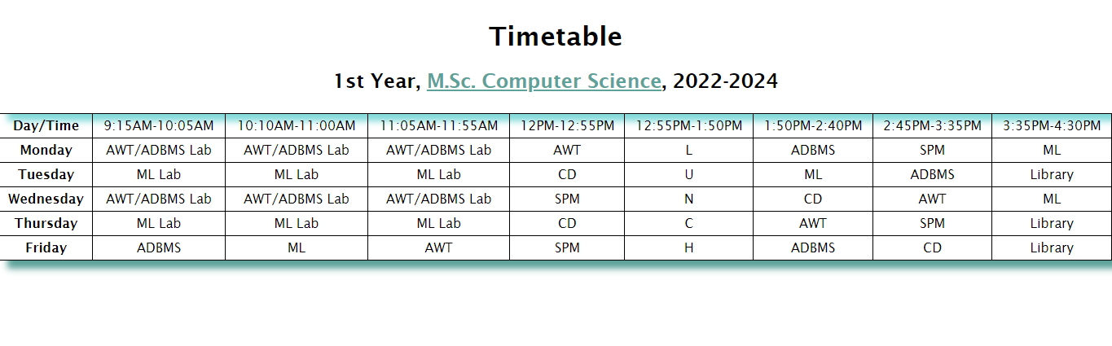

***2. Create a static website for an online business which includes a registration page, which contains these:***

***(a) Home (At least 3 div elements)***

***(b) Login (A Form)***

***(c) Registration Page (A Form)***

**index.html**

<!DOCTYPE html>

<html lang="en">

  <head>

    <meta charset="UTF-8" />

    <meta http-equiv="X-UA-Compatible" content="IE=edge" />

    <meta name="viewport" content="width=device-width, initial-scale=1.0" />

    <link rel="preconnect" href="https://fonts.googleapis.com" />

    <link rel="preconnect" href="https://fonts.gstatic.com" crossorigin />

    <link rel="stylesheet" href="styles.css" />

    <link

      href="https://fonts.googleapis.com/css2?family=Source+Serif+Pro&display=swa

p"

      rel="stylesheet"

    />

    <link href="https://fonts.googleapis.com/css2?family=Montserrat:wght@300&display=swap" rel="stylesheet">

    <link href="https://fonts.googleapis.com/css2?family=Philosopher&display=swap" rel="stylesheet">

    <title>Wholesome Bakes</title>

  </head>

  <body>

    <header>

      <div id="navbar">

        <h1 id="nav-logo">Wholesome Bakes</h1>

        <ul id="nav-list">

          <li><a href="#home">Home</a></li>

          <li><a href="#products">Products</a></li>

          <li><a href="#register">Register</a></li>

          <li><a href="#contact-us">Contact Us</a></li>

          <li><a href="login.html" target="_blank">Login</a></li>

        </ul>

      </div>

    </header>

    <main>

      <section id="home">

        <div id="home-header">

            <h2>Fresh, Delicious, Homely.</h2>

            <h3>We are committed to quality services, everywhere, all the

time.</h3>

            <figure>

                <img src="bakery.jpg" alt="Bakery Shop">

<figcaption>Photo by <a href="https://unsplash.com/fr/@blsnki?utm_source=unsplash&utm_medium=referral&utm_content=creditCopyText">Yeh Xintong</a> on <a href="https://unsplash.com/photos/go3DT3PpIw4?utm_source=unsplash&utm_medium=referral&utm_content=creditCopyText">Unsplash</a>

                </figcaption>

            </figure>

        </div>

      </section>

      <section id="about-us">

      </section>

      <section id="products">

      </section>

      <section id="register">

        <div>

            <h3>Register now!</h3>

            <form action="submitted.html" method="post" onsubmit="validate()">

                <section id="personal-details">

                  <label for="name"

                    >Enter your name:

                    <br />

                    <input type="text" name="name" id="name" placeholder="Enter

your name..." required />

                  </label>

                  <label for="email"

                    >Enter your email:

                    <br />

                    <input type="email" name="email" id="email"

placeholder="Enter your email..."required />

                  </label>

                  <label for="dob"

                    >Enter your date of birth:

                    <br />

                    <input type="date" name="dob" id="dob" required />

                  </label>

                </section>

                <section id="gender-details">

                  <label for="gender-choices">Select your gender:</label>

                  <ul>

                    <li>

                      <input type="radio" name="gender" id="gender-f" value="f"

/>F

                    </li>

                    <li>

                      <input type="radio" name="gender" id="gender-m" value="m"

/>M

                    </li>

                    <li>

                      <input

                        type="radio"

                        name="gender"

                        id="gender-o"

                        value="other"

                      />Other

                    </li>

                  </ul>

                </section>

                <section id="source-section">

                  <label for="sources">Where did you hear about us?</label>

                  <br />

                  <select name="" id="">

                    <option value="">(select one)</option>

                    <option value="instagram">Instagram</option>

                    <option value="twitter">Twitter</option>

                    <option value="facebook">Facebook</option>

                    <option value="website">Our Official Website</option>

                  </select>

                </section>

                <section id="comment-box">

                  <label for="comments">Any suggestions/comments for us?</label>

                  <br />

                  <textarea

                    name="comments-area"

                    id="comments"

                    cols="30"

                    rows="5"

                    placeholder="Enter your comments here..."

                  ></textarea>

                </section>

                <section>

                  <label for="password-box">Enter your password</label>

                  <br />

                  <input

                    type="password"

                    id="password-box"

                    name="password-box"

                    placeholder="Enter your password..."

                    required

                  />

                </section>

                <br />

                <section>

                  <label for="confirm-pwd">Re-enter your password</label>

                  <br />

                  <input type="password" id="confirm-pwd" name="confirm-pwd"

placeholder="Enter your password..."/>

                </section>

                <br />

                <section id="submit-section">

                  <input type="submit" name="" id="submit-btn" value="Submit" />

                </section>

              </form>

        </div>

    </section>

    </main>

    <footer>

      <section id="contact-us">

      </section>

    </footer>

  </body>

</html>

**login.html**

<!DOCTYPE html>

<html lang="en">

  <head>

    <meta charset="UTF-8" />

    <meta http-equiv="X-UA-Compatible" content="IE=edge" />

    <meta name="viewport" content="width=device-width, initial-scale=1.0" />

    <link rel="preconnect" href="https://fonts.googleapis.com" />

    <link rel="preconnect" href="https://fonts.gstatic.com" crossorigin />

    <link rel="stylesheet" href="styles.css" />

    <link

      href="https://fonts.googleapis.com/css2?family=Source+Serif+Pro&display=swap"

      rel="stylesheet"

    />

    <link

      href="https://fonts.googleapis.com/css2?family=Montserrat:wght@300&display=swap

" rel="stylesheet"

    />

    <link

      href="https://fonts.googleapis.com/css2?family=Philosopher&display=swap"

      rel="stylesheet"

    />

    <title>Login</title>

  </head>

  <body>

    <header id="login-header">

      <h1>Welcome to Wholesome Bakes!</h1>

    </header>

    <main>

      <section id="login-screen">

        <section id="login">

          <div>

            <h3>Log In</h3>

            <form action="submitted.html" method="post" onsubmit="validate()">

              <section id="personal-details">

                <label for="email"

                  >Enter your email:

                  <br />

                  <input

                    type="email"

                    name="email"

                    id="email"

                    placeholder="Enter your email..."

                    required

                  />

                </label>

              </section>

              <br />

              <section>

                <label for="password-box">Enter your password</label>

                <br />

                <input

                  type="password"

                  id="password-box"

                  name="password-box"

                  placeholder="Enter your password..."

                  required

                />

              </section>

              <br />

              <section id="submit-section">

                <input type="submit" name="" id="submit-btn" value="Submit" />

              </section>

            </form>

          </div>

        </section>

      </section>

    </main>

  </body>

</html>

**styles.css**

* {

  box-sizing: border-box;

}

html,

::before,

::after {

  box-sizing: inherit;

}

body {

  margin: 0;

  font-family: "Philosopher", sans-serif;

  background-color: #3a071b;

}

#navbar {

  display: grid;

  grid-template-columns: auto auto;

  align-items: center;

  background-color: #3a071b;

  background-size: cover;

  position: fixed;

  height: 12vh;

  width: 100vw;

  max-width: 100%;

}

#navbar #nav-logo {

  padding: 0 0.5rem 0 0.5rem;

  text-transform: uppercase;

  color: #ecd4f1;

  font-size: clamp(0.5rem, 10rem, 2rem);

}

#navbar #nav-list {

  display: flex;

  flex-direction: row;

  justify-content: space-evenly;

  align-items: center;

}

#nav-list li {

  list-style-type: none;

  text-transform: uppercase;

  font-size: clamp(0.2rem, 5rem, 1.1rem);

  font-weight: bold;

}

#nav-list a {

  text-decoration: none;

  color: #ecd4f1;

}

#nav-list a:hover {

  text-shadow: 1px 0.1px 5px rgba(255, 255, 255, 0.541);

}

#home {

  height: 110vh;

  width: 100vw;

  max-width: 100%;

  padding-top: 4.5rem;

  background-color: #d1bcd6;

}

#home #home-header {

  display: flex;

  flex-direction: column;

  text-align: center;

  font-family: "Source Serif Pro", serif;

}

#home-header h2,

#home-header h3 {

  margin: 0;

}

#home-header h2 {

  padding-top: 1rem;

  text-shadow: 1px 0.1px 5px #ffffff;

}

#home-header h3 {

  padding-top: 0.4rem;

  padding-bottom: 0.2rem;

  text-shadow: 1px 0.1px 5px #ffffff;

}

#home figure figcaption {

  font-family: "Source Serif Pro", serif;

  font-family: "Philosopher", sans-serif;

  font-size: clamp(0.1rem, 1rem, 0.6rem);

  color: rgba(0, 0, 0, 0.432);

}

#home figure figcaption a {

  color: rgba(0, 0, 0, 0.432);

  text-decoration: none;

}

#register {

  height: 120vh;

  background: #a36e84;

}

#register div,

#login div {

  display: flex;

  flex-direction: column;

  align-items: center;

}

#register div h3,

#login div h3 {

  text-transform: uppercase;

  font-size: clamp(1rem, 6rem, 2rem);

  text-shadow: 1px 0.5px 3px #ecd4f1;

}

form {

  background-color: rgba(25, 0, 0, 0.5);

  color: rgb(255, 255, 255);

  border: 1px solid #3a071b8e;

  border-radius: 13px;

  display: block;

  margin: 0 auto;

  width: 500px;

  padding: 1rem 1rem;

  font-family: "Source Serif Pro", serif;

  font-family: "Philosopher", sans-serif;

}

input {

  font-family: "Montserrat", sans-serif;

}

#personal-details label {

  display: block;

  padding-bottom: 5px;

}

#personal-details input {

  width: 150px;

}

#gender-details {

  margin-top: 5px;

}

#gender-details label {

  display: block;

  margin-bottom: -10px;

}

#gender-details ul {

  padding-left: 0;

}

#gender-details li {

  list-style-type: none;

}

#class-details {

  margin-top: -7px;

}

#class-details label {

  display: block;

  margin-bottom: -10px;

}

#class-details ul {

  padding-left: 0;

}

#class-details li {

  list-style-type: none;

}

#source-section {

  display: block;

  margin-top: -5px;

  margin-bottom: 15px;

}

#source-section select {

  font-family: "Montserrat", sans-serif;

}

#source-section option {

  font-family: "Montserrat", sans-serif;

  color: black;

  font-weight: 600;

}

#comment-box {

  margin-top: -5px;

  margin-bottom: 5px;

}

#comment-box textarea {

  font-family: "Montserrat", sans-serif;

  color: black;

}

#submit-btn {

  background: #3a071b;

  background-size: cover;

  background-repeat: no-repeat;

  color: aliceblue;

  border: 1px solid #d1bcd6;

  border-radius: 10px;

  width: 7vw;

  height: 4vh;

  text-transform: uppercase;

}

#submit-btn:hover {

  background-size: cover;

  background-repeat: no-repeat;

  color: #3a071b;

  background-color: #d1bcd6;

  border: 1px solid #3a071b;

}

#login-header,

#login-screen {

  display: flex;

  flex-direction: column;

*/* background: #a36e84; */*

  align-items: center;

}

#login-header {

  color:#ecd4f1;

}

#login-header h1 {

  text-transform: uppercase;

}

#login-screen #yum {

  color:#ecd4f1;

}

#login-screen #login-msg {

  color: #3a071b;

}

#login {

  height: 60vh;

  width: 100vw;

  background-color: #d1bcd6;

}

**OUTPUT**

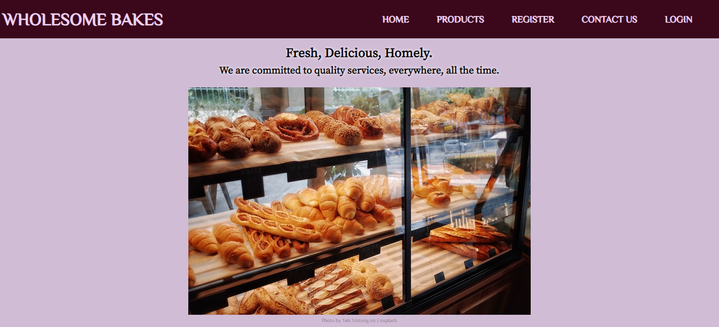

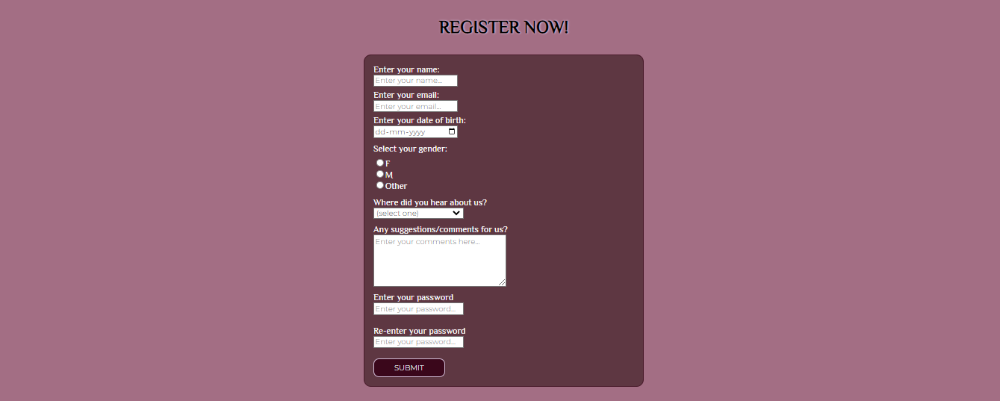



***3. Create a static webpage for an online bookstore which contains a catalogue of available books.***

**index.html**

<!DOCTYPE html>

<html lang="en">

  <head>

    <meta charset="UTF-8" />

    <meta http-equiv="X-UA-Compatible" content="IE=edge" />

    <meta name="viewport" content="width=device-width, initial-scale=1.0" />

    <link rel="preconnect" href="https://fonts.googleapis.com" />

    <link rel="preconnect" href="https://fonts.gstatic.com" crossorigin />

    <link rel="stylesheet" href="styles.css" />

    <link

      href="https://fonts.googleapis.com/css2?family=Montserrat:wght@300&display=swap

" rel="stylesheet"

    />

    <link

      href="https://fonts.googleapis.com/css2?family=IBM+Plex+Mono:wght@200&display=s

wap"

      rel="stylesheet"

    />

    <link

      href="https://fonts.googleapis.com/css2?family=Rokkitt:wght@100&display=swap"

      rel="stylesheet"

    />

    <link href="https://fonts.googleapis.com/css2?family=Roboto+Mono&display=swap"

rel="stylesheet">

    <title>Bookworm</title>

  </head>

  <body>

    <header>

      <div id="navbar">

        <h1 id="nav-logo">Bookworm</h1>

        <ul id="nav-list">

          <li><a href="#home">Home</a></li>

          <li><a href="#books">Books</a></li>

          <li><a href="#register">Register</a></li>

          <li><a href="#contact-us">Contact Us</a></li>

          <li><a href="login.html" target="_blank">Login</a></li>

        </ul>

      </div>

    </header>

    <main>

      <section id="home">

        <div id="home-header">

          <figure>

            <img src="bookstore.jpg" alt="Book Store" />

            <figcaption>

              Photo by

              <a

                href="https://unsplash.com/@ninjason?utm_source=unsplash&utm_medium=r

eferral&utm_content=creditCopyText"

                >Jason Leung</a

              >

              on

              <a

                href="https://unsplash.com/photos/gWZzETD0Ad4?utm_source=unsplash&utm

_medium=referral&utm_content=creditCopyText"

                >Unsplash</a

              >

            </figcaption>

          </figure>

          <h2>Enter a world, of your choice...</h2>

        </div>

      </section>

      <section id="about-us"></section>

      <section id="books">

        <div>

          <ul>

            <li>

              <figure>

                <img

                  src="https://images-na.ssl-images-

amazon.com/images/S/compressed.photo.goodreads.com/

books/1542542538i/42857229.jpg"

                  alt=""

                />

                <figcaption>The Year of the Ladybird, Graham Joyce</figcaption>

              </figure>

            </li>

            <li>

                <figure>

                    <img

                      src="https://m.media-amazon.com/images/W/IMAGERENDERING_521856-

T1/images/I/51I9fQLhnpL.jpg"

                      alt=""

                    />

                    <figcaption>Inception (The Marked Saga Book 1), Bianca

Scardoni</figcaption>

                  </figure>

            </li>

            <li><figure>

                <img

                  src="https://m.media-amazon.com/images/W/IMAGERENDERING_521856-

T1/images/I/81tNBrrGSJL.jpg"

                  alt=""

                />

                <figcaption>The Loser, Thomas Bernhard</figcaption>

              </figure></li>

          </ul>

        </div>

        <div>

          <ul>

            <li><figure>

                <img

                  src="https://m.media-amazon.com/images/W/IMAGERENDERING_521856-

T1/images/I/71SCqfZfHEL.jpg"

                  alt=""

                />

                <figcaption>Atonement, Ian McEwan</figcaption>

              </figure></li>

            <li><figure>

                <img

                  src="https://m.media-amazon.com/images/W/IMAGERENDERING_521856-

T1/images/I/71kW3I8WH5L.jpg"

                  alt=""

                />

                <figcaption>Gilead, Marilynne Robinson</figcaption>

              </figure></li>

            <li><figure>

                <img

                  src="https://m.media-amazon.com/images/W/IMAGERENDERING_521856-

T1/images/I/51GTpkH-JJL._SX343_BO1,204,203,200_.jpg"

                  alt=""

                />

                <figcaption>The Fire Eternal, Chris d'Lacey</figcaption>

              </figure></li>

          </ul>

        </div>

        <div>

          <ul>

            <li><figure>

                <img

                  src="https://m.media-amazon.com/images/W/IMAGERENDERING_521856-

T1/images/I/91ZaXXD8K8L.jpg"

                  alt=""

                />

                <figcaption>Ringworld, Larry Niven</figcaption>

              </figure></li>

            <li><figure>

                <img

                  src="https://m.media-amazon.com/images/W/IMAGERENDERING_521856-

T1/images/I/71mWiiUV9ZL.jpg"

                  alt=""

                />

                <figcaption>History Is All You Left Me, Adam Silvera</figcaption>

              </figure></li>

            <li><figure>

                <img

                  src="https://m.media-amazon.com/images/W/IMAGERENDERING_521856-

T1/images/I/71XtGTK8OpL.jpg"

                  alt=""

                />

                <figcaption>Trainspotting, Irvine Welsh</figcaption>

              </figure></li>

          </ul>

        </div>

      </section>

      <section id="register">

        <div>

          <h3>Register now!</h3>

          <form action="submitted.html" method="post" onsubmit="validate()">

            <section id="personal-details">

              <label for="name"

                >Enter your name:

                <br />

                <input

                  type="text"

                  name="name"

                  id="name"

                  placeholder="Enter your name..."

                  required

                />

              </label>

              <label for="email"

                >Enter your email:

                <br />

                <input

                  type="email"

                  name="email"

                  id="email"

                  placeholder="Enter your email..."

                  required

                />

              </label>

              <label for="dob"

                >Enter your date of birth:

                <br />

                <input type="date" name="dob" id="dob" required />

              </label>

            </section>

            <section id="gender-details">

              <label for="gender-choices">Select your gender:</label>

              <ul>

                <li>

                  <input type="radio" name="gender" id="gender-f" value="f" />F

                </li>

                <li>

                  <input type="radio" name="gender" id="gender-m" value="m" />M

                </li>

                <li>

                  <input

                    type="radio"

                    name="gender"

                    id="gender-o"

                    value="other"

                  />Other

                </li>

              </ul>

            </section>

            <section id="source-section">

              <label for="sources">Where did you hear about us?</label>

              <br />

              <select name="" id="">

                <option value="">(select one)</option>

                <option value="instagram">Instagram</option>

                <option value="twitter">Twitter</option>

                <option value="facebook">Facebook</option>

                <option value="website">Our Official Website</option>

              </select>

            </section>

            <section id="comment-box">

              <label for="comments">Any suggestions/comments for us?</label>

              <br />

              <textarea

                name="comments-area"

                id="comments"

                cols="30"

                rows="5"

                placeholder="Enter your comments here..."

              ></textarea>

            </section>

            <section>

              <label for="password-box">Enter your password</label>

              <br />

              <input

                type="password"

                id="password-box"

                name="password-box"

                placeholder="Enter your password..."

                required

              />

            </section>

            <br />

            <section>

              <label for="confirm-pwd">Re-enter your password</label>

              <br />

              <input

                type="password"

                id="confirm-pwd"

                name="confirm-pwd"

                placeholder="Enter your password..."

              />

            </section>

            <br />

            <section id="submit-section">

              <input type="submit" name="" id="submit-btn" value="Submit" />

            </section>

          </form>

        </div>

      </section>

    </main>

    <footer>

      <section id="contact-us"></section>

    </footer>

  </body>

</html>

**styles.css**

* {

    box-sizing: border-box;

  }

  html,

  ::before,

  ::after {

    box-sizing: inherit;

  }

  body {

    margin: 0;

    font-family: 'IBM Plex Mono', monospace;

    background-color: #7591ec;

  }

  #navbar {

    display: grid;

    grid-template-columns: auto auto;

    align-items: center;

    background-color: #07153a;

    background-size: cover;

    position: fixed;

    height: 13vh;

    width: 100vw;

    max-width: 100%;

  }

  #navbar #nav-logo {

    padding: 0 0.5rem 0 0.5rem;

    text-transform: uppercase;

    color: #ffffff;

    font-size: clamp(0.5rem, 10rem, 2rem);

  }

  #navbar #nav-list {

    display: flex;

    flex-direction: row;

    justify-content: space-evenly;

    align-items: center;

  }

  #nav-list li {

    list-style-type: none;

    text-transform: uppercase;

    font-size: clamp(0.2rem, 5rem, 1.1rem);

    font-weight: bold;

  }

  #nav-list a {

    text-decoration: none;

    color: #ffffff;

  }

  #nav-list a:hover {

    text-shadow: 1px 0.1px 5px rgba(255, 255, 255, 0.541);

  }

  #home {

    height: 105vh;

    width: 100vw;

    max-width: 100%;

    padding-top: 4.5rem;

    background-color: #bfccf7;

  }

  #home #home-header {

    display: flex;

    flex-direction: column;

    text-align: center;

    font-family: 'IBM Plex Mono', monospace;

    font-style: italic;

    letter-spacing: 0.2rem;

*/* font-family: 'Rokkitt', serif;    */*

  }

  #home-header h2,

  #home-header h3 {

    margin: 0;

    font-weight: 600;

  }

  #home figure {

    margin-bottom: 0;

    padding-bottom: 1.4rem;

}

  #home figure figcaption {

    font-family: 'Rokkitt', serif;

    font-size: clamp(0.1rem, 1rem, 0.7rem);

    font-weight: 600;

    color: #00000085;

  }

  #home figure figcaption a {

    color: rgba(0, 0, 0, 0.774);

    text-decoration: none;

  }

  #books {

    display: grid;

    grid-template-columns: auto auto auto;

    height: 150vh;

    padding-top:1rem;

    background-color: #07153a;

}

  #books li {

    list-style-type: none;

  }

  #books figure {

    display: flex;

    flex-direction: column;

    align-items: center;

  }

  #books figure figcaption{

    padding-top: 0.1rem;

    color:#b0c1f8;

    font-size: clamp(0.2rem, 1rem, 0.7rem);

    font-family: 'Roboto Mono', monospace;

    font-style: italic;

    letter-spacing: 0.5px;

}

  #books img {

    height: 40vh;

    width:fit-content;

  }

  #register {

    height: 120vh;

    background-color: #7591ec;

  }

  #register div,

  #login div {

    display: flex;

    flex-direction: column;

    align-items: center;

  }

  #register div h3,

  #login div h3 {

    text-transform: uppercase;

    font-size: clamp(1rem, 6rem, 2rem);

    text-shadow: 1px 0.5px 3px #07153abd;

  }

  form {

    background-color: #07153abd;

    color: rgb(255, 255, 255);

    border: 1px solid #07153ac2;

    border-radius: 13px;

    display: block;

    margin: 0 auto;

    width: 500px;

    padding: 1rem 1rem;

    font-family: 'Rokkitt', serif;

    font-weight: 500;

    font-size: clamp(0.5rem,3rem,1.2rem);

  }

  input {

    font-family: "Montserrat", sans-serif;

  }

  #personal-details label {

    display: block;

    padding-bottom: 5px;

  }

  #personal-details input {

    width: 150px;

  }

  #gender-details {

    margin-top: 5px;

  }

  #gender-details label {

    display: block;

    margin-bottom: -10px;

  }

  #gender-details ul {

    padding-left: 0;

  }

  #gender-details li {

    list-style-type: none;

  }

  #class-details {

    margin-top: -7px;

  }

  #class-details label {

    display: block;

    margin-bottom: -10px;

  }

  #class-details ul {

    padding-left: 0;

  }

  #class-details li {

    list-style-type: none;

  }

  #source-section {

    display: block;

    margin-top: -5px;

    margin-bottom: 15px;

  }

  #source-section select {

    font-family: "Montserrat", sans-serif;

  }

  #source-section option {

    font-family: "Montserrat", sans-serif;

    color: black;

    font-weight: 600;

  }

  #comment-box {

    margin-top: -5px;

    margin-bottom: 5px;

  }

  #comment-box textarea {

    font-family: "Montserrat", sans-serif;

    color: black;

  }

  #submit-btn {

    background: #07153a;

    background-size: cover;

    background-repeat: no-repeat;

    color: aliceblue;

    border: 1px solid #7591ec;

    border-radius: 10px;

    width: 7vw;

    height: 4vh;

    text-transform: uppercase;

  }

  #submit-btn:hover {

    background-size: cover;

    background-repeat: no-repeat;

    color: #07153a;

    background-color: #7591ec;

    border: 1px solid #07153a;

  }

  #login-header,

  #login-screen {

    display: flex;

    flex-direction: column;

*/* background: #a36e84; */*

    align-items: center;

  }

  #login-header {

    color:#ecd4f1;

  }

  #login-header h1 {

    text-transform: uppercase;

  }

  #login-screen #yum {

    color:#ecd4f1;

  }

  #login-screen #login-msg {

    color: #3a071b;

  }

  #login {

    height: 60vh;

    width: 100vw;

    background-color: #d1bcd6;

  }

**OUTPUT**

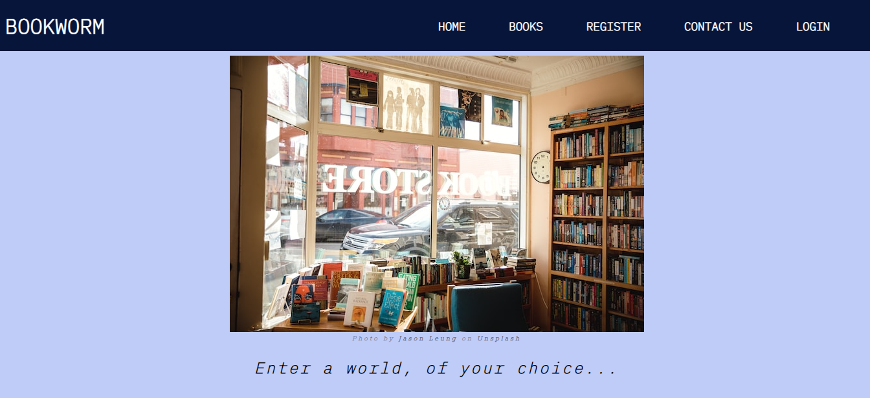

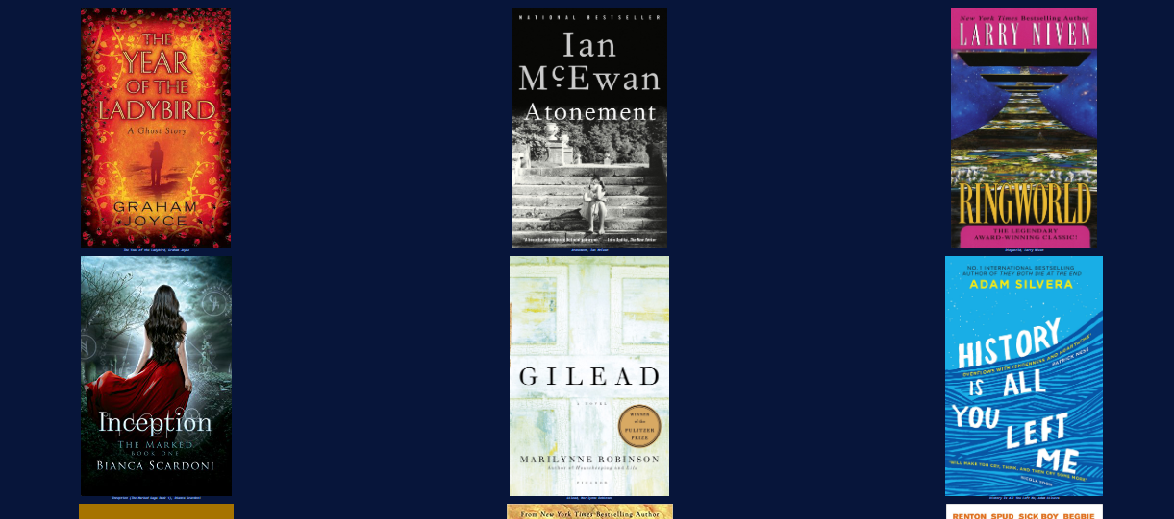

***4. Write a Javascript program to convert numbers to Roman numerals.***

**convert.js**

function convertToRoman(num) {

var l = [1000,900,500,400,100,90,50,40,10,9,5,4,1];

var sym = ['M','CM','D','CD','C','XC','L','XL','X','IX','V','IV','I']

var str = "";

let i = 0;

while(num>0){

if(l[i]<=num){

str+=sym[i];

num-=l[i];

}

else{

i++;

}

}

return str;

}

console.log(convertToRoman(36));

**OUTPUT**

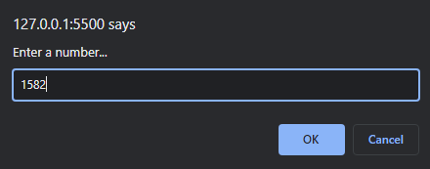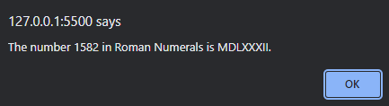

***5. Write a Javascript program to validate a form, which satisfies the conditions:***

***(a) Name should only contain alphabets.***

***(b) Password should not be less than 6 characters length.***

***(c) E-mail id must follow the pattern*** [***name@domain.com***](mailto:name@domain.com)***.***

***(d) Phone number should contain 10 digits only.***

***(e) Last Name and Address should not be empty.***

**index.html**

<!DOCTYPE html>

<html lang="en">

  <head>

    <meta charset="UTF-8" />

    <meta http-equiv="X-UA-Compatible" content="IE=edge" />

    <meta name="viewport" content="width=device-width, initial-scale=1.0" />

    <link rel="stylesheet" href="styles.css" />

    <link rel="preconnect" href="https://fonts.googleapis.com" />

    <link rel="preconnect" href="https://fonts.gstatic.com" crossorigin />

    <link

      href="https://fonts.googleapis.com/css2?family=Nunito&display=swap"

      rel="stylesheet"

    />

    <link

      rel="shortcut icon"

      href="https://cdn-icons-png.flaticon.com/512/9318/9318633.png"

      type="image/x-icon"

    />

    <title>Webvy</title>

    <script>

**const** validate = () **=>**{

**const** phVal = document.getElementById('number').value;

**const** pwdVal = document.getElementById('pwd').value;

**const** fnameVal = document.getElementById('name').value;

            if (String(phVal).length != 10){

                alert("Phone no. should have 10 digits");

                return false;

            }

            if (fnameVal.length < 7){

                alert("First name has to be 6 charaters long!");

                return false;

            }

            if (!/^[a-zA-z]*$/g.test(fnameVal)){

                alert("First name has to be characters only!");

                return false;

            }

            if(pwdVal.length < 7){

                 alert("Password should be greater than 6 characters!");

                return false;

            }

            return true;

        }

    </script>

  </head>

  <body>

    <main>

      <div id="form-heading">

        <h1 id="title">Webvy Registration</h1>

        <p id="description">For Students</p>

      </div>

      <form action="#index.html" id="survey-form" method="post" onsubmit="return

validate()">

        <div id="form-body">

          <fieldset id="personal-details">

            <h2>Personal Details</h2>

            <hr>

            <label id="name-label" for="name"

              >First Name

              <input

                id="name"

                type="text"

                placeholder="Enter your first name"

                required

              />

</label>

             <label id="lname-label" for="lname"

              >Last Name

              <input

                id="lname"

                type="text"

                placeholder="Enter your last name"

                required

              />

            </label>

            <label id="email-label" for="email"

              >Email

              <input

                id="email"

                type="email"

                placeholder="Enter your email"

                required

              />

            </label>

            <label id="number-label" for="number"

              >Phone No.

              <input

                id="phone"

                type="phone"

                placeholder="Enter your number"

                required

              />

</label>

            <label id="pwd-label" for="pwd"

              >Password

              <input

                id="pwd"

                type="password"

                placeholder="Enter your password"

                required

              />

            </label>

          </fieldset>

          <fieldset id="learning-details">

            <h2>Learning Progress</h2>

            <hr>

            <label id="radio-buttons" class="learning-q">

              Are you currently learning web development?

              <label for="yes-web">

                <input type="radio" name="recs" id="yes-adopt" value="yes" />

                Yes

              </label>

              <label for="no-web">

                <input type="radio" name="recs" id="no-adopt" value="no" />

                No

              </label>

            </label>

            <label id="checkbox-options" class="learning-q">

              What have you learnt so far?

              <label for="html-skill">

                <input

                  type="checkbox"

                  name="skill-set"

                  id="html-skill"

                  value="html-skill"

                />

                HTML

              </label>

              <label for="css-skill">

                <input

                  type="checkbox"

                  name="skill-set"

                  id="css-skill"

                  value="css-skill"

                />

                CSS

              </label>

              <label for="js-skill">

                <input

                  type="checkbox"

                  name="skill-set"

                  id="js-skill"

                  value="js-skill"

                />

                Javascript

              </label>

              <label for="frameworks">

                <input

                  type="checkbox"

                  name="skill-set"

                  id="frameworks"

                  value="frameworks"

                />

                Frameworks(Bootstrap, React, etc..)

              </label>

            </label>

            <label for="dropdown" class="learning-q">

              What do you find most difficult to learn?

              <select id="dropdown" name="dropdown" >

                <option value="" name="options">(select one)</option>

                <option value="1" name="options">The Box Model</option>

                <option value="3" name="options">Grid and Flexbox</option>

                <option value="2" name="options">Javascript programming</option>

                <option value="2" name="options">None of the above</option>

              </select>

            </label>

          </fieldset>

          <fieldset id="student-feedback">

            <h2>About Me</h2>

            <hr>

            <label for="feedback">

              Please tell us about yourself and how got into web development

              <textarea

                name="feedback"

                id="feedback"

                cols="45"

                rows="10"

                placeholder="Enter your feedback here..."

                required

              ></textarea>

            </label>

          </fieldset>

          <fieldset id="submit-button"><button id="submit" type="submit">

Submit</button>

          </fieldset>

        </div>

      </form>

    </main>

  </body>

</html>

**styles.css**

html {

  box-sizing: border-box;

}

*,

::before,

::after {

  box-sizing: inherit;

}

body {

  background-image: linear-gradient(

    90deg,

    #1c3c6b 0%,

    #7ebffc 35%,

    #7ebffc 50%,

    #7ebffc 70%,

    #1c3c6b 100%

  );

  background-color: white;

  background-size: cover;

  margin: 0;

  font-family: "Nunito", sans-serif;

  color: white;

}

#form-heading {

  text-align: center;

  margin: 0 auto;

}

#form-heading h1 {

  margin-top: -0.1rem;

  font-size: 2.3rem;

  color: white;

  text-shadow: 1px 0.1px 20px #ffffffe1;

}

#form-heading p {

  margin-top: -1.7rem;

  font-size: 1.3rem;

  font-weight: 600;

  color: #ffffffe1;

}

#form-body {

  margin-top: -1.5rem;

  background: #1c3c6b70;

  border-radius: 5px;

}

form {

  width: 50vw;

  max-width: 500px;

  min-width: 350px;

  margin: 0 auto;

  padding: 1% 0;

}

form h2 {

  margin-top: 1px;

  margin-bottom: 0;

}

form hr {

  width: 45%;

  margin: 0 0 5px 0;

  opacity: 45%;

}

fieldset {

  border: none;

  padding: 0.7rem 0.5rem;

  border-bottom: 1px solid rgba(226, 215, 175, 0.5);

}

label {

  display: block;

  margin: 0.5rem 0;

}

input,

select,

textarea {

  font-size: small;

  font-style: italic;

  margin: 10px 0 0 0;

  font-family: "Nunito", sans-serif;

  border-radius: 5px;

  border: 1px solid transparent;

}

#name,

#lname,

#email,

#phone,

#pwd {

  display: block;

  width: 55%;

  padding-bottom: 1%;

}

#learning-details .learning-q {

  padding-top: 15px;

}

select#dropdown {

  display: block;

  background: #1c3c6b70;

  color: white;

  width: 57%;

  border: none;

  font-family: "Nunito", sans-serif;

}

#submit-button {

  border-bottom: none;

}

#submit {

  border: none;

  display: block;

  height: 20%;

  width: 85px;

  text-align: center;

  margin: 0 auto;

  font-family: "Nunito", sans-serif;

  background: #1c3c6b70;

  color: white;

  font-size: 17px;

  border-radius: 10px;

}

button#submit:hover {

  background: #7ebffc;

}

**OUTPUT**

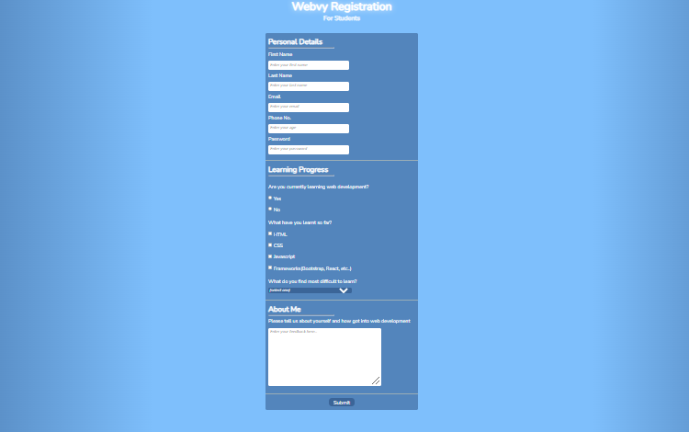

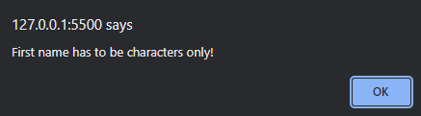

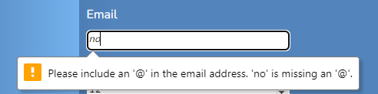

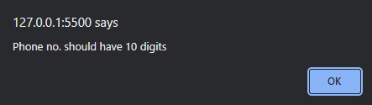

***6. Write a Javascript program to demonstrate pop-up boxes, for the following:***

***(a) Display date***

***(b) Factorial of a number***

***(c) A multiplication table of numbers from 1 to 10***

***(d) Sum of n numbers***

**popupboxes.html**

<!DOCTYPE html>

<html lang="en">

  <head>

    <meta charset="UTF-8" />

    <meta http-equiv="X-UA-Compatible" content="IE=edge" />

    <meta name="viewport" content="width=device-width, initial-scale=1.0" />

    <link rel="stylesheet" href="styles.css" />

    <link rel="preconnect" href="https://fonts.googleapis.com" />

    <link rel="preconnect" href="https://fonts.gstatic.com" crossorigin />

    <link

      href="https://fonts.googleapis.com/css2?family=Anonymous+Pro&display=swap"

      rel="stylesheet"

    />

    <title>Pop Up Box Demo</title>

  </head>

  <body>

    <header>

      <h1>Random Operations 4 Fun <sup>Javascript</sup></h1>

    </header>

    <main>

      <div>

        <button onclick="displayDate()">Today's Date</button>

        <button onclick="promtDemo()">Factorial of a number</button>

        <button onclick="alertDemo()" onmouseout="mouseOut()">

          Multiplication table

        </button>

        <button onclick="confirmDemo()" onmouseout="mouseOut()">

          Sum of 2 numbers

        </button>

      </div>

    </main>

    <script>

      const displayDate = () => {

        date = new Date();

        day = date.getDate();

        month = date.getMonth() + 1;

        year = date.getFullYear();

        window.alert(`Today's date is ${day}/${month}/${year}.`);

      };

      const promtDemo = () => {

        let n = window.prompt("Enter a number...");

        console.log("your number is " + n);

        let fact = 1;

        for (let i = n; i > 1; i--) {

          fact *= i;

        }

        window.alert(" The factorial of " + n + " is " + fact + ".");

      };

      const alertDemo = () => {

        let n = window.prompt("Enter a number...");

        str = "";

        for (let i = 1; i <= 10; i++) {

          str += `${n} x ${i} = ${n * i} \n`;

        }

        window.alert("Multiplication table of " + parseInt(n) + "\n" + str);

      };

      const confirmDemo = () => {

        let num1 = window.prompt("Enter number 1");

        if (

          window.confirm(

            "Press OK if number 2 = 10\nPress Cancel if number 2 = 20"

          )

        ) {

          num2 = 10;

        } else {

          num2 = 20;

        }

        let num3 = window.prompt("Enter number 3");

        num1 = parseInt(num1);

        num2 = parseInt(num2);

        num3 = parseInt(num3);

        window.alert(

          num1 + " + " + num2 + " + " + num3 + " = " + (num1 + num2 + num3)

        );

      };

    </script>

  </body>

</html>

**styles.css**

* {

  box-sizing: border-box;

}

html,

::before,

::after {

  box-sizing: inherit;

}

body {

  background: linear-gradient(

      180deg,

      #a4ff4fcc,

      #f3c80686 70.71%

    ),

    linear-gradient(127deg, #00ff4ccc, #0099ff00 70.71%),

    linear-gradient(

      336deg,

      #11ff45cc,

      #ff00f200 70.71%

    );

  background-attachment: fixed;

  margin: 0;

  font-family: "Anonymous Pro", monospace;

  padding: 1rem;

}

header {

    display: flex;

    flex-direction: row;

    justify-content: center;

}

header h1 {

    font-size: clamp(1rem, 4rem, 2rem);

    color: #063d01;

    text-shadow: 1px 0.5px 1px #90ff11cc, 1px 0.5px 1px #063d01;

}

header sup {

    vertical-align: top;

    font-size: clamp(0.2rem, 2rem, 1rem);

    position: relative;

    top: -0.7em;

    color: #063d01;

    text-shadow: 1px 0.5px 1px #90ff11cc;

    text-transform: uppercase;

    letter-spacing: 1.5px;

}

main div {

    padding: 1rem;

    display: grid;

    grid-template-columns: auto auto auto auto;

    gap: 2rem;

    justify-content: center;

}

main div button {

    width: 15vw;

    height: 10vh;

    background-color: #268f1da8;

    border: 1px solid #32bb2660;

    border-radius: 3px 8px;

    box-shadow: 1px 0.5px 8px #90ff11cc;

    font-family: "Anonymous Pro", monospace;

    font-weight: 600;

    color: #acffa6;

    text-transform: uppercase;

    font-size: clamp(0.5rem, 3rem, 1rem);

}

main div button:hover {

    background-color: #90ff11cc;

    border: 1px solid #5eff004f;

    color: #1f6e18;

    box-shadow: 1px 0.1px 10px #5eff00;

}

**OUTPUT**



Today’s Date

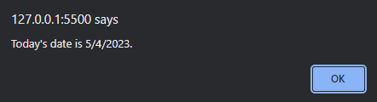

Factorial of a number

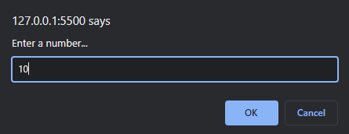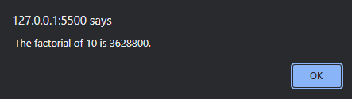

Multiplication Table

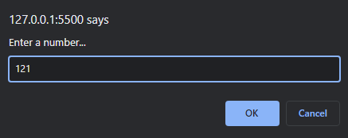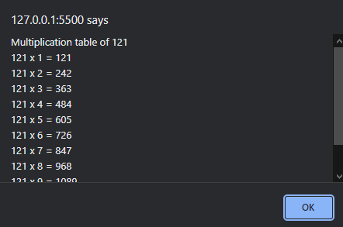

Sum of numbers

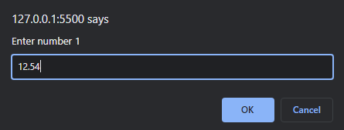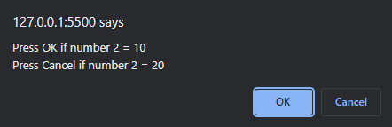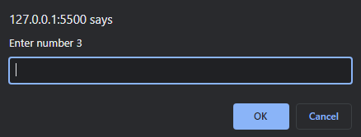

***7. Create a portfolio website. Demonstrate use of inline, internal and external CSS stylesheets.***

**index.html**

<!DOCTYPE html>

<html lang="en">

<head>

<meta charset="UTF-8" />

<meta http-equiv="X-UA-Compatible" content="IE=edge" />

<meta name="viewport" content="width=device-width, initial-scale=1.0" />

<link rel="stylesheet" href="styles.css" />

<link rel="preconnect" href="https://fonts.googleapis.com" />

<link rel="preconnect" href="https://fonts.gstatic.com" crossorigin />

<link

href="https://fonts.googleapis.com/css2?family=Montserrat&display=swap"

rel="stylesheet"

/>

<link

href="https://fonts.googleapis.com/css2?family=Unbounded&display=swap"

rel="stylesheet"

/>

<title>Portfolio</title>

</head>

<body>

<!-- HEADER -->

<header>

<nav id="navbar">

<ul id="nav-list">

<li><a href="#welcome-section" class="nav-link">About</a></li>

<li><a href="#projects-section" class="nav-link">Projects</a></li>

<li><a href="#contact-section" class="nav-link">Contact</a></li>

</ul>

</nav>

</header>

<!-- MAIN -->

<main>

<!-- ABOUT ME -->

<section id="welcome-section">

<h1>Hi! I'm Ady.</h1>

<h2>An aspiring <span class="special-text">web developer</span>.</h2>

</section>

<!-- PROJECTS -->

<section id="projects-section">

<h2>These are some of my projects.</h2>

<div id="project-grid">

<a

href="https://codepen.io/codeyady/full/YzjYXwm"

target="_blank"

class="project-tile"

>

<img src="https://shots.codepen.io/codeyady/pen/YzjYXwm-

1280.webp?version=1674412125" alt="Project-1" />

<p>FCC Documentation Page</p>

</a>

<a

href="https://codepen.io/codeyady/full/ZEjvwqj"

target="_blank"

class="project-tile"

><img src="https://shots.codepen.io/codeyady/pen/ZEjvwqj-

512.webp?version=1675013670" alt="Project-2" />

<p>FCC Survey Form</p>

</a>

<a

href="https://codepen.io/codeyady/full/VwBzmqM"

target="_blank"

class="project-tile"

><img src=" https://shots.codepen.io/codeyady/pen/VwBzmqM-

512.webp?version=1674315629" alt="Project-3" />

<p>Silly Cat Page</p>

</a>

</div>

<div id="codepen-box">

<a href="https://codepen.io/codeyady" id="codepen-link">Show all</a>

</div>

</section>

<!-- CONTACT ME -->

<section id="contact-section">

<h2>Find me on...</h2>

<div id="profile-list">

<a

href="https://github.com/adelicia-js"

class="profile-link"

target="_blank"

><img src="https://cdn-icons-png.flaticon.com/512/2111/2111432.png"

alt=""> </a

>

<a

href="https://codepen.io/codeyady"

class="profile-link"

target="_blank"

><img src="https://cdn-icons-png.flaticon.com/512/2111/2111501.png"

alt=""> </a

>

</div>

</section>

</main>

</body>

</html>

**styles.css**

html {

box-sizing: border-box;

}

*, ::before, ::after {

box-sizing: inherit;

}

body {

margin: 0;

padding: 0;

font-family: 'Montserrat',sans-serif;

background: rgba(9, 183, 252, 0.1);

width: 100%;

height: auto;

background-size: cover;

}

/* NAV BAR */

#navbar {

display: flex;

justify-content: center;

position: fixed;

top: 0;

left: 0;

width: 100%;

background-color: #201136;

z-index: 10;

overflow: hidden;

}

#nav-list {

display: flex;

gap: 25rem;

}

#nav-list li {

list-style-type: none;

margin-right: 1rem;

font-weight: 600;

padding-left: 0;

}

.nav-link {

font-size: 1.2rem;

color: rgb(255, 255, 255);

text-decoration: none;

text-transform: uppercase;

letter-spacing: 0.3rem;

}

.nav-link:hover {

color: #9f80cf;

text-shadow: 1px 0.1px 5px #201136,0 0 2px #201136, 0 0 2px #ffffff;

}

/* MAIN */

/* WELCOME */

#welcome-section {

display: flex;

width: 100%;

height: 100vh;

flex-direction: column;

justify-content: center;

align-items: center;

background-color: black;

/* background-image: #9f80cf; */

background-image: linear-gradient(62deg, #9f80cf 0%, #9f80cf 50%, #9f80cf 100%);

padding: 5rem;

margin: 0;

}

#welcome-section h1, #welcome-section h2 {

font-family: 'Unbounded',sans-serif;

text-align: center;

}

#welcome-section h1{

font-size: 3rem;

color: white;

margin-bottom: 0;

}

#welcome-section h2 {

font-size: 2rem;

font-style: oblique;

color: #201136;

margin-top: 0.1rem;

}

/* PROJECTS */

#projects-section {

/* width: 100%; */

/* height: 70vh; */

text-align: center;

padding: 2rem 1rem;

background-color: rgb(0, 0, 0);

background-image: linear-gradient(62deg, #c2a9e9 0%, #dad3e7 50%, #9c7ad4 100%);

}

#projects-section h2 {

color: white;

/* text-shadow: 1px 0.1px 10px #ffae00; */

text-shadow: 1px 0.1px 10px #201136;

font-family: 'Unbounded',sans-serif;

padding-bottom: 0.5rem;

}

#project-grid {

display: grid;

width: 100%;

max-width: 1500px;

margin: 0;

margin-bottom: 1rem;

grid-template-columns: repeat(auto-fit, minmax(350px, 1fr));

gap: 2rem;

padding-bottom: 0.5rem;

}

.project-tile {

background-color: #201136;

border-radius: 5px;

text-decoration: none;

}

.project-tile img {

width: 100%;

height: 87%;

object-fit: cover;

border-radius: 5px 5px 0 0;

color: rgba(255, 255, 255, 0.801);

}

.project-tile p {

color: white;

text-decoration: none;

margin: 0;

font-weight: 600;

font-family: 'Unbounded',sans-serif;

/* font-style: ; */

font-weight: normal;

}

.project-tile:hover {

box-shadow: 1px 0.1px 40px #4d3177;

}

#codepen-box {

padding-top: 1rem;

padding-bottom: 2rem;

}

#codepen-link {

background: #ffffff;

padding: 0.5rem 1rem;

border-radius: 5px;

color: #201136;

text-decoration: none;

}

#codepen-link:hover {

background: #201136;

color: #ffffff;

box-shadow: 1px 0.1px 10px #4d3177;

}

/* CONTACT */

#contact-section {

width: 100%;

text-align: center;

padding: 2rem 1rem;

background-color: rgb(0, 0, 0);

background-image: linear-gradient(118deg, #2b1b42 0%, #4d3177 50%, #201136 100%);

color: white;

}

#profile-list {

display: flex;

flex-direction: row;

flex-wrap: wrap;

justify-content: center;

align-items: center;

gap: 2rem;

width: 100%;

max-width: 1500px;

}

.profile-link img {

width: 2rem;

height: auto;

max-width: 20vw;

object-fit: cover;

}

**OUTPUT**

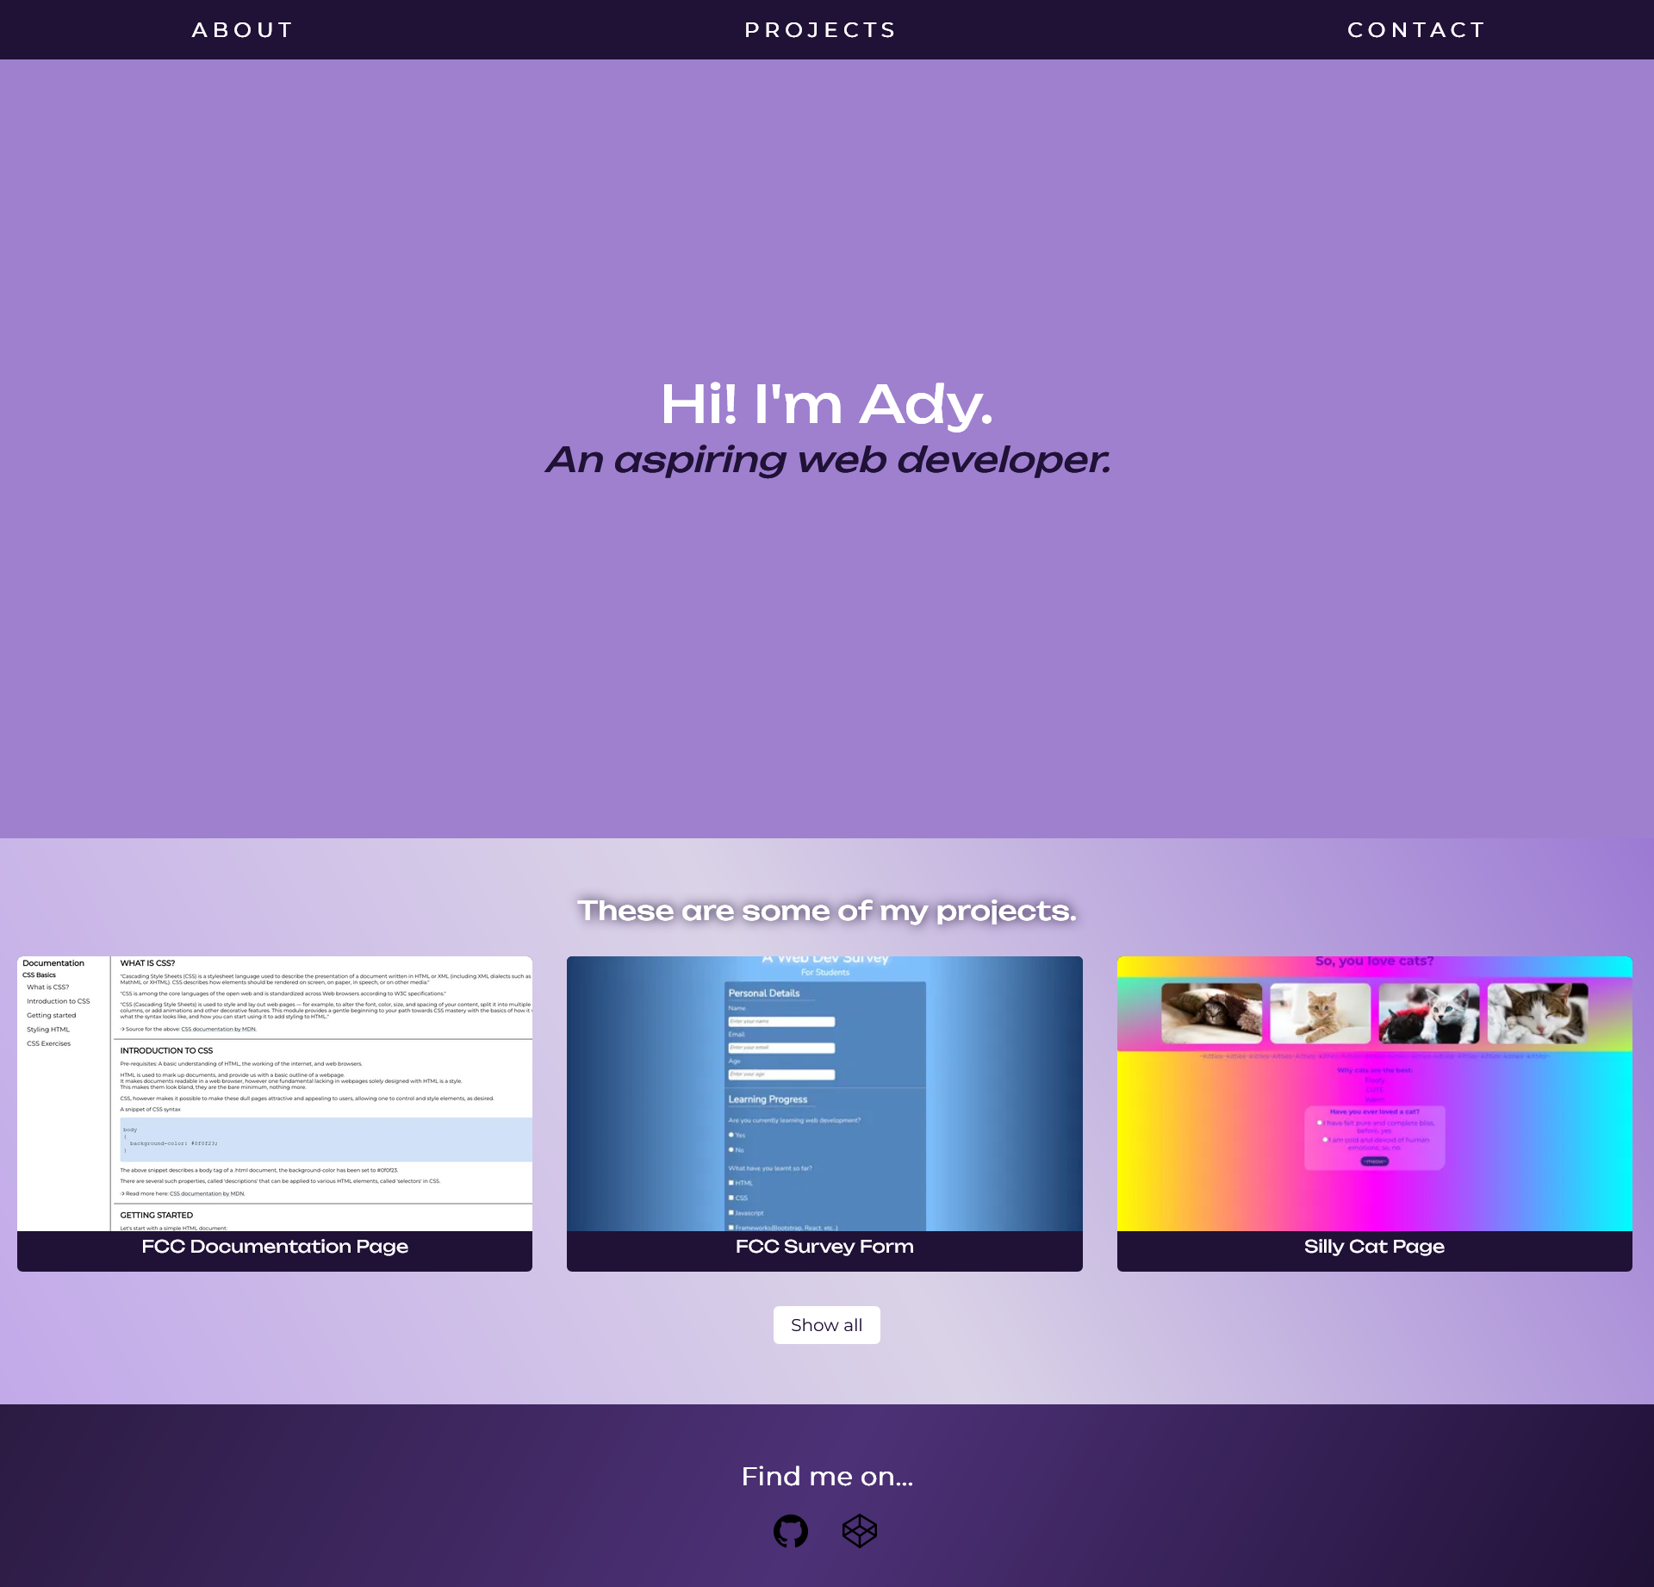

***8. Write a program to implement Typescript classes with inheritance.***

**BankAccount.ts**

class BankAccount {

    balance: number;

    constructor() {

        this.balance = 0;

    }

    deposit(amount: number) {

        this.balance += amount;

    }

    withdraw(amount: number) {

        if (this.balance > amount)

            this.balance -= amount;

    }

    transfer(amount: number, toAccount: BankAccount) {

        this.balance -= amount;

        toAccount.balance += amount;

    }

}

const adyAccount = new BankAccount();

const celAccount = new BankAccount();

adyAccount.deposit(5500);

celAccount.deposit(2000);

celAccount.transfer(2500, adyAccount);

console.log(adyAccount.balance);

console.log(celAccount.balance);

**Output**

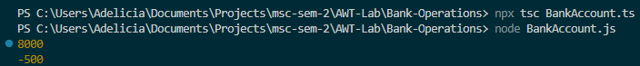

***9. Write a program to implement Angular Modules.***

<!DOCTYPE html>

<html>

<script src="https://ajax.googleapis.com/ajax/libs/angularjs/1.6.9/angular.min.js"></script>

<body>

<div ng-app="myApp"  ng-controller="myCtrl">

    {{ firstName + " " + lastName }}

</div>

<script>

    var app = angular.module("myApp", []);

    app.controller("myCtrl", function($scope) {

  $scope.firstName = "Adelicia";

  $scope.lastName = "Sequeira";

});

    </script>

</body>

</html>

**Output**



***10. Write a program to implement Angular Controllers.***

<!DOCTYPE html>

<html>

<script src="https://ajax.googleapis.com/ajax/libs/angularjs/1.6.9/angular.min.js"></script>

<body>

    <div ng-app="myApp" ng-controller="myCtrl">

        First Name: <input type="text" ng-model="firstName"><br>

        Last Name: <input type="text" ng-model="lastName"><br>

        <br>

        Full Name: {{firstName + " " + lastName}}

        </div>

        <script>

        var app = angular.module('myApp', []);

        app.controller('myCtrl', function($scope) {

          $scope.firstName = "John";

          $scope.lastName = "Doe";

        });

        </script>

</body>

</html>

**Output**

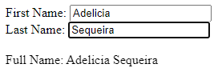

***11. Write a program to implement Angular Directives.***

<!DOCTYPE html>

<html>

<script src="https://ajax.googleapis.com/ajax/libs/angularjs/1.6.9/angular.min.js"></script>

<body>

<div ng-app=""  ng-init="firstName='John'">

    <p>Name: <input type="text" ng-model="firstName"></p>

    <p>You wrote: {{ firstName }}</p>

</div>

</body>

</html>

**Output**

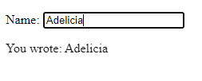

***12. Write a program to implement Angular components.***

<!DOCTYPE html>

<html>

<script src="https://ajax.googleapis.com/ajax/libs/angularjs/1.6.9/angular.min.js"></script>

<body>

<div ng-app="">

<p>Name: <input type="text" ng-model="name"></p>

<p ng-bind="name"></p>

</div>

</body>

</html>

**Output**

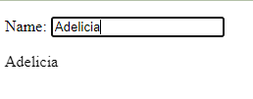

***13. Write a program to implement Angular Forms.***

<!DOCTYPE html>

<html lang="en">

<script src="https://ajax.googleapis.com/ajax/libs/angularjs/1.6.9/angular.min.js"></script>

<body>

<div ng-app="myApp" ng-controller="formCtrl">

  <form novalidate>

    First Name:<br>

    <input type="text" ng-model="user.firstName"><br>

    Last Name:<br>

    <input type="text" ng-model="user.lastName">

    <br><br>

    <button ng-click="reset()">RESET</button>

  </form>

  <p>form = {{user}}</p>

  <p>master = {{master}}</p>

</div>

<script>

var app = angular.module('myApp', []);

app.controller('formCtrl', function($scope) {

    $scope.master = {firstName:"John", lastName:"Doe"};

    $scope.reset = function() {

        $scope.user = angular.copy($scope.master);

    };

    $scope.reset();

});

</script>

</body>

</html>

**Output**

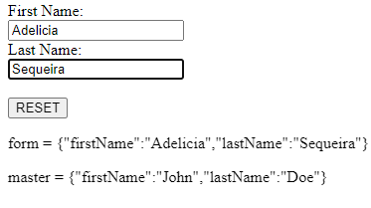

***ADVANCED DATABASE MANAGEMENT SYSTEMS***

***INDEX***

|  |  |  |
| --- | --- | --- |
| S. No. | Program Names | Page No. |
| 1. | Creating Databases/Table Spaces/Constraints/Keys   1. Create a database using DDL commands for any real-world entity (with all type of constraints – null, not null, primary key, foreign key, check) 2. Implement DML commands for the above created database on all tables 3. Implement DCL commands for the above database in all tables | 72 |
| 2. | Creating Objects  Implement view commands to create a view object for the above  tables | 82 |
| 3. | Moving Data   1. Demonstrate how a database can be exported from MySQL 2. Demonstrate how to import table from another application to MySQL | 83 |
| 4. | Recovery  Implement commands for backward recovery (Savepoint, Commit, Rollback) | 85 |
| 5. | Locking   1. Implement lock commands on 2 transactions 2. Demonstrate acquiring locks and releasing locks by using a proper transaction flow | 88 |
| 6. | Preparing Application for execution using a front end tool  Design a form in HTML, Create a table in MySQL and use PHP to connect the form to a MySQL database | 89 |

***1. Creating Databases/Table Spaces/Constraints/Keys.***

***(a)***  ***Create a database using DDL commands for any real-world entity***

***(with all type of constraints – null, not null, primary key, foreign key)***

**CREATE**

create database college_db;



use college_db;

create table Students (

    Registration_Number varchar(6) primary key,

    Student_Name varchar(100) not null,

    Age integer not null,

    Class char(10) not null,

    Phone_Number bigint not null,

    Email varchar(100) not null,

    Date_Of_Birth date not null

);

create table Internals (

    Subject_Code varchar(100) not null,

    Subject_Name varchar(100) not null,

    Semester integer not null,

    Test_1 integer not null,

    Test_2 integer not null,

    Activity integer not null,

    Total integer not null,

    foreign key (Registration_Number) references Students(Registration_Number)

);

create table Finals (

    Subject_Code varchar(100) not null,

    Subject_Name varchar(100) not null,

    Semester integer not null,

    Theory integer not null,

    Practicals integer not null,

    Total integer not null,

    Grade varchar(10) not null,

    foreign key (Registration_Number) references Students(Registration_Number)

);

create table Department (

    Department_ID varchar(10) primary key,

    Department_Name varchar(20) not null,

    Staff_Strength integer not null,

    HOD_ID varchar(20) not null

);

create table Staff (

    Department_ID varchar(20) not null,

    Staff_ID varchar(20) primary key,

    Staff_Name varchar(100) not null,

    foreign key (Department_ID) references Department(Department_ID)

);

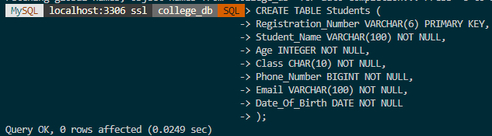

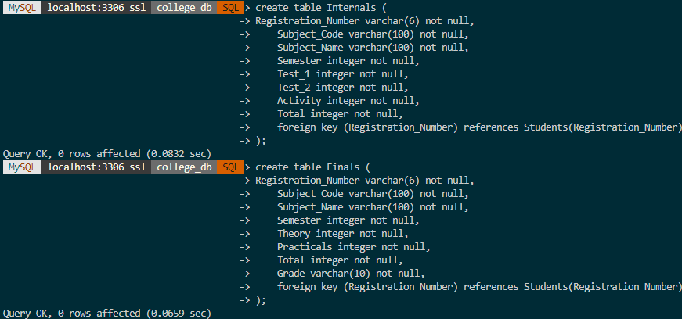

**DESCRIBE**

describe Students;

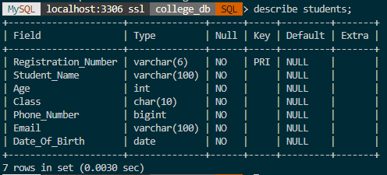

describe Department;

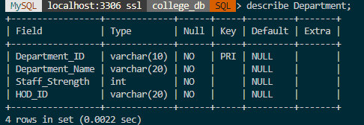

**ALTER**

alter table Students

add Gender char(6) not null;

describe Students;

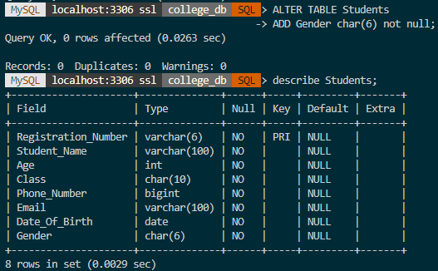

alter table department

modify HOD_ID integer not null;

describe Department;

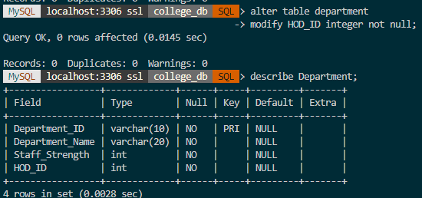

**DROP**

drop table Department;

describe Department;

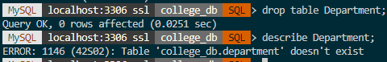

**TRUNCATE**

truncate table Students;

select * from Students;

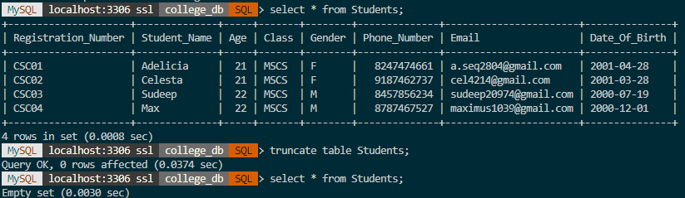

***(b)* *Implement DML commands for the above created database on all tables***

**INSERT**

insert into Staff(Department_ID, Staff_ID, Staff_Name)

values('SJU01', 'SJU0101', 'Angelina'),

('SJU01', 'SJU0102', 'Mary'),

('SJU01', 'SJU0103', 'Karen'),

('SJU01', 'SJU0104', 'Joseph'),

('SJU02', 'SJU0201', 'Jonathan'),

('SJU02','SJU0202','Sanjana'),

('SJU02','SJU0203','David'),

('SJU03', 'SJU0301', 'Javier'),

('SJU03','SJU0302','Mridula'),

('SJU03','SJU0303','Sumanth'),

('SJU03','SJU0304','Josephine'),

('SJU03','SJU0305','Karim'),

('SJU04', 'SJU0401', 'Oindrila'),

('SJU04','SJU0402','Ila'),

('SJU04','SJU0403','Swapnil'),

('SJU04','SJU0404','Meryn'),

('SJU04','SJU0405','Sapna'),

('SJU04','SJU0406','Muthoot'),

('SJU04','SJU0407','Priya');

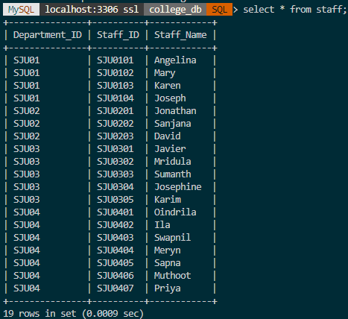

**UPDATE**

update Internals

set Subject_Name = ‘Theory Of Computation’

where Subject_Code = ‘C01’;

select * from Internals;

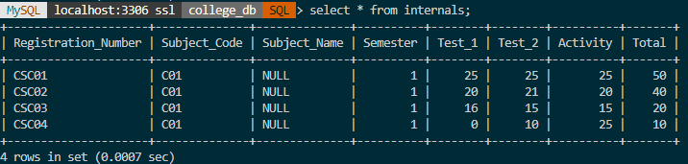 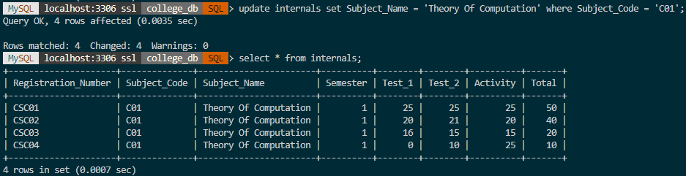

**DELETE**

delete from Internals

where Test_1 = 0;

select * from Internals;

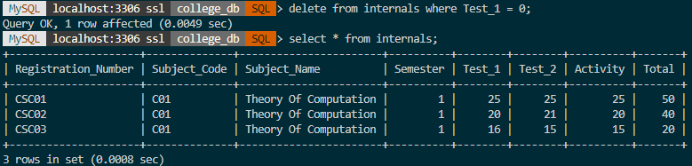

***(c) Implement DCL commands for the above database in all tables***

**CREATE USER**

Create user ady@localhost identified by ‘ady2838’;



*Connecting to new user…*

>mysqlsh

>\sql

>\connect ady@localhost -p

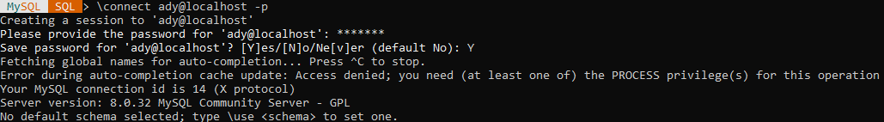

**GRANT**

grant all on college_db.* to ady@localhost;

show grants for ady@localhost;

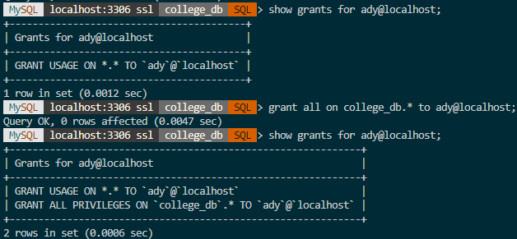

*Connecting to other user…*

insert into values (‘SJU05’, ‘Big Data Analytics’, 10, ‘H05’);

select * from Dsepartment;

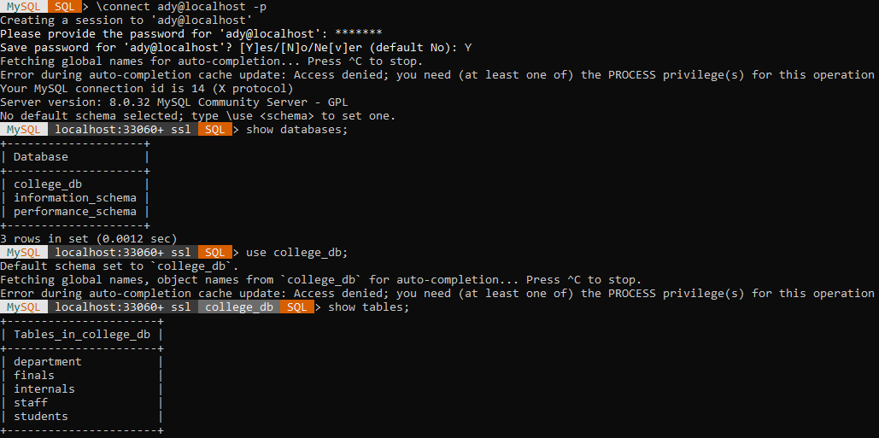

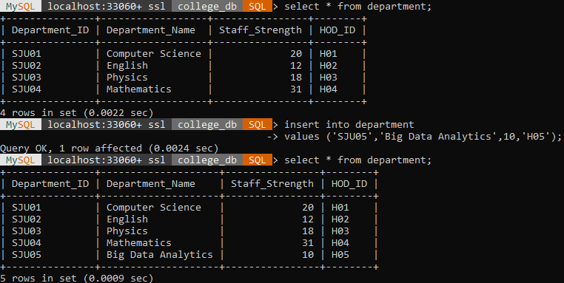

**REVOKE**

revoke all on college_db.* from ady@localhost;

show grants for ady@localhost;

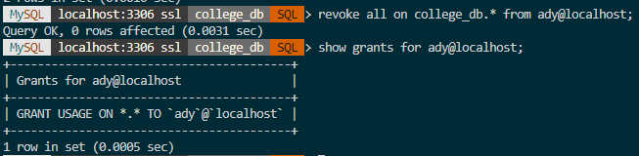

***2. Create Objects.***

***Implement view commands to create a view object for the above tables***

**CREATE VIEW**

create view StudentName as

select Registration_Number, Student_Name from Students;

select * from StudentName;

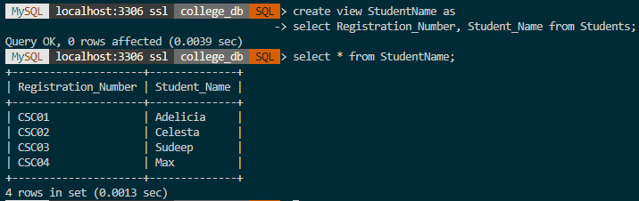

create view ady_details as

select * from Students

where Registration_Number = ‘CSC01’;

select * from ady_details;

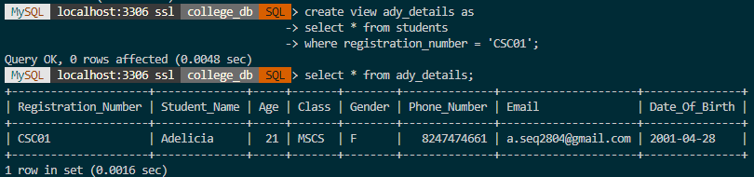

***3. Moving Data.***

***a) Demonstrate exporting a database from MySQL***

SELECT *

FROM (

SELECT 'id', 'name', 'color', 'price'

UNION ALL

SELECT id, name, color, price

FROM flowers

) AS data

INTO OUTFILE '/var/lib/mysql-files/flowersexport.csv'

FIELDS TERMINATED BY ','

ENCLOSED BY '"'

LINES TERMINATED BY '\n';

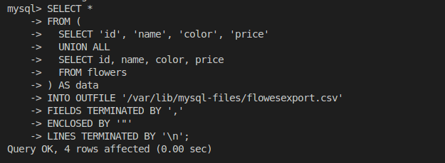

**Flowersexport.csv**

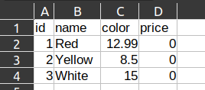

***b) Demonstrate importing a table from another application to MySQL***

set GLOBAL local_infile = 1; --Can be set as root only

exit

> mysql -u 'username' --local-infile=1 --secure-file-priv='' -p 'password'

--start sql server with local inline enabled

CREATE TABLE flowers (

id INT AUTO_INCREMENT PRIMARY KEY,

name VARCHAR(255) NOT NULL,

color VARCHAR(255) NOT NULL,

price DECIMAL(10, 2) NOT NULL

);

LOAD DATA LOCAL INFILE './flowers.csv'

INTO TABLE flowers

FIELDS TERMINATED BY ','

ENCLOSED BY '"'

LINES TERMINATED BY '\n'

IGNORE 1 ROWS;

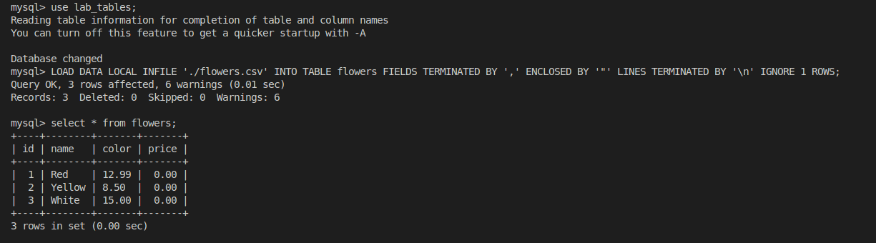

***4. Recovery.***

***Implement commands for backward recovery (Savepoint, Commit, Rollback)***

**SAVEPOINT**

start transaction;

savepoint college_save;



**COMMIT**

start transaction;

select * from Finals;

delete from Finals

where Theory < 50;

select * from Finals;

savepoint college_save;

commit;

***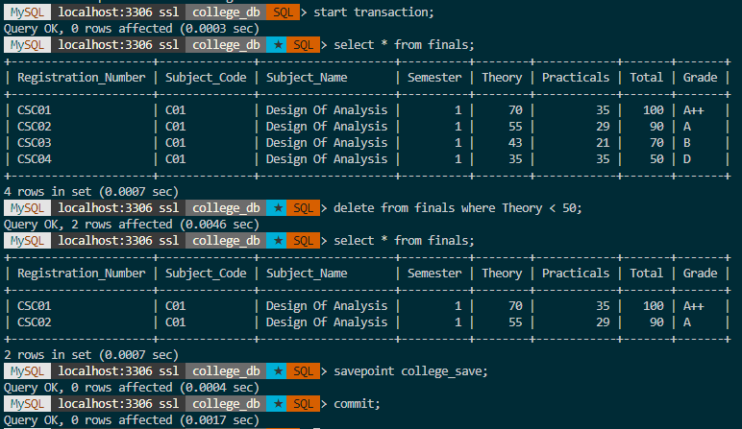*ROLLBACK**

start transaction;

select * from Finals;

delete from Finals

where Theory > 50;

select * from Finals;

rollback;

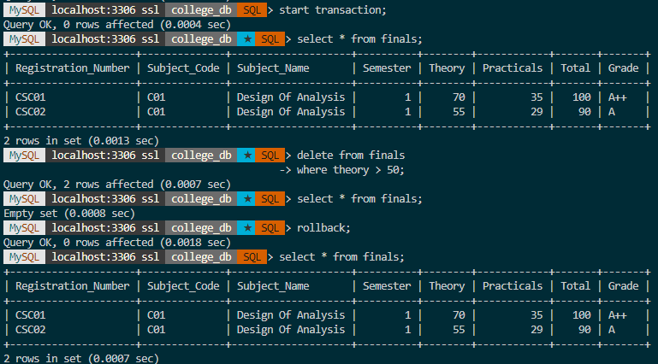

start transaction;

select * from Finals;

savepoint college_save;

delete from Finals

where Subject_Code = ‘C01’;

rollback to savepoint college_save;

select * from Finals;

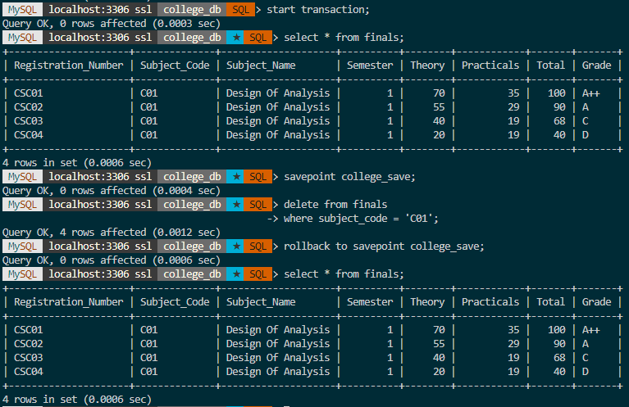

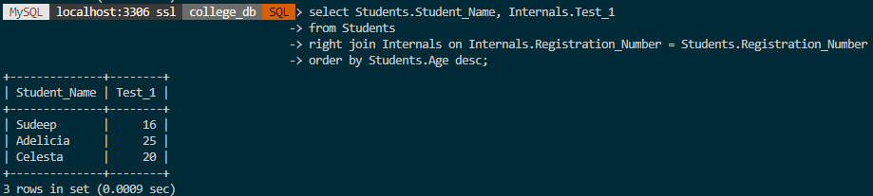

***5. Locking***

Start transaction;

Lock tables employee write, form__data read;

Select * from employee;

Select * from for_data;

Update form_data set name=’shashank3’ where email=’shashank20022801@gmail.com’;

Update employee set name=’Kaif’ where empID=1;

Select * from person_salary

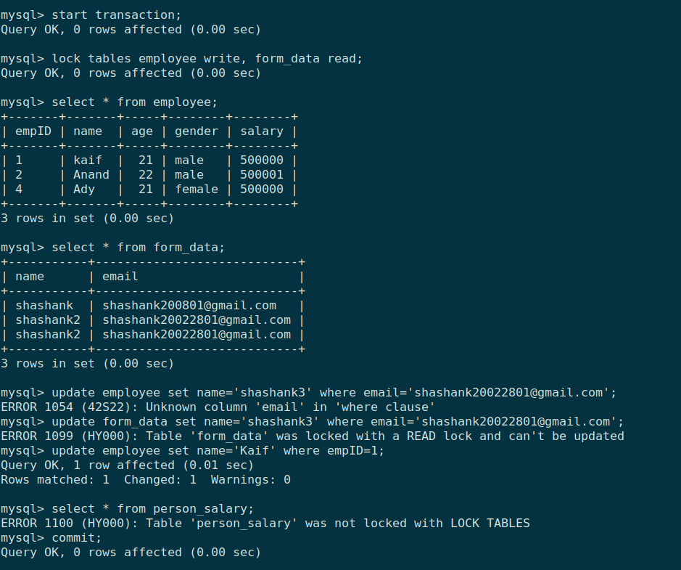

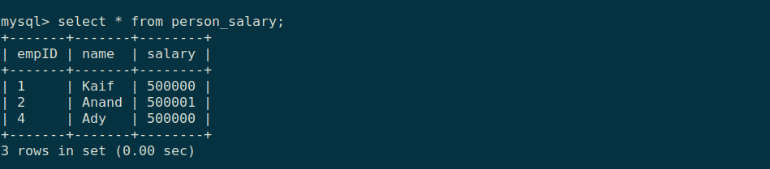

***6. Preparing Application for execution using a front end tool***

1. ***Design a form in HTML***
2. ***Create a table in MySQL***
3. ***Use PHP to connect the content of the form to the MySQL database***

**index.html**

<!DOCTYPE html>

<html>

<head>

<title>Registration Page</title>

<link rel="stylesheet" type="text/css" href="css/bootstrap.css" />

</head>

<body>

<div class="container">

<div class="row col-md-6 col-md-offset-3">

<div class="panel panel-primary">

<div class="panel-heading text-center">

<h1>Registration Form</h1>

</div>

<div class="panel-body">

<form action="connect.php" method="post">

<div class="form-group">

<label for="firstName">First Name</label>

<input

type="text"

class="form-control"

id="firstName"

name="firstName"

/>

</div>

<div class="form-group">

<label for="lastName">Last Name</label>

<input

type="text"

class="form-control"

id="lastName"

name="lastName"

/>

</div>

<div class="form-group">

<label for="gender">Gender</label>

<div>

<label for="male" class="radio-inline"

><input

type="radio"

name="gender"

value="m"

id="male"

/>Male</label

>

<label for="female" class="radio-inline"

><input

type="radio"

name="gender"

value="f"

id="female"

/>Female</label

>

<label for="others" class="radio-inline"

><input

type="radio"

name="gender"

value="o"

id="others"

/>Others</label

>

</div>

</div>

<div class="form-group">

<label for="email">Email</label>

<input

type="text"

class="form-control"

id="email"

name="email"

/>

</div>

<div class="form-group">

<label for="password">Password</label>

<input

type="password"

class="form-control"

id="password"

name="password"

/>

</div>

<div class="form-group">

<label for="number">Phone Number</label>

<input

type="number"

class="form-control"

id="number"

name="number"

/>

</div>

<input type="submit" class="btn btn-primary" />

</form>

</div>

<div class="panel-footer text-right">

<small>&copy; Technical Babaji</small>

</div>

</div>

</div>

</div>

<div class="toast" role="alert" aria-live="assertive" aria-atomic="true">

<div class="toast-header">

<img src="..." class="rounded mr-2" alt="...">

<strong class="mr-auto">Bootstrap</strong>

<small>11 mins ago</small>

<button type="button" class="ml-2 mb-1 close" data-dismiss="toast" aria-label="Close">

<span aria-hidden="true">&times;</span>

</button>

</div>

<div class="toast-body">

Hello, world! This is a toast message.

</div>

</div>

</body>

</html>

**connect.php**

<?php

$firstName = $_POST['firstName'];

$lastName = $_POST['lastName'];

$gender = $_POST['gender'];

$email = $_POST['email'];

$password = $_POST['password'];

$number = $_POST['number'];

// Database connection

$conn = new mysqli('localhost','root','','test');

if($conn->connect_error){

echo "$conn->connect_error";

die("Connection Failed : ". $conn->connect_error);

} else {

$stmt = $conn->prepare("insert into registration(firstName,

lastName, gender, email, password, number) values(?, ?, ?, ?, ?,

?)");

$stmt->bind_param("sssssi", $firstName, $lastName, $gender, $email,

$password, $number);

$execval = $stmt->execute();

echo $execval;

echo "Registration successfully...";

$stmt->close();

$conn->close();

}

?>

**Output**

