**Exercise 1: Control Structures**

**Table Creation:**

CREATE TABLE Customers (

    CustomerID NUMBER PRIMARY KEY,

    Name VARCHAR2(100),

    DOB DATE,

    Balance NUMBER,

    LastModified DATE,

    IsVIP VARCHAR2(5) DEFAULT 'FALSE'

);

ALTER TABLE Customers ADD IsVIP VARCHAR2(5) DEFAULT 'FALSE';

CREATE TABLE Loans (

    LoanID NUMBER PRIMARY KEY,

    CustomerID NUMBER,

    LoanAmount NUMBER,

    InterestRate NUMBER,

    StartDate DATE,

    EndDate DATE,

    FOREIGN KEY (CustomerID) REFERENCES Customers(CustomerID)

);

INSERT INTO Customers VALUES (1, 'John Doe', TO_DATE('1950-05-15', 'YYYY-MM-DD'), 12000, SYSDATE, 'FALSE');

INSERT INTO Customers VALUES (2, 'Jane Smith', TO_DATE('1990-07-20', 'YYYY-MM-DD'), 8000, SYSDATE, 'FALSE');

INSERT INTO Loans VALUES (1, 1, 5000, 5, SYSDATE, ADD_MONTHS(SYSDATE, 15));

COMMIT;

**Scenario 1:**

**Question:** Write a PL/SQL block that loops through all customers, checks their age, and if they are above 60, apply a 1% discount to their current loan interest rates.

BEGIN

  FOR rec IN (

    SELECT CustomerID

    FROM Customers

    WHERE MONTHS_BETWEEN(SYSDATE, DOB)/12 > 60

  ) LOOP

    UPDATE Loans

    SET InterestRate = InterestRate - 1

    WHERE CustomerID = rec.CustomerID;

  END LOOP;

  COMMIT;

END;

/

SELECT * FROM Loans;

**Output**

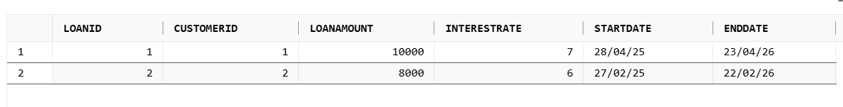

**Scenario 2:**

**Question:** Write a PL/SQL block that iterates through all customers and sets a flag IsVIP to TRUE for those with a balance over $10,000.

BEGIN

  FOR rec IN (

    SELECT CustomerID

    FROM Customers

    WHERE Balance > 10000

  ) LOOP

    UPDATE Customers

    SET IsVIP = 'TRUE'

    WHERE CustomerID = rec.CustomerID;

  END LOOP;

  COMMIT;

END;

/

SELECT CustomerID, Name, Balance, IsVIP FROM Customers;

**Output**



**Scenario 3:**

**Question:** Write a PL/SQL block that fetches all loans due in the next 30 days and prints a reminder message for each customer.

SET SERVEROUTPUT ON;

DECLARE

  v_name Customers.Name%TYPE;

BEGIN

  FOR rec IN (

    SELECT LoanID, CustomerID, EndDate

    FROM Loans

    WHERE EndDate BETWEEN SYSDATE AND SYSDATE + 30

  ) LOOP

    BEGIN

      SELECT Name INTO v_name

      FROM Customers

      WHERE CustomerID = rec.CustomerID;

      DBMS_OUTPUT.PUT_LINE(

        'Reminder: ' || v_name || ', your loan (ID ' || rec.LoanID ||

        ') is due on ' || TO_CHAR(rec.EndDate, 'DD-Mon-YYYY')

      );

    EXCEPTION

      WHEN NO_DATA_FOUND THEN

        DBMS_OUTPUT.PUT_LINE('No customer found for Loan ID: ' || rec.LoanID);

    END;

  END LOOP;

END;

/

**Output**



**Exercise 2: Error Handling**

CREATE TABLE Customers (

    CustomerID NUMBER PRIMARY KEY,

    Name VARCHAR2(100),

    DOB DATE,

    Balance NUMBER,

    LastModified DATE

);

CREATE TABLE Accounts (

    AccountID NUMBER PRIMARY KEY,

    CustomerID NUMBER,

    AccountType VARCHAR2(20),

    Balance NUMBER,

    LastModified DATE,

    FOREIGN KEY (CustomerID) REFERENCES Customers(CustomerID)

);

CREATE TABLE Employees (

    EmployeeID NUMBER PRIMARY KEY,

    Name VARCHAR2(100),

    Position VARCHAR2(50),

    Salary NUMBER,

    Department VARCHAR2(50),

    HireDate DATE

);

INSERT INTO Customers VALUES (1, 'John Doe', TO_DATE('1985-05-15', 'YYYY-MM-DD'), 1000, SYSDATE);

INSERT INTO Customers VALUES (2, 'Jane Smith', TO_DATE('1990-07-20', 'YYYY-MM-DD'), 1500, SYSDATE);

INSERT INTO Accounts VALUES (1, 1, 'Savings', 1000, SYSDATE);

INSERT INTO Accounts VALUES (2, 2, 'Checking', 1500, SYSDATE);

INSERT INTO Employees VALUES (1, 'Alice Johnson', 'Manager', 70000, 'HR', TO_DATE('2015-06-15', 'YYYY-MM-DD'));

INSERT INTO Employees VALUES (2, 'Bob Brown', 'Developer', 60000, 'IT', TO_DATE('2017-03-20', 'YYYY-MM-DD'));

COMMIT;

**Scenario 1:**

**Question:** Write a stored procedure **SafeTransferFunds** that transfers funds between two accounts. Ensure that if any error occurs (e.g., insufficient funds), an appropriate error message is logged and the transaction is rolled back.

CREATE OR REPLACE PROCEDURE SafeTransferFunds (

  p_from_account_id IN NUMBER,

  p_to_account_id   IN NUMBER,

  p_amount          IN NUMBER

)

IS

  v_from_balance NUMBER;

BEGIN

  SELECT Balance INTO v_from_balance FROM Accounts WHERE AccountID = p_from_account_id FOR UPDATE;

IF v_from_balance < p_amount THEN

    RAISE_APPLICATION_ERROR(-20001, 'Insufficient funds');

  END IF;

UPDATE Accounts SET Balance = Balance - p_amount WHERE AccountID = p_from_account_id;

  UPDATE Accounts SET Balance = Balance + p_amount WHERE AccountID = p_to_account_id;

COMMIT;

  DBMS_OUTPUT.PUT_LINE('Transfer successful.');

EXCEPTION

  WHEN OTHERS THEN

    ROLLBACK;

    DBMS_OUTPUT.PUT_LINE('Transfer failed: ' || SQLERRM);

END;

/

BEGIN

    SafeTransferFunds(1, 2, 500);

    END;

    /

**Output**

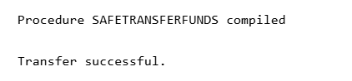

**Scenario 2:**

**Question:** Write a stored procedure **UpdateSalary** that increases the salary of an employee by a given percentage. If the employee ID does not exist, handle the exception and log an error message.

CREATE OR REPLACE PROCEDURE UpdateSalary (

  p_emp_id   IN NUMBER,

  p_percent  IN NUMBER

)

IS

BEGIN

  UPDATE Employees

  SET Salary = Salary + (Salary * p_percent / 100)

  WHERE EmployeeID = p_emp_id;

  IF SQL%ROWCOUNT = 0 THEN

    RAISE_APPLICATION_ERROR(-20002, 'Employee ID not found.');

  END IF;

  COMMIT;

  DBMS_OUTPUT.PUT_LINE('Salary updated.');

EXCEPTION

  WHEN OTHERS THEN

    ROLLBACK;

    DBMS_OUTPUT.PUT_LINE('Salary update failed: ' || SQLERRM);

END;

/

BEGIN

    UpdateSalary(1, 10);

END;

/

**Output**

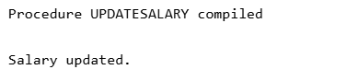

**Scenario 3:**

**Question:** Write a stored procedure **AddNewCustomer** that inserts a new customer into the Customers table. If a customer with the same ID already exists, handle the exception by logging an error and preventing the insertion.

CREATE OR REPLACE PROCEDURE AddNewCustomer (

  p_customer_id IN NUMBER,

  p_name        IN VARCHAR2,

  p_dob         IN DATE,

  p_balance     IN NUMBER

)

IS

BEGIN

  INSERT INTO Customers (CustomerID, Name, DOB, Balance, LastModified)

  VALUES (p_customer_id, p_name, p_dob, p_balance, SYSDATE);

  COMMIT;

  DBMS_OUTPUT.PUT_LINE('Customer added.');

EXCEPTION

  WHEN DUP_VAL_ON_INDEX THEN

    DBMS_OUTPUT.PUT_LINE('Customer ID already exists.');

  WHEN OTHERS THEN

    ROLLBACK;

    DBMS_OUTPUT.PUT_LINE('Add failed: ' || SQLERRM);

END;

/

BEGIN

    AddNewCustomer(3, 'Samuel Jackson', TO_DATE('1975-01-10','YYYY-MM-DD'), 4000);

    END;

    /

**Output**

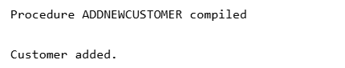

**Exercise 3: Stored Procedures**

CREATE TABLE Accounts (

    AccountID NUMBER PRIMARY KEY,

    CustomerID NUMBER,

    AccountType VARCHAR2(20),

    Balance NUMBER,

    LastModified DATE

);

CREATE TABLE Employees (

    EmployeeID NUMBER PRIMARY KEY,

    Name VARCHAR2(100),

    Position VARCHAR2(50),

    Salary NUMBER,

    Department VARCHAR2(50),

    HireDate DATE

);

INSERT INTO Accounts VALUES (1, 101, 'Savings', 10000, SYSDATE);

INSERT INTO Accounts VALUES (2, 101, 'Checking', 5000, SYSDATE);

INSERT INTO Accounts VALUES (3, 102, 'Savings', 15000, SYSDATE);

INSERT INTO Employees VALUES (1, 'Alice Johnson', 'Manager', 70000, 'HR', TO_DATE('2015-06-15', 'YYYY-MM-DD'));

INSERT INTO Employees VALUES (2, 'Bob Brown', 'Developer', 60000, 'IT', TO_DATE('2017-03-20', 'YYYY-MM-DD'));

COMMIT;

**Scenario 1:**

**Question:** Write a stored procedure **ProcessMonthlyInterest** that calculates and updates the balance of all savings accounts by applying an interest rate of 1% to the current balance.

SET SERVEROUTPUT ON;

CREATE OR REPLACE PROCEDURE ProcessMonthlyInterest

IS

BEGIN

  UPDATE Accounts

  SET Balance = Balance + (Balance * 0.01)

  WHERE AccountType = 'Savings';

  COMMIT;

  DBMS_OUTPUT.PUT_LINE('Monthly interest applied to all savings accounts.');

EXCEPTION

  WHEN OTHERS THEN

    ROLLBACK;

    DBMS_OUTPUT.PUT_LINE('Interest application failed: ' || SQLERRM);

END;

/

BEGIN

  ProcessMonthlyInterest;

END;

/

**Output**

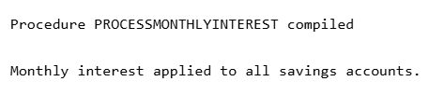

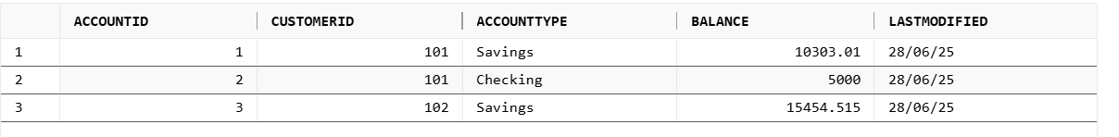

**Scenario 2:**

**Question:** Write a stored procedure **UpdateEmployeeBonus** that updates the salary of employees in a given department by adding a bonus percentage passed as a parameter.

CREATE OR REPLACE PROCEDURE UpdateEmployeeBonus (

  p_department IN VARCHAR2,

  p_bonus_percent IN NUMBER

)

IS

BEGIN

  UPDATE Employees

  SET Salary = Salary + (Salary * p_bonus_percent / 100)

  WHERE Department = p_department;

  IF SQL%ROWCOUNT = 0 THEN

    RAISE_APPLICATION_ERROR(-20002, 'No employees found in department: ' || p_department);

  END IF;

  COMMIT;

  DBMS_OUTPUT.PUT_LINE('✅ Bonus applied to department: ' || p_department);

EXCEPTION

  WHEN OTHERS THEN

    ROLLBACK;

    DBMS_OUTPUT.PUT_LINE('❌ Bonus update failed: ' || SQLERRM);

END;

/

BEGIN

  TransferFunds(1, 2, 3000);

END;

/

**Output**

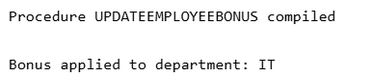



**Scenario 3:**

**Question:** Write a stored procedure **TransferFunds** that transfers a specified amount from one account to another, checking that the source account has sufficient balance before making the transfer.

CREATE OR REPLACE PROCEDURE TransferFunds (

  p_from_account IN NUMBER,

  p_to_account   IN NUMBER,

  p_amount       IN NUMBER

)

IS

  v_balance NUMBER;

BEGIN

  SELECT Balance INTO v_balance FROM Accounts WHERE AccountID = p_from_account FOR UPDATE;

IF v_balance < p_amount THEN

    RAISE_APPLICATION_ERROR(-20001, 'Insufficient funds in source account.');

  END IF;

  UPDATE Accounts SET Balance = Balance - p_amount WHERE AccountID = p_from_account;

  UPDATE Accounts SET Balance = Balance + p_amount WHERE AccountID = p_to_account;

COMMIT;

  DBMS_OUTPUT.PUT_LINE('✅ Funds transferred successfully.');

EXCEPTION

  WHEN OTHERS THEN

    ROLLBACK;

    DBMS_OUTPUT.PUT_LINE('❌ Fund transfer failed: ' || SQLERRM);

END;

/

BEGIN

  TransferFunds(1, 2, 3000);

END;

/

**Output**

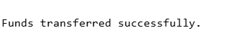

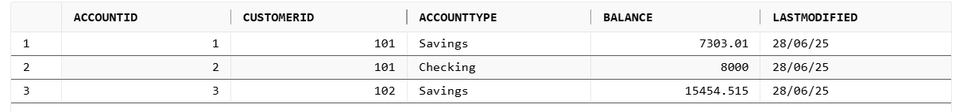

**Exercise 4: Functions**

CREATE TABLE Customers (

  CustomerID NUMBER PRIMARY KEY,

  Name VARCHAR2(100),

  DOB DATE

);

CREATE TABLE Accounts (

  AccountID NUMBER PRIMARY KEY,

  CustomerID NUMBER,

  Balance NUMBER,

  FOREIGN KEY (CustomerID) REFERENCES Customers(CustomerID)

);

INSERT INTO Customers VALUES (1, 'John Doe', TO_DATE('1980-05-10', 'YYYY-MM-DD'));

INSERT INTO Customers VALUES (2, 'Jane Smith', TO_DATE('2000-07-20', 'YYYY-MM-DD'));

INSERT INTO Accounts VALUES (1, 1, 8000);

INSERT INTO Accounts VALUES (2, 2, 4000);

COMMIT;

**Scenario 1:**

**Question:** Write a function CalculateAge that takes a customer's date of birth as input and returns their age in years.

CREATE OR REPLACE FUNCTION CalculateAge (p_dob DATE)

RETURN NUMBER

IS

  v_age NUMBER;

BEGIN

  v_age := TRUNC(MONTHS_BETWEEN(SYSDATE, p_dob) / 12);

  RETURN v_age;

END;

/DECLARE

  v_age NUMBER;

BEGIN

  v_age := CalculateAge(TO_DATE('1980-05-10', 'YYYY-MM-DD'));

  DBMS_OUTPUT.PUT_LINE('Age: ' || v_age);

END;

/

**Output**

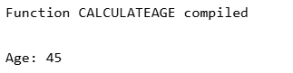

**Scenario 2:**

**Question:** Write a function **CalculateMonthlyInstallment** that takes the loan amount, interest rate, and loan duration in years as input and returns the monthly installment amount.

CREATE OR REPLACE FUNCTION CalculateMonthlyInstallment (

  p_loan_amount NUMBER,

  p_annual_rate NUMBER,

  p_years NUMBER

)

RETURN NUMBER

IS

  v_monthly_rate NUMBER := p_annual_rate / 12 / 100;

  v_months NUMBER := p_years * 12;

  v_emi NUMBER;

BEGIN

  IF v_monthly_rate = 0 THEN

    v_emi := p_loan_amount / v_months;

  ELSE

    v_emi := p_loan_amount * v_monthly_rate * POWER(1 + v_monthly_rate, v_months) /

             (POWER(1 + v_monthly_rate, v_months) - 1);

  END IF;

  RETURN ROUND(v_emi, 2);

END;

/

DECLARE

  v_emi NUMBER;

BEGIN

  v_emi := CalculateMonthlyInstallment(100000, 10, 5); -- ₹100,000, 10% annual, 5 years

  DBMS_OUTPUT.PUT_LINE('Monthly EMI: ₹' || v_emi);

END;

/

**Output**

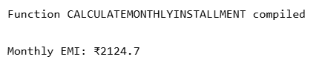

**Scenario 3:**

**Question:** Write a function **HasSufficientBalance** that takes an account ID and an amount as input and returns a boolean indicating whether the account has at least the specified amount.

CREATE OR REPLACE FUNCTION HasSufficientBalance (

  p_account_id NUMBER,

  p_amount NUMBER

)

RETURN BOOLEAN

IS

  v_balance NUMBER;

BEGIN

  SELECT Balance INTO v_balance FROM Accounts WHERE AccountID = p_account_id;

  RETURN v_balance >= p_amount;

EXCEPTION

  WHEN NO_DATA_FOUND THEN

    RETURN FALSE;

END;

/

DECLARE

  v_result BOOLEAN;

BEGIN

  v_result := HasSufficientBalance(1, 5000);

  IF v_result THEN

    DBMS_OUTPUT.PUT_LINE('Account 1 has sufficient balance.');

  ELSE

    DBMS_OUTPUT.PUT_LINE('Account 1 does NOT have sufficient balance.');

  END IF;

END;

/

**Output**

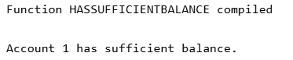

**Exercise 5: Triggers**

CREATE TABLE Customers (

  CustomerID NUMBER PRIMARY KEY,

  Name VARCHAR2(100),

  DOB DATE,

  Balance NUMBER,

  LastModified DATE

);

CREATE TABLE Accounts (

  AccountID NUMBER PRIMARY KEY,

  CustomerID NUMBER,

  AccountType VARCHAR2(20),

  Balance NUMBER,

  LastModified DATE,

  FOREIGN KEY (CustomerID) REFERENCES Customers(CustomerID)

);

CREATE TABLE Transactions (

  TransactionID NUMBER PRIMARY KEY,

  AccountID NUMBER,

  TransactionDate DATE,

  Amount NUMBER,

  TransactionType VARCHAR2(10), -- Deposit or Withdrawal

  FOREIGN KEY (AccountID) REFERENCES Accounts(AccountID)

);

CREATE TABLE AuditLog (

  LogID NUMBER GENERATED ALWAYS AS IDENTITY PRIMARY KEY,

  TransactionID NUMBER,

  ActionType VARCHAR2(50),

  LogDate DATE

);

INSERT INTO Customers VALUES (1, 'John Doe', TO_DATE('1980-05-10', 'YYYY-MM-DD'), 1000, SYSDATE);

INSERT INTO Accounts VALUES (1, 1, 'Savings', 1000, SYSDATE);

COMMIT;

**Scenario 1:**

**Question:** Write a trigger **UpdateCustomerLastModified** that updates the LastModified column of the Customers table to the current date whenever a customer's record is updated.

CREATE OR REPLACE TRIGGER UpdateCustomerLastModified

BEFORE UPDATE ON Customers

FOR EACH ROW

BEGIN

  :NEW.LastModified := SYSDATE;

END;

/

UPDATE Customers SET Balance = 1500 WHERE CustomerID = 1;



**Scenario 2:**

**Question:** Write a trigger **LogTransaction** that inserts a record into an AuditLog table whenever a transaction is inserted into the Transactions table.

CREATE OR REPLACE TRIGGER LogTransaction

AFTER INSERT ON Transactions

FOR EACH ROW

BEGIN

  INSERT INTO AuditLog (TransactionID, ActionType, LogDate)

  VALUES (:NEW.TransactionID, 'INSERT', SYSDATE);

END;

/

INSERT INTO Transactions (TransactionID, AccountID, TransactionDate, Amount, TransactionType)

VALUES (1, 1, SYSDATE, 500, 'Deposit');

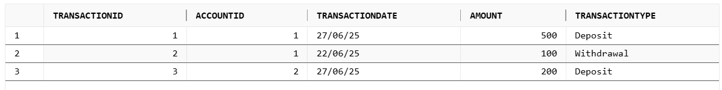

**Scenario 3:**

**Question:** Write a trigger **CheckTransactionRules** that ensures withdrawals do not exceed the balance and deposits are positive before inserting a record into the Transactions table.

CREATE OR REPLACE TRIGGER CheckTransactionRules

BEFORE INSERT ON Transactions

FOR EACH ROW

DECLARE

  v_balance NUMBER;

BEGIN

  SELECT Balance INTO v_balance FROM Accounts WHERE AccountID = :NEW.AccountID;

  IF :NEW.TransactionType = 'Withdrawal' AND :NEW.Amount > v_balance THEN

    RAISE_APPLICATION_ERROR(-20001, 'Withdrawal amount exceeds balance.');

  ELSIF :NEW.TransactionType = 'Deposit' AND :NEW.Amount <= 0 THEN

    RAISE_APPLICATION_ERROR(-20002, 'Deposit amount must be positive.');

  END IF;

END;

/

BEGIN

  INSERT INTO Transactions (TransactionID, AccountID, TransactionDate, Amount, TransactionType)

  VALUES (2, 1, SYSDATE, 10000, 'Withdrawal');

EXCEPTION

  WHEN OTHERS THEN

    DBMS_OUTPUT.PUT_LINE('Expected failure: ' || SQLERRM);

END;

/

**Output**

**Exercise 6: Cursors**

**Scenario 1:**

**Question:** Write a PL/SQL block using an explicit cursor **GenerateMonthlyStatements** that retrieves all transactions for the current month and prints a statement for each customer.

DECLARE

  CURSOR txn_cursor IS

    SELECT c.Name, t.TransactionDate, t.Amount, t.TransactionType

    FROM Transactions t

    JOIN Accounts a ON t.AccountID = a.AccountID

    JOIN Customers c ON a.CustomerID = c.CustomerID

    WHERE TRUNC(t.TransactionDate, 'MM') = TRUNC(SYSDATE, 'MM');

  v_name Customers.Name%TYPE;

  v_date DATE;

  v_amount NUMBER;

  v_type VARCHAR2(10);

DBMS_OUTPUT.PUT_LINE('Monthly Statement - Transactions');

  FOR txn IN txn_cursor LOOP

    DBMS_OUTPUT.PUT_LINE(txn.Name || ' | ' ||TO_CHAR(txn.TransactionDate, 'DD-Mon-YYYY') || ' | ' ||

                         txn.TransactionType || ' | ₹' || txn.Amount);

  END LOOP;

COMMIT;

END;

/

**Output**

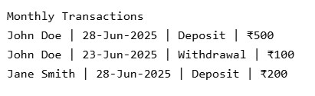

**Scenario 2:**

**Question:** Write a PL/SQL block using an explicit cursor **ApplyAnnualFee** that deducts an annual maintenance fee from the balance of all accounts.

DECLARE

CURSOR acc_cursor IS

SELECT AccountID, Balance FROM Accounts

v_fee NUMBER := 100;

BEGIN

DBMS_OUTPUT.PUT_LINE('Annual Maintenance Fee Deduction');

    FOR acc IN acc_cursor LOOP

    IF acc.Balance >= v_fee THEN

      UPDATE Accounts

      SET Balance = Balance - v_fee,

          LastModified = SYSDATE

      WHERE AccountID = acc.AccountID;

DBMS_OUTPUT.PUT_LINE('Fee applied to Account ID: ' || acc.AccountID);

    ELSE

      DBMS_OUTPUT.PUT_LINE('Skipped (Low Balance): Account ID: ' || acc.AccountID);

    END IF;

  END LOOP;

COMMIT;

END;

/

**Output**

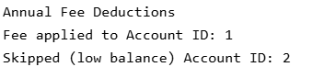

**Scenario 3:**

**Question:** Write a PL/SQL block using an explicit cursor **UpdateLoanInterestRates** that fetches all loans and updates their interest rates based on the new policy.

DECLARE

CURSOR loan_cursor IS

    SELECT LoanID, InterestRate FROM Loans;

  v_new_rate NUMBER;

BEGIN

  DBMS_OUTPUT.PUT_LINE('Loan Interest Rate Adjustment');

    FOR l IN loan_cursor LOOP

    IF l.InterestRate > 6 THEN

      v_new_rate := l.InterestRate - 0.5;

    ELSE

      v_new_rate := l.InterestRate;

    END IF;

    UPDATE Loans

    SET InterestRate = v_new_rate

    WHERE LoanID = l.LoanID;

    DBMS_OUTPUT.PUT_LINE('Loan ID ' || l.LoanID || ' new rate: ' || v_new_rate || '%');

  END LOOP;

  COMMIT;

END;

/

**Output**

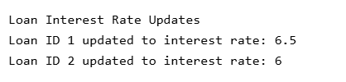

**Exercise 7: Packages**

**Scenario 1:**

**Question:** Create a package **CustomerManagement** with procedures for adding a new customer, updating customer details, and a function to get customer balance.

CREATE OR REPLACE PACKAGE CustomerManagement AS

  PROCEDURE AddCustomer(p_id NUMBER, p_name VARCHAR2, p_dob DATE, p_balance NUMBER);

  PROCEDURE UpdateCustomer(p_id NUMBER, p_name VARCHAR2, p_balance NUMBER);

  FUNCTION GetCustomerBalance(p_id NUMBER) RETURN NUMBER;

END CustomerManagement;

/

CREATE OR REPLACE PACKAGE BODY CustomerManagement AS

  PROCEDURE AddCustomer(p_id NUMBER, p_name VARCHAR2, p_dob DATE, p_balance NUMBER) IS

  BEGIN

    INSERT INTO Customers VALUES (p_id, p_name, p_dob, p_balance, SYSDATE);

DBMS_OUTPUT.PUT_LINE('Customer added.');

EXCEPTION

    WHEN DUP_VAL_ON_INDEX THEN

      DBMS_OUTPUT.PUT_LINE('Customer already exists.');

  END;

  PROCEDURE UpdateCustomer(p_id NUMBER, p_name VARCHAR2, p_balance NUMBER) IS

  BEGIN

    UPDATE Customers

    SET Name = p_name,

        Balance = p_balance,

        LastModified = SYSDATE

    WHERE CustomerID = p_id;

    DBMS_OUTPUT.PUT_LINE('Customer updated.');

  END;

  FUNCTION GetCustomerBalance(p_id NUMBER) RETURN NUMBER IS

    v_balance NUMBER;

  BEGIN

    SELECT Balance INTO v_balance FROM Customers WHERE CustomerID = p_id;

    RETURN v_balance;

  EXCEPTION

    WHEN NO_DATA_FOUND THEN

      RETURN -1;

  END;

END CustomerManagement;

/

SET SERVEROUTPUT ON;

BEGIN

  CustomerManagement.AddCustomer(2, 'Mary Jane', TO_DATE('1990-02-15','YYYY-MM-DD'), 3000);

  DBMS_OUTPUT.PUT_LINE('Balance: ' || CustomerManagement.GetCustomerBalance(2));

END

/

**Output**



**Scenario 2:**

**Question:** Write a package **EmployeeManagement** with procedures to hire new employees, update employee details, and a function to calculate annual salary.

CREATE OR REPLACE PACKAGE EmployeeManagement AS

  PROCEDURE HireEmployee(p_id NUMBER, p_name VARCHAR2, p_pos VARCHAR2, p_salary NUMBER, p_dept VARCHAR2);

  PROCEDURE UpdateEmployee(p_id NUMBER, p_salary NUMBER);

  FUNCTION GetAnnualSalary(p_id NUMBER) RETURN NUMBER;

END EmployeeManagement;

/

CREATE OR REPLACE PACKAGE BODY EmployeeManagement AS

  PROCEDURE HireEmployee(p_id NUMBER, p_name VARCHAR2, p_pos VARCHAR2, p_salary NUMBER, p_dept VARCHAR2) IS

  BEGIN

    INSERT INTO Employees VALUES (p_id, p_name, p_pos, p_salary, p_dept, SYSDATE);

    DBMS_OUTPUT.PUT_LINE('Employee hired.');

  EXCEPTION

    WHEN DUP_VAL_ON_INDEX THEN

      DBMS_OUTPUT.PUT_LINE('Employee already exists.');

  END;

  PROCEDURE UpdateEmployee(p_id NUMBER, p_salary NUMBER) IS

  BEGIN

    UPDATE Employees SET Salary = p_salary WHERE EmployeeID = p_id;

    DBMS_OUTPUT.PUT_LINE('Salary updated.');

  END;

  FUNCTION GetAnnualSalary(p_id NUMBER) RETURN NUMBER IS

    v_salary NUMBER;

  BEGIN

    SELECT Salary INTO v_salary FROM Employees WHERE EmployeeID = p_id;

    RETURN v_salary * 12;

  EXCEPTION

    WHEN NO_DATA_FOUND THEN

      RETURN -1;

  END;

END EmployeeManagement;

/

SET SERVEROUTPUT ON;

BEGIN

EmployeeManagement.HireEmployee(2, 'Bob', 'Developer', 50000, 'IT');

  DBMS_OUTPUT.PUT_LINE('Annual Salary: ' || EmployeeManagement.GetAnnualSalary(2));

END

/

**Output**



**Scenario 3:**

**Question:** Create a package **AccountOperations** with procedures for opening a new account, closing an account, and a function to get the total balance of a customer across all accounts.

CREATE OR REPLACE PACKAGE AccountOperations AS

  PROCEDURE OpenAccount(p_id NUMBER, p_cust_id NUMBER, p_type VARCHAR2, p_balance NUMBER);

  PROCEDURE CloseAccount(p_id NUMBER);

  FUNCTION GetTotalBalance(p_cust_id NUMBER) RETURN NUMBER;

END AccountOperations;

/

CREATE OR REPLACE PACKAGE BODY AccountOperations AS

  PROCEDURE OpenAccount(p_id NUMBER, p_cust_id NUMBER, p_type VARCHAR2, p_balance NUMBER) IS

  BEGIN

    INSERT INTO Accounts VALUES (p_id, p_cust_id, p_type, p_balance, SYSDATE);

    DBMS_OUTPUT.PUT_LINE('Account opened.');

  EXCEPTION

    WHEN DUP_VAL_ON_INDEX THEN

      DBMS_OUTPUT.PUT_LINE('Account already exists.');

  END;

  PROCEDURE CloseAccount(p_id NUMBER) IS

  BEGIN

    DELETE FROM Accounts WHERE AccountID = p_id;

    DBMS_OUTPUT.PUT_LINE('Account closed.');

  END;

  FUNCTION GetTotalBalance(p_cust_id NUMBER) RETURN NUMBER IS

    v_total NUMBER := 0;

  BEGIN

    SELECT SUM(Balance) INTO v_total FROM Accounts WHERE CustomerID = p_cust_id;

    RETURN NVL(v_total, 0);

  END;

END AccountOperations;

/

SET SERVEROUTPUT ON;

BEGIN

AccountOperations.OpenAccount(2, 2, 'Checking', 2000);

  DBMS_OUTPUT.PUT_LINE('Total Balance for Customer 2: ' || AccountOperations.GetTotalBalance(2));

END;

/

**Output**

