**Hands On 1: Securing RESTful Web Services with Spring Security**

**CountryController.java**

package com.example.demo.controller;  
  
import org.springframework.web.bind.annotation.GetMapping;  
import org.springframework.web.bind.annotation.RestController;  
  
import java.util.ArrayList;  
import java.util.List;  
import java.util.Map;  
  
@RestController  
public class CountryController {  
  
 @GetMapping("/countries")  
 public List<Map<String, String>> getCountries() {  
 List<Map<String, String>> countries = new ArrayList<>();  
 countries.add(Map.*of*("code", "US", "name", "United States"));  
 countries.add(Map.*of*("code", "DE", "name", "Germany"));  
 countries.add(Map.*of*("code", "IN", "name", "India"));return countries;  
 }  
**}**

**DemoApplication.java**

package com.example.demo;  
  
import org.springframework.boot.SpringApplication;  
import org.springframework.boot.autoconfigure.SpringBootApplication;  
  
@SpringBootApplication  
public class DemoApplication {  
  
 public static void main(String[] args) {  
 SpringApplication.*run*(DemoApplication.class, args);  
 }  
  
}

**Output Without Authorization**

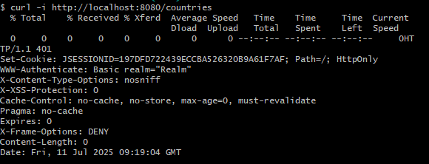

**Output With Authorization**