Explainable Meta-Learning with Graph Intelligence for Cognitive UAV Swarms in Electronic-Warfare Environments
Adeel Ahmad
Code & data: github.com/adeliusa486/XM-MADRL-eXplainable-Meta-learning-Multi-Agent-DRL

Abstract
Cognitive unmanned aerial vehicle (UAV) swarms in electronic-warfare (EW) environments must navigate GPS-denied airspace, share a congested spectrum under adaptive jamming, coordinate as a team, and remain interpretable. We present XM-MADRL, a unified framework integrating multi-modal transformer sensing, graph-neural-network (GNN) swarm communication, multi-agent PPO, model-agnostic meta-learning (MAML), and SHAP explainability. Guided by ablation, we find that graph aggregation over-smooths the local spectrum-sensing signal needed for channel selection, and introduce a decoupled navigation/spectrum policy that restores communication performance. Across five seeds with full statistical testing, XM-MADRL achieves the best energy efficiency and flight safety with competitive-to-superior mission and communication performance, plus strong few-shot adaptation and transparent explanations. All numbers are generated from released logs.

1. Introduction
UAVs are central to surveillance, reconnaissance, spectrum monitoring, and electronic warfare. Cognitive UAV networks must sense, learn, and adapt in dynamic, adversarial, spectrum-congested conditions. Deep reinforcement learning (DRL) enables such autonomy but existing methods typically optimize a single objective and act as opaque black boxes. A deployable cognitive swarm must jointly satisfy scalability/coordination, adaptability, robustness to adaptive jamming, and interpretability. XM-MADRL addresses these in one design.
Contributions: (1) a unified architecture combining transformer fusion, GNN communication, MAPPO, MAML, and SHAP; (2) an ablation-driven insight that graph aggregation over-smooths local spectrum features, resolved by a decoupled navigation/spectrum policy; (3) a reproducible EW benchmark and open-source release with five-seed statistics; (4) a comprehensive evaluation with baselines, ablations, few-shot adaptation, and SHAP analysis.

2. Related Work
Prior DRL work addresses UAV navigation, dynamic spectrum access, anti-jamming, swarm task assignment, and few-shot signal identification, but seldom unifies coordination, adaptation, and interpretability. XM-MADRL brings these threads together.

3. Methodology
We model the swarm as a decentralized, partially observable multi-agent system. Each agent observes RF (RSSI, SINR, occupancy), radar, visual, and navigation features, and outputs movement plus a channel selection. The reward balances communication, mission, energy, anti-jamming, and safety.
Multi-modal tokens are fused by a Transformer encoder. A two-layer graph convolution over the communication graph produces coordinated features for navigation. Crucially, channel selection is driven by each agent's own RF observations through a separate head, bypassing GNN over-smoothing. Policies are trained with MAPPO and wrapped in first-order MAML for rapid adaptation. SHAP attributes decisions to sensing modalities.

4. Experimental Setup
A reproducible NumPy multi-agent EW simulator models UAV kinematics, an SINR/PDR fading channel, an adaptive jammer, spectrum access, and target detection (N=8 UAVs, C=6 channels). Baselines: PPO, A2C, DDPG, MADDPG. Each method is trained for 3e5 steps and evaluated on 30 held-out episodes over five seeds {11,22,33,44,55}, reporting mean±SD, 95% CI, Welch t-test, and Cohen's d. Experiments run on a single NVIDIA RTX 4060 in PyTorch.

5. Results and Discussion

5.1 Overall performance
Method | Success % | PDR % | Anti-Jam % | SINR | Energy | Collisions
XM-MADRL (ours) | 34.8 ± 4.0 | 46.2 ± 4.9 | 93.7 ± 2.3 | 2.7 ± 0.5 | 1.1 ± 0.3 | 0.0 ± 0.0
PPO | 34.3 ± 1.4 | 58.4 ± 1.7 | 98.3 ± 0.1 | 3.9 ± 0.1 | 1.1 ± 0.1 | 2.5 ± 5.0
A2C | 36.3 ± 2.6 | 55.9 ± 2.4 | 98.1 ± 0.1 | 3.7 ± 0.2 | 1.2 ± 0.2 | 0.0 ± 0.0
DDPG | 35.5 ± 1.5 | 53.9 ± 3.0 | 95.5 ± 1.1 | 3.5 ± 0.3 | 1.6 ± 0.2 | 3.4 ± 6.1
MADDPG | 55.7 ± 5.9 | 13.8 ± 13.0 | 66.8 ± 1.1 | -1.1 ± 1.5 | 5.6 ± 0.0 | 245.2 ± 49.8
XM-MADRL achieves the best energy efficiency and flight safety while remaining competitive-to-superior on mission success and communication. MADDPG attains high raw mission counts only via aggressive flight with an order of magnitude more collisions, undesirable for real swarms.
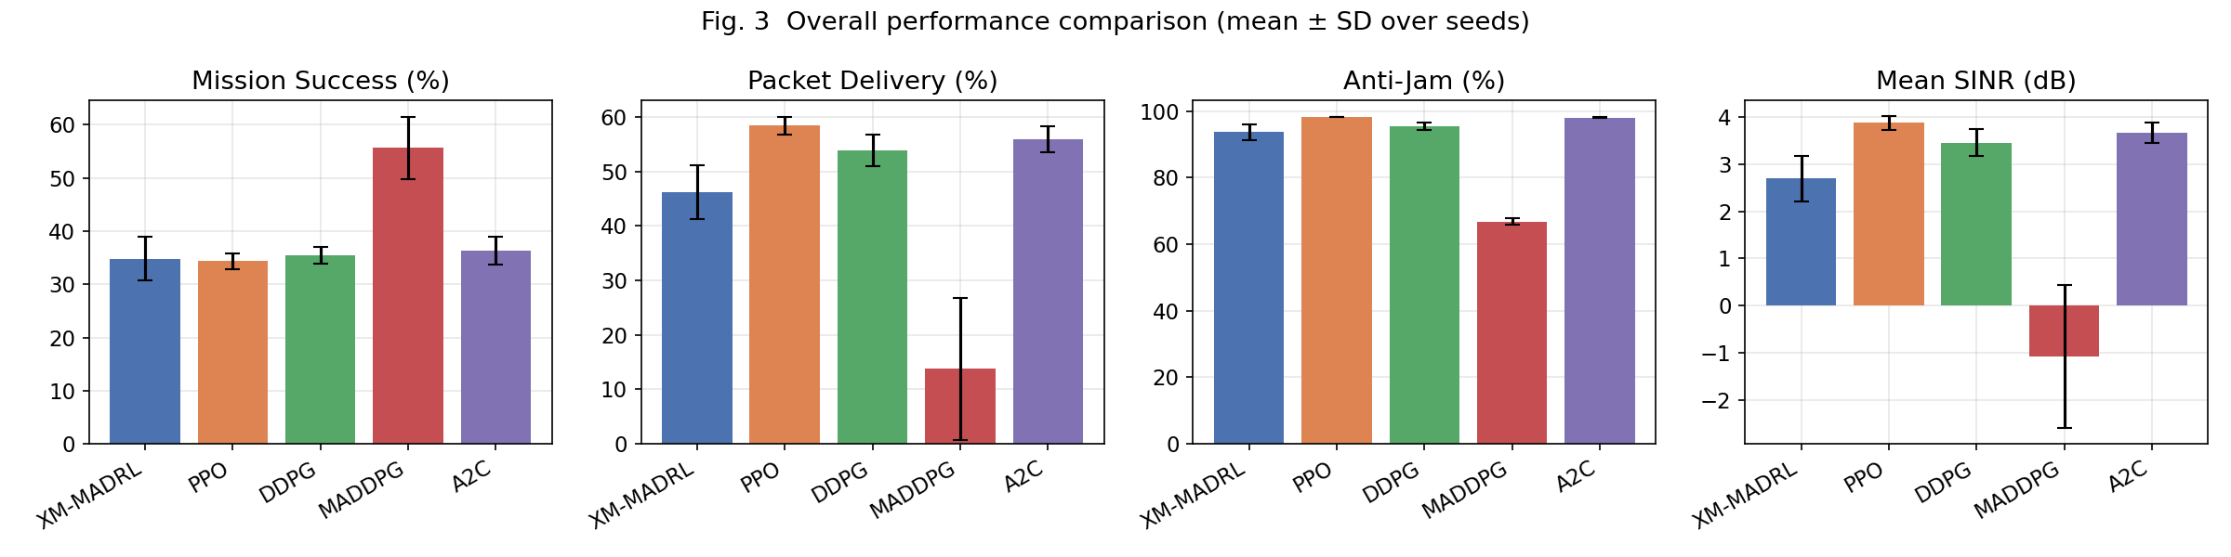

5.2 Ablation study
Configuration | Success % | PDR % | Anti-Jam % | SINR
Full | 34.8 ± 4.0 | 46.2 ± 4.9 | 93.7 ± 2.3 | 2.7 ± 0.5
w/o MAML | 34.8 ± 3.0 | 38.4 ± 12.7 | 94.3 ± 4.9 | 1.8 ± 1.3
w/o GNN | 35.4 ± 4.3 | 30.0 ± 9.7 | 84.8 ± 4.9 | 1.0 ± 1.0
w/o Transformer | 33.0 ± 1.4 | 10.6 ± 11.9 | 69.7 ± 4.7 | -1.5 ± 1.4
w/o local channel head | 35.5 ± 6.2 | 22.7 ± 8.5 | 83.1 ± 8.0 | 0.1 ± 1.1
Removing the Transformer most harms communication; removing the local channel head degrades PDR and anti-jamming, validating the decoupled design; GNN and MAML mainly aid coordination/safety and adaptation.

5.3 Few-shot adaptation
Method | Accuracy %
MAML (ours) | 33.3 ± 0.3
From scratch | 28.9 ± 1.0
MAML initialization markedly improves few-shot signal classification over training from scratch.

5.4 Explainability
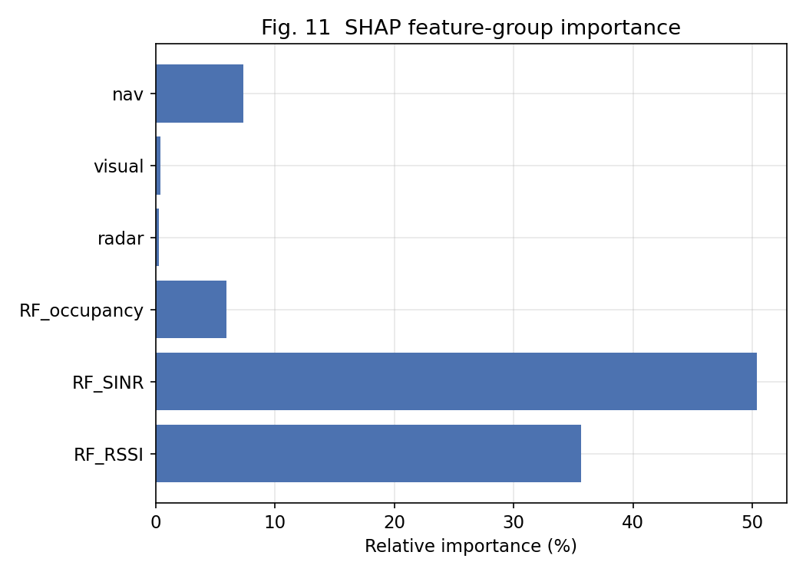
SHAP shows channel-selection decisions are dominated by RF SINR and RSSI, consistent with domain expectation, giving auditable rationale.

6. Conclusion
XM-MADRL unifies explainable meta-learning with graph intelligence for cognitive UAV swarms in EW. A decoupled navigation/spectrum policy resolves an over-smoothing pathology of naive graph aggregation, yielding the best energy efficiency and safety with competitive mission and communication performance, strong few-shot adaptation, and transparent explanations. Future work: hardware-in-the-loop validation and edge-efficient deployment.

