Special topics: Philosophy of Visual Media

Matthew X. Curinga

**Educational Technology 0858-723, Cycle 2 2013**

**Keywords:** visual culture, media studies, multimedia

**Description:** This course focuses on the philosophy of visual media, with a pragmatic approach to understanding visual culture in our society: schools, youth media, mass media, etc. Students study theories of visuality and multimodal semiotics. They write philosophical critiques of current media, and develop original media projects informed by course readings.

**Cylce 2:** Nov. 1 — Jan. 12

**Class meetings:** Online

**Instructor**

* [Matthew X. Curinga](http://matt.curinga.com), [mcuringa@adelphi.edu](mailto:mcuringa@adelphi.edu)
* [Post Annex, Room 1](http://goo.gl/maps/XReYB)

## Goals and Objectives

The course provides students with a broad historical perspective of the philosophical positions on the role of technology in society. In addition to understanding how technology is used, students should also be aware of how it changes our relation to mind, perception, reality and society.

By the end of the course, students should be able to:

1. Understand major topics in philosophy of technology
2. Apply a philosophical lens to critique current and emerging technologies
3. Compare and contrast different philosophical traditions and synthesize them to make coherent arguments and assess the role of technology in society
4. Understand various positions (e.g. feminist, anti-technology, post-colonial) and why they are relevant to the development and use of educational technology

**Dr. Curinga Office Hours**

* Tuesday, 4:30-6:30PM
* Wednesday, 3-5PM
* Thursday, 3-5PM

## Required Books

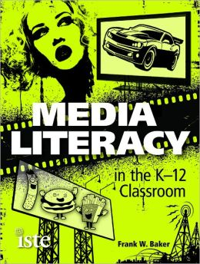 Baker, F. W. (2012). *Media literacy in the K-12 classroom (1st ed.)*. Eugene, Or: International Society for Technology in Education. ISBN 9781564843074 [powells](http://www.powells.com/biblio/61-9781564843074-0) [b&n](http://www.barnesandnoble.com/w/media-literacy-in-the-k-12-classroom-frank-w-baker/1104160405) [amz](http://www.amazon.com/Media-Literacy-Classroom-Frank-Baker/dp/1564843076/)

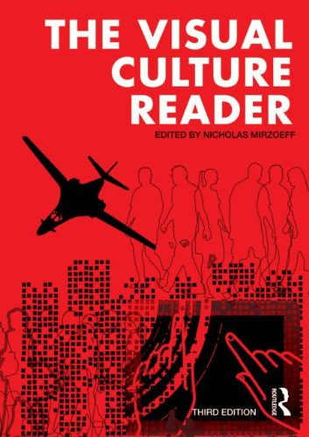 Mirzoeff, N. (Ed.). (2013). *The visual culture reader (3rd ed.)*. London ; New York: Routledge. ISBN 9780415620550 [amz](http://www.amazon.com/Visual-Culture-Reader-Nicholas-Mirzoeff/dp/0415782627/) [b&n](http://www.barnesandnoble.com/w/visual-culture-reader-nicholas-mirzoeff/1100170490) [powells](http://www.powells.com/biblio/9780415782623)

## Course Format

This is an online cycle course, which will be primarily conducted using the course Moodle site. **Students are required** to check Moodle and class email at least once a day during the Cycle 2 dates. The course will operate on a Friday-Friday schedule, all work due for a given week *must* be completed by end of day on Friday of that week.

As this is a Cylce course, it will be faster paced and more condensed than a traditional 15-week semester course. Students *must* budget their time accordingly. Generally, the expectation is that students will spend the following amount of time for each week of the course:

* 4 hours: instruction
* reading instructor posts
* watching instructor video
* posting/commenting on online forums
* uploading video/audio comments
* 4 hours: reading, this is a theorertical course and we will engage closely with the literature
* 3 hours: writing and media production

Technical competencies for participation in an online course:

* advanced use of Moodle including, uploading files, posting and commenting on discussion forums, completing online timed assessments, etc.
* use of Adelphi domain Google Docs/Google Drive
* sharing documents with classmates
* using Google Doc comment feature
* tracking revision history through Google docs
* access to a computer with a video camera and microphone
* ability to use Skype and Google Hangout for video calls

## Class meetings

|  |  |  |  |
| --- | --- | --- | --- |
| Week | Date | Topic | Due |
| 1 | Fri, Nov 1, 13 | Intro to visuality |  |
| 2 | Fri, Nov 8, 13 | Violence | Media Pitch |
| 3 | Fri, Nov 15, 13 | Violence | Media Sketches |
| 4 | Fri, Nov 22, 13 | Identity: sexuality | Media Prototype |
| 5 | Fri, Nov 29, 13 | Identity: ethnicity | Prototype Comments |
| 6 | Fri, Dec 6, 13 | Markets | Ed. Media |
| 7 | Fri, Dec 13, 13 | Desire and consumption | Critique Topic |
| 8 | Fri, Dec 20, 13 | Power/Politics | Critique Outline |
| 9 | Fri, Dec 27, 13 | Politics & Aesthetics | Critique Draft |
| 10 | Fri, Jan 3, 14 | Writing workshop | Draft Comments |
| 11 | Fri, Jan 10, 14 | Media Critique | Final Essay |

## Assignments and Grading

### Educational Media Studio (50%)

Working from a visuality and media literacy perspective, students will develop a substantial educational media project with explicit instructional value. Students will choose their own audience for this work: both the target age and ability level, as well as the domain and content for instruction.

Regardless of the content, the work *must* pay explicit attention to the aesthetic and semantic content of the work, beyond the instructional value.

Acceptable media for this project include:

* original digital or analog games for learning
* websites, web applications, or mobile (web) apps
* interactive SMARTBoard lessons
* original instructional video or audio (video can be animated, live action, screencasts, or a combination)

Along with the educational media, each student will turn in a ~300 word reflection where they indicate the goals of their project in terms of visual culture and media literacy, and discuss their successes and difficulties in meeting these goals.

The media project will be evaluated in each of the following criteria, with a possible 10 points available for each area of evaluation:

1. *Aesthetics*: is the the work visually appealing? does it use visual metaphors and “visuality” to make it more powerful and appealing? does the author carefully use color and composition?
2. *Learning sciences*: in what ways does the author draw on the best practices for how people learn and how people learn from visual media?
3. *Curriculum*: how does the project meet the stated curricular goals? does it address an important learning goal for the target audience? does the scale of the media match the learning goals? i.e., does the media focus on the most important or most challening apsects to teach?
4. *Technqique*: how well does the author demonstrate his/her facility with the given media? for example, do SMARTBoard lessons take advantage of the diverse tools available in the Notebook software? are digital images cropped and scaled “cleanly”? does the author demonstrate the ability to compose text and images?
5. *Reflection*: does the reflective paper clearly state the goals for the project? does the author clearly articulate the reasons for the choices in the project?

### Visuality in Educational Media or Youth Media (50%)

Students will choose a work of educational media and write a critique based on the course readings. The essay should connect to the visuality of course themes, as they are represented in the media being studied. Themes include:

* media and violence
* bodies and difference
* visuality of power, coloniality, and empire
* markets, attention, and visual media
* mediation

Specifically, this paper should draw from at least four different essays from the *The visual culture reader* as well as *Media literacy in the K-12 classroom*.

Suitable media:

* illustrated text books
* illustrated children’s literature
* “multimedia” textbooks (such as iBooks)
* youth magazines
* video games (educational or otherwise)
* children’s/youth television or films (e.g. PBS, Nickelodian)
* educational “apps” or websites
* educational video or documentaries
* SMARTBoard lessons

This assignment must be between 4,000 and 5,000 words, and be written following the style and citation format of the APA.

**Assessment criteria:**

argument

does the author state a clear proposition? is the argument supported with relevant examples and references to scholarship? is the topic explored with depth and rigor?

style

is the paper clear and straightforward? is it organized in a way that engages the reader? does sections flow together and build towards a cohesive essay? is the manuscript properly prepared according to the scholarly standards of the APA?

relevance

what is at stake in this paper? does the essay engage with current and important themes in the field of visual studies? with the pragmatic approach of this course inm mind, does the author adequately connect the scholarly themes of the paper with the lived experience of people in the world?