

Functional Safety Concept Lane Assistance

**Document Version: 2.0**

**Template Version 1.0, Released on 2017-06-21**



# Document history

**[Instructions: Fill in the date, version and description fields. You can fill out the Editor field with your name if you want to do so. Keep track of your editing as if this were a real world project.**

**For example, if this were your first draft or first submission, you might say version 1.0. If this is a second submission attempt, then you'd add a second line with a new date and version 2.0]**

|  |  |  |  |
| --- | --- | --- | --- |
| Date | Version | Editor | Description |
| 11/12/2017 | 1.0 | Sam Adelman | Started working on module |
| 11/26/2017 | 2.0 | Sam Adelman | Added information from lessons |
|  |  |  |  |
|  |  |  |  |
|  |  |  |  |

# Table of Contents

**[Instructions: We have provided a table of contents. If you change the document structure, please update the table of contents accordingly. The table of contents should show each section of the document and page numbers or links. Most word processors can do this for you. In** [**Google Docs**](https://support.google.com/docs/answer/116338?co=GENIE.Platform%3DDesktop&hl=en)**, you can use headings for each section and then go to Insert > Table of Contents.** [**Microsoft Word**](https://support.microsoft.com/en-us/help/285059/how-to-create-a-table-of-contents-by-marking-text-in-word) **has similar capabilities]**

[Document history](#_1t3h5sf)

[Table of Contents](#_ktt3lgighckp)

[Purpose of the Functional Safety Concept](#_fulgh8sf1ocg)

[Inputs to the Functional Safety Analysis](#_757cx6xm46zb)

[Safety goals from the Hazard Analysis and Risk Assessment](#_pi1c1upmo8jt)

[Preliminary Architecture](#_s0p6ihti6jgk)

[Description of architecture elements](#_cqb49updinx4)

[Functional Safety Concept](#_mx8us8onanqo)

[Functional Safety Analysis](#_mtn6qbhgsr36)

[Functional Safety Requirements](#_frlc9y84ede8)

[Refinement of the System Architecture](#_74udkdvf7nod)

[Allocation of Functional Safety Requirements to Architecture Elements](#_g2lqf7kmbspk)

[Warning and Degradation Concept](#_4w6r8buy4lrp)

# Purpose of the Functional Safety Concept

**[Instructions: Answer what is the purpose of a functional safety concept?]**

# Inputs to the Functional Safety Concept

## Safety goals from the Hazard Analysis and Risk Assessment

|  |  |
| --- | --- |
| **ID** | **Safety Goal** |
| Safety\_Goal\_01 | The oscillating steering torque from the lane departure warning function shall be limited |
| Safety\_Goal\_02 | The lane keeping assistance function shall be time limited and the additional steering torque shall end after a given time interval so that the driver cannot misuse the system for autonomous driving |

## Preliminary Architecture

**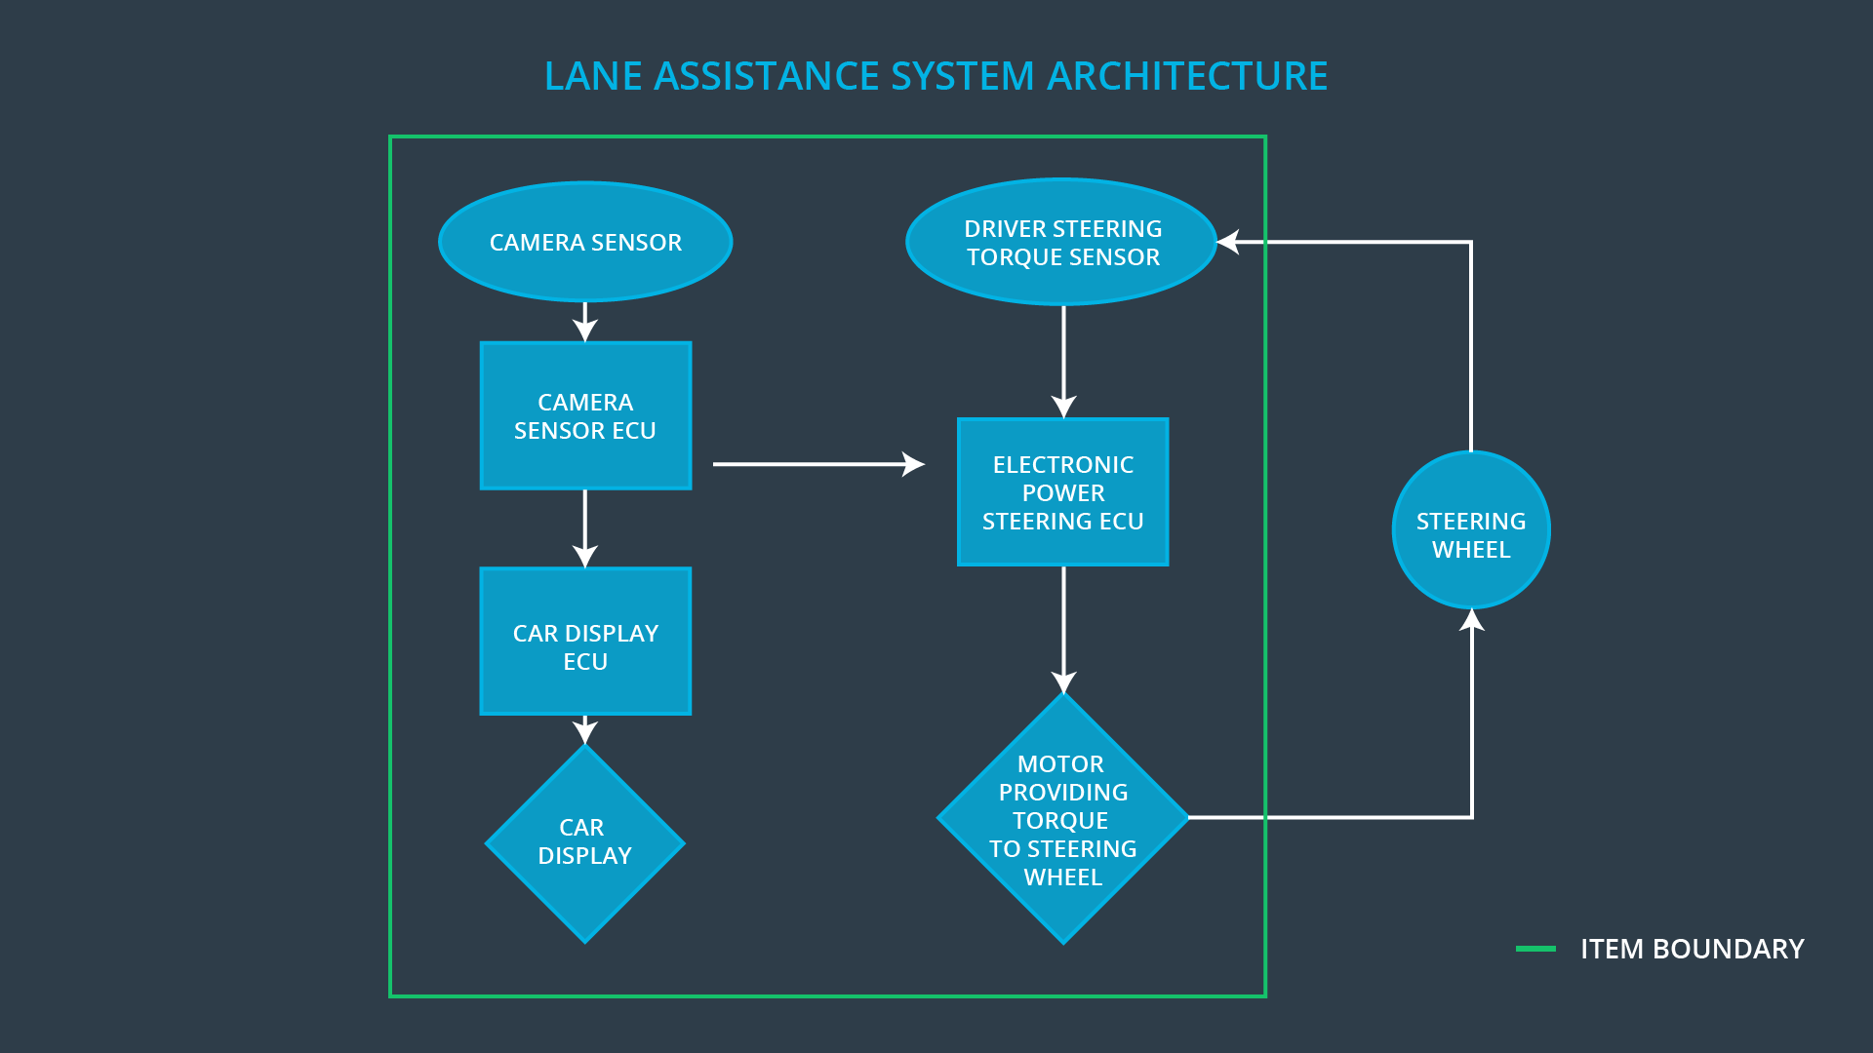**

### Description of architecture elements

|  |  |
| --- | --- |
| **Element** | **Description** |
| Camera Sensor | Captures images of the lane |
| Camera Sensor ECU | Lane sensing and Torque request generator |
| Car Display | Displays information to driver |
| Car Display ECU | Visual indication of Lane Assistance On/Off status and Lane Assistance Active/Inactive |
| Driver Steering Torque Sensor | Senses driver steering torque |
| Electronic Power Steering ECU | Processes driver steering torque, receives vibrational torque request from Camera Sensor ECU, Regulates the final torque applied to the steering wheel |
| Motor | Provides torque to the steering wheel |

# Functional Safety Concept

The functional safety concept consists of:

* Functional safety analysis
* Functional safety requirements
* Functional safety architecture
* Warning and degradation concept

## Functional Safety Analysis

|  |  |  |  |
| --- | --- | --- | --- |
| **Malfunction ID** | **Main Function of the Item Related to Safety Goal Violations** | **Guidewords (NO, WRONG, EARLY, LATE, MORE, LESS)** | **Resulting Malfunction** |
| Malfunction\_01 | Lane Departure Warning (LDW) function shall apply an oscillating steering torque to provide the driver a haptic feedback | MORE | The lane departure warning function applies an oscillating torque with very high torque amplitude (above limit) |
| Malfunction\_02 | Lane Departure Warning (LDW) function shall apply an oscillating steering torque to provide the driver a haptic feedback | MORE | The lane departure warning function applies an oscillating torque with very high torque frequency (above limit) |
| Malfunction\_03 | Lane Keeping Assistance (LKA) function shall apply the steering torque when active in order to stay in ego lane | NO | The lane keeping assistance function is not limited in time duration which leads to misuse as an autonomous driving function. |

## Functional Safety Requirements

Lane Departure Warning (LDW) Requirements:

|  |  |  |  |  |
| --- | --- | --- | --- | --- |
| **ID** | **Functional Safety Requirement** | **ASIL** | **Fault Tolerant Time Interval** | **Safe State** |
| Functional  Safety  Requirement  01-01 | The lane keeping item shall ensure that the lane departure oscillating torque amplitude is below Max\_Torque\_Amplitude | C | 50 mS | Torque request set to zero |
| Functional  Safety  Requirement  01-02 | The lane keeping item shall ensure that the lane departure oscillating torque frequency is below Max\_Torque\_Frequency | C | 50 mS | Torque request set to zero |

Lane Departure Warning (LDW) Verification and Validation Acceptance Criteria:

|  |  |  |
| --- | --- | --- |
| **ID** | **Validation Acceptance**  **Criteria and Method** | **Verification Acceptance**  **Criteria and Method** |
| Functional  Safety  Requirement  01-01 | Max\_Torque\_Amplititude will be tested with drivers to determine an appropriate value | Software test with an intentional fault |
| Functional  Safety  Requirement  01-02 | Max\_Torque\_Frequency will be tested with drivers to determine an appropriate value | Software test with an intentional fault |

**[Instructions: Fill in the functional safety requirements for the lane keeping assistance]**

Lane Keeping Assistance (LKA) Requirements:

|  |  |  |  |  |
| --- | --- | --- | --- | --- |
| **ID** | **Functional Safety Requirement** | **ASIL** | **Fault Tolerant Time Interval** | **Safe State** |
| Functional  Safety  Requirement  02-01 | The electronic power steering ECU shall ensure that the lane keeping assistance torque is applied for only Max\_Duration | B | 500 ms | Lane Keeping Assistance disengages, no corrective steering torque applied |

Lane Keeping Assistance (LKA) Verification and Validation Acceptance Criteria:

|  |  |  |
| --- | --- | --- |
| **ID** | **Validation Acceptance**  **Criteria and Method** | **Verification Acceptance**  **Criteria and Method** |
| Functional  Safety  Requirement  02-01 | Max\_Duration will be tested with drivers to determine an appropriate value | Software test to ensure system disengages after pre-determined time has elapsed. |

## Refinement of the System Architecture

## ../Architecture_Diagrams/graphic_asset_3.png

## Allocation of Functional Safety Requirements to Architecture Elements

|  |  |  |  |  |
| --- | --- | --- | --- | --- |
| **ID** | **Functional Safety Requirement** | **Electronic Power Steering ECU** | **Camera ECU** | **Car Display ECU** |
| Functional  Safety  Requirement  01-01 | The lane keeping item shall ensure that the lane departure oscillating torque amplitude is below Max\_Torque\_Amplitude | **X** |  | **X** |
| Functional  Safety  Requirement  01-02 | The lane keeping item shall ensure that the lane departure oscillating torque frequency is below Max\_Torque\_Frequency | **X** |  | **X** |
| Functional  Safety  Requirement  02-01 | The electronic power steering ECU shall ensure that the lane keeping assistance torque is applied for only Max\_Duration |  | **X** | **X** |

## Warning and Degradation Concept

|  |  |  |  |  |
| --- | --- | --- | --- | --- |
| **ID** | **Degradation Mode** | **Trigger for Degradation Mode** | **Safe State invoked?** | **Driver Warning** |
| WDC-01 | Turn off functionality | Vibration amplitude too high (+/- 3 N-m) or frequency too high | Yes | Warning light |
| WDC-02 | Turn off functionality | Lane keeping assistance duration exceeds Max\_Duration | Yes | Warning light |