

Technical Safety Concept Lane Assistance

**Document Version: 2.0**

**Template Version 1.0, Released on 2017-06-21**



# Document history

**[Instructions: Fill in the date, version and description fields. You can fill out the Editor field with your name if you want to do so. Keep track of your editing as if this were a real world project.**

**For example, if this were your first draft or first submission, you might say version 1.0. If this is a second submission attempt, then you'd add a second line with a new date and version 2.0]**

|  |  |  |  |
| --- | --- | --- | --- |
| Date | Version | Editor | Description |
| 11/12/2017 | 1.0 | Sam Adelman | Begin assignment |
| 11/26/2017 | 2.0 | Sam Adelman | Added information from lessons |
|  |  |  |  |
|  |  |  |  |
|  |  |  |  |

# 

# Table of Contents

**[Instructions: We have provided a table of contents. If the table of contents is not showing up correctly in your word processor of choice, please update it. The table of contents should show each section of the document and page numbers or links. Most word processors can do this for you. In** [**Google Docs**](https://support.google.com/docs/answer/116338?co=GENIE.Platform%3DDesktop&hl=en)**, you can use headings for each section and then go to Insert > Table of Contents.** [**Microsoft Word**](https://support.microsoft.com/en-us/help/285059/how-to-create-a-table-of-contents-by-marking-text-in-word) **has similar capabilities]**

Document history

Table of Contents

Purpose of the Technical Safety Concept

Inputs to the Technical Safety Concept

Functional Safety Requirements

Refined System Architecture from Functional Safety Concept

Functional overview of architecture elements

Technical Safety Concept

Technical Safety Requirements

Refinement of the System Architecture

Allocation of Technical Safety Requirements to Architecture Elements

Warning and Degradation Concept

# Purpose of the Technical Safety Concept

# The technical safety concept involves:

# Turning functional safety requirements into technical safety requirements

# Allocating technical safety requirements to the system architecture

# Inputs to the Technical Safety Concept

## Functional Safety Requirements

|  |  |  |  |  |
| --- | --- | --- | --- | --- |
| **ID** | **Functional Safety Requirement** | **ASIL** | **Fault Tolerant Time Interval** | **Safe State** |
| Functional  Safety  Requirement  01-01 | The lane keeping item shall ensure that the lane departure oscillating torque amplitude is below Max_Torque_Amplitude | C | 50 mS | Torque request set to zero |
| Functional  Safety  Requirement  01-02 | The lane keeping item shall ensure that the lane departure oscillating torque frequency is below Max_Torque_Frequency | C | 50 mS | Torque request set to zero |
| Functional  Safety  Requirement  02-01 | The electronic power steering ECU shall ensure that the lane keeping assistance torque is applied for only Max_Duration | B | 500 mS | Lane Keeping Assistance disengages, no corrective steering torque applied |

## Refined System Architecture from Functional Safety Concept

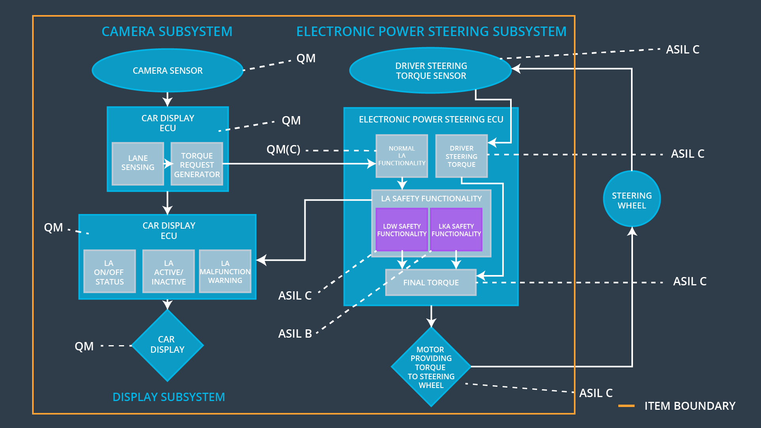

### 

### Functional overview of architecture elements

**[Instructions: Provide a description for each functional safety element; what is each element's purpose in the lane assistance item? ]**

|  |  |
| --- | --- |
| **Element** | **Description** |
| Camera Sensor | Captures images of the lane |
| Camera Sensor ECU - Lane Sensing | Finds relative position of vehicle in lane from Camera Sensor input |
| Camera Sensor ECU - Torque request generator | Generates oscillating torque request if vehicle is drifting out of its lane |
| Car Display | Provides visual feedback to driver |
| Car Display ECU - Lane Assistance On/Off Status | Indicates to driver if the LKA system is on or off. |
| Car Display ECU - Lane Assistant Active/Inactive | Indicates to driver if the LKA has detected that the vehicle is drifting out of its lane |
| Car Display ECU - Lane Assistance malfunction warning | Indicates to the driver a malfunction in the LKA system |
| Driver Steering Torque Sensor | Detects current steering torque input from driver using the steering wheel. |
| Electronic Power Steering (EPS) ECU - Driver Steering Torque | Receives information from Driver Steering Torque Sensor about the steering torque provided by the driver via the steering wheel |
| EPS ECU - Normal Lane Assistance Functionality | Provides EPS functionality during normal driving when the LDW system does not detect lane departure |
| EPS ECU - Lane Departure Warning Safety Functionality | Processes haptic feedback to the user from the torque request generator when the LDW system detects lane departure |
| EPS ECU - Lane Keeping Assistant Safety Functionality | Limits the haptic feedback to the user when from the torque request generator to remain below the Max_Torque_Amplitude and Max_Torque_Frequency. |
| EPS ECU - Final Torque | Final torque request sent out to the Motor providing torque to the steering wheel |
| Motor | Actuator that provides torque to the steering wheel. |

# Technical Safety Concept

## Technical Safety Requirements

**Lane Departure Warning (LDW) Requirements:**

Functional Safety Requirement 01-01 with its associated system elements

(derived in the functional safety concept)

|  |  |  |  |  |
| --- | --- | --- | --- | --- |
| **ID** | **Functional Safety Requirement** | **Electronic Power Steering ECU** | **Camera ECU** | **Car Display ECU** |
| Functional  Safety  Requirement  01-01 | The lane keeping item shall ensure that the lane departure oscillating torque amplitude is below Max_Torque_Amplitude | X |  |  |

Technical Safety Requirements related to Functional Safety Requirement 01-01 are:

|  |  |  |  |  |  |
| --- | --- | --- | --- | --- | --- |
| **ID** | **Technical Safety Requirement** | **ASIL** | **Fault Tolerant Time Interval** | **Architecture Allocation** | **Safe State** |
| Technical  Safety  Requirement  01 | The LDW safety component shall ensure that the amplitude of the 'LDW_Torque_Request' sent to the 'Final electronic power steering Torque' component is below 'Max_Torque_Amplitude. | C | 50 mS | LDW Safety Software Component | Torque amplitude below maximum |
| Technical  Safety  Requirement  02 | As soon as the LDW function deactivates the LDW feature, the 'LDW Safety' software block shall send a signal to the car display ECU to turn on a warning light. | C | 50 mS | LDW Safety Software Component | N/A |
| Technical  Safety  Requirement  03 | As soon as a failure is detected by the LDW function, it shall deactivate the LDW feature and the 'LDW_Torque_Request' shall be set to zero. | C | 50 mS | LDW Safety Software Component | Torque set to zero |
| Technical  Safety  Requirement  04 | The validity and integrity of the data transmission for 'LDW_Torque_Request' signal shall be ensured. | C | 50 mS | Data Transmission Integrity Check | N/A |
| Technical  Safety  Requirement  05 | Memory test shall be conducted at start up of the EPS ECU to check for any faults in memory. | A | Ignition cycle | Safety Startup | N/A |

Functional Safety Requirement 01-2 with its associated system elements

(derived in the functional safety concept)

|  |  |  |  |  |
| --- | --- | --- | --- | --- |
| **ID** | **Functional Safety Requirement** | **Electronic Power Steering ECU** | **Camera ECU** | **Car Display ECU** |
| Functional  Safety  Requirement  01-02 | The lane keeping item shall ensure that the lane departure oscillating torque frequency is below Max_Torque_Frequency | X |  |  |

Technical Safety Requirements related to Functional Safety Requirement 01-02 are:

|  |  |  |  |  |  |
| --- | --- | --- | --- | --- | --- |
| **ID** | **Technical Safety Requirement** | **ASIL** | **Fault Tolerant Time Interval** | **Architecture Allocation** | **Safe State** |
| Technical  Safety  Requirement  01 | The LDW safety component shall ensure that the amplitude of the 'LDW_Torque_Request' sent to the 'Final electronic power steering Torque' component is below 'Max_Torque_ Frequency. | C | 50 mS | LDW Safety Software Component | Torque frequency below maximum |
| Technical  Safety  Requirement  02 | As soon as the LDW function deactivates the LDW feature, the 'LDW Safety' software block shall send a signal to the car display ECU to turn on a warning light. | C | 50 mS | LDW Safety Software Component | N/A |
| Technical  Safety  Requirement  03 | As soon as a failure is detected by the LDW function, it shall deactivate the LDW feature and the 'LDW_Torque_Request' shall be set to zero. | C | 50 mS | LDW Safety Software Component | Torque set to zero |
| Technical  Safety  Requirement  04 | The validity and integrity of the data transmission for 'LDW_Torque_Request' signal shall be ensured. | C | 50 mS | Data Transmission Integrity Check | N/A |
| Technical  Safety  Requirement  05 | Memory test shall be conducted at start up of the EPS ECU to check for any faults in memory. | A | Ignition cycle | Safety Startup | N/A |

**Lane Keeping Assistance (LKA) Requirements:**

**[Instructions: Fill in the technical safety requirements for the lane keeping assistance functional safety requirement 02-01. We have provided the associated functional safety requirement in the table below. Hint:. You can reuse the technical safety requirements from functional safety requirement 01-01. But you need to change the language because we are now looking at a different system. The ASIL and Fault Tolerant Time Interval are different as well.]**

Functional Safety Requirement 02-1 with its associated system elements

(derived in the functional safety concept)

|  |  |  |  |  |
| --- | --- | --- | --- | --- |
| **ID** | **Functional Safety Requirement** | **Electronic Power Steering ECU** | **Camera ECU** | **Car Display ECU** |
| Functional  Safety  Requirement  02-01 | The lane keeping item shall ensure that the lane keeping assistance torque is applied for only Max_Duration | X |  |  |

Technical Safety Requirements related to Functional Safety Requirement 02-01 are:

|  |  |  |  |  |  |
| --- | --- | --- | --- | --- | --- |
| **ID** | **Technical Safety Requirement** | **ASIL** | **Fault Tolerant Time Interval** | **Allocation to Architecture** | **Safe State** |
| Technical  Safety  Requirement  01 | The lane keeping assistance function shall be time limited and the additional steering torque shall end after a given timer interval so that the driver can not misuse the system for autonomous driving. | B | 500 ms | LKA Safety Software Component | Lane Keeping Assistance disengages, no corrective steering torque applied |
| Technical  Safety  Requirement  02 | As soon as the LKA function deactivates the LKA feature, the LKA Safety' software block shall send a signal to the car display ECU to turn on a warning light. | B | 500 ms | LKA Safety Software Component | N/A |
| Technical  Safety  Requirement  03 | As soon as a failure is detected by the LKA function, it shall deactivate the LKA feature and the ' LKA_Torque_Request' shall be set to zero. | B | 500 ms | LKA Safety Software Component | Torque set to zero |
| Technical  Safety  Requirement  04 | The validity and integrity of the data transmission for 'LKA_Torque_Request' signal shall be ensured. | B | 500 ms | Data Transmission Integrity Check | N/A |
| Technical  Safety  Requirement  05 | Memory test shall be conducted at start up of the EPS ECU to check for any faults in memory. | A | Ignition cycle | Safety Startup | N/A |

## Refinement of the System Architecture

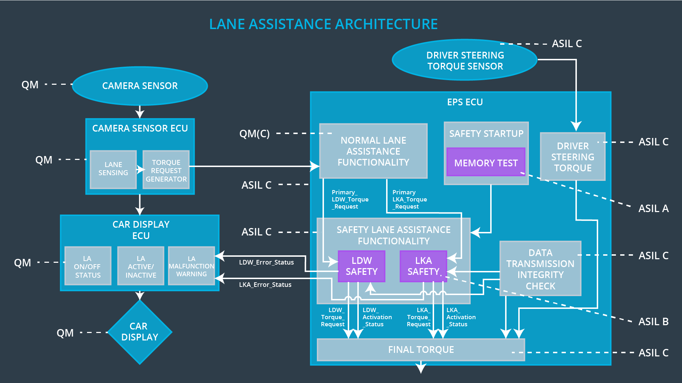

## Allocation of Technical Safety Requirements to Architecture Elements

Included above in the technical requirement tables. All technical safety requirements for this item are allocated to the Electronic Power Steering ECU.

## Warning and Degradation Concept

|  |  |  |  |  |
| --- | --- | --- | --- | --- |
| **ID** | **Degradation Mode** | **Trigger for Degradation Mode** | **Safe State invoked?** | **Driver Warning** |
| WDC-01 | Turn off functionality | Vibration amplitude too high (+/- 3 N-m) or frequency too high | Yes | Warning light |
| WDC-02 | Turn off functionality | Lane keeping assistance duration exceeds Max_Duration | Yes | Warning light |