Multi-Agent Nutrition Planner
Project Report — Design, Implementation & Evaluation

1. Project Overview
This project implements a multi-agent AI pipeline that generates personalised daily meal plans from a user's physical profile. The user provides their age, sex, weight, height, activity level, and goal — either as free text, through a manual form, or by uploading an InBody body composition scan — and the system produces a structured meal plan with verified macro-nutrient totals.
The pipeline is built entirely in Python using the Groq API for all language model calls and a local USDA food database for nutritional data. A web interface built with Gradio makes the system accessible without any coding knowledge.

2. Why We Built a Web Interface
A Jupyter notebook is an effective way to develop and test a pipeline, but it is not a practical tool for end users. The Gradio web interface was built for several reasons:
- Accessibility — anyone can use the system through a browser without installing Python or understanding the code.
- Multiple input modes — users can describe themselves in plain English, fill in a structured form, or upload an InBody scan, covering different levels of technical comfort.
- Model comparison — the interface lets users run all four model variants on the same profile simultaneously and compare their outputs side by side, which would require manual code changes in a notebook.
- Food substitution — the 'Swap Foods' feature lets users interactively refine their meal plan by telling the system what they dislike, replacing items while preserving macro targets.
- Deployment — the interface can be shared publicly via Gradio's share link, making it usable on any device including mobile.
In short, the notebook demonstrates the pipeline technically; the interface makes it usable in practice.

3. Technology Stack
Component | Technology
LLM (text generation) | Groq API — llama-3.1-8b-instant
LLM (vision / InBody scan) | Groq API — meta-llama/llama-4-scout-17b-16e-instruct
Food database (primary) | Local USDA SR Legacy CSV — 7,756 foods
Food database (fallback 1) | USDA FoodData Central REST API
Food database (fallback 2) | Open Food Facts API
Web interface | Gradio
Language | Python 3
Notebooks | Jupyter

4. Pipeline Agents
The system is structured as a pipeline of six specialised agents, each responsible for a distinct stage of the process. Data flows sequentially from profile collection through to the final meal plan.

Agent 1 — User Profile Collector
Accepts free-text input such as "I'm 25, male, 180 lbs, 5'11, gym 5x a week, want to bulk" and extracts a structured profile from it. A built-in unit converter handles imperial measurements (lbs to kg, ft/in to cm) using regex before the LLM processes the text.
- Extracts: age, sex, weight, height, activity level, goal
- Falls back to interactive prompts for any missing fields
- Outputs a structured profile dict passed to Agent 2

Agent 2 — Macro Calculator & Validator
Validates the profile, normalises free-form values, applies safety checks, and calculates precise calorie and macro targets using Groq function calling.
- Validation: checks all fields are present, numeric, and in range
- Normalisation: maps values like 'gym 3x' to 'moderate' via lookup maps; falls back to LLM for unknown values
- Safety checks: blocks users under 18, BMI below 18.5, BMI above 35
- Groq function calling: model calls calculate_bmr → calculate_tdee → apply_goal → calculate_macros in sequence
- Mifflin-St Jeor formula for BMR; activity multipliers for TDEE
- Goal adjustments: weight_loss -400 kcal, muscle_gain +300 kcal, maintenance 0
- Protein: 2.0g/kg (muscle gain), 1.8g/kg (weight loss), 1.4g/kg (maintenance)
- Direct Python fallback if Groq returns implausible values (< 1200 or > 5000 kcal)

Agent 3 — Meal Planner
Receives the calorie and macro targets and generates a structured daily meal plan by calling the Groq LLM with a detailed prompt. The model is instructed to output only valid JSON with specific food names and gram amounts per meal.
- Meal budget splits: breakfast 25%, lunch 35%, dinner 30%, snack 10%
- Prompt enforces lean whole foods and prohibits processed items
- JSON output is verified against the food database (Agent 4)
- Verified meals are scaled to exactly hit the target calorie total
- Temperature is the key experimental variable — see Section 6

Agent 4 — Food Database
Looks up nutritional data for any food name and gram amount. Uses a three-tier fallback strategy to maximise coverage.
- Primary: local USDA SR Legacy CSV (7,756 foods) — full string match, then word-by-word fallback
- Filters out junk matches: baby food, candy, infant formula, dry mix
- Prefers shortest matching food name for the most generic entry
- Fallback 1: USDA FoodData Central REST API
- Fallback 2: Open Food Facts API

Agent 5 — InBody Extractor (Vision)
Takes a photo of an InBody body composition report, encodes it to base64, and sends it to the Groq vision model. Extracted weight and height are fed directly into Agent 2, bypassing manual input.
- Extracts: weight, height, skeletal muscle mass, body fat mass, body fat %, BMI, BMR, visceral fat level, total body water
- Returns null for any field not visible in the image

Substitution Agent
Runs after a meal plan is generated, on user feedback such as 'I hate salmon' or 'no eggs'. Calls the LLM to extract disliked foods, then finds nutritionally equivalent replacements from the food database.
- Parses dislikes from natural language into a structured list
- Suggests 5 candidate substitutes per disliked food via LLM
- Looks up each candidate in the database and swaps in the first match
- Returns the updated meal plan and a list of all changes made

5. Web Interface (Gradio)
The Gradio app wraps the full pipeline in a browser-based interface with three input methods and several interactive features.

Input Tabs
- Describe Yourself — free-text input, processed by Agent 1
- InBody Scan — upload an image, Agent 5 extracts the metrics automatically
- Manual Entry — form fields for all profile values

Model Selector
Model | Underlying LLM | Temperature | Characteristic
M1 — Consistent | llama-3.1-8b-instant | 0.0 | Deterministic — same output every run
M2 — Balanced | llama-3.1-8b-instant | 0.4 | Slight variation run to run
M3 — Creative | llama-3.1-8b-instant | 0.9 | Different output each run
M4 — Llama 3.2 | llama-3.2-3b-preview | 0.4 | Smaller model, faster response

Compare All Models
Runs all four models on the same profile simultaneously and displays calorie, macro, and per-meal results in a side-by-side table.

Swap Foods
After a plan is generated, the user can type what they want to avoid. The substitution agent replaces those items with nutritionally equivalent alternatives.

6. Variants Experiment — Temperature Comparison
To evaluate how LLM temperature affects meal plan quality, Agent 3 was run three times on the same profile and targets, varying only the temperature parameter.

Test Profile
Field | Value
Age | 25
Sex | Male
Height | 174 cm
Weight | 71 kg
Activity | Active
Goal | Muscle gain

Calorie & Macro Targets
Calories | Protein | Fat | Carbs
3,194 kcal | 142g | 89g | 457g

Variants Tested
Variant | Temperature | Behaviour
V1 — Deterministic | 0.0 | Same output every run
V2 — Balanced | 0.4 | Slight variation run to run
V3 — Creative | 0.9 | Different output each run

7. Variant Results & Analysis

7.1 Summary Results
Metric | V1 — Deterministic (0.0) | V2 — Balanced (0.4) | V3 — Creative (0.9)
Calorie accuracy | 0.2% error (over by 5 kcal) | 0.0% error (over by 1 kcal) | 0.1% error (under by 3 kcal)
Macro split | 22.7% P | 19.3% F | 65.0% C | 22.9% P | 23.8% F | 59.5% C | 14.2% P | 32.3% F | 53.8% C
Protein vs target | +39g over | +41g over | -29g under
Fat vs target | -20g under | near target | +25g over
Protein density | 5.7g per 100 kcal | 5.7g per 100 kcal | 3.6g per 100 kcal
Food variety | 10 unique foods | 10 unique foods | 10 unique foods
Heaviest meal | Lunch (1,164 kcal) | Lunch (1,109 kcal) | Dinner (988 kcal)

7.2 Winner per Metric
Metric | Winner
Best calorie accuracy | V2 — Balanced
Most protein | V2 — Balanced
Most food variety | V1 — Deterministic (tied)
Leanest (lowest fat) | V1 — Deterministic

7.3 Key Observations
- All three variants hit calorie targets within 0.2% — the scaling step in Agent 3 forces this regardless of temperature.
- V1 and V2 are protein-heavy because the model defaults to lean foods (chicken, turkey, egg whites) and the database matches these to the leanest available entries.
- V3 at temperature 0.9 broke the protein target significantly (-29g) and overshot fat (+25g). Higher creativity trades macro accuracy for food variety.
- Food variety is identical across all three variants (10 unique foods). The food database constraint dominates over LLM creativity — the model can only suggest foods the database can match.
- Lunch is consistently the heaviest meal in V1 and V2 (35% budget). V3 shifted the heaviest meal to dinner, reflecting its more unpredictable planning behaviour.

8. Charts & Visualisations

8.1 Macro Accuracy — Achieved vs Target
Four-panel bar chart showing achieved vs target values for calories, protein, fat, and carbs across all three variants.
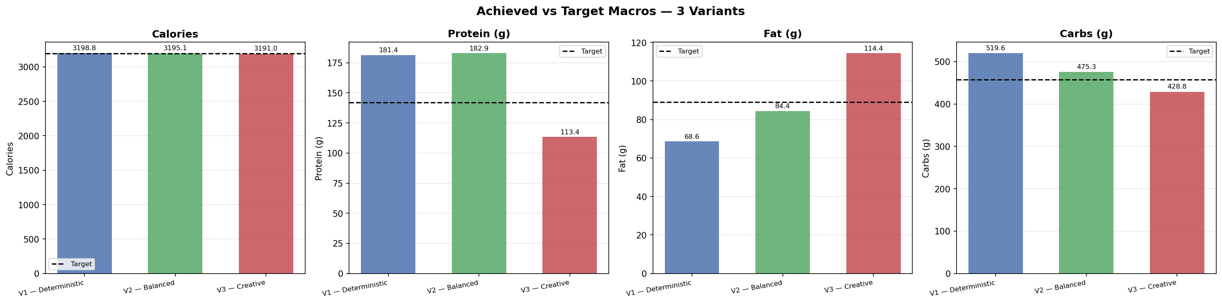
Figure 1 — Achieved vs Target macros for V1, V2, V3

8.2 Calorie Error per Macro
Grouped bar chart showing percentage deviation from target per macro per variant. Lower is better.
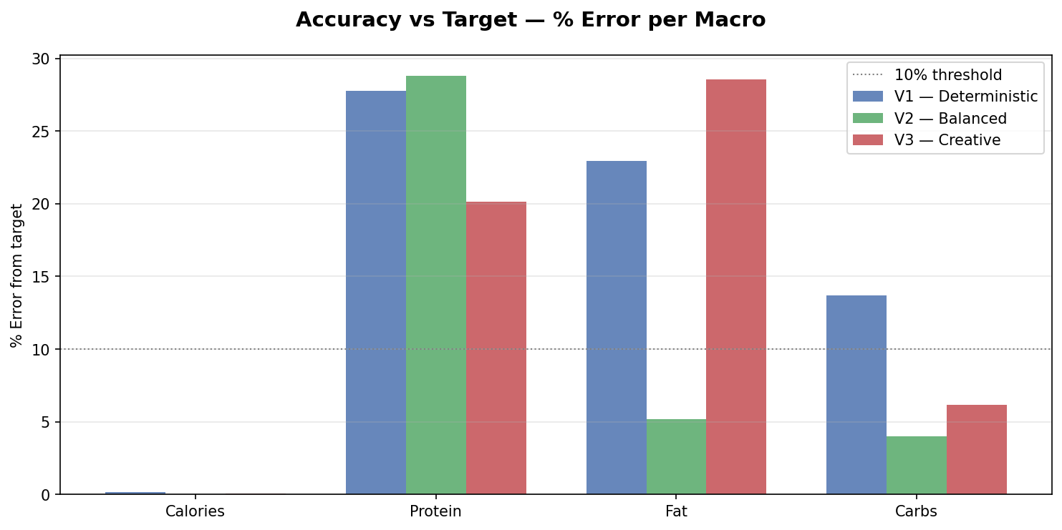
Figure 2 — Macro error % per variant

8.3 Meal Calorie Distribution
Three pie charts showing how calories are distributed across breakfast, lunch, dinner, and snack for each variant.
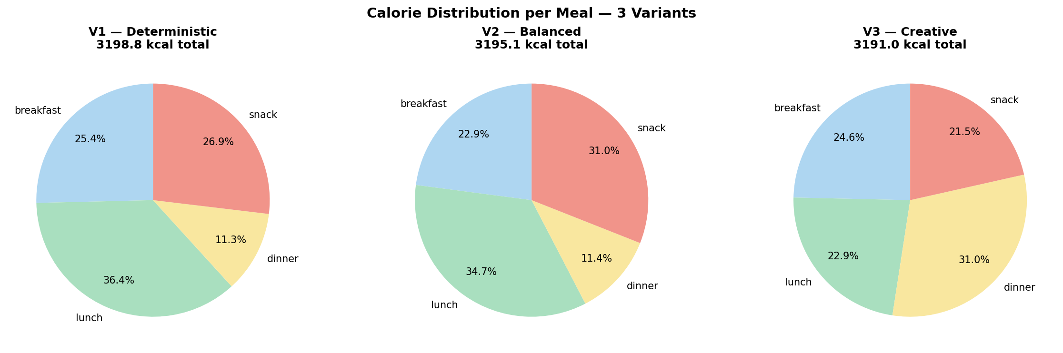
Figure 3 — Meal calorie distribution per variant

8.4 Per-Meal Calorie Accuracy
Bar chart comparing each meal's achieved calories against its budget target across all three variants.
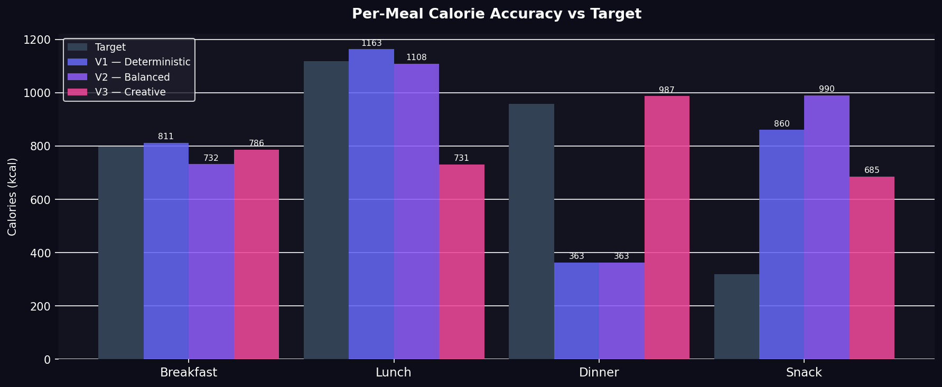
Figure 4 — Per-meal calorie accuracy

8.5 Macro Split Radar
Radar chart comparing the protein / fat / carbs percentage split for each variant against the reference target shape.
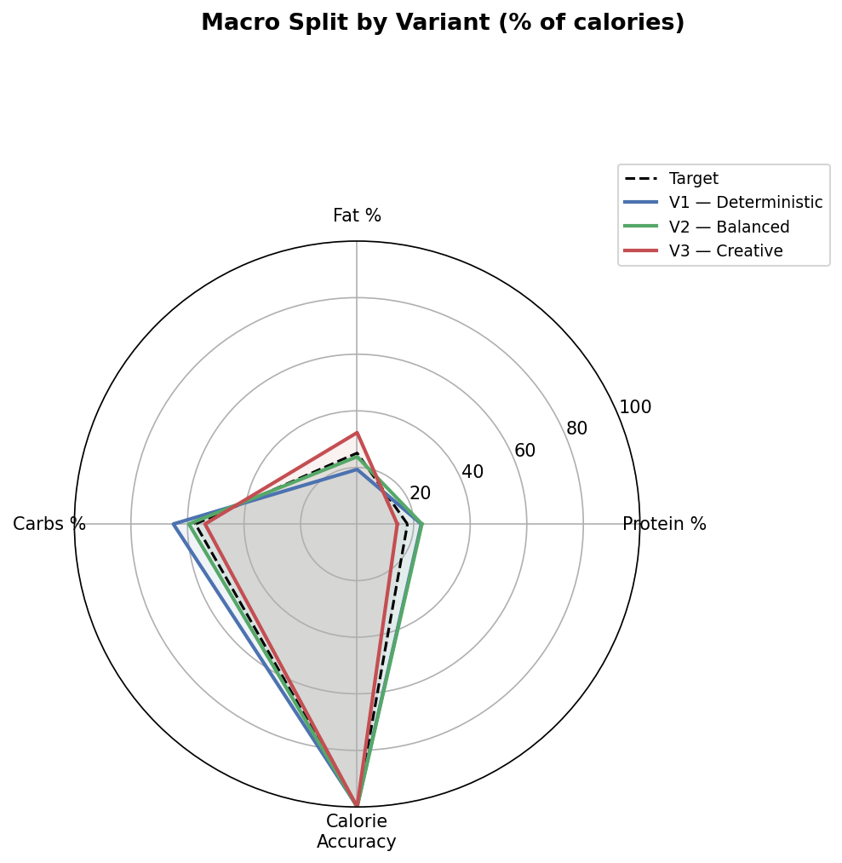
Figure 5 — Macro % split radar chart

8.6 Food Overlap Heatmap
Heatmap showing which foods appear in which variants, highlighting foods shared across multiple plans.
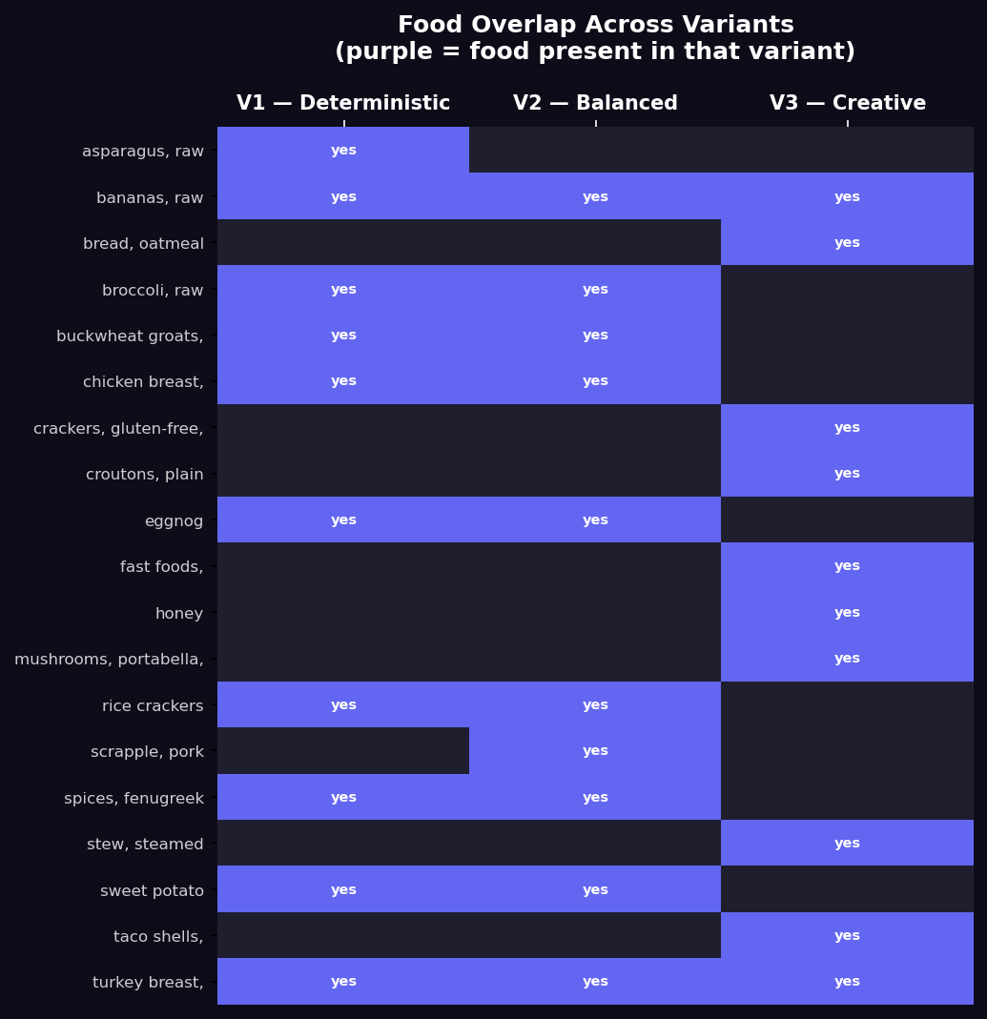
Figure 6 — Food overlap across variants

8.7 API Response Time
Bar chart showing Groq API wall-clock response time per variant. Higher temperature does not consistently increase latency.
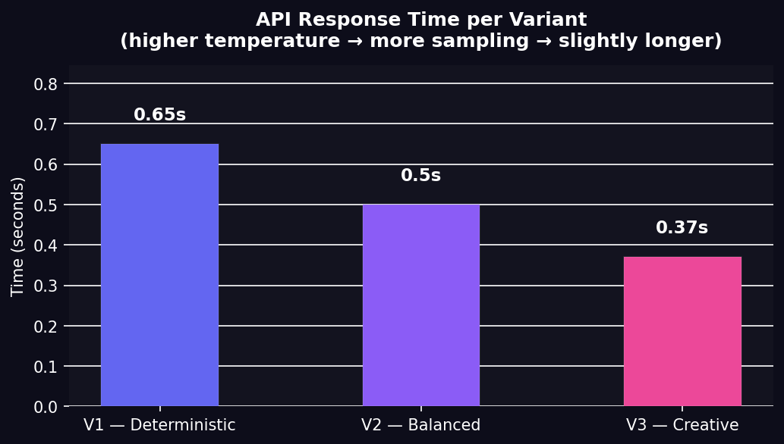
Figure 7 — Groq API response time per variant

9. Evaluation Metrics
Metric | Definition
Calorie accuracy (%) | abs(achieved - target) / target × 100
Protein / fat / carbs error (%) | Same formula applied per macro
Macro split (%) | protein×4, fat×9, carbs×4 as % of total calories
Protein density | grams of protein per 100 kcal
Food variety | Count of unique food names across the full day
Heaviest meal | The meal with the highest calorie total
API response time | Wall-clock seconds for the Agent 3 LLM call

10. Web Interface
The Gradio web interface provides three input methods (free text, InBody scan upload, and manual form), a model selector to switch between temperature variants, and a food substitution tool. The interface is accessible through any browser without installing Python.
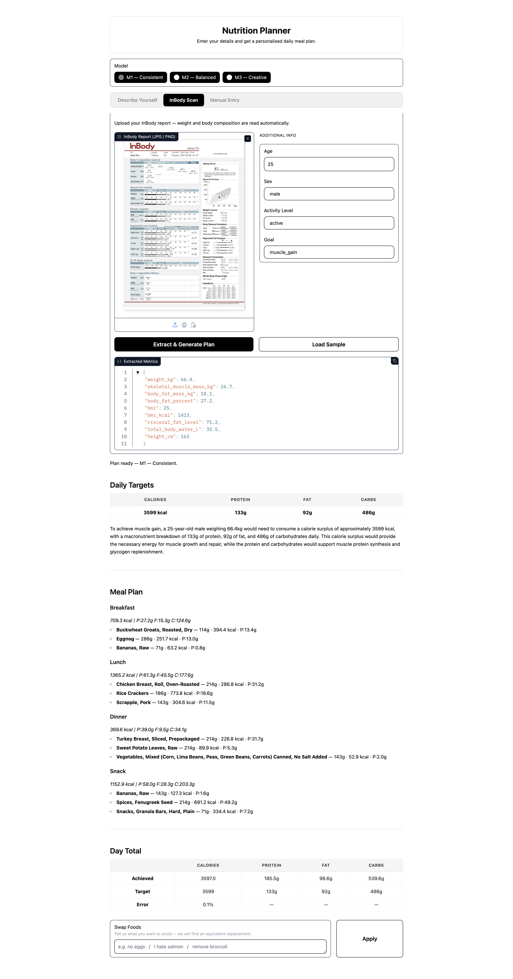
Figure 8 — Gradio web interface

