TRIPLE BURDEN

METHODOLOGY

For each municipality or district in the world (ADM2 divisions), we identified the share of population in the municipality according to three variables: Poverty levels, population at high risk of flooding, and access to improved water and sanitation services. For each variable, the around 38,500 municipalities or districts are ranked, and the bottom and top third of the distribution is identified. The triple burden are the municipalities that at the same time have high poverty (top 33% of the municipalities or districts), high risk of flooding (top 33% of the municipalities or districts), and either low access to improved water or sanitation (bottom 33% of the municipalities or districts).

Only municipalities or districts with information for all three variables are depicted. The information at the ADM2 for water and sanitation covers around 130 countries, mostly developing countries. In this version of the triple burden, all municipalities or districts in high income countries are deemed to not have the burden of low access to water or sanitation services but the information is not available.

Data sources

(1) Access to improved water and sanitation services: Deshpande, et al. 2020. “Mapping Geographical Inequalities in Access to Drinking Water and Sanitation Facilities in Low-Income and Middle-Income Countries, 2000–17.” The Lancet Global Health 8 (9): E1162–E1185.

(2) Poverty: Poverty headcount ratio is the percentage of the population living on less than a specific poverty line a day at 2017 international prices (PPP). Line used: $6.85 (upper-middle income line). The Global Subnational Atlas of Poverty (GSAP), a database of subnational line-up poverty rates www.pipmaps.worldbank.org.

(3) Flood risk: Share of population exposed to at least a 15cm inundation depth during a 1-in-100 year flood event. Own analysis of flood risk rasters by Rentschler et al. (2022). Rentschler, J., Salhab, M. & Jafino, B.A. Flood exposure and poverty in 188 countries. Nature Communications 13, 3527 (2022).

(4) Drought risk: Drought risk measures where droughts are likely to occur, the population and assets exposed, and the vulnerability of the population and assets to adverse effects. AQUEDUCT 4. World Resources Institute

STORYLINE

(1) What is the triple burden and why it matters?

The triple burden consists of people exposed to (1) high poverty, (2) high climate risk (here high risk of flooding), and (3) low access to water and sanitation services.

Areas experiencing the Triple Burden are the most vulnerable and must be prioritized
- Low access to water and sanitation combined with poverty can lead to a poverty trap that increases mortality and morbidity; stalls human capital formation; and reduces long-term earnings and employment opportunities, keeping people and their offspring in poverty
- Those in the poverty trap of low access to services are less resilient to climate risks shocks. Water and sanitation infrastructure is vulnerable to climate risks shocks and sanitation infrastructure can generate greenhouse emissions, exacerbating climate risks

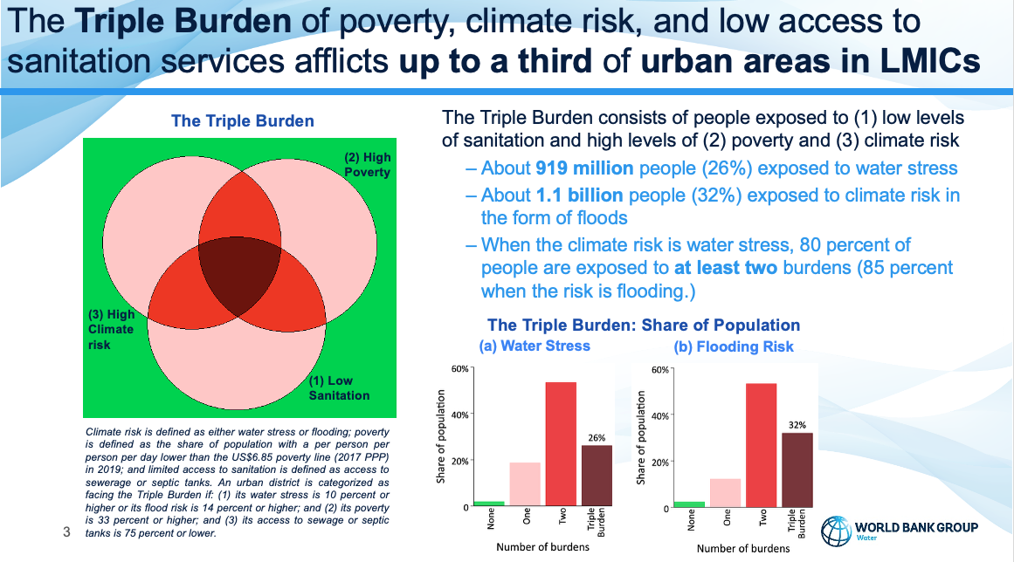

Note: In the maps and graphs, we use
[0] color (hexadecimal) #e4efff for no burdens (muns/districts that experience no burden; mostly high income countries; depicted in the figure above as green)
[1] #f1eebc for one burden (muns/districts that experience only one burden; depicted in the figure above as pink)
[2] #f46d43" for two burdens (muns/districts that experience two burdens; depicted in the figure above as red)
[3] # a50026" for three burdens (muns/districts that experience two burdens; depicted in the figure above as red)

(1) The triple burden in 2022

In developing countries, 1,136 million people (17.4 percent of the population), live under high poverty, high risk of droughts, and low access to water services.

Water
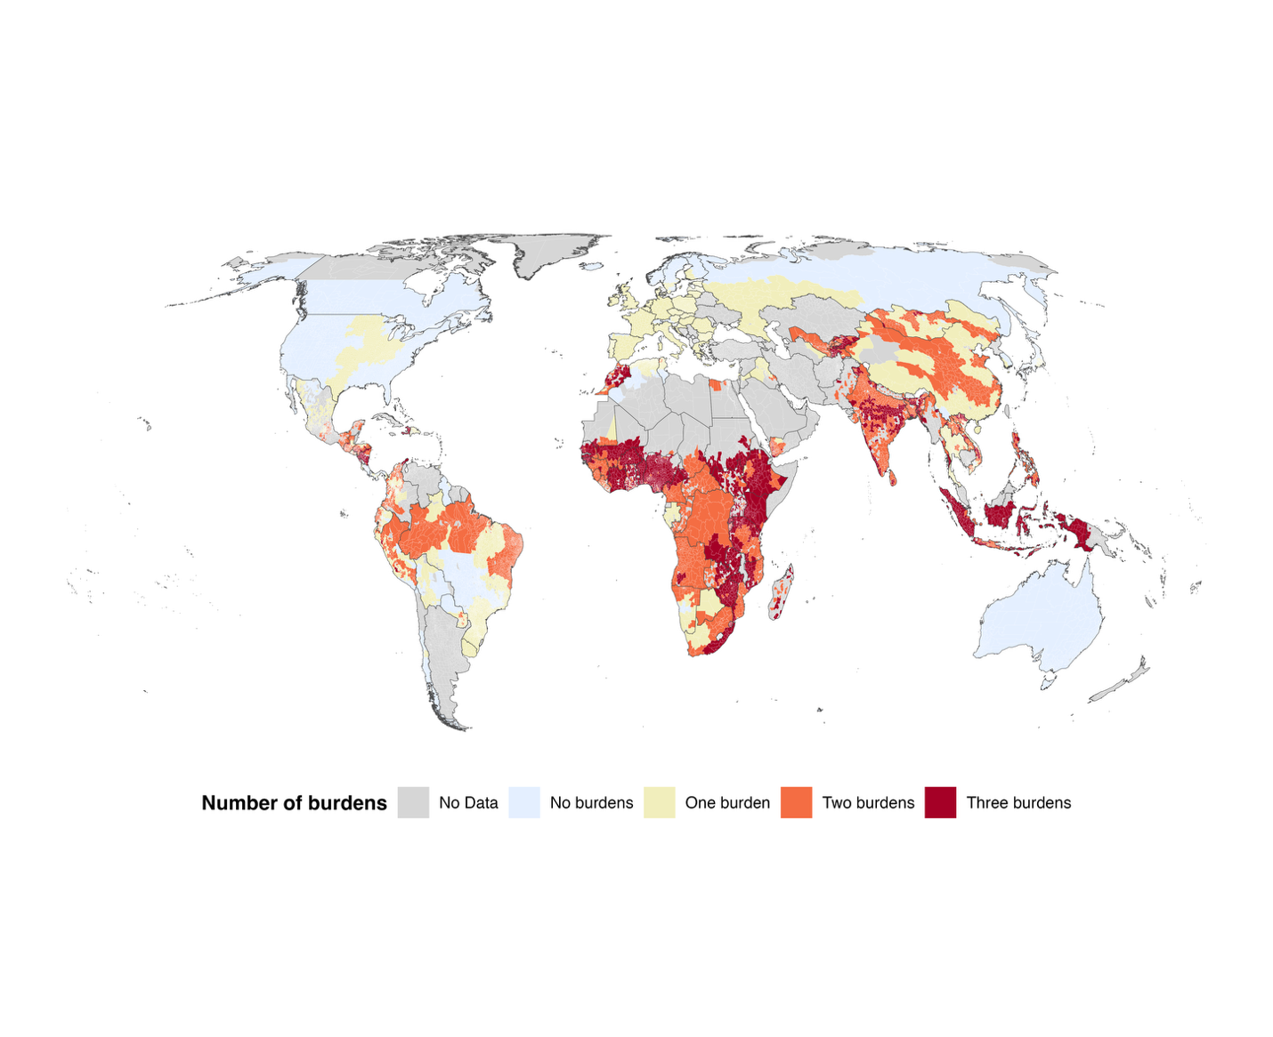
File: TripleBurden_Poverty_HighFloodRisk_LowAccessWater.png

<Perhaps dissolved to next map as transition>

Sanitation

In developing countries, 1,105 million people (16.9 percent of the population), live under high poverty, high risk of flooding, and low access to sanitation services.

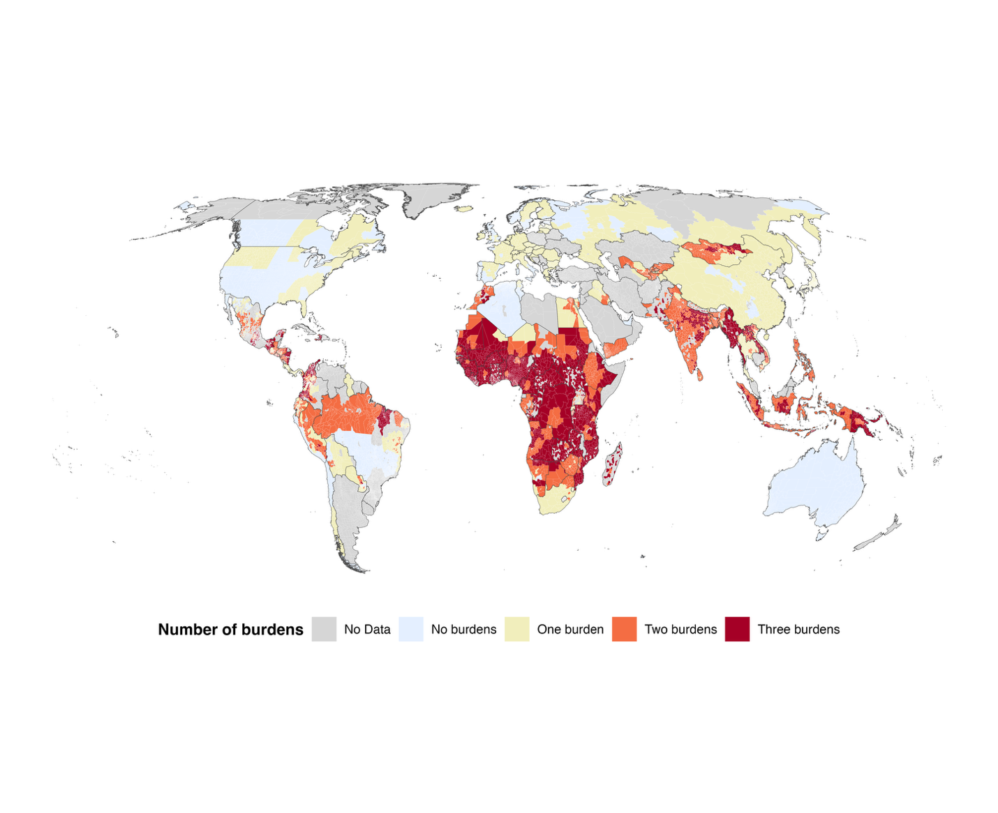
File: TripleBurden_Poverty_HighFloodRisk_LowAccessSanitation.png

