INTRODUCTION TO MACHINE LEARNING—CSC 812
MACHINE LEARNING- SECTION 1
Machine learning (ML) is a branch of artificial intelligence (AI) that enables computers to learn from data and make decisions or predictions without being explicitly programmed. In simple terms, machine learning is about teaching computers to recognize patterns and improve their performance on a task through experience (i.e., data), rather than through hard-coded rules. Simple analogy of machine learning. Imagine teaching a child how to recognize apples and bananas:
- Traditional programming: You write a list of rules— “if it’s yellow and long, it’s a banana; if it’s red and round, it’s an apple.”
- Machine learning: You show the child hundreds of pictures of apples and bananas, and over time, they learn to identify them based on patterns in shape, color, and size.
ML works the same way—it learns from examples.
- Applications of Machine Learning
Machine learning is now applied in virtually every sector due to its ability to analyze large volumes of data, recognize patterns, and make intelligent decisions. From healthcare and finance to agriculture, education, and entertainment, ML is driving innovation, improving efficiency, and enabling smarter systems that adapt and learn over time.

- Healthcare
Machine learning has become a game-changer in the healthcare industry. It is used to predict diseases, assist in diagnosis, and personalize treatment plans. For example, ML models can analyze patient data, such as lab results, medical history, and genetic information, to forecast the likelihood of diseases like diabetes or cancer. In medical imaging, ML algorithms help detect anomalies such as tumors in X-rays, MRIs, and CT scans with high accuracy. Additionally, ML accelerates drug discovery by identifying potential drug compounds and predicting their effectiveness, significantly reducing research time and costs.

- Finance
In finance, machine learning is widely applied for fraud detection, credit scoring, risk assessment, and automated trading. ML models can detect unusual patterns in financial transactions that may indicate fraudulent activity, helping to protect both consumers and institutions. Credit scoring systems powered by ML assess an individual’s creditworthiness by analyzing various factors beyond traditional credit reports, including online behavior and transaction history. Moreover, machine learning drives algorithmic trading strategies by making real-time predictions about market trends, leading to faster and more efficient trading decisions.

- Entertainment
The entertainment industry leverages machine learning to personalize user experiences, recommend content, and even generate creative works. Streaming platforms like Netflix, YouTube, and Spotify use ML algorithms to suggest movies, videos, or music based on user preferences and behavior. These systems continuously learn and adapt, ensuring recommendations remain relevant. Machine learning is also used for content moderation by detecting and filtering inappropriate or harmful material. Furthermore, in areas like gaming and digital music composition, ML can be used to create music or generate character behaviors, enhancing interactive entertainment.

- Transportation
Machine learning plays a vital role in the advancement of intelligent transportation systems. One of the most notable applications is in autonomous vehicles, where ML models process real-time data from sensors and cameras to detect lanes, pedestrians, and obstacles, enabling safe navigation. ML also supports traffic prediction by analyzing historical and real-time data to optimize routing and reduce congestion. In logistics and delivery services, ML helps predict delays, optimize delivery routes, and manage fleet operations more efficiently.

- Agriculture
In agriculture, machine learning supports precision farming, crop monitoring, and disease detection. Using images from drones or sensors, ML models can identify signs of plant diseases, pest infestations, or nutrient deficiencies at early stages. This allows farmers to take targeted action, reducing waste and improving crop yield. ML is also used to predict weather patterns, optimize irrigation, and recommend the best planting schedules. These intelligent systems help farmers make data-driven decisions, improving efficiency and sustainability in agriculture.

- Retail and E-commerce
Retail and e-commerce businesses utilize machine learning to enhance customer experiences, increase sales, and streamline operations. ML algorithms power product recommendation engines that suggest items based on a shopper’s browsing history, past purchases, and preferences. Retailers also use ML to forecast demand, manage inventory, and set dynamic pricing. Sentiment analysis tools analyze customer reviews and feedback to gain insights into consumer satisfaction. Additionally, chatbots powered by ML provide real-time customer support, resolving queries and guiding users through shopping processes.

- Education
Machine learning is transforming education by enabling personalized learning experiences, automating administrative tasks, and predicting student performance. ML-driven platforms adapt content and pacing based on individual student needs, helping learners progress at their own pace. Educators use ML to analyze student behavior and performance data, identifying those who may need additional support. ML algorithms can also automate grading of assignments, especially in objective assessments, freeing up time for teachers to focus on instruction and mentoring.

- Types of Machine Learning: Supervised, Unsupervised, Reinforcement
Machine Learning can be broadly classified into three main types based on how models learn from data. These are Supervised Learning, Unsupervised Learning, and Reinforcement Learning. Below is a detailed explanation of each.

- Supervised Learning
Supervised learning is a type of machine learning where the model is trained using labeled data. This means that each training example includes an input and the corresponding correct output (label). The goal is for the model to learn the mapping from inputs to outputs so it can predict outcomes for new, unseen data. The algorithm looks at the input-output pairs and learns patterns or relationships between them. Over time, it minimizes the error between its predictions and the actual results.
Examples:
- Email Spam Detection: The model learns from examples labeled as "spam" or "not spam."
- House Price Prediction: Given features like location, size, and number of bedrooms (inputs), the model predicts the price (output).
- Image Classification: An image dataset labeled with categories (e.g., dog, cat, car).
Common algorithms used for supervised learning include:
- Linear Regression
- Logistic Regression
- Decision Trees
- Support Vector Machines (SVM)
- Neural Networks

- Unsupervised Learning
Unsupervised learning deals with unlabeled data. That is, there is no predefined output. The model tries to find hidden patterns, groupings, or structures within the input data. The algorithm analyzes the input data and identifies similarities or structures without being told what to look for. It is often used for exploratory data analysis or feature learning.
Examples:
- Customer Segmentation: Grouping customers based on behavior or demographics without knowing the target groups beforehand.
- Market Basket Analysis: Finding items that are frequently purchased together.
- Anomaly Detection: Detecting unusual patterns (e.g., fraud detection or network intrusion).
Common algorithms for unsupervised learning are:
- K-Means Clustering
- Hierarchical Clustering
- Principal Component Analysis (PCA)
- Autoencoders
- Reinforcement Learning
Reinforcement learning (RL) is a type of machine learning where an agent learns to make decisions by performing actions in an environment to maximize some notion of cumulative reward. The agent interacts with the environment, and after each action, it receives feedback in the form of rewards or penalties. Over time, it learns which actions lead to the best outcomes and adjusts its strategy accordingly.

Reinforcement Learning (RL) is a type of machine learning where a computer program (called an agent) learns to make decisions by trial and error to achieve a goal.
Practical examples:
Self-Driving Cars
- The car gets a reward for staying in its lane and avoiding accidents.
- It gets a penalty for hitting obstacles.
- It learns safe driving behaviors over time.
Robot Vacuum Cleaner
- Reward: Cleaning a dirty spot.
- Penalty: Bumping into furniture.
- Learns the most efficient way to clean the whole room.

Key Concepts in reinforcement learning
- Agent: The learner or decision-maker.
- Environment: Where the agent operates.
- Action: What the agent does.
- Reward: Feedback from the environment.

Common algorithms used in reinforcement learning
- Q-Learning: Q-Learning stands for "Quality-Learning", which is a model-free reinforcement learning algorithm used to find the optimal action-selection policy for any given environment. It seeks to learn the "Q-values" (or quality values), which represent the expected future rewards of taking a certain action in a given state.

- Deep Q-Networks (DQN): Deep Q-Networks is short for "Deep Q-Learning Networks". It combines Q-Learning with Deep Neural Networks to handle environments with large or complex state spaces. Instead of using a table to store Q-values, DQN uses a neural network to approximate them, allowing the agent to learn optimal policies in high-dimensional environments like video games or robotics.

- Policy Gradient Methods: Policy Gradient Methods are a class of reinforcement learning algorithms that learn a policy directly by optimizing the parameters of the policy function using gradient ascent. Instead of learning a value function (like Q-values), these methods learn the probability distribution over actions, aiming to increase the probability of actions that yield higher rewards. They adjust the policy in the direction that maximally increases the expected reward, using gradients computed from the environment's feedback.

- Actor-Critic Models: Actor-Critic Models are hybrid reinforcement learning algorithms that combine two components:
Actor: Learns the policy function (i.e., how to act).
Critic: Learns the value function (i.e., how good the action was).
The Actor decides which action to take, while the Critic evaluates how good the action was and provides feedback. This combination helps improve learning stability and efficiency.

PYTHON FOR MACHINE LEARNING- SECTION 2
Python has become the leading programming language for machine learning due to its simplicity, readability, and the huge elements of powerful libraries and tools. It allows researchers and developers to build, train, and deploy machine learning models efficiently. With the use of different libraries, Python provides complete support for tasks such as data preprocessing, feature selection, model training, evaluation, and visualization.
Before discussing different Python libraries, it is important to first understand what a Python library is. In Python, a library refers to a collection of modules and packages that provide pre-written code for performing a different task, such as mathematical computations and data visualization. They help in reducing the need to develop functionalities from the scratch. The Python environment includes thousands of libraries contributed by a vibrant developer community. In this lecture, our focus will be on some of the most widely utilized libraries in data science described in the following section.

- Introduction to NumPy, Pandas, Seaborn, Scikit-learn, and Matplotlib
NumPy, Pandas, Seaborn, and Scikit-learn are among the most widely used libraries in Python programming. NumPy is a library for scientific computing, Pandas is used for data analysis, Seaborn enables data visualization, Scikit-learn provides tools for machine learning and Matplotlib for creating static, animated, and interactive visualizations. Each of these libraries provides powerful yet easy-to-use tools for data manipulation and analysis. With them, developers can quickly and efficiently build robust applications that leverage the power of data science.
NumPy (Numerical Python): It is a fundamental library for scientific computing in Python. It provides support for large, multi-dimensional arrays and matrices, along with a collection of mathematical functions to operate on these arrays efficiently. NumPy's array operations are faster than traditional Python lists. Thus, it a popular choice for numerical computations. It is the foundation for many other libraries in the scientific Python ecosystem.
Benefits of using NumPy Library
- Easy to use: NumPy is very easy to use, and its syntax is simple, this makes it easier to code.
- Speed: NumPy is very fast as it uses highly optimized C and Fortran libraries under the hood.
- Memory efficiency: NumPy is very memory efficient as it stores data in a compact form and uses less memory compared to other libraries.
- Compatibility: NumPy is compatible with many other libraries such as SciPy, Scikit-learn, Matplotlib, etc.
- Array broadcasting: Array broadcasting allows you to perform operations on arrays of different shapes. This helps in writing efficient and concise code.
- Math library: NumPy has an extensive math library that provides many mathematical functions such as trigonometric functions, logarithms, etc.
- Linear algebra support: NumPy supports linear algebra operations such as matrix multiplication, vector operations, etc.

How to Create NumPy Arrays
NumPy is used to work with arrays. The array object in NumPy is called ndarray. We can create a NumPy ndarray object by using the array() function.

Example:
import numpy as np
# Creating a 1D array
x = np.array([1, 2, 3])
# Creating a 2D array
y = np.array([[1, 2], [3, 4]])
# Creating a 3D array
z = np.array([[[1, 2], [3, 4]], [[5, 6], [7, 8]]])
print(x)
print(y)
print(z)

Pandas: Pandas is a powerful Python library for data manipulation and analysis. It provides easy-to-use data structures such as DataFrames, which are tabular structures that allow you to store and manipulate data efficiently. Pandas provides a wide range of functions and methods for data cleaning, preprocessing, merging, grouping, and more. It is widely used for data wrangling and exploration tasks in data science projects. Pandas can be used to accomplish the following tasks:

- Data Cleaning, Merging and Joining: Clean and combine data from multiple sources, handling inconsistencies and duplicates.
- Handling Missing Data: Manage missing or null values in both floating and non-floating-point data.
- Column Insertion and Deletion: Easily add, remove or modify columns in a DataFrame.
- Group By Operations: Use "split-apply-combine" to group and analyze data.
- Data Visualization: Create visualizations with Matplotlib and Seaborn, integrated with Pandas.

Example in Pandas:
import pandas as pd
df = pd.DataFrame({
'Name': ['Alice', 'Bob', 'Charlie'],
'Score': [85, np.nan, 92]
})
print(df)

Output
Name Score
0 Alice 85.0
1 Bob NaN
2 Charlie 92.0

Seaborn: Seaborn is a data visualization library built on top of Matplotlib. It provides a high-level interface for creating attractive and informative statistical graphics. Seaborn simplifies the creation of complex visualizations such as heatmaps, pair plots, distribution plots, and regression plots. It offers a wide range of built-in themes and color palettes, making it easy to create visually appealing plots. Seaborn is often used in conjunction with pandas for visualizing patterns and relationships in data. That is, Seaborn aims to make visualization the central part of exploring and understanding data. It provides dataset-oriented APIs so that we can switch between different visual representations for the same variables for a better understanding of the dataset. Key tasks that Seaborn can be used to accomplish:

- Create attractive and informative statistical graphics
- Visualize distributions (e.g., histograms, KDE plots)
- Show relationships between variables (e.g., scatter plots, line plots)
- Create categorical plots (e.g., bar plots, box plots, violin plots)
- Draw regression plots to analyze trends and patterns
- Plot multi-variable relationships using facets and subplots
- Add themes and color palettes for customized styling
- Combine Pandas DataFrames directly with plotting functions
- Add statistical estimates (e.g., confidence intervals) automatically
- Visualize correlation matrices and heatmaps

import numpy as np
import seaborn as sns
sns.set(style="white")
# Generate a random univariate dataset
rs = np.random.RandomState(10)
d = rs.normal(size=100)
# Plot a simple histogram and kde
sns.histplot(d, kde=True, color="m")

Output:
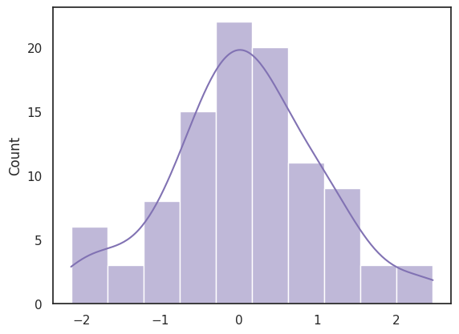

Scikit-learn: Scikit-learn is a popular machine learning library in Python. It provides a wide range of algorithms and tools for tasks such as classification, regression, clustering, dimensionality reduction, and model selection. Scikit-learn is designed with a user-friendly and consistent API, making it easy to experiment with different machine learning models and evaluate their performance. It also includes utilities for data preprocessing, feature extraction, and model evaluation. Key Tasks with Scikit-learn include:
- Machine Learning Modeling
  - Build models for classification, regression, and clustering
- Data Preprocessing
  - Handle missing values, scaling, normalization, encoding categorical variables
- Supervised Learning
  - Algorithms like Linear Regression, Logistic Regression, Decision Trees, Random Forests, Support Vector Machines (SVMs), K-Nearest Neighbors (KNN), etc.
- Unsupervised Learning
  - Algorithms such as K-Means, DBSCAN, Hierarchical Clustering, and Principal Component Analysis (PCA)
- Model Evaluation and Validation
  - Use metrics like accuracy, precision, recall, F1-score, ROC-AUC, etc.
  - Perform cross-validation to assess model performance
- Model Selection and Tuning
  - Use tools like GridSearchCV and RandomizedSearchCV for hyperparameter tuning
- Pipeline Creation
  - Combine preprocessing steps and model training into a clean, reusable pipeline
- Dataset Loading
  - Load popular built-in datasets (e.g., Iris, Boston, Digits) or custom data
- Model Persistence
  - Save and load models using tools like joblib or pickle
- Dimensionality Reduction
  - Reduce feature space using techniques like PCA, t-SNE, etc.

Exercise on Iris Flower Classification Using Scikit-learn
Question: The Iris dataset contains measurements of 150 iris flowers from three different species: setosa, versicolor, and virginica. Each flower has four features:
- Sepal length
- Sepal width
- Petal length
- Petal width
Your task is to build a simple classification model using the K-Nearest Neighbors (KNN) algorithm to predict the species of an iris flower based on its measurements.
Instructions
- Import the necessary libraries from Scikit-learn.
- Load the Iris dataset using load_iris().
- Split the dataset into training and testing sets using train_test_split().
  - Use 80% of the data for training and 20% for testing.
- Create a KNN model with n_neighbors = 3.
- Train the model using the training data.
- Make predictions using the test data.
- Evaluate the model by calculating and printing the accuracy score.
- (Bonus) Print a few predicted vs actual labels from the test set for comparison.
Deliverables
- Your complete Python code
- The accuracy score of the model
- Printed output that compares actual vs predicted labels

Matplotlib: Matplotlib is a widely-used plotting library in Python. It provides a comprehensive set of functions for creating static, animated, and interactive visualizations. Matplotlib allows you to generate various types of plots, including line plots, scatter plots, bar plots, histograms, and more. It provides extensive customization options to control the appearance of plots, such as axes, labels, colors, and styles. Matplotlib is often used in combination with other libraries like pandas and NumPy to visualize data. Key tasks that Matplotlib can perform are:
- Create a wide range of plots, including line plots, bar charts, histograms, scatter plots, pie charts, and more
- Customize every aspect of a plot – titles, axes, ticks, legends, colors, markers, line styles, etc.
- Control figure size, resolution (DPI), and layout for publication-quality output
- Save plots in various formats (e.g., PNG, PDF, SVG, EPS)
- Overlay multiple plots in the same figure using subplots
- Add annotations, labels, grids, and shapes (arrows, rectangles, circles)
- Work with both functional (pyplot) and object-oriented APIs for flexibility
- Visualize 3D data using mpl_toolkits.mplot3d
- Create simple animations and interactive visualizations
- Integrate with other libraries like NumPy, Pandas, and Seaborn for enhanced plotting

Line Plot Example
import matplotlib.pyplot as plt
# Sample data
x = [1, 2, 3, 4, 5]
y = [2, 4, 6, 8, 10]
# Create the plot
plt.plot(x, y)
# Add labels and title
plt.xlabel("X Axis")
plt.ylabel("Y Axis")
plt.title("Simple Line Plot")

# Show the plot
plt.show()

Output
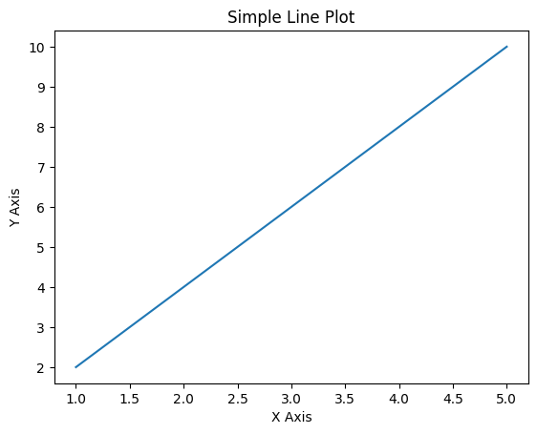

Data Structures and Operations
Data structures are ways of organizing and storing data so it can be accessed and modified efficiently. They are like the different types of containers you use to store things, but each type is designed for a specific purpose.
- Some containers (like a list) let you keep items in a specific order and change them whenever you want.
- Some (like a tuple) keep items in order but don’t let you change them — like sealing a box after packing.
- Others (like a dictionary) let you store information in a label–value style, so you can quickly find something using its label.
- And some (like a set) don’t care about order but make sure there are no duplicates.
The “organizing” part is how the data is structured internally — this determines how quickly you can search, insert, update, or delete things.
For instance:
- If you want to keep a list of students in the order they registered, use a list.
- If you want to link each student’s name to their score, use a dictionary.
- If you want to store unique tags for a project, use a set.

- Loading and manipulating datasets
Loading and manipulating datasets is the process of bringing data from a storage source into a working environment (like Python) and then cleaning, adjusting, or restructuring it so you can analyze it effectively. Common sources form where you can load datasets are:
  - CSV files (Comma-Separated Values)
  - Excel files
  - Databases (SQL, NoSQL)
  - APIs (fetching live data from the internet)
- Manipulating datasets
Once data is loaded, it often needs cleaning or reshaping before analysis. Tasks that can be done include:
- Selecting specific columns or rows
- Filtering data (e.g., only include sales after 2020)
- Renaming columns
- Handling missing values (fill, drop, or replace them)
- Sorting and grouping for summaries
- Merging datasets from different sources
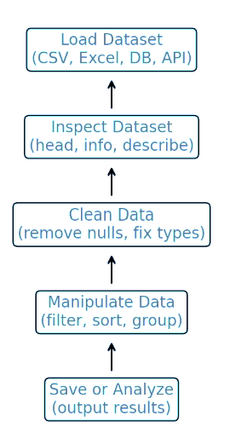
Figure 1: The process of loading and manipulating datasets

- Introduction to data visualization: Matplotlib, Seaborn
Data visualization is the process of turning raw data into visual forms like charts, graphs, and maps so patterns, trends, and relationships are easier to understand. In Python, two of the most widely used libraries for this are Matplotlib and Seaborn.

Matplotlib
- It a foundational plotting library in Python for creating static, animated, and interactive visualizations.
- Strengths:
  - Highly customizable (control over every element of a plot)
  - Supports a wide variety of plots (line, bar, scatter, histograms, etc.)
  - Good for low-level plotting where you want precise control.
Example:
import matplotlib.pyplot as plt
x = [1, 2, 3, 4, 5]
y = [2, 4, 6, 8, 10]
plt.plot(x, y)
plt.title("Simple Line Plot")
plt.xlabel("X-axis")
plt.ylabel("Y-axis")
plt.show()

DATA PREPROCESSING I- SECTION 3
Data preprocessing is a fundamental and often time-consuming step in the machine learning workflow. It transforms raw, imperfect data into a clean, structured format suitable for analysis and modeling. Without this crucial step, machine learning models are likely to perform poorly, producing inaccurate or unreliable results.
Why Data Preprocessing?
Raw data collected from the real world is rarely perfect. It usually contains missing values, inconsistent formats, or variables in a form that cannot be directly used by machine learning algorithms. Data preprocessing ensures that our dataset is clean, consistent, and machine-readable, which improves model accuracy and reliability.
Key Reasons for Data Preprocessing
1. Handling Missing Data
Raw data frequently has missing values due to data entry errors, equipment malfunctions, or simply a lack of information. Machine learning models cannot handle these gaps. If you feed a model a dataset with missing values, it will either crash or produce highly skewed results.
- Expansion: Common methods to handle missing data include:
  - Imputation: Filling in missing values with a substituted value, such as the mean, median, or mode of the feature. For categorical data, this might involve using the most frequent category.
  - Deletion: Removing rows or columns with missing values. This is only viable if the amount of missing data is small; otherwise, you risk losing valuable information.
  - Prediction: Using another machine learning model to predict and fill in the missing values.
2. Normalization and Scaling
Machine learning algorithms are sensitive to the scale of the features. A feature with a large range of values (e.g., salary) can dominate a feature with a small range (e.g., age), causing the model to prioritize the larger-scaled feature. Normalization and scaling techniques adjust the range of features to a standard scale.
  - Normalization (Min-Max Scaling): Rescales features to a fixed range, typically between 0 and 1. This is useful for algorithms like neural networks.
  - Standardization (Z-score normalization): Rescales features to have a mean of 0 and a standard deviation of 1. This is mostly effective for algorithms that assume a Gaussian distribution, such as Support Vector Machines (SVMs).
3. Handling Inconsistent and Noisy Data
Noisy data contains random errors or variance, such as outliers or incorrect values. Inconsistent data can have different formats for the same information (e.g., 'USA' vs. 'United States'). These issues can confuse a model and lead to incorrect learning. Cleaning this data involves the following steps:
  - Outlier Detection and Removal: Identifying and removing extreme values that can disproportionately influence a model's training. This can be done using statistical methods (e.g., Z-score) or visualization.
  - Data Deduplication: Removing duplicate records that can bias the model toward the duplicated information.
  - Data Formatting: Ensuring consistent data types and formats across the dataset. For example, converting all date formats to a single standard.
4. Feature Engineering
Raw data often is not usually in a format that is most useful for a model. Feature engineering involves creating new features from existing ones to improve model performance. This creative process can boost model accuracy. The following can be considered under here:
  - One-Hot Encoding: Converting categorical variables (e.g., 'color': 'red', 'green', 'blue') into a numerical format that a model can understand. This creates new binary columns for each category.
  - Feature Transformation: Applying mathematical functions (e.g., logarithm, square root) to a feature to change its distribution to make it more suitable for a model.
  - Creating Interaction Features: Combining two or more features to create a new one that captures their relationship (e.g., age * salary).

The Impact on Model Performance
Data preprocessing is not just a cleanup task; it directly impacts the reliability and accuracy of the final model. By preparing the data properly, you:
- Increase Model Accuracy: A clean, well-structured dataset allows the model to learn the true underlying patterns instead of noise and errors.
- Improve Training Efficiency: A clean dataset often leads to faster model convergence, reducing training time.
- Enhance Model Interpretability: A clean dataset makes it easier to understand which features are most important, leading to better insights.
In essence, garbage in, garbage out is a core principle in machine learning. No matter how sophisticated your model is, if the data you feed it is of poor quality, the results will be unreliable. Data preprocessing is the critical step that ensures the data is of high quality, setting the stage for a successful and reliable machine learning project.

Understanding Data Types
Before preprocessing, it is important to understand the types of data we work with.
- Categorical Data: Categorical data, also known as qualitative data, represents a set of distinct categories or labels. It classifies information into groups based on a qualitative characteristic rather than a numerical value. While the data may sometimes be represented by numbers (e.g., "1" for male, "2" for female), these numbers have no mathematical meaning and cannot be used for arithmetic operations like addition or averaging.
  - Represents discrete categories or labels.
  - Example: "Male", "Female", "Yes", "No", "Red", "Green", "Blue".
  - Machine learning algorithms cannot directly work with text labels — they must be converted into numerical representations.
- Numerical Data: Numerical data, also called quantitative data, represents information that can be counted or measured. Unlike categorical data, which represents labels or groups, numerical data consists of numbers that have mathematical meaning, allowing for arithmetic operations like addition, subtraction, and averaging.
  - Represents measurable quantities.
  - Two types:
    - Integer (discrete): e.g., number of children (0, 1, 2, …).
    - Float (continuous): e.g., height (165.4 cm), temperature (36.7 °C).
- Boolean Data: Boolean data is a fundamental data type that represents a logical state with only two possible values: true or false. In many programming languages and machine learning frameworks, these values are numerically represented as 1 for true and 0 for false.
  - Special case of categorical data with only two values: True/False or 0/1.
  - Example: "Is student enrolled? → Yes (1) / No (0)".
It is critical to understand data types in machine learning because different data types require specific preprocessing techniques to be effectively used by algorithms. Machine learning models cannot directly process raw, varied data formats; they need clean, numerical input to learn from.
Also, choosing the wrong preprocessing technique for a given data type can lead to a model that performs poorly, learns incorrect patterns, or fails to train at all. For example, using label encoding on nominal data would create an artificial hierarchy that could mislead the model. Therefore, identifying and understanding data types is the first and most crucial step in any successful machine learning project.

Practical Assignment
- Use Pandas to clean a sample dataset
- Apply label encoding and one-hot encoding

DATA PREPROCESSING II- SECTION 4
Why Preprocessing Matters (Recap)
We have seen how to clean raw data (handling missing values, encoding categories). However, even after cleaning, datasets are rarely ready for machine learning. Some models are sensitive to feature scales, others need irrelevant features removed, and we must always test model performance on unseen data. In this section, we are focusing on scaling, selecting, and splitting data.

4.1 Feature Scaling
Many machine learning algorithms (e.g., KNN, SVM, Neural Networks) are distance-based which means, they measure similarity using distances like Euclidean distance. If features are on different scales (e.g., "age in years" vs "salary in dollars"), larger values dominate and mislead the model.
Two Main Techniques
- Normalization (Min-Max Scaling)
  - Rescales data to a fixed range, usually [0, 1]. The formula is:
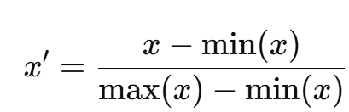
  - The formula is best when features have different ranges and you want bounded values (e.g., neural networks).
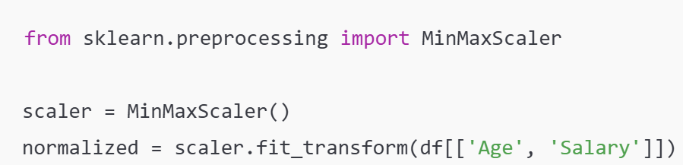
Example:
  - Age: [20, 30, 40, 50] → [0.0, 0.33, 0.67, 1.0]
  - Salary: [2000, 4000, 6000, 8000] → [0.0, 0.33, 0.67, 1.0]

- Standardization (Z-score Scaling)
  - Rescales data to have mean = 0 and standard deviation = 1. Formula:
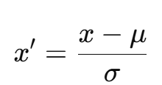
  - It is best used when data is normally distributed, or algorithm assumes Gaussian distribution (e.g., Linear Regression, Logistic Regression).
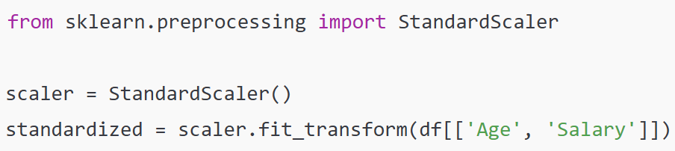
Example:
- Age: [20, 30, 40, 50], Mean = 35, Std = 12.9
- Transformed values: [-1.16, -0.39, 0.39, 1.16]

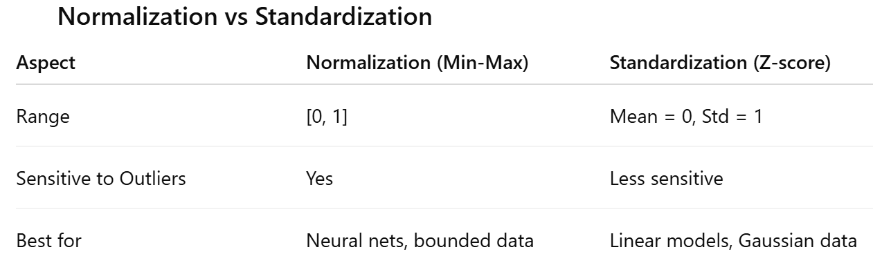

4.2 Feature Selection
Feature selection is the process of choosing a subset of the most relevant features (variables, predictors) for use in a machine learning model. The goal is to improve model performance by removing features that are irrelevant or redundant.
Why is Feature Selection Important?
- Reduces Model Complexity: A model with too many features becomes overly complex. Think of it like a detective trying to solve a case by considering every single piece of information, no matter how trivial. This can make the model difficult to interpret and prone to errors. By selecting only the most important features, we create a simpler, more manageable model that is easier to understand and debug.
- Prevents Overfitting: Overfitting occurs when a model learns the noise in training data and specific details too well. This makes the model to perform poorly on new, unseen data. Including irrelevant or redundant features increases the risk of overfitting because the model might mistakenly attribute importance to noise. By removing these features, we force the model to focus on the truly important patterns. This will lead to better generalization and more reliable predictions on new data.
- Speeds Up Training: A larger number of features requires more computational resources and time to train a model. Removing unnecessary features reduces the dimensionality of the dataset, which in turn reduces the computational cost. This leads to faster training times, allowing for quicker experimentation and deployment.
In essence, feature selection helps us build a more efficient, accurate, and robust model by getting rid of the "noise" and focusing on the "signal."
Methods of Feature Selection
Feature selection is a crucial process for improving the performance and efficiency of machine learning models. There are three main categories of methods to accomplish this: Filter, Wrapper, and Embedded methods.

1. Filter Methods
Filter methods are a quick and computationally inexpensive way to select features. They work by evaluating the relationship between each feature and the target variable using statistical measures. This evaluation happens independently of any machine learning model.
- How they work: Features are ranked based on a statistical score, and you then select the top-ranking features. Common statistical measures used include:
- Correlation Coefficient: For numerical features, this measures how strongly a feature is related to the target variable. A low correlation suggests the feature is not very useful for predicting the target.
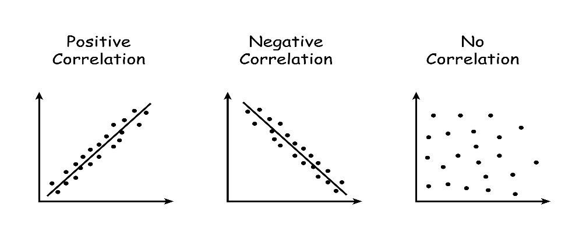
- Chi-Square Test: Used for categorical features, this statistical test measures the dependence between a feature and the target variable. A high chi-square value indicates a strong relationship.
- ANOVA F-value: This is used to test the relationship between a numerical target and a categorical feature.
- Pros: They are fast and computationally efficient because they do not involve training a model.
- Cons: They do not consider the interactions between features, which can be an important drawback. A feature that seems unimportant on its own might become very valuable when combined with another feature.

2. Wrapper Methods
Wrapper methods are generally more accurate than filter methods but are also more computationally intensive. They treat the feature selection process as a search problem and use a specific machine learning model to evaluate different subsets of features.
- How they work:
  - Recursive Feature Elimination (RFE): A common wrapper method that starts with all features and iteratively removes the least important ones. It trains a model on the remaining features, ranks them by importance, and then prunes the least important ones until the desired number of features is reached.
  - Forward Selection: Starts with no features and adds one at a time, training the model with each new addition, and selecting the one that most improves performance.
  - Backward Elimination: Starts with all features and iteratively removes the least important one, training the model with each removal, and continuing until performance no longer improves.
- Pros: They are highly accurate because they consider the performance of the actual model and the interactions between features.
- Cons: They are computationally expensive, especially with a large number of features, as they require training a new model for every subset of features.

3. Embedded Methods
They combine the benefits of both filter and wrapper methods. They perform feature selection as a part of the model training process. The algorithm itself has a built-in mechanism to select the most relevant features.
- How they work: These methods are "embedded" in the learning algorithm.
  - Lasso Regression (L1 regularization): This method automatically penalizes the coefficients of less important features, effectively shrinking them to zero. Any feature with a coefficient of zero is essentially "removed" from the model.
  - Tree-based Models (e.g., Random Forest, Gradient Boosting): These models have built-in feature importance scores. They calculate how much each feature contributes to the reduction of impurity (or error), and you can use these scores to select the top features.
- Pros: They are more efficient than wrapper methods and more accurate than filter methods because they consider feature interactions during training.
- Cons: The feature selection is specific to the model being used; a feature selected by Lasso might not be the same one selected by a Random Forest.
Example:
When predicting student exam scores, the feature "Eye Color" adds no value and should be dropped.

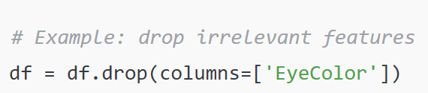
4.3 Splitting Datasets (Train/Test Sets)
Splitting a dataset into training and testing sets is a fundamental step in machine learning to ensure a model's performance is accurately and fairly evaluated. This process helps to determine how well a model will perform on new, unseen data, which is the major goal of machine learning.

Why is it Necessary to Split Data?
The core purpose of the train-test split is to prevent overfitting. Overfitting occurs when a model learns the training data, including its random fluctuations and noise, too well. It essentially "memorizes" the training set rather than learning the underlying patterns. If we were to train and test a model on the same data, the model would likely show a very high accuracy score. However, this score is misleading because it does not reflect the model's ability to generalize to new data. The model would fail enormously on any data it has not seen before. The train-test split addresses this by reserving a portion of the data specifically for a final, unbiased evaluation.

The Train-Test Split Process
The process involves randomly partitioning the dataset into two distinct subsets:
- Training Set: This is the largest portion of the dataset, typically comprising 70-80% of the data. This subset is used to train the machine learning model. The model learns the relationships, patterns, and features from this data. It is like the "classroom" where the model studies.
- Testing Set: This is the remaining portion, usually 20-30% of the data. This subset is held back and is not used during the training phase. It serves as an independent "final exam" to evaluate the model's performance on data it has never seen. The model's accuracy, precision, and other metrics on this set are a much more reliable indicator of its true performance and ability to generalize.
Best Practices for Splitting
- Randomness: The split must be random to ensure that both sets are representative of the overall data distribution. Using a non-random split could lead to biased training or testing sets.
- Proportion: The 70/30 or 80/20 split is a common rule of thumb, but the optimal proportion can depend on the size of the dataset. For very large datasets, a smaller testing set (e.g., 10%) might be sufficient.
- Stratification: For classification problems, it is also a good practice to use stratified sampling. This ensures that the proportion of each class (e.g., "Yes" vs. "No") in the training and testing sets is the same as in the original dataset. This prevents a situation where, by chance, the training set contains a disproportionate number of one class, which would skew the model's learning. For instance:
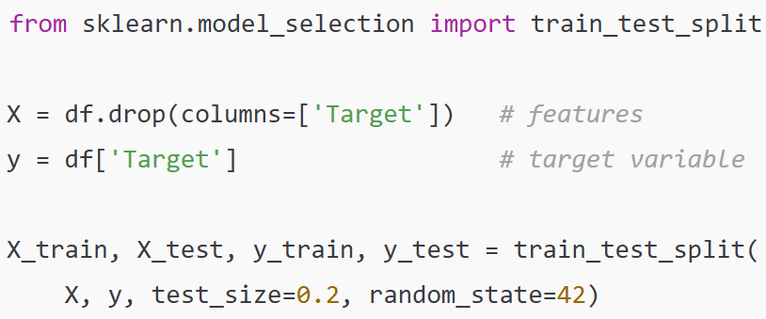

random_state=42 ensures reproducibility (same split at every run).

4.4 Lab Practice for scaling, feature selection, and dataset splitting steps
- Load Dataset
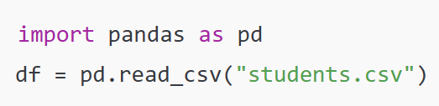
- Feature Scaling
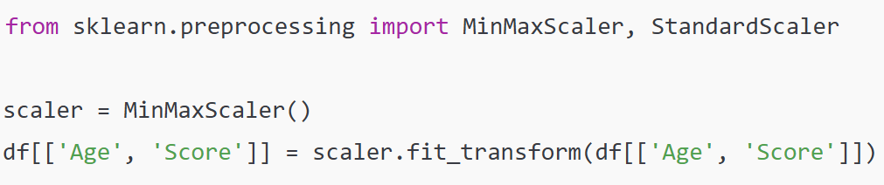
- Feature Selection
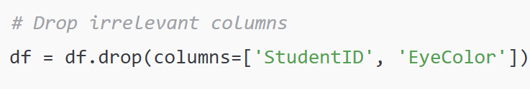
- Train-Test Split
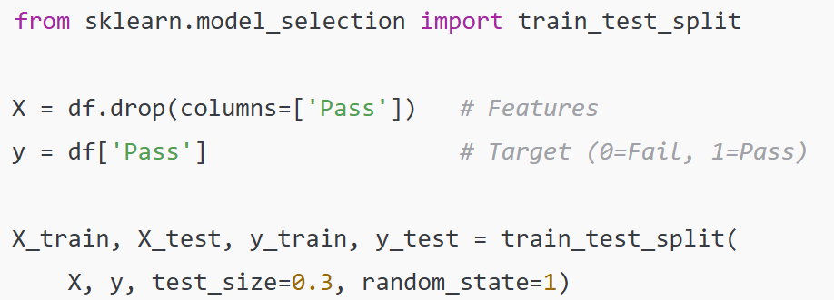

SUPERVISED LEARNING – REGRESSION- SECTION 5
Regression analysis is a core machine learning technique used to predict a continuous outcome based on a set of input variables. It is a powerful statistical method that helps us understand the relationships between different variables and make predictions about future outcomes. The fundamental goal of regression is to find a function that best describes the relationship between a dependent variable (the one you want to predict, also called the target or response variable) and one or more independent variables (the features or predictors). Consider the example of predicting house prices. The dependent variable is the house price, a continuous numerical value. The independent variables could be factors like the size of the house in square feet, the number of bedrooms, and its geographic location. Regression analysis finds the mathematical equation that uses these features to output a price prediction.

5.1 Regression vs. Classification: A Key Difference
It is easy to confuse regression with another supervised learning technique called “classification”. The key difference lies in the type of output they produce:
- Regression predicts a continuous numerical value. For examples:
    - Predicting the exact price of a house ($250,000).
    - Forecasting the amount of rainfall in inches (3.5 inches).
    - Estimating a student's final exam score (92.5).
- Classification predicts a discrete category or label. For examples:
    - Classifying an email as "spam" or "not spam."
    - Determining if an image contains a "cat" or a "dog."
    - Predicting if a customer will "churn" or "not churn."
When should Regression be used?
Regression is essential in many fields, from economics and finance to science and engineering. It allows us to:
- Make Predictions: Forecast future trends or values.
- Identify Influential Factors: Determine which independent variables have the most significant impact on the dependent variable.
- Test Hypotheses: Verify relationships between variables.

5.2 Linear Regression
Simple Linear Regression is a fundamental statistical method used to model the relationship between two continuous variables: a single independent variable (the feature, X) and a single dependent variable (the target, y). The core idea is to find a straight line that best fits the data points on a scatter plot, allowing us to predict the value of y for a given value of X. The formula for simple linear regression is:
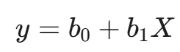
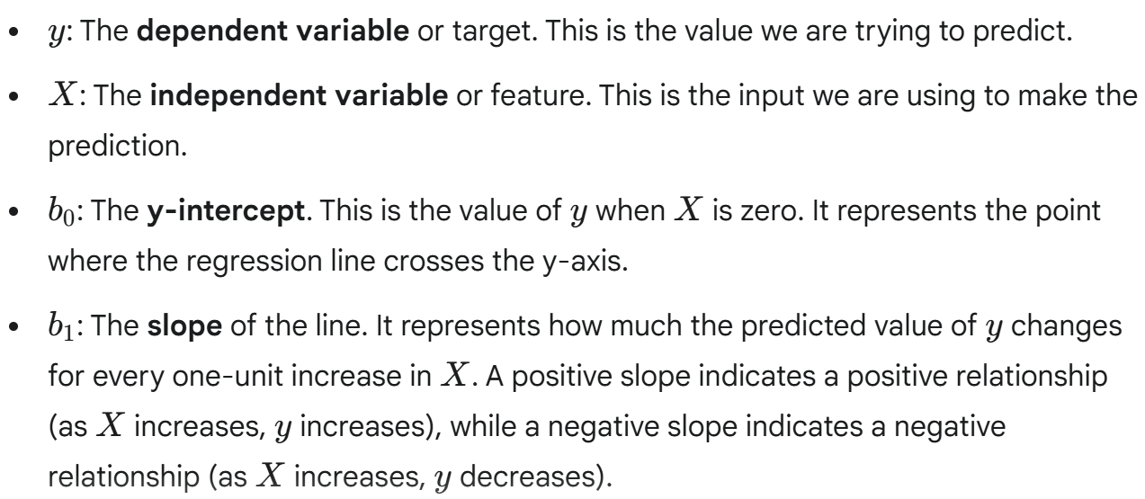

How It Works: The goal of simple linear regression is to find the values of b₀​ and b₁​ that minimize the difference between the predicted values (the points on the line) and the actual data points. This is typically done using the Ordinary Least Squares (OLS) method, which minimizes the sum of the squared distances (residuals) from each data point to the regression line. By minimizing these squared residuals, we find the "best-fit" line that provides the most accurate predictions.

Example: Predicting a student’s exam score based on hours studied.
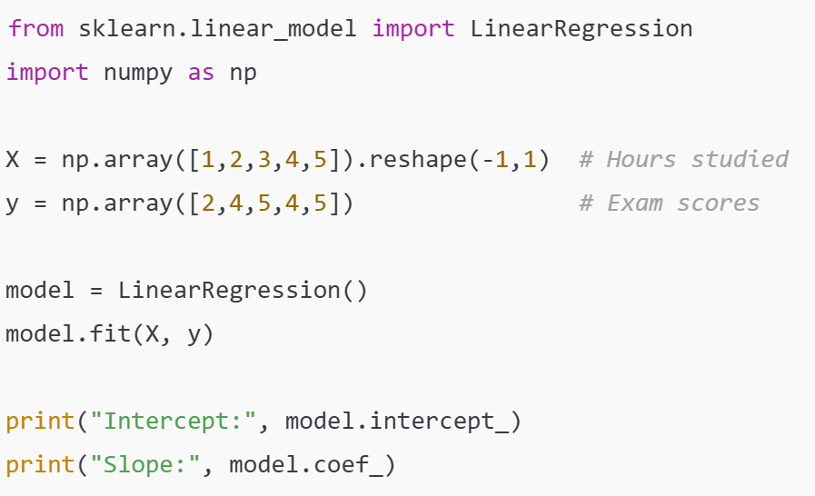
Multiple Linear Regression
Multiple Linear Regression extends simple linear regression by using more than one independent variable to predict a single dependent variable. This technique is more common in real-world applications because outcomes are rarely determined by a single factor. The formula for multiple linear regression is:

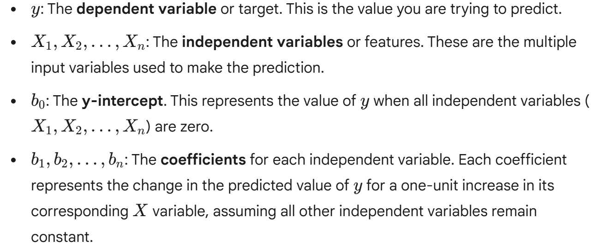
Similar to the simple linear regression, the goal is to find the optimal values for the coefficients (b₀​ to b_{n}​) that minimize the sum of the squared differences between the predicted values and the actual data points.

Example: Write a pseudocode using Multiple Linear Regression to predict salary based on years of experience, education level, and hours worked.

Pseudocode for Multiple Linear Regression
1. Start
Initialize the process.
2. Load and Prepare Data
- Load Data:
  - Create a data structure (e.g., a table or DataFrame) to hold the dataset.
  - Define the features: years_of_experience, education_level, hours_worked_per_week.
  - Define the target variable: salary.
- Preprocess Data:
  - Identify categorical features: education_level.
  - Encode Categorical Data:
    - Use Label Encoding to convert education_level (e.g., 'Bachelor', 'Master', 'PhD') into numerical values (e.g., 0, 1, 2) to create a new feature education_level_encoded.
    - Store this mapping for future reference.
3. Split the Dataset
- Define Features and Target:
  - Create a set X with the independent variables: years_of_experience, education_level_encoded, hours_worked_per_week.
  - Create a set y with the dependent variable: salary.
- Split Data:
  - Divide the data into two subsets: a training set and a testing set.
  - Typically, allocate 80% of the data to the training set (X_train, y_train) and the remaining 20% to the testing set (X_test, y_test).
  - Ensure the split is done randomly.
4. Train the Model
- Initialize Model:
  - Create an instance of a Linear Regression model.
- Fit Model:
  - Train the model using the training data (X_train, y_train).
  - The model will learn the coefficients (b0​, b1​, b2​, b3​) that best fit the data.
5. Evaluate Model Performance
- Make Predictions:
  - Use the trained model to predict salaries on the testing data (X_test).
  - Store these predictions as y_pred.
- Calculate Metrics:
  - Compute performance metrics to evaluate the model's accuracy, such as:
    - Mean Squared Error (MSE): Measures the average squared difference between the actual and predicted values.
    - R-squared (R2): Represents the proportion of the variance in the dependent variable that is predictable from the independent variables.
6. Predict New Values
- Provide New Data:
  - Input a new set of feature values for a person (e.g., 6 years of experience, 'Master's degree' (represented as 1), 45 hours worked).
- Predict Salary:
  - Use the trained model to predict the salary for this new data.
- Output Result:
  - Display the predicted salary.
7. End

5.3 Polynomial Regression
Polynomial regression is a type of regression analysis used to model the relationship between the independent variable(s) and the dependent variable as an n-th degree polynomial. This technique is a powerful extension of linear regression that allows for curved fits to the data, making it suitable for datasets where the relationship is not a simple straight line. The formula for polynomial regression is an extension of the multiple linear regression equation, where we add polynomial terms (e.g., X², X³) as new features.

For a single independent variable (X), the formula for a polynomial of degree k is:

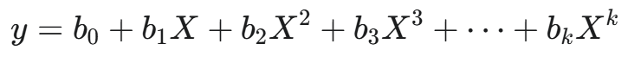
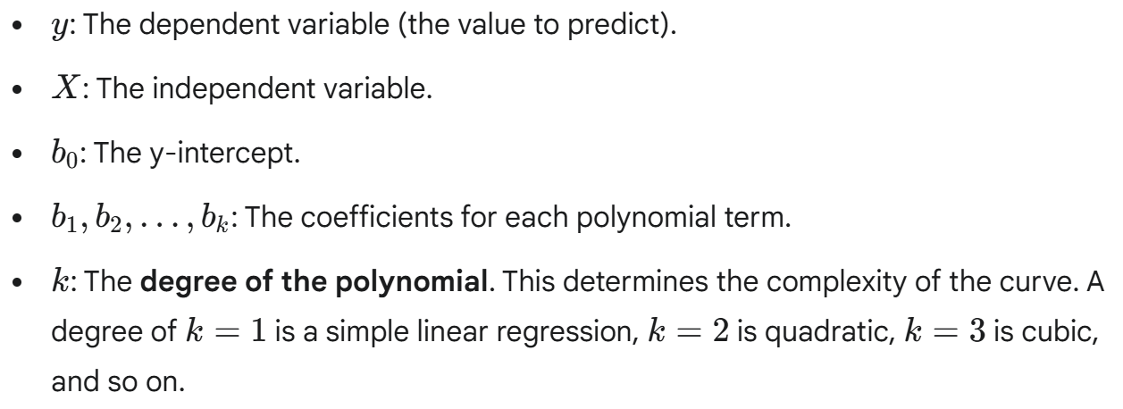
The "Linear" in Polynomial Regression
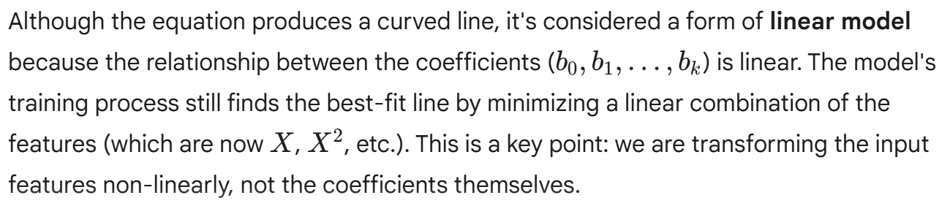

Example: To predicting the growth of plants over time — growth accelerates, then slows, which is not a straight line.
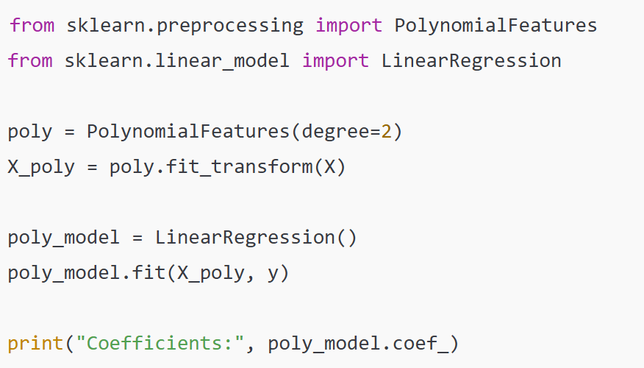
5.4 Evaluation Metrics for Regression
Evaluation metrics are crucial for measuring how well a regression model's predictions align with the actual values. They provide a quantitative way to assess the model's performance and compare different models.

- Mean Absolute Error (MAE)
It is a simple and intuitive metric that measures the average magnitude of the errors in a set of predictions, without considering their direction. It tells you, on average, how far your predictions are from the actual values. The formula for MAE is:
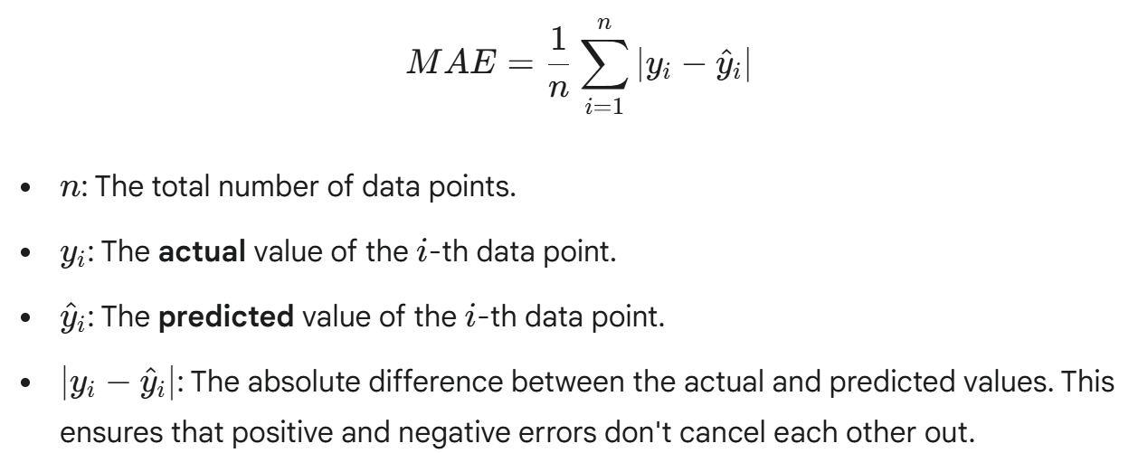

Why Use MAE?
- Interpretability: MAE is in the same units as the dependent variable, making it very easy to understand. For example, if you are predicting house prices in dollars, an MAE of $5,000 means your predictions are, on average, off by $5,000.
- Robustness to Outliers: Unlike other metrics like Mean Squared Error, MAE is less sensitive to outliers because it does not square the errors. A large error from an outlier has a smaller impact on the overall MAE score, which makes it a good choice when your data contains significant anomalies.

- Mean Squared Error (MSE)
It is one of the most common metrics used to evaluate the performance of a regression model. It measures the average of the squared differences between the predicted and actual values. By squaring the errors, MSE gives a higher penalty to larger errors, which makes it particularly useful when large errors are undesirable. The formula for MSE is:
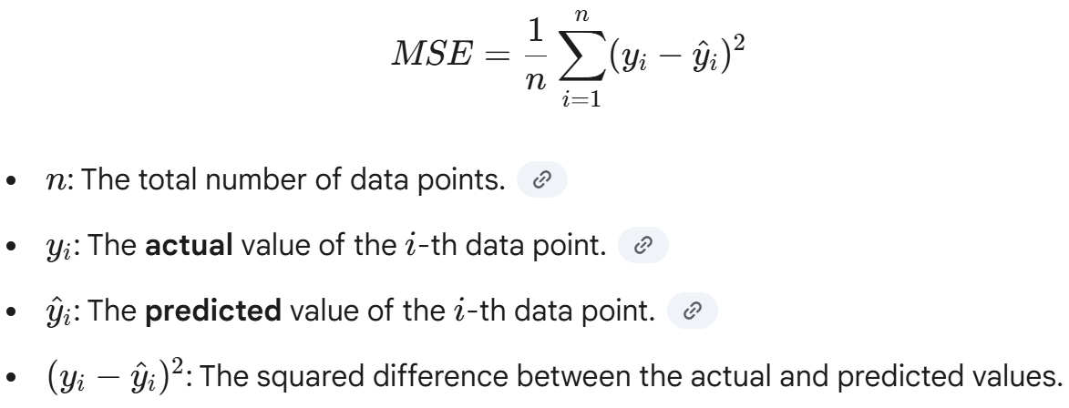
Why Use MSE?
- Penalizes Large Errors: The squaring of the error term means that a model with a few large errors will have a significantly higher MSE than a model with many small errors, even if the sum of the absolute errors is similar. This characteristic makes MSE a good choice when you want to heavily penalize outliers.
- Mathematical Convenience: The squared function is differentiable, which is a crucial property for many optimization algorithms, such as gradient descent, that are used to train machine learning models. This makes MSE a popular choice for cost functions.
Disadvantages
- Units: Since the error is squared, the unit of MSE is also squared. This makes it less intuitive to interpret than MAE. For example, if your target variable is in dollars, the MSE will be in dollars squared.
- Sensitivity to Outliers: While penalizing large errors can be an advantage, it also means that MSE is very sensitive to outliers. A single outlier can disproportionately increase the MSE. This makes it a potentially misleading metric if the dataset contains many anomalies.

- Root Mean Squared Error (RMSE)
The Root Mean Squared Error (RMSE) is an extension of the Mean Squared Error (MSE). It's calculated by taking the square root of the MSE. This simple transformation makes the metric much more interpretable because the resulting value is in the same units as the dependent variable. The formula for RMSE is:
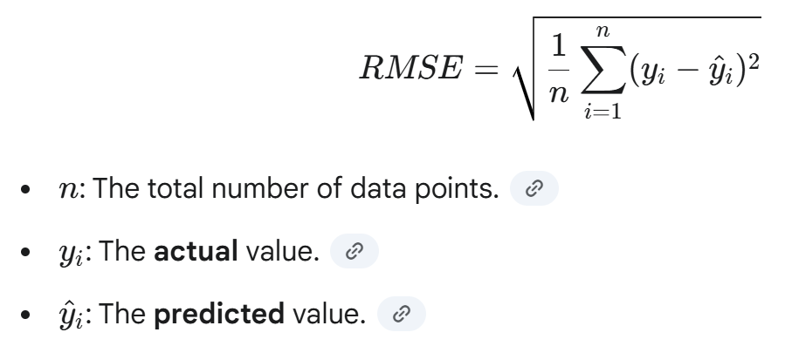
Why Use RMSE?
- Interpretability: The primary advantage of RMSE over MSE is that it is in the same unit as the target variable. For example, if you are predicting house prices in dollars, an RMSE of $2,000 means the model's predictions are, on average, off by about $2,000. This makes it much easier to communicate the model's performance to non-technical stakeholders.
- Emphasis on Large Errors: Like MSE, RMSE also penalizes large errors more heavily than small ones due to the squaring operation inside the formula. This makes it a good metric to use when large prediction errors are particularly undesirable.
- Standard Practice: RMSE is a widely used and well-understood metric in many fields, from data science to climate science, and this makes it a common choice for reporting model performance.
In general, RMSE is a good all-purpose metric for regression problems as it provides a balance between penalizing large errors and being easy to interpret.

- R² Score (Coefficient of Determination)
The R² Score, also known as the Coefficient of Determination, is a key metric in regression analysis that measures how well the model's predictions explain the variability of the dependent variable. In simpler terms, it indicates the proportion of the variance in the target variable that can be predicted from the independent variable(s). The formula for the R2 score is:
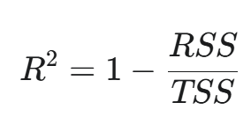
Where, RSS (Residual Sum of Squares) is the sum of the squared differences between the actual values and the model's predicted values. It represents the variance not explained by the model.

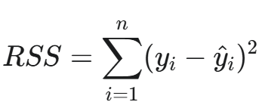
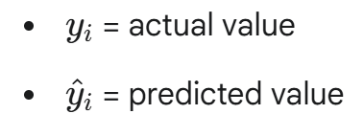

TSS (Total Sum of Squares) is the sum of the squared differences between the actual values and the mean of the actual values. It represents the total variance in the dependent variable.
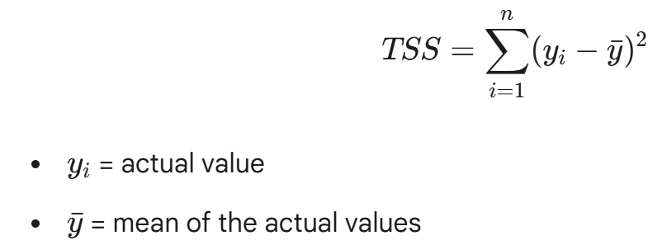
Interpretation
The value of R² ranges from 0 to 1.
- An R² of 1 means the model perfectly explains the variance of the target variable. The model's predictions align well with the actual data points.
- An R² of 0 indicates that the model explains none of the variance. The model is no better than simply predicting the mean of the target variable for every data point.
- An R² of 0.75 suggests that 75% of the variance in the target variable is explained by the model's features.
R² is not a definitive measure of a model's goodness. A high R² can be misleading if the model is overfitted. The Adjusted R² is a more reliable version that accounts for the number of features in the model, providing a more balanced evaluation.

5.5 Lab Practice for the Implementation of Regression Analysis
Regression analysis is implemented by building a model to predict a continuous outcome from a dataset, a process that involves a sequence of steps from data preparation to model evaluation.

Step 1: Import Libraries & Dataset
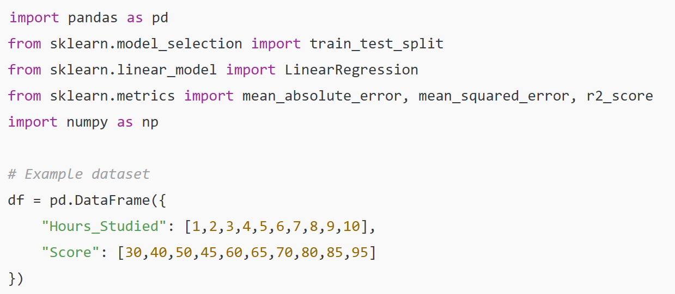
Step 2: Train-Test Split
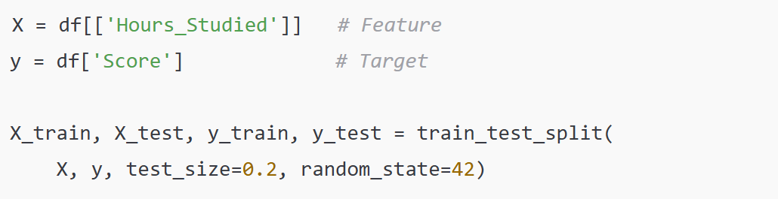
Step 3: Train Linear Regression Model
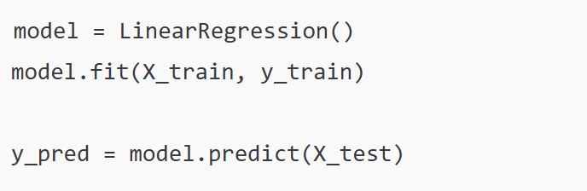
Step 4: Evaluate Performance
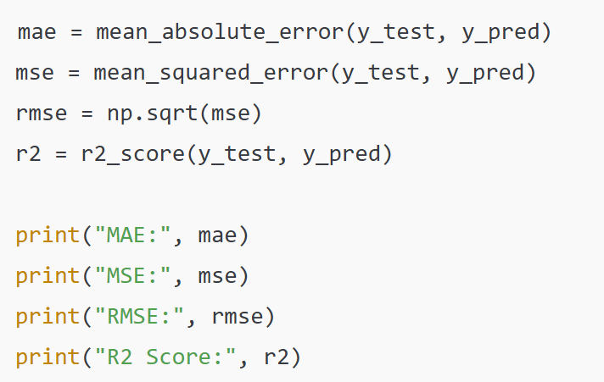

SUPERVISED LEARNING – CLASSIFICATION- SECTION 6
Classification is a fundamental supervised learning task where a model learns to predict a discrete category or class for a given input. Unlike regression, which predicts a continuous number, classification sorts data points into predefined labels. This is a core task in many real-world applications, from medical diagnosis to image recognition.

6.1 Types of Classifications
Binary classification and multi-class classification are the two main types, with the former distinguishing between two categories (e.g., spam vs. not spam) and the latter distinguishing among three or more categories (e.g., classifying fruits as apple, orange, or banana).

Binary Classification: This is the simplest type of classification, where there are only two possible classes for the model to predict. The model essentially makes a yes-or-no decision.
- Example: Email Spam Detection. The model's task is to determine if an email belongs to one of two categories: Spam or Not Spam.
- Other Examples:
  - Medical Diagnosis: "Does the patient have a certain disease?" (Yes/No).
  - Fraud Detection: "Is the transaction fraudulent?" (Yes/No).
  - Quality Control: "Is the product defective?" (Yes/No).
The output of a binary classifier is usually a probability score (e.g., 95% chance of being spam), which is then converted into a final class prediction based on a threshold (e.g., if the probability is > 0.5, classify as spam).

Multi-class Classification: It involves more than two possible classes. The model must choose one class from a list of three or more mutually exclusive categories.
- Example: Handwritten Digit Recognition. The model must classify an image of a handwritten digit into one of ten possible classes: 0, 1, 2, 3, 4, 5, 6, 7, 8, or 9.
- Other Examples:
  - Image Classification: "What kind of animal is in this picture?" (Cat, Dog, Bird, etc.).
  - News Article Tagging: "What is the topic of this article?" (Politics, Sports, Technology, etc.).
  - Sentiment Analysis: "Is the review positive, neutral, or negative?"
In multi-class classification, models are trained to output a probability for each possible class. The class with the highest probability is then chosen as the final prediction.

6.2 Logistic Regression
Logistic Regression is a statistical model used for binary classification, despite its name. It predicts the probability that an instance belongs to a certain class, with the output always falling between 0 and 1. Unlike linear regression, which outputs a continuous value, logistic regression uses a special function called the sigmoid function to transform its output. The sigmoid function takes any real-valued number and maps it to a value between 0 and 1, which can be interpreted as a probability. For a simple case with a single feature (x), the formula is:
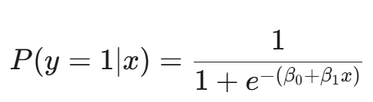

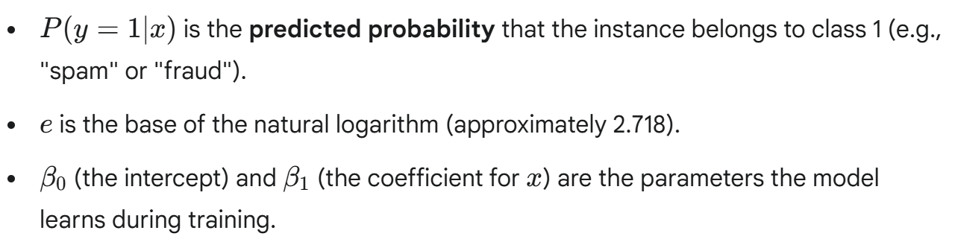
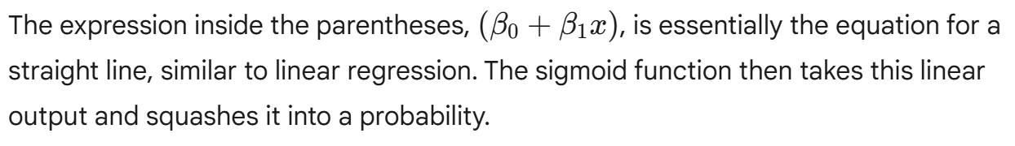
Decision Boundary: Once the model predicts a probability, a decision boundary is used to classify the instance. This is typically a threshold, often set at 0.5. If the predicted probability is greater than 0.5, the instance is classified as belonging to class 1; otherwise, it is classified as class 0.

Beyond Binary: Logistic regression can also be extended for multi-class classification using techniques like One-vs-Rest, where a separate logistic regression model is trained for each class to distinguish it from all other classes.

Example: To predicting whether a student passes (1) or fails (0) based on study hours.
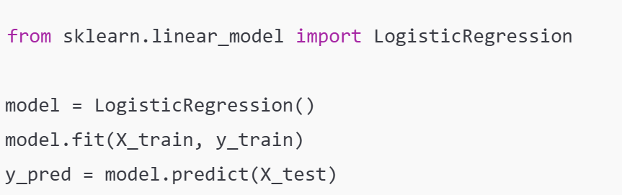

6.3 K-Nearest Neighbors (KNN)
K-Nearest Neighbors (KNN) is a simple yet powerful lazy learning algorithm used for both classification and regression. Unlike other models that learn a function from the training data, KNN simply stores the entire training dataset. It does not perform any real computation until it is time to make a prediction. This "lazy" approach makes it an intuitive and easy-to-understand algorithm.

Implementation Steps of K-Nearest Neighbors (KNN)
When a new, unseen data point needs to be classified, KNN follows these steps:
- Choose k: First, you must select the value of k, which represents the number of neighbors to consider. Choosing the right k is central and can impact the model's performance. A small k can be sensitive to noise, while a large k might smooth out the decision boundary too much.
- Measure Distance: The algorithm calculates the distance between the new data point and every single data point in the training set. A common method is the Euclidean distance, which is the straight-line distance between two points in Euclidean space.
- Find the k-Nearest Neighbors: After calculating all the distances, the algorithm identifies the k data points from the training set that are closest to the new point.
- Assign the Class: The new data point is assigned to the class that is most common among its k nearest neighbors. For example, if k=5 and three of the five neighbors are "Iris-setosa" while two are "Iris-versicolor," the new data point will be classified as "Iris-setosa."
This simple, majority-vote mechanism makes KNN a straightforward and effective model for many classification tasks.

The "Lazy" Advantage and Disadvantage
The main advantage of KNN is its simplicity and lack of a training phase. It can be very effective for datasets with complex or irregular decision boundaries.
However, its "laziness" is also its biggest disadvantage. Because it stores the entire dataset, KNN can be computationally expensive and slow for prediction on large datasets, as it has to calculate the distance to every single training point for each new prediction.

Example: Predicting whether a flower is Iris-setosa, Iris-versicolor, or Iris-virginica based on petal measurements.
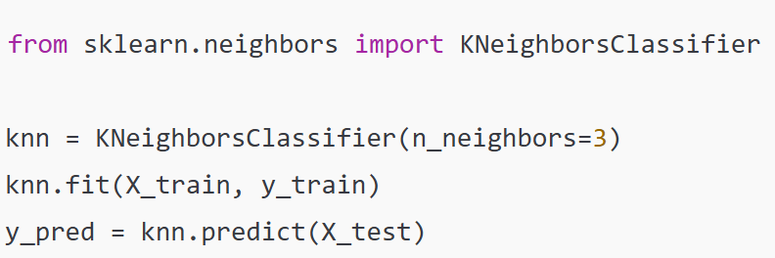

6.4 Decision Trees
Decision Trees are a non-parametric supervised learning algorithm used for both classification and regression tasks. They model decisions as a tree-like structure, breaking down data into smaller and smaller subsets based on feature values until a final prediction is reached. They are a favorite for their interpretability. The decision tree algorithm recursively splits the data based on the most significant features. The process begins with the entire dataset at the root node and proceeds as follows:
- Splitting the Data: The algorithm evaluates different features to find the one that best divides the data into distinct, homogeneous groups. The "best" split is determined by metrics like Gini Impurity or Information Gain, which measure how effectively a feature separates the classes. For example, in a tennis example, the tree might first split based on "Weather," as it is the most central factor.
- Creating Nodes: Each split creates a new internal node in the tree. This node represents a condition or question (e.g., "Is the weather 'Sunny'?").
- Branching: The data is then distributed down the branches according to the answer to the question.
- Reaching a Leaf: The splitting process continues until a leaf node is reached. A leaf node is a terminal node that represents the final prediction or class label (e.g., "Play Tennis" or "Don't Play Tennis").

Advantages and Disadvantages
Advantages:
- Easy to Interpret: The tree's structure mimics human decision-making, which makes it very easy to understand and explain.
- Minimal Data Preparation: They require less data cleaning and preprocessing compared to other algorithms.
Disadvantages:
- Prone to Overfitting: Decision trees can easily become overly complex and memorize the training data. This can lead to poor performance on new data. This happens when the tree is allowed to grow too deep.
- Instability: A small change in the data can lead to a completely different tree structure, making them unstable.

Example: To predicting whether to play tennis based on weather conditions (Sunny, Rainy, Humid).
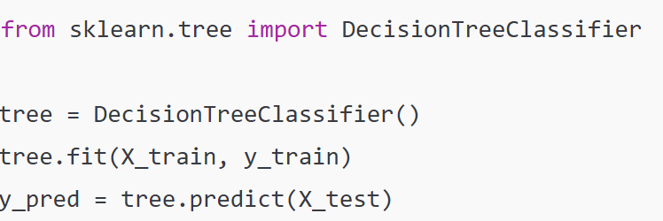

6.5 Confusion Matrix and Classification Report
It is a table that summarizes the performance of a classification model. It shows the number of correct and incorrect predictions made by the model, broken down by each class. It's a much more informative way to evaluate a model than simple accuracy, especially when dealing with imbalanced datasets.

Components of a Confusion Matrix
A typical binary classification confusion matrix has four key components:
- True Positive (TP): The number of instances correctly predicted as the positive class.
  - Example: The model correctly predicted a transaction as fraudulent.
- True Negative (TN): The number of instances correctly predicted as the negative class.
  - Example: The model correctly predicted an email as not spam.
- False Positive (FP): The number of instances incorrectly predicted as the positive class when they were actually negative. This is also known as a Type I error.
  - Example: The model incorrectly predicted a benign tumor as malignant.
- False Negative (FN): The number of instances incorrectly predicted as the negative class when they were actually positive. This is also known as a Type II error.
  - Example: The model incorrectly predicted a fraudulent transaction as genuine.
Why confusion matrix Useful
The confusion matrix provides a detailed breakdown of a model's performance. By looking at the different types of errors, you can understand where your model is making mistakes. For instance, in a medical diagnosis task, a False Negative (failing to detect a disease) is far more serious than a False Positive (wrongly diagnosing a healthy person with a disease), and the confusion matrix highlights this imbalance. Table 1 is a 2x2 table (for binary) that compares predicted vs actual classes.

 | Predicted Positive | Predicted Negative
Actual Positive | True Positive (TP) | False Negative (FN)
Actual Negative | False Positive (FP) | True Negative (TN)

Metrics derived are as follow:
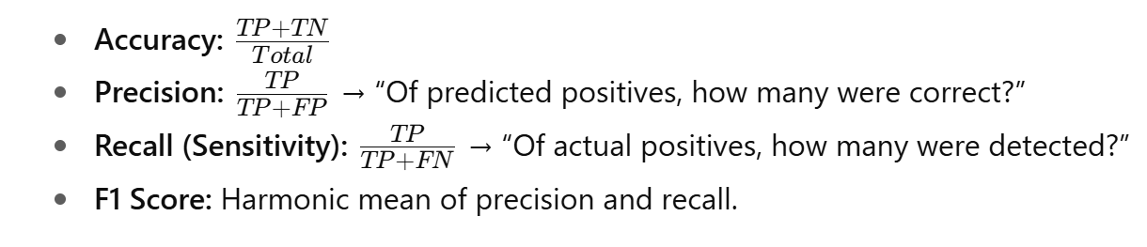
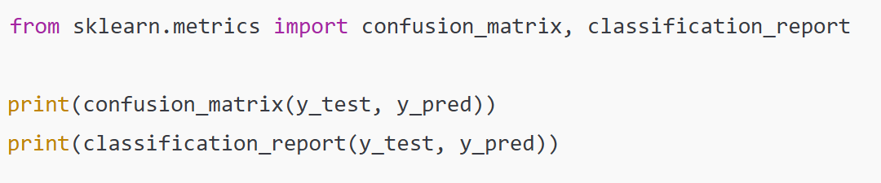

MODEL EVALUATION AND VALIDATION- SECTION 7
Model evaluation and validation are essential steps in the machine learning process to determine how well a trained model will perform on new, unseen data, ensuring its predictions are reliable and its performance metrics are trustworthy. The Bias-Variance Tradeoff, Cross-validation techniques, Overfitting and Underfitting, and Model Selection techniques are a core set of concepts and practices in Model Evaluation and Validation. They represent the foundational principles and methods used to ensure a machine learning model is both accurate and reliable.

- Bias-Variance Tradeoff
The Bias-Variance Tradeoff is a central concept in machine learning that describes the challenge of simultaneously minimizing two sources of error that prevent a model from generalizing well to new data. A model's total error on a test set is the sum of its bias, its variance, and a third component called irreducible error.
- Bias represents the error from overly simplistic assumptions in the learning algorithm. A model with high bias is too simple to capture the underlying patterns in the data, leading it to consistently miss the mark. This results in underfitting, where the model performs poorly on both the training and test data because it's not complex enough to learn the relationships. Think of it as an inaccurate, but consistent, shot at a dartboard.
- Variance represents the error from the model's sensitivity to small fluctuations in the training data. A model with high variance is too complex and fits the training data too closely, effectively memorizing the noise and random variations. This results in overfitting, where the model performs exceptionally well on the training data but fails to generalize to new data because it hasn't learned the general pattern. This is like a very inconsistent, but on average correct, shot at a dartboard.
- The Tradeoff is the inverse relationship between these two errors. As you make a model more complex to reduce bias (e.g., adding more features or polynomial terms), its variance tends to increase because it becomes more sensitive to the training data. Conversely, simplifying a model to reduce variance increases its bias. The goal is to find the sweet spot where both bias and variance are low enough to minimize the total error and achieve optimal performance on unseen data.

- Overfitting and Underfitting
Models that are either too simple or too complex fail to learn the underlying patterns in data effectively, leading to poor predictive performance. Finding the ideal fit is about balancing this complexity.

Underfitting: It occurs when a model is too simple to capture the fundamental relationships within the data. It is like trying to explain a complex topic with an overly simplified analogy. You can miss all the important details in such situation. This results in the model having high bias and low variance. The model is too rigid and makes the same consistent, but wrong, predictions across different data sets.
- Indications: The model performs poorly on both the training data and new, unseen test data.
- Example: Predicting house prices using only the number of rooms and ignoring crucial factors like square footage, location, and age. This simple model cannot capture the true complexity of the housing market, leading to inaccurate predictions.

Overfitting: It happens when a model is too complex and has learned not just the underlying patterns but also the noise and random fluctuations in the training data. This results in the model having low bias but high variance. It's like memorizing the answers to a specific test without understanding the subject. You ace that test but fail a different one.
- Indications: The model performs exceptionally well on the training data but poorly on the test data.
- Example: A decision tree that is allowed to grow too deep will create a rule for every single data point in the training set, including any outliers or errors. When presented with new data, these overly specific rules fail to generalize.

Ideal Fit
The ideal fit is the goal of every machine learning task. It is the balance between a model that is too simple and one that is too complex. A model with an ideal fit has a balanced complexity, a healthy level of both bias and variance.
- Characteristics: The model performs well on both the training data and, most importantly, on the test data. It has learned the generalizable patterns without getting bogged down in noise.
- Outcome: The model is ready to be deployed to make reliable and accurate predictions on real-world data.

- Cross-validation techniques
Cross-validation is a set of techniques used to reliably assess a model's performance and ensure it generalizes well to new data by systematically training and testing it on different subsets of the dataset.

1. The Hold-out Method: is the simplest and most common form of validation. You split the dataset into two parts: a training set to fit the model and a testing set to evaluate its performance. This is the train-test split you often see.
- Pros: It's fast and easy to implement.
- Cons: The model's performance can be highly dependent on the random nature of the single split. A "lucky" split might give you an overly optimistic result, while a "bad" split could lead to a pessimistic one. It also withholds a significant portion of data for testing, which means the model isn't trained on the entire dataset.
2. K-Fold Cross-Validation: is a more robust technique that provides a more reliable estimate of model performance. The dataset is first divided into k equally sized subsets or "folds." The process then repeats k times. In each iteration, one-fold is used as the testing set, and the remaining k−1 folds are used for training.
- Process:
  - The dataset is divided into 5 or 10 folds.
  - For the first iteration, fold 1 is the test set, and folds 2-5 are the training set.
  - For the second iteration, fold 2 is the test set, and folds 1, 3, 4, and 5 are the training set.
  - This continues until every fold has served as the test set exactly once.
- Final Result: The performance metric (e.g., accuracy, MSE) is calculated for each of the k iterations, and the final reported performance is the average of these k scores. This average is a much more stable and reliable estimate of the model's true performance.
3. Stratified K-Fold Cross-Validation: is a variation of k-fold that is essential for imbalanced datasets (where one class is much more frequent than others). It ensures that each of the k folds has the same proportion of classes as the original dataset.
- Why it is important: Without stratification, a standard k-fold split could, by chance, create a fold with very few or even zero instances of the minority class. The model would then be unable to learn to predict that class, leading to a misleadingly poor performance score. Stratified k-fold prevents this and provides a fairer evaluation.
4. Leave-One-Out Cross-Validation (LOOCV): is an extreme form of k-fold where the number of folds (k) is equal to the number of data points (n). In each iteration, a single data point is used as the test set, and the remaining n−1 points are used for training.
- Pros: It is a highly accurate and unbiased method for evaluating model performance because every single data point gets to be the test set exactly once. The model is also trained on almost the entire dataset.
- Cons: It is extremely computationally expensive and slow, which makes it impractical for large datasets. You have to train the model n times, which can be millions of times for a large dataset.

- Model selection techniques
Model selection is the process of choosing the best-performing model from a set of candidates for a given machine learning problem. It involves both selecting the right algorithm and tuning its parameters to achieve optimal performance on new, unseen data.

  - Hyperparameter Tuning Techniques
Hyperparameters are the parameters of a model that are not learned from the data but are set by the user before training. Choosing the right hyperparameters is central for model performance.
- Grid Search: This is a brute-force method that systematically tries every possible combination of hyperparameters specified in a grid. For example, if you want to tune a K-Nearest Neighbors model, you might create a grid with k values from 1 to 20. Grid search will train a model for each of those 20 values, and the one that performs best is selected. While it guarantees finding the best combination within the defined grid, it can be computationally very expensive if the number of hyperparameters and their values are large.
- Random Search: As an alternative to Grid Search, Random Search randomly samples a fixed number of hyperparameter combinations from the specified search space. This approach is often more efficient because it is more likely to find a good combination faster than a systematic grid search, especially when many hyperparameters have a small impact on the model's performance. It's a great choice when your hyperparameter search space is very large.
- Bayesian Optimization/AutoML: These are more advanced and intelligent techniques. Instead of just randomly or exhaustively searching, they use the results of previous trials to intelligently choose the next best set of hyperparameters to test. They build a probabilistic model of the objective function (e.g., model accuracy) and use it to guide the search, making them much more efficient than Grid Search or Random Search. This is a common approach in modern automated machine learning (AutoML) tools.

2. Using Evaluation Metrics for Selection
After a model is trained with a specific set of hyperparameters, its performance must be evaluated using appropriate metrics.
- For Classification: You should use metrics like Precision, Recall, and F1-score, in addition to simple Accuracy. Accuracy can be misleading on imbalanced datasets, whereas Precision and Recall provide a more detailed view of the model's performance on each class. The ROC-AUC (Receiver Operating Characteristic - Area Under Curve) is also a robust metric for binary classification that evaluates the model's ability to distinguish between classes across various threshold settings.
- For Regression: Metrics like Mean Absolute Error (MAE), Mean Squared Error (MSE), and Root Mean Squared Error (RMSE) are used to measure the difference between predicted and actual values. The R-squared (R2) Score measures the proportion of variance in the dependent variable that is predictable from the independent variables.
- The Importance of Cross-Validation: It is vital to always use cross-validation scores when selecting a model or tuning hyperparameters. Using only the training accuracy will lead to selecting an overfitted model that performs poorly on new data. By using cross-validation, you get an average performance score across multiple training/testing splits, which is a much more reliable indicator of how well the model will generalize.

UNSUPERVISED LEARNING – CLUSTERING- SECTION 8

8.1 Clustering
Clustering is an unsupervised machine learning task that organizes a dataset into groups or clusters based on the inherent similarity of the data points. Unlike supervised learning, it doesn't rely on pre-existing labels or categories. The model discovers the hidden structure in the data on its own.
The primary goal of clustering is to find meaningful groupings. This is achieved by maximizing two key principles:
- High Intra-cluster Similarity: Data points within the same cluster should be as similar to each other as possible.
- Low Inter-cluster Similarity: Data points in different clusters should be as dissimilar from each other as possible.
The "similarity" or "dissimilarity" is measured using distance metrics, such as Euclidean distance, between data points in a multidimensional space.

Clustering is a versatile technique with different applications in several industries:
- Customer Segmentation: Businesses use clustering to group customers with similar purchasing habits, demographics, or behaviors. This allows for targeted marketing campaigns and personalized product recommendations, as seen in the example of grouping supermarket customers.
- Image Processing: In image compression, clustering can be used to group pixels with similar color values, reducing the number of unique colors and thus the file size. In pattern recognition, it can identify similar shapes or objects within an image.
- Natural Language Processing (NLP): Clustering is used to group similar documents, articles, or topics. This helps in organizing large text corpora and building recommendation systems.
- Anomaly Detection: Data points that are far from any cluster are considered outliers or anomalies. This is used to detect fraudulent transactions, network intrusions, or defective products on an assembly line.
In essence, clustering is about finding order in chaos by automatically discovering natural groupings within complex datasets.

8.2 K-Means Clustering
K-Means is an unsupervised clustering algorithm that partitions a dataset into K distinct, non-overlapping clusters. The core idea is to group data points into clusters where each point belongs to the cluster with the nearest centroid, which is the center or mean of that cluster. This simple, iterative process aims to minimize the distance between data points and their assigned cluster's centroid.
Algorithm Steps
- Choose K: You must first specify the number of clusters (K) you want to find in the data. This is a crucial hyperparameter that needs to be determined before the algorithm runs.
- Initialize Centroids: The algorithm randomly selects K data points from the dataset to serve as the initial centroids for each cluster.
- Assign Data Points: Each data point is assigned to the nearest centroid. The "nearest" is typically measured using the Euclidean distance.
- Update Centroids: After all points are assigned, the algorithm recalculates the centroid for each cluster by taking the average of all data points within that cluster.
- Repeat: Steps 3 and 4 are repeated until the centroids no longer change significantly. At this point, the clusters have converged, and the algorithm stops.
Strengths: K-Means is a popular algorithm because it's simple, fast, and computationally efficient, making it ideal for large datasets. It scales well with the number of data points.
Limitations: Its main drawbacks are the need to manually define K beforehand, its sensitivity to the initial random placement of centroids, and its struggle with clusters that are non-spherical or have varying densities.

Example of K-Means Clustering: Segmenting a dataset of students into groups based on study hours and exam performance.
8.3 Hierarchical Clustering
Hierarchical clustering builds a nested sequence of clusters, which can be visualized as a dendrogram (a tree-like diagram). Unlike K-Means, you don't need to specify the number of clusters (K) in advance; you can decide the number of clusters by cutting the dendrogram at a specific height.
Two Approaches of Hierarchical Clustering
- Agglomerative (Bottom-Up): This is the most common approach. It starts with each data point as its own individual cluster. In each step, the algorithm merges the two closest clusters, continuing until all points are in a single, all-encompassing cluster.
- Divisive (Top-Down): This approach works in the opposite direction. It begins with all data points in a single cluster and recursively splits the clusters into smaller ones until each data point is its own cluster.
Distance Metrics (Linkage)
To determine which clusters to merge (or split), hierarchical clustering uses distance metrics (also called linkage criteria) to measure the similarity between clusters:
- Single Linkage: Merges clusters based on the minimum distance between any two points in the different clusters.
- Complete Linkage: Merges clusters based on the maximum distance between any two points.
- Average Linkage: Merges clusters based on the average distance between all points.
Advantages and Disadvantages
Advantages: Hierarchical clustering does not require you to predefine the number of clusters and produces a beautiful dendrogram that helps in visualizing the cluster structure.
Disadvantages: It is computationally expensive, with a time complexity of at least O(n²), making it impractical for very large datasets. It can also be sensitive to noise and outliers.

Example of Hierarchical clustering: Grouping books in a library by subject similarity, then sub-grouping by topics.

8.4 Cluster evaluation metrics (Silhouette score)
Evaluating clustering performance is tricky because there are no true labels to compare against. To address this, special metrics are used to measure the quality of the clusters. These metrics generally fall into two categories: extrinsic methods, which require external, ground-truth labels, and intrinsic methods, which evaluate the clusters using only the data itself.

  - Extrinsic Metrics (Requires Ground-Truth Labels)
These metrics measure how well the clusters match a known set of true class labels. While clustering is unsupervised, these are useful for research or when a small, labeled dataset is available for validation.
- Adjusted Rand Index (ARI): This metric measures the similarity between the clustering output and the true labels, taking chance into account. A score of 1.0 indicates a perfect match, 0 indicates a random assignment, and negative values suggest a worse-than-random assignment.
- Homogeneity, Completeness, and V-measure:
  - Homogeneity: Measures if each cluster contains only data points from a single class. A score of 1.0 is perfectly homogeneous.
  - Completeness: Measures if all data points belonging to a given class are in the same cluster. A score of 1.0 is perfectly complete.
  - V-measure: The harmonic mean of homogeneity and completeness, providing a single score that balances both.

  - Intrinsic Metrics (No Labels Required)
These metrics evaluate the quality of the clusters based on how well-separated and compact they are, using only the data's internal structure.
- Silhouette Score: This is one of the most popular intrinsic metrics. It measures how similar a data point is to its own cluster compared to other clusters. The score ranges from -1 to 1. A score close to 1 indicates that the data point is well-matched to its own cluster and poorly matched to its neighbors. A score near 0 means the data point is on or near the decision boundary between two clusters. A negative score means the data point is in the wrong cluster.
- Davies-Bouldin Index: This metric measures the average "compactness" and "separation" of the clusters. A lower score indicates a better clustering, where clusters are well-separated and dense.
- Dunn Index: This metric measures the ratio of the minimum inter-cluster distance to the maximum intra-cluster distance. A higher Dunn Index indicates better clustering, with well-separated and compact clusters.

Lab Practice for Clustering Techniques
Implement K-Means Clustering and Hierarchical Clustering using Python’s scikit-learn and evaluate clusters using the Silhouette Score.

Step 1: Import Libraries
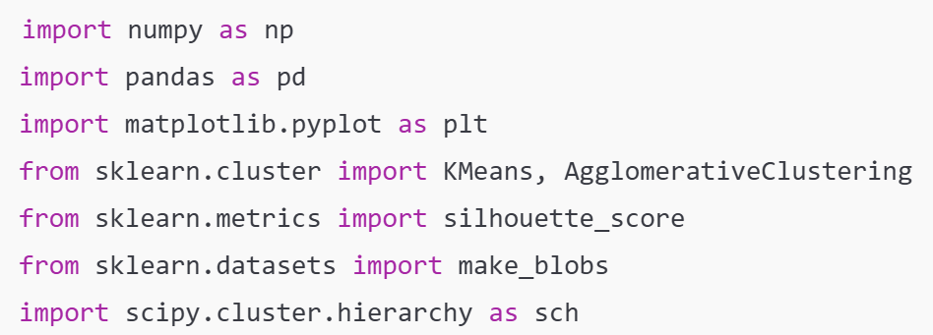
Step 2: Create a Sample Dataset
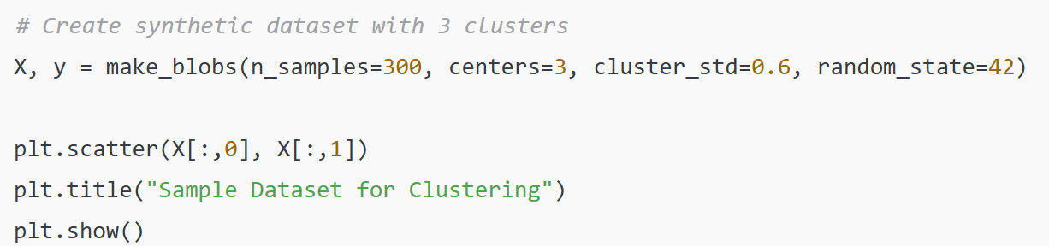
Step 3: Apply K-Means Clustering
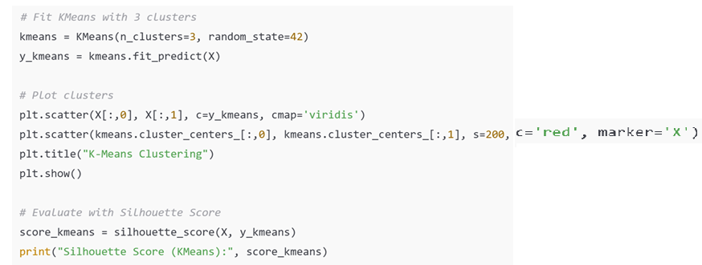
Step 4: Apply Hierarchical Clustering
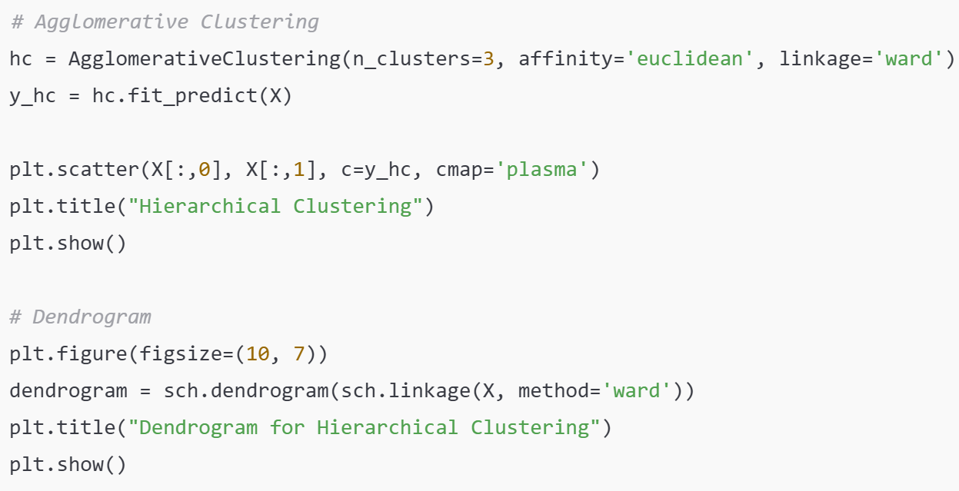
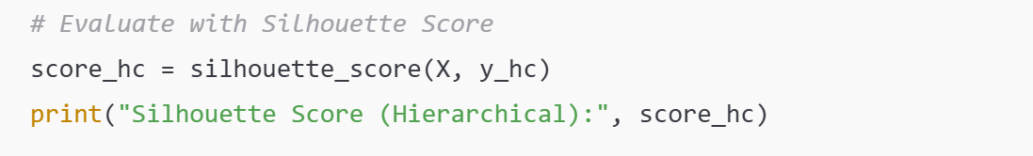
UNSUPERVISED LEARNING – DIMENSIONALITY REDUCTION- SECTION 9
Dimensionality reduction is an unsupervised learning technique that reduces the number of features in a dataset while retaining most of the important information. Its primary goal is to simplify data for better visualization, faster computation, and improved model performance by removing redundant or less informative features.

- The Curse of Dimensionality is a phenomenon in machine learning that describes the various problems that arise as the number of features, or dimensions, in a dataset increases. As the dimensionality grows, the volume of the feature space expands exponentially, causing the available data to become incredibly sparse. This sparsity makes it difficult for algorithms to find meaningful patterns and relationships.
Problems Caused by the Curse of Dimensionality
- Distance Metrics Lose Meaning: In high-dimensional space, the distance between any two data points tends to converge, meaning the difference between the closest and farthest points becomes negligible. This makes distance-based algorithms like K-Nearest Neighbors (KNN) and clustering less effective, as every data point appears to be equally far away from its neighbors. .
- Increased Risk of Overfitting: With a vast number of features, a model can easily find spurious, non-generalizable patterns in the training data, essentially "memorizing" the noise. This is particularly true when many of the features are irrelevant or redundant. The model may perform perfectly on the training set but fail on new, unseen data, which is the classic definition of overfitting.
- Higher Computational Cost: More dimensions mean more data points to store and process. This leads to a significant increase in the computational resources and time required to train and run machine learning models. The algorithms become slower and more complex, making experimentation and deployment more difficult.
In essence, while more data is usually a good thing, a larger number of dimensions can lead to a less reliable and more computationally expensive model. Dimensionality reduction techniques are crucial for mitigating these issues.

- Principal Component Analysis (PCA) is a powerful, unsupervised learning algorithm used for dimensionality reduction. Its core idea is to transform a high-dimensional dataset into a new, lower-dimensional space while preserving as much of the original information as possible. It does this by identifying the directions in the data that account for the most variance. These new axes are called principal components.
The Key Idea of PCA is Maximizing Variance
PCA works on the principle that features with higher variance contain more information. It rotates the original coordinate system so that the new axes (the principal components) are aligned with the directions of maximum variance. The first principal component captures the largest amount of variance, the second captures the second largest (orthogonal to the first), and so on. By selecting only a few of these top components, we can represent the data with a much smaller number of features without losing much of the important information. Steps in the PCA Algorithm are:
- Standardize the Data: First, the data must be standardized so that each feature has a mean of 0 and a standard deviation of 1. This ensures that all features contribute equally to the variance calculation, preventing features with larger scales from dominating the analysis.
- Compute the Covariance Matrix: This matrix shows how the different features in the dataset vary with respect to each other. It's a crucial step because it reveals the relationships between the original features.
- Find Eigenvectors and Eigenvalues: The eigenvectors and eigenvalues are computed from the covariance matrix. The eigenvectors represent the directions of the principal components, and the corresponding eigenvalues represent the magnitude of the variance along those directions.
- Sort and Select Components: The eigenvectors are sorted in descending order based on their corresponding eigenvalues. The one with the highest eigenvalue is the first principal component. We then select the top k eigenvectors, where k is the desired number of dimensions.
- Transform the Data: Finally, the original dataset is projected onto the new, lower-dimensional feature space defined by the selected principal components. The result is a reduced dataset that retains most of the original variance.

Applications of PCA include the following:
- Data Visualization: Reducing high-dimensional data (e.g., 50 features) to 2 or 3 dimensions allows for easy plotting and visual exploration.
- Image Compression: It can reduce the number of pixel values required to represent an image while retaining visual fidelity.
- Noise Reduction: PCA can filter out noise and redundant features, leading to cleaner data and potentially better model performance.
For instance, reducing a dataset of 100 features to just 2 principal components could still capture over 90% of the original variance. This allowing you to plot and analyze the data effectively without dealing with the curse of dimensionality.

3. Feature Extraction vs Feature Selection- While both feature selection and feature extraction aim to reduce the number of features in a dataset, they achieve this in fundamentally different ways
Feature Selection is the process of choosing a subset of the original features that are most relevant to the predictive model. The goal is to eliminate features that are either redundant or irrelevant, thereby simplifying the model and improving its performance. The selected features remain in their original form.
- Methods: Methods like Filter, Wrapper, and Embedded are used to evaluate and rank features. A common filter method involves calculating the correlation between each feature and the target variable, then dropping features with a low correlation.
Example: In a medical dataset with 50 attributes, you might use feature selection to identify that only "age," "blood pressure," and "cholesterol" are the most significant predictors for a certain disease. The final model would only use these three original features.

Feature Extraction is the process of creating new features by transforming or combining the original ones. These new features, or components, are a compressed representation of the original data. The original features are not kept; instead, they are converted into a more compact form.
- Methods: A classic example is Principal Component Analysis (PCA), which creates new features (principal components) that are linear combinations of the original features. These new components are orthogonal and capture the maximum amount of variance. Another method is using Autoencoders in deep learning, which learn to encode the input data into a lower-dimensional representation.
- Example: In facial recognition, instead of using all thousands of individual pixel values as features, you could use feature extraction to reduce them to a handful of components that represent the key facial features, like the shape of the eyes and the distance between the nose and mouth. This new set of features is then used for the model.
Key Difference
- Feature Selection: Keeps a subset of the existing features. It is like choosing the best students from a class to represent the school.
- Feature Extraction: Creates entirely new features from the old ones. It is like creating a composite student from the best qualities of all the students in a class.
Both techniques are central for mitigating the curse of dimensionality, which is the problem of dealing with high-dimensional data that becomes sparse and computationally expensive. By reducing the number of features, they lead to faster training times, lower memory usage, and often, better model performance.

INTRODUCTION TO NEURAL NETWORKS- SECTION 10
Neural networks are a type of machine learning model inspired by the human brain, designed to recognize complex patterns in data. They consist of interconnected nodes, or neurons, organized in layers, that process information to make predictions or classifications.

1. Biological Neuron vs Artificial Neuron
The artificial neuron is a fundamental building block of a neural network, directly inspired by the structure and function of its biological counterpart found in the human brain. While an artificial neuron is a simplified mathematical model, it mimics the core process of a biological neuron: receiving and processing information to produce an output.

Biological Neuron: A biological neuron is a nerve cell that serves as the basis of the nervous system. It has three main parts:
- Dendrites: These tree-like structures receive incoming electrical and chemical signals from other neurons.
- Cell Body (Soma): This is the central part of the neuron where the signals from the dendrites are processed. If the combined signal strength reaches a certain threshold, the neuron "fires."
- Axon: This long extension transmits the output signal as an electrical impulse to other neurons.
Communication between neurons happens at junctions called synapses, where chemical neurotransmitters carry the signal from one neuron to the next. The strength of these connections can change over time, a process known as plasticity, which is the biological basis for learning and memory.

Artificial Neuron (Perceptron) is a mathematical model that simulates this process with numbers. It is the computational unit of a neural network. It works as follows:
- Inputs: An artificial neuron receives numerical inputs, which are the features of the data (e.g., student's study hours, exam scores).
- Weights: Each input is multiplied by a weight, a numerical value that represents the input's importance. A higher weight means that the corresponding input has a greater influence on the neuron's output. These weights are the parameters the model learns during training.
- Summation: The weighted inputs are summed up. A bias term is often added to this sum to shift the activation function, giving the model more flexibility.
- Activation Function: The summed value is passed through a non-linear activation function. This function determines the neuron's output. It can be thought of as the neuron's "firing" decision. Common activation functions include the Sigmoid, ReLU, and Tanh, which introduce non-linearity, allowing the neural network to learn complex patterns.
Just as a biological neuron processes and transmits signals, an artificial neuron processes numerical inputs to produce a single numerical output, which can then be passed on to other neurons in the network. The ability to adjust weights in response to errors is what allows the network to learn.

- Perceptron Algorithm
The Perceptron, introduced by Frank Rosenblatt in 1958, is the foundational building block of artificial neural networks. As the simplest type of artificial neuron, it is a single-layer neural network used for binary classification. The Perceptron models a neuron's decision-making process. It takes a set of numerical inputs, performs a simple calculation, and outputs a single binary value (0 or 1). It works by following the steps below.
- Inputs: It receives one or more numerical inputs, which represent the features of the data point.
- Weights: Each input is multiplied by a weight, a value that signifies its importance to the output. These weights are learned during the training process.
- Summation: The weighted inputs are summed together. A bias term is also added to this sum, allowing the decision boundary to be shifted.
- Activation Function: The sum is passed through a simple step function. If the sum is greater than a certain threshold, the Perceptron "fires" and outputs a 1; otherwise, it outputs a 0.
The formula for the Perceptron's output is:
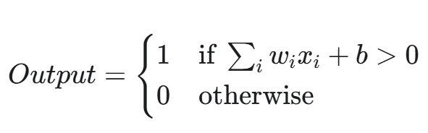
Strengths and Limitations
The Perceptron is a powerful model for its simplicity, but it has a significant limitation: it can only solve problems that are linearly separable. This means it can only classify data that can be perfectly divided into two classes by a single straight line.
For problems that are not linearly separable, such as the famous XOR problem, a single Perceptron fails. This limitation led to the development of more complex, multi-layer neural networks with non-linear activation functions that can solve these more intricate problems.

3. Activation Functions
Activation functions are critical components of a neural network that determine the output of a neuron. They introduce non-linearity into the model, which is essential for a neural network to learn and approximate complex, real-world patterns that are not linearly separable. Without an activation function, a neural network would simply be a series of linear regressions, regardless of how many layers it has.
The Sigmoid function, also known as the logistic function, is a classic activation function used in the output layer of neural networks, particularly for binary classification problems. It takes any real-valued number as input and squashes it into a value between 0 and 1. This output can be interpreted as a probability. The formula for the Sigmoid function is:

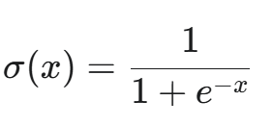
Where x is the input to the activation function (the weighted sum of inputs plus bias).
Characteristics include the following:
- Output Range: The output is always between 0 and 1, making it perfect for predicting probabilities in binary classification.
- Non-linear: The S-shaped curve of the Sigmoid function introduces non-linearity, allowing the network to learn more complex relationships than a simple linear model.
- Gradient Issues: A major drawback of the Sigmoid function is the vanishing gradient problem. As the input becomes very large or very small, the slope of the curve approaches zero. During backpropagation, the gradients become tiny, which can slow down or completely stop the training of the network, especially in deep layers.

- Forward Propagation Concept
Forward propagation is the process where a neural network takes input data and "feeds" it forward through its layers to produce a final prediction. It is the core mechanism by which a trained network makes a guess or an inference. This process is like an assembly line for data, where each neuron performs a specific task and passes the result to the next.
The Steps of Forward Propagation
- Input Layer: The process begins by feeding the raw input data into the network's first layer, the input layer. In the example of an image recognition model, this would be the pixel values of the image.
- Weighted Sum: The inputs are then passed to the first hidden layer. Each neuron in this layer receives every input and multiplies it by a corresponding weight, which represents the importance of that connection. All of these weighted inputs are then summed up, and a bias term is added. This is a linear transformation.
- Activation Function: The result of the weighted sum is passed through an activation function. This function introduces non-linearity into the network, allowing it to learn and model complex, non-linear relationships in the data. The output of the activation function is the output of that neuron.
- Propagation to the Next Layer: The output of each neuron in the first hidden layer becomes the input for all the neurons in the next layer. This process of weighted summation and activation is repeated for every subsequent hidden layer.
- Output Layer: The final layer, the output layer, takes the outputs from the last hidden layer and performs the same calculation. The activation function in this layer is chosen based on the task: a sigmoid for binary classification, a SoftMax for multi-class classification, or a linear function for regression. The result is the network's final prediction.

This process continues in one direction, from the input layer to the output layer, which is why neural networks that operate this way are often called "feedforward" networks. A relevant video to understand this concept further is a YouTube video explaining how to train neural networks. Forward Propagation and Backward Propagation. This video is a great visual guide that explains forward propagation and its relation to backward propagation.

ETHICS AND FAIRNESS IN MACHINE LEARNING- SECTION 11
Ethics and fairness in machine learning are concerned with ensuring that AI systems are developed and deployed responsibly, producing decisions that are not only accurate but also equitable, transparent, and accountable. The goal is to prevent models from perpetuating or amplifying societal biases and to ensure they serve the well-being of all people.

1. Algorithmic Bias
Algorithmic bias is a significant and growing problem where a machine learning model produces systematically unfair or discriminatory outcomes against certain groups of people. This is not a bug in the code, but a reflection of the biases inherent in the data or the way the model was designed.

Causes of Algorithmic Bias
The root causes of algorithmic bias are complex and often unintentional and include the following:
- Biased Training Data: This is the most common cause. If the data used to train the model reflects historical and societal inequalities, the model will learn and amplify those biases. For example, a hiring algorithm trained on a company's past hiring data might learn that male candidates were historically preferred and, as a result, will continue to rank male applicants higher, even if other factors are equal.
- Prejudiced Feature Selection: Sometimes, the problem lies in the choice of features used for the model. Even if a sensitive attribute like race or gender is removed, the model can still use other features that are highly correlated with it (e.g., zip code, name, education history) to make a biased prediction. This is known as a proxy variable.
- Feedback Loops: This is a particularly insidious form of bias. When a biased model is deployed, its predictions can influence the real world, generating new data that further reinforces the original bias. For example, a predictive policing algorithm that disproportionately sends officers to minority neighborhoods will lead to more arrests in those areas, creating data that suggests more crime exists there, reinforcing the model's initial bias.
Consequences of Algorithmic Bias
The consequences of algorithmic bias are severe and can perpetuate real-world discrimination:
- Social and Economic Harm: Biased algorithms can deny people access to loans, jobs, or healthcare, causing significant economic and social harm.
- Erosion of Trust: When people discover that AI systems are making biased decisions, it leads to a loss of public trust in technology and the organizations that use it.
- Legal and Ethical Issues: The use of biased algorithms can lead to legal challenges, as it may violate anti-discrimination laws.
The issue of algorithmic bias is a critical ethical consideration in the development and deployment of machine learning and AI. It highlights the need for a human-centered approach to technology, with a focus on fairness and accountability.

2. Fairness, Transparency, and Accountability
Fairness, transparency, and accountability are core ethical principles in machine learning that ensure AI systems are not only effective but also responsible and trustworthy.

Fairness in machine learning means designing models that produce equitable outcomes and do not discriminate against individuals or groups based on sensitive attributes like gender, race, or age. It’s about mitigating the biases that can creep in from data or model design.
- Pre-processing approaches focus on correcting biases in the training data itself before the model even begins to learn. This can involve techniques like re-sampling to balance the representation of different groups or re-weighting data points to ensure that all groups are treated with equal importance.
- In-processing approaches modify the training algorithm to introduce a fairness constraint. The algorithm is given an additional objective: not only to be accurate but also to reduce bias during the training process.
- Post-processing approaches adjust the model’s predictions after they have been generated. This can involve setting different decision thresholds for different demographic groups to ensure that the rates of false positives and false negatives are similar across all groups.

Transparency (or explainability) is the ability to understand how and why a machine learning model makes a particular decision. Unlike traditional software, where every line of code is clear, complex models like deep neural networks can be "black boxes" that are hard to interpret.
- Explainable AI (XAI) is a field dedicated to creating methods that make model decisions understandable to humans. Techniques include providing feature importance scores, which show which features influenced a prediction the most, or generating a simple set of rules that approximate a complex model's behavior.
- Documentation is also key to transparency. Tools like Model Cards and Datasheets for Datasets provide a standardized way to document a model's purpose, performance, limitations, and ethical considerations.

Accountability requires that organizations and individuals take responsibility for the outcomes and consequences of their AI systems. It’s a crucial principle that establishes a framework for governance and oversight.
- Monitoring and Auditing: Organizations must continuously monitor their deployed AI models for signs of bias or unexpected behavior. Regular audits can help identify and rectify issues before they cause significant harm.
- Legal Compliance: This involves adhering to regulations such as the GDPR in Europe or specific anti-discrimination laws.
- Consequence Management: In cases of a wrongful decision, like a mistaken loan rejection or wrongful denial of an insurance claim, a clear process must be in place to review the decision, explain the reasoning, and provide a path for appeal. The insurance company example highlights this need for a system that is not only automated but also auditable and responsible.

3. Ethical AI Practices
Ethical AI practices ensure that machine learning systems are developed and used responsibly to promote human well-being and avoid harm. These practices are guided by several core principles:
- Beneficence: AI should be a force for good, actively contributing to human welfare and societal progress.
- Non-maleficence: Developers must take proactive steps to prevent their models from causing harm, such as through bias, inaccurate predictions, or unsafe operation.
- Justice: AI systems should provide equal treatment and opportunity for all individuals, without discrimination.
- Autonomy: AI should respect individual user choice and consent, ensuring that users have control over their data and how they interact with AI.
To put these principles into action, organizations must adopt best practices, including using diverse datasets to prevent bias, regularly auditing models for fairness, and incorporating human oversight in critical decision-making processes. For example, in healthcare, an AI system that recommends treatment plans should always be reviewed by a human doctor to ensure patient safety.

4. Privacy Concerns in Data Collection and
The need for vast amounts of data to train machine learning models creates significant privacy risks, as this often involves the collection of sensitive, personal information. The more data a model has, the better it can learn patterns, but this comes at the cost of potential privacy breaches, unauthorized access, and a lack of user control over their own information.

Key Privacy Challenges
- Data Breaches: Centralizing large volumes of personal data makes it a prime target for cyberattacks. A single data breach could expose the sensitive information of millions of people, leading to identity theft and financial fraud.
- Lack of Informed Consent: Users are often unaware of what data is being collected, how it's being used, or who it's being shared with. Consent forms can be long and complex, making it difficult for individuals to give truly informed consent.
- Re-identification: Even when data is anonymized, it's not always secure. Researchers have shown that it's often possible to re-identify individuals by cross-referencing seemingly anonymous data with other publicly available datasets.
- Inference: Machine learning models can infer sensitive information about individuals that was not explicitly provided in the data. For example, a model trained on purchasing habits could infer a person's health status, political views, or sexual orientation.

Mitigation Strategies to Protect Privacy
To address these concerns, several strategies are used to balance the need for data with the right to privacy:
- Data Minimization: This principle dictates that only the data strictly necessary for a model's purpose should be collected.
- Anonymization and Encryption: Techniques like differential privacy add statistical noise to data to protect individual records while still allowing for analysis. Encryption secures data in transit and at rest, making it unreadable to unauthorized parties.
- Federated Learning: This is a powerful technique that allows a model to be trained on data located on decentralized devices (like smartphones) without ever centralizing the raw data. Only the model updates are sent back to the server.
- Regulatory Compliance: Adhering to robust data protection laws like the General Data Protection Regulation (GDPR) and the Health Insurance Portability and Accountability Act (HIPAA) is essential for ensuring legal and ethical data usage.
By implementing these strategies, organizations can build user trust and ensure that the power of machine learning is harnessed responsibly.

TUTORIAL QUESTIONS
Section 1-2: Fill-in-the-blank questions
Section 3–4: Data Preprocessing I & II
- Distinguish between categorical, numerical, and Boolean data with examples.
- Describe three methods of handling missing data and explain their advantages and disadvantages.
- Compare label encoding and one-hot encoding. In what situation would you prefer one over the other?
- Differentiate between normalization and standardization. Provide a use case for each.
- Explain why splitting data into training and testing sets is important in machine learning.
Section 5: Regression Analysis
- Describe the difference between linear regression and polynomial regression. Give an example problem suitable for each.
- Define MAE, MSE, RMSE, and R² score. How does each metric interpret model performance differently?
- Build a simple linear regression model (using Python or pseudocode) for predicting house prices based on size. Show the forward propagation steps.
Section 6: Classification
- Explain the difference between binary classification and multi-class classification, with examples.
- Compare logistic regression with K-Nearest Neighbors (KNN) in terms of assumptions, strengths, and weaknesses.
- What is a confusion matrix? Draw one for a binary classifier and explain each component (TP, FP, TN, FN).
- Write a short note on the role of decision trees in classification.
Section 7: Model Evaluation & Selection
- Define the bias-variance tradeoff. How does it affect underfitting and overfitting?
- Explain how cross-validation improves model reliability compared to a single train-test split.
- Discuss two model selection techniques commonly used in practice.
Section 8: Clustering
- Explain the difference between K-Means and Hierarchical Clustering. In what scenarios is each preferred?
- What is the Silhouette Score? Provide an interpretation for values close to +1, 0, and -1.
- A dataset with three clusters is given. Walk through the steps of applying K-Means to cluster it.
Section 9: Dimensionality Reduction
- Define the curse of dimensionality and explain why it is a problem in high-dimensional data analysis.
- Explain how PCA reduces dimensionality while retaining most of the information.
- Differentiate between feature selection and feature extraction, giving an example of each.
Section 10: Neural Networks Basics
- Compare a biological neuron with an artificial neuron.
- Write down the perceptron learning rule and explain how weights are updated.
- Describe the characteristics, advantages, and disadvantages of the following activation functions: Sigmoid, ReLU, Tanh.
- Outline the steps in forward propagation using a simple 2-layer neural network.
Section 11: Ethics & Fairness in Machine Learning
- Define algorithmic bias and explain one real-world example where it caused harm.
- How can fairness, transparency, and accountability be integrated into the design of machine learning systems?
- Suggest ethical practices that developers should adopt when deploying AI in healthcare.
- Discuss privacy concerns in data collection and usage, and propose at least two methods to mitigate them.

