CSE344_HW1-REPORT

Adem Murat ÖZDEMİR

Compilation and Running Program :
There is a makefile in the .zip. First enter the terminal “make” to compile the “gtuStudentGrades.c” . Then enter “make run” to run the program. When you finish running program , enter “make clean” to remove object file and “log.txt” file.

This program running correctly according to the pdf. Except for the logCompletion function, a process is created with fork() for all file opening, closing and reading and writing operations.

The test results of the functions are as follows.

“gtuStudentGrades” command without no other parameter:
This command shows the command usage menu to the user. Just enter “gtuStudentGrades” .

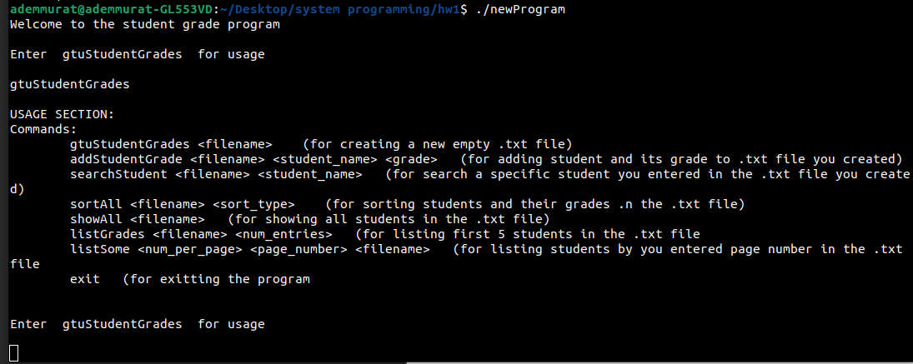
“gtuStudentGrades <fileName>” command:

This command creates a .txt file with the parameter name entered next to it.

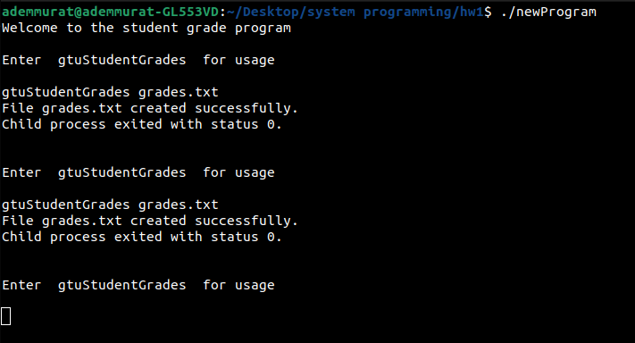
“addStudentGrade <fileName> <nameSurname> <grade> command:
This command enters an entry into the entered file with name and grade parameters.

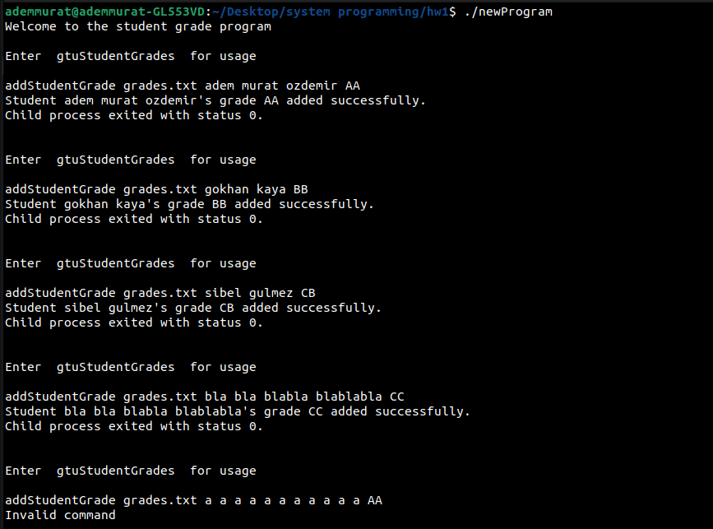
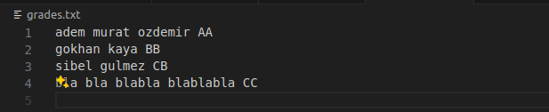

“searchStudent <fileName> <studentName>” command:
This command searches for the studentName entered in the entered txt file.

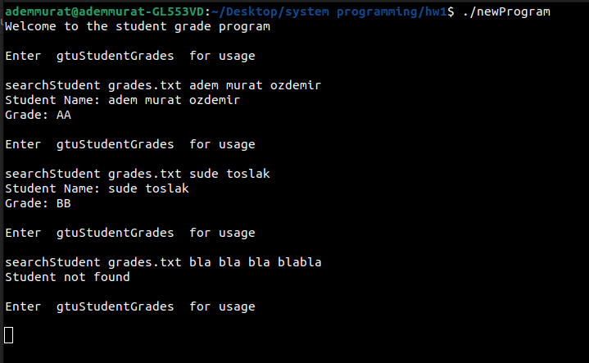
“sortAll <fileName> command:
This command is used to sort the entries in the entered file. After entering the command, the program will ask for an integer from 1 to 4.
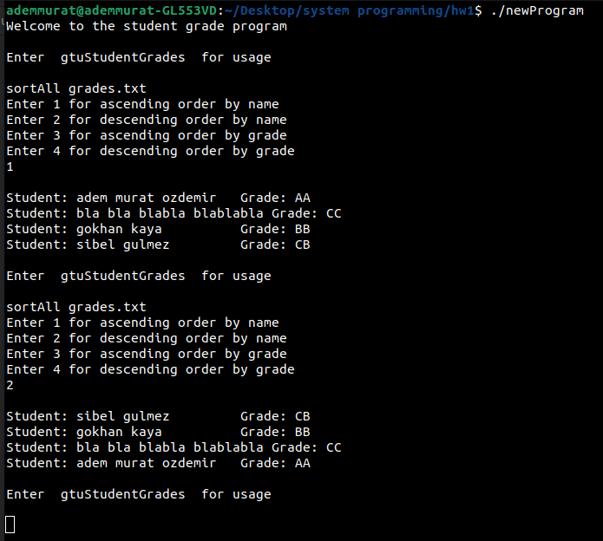

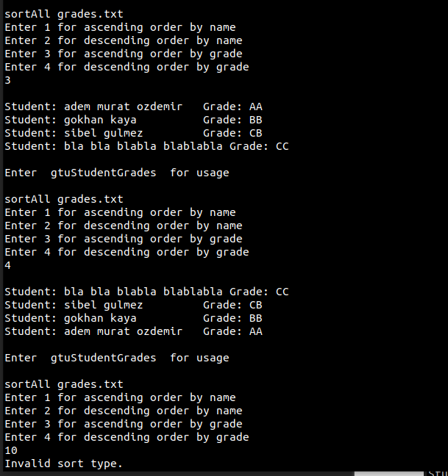

“showAll <fileName>” command:
This command will print all entries in the entered file.

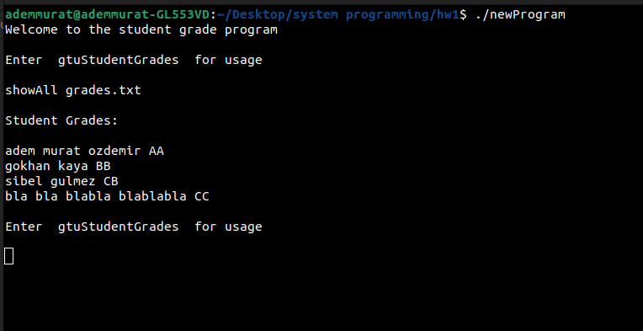

“listGrades <fileName>” command:

This command will print the first 5 entries in the entered file.

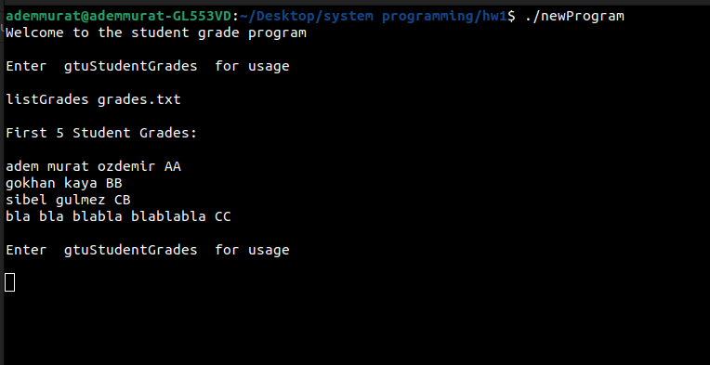

“listSome <numofEntries> <pageNumber> <grades.txt>” command :
This command will print the entries on the entered page.

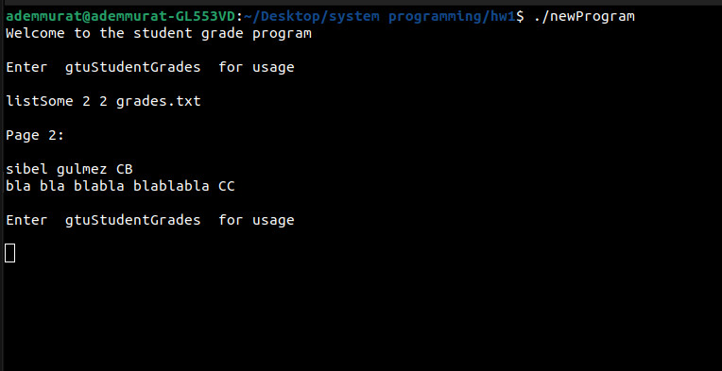

At the beginning of all these functions, logCompletion("command"); is called and writes the execution status of the function to the "log.txt" file.

