CSE344 – HW2 REPORT

Adem Murat ÖZDEMİR

Usage of Program

There is a makefile in the .zip file. You can use this file for compiling and run program. Example usage is below :

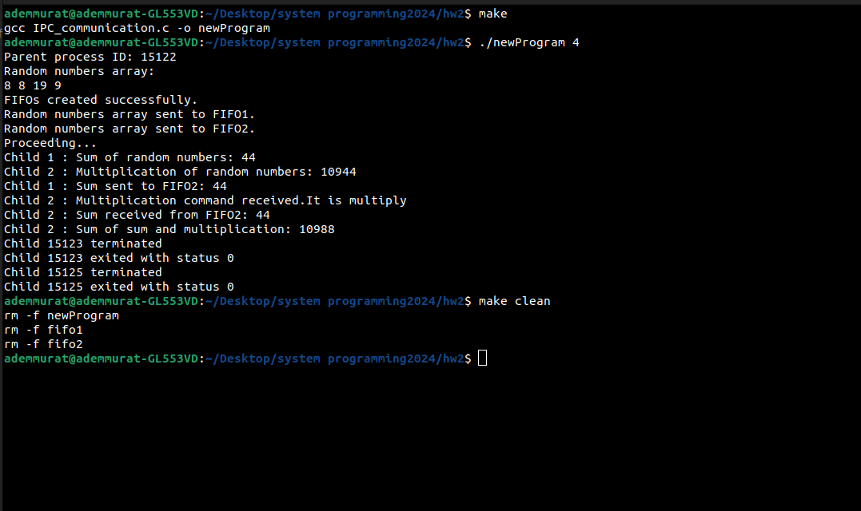
You must enter an integer greater than 0 while starting the program.

If the program is run to complete without stopping, it automatically deletes the fifo files.
However, if you close the program with Ctrl+C while the program is running, you need to delete the fifos with “make clean”. It also removes the object file.

File Structure :

IPC_communication.c : The main program where I test and run the code. Takes an integer argument from the user to create ‘n’ random numbers.

Usage : ./newProgram <positive integer>

signal_handler : Listens the child processes exit status and counts how many child processes are terminated. When a child is died, it shows the status of the child termination.

Error Handling: The fprintf function is used to notify the user of errors found in system calls (invalid message, erroneous command line argument, etc.), in addition to identifying incorrect inputs within the application.

Program Progress:

Parent Process :

- Confirm command line argument
- Generate random numbers
- Create fifos
- Create child processes using fork()
- Open fifos and send them random numbers
- Send “multiply” command to “FIFO2”
- Handle SIGCHLD

Child Process 1 :

- Sleep for 10 seconds.
- Open FIFO1 to read random numbers and calculate sum of them
- Open FIFO2 to write sum to it

Child Process 2 :

- Sleep for 10 seconds.
- Open FIFO2 to get random numbers and calculate product of them
- Read “multiply” command from FIFO2
- Read sum that calculated in child process 1 from FIFO2
- Calculate and print Sum of sum and product

Code : Comments were written in the code for the understandability of the program.

Signal Handlers and Signal Registration:

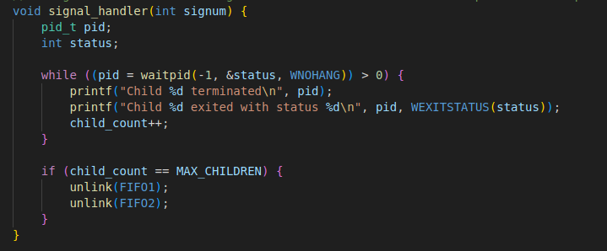
The signal_handler function is responsible for handling the SIGCHLD signal, which is sent to the parent process when a child process terminates.
- Inside the signal_handler function, the waitpid function is called with the WNOHANG flag, which makes it non-blocking. This allows the parent process to continue executing other tasks while waiting for child processes to terminate.
- The loop in signal_handler waits for all terminated child processes and prints their process IDs and exit statuses.
- If the maximum number of child processes (MAX_CHILDREN) have been terminated, the unlink function is called to delete two FIFOs (FIFO1 and FIFO2).

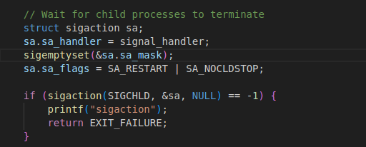
The sigaction function is used to set up the signal handler signal_handler for the SIGCHLD signal. If sigaction fails, an error message is printed, and the program exits with a failure status.

Printing “Proceeding…”

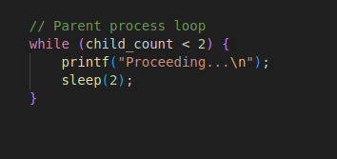
Read And Write Functions:

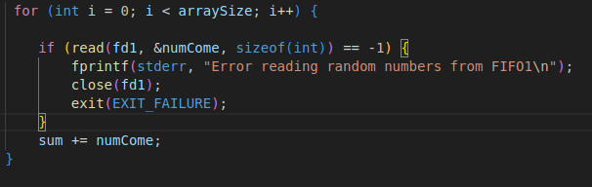
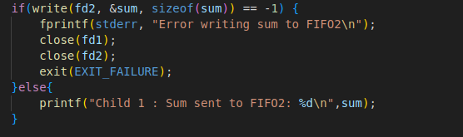

Since program write the int size while doing the write operation, program proceed by reading the int size while reading.

Synchronization :

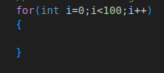
Since I do not know whether it is forbidden to use extra sleep in child processes, I put two empty for loops in child process 2 to ensure synchronization (so that child process 2 does not read before child process 1 writes).

Example Output:
