# [https://github.com/ademus/basic-back-office](https://github.com/ademus/basic-back-office" \t "_blank)

Homemade back-office, ready to use and easy to configure handling multi-files upload and image/text-editor

Demo : <http://www.softpeople.fr/effacer/olivia/BO/index.php>

# 

# FILES

|  |  |
| --- | --- |
| File | Role |
| connexion.php | SET HERE DATABASE CONNEXION PARAMS AND UPLOAD DIR |
| display\_table.php | THIS FILE DISPLAYS 1 SINGLE TABLE USER REQUESTED TO SEE |
| upload\_import.php | USED BY SYSTEM TO UPLOAD (MULTI)-FILES OR IMPORT CSV |
| form.php | THIS FILE DISPLAYS A FORM TO INSERT OR UPDATE A ROW IN A TABLE |
| form.quilljs\_txt\_edit.inc.php | DISPLAYS QUILLJS TEXTEDITOR |
| index.php | MAIN FILE, CONTROL ALL ACTIONS |
| list\_tables.php | DISPLAYS LIST OF TABLES |
| structure.php | SET HERE TABLES AND THEIR FIELDS |
| title.php | SMALL FILE DISPLAYING TITLE PAGE OR TABLE |
|  |  |

# Paramètres

|  |  |
| --- | --- |
| Name | path |
| Upload directory | connexion.php |
| Database connexion | connexion.php |
| Database structure | Structure.php |
|  |  |

# 1st steps

Define database in **structure.php** and set connexion parameters in **connexion.php**

Use sql\_example.txt to import demo tables in your database

Add autoinc field to each table.   
Set autoinc field name ($\_pKey\_label\_) in structure.php > top page

call your server / index.php

# File & drag, Files Upload

You can both define classic input file or ‘drop zone’ for upload files.  


When using drop zone, no submit button appear, so there is no script treatment by index.php.   
Only action in file\_upload.php (Line 46) is executed.

Set it when you 1st define your tables structure in structure.php

# Text and texteditor fields

You can define classic input text field or texteditor.  
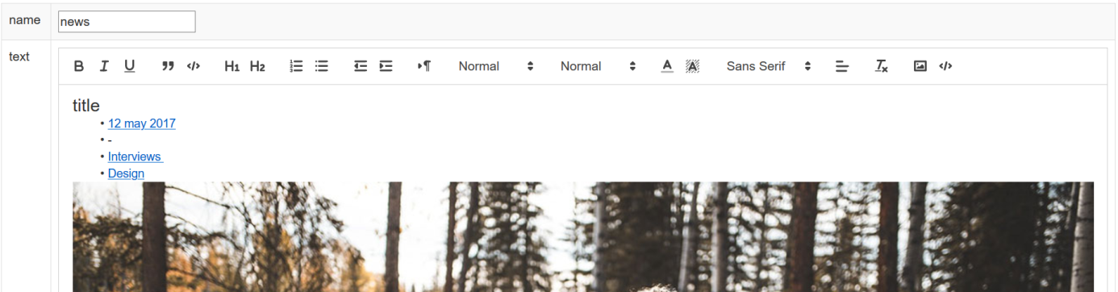

Set it when you 1st define your tables structure in structure.php

Better use longtext mysqli field with texteditor

# FRONT END UTILISATION

## Example

<?php

include\_once ('BO/connexion.php');

include\_once ('BO/structure.php');

$requete = "select \* from `pages`";

$\_connexion\_ = connexion(serveur, user, passe, base);

$resultats = query($requete, $\_connexion\_);

while ($res = mysqli\_fetch\_array($resultats))

{

{

echo '<li><a ref="index.php?page='.$res['name'].'" >'.$res['name'].'</a></li>';

}

}

?>