MAJESTY WELLBEING CENTRE (NDIS services provider)



[Photo](https://www.qld.gov.au/disability)by Unknown Author is licensed under [CC BY](https://creativecommons.org/licenses/by/3.0/)

*Holistic and quality care matters*

***WHO WE ARE***

***MWC*** *is an initiative of a visionary with passion for enhancing quality of life and for provision of services according to the needs of individuals living with disability. The vision is not limited to promotion of quality lifestyle for participants, but it is also supportive of clients' decisions and choices.* *We also provide ethical and legal care services to the participants.*

***GOALS AND OBJECTIVES***

* *To provide services in accordance with the Quality and Safety criteria of NDIS.*
* *Operate in accordance with and even exceed the set standards of the NDIS*
* *Collaboratively provide care that will promote happiness, trust, integrity and respect of our participants.*

***TEAM:*** *We are a dedicated team of experienced health professionals that includes nurses, support workers, allied health workers such as psychologists, counsellors, therapists, exercise physiologists, dieticians, nurse practitioner etc.*

***How do we operate****: MWC comes to you. Services are provided in your familiar home environment.*

*Our Services include:*



Community Nursing care include:

* Home care services
* Showering/Grooming
* Cleaning/ shopping/ meal preparation
* Transport/ appointment
* Medication administration
* Diabetic monitoring
* Wound dressing
* Nursing care that includes stoma care, IDC and PEG feeds etc.

Accommodation/Tenancy include:

* Shared apartment

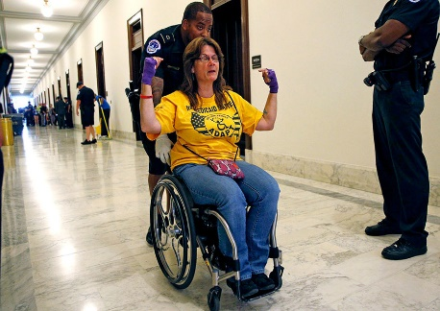

[This Photo](https://brewminate.com/how-congress-is-hacking-away-at-disability-rights/) by Unknown Author is licensed under [CC BY-SA-NC](https://creativecommons.org/licenses/by-nc-sa/3.0/)

* Shared house
* Cleaning/meal preparation
* Assist travel/Transport
* Shopping
* Recreational activities

Assist-Personal Activities

* Grooming
* Cleaning
* Meal preparation
* Shopping
* Social outing including transport to medical appointment and church/mosque

Home Modification

* General home repair
* Home maintenance: gardening/lawmaking
* 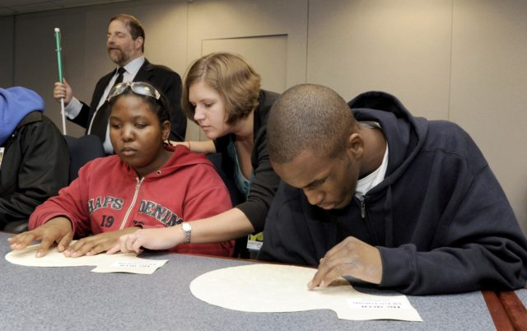Cleaning
* Renovation

Daily task/shared living

* Bill payment
* Shopping/transport/cleaning
* Social function

Development life skills



[This Photo](https://en.wikipedia.org/wiki/Intellectual_disability) by Unknown Author is licensed under [CC BY-SA](https://creativecommons.org/licenses/by-sa/3.0/)

* Education: Tafe/university transport
* Attending community engagement
* Social function

Household tasks

* Cooking/shopping/cleaning
* Laundry/ lawnmowing
* Budgeting

Participate in the community

* Transport to recreational centres



[This Photo](https://en.wikipedia.org/wiki/Accessibility) by Unknown Author is licensed under [CC BY-SA](https://creativecommons.org/licenses/by-sa/3.0/)

* Beach and botanical garden
* Community engagement
* Attending conferences
* Personal training
* Exercises, gym and cultural connect.

Therapeutic Supports

* Mental health support: counselling
* Massage, exercise physiologist, dietician, and therapist

Group centre activities: organised outings

*MWC is a mobile NDIS services, flexible with 24/7 services as needed.*

For referral Email: [MyChoice@majestywellbeingcentre.com.au](mailto:MyChoice@majestywellbeingcentre.com.au)

Phone: 07 31085738

Mobile: 0423627765