A SYSTEM FOR MONITORING PROJECT ETHICAL APPROVAL

BY

ADENIJI CHARLES AYODIPUPO
STUDENT ID: 2000916

PROGRAM: INFORMATION TECHNOLOGY WITH CYBER SECURITY

COURSE: INTRANET SYSTEMS DEVELOPMENT
COURSE CODE: CMM007
DESCRIPTION
Currently at the Robert Gordon University, Aberdeen, Scotland, the process of seeking ethical approval for an experiment is a manual and time consuming task. This process is currently being fulfilled by a form that is downloaded, filled by the student and then stored online. This web application is being developed to digitize this process.
The web application will have three main sections for three classes of users – Administrators, Experiment Approval Officers (EAO) and finally, students. Students who need an ethical approval for an experiment that they want to conduct will be able to sign up for an account on Approvr. After signup students will login to create an experiment – filling all the required details that the approval process officers need. After creating an experiment, student can either fill the ethical approval form and submit immediately or save for later. Students can also upload additional documents to back up their experiments. After submission, the Super Administrator will then be notified of this submission and then assign the approval request to two Experiment Approval Officers to review, comment or give feedbacks on an experiment that was submitted and finally decide to grant ethical approval for the project or not. The administrator will also be able to view the experiment, see comments by the Experiment Approval Officers.
At every step of the way, participants in the ethical approval process will be notified by email and the progress will also be tracked via the web application.

CONSTRAINTS
The code for Approvr will be stored on the GitHub and is accessible on a public repository by clicking this link https://github.com/adenijicharles/Ethical-Approval-App
On completion, the web application will be hosted on the CSDM web server so that the marker will be able to access all parts of the application.
The client side of the application will be developed with HTML, CSS and JavaScript while the server side language used will be PHP (while the database will be designed with MySQL.
There are three user roles each catering for all participants in the ethical approval process. These are Administrators, Experiment Approval Officers (EAO) and Students.
Students will be able to upload documents to back up their ethical approval request
Forms will be designed for registration, login, approval request creation, edition and deletion, feedback forms for Experiment Approval Officers.

FUNCTIONAL REQUIREMENTS OF THE EXPERIMENT ETHICAL APPROVAL APPLICATION
STUDENTS
REQUIREMENT ID | SPECIFICATION | MoSCoW ANALYSIS
REQ 1 | The system should allow students to create an account | Must
REQ 2 | The system must allow students to login after account creation | Must
REQ 3 | The system must perform checks when a student wants to register an account to prevent duplicate accounts | Must
REQ 4 | Once login is successful the student must be redirected to the dashboard where a list of all experiments that has been created by the student is shown | Must
REQ 5 | The system must allow student to create a new experiment, edit an experiment and if the approval has not been granted for an experiment, student can delete the experiment | Must
REQ 6 | The student must be able to select an experiment and then submit an ethical approval request for it | Must
REQ 7 | The system should allow students upload documents files in any format that may supplement their ethical approval process | Must
REQ 8 | If an ethical request has not been approved, a student should be able to edit or delete the request | Must
REQ 9 | Once an ethical request is denied or approved, student must be notified in their email of the decision | Must

EXPERIMENT APPROVAL OFFICER
REQUIREMENT ID | SPECIFICATION | MoSCoW ANALYSIS

REQ 1 | The system should allow staff already registered as Experiment Approval Officers (EAO) to login | Must
REQ 2 | The system must redirect EAO to their dashboard if login is successful | Must
REQ 3 | The dashboard must display all experiments that has been assigned to the EAO by the admin | Must
REQ 4 | An EAO must be able to select an experiment to view the details and also preview the ethical request | Must
REQ 5 | The system must allow an experiment approval officer to approve an ethical request | Must
REQ 6 | The system must allow an experiment approval officer to reject an ethical request approval | Must
REQ 7 | The system must allow an EAO to give feedbacks on an ethical request | Must

ADMINISTRATOR
REQUIREMENT ID | SPECIFICATION | MoSCoW ANALYSIS
REQ 1 | The administrator must be able to login | Must
REQ 2 | On successful login, administrator must see all experiments added by students | Must
REQ 3 | Admin must be able to assign an experiment to two Experiment Approval Officers to verify | Must
REQ 4 | Admin must be able to see all approved ethical approval requests | Must
REQ 5 | Admin must be able to see all rejected approval requests | Must
REQ 6 | Admin must be able to add an Experiment Approval Officer to the system | Must

NON FUNCTIONAL REQUIREMENTS
NON FUNCTIONAL REQUIREMENT ID | SPECIFICATION | MoSCoW ANALYSIS
NREQ1 | The school logo must be seen on all authentication pages | Must
NREQ2 | The web application must display all status messages (errors and success) clearly | Must
NREQ3 | Application must be responsive | Must
NREQ4 | The web application must be easily accessible on all browsers | Must
NREQ 5 | The user experience on all browsers must be the same | Must

WIREFRAMES
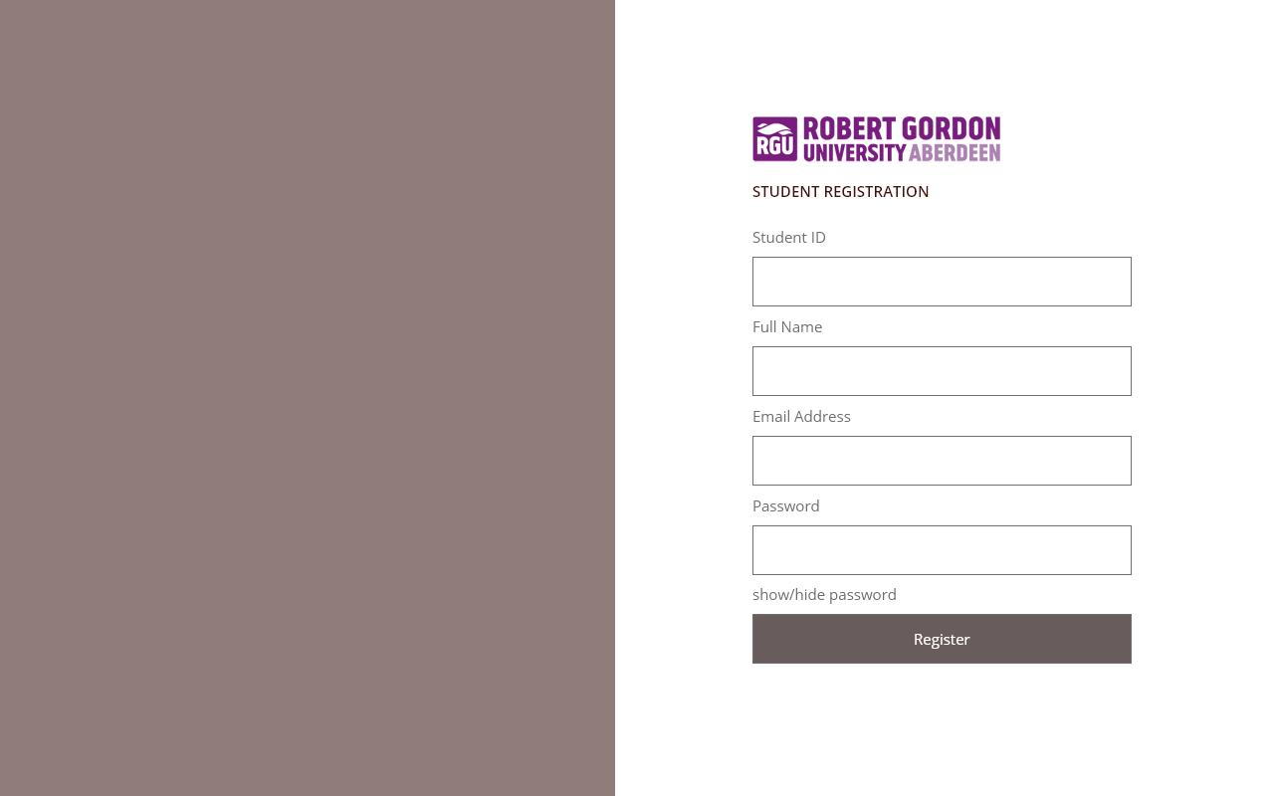
STUDENT REGISTRATION PAGE
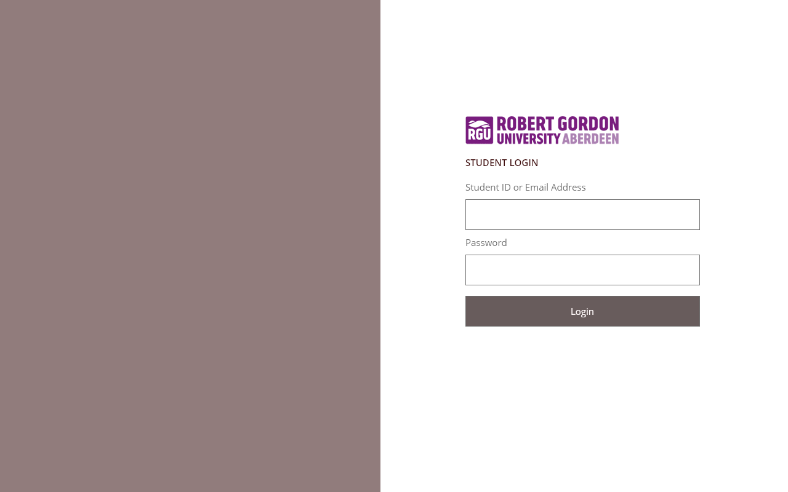
STUDENT REGISTRATION PAGE
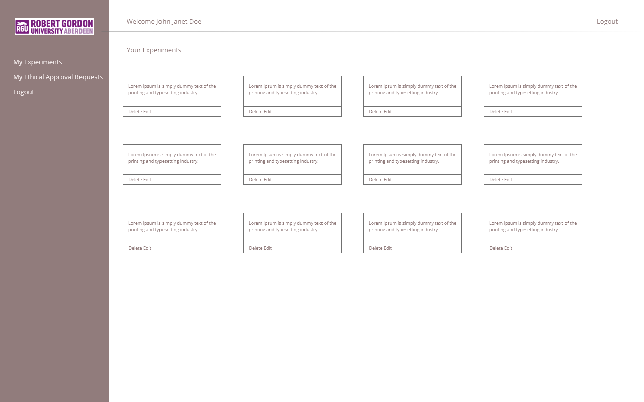
STUDENT EXPERIMENT PAGE
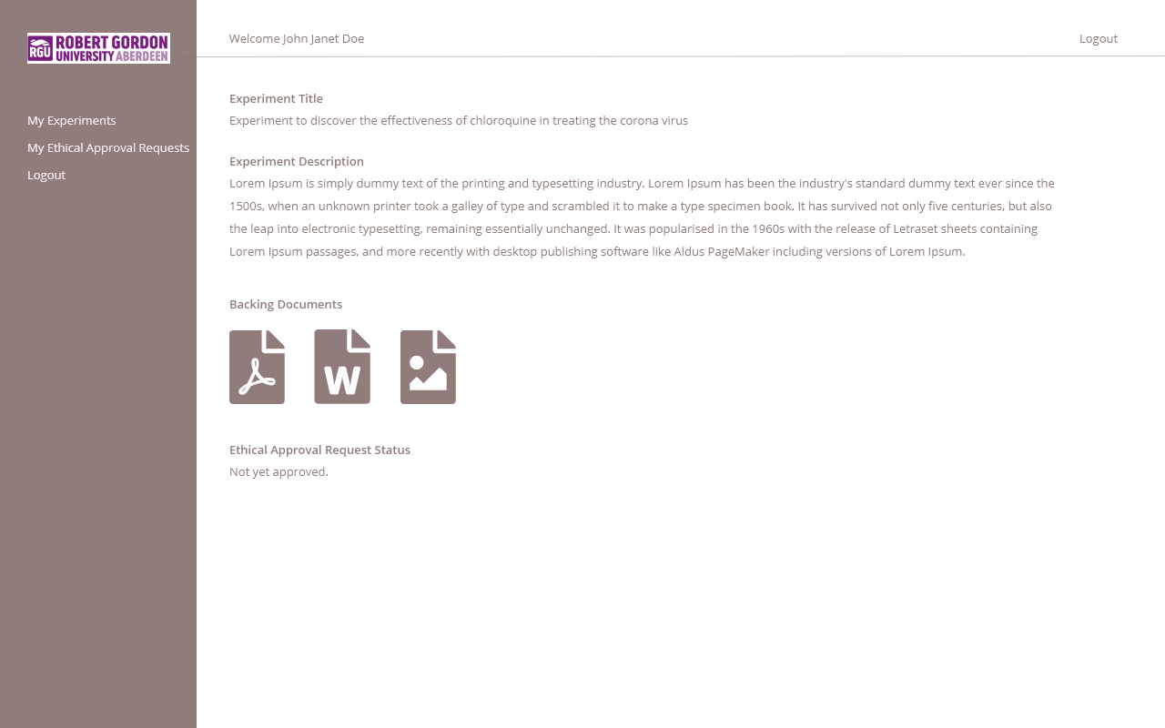
STUDENT SINGLE EXPERIMENT PAGE
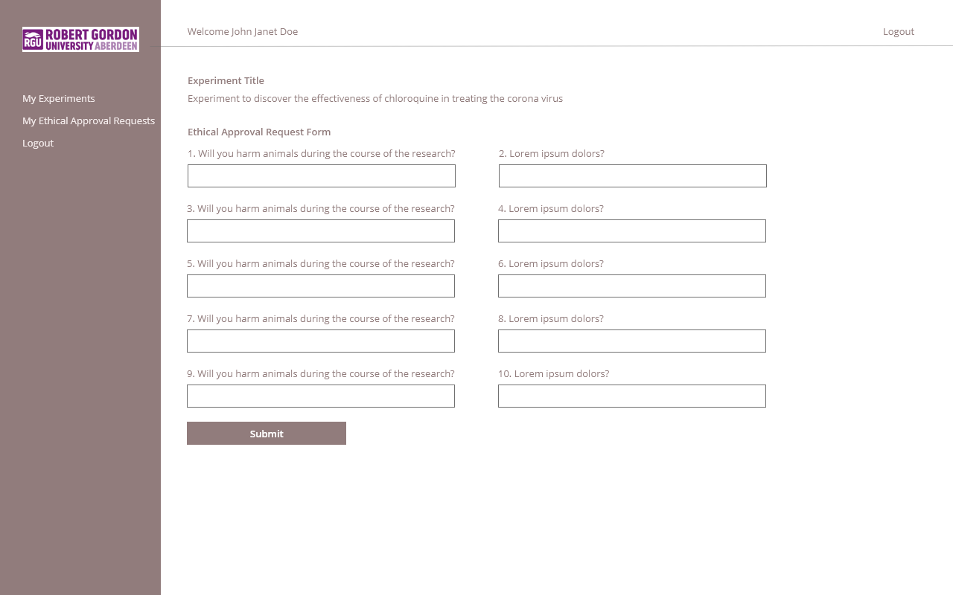
STUDENT ETHICAL REQUEST FORM PAGE
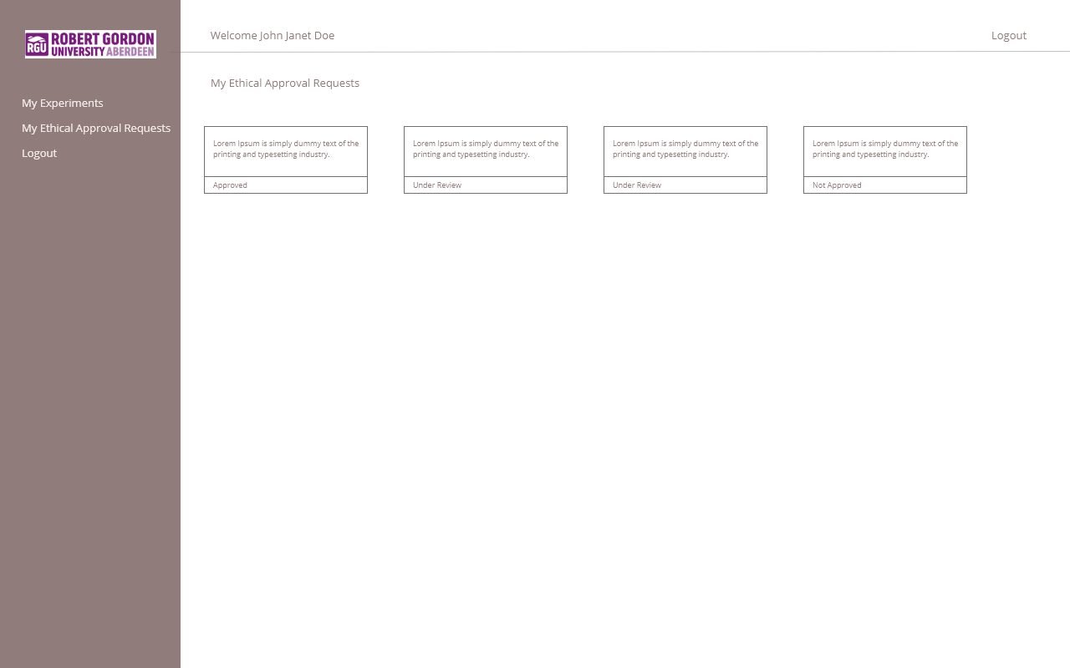
STUDENT ETHICAL REQUEST STATUS PAGE
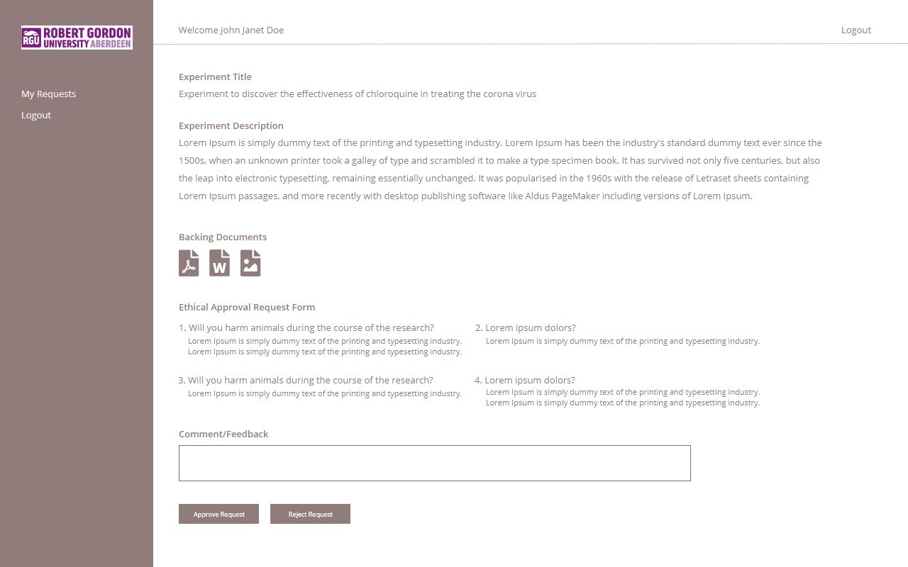
EXPERIMENT APPROVAL OFFICER REQUEST CONFIRMATION OR DENIAL PAGE
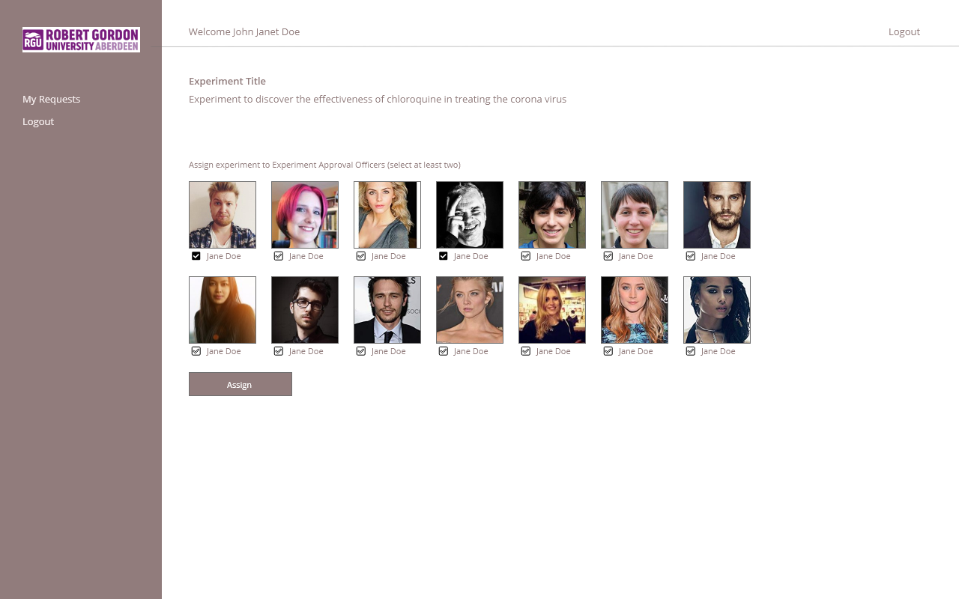
ADMININSTRATOR ASSIGN EXPERIMENT TO TWO EXPERIMENT APPROVAL OFFICERS

