


Review on WithSecure Integration and Optimization
AB Bank Zambia

Contents
1. Executive Summary 2
1.1. Key Highlights: 2
1.1.1. Incident Volume & Trends: 2
1.1.2. Detection & Response Performance: 2
1.2. Incident Trends & Analysis: 3
1.3. High-Severity Incidents: 4
2. January Alerts & Incidents Overview 4
2.1. Overall Volume 4
2.2. Incidents Processing 5
2.3. Mean Time To Detect (MTTD) 5
3. Incidents Highlights 6
3.1. Top Incidents by type 6
3.2. Analysis of Key Incident Trends 7
3.3. High Severity 9
4. Cybersecurity Trends and Threats (January 2026) 10
4.1. Key Threats and Incidents 10
4.2. Regional Spillover and Infrastructure Risks 11
4.3. Government and Infrastructure Response 11
5. Conclusion and Recommendations 12
5.1. Recommendations 12
5.2. Conclusion 13
Appendix – Test-server Alerts 13
Total Incidents by Severity 13
Top 10 Incidents 14
High Severity Incidents 14

Executive Summary
1. Executive Summary
Issue: Incidents missing from Sentinel for [time period]
WsSecurityEvents_CL
| project Activity
| summarize EventCount=count() by Activity

Impact: [X] high-severity incidents missed, [Y] total incidents affected

Root Cause: [Primary cause identified]

Status: [Resolved/Partially Resolved/Investigating]

2. Investigation Details
2.1 Gap Analysis
Timeframe: [Start] to [End]

Total Missing: [Number] incidents ([%] of expected volume)

Critical Missed: List high-priority incidents that weren't captured

Pattern: [Continuous drop/Specific periods/Intermittent]

2.2 Root Cause
text
Primary Issue: [e.g., API token expired]
Secondary Factors: [e.g., network timeout, schema change]
Detection Lag: [Time until gap was noticed]
2.3 Detection Queries Used
Absence Detection: WithSecure_CL | where TimeGenerated > ago(6h)

Volume Drop: Compared current vs 7-day baseline

Data Quality: Checked for missing critical fields

3. Immediate Actions Taken
✅ Restarted Sentinel data connector at [time]

✅ Verified API connectivity to WithSecure

✅ Manually ingested critical missed incidents: [List IDs]

✅ Enabled additional monitoring rules

4. Current Monitoring Setup
Active Detection Rules:
Rule 1: 6-hour absence alert (Medium severity)

Rule 2: >30% volume drop (High severity)

Rule 3: High-severity incident gap (Critical)

Dashboard Views:
WithSecure Ingestion Health (Sentinel Workbook)

Real-time incident flow (Live metrics)

Data quality monitoring (Field validation)

5. Recommendations
Short-term (This Week):
Add automated connector health check (Logic App)

Update SOC playbook: "WithSecure Ingestion Failure"

Daily manual verification at 9 AM & 4 PM

Long-term (Next Month):
Implement redundant data collection path

Create weekly integration test

Add SLA monitoring and reporting

6. Next Steps
Action Owner Due Date Status
Configure automated alerts [Name] [Date] Pending
Update escalation procedures [Name] [Date] In Progress
Validate fix for 48 hours [Name] [Date] Not Started
7. Escalation Contacts
Primary: [Name] - [Role] - [Contact]

Secondary: [Name] - [Role] - [Contact]

WithSecure Support: Ticket #[Number]

Reported By: [Your Name], SOC Analyst
Date: [Current Date]
Next Review: [Date for follow-up]
Distribution: SOC Team, Security Engineering, Incident Manager
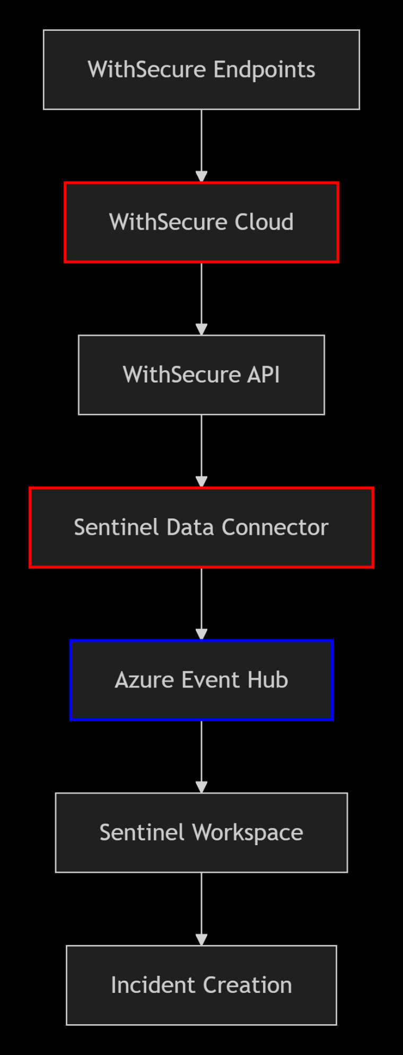
1. Threshold-Based Detection Rules
Rule 1: Absence of Recent Incidents
Logic: Alert when no WithSecure incidents received in X hours (based on historical patterns)

KQL Query Framework:

kql
let timeThreshold = 6h; // Adjust based on expected frequency
WithSecure_CL
| where TimeGenerated > ago(timeThreshold)
| summarize IncidentCount = count()
| where IncidentCount == 0
Rule 2: Sudden Drop in Incident Volume
Logic: Compare current incident rate against historical baseline

KQL Query Framework:

kql
let baselinePeriod = 7d;
let evaluationPeriod = 2h;
let thresholdReduction = 0.7; // 30% drop threshold

WithSecure_CL
| where TimeGenerated > ago(baselinePeriod)
| make-series Count = count() default=0
on TimeGenerated step evaluationPeriod
| extend CurrentCount = array_slice(Count, -1, -1)[0]
| extend HistoricalAvg = array_slice(Count, 0, -2)
| extend AvgHistorical = toscalar(HistoricalAvg | summarize avg(HistoricalAvg))
| where CurrentCount < (AvgHistorical * thresholdReduction)
2. Timestamp Analysis Rules
Rule 3: Incident Age vs Ingestion Time Mismatch
Logic: Detect when incidents are significantly delayed in ingestion

KQL Query Framework:

kql
let maxAllowedDelay = 1h;
WsSecurityEvents_CL
| extend IncidentCreatedTime = todatetime(createdTime_s) // Adjust field name
| extend IngestionDelay = TimeGenerated - IncidentCreatedTime
| where IngestionDelay > maxAllowedDelay
| project TimeGenerated, IncidentId, IncidentCreatedTime, IngestionDelay
Rule 4: Out-of-Order Incident Sequencing
Logic: Identify incidents arriving with non-sequential timestamps

KQL Query Framework:

kql
WsSecurityEvents_CL
| sort by TimeGenerated asc
| extend PrevTime = prev(TimeGenerated)
| extend TimeGap = TimeGenerated - PrevTime
| where TimeGap > 1h and isnotempty(PrevTime)
| project TimeGenerated, IncidentId, TimeGap
3. Data Quality Validation Rules
Rule 5: Missing Critical Fields
Logic: Alert on incidents with incomplete/empty required fields

KQL Query Framework:

kql
WsSecurityEvents_CL
| where isempty(incidentId_s)
or isempty(severity_s)
or isempty(deviceName_s)
| summarize BrokenIncidents = count() by bin(TimeGenerated, 1h)
| where BrokenIncidents > 5
Rule 6: Schema/Field Pattern Changes
Logic: Detect unexpected changes in data structure

KQL Query Framework:

kql
WsSecurityEvents_CL
| getschema
| summarize FieldCount = count()
| join kind=inner (
WithSecure_CL
| ago(7d) | getschema | summarize FieldCount = count()
) on $table.FieldCount != $left.FieldCount
4. Integration Health Monitoring Rules
Rule 7: API/Connector Failure Patterns
Logic: Monitor for error messages in ingestion logs

KQL Query Framework:

kql
AzureDiagnostics
| where ResourceProvider == "MICROSOFT.OPERATIONALINSIGHTS"
| where Category == "Heartbeat"
| where Resource contains "WithSecure" or Resource contains "Sentinel"
| where ResultType != "Success"
| summarize Failures = count() by bin(TimeGenerated, 15m), ResultType
| where Failures > 3
Rule 8: Sentinel-Workspace Correlation Gap
Logic: Compare WithSecure console incidents vs. Sentinel ingested incidents

KQL Query Framework:

kql
// This requires access to WithSecure audit logs or API call logs
let externalIncidents = externaldata(incidentId:string, createdTime:datetime)
[@"https://withsecure-api-example.com/incidents"]
with (format="json");
WithSecure_CL
| join kind=rightanti externalIncidents on $left.incidentId_s == $right.incidentId
| where createdTime > ago(24h)
| summarize MissingCount = count()
| where MissingCount > 0
5. Time Series Anomaly Detection
Rule 9: Machine Learning-Based Anomaly Detection
Logic: Use built-in time series anomaly functions

KQL Query Framework:

kql
WithSecure_CL
| make-series Incidents = count() default=0 on TimeGenerated step 15m
| extend anomalies = series_decompose_anomalies(Incidents)
| mv-expand Incidents, TimeGenerated, anomalies to typeof(double)
| where anomalies > 1.5 // Threshold for anomaly score
6. Correlation with Other Data Sources
Rule 10: Missing High-Severity Incidents
Logic: Correlate WithSecure device alerts with missing incidents

KQL Query Framework:

kql
let highSeverityEvents =
SecurityEvent
| where EventID in (4688, 4104, 4103) // Example critical events
| where TimeGenerated > ago(1h);
WithSecure_CL
| where TimeGenerated > ago(1h)
| join kind=rightanti highSeverityEvents on DeviceName
| summarize MissingHighSeverity = count()
| where MissingHighSeverity > 0
Implementation Recommendations:
Alert Configuration:
Severity Levels: Medium for gaps >1h, High for gaps >4h

Suppression: Group alerts into 1-hour windows

Auto-Remediation: Trigger logic app to restart connector

Notifications: Teams/Slack channel + ServiceNow ticket creation

Additional Monitoring:
kql
// Continuous health dashboard query
WithSecure_CL
| summarize
TotalIncidents = count(),
LastIncidentTime = max(TimeGenerated),
MissingFields = countif(isempty(incidentId_s)),
AvgIngestionDelay = avg(datetime_diff('minute', TimeGenerated, todatetime(createdTime_s)))
by bin(TimeGenerated, 1h)
Response Playbook Triggers:
Check WithSecure API status

Validate Sentinel data connector health

Verify network connectivity between systems

Check for API quota/throttling issues

Validate credential expiration

This ruleset provides layered detection from simple threshold alerts to ML-based anomaly detection, ensuring comprehensive monitoring of the WithSecure-Sentinel integration health.

