FAITH & PRAISE MONTESSORI SCHOOL
ZONE 6, ONIBUEJA COMMUNITY, IDO OSUN, OSUN STATE.
2ND TERM EXAMINATION — 2026/2027 SESSION
CLASS: Nursery 1/2 SUBJECT: Computer

Instruction: Answer all questions.
SECTION A: MATCHING EXERCISE
Match the names on the left with the correct pictures on the right:
1. Monitor | 
2. Calculator | 
3. Radio | 
4. Phone | 
5. Mouse | 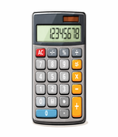

2. Write out the meaning of CPU
3. Mention 4 parts of a computer.
4. What does monitor look like?
5. State three things we can use computer for?

FAITH & PRAISE MONTESSORI SCHOOL
ZONE 6, ONIBUEJA COMMUNITY, IDO OSUN, OSUN STATE.
2ND TERM EXAMINATION — 2026/2027 SESSION
CLASS: Nursery One / Two SUBJECT: Yoruba

APA KEYI
1. Ko oruko nkan meta ti o bere pelu "B":
(i) __________ (ii) __________ (iii) __________

2. Ko oruko awon nkan wonyi ni ede Yoruba:
Spoon: __________ Chair: __________ Knife: __________

3. Ko awon nomba wonyi ni ede Yoruba:
(i) 3: __________ (ii) 7: __________ (iii) 12: __________ (iv) 20: __________ (v) 30: __________

4. Daruko awon nkan ile marun (5).

5. Daruko eya ara marun (5).

APA KETA
Aroko — "Oruko baba re".

FAITH & PRAISE MONTESSORI SCHOOL
ZONE 6, ONIBUEJA COMMUNITY, IDO OSUN, OSUN STATE.
2ND TERM EXAMINATION — 2026/2027 SESSION
CLASS: Pre-Basic One & Two SUBJECT: Computer

Instruction: Attempt all questions.
1. What is a computer? _________________________________________________________

2. Computer monitor shows the information in the computer. (a.) Yes (b.) No

3. Mention three (3) places where we can use a computer:
(i.) ____________________________ (ii.) ____________________________ (iii.) ____________________________

4. Keyboard looks like a typewriter. (a.) Yes (b.) No

5. The C.P.U. means _________________________________________________________
6. Look at the computer below. Identify and name its main parts:
(i.) Monitor (ii.) Keyboard (iii.) CPU


FAITH & PRAISE MONTESSORI SCHOOL
ZONE 6, ONIBUEJA COMMUNITY, IDO OSUN, OSUN STATE.
2ND TERM EXAMINATION — 2026/2027 SESSION
CLASS: Pre-Basic One & Two SUBJECT: Creative Arts

Instruction: Identify and colour the following pictures with appropriate colours.

1. | 2. | 3.
  Name: _____________________ | 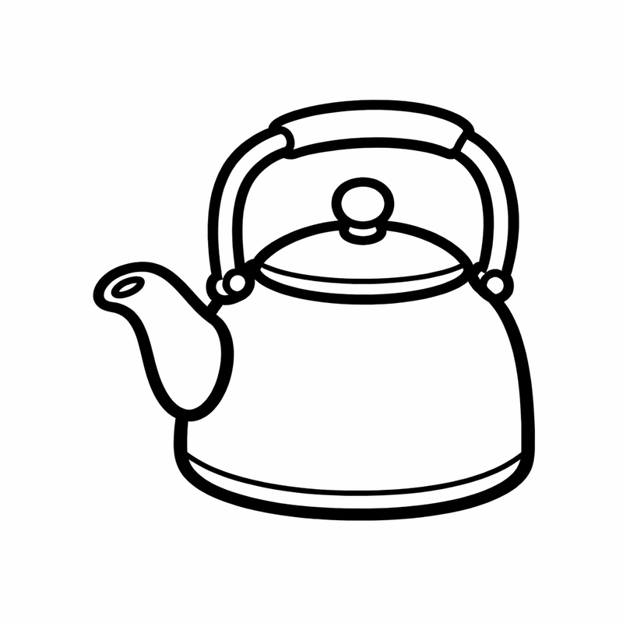  Name: _____________________ |   Name: _____________________
4. | 5.
  Name: _____________________ |   Name: _____________________

FAITH & PRAISE MONTESSORI SCHOOL
ZONE 6, ONIBUEJA COMMUNITY, IDO OSUN, OSUN STATE.
2ND TERM EXAMINATION — 2026/2027 SESSION
CLASS: Creche SUBJECT: Colouring

Instruction: Name and colour these objects.

1. | 2. | 3.
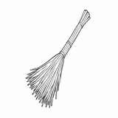  Name: __________________ |   Name: __________________ | 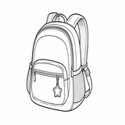  Name: __________________
4. | 5.
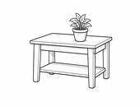  Name: __________________ |   Name: __________________

FAITH & PRAISE MONTESSORI SCHOOL
ZONE 6, ONIBUEJA COMMUNITY, IDO OSUN, OSUN STATE.
2ND TERM EXAMINATION — 2026/2027 SESSION
CLASS: Creche SUBJECT: Science

Instruction: Attempt all questions.

1. Touch and demonstrate "Parts of the Body":
Head • Neck • Finger • Stomach • Leg

2. Food we eat are:
(i.) ____________________ (ii.) ____________________ (iii.) ____________________

3. Objects at school are:
(i.) ____________________ (ii.) ____________________ (iii.) ____________________

4. Name these fruits:

 |  | 
Name: __________________ | Name: __________________ | Name: __________________

FAITH & PRAISE MONTESSORI SCHOOL
ZONE 6, ONIBUEJA COMMUNITY, IDO OSUN, OSUN STATE.
2ND TERM EXAMINATION — 2026/2027 SESSION
CLASS: Grade 3/4 SUBJECT: Vocational Studies

Instruction: Answer all questions.

1. Give 5 tools used in photography.
2. Mention 3 qualities of a journalist.
3. Who is a barber? Mention tools used by a hairdresser.
4. What is a career? List the types of dyes.
5. Mention 4 importances of cooking
.

FAITH & PRAISE MONTESSORI SCHOOL
ZONE 6, ONIBUEJA COMMUNITY, IDO OSUN, OSUN STATE.
2ND TERM EXAMINATION — 2026/2027 SESSION
CLASS: Primary 1 SUBJECT: Social Studies

Instruction: Answer all questions.

1a. What is an environment?
1b. State 3 ways of keeping our environment clean.
1c. List 4 materials for cleaning our environment.

2a. Greeting means _______________________________________________.
2b. Mention 3 people we must greet.
2c. Mention 4 forms of greeting.

3a. List 2 types of accidents.
3b. State 4 causes of accidents.
3c. Mention 4 prevention methods for accidents.

FAITH & PRAISE MONTESSORI SCHOOL
ZONE 6, ONIBUEJA COMMUNITY, IDO OSUN, OSUN STATE.
2ND TERM EXAMINATION — 2026/2027 SESSION
CLASS: Primary 1 & 2 SUBJECT: Yoruba

Instruction: Dahun gbogbo ibeere.

1a. Kini Silebu?
1b. Pin awon oro wonyi si silebu:
(i) Aso: __________
(ii) Owo: __________
(iii) Agbalagba: __________
(iv) Baba: __________

2. Ko leta Alifabeti Yoruba lati Aa — Yy.

3a. Kini Yoruba pe ni "Owe"?
3b. Pari owe wonyi:
(i) Bami na omo mi, ____________________________
(ii) Omode gbon, agba gbon, ____________________________
(iii) Maalu ki ko ni ____________________________

4. Ko apeere ounje amara-da merin (4).

SECTION B - LITERATURE

Instruction: Dahun gbogbo ibeere.

1. Kini oruko aja Kasali?
2. Aja Kasali si je alawo __________
3. Kasali je eya ara __________
4. Kini akole litireso re? __________
5. Kasali je __________

FAITH & PRAISE MONTESSORI SCHOOL
ZONE 6, ONIBUEJA COMMUNITY, IDO OSUN, OSUN STATE.
2ND TERM EXAMINATION — 2026/2027 SESSION
CLASS: Primary 4 SUBJECT: Yoruba

Instruction: Dahun gbogbo ibeere.

1. Dahun awon ibeere wonyi lori litireso re:
(i) Tani Ajike?
(ii) Kini oruko atokun litireso re?
(iii) Ojo melo ni Ajike lo ninu igbo nigba ti o kuro ni ilu baba re?
(iv) Bawo ni Ajike se wo oba Saan?
(v) Ohun woni Ajike gbo nigba ti apamowo re bo sinu odo?

2a. Kini itumo Aroko Alariyanjiyan?
2b. Daruko ni sise n tele ilana Aroko Alariyanjiyan.
2c. Daruko igbese merin fun eto igbeyawo.

3. Fi ila si oro aponle ninu gbolohun wonyi:
(i) Ile na wo patapata.
(ii) Raurau ni ina najo.
(iii) Ni gbigbona felifeli ni mo fe je iyan na.
(iv) Sola n rin jaujau.
(v) Okele titobi jaburata ni Bola bu.

FAITH & PRAISE MONTESSORI SCHOOL
ZONE 6, ONIBUEJA COMMUNITY, IDO OSUN, OSUN STATE.
2ND TERM EXAMINATION — 2026/2027 SESSION
CLASS: Grade 3 SUBJECT: Christian Religious Studies DURATION: 2 Hours

Instruction: Attempt all questions.
1a. List four (4) importance of showing love to one another in the society.
1b. Mention three (3) reasons why Jesus Christ gave His life for us.
2a. What is the meaning of a new life?
2b. State three (3) evidences of a new life.
3a. State five (5) fruits of a new life.
3b. Write a short note about yourself.
4. Write a short story about Zacchaeus.

FAITH & PRAISE MONTESSORI SCHOOL
ZONE 6, ONIBUEJA COMMUNITY, IDO OSUN, OSUN STATE.
2ND TERM EXAMINATION — 2026/2027 SESSION
CLASS: Grade 3 SUBJECT: Mathematics DURATION: 2 Hours

Instruction: Attempt all questions.
1a. Simplify these:
(i.) 4/7 − 1/7 (ii.) 2/3 + 1/12 (iii.) 3 1/5 + 3 ¾ (iv.) 4 1/3 − 2 ¼
1b. Find the value of the following:
(i.) 3 + 2 (ii.) 12 − 10 (iii.) 7 + 6 (iv.) 8 − 7
2. Find the common factors of the following:
(i.) 18 and 24 (ii.) 8 and 12

3a. Divide ₦64.80 by 8
3b. 4 ) 16
3c. 11 ) 121

FAITH & PRAISE MONTESSORI SCHOOL
ZONE 6, ONIBUEJA COMMUNITY, IDO OSUN, OSUN STATE.
2ND TERM EXAMINATION — 2026/2027 SESSION
CLASS: J.S.S. One SUBJECT: Mathematics DURATION: 2 Hours

Instruction: Attempt just three (3) questions.

1a. Solve these equations:
(i.) 4p + 5 = 17 (ii.) 3(r + 2) = 15r
1b. Approximate the following to the nearest: (i.) thousand (ii.) hundred (iii.) ten
(a.) 18624 (b.) 26888

2a. Simplify these:
(i.) 12/15 × (1 ¼) (ii.) 5 ¼ × 2 4/5 / 3 ¾
2b. Convert the following numbers to binary numbers:
(i.) 12 (base 4) (ii.) 73.5 (base 9) (iii.) 205.75 (base 8)

3a. If x = 9, y = 5, z = 16, evaluate each of the following:
(i.) y / (y − 1) (ii.) 5xy / (x − y)
3b. Simplify: 7abc / 35cab

4. Twenty housewives were asked their favourite colour. Their responses:

Colour | White | Red | Blue | Green | Yellow | Pink
No. of Housewives | 2 | 3 | 5 | 2 | 1 | 2

(a.) Which colour is most preferred by the housewives?
(b.) Which colour is least popular among the housewives?

FAITH & PRAISE MONTESSORI SCHOOL
ZONE 6, ONIBUEJA COMMUNITY, IDO OSUN, OSUN STATE.
2ND TERM EXAMINATION — 2026/2027 SESSION
CLASS: JSS 1 SUBJECT: History DURATION: 2 HOURS

INSTRUCTION: Attempt only THREE (3) questions out of four (4).

1a. Mention the major centralized states in pre-colonial Nigeria.
1b. Give 2 challenges of a centralized state.
1c. Give 2 advantages of a centralized state.

2a. Explain Igbo-Ukwu Culture.
2b. Give 2 significance of Igbo-Ukwu Culture.
2c. Mention all the occupations in Igbo-Ukwu Culture.

3a. Explain the culture and tradition of Ife.
3b. Give 3 significance of the Ife culture.
3c. Mention the occupation of Ife culture.
3d. What is the king of Ife called?

4a. Where is the city of Benin located on the map of Nigeria?
4b. Give one significance of Edo culture.
4c. Name the first archaeologist to discover evidence of the settlement.
4d. Mention the artifacts of Benin culture.

