Technical Case - Staff Data Reliability Engineer
DataWave Industries – SQL Federation Architecture Case

Introduction

DataWave Industries is a mid‑size global logistics and supply‑chain company undergoing a major modernization of its data platform.
For the last decade, the company relied on an on‑premises Hadoop‑era cluster, which has reached its limits as the business expanded into new markets and exponentially increased the tracking of shipments.

The on‑prem cluster now struggles with:
- Limited scalability
- Performance bottlenecks
- Frequent availability issues
- High operational overhead

To enable advanced analytics, real‑time decisioning, and future AI/ML capabilities, DataWave leadership approved the migration of their analytical platform to Azure Cloud.
The first foundational step in this transformation is to build a SQL Federation Layer, which unifies access to disparate data sources through a single query engine.

This technical case evaluates your ability to design, implement, document, and deliver this SQL federation architecture using modern DevOps and Reliability Engineering principles.

Important: This role requires strong Azure proficiency. In addition to implementing the architecture locally using Docker Compose, you must also provide a production-oriented Azure architecture proposal for running this platform in Azure.

Your Assignment

You must complete two mandatory parts:

Part 1 – Local Working Implementation
Implement the SQL Federation Architecture locally using Docker Compose, simulating the main components.

Part 2 – Azure Production Architecture Proposal
Design and document a target Azure architecture for running this application in a production-ready cloud environment.
Reference Architecture:
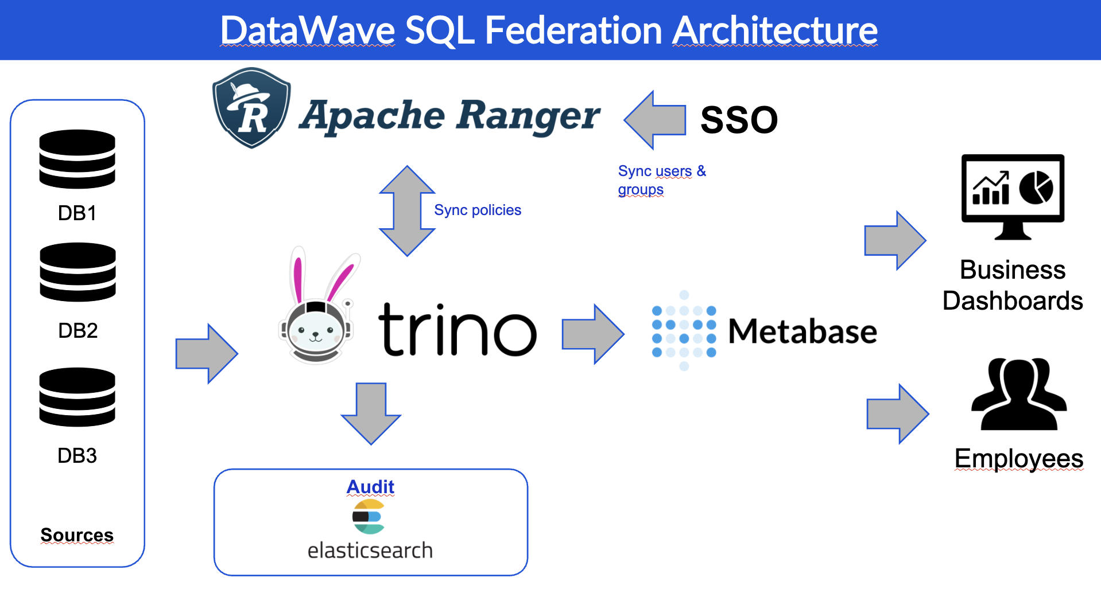

Your solution should follow these guidelines:

Part 1 – Local Implementation Requirements

You must implement the following components:
- A SQL federation engine (e.g., Trino, Presto, or similar)
  - At least two data source connectors, such as:
    - PostgreSQL
    - MySQL
    - MinIO/S3 (optional but preferred)
- A metadata/catalog layer if required by your chosen engine
- A UI or simple API endpoint to demonstrate query execution (can be a BI tool, such as Metabase as well)
- A containerized environment orchestrated via Docker Compose

[OPTIONAL] SSO Integration (+10 pts)

If you want to earn additional points, implement SSO integration to secure access to the federation engine UI or API.

Accepted SSO methods include:
- OAuth2 (Google, GitHub, etc.)
- OpenID Connect
- Keycloak integration
- Any other SAML or OAuth federation tool (running locally)

This part is optional but will count as extra credit.

Part 2 – Azure Architecture Proposal Requirements

You must provide a production-grade Azure architecture proposal for this SQL federation platform.
Your proposal must cover:

1. Core Azure Services Selection
Explain which Azure services you would use for each architectural component, for example:
- Compute / orchestration
  - AKS, Azure Container Apps, Azure Container Instances, or VMs

- Storage
  - Azure Blob Storage / ADLS Gen2

- Databases
  - Azure Database for PostgreSQL / MySQL

- Networking
  - VNets, subnets, NSGs, Private Endpoints, Load Balancers, Application Gateway

- Secrets and configuration
  - Azure Key Vault, Managed Identities, App Configuration

- Monitoring / observability
  - Azure Monitor, Log Analytics, Application Insights, Prometheus/Grafana

- CI/CD and IaC
  - Terraform, Bicep, GitHub Actions, Azure DevOps

2. Reliability and Operational Design
Describe how your Azure design addresses:
- High availability
- Scaling strategy
- Failure isolation
- Backup and recovery
- Disaster recovery
- Upgrade / rollback strategy
- Observability and alerting
- Capacity management

3. Security Design
Explain:
- Identity and access management
- Authentication and authorization
- Secret management
- Network isolation
- Private vs public exposure
- Encryption in transit and at rest
- Least-privilege principles

4. Data Platform Design
Describe how the SQL federation layer would connect to:
- Azure-hosted relational databases
- Object storage / lakehouse storage
- Potential future data sources
- Metadata and catalog services if needed

5. Deployment Model
Provide your recommendation for how this platform should be deployed in Azure:
- Environment strategy (dev / test / prod)
- IaC approach
- Release process
- Operational ownership model

6. Architecture Diagram
Include at least one diagram showing the proposed Azure deployment.

Technical Expectations

Docker Compose Environment

You must deliver a fully functioning local environment using Docker Compose:
- All services must start cleanly
- Federation engine should be reachable
- Queries must run successfully against the federated sources
- Logs should show services running without critical errors
- Network dependencies must be correctly configured (ports, hostnames, volumes)

SQL Federation Capabilities

Your implementation should demonstrate:
- The ability to query multiple backend systems via a single SQL endpoint
- Basic SQL operations such as
  - SELECT across one source
  - SELECT joining two different sources
- Proper connector configuration
- Schema structure visible via catalogs

Azure Proposal Expectations
Your Azure proposal should demonstrate:
- Sound platform design choices
- Clear reasoning behind service selection
- Reliability engineering judgment
- Security best practices
- Operational readiness
- Awareness of trade-offs, including complexity and cost

Architecture Overview
- Each local component
- How they interact
- How the local architecture maps to the provided challenge diagram

Azure Architecture Overview
- Target Azure services
- How the local proof-of-concept maps to the cloud design
- Why each Azure service was selected
- Operational and reliability considerations

Setup Instructions
- How to clone the repository
- How to install dependencies
- How to run the system
- How to validate all services are operational

Usage Guide
- How to access the federation UI/API/CLI
- Example SQL queries
- How to add new connectors

Azure Design Guide
- Assumptions
- Azure deployment model
- Security model
- Reliability model
- Monitoring model
- Trade-offs and future improvements

Optional SSO Documentation (+10 pts)
- Configuration steps
- Authentication flow
- Local or Azure identity integration details

Deliverables

You must deliver the following via a public GitHub repository:
- A working Docker Compose environment
- All configuration files (YAML, SQL, connector configs, env files)
- Source code if applicable
- Full documentation (README.md required)
- [Optional] SSO implementation
- Any diagrams you create to support your explanation

All materials should be committed cleanly and organized in a conventional project structure.

Scoring Criteria (100 Points Total + 20 Extra Points)

Your submission will be evaluated across the following criteria:

Execution – 25 points
- Completeness of implementation
- Correctly configured federation engine
- Quality of the architecture replication
- [Optional] SSO implementation (+10 extra points)

Run Without Errors – 20 points
- docker compose up should start cleanly
- All services must run without critical errors
- Query engine must be usable end‑to‑end

Architecture Quality – 15 points
- Clear, correct mapping to the architecture diagram provided
- Appropriate container networking and configuration patterns
- Correct connectors and catalog setup

Azure Architecture Proposal – 25 points
- Services selection and proper correlations
- Reliability, Security and Scalability
- Design Trade-offs

Documentation – 15 points
- Clear explanation of architecture
- Step‑by‑step setup instructions
- Usage examples and troubleshooting notes
- [Optional] User guide (+10 extra points)

What We Are Evaluating

This exercise helps assess:
- Your ability to design and implement reliable distributed data systems
- Your understanding of SQL federation patterns
- Hands‑on DevOps and containerization expertise
- Documentation and communication skills
- Your capacity to deliver production‑ready components
- How you structure complex systems in a portable environment

A Staff‑level candidate is expected to show strong architectural judgment, clarity of documentation, and a clean, reliable implementation.

