Whispers and Wounds

By Apriène

*A personal archive of memory, restraint, identity, and the quiet act of becoming.*

Featured Works

1. All the Girls I’ve Been (And the Ones I Skipped on Purpose)

Subtitle:A personal archive of memory, restraint, and womanhood.*

Published: January 22, 2026

- *”A look back through the layers of identity—tracing every version of myself I have lived through, and honoring the paths left untaken.”
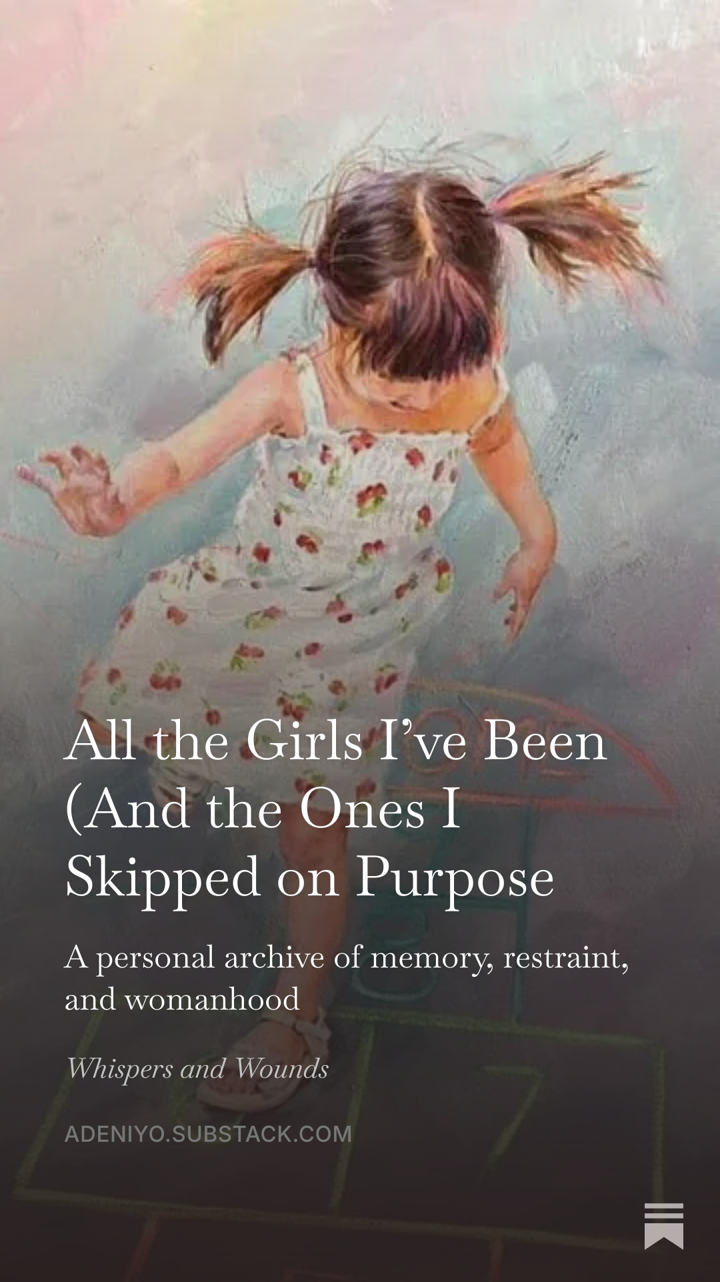

[Read the Full Piece](https://www.google.com/search?q=https://adeniyo.substack.com/p/all-the-girls-ive-been-and-the-ones)**

2. I Feel Behind, But I Haven’t Given Up

Subtitle:Trying my best, even when it doesn’t feel like enough.

Published:January 8, 2026

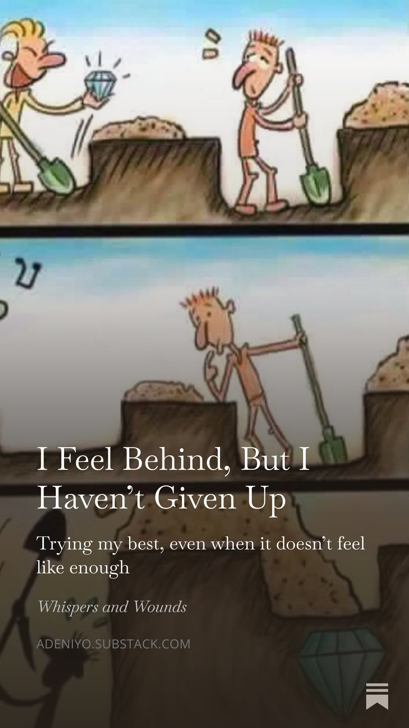
- ”I came outside today because I realized I have been sitting in the same place for too long. Not just physically. Emotionally. Mentally. Spiritually… Starting from scratch is humiliating in a way no one prepares you for, but even when I feel behind, I haven’t given up.”

[Read the Full Piece](https://adeniyo.substack.com/p/i-feel-behind-but-i-havent-given)**

3. I Have a Crush on the Life I Haven’t Lived Yet

**Subtitle : An ode to future apartments, soft mornings, and becoming.

Published: July 4, 2026
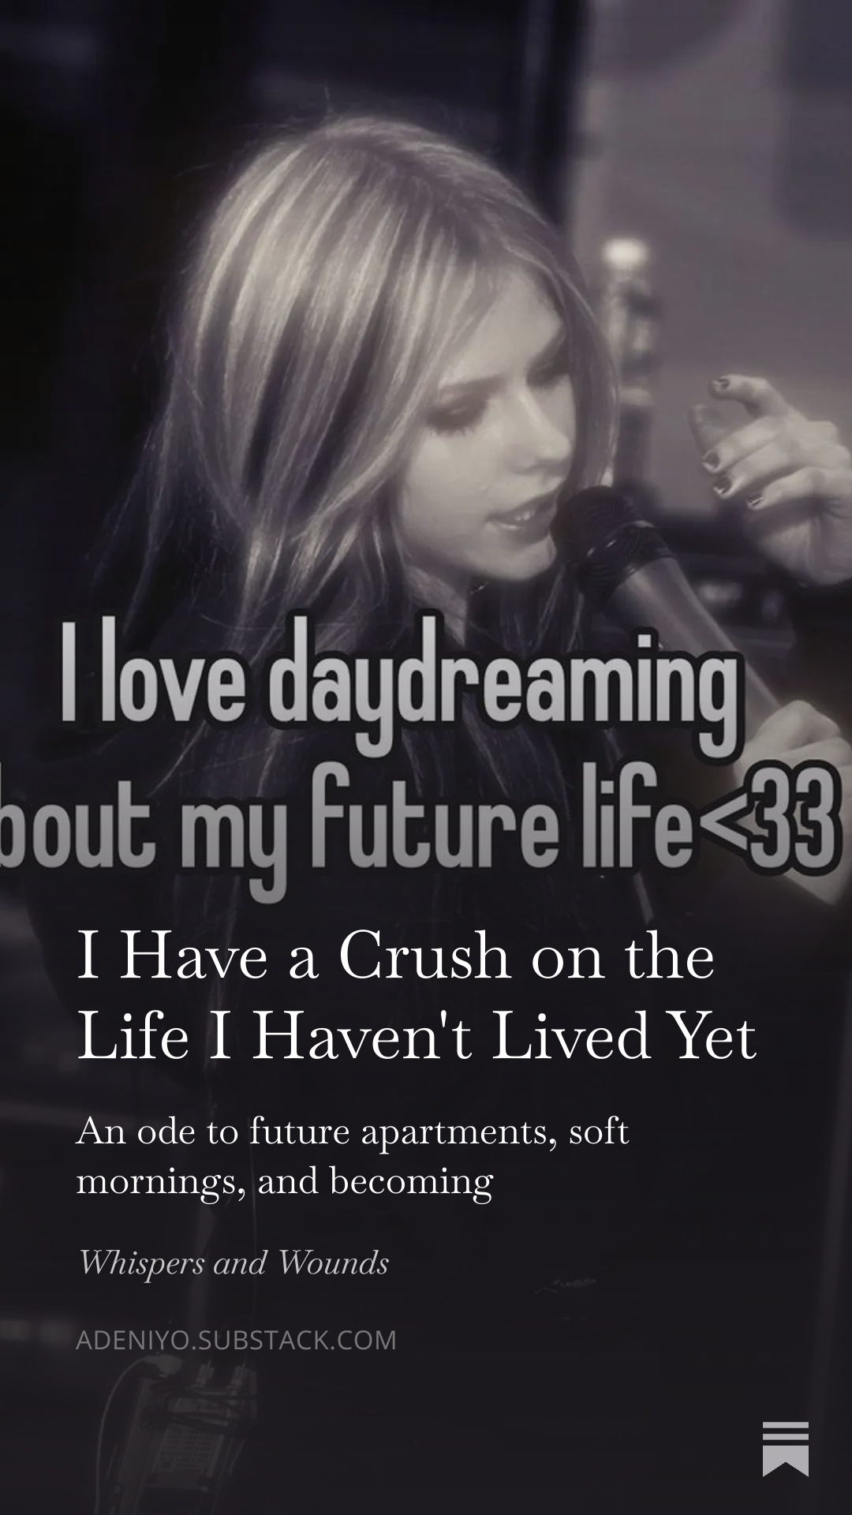
- ”I think about her a lot. The version of me that doesn’t exist yet. She wakes up early, but not because anxiety chased away her sleep… Maybe that’s what hope is. A tiny crush on your future.”

[Read the Full Piece](https://adeniyo.substack.com/p/i-have-a-crush-on-the-life-i-havent)**

About the Author

I write about the quiet pressures of growing up, the messy space between effort and arrival, and the subtle beauty of persistence. Whispers and Wounds is my dedicated space for honest reflections on womanhood, growth, and hope.

