Contents
Introduction 2
1.1 Objective 2
1.2 Motivation 2
1.3 Critical Challenges 2
1.4 Social and Environmental Impact 2
Project Description 2
2.1 Description of Project 2
2.2 Proposed Functionalities/Features 3
2.3 User control 3
Project Design 3
3.1 Architecture of the Proposed System 3
Models: 4
Views: 4
Template: 5
manage.py: 6
settings.py: 6
admin.py: 6
forms.py: 7
urls.py: 7
3.2 ER Diagram 9
Project Implementation 10
4.1 Tools 10
4.2 Example Walk-through 11
Team Contributions 11
Conclusion and Future Work 12
Conclusion 12
Future Work 12
CEP Mapping 13

Introduction

1.1 Objective
This project provides a web application platform, and users will be able to access Event services and event products online. The objective of this project is to build a two-user-based Event Planning and Management Website that simplifies the process of planning and organizing events. It provides vendors the ability to showcase services or products and allows customers to view and utilize them while managing their events through features like checklists, scheduling, and budgeting

1.2 Motivation
Planning events can be overwhelming and time-consuming. In Bangladesh and many similar regions, event planning still heavily relies on manual efforts. This platform aims to offer users a simple, centralized online tool for organizing events efficiently, minimizing stress, and improving the experience.

1.3 Critical Challenges
- Designing a flexible system that supports multiple user types.
- Handling secure user authentication and authorization.
- Managing and associating user-specific data (e.g., checklists, schedules).
- Time constraints to develop and test core features

1.4 Social and Environmental Impact
This website promotes digital adoption in event planning, potentially reducing paper waste (due to digital checklists and reminders) and increasing accessibility to vendors. It supports small businesses by providing them a platform to connect with customers directly.

Project Description

2.1 Description of Project
Our ‘ManageHoise?’ website is a Django-based web application designed to streamline the process of planning and organizing events. It supports two types of users: vendors and customers. Vendors can register on the platform and add, update, or remove products or services they offer for events, such as catering, decoration, or rental items. Customers, on the other hand, can browse these offerings, manage their user profiles, and eventually plan their events using various tools. Although the core planning features, such as checklists, budgeting, scheduling, and reminders, have not yet been implemented, the website has laid the foundation for a structured and expandable system. The site utilizes Django’s model-view-template (MVT) architecture to manage data flow and user interaction. It also includes essential features such as user authentication, profile editing, and role-based access, making it a functional two-user platform. Future developments aim to incorporate interactive planning features that will enhance the user experience and make the platform a comprehensive solution for event management.

2.2 Proposed Functionalities/Features
1. Two-user system (Vendor and Customer)
2. Vendor can add/edit/delete items (services or products)
3. Customer can view and purchase items
4. Profile creation and editing
5. Planned: Checklist creation, Budget tracking, Scheduling, Notifications
6. Customer can see the vendor list and the vendor profile

2.3 User control
- Vendors have control over their products.
- Customers can create accounts, manage profiles, and use event tools.
- Admin can manage all users and data through the Django admin panel.

Project Design

3.1 Architecture of the Proposed System
We developed ‘ManageHoise?’ in Django, which follows the MVT(Model-View-Template) structure. MVT in Django provides a structured approach for separating concerns in web development, promoting code modularity and maintainability. Models handle data, views handle user interactions, and templates handle the presentation, contributing to a scalable and organized project architecture.

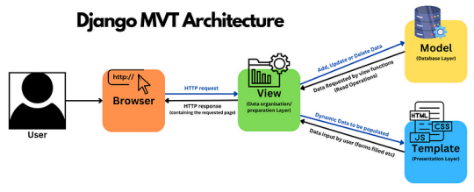

Models:

The models.py file for the ‘ManageHoise?’ project encapsulates the data structure for a management system. Key models include C_Profile for user details, Product for product, and Cart Item to manage items in a user's cart. Additionally, an event model for our previous work. Relationships between these models are established to capture the complex interactions within the home domain, providing a solid foundation for data management and retrieval in the ‘managehoise?’ project.

Views:
The `views.py` file handles all the core logic for rendering pages and processing user interactions in our Django Event Planner website. It begins by importing necessary modules, including Django shortcuts like `render`, `redirect`, and models and forms that interact with the database. Several views manage product functionality: `add_product`, `update_product`, and `delete_product` allow vendors to create, modify, and remove their products using a form and conditional logic based on HTTP POST requests. Shopping cart functionality is implemented through views like `add_to_cart`, `view_cart`, `remove_from_cart`, and `checkout`, enabling authenticated users to manage products in their cart, calculate totals, and place orders. The `order_history` view displays a logged-in user's past orders.
The homepage and various static content pages, such as help, policy, and team profiles, are handled by simple `render` calls. The `product` view dynamically fetches and displays all products and determines the logged-in user's role to personalize the interface. There is also a `search` view that enables keyword-based product search. The `signup` view processes new user registration using a custom form, validates the uniqueness of username and email, creates a corresponding `C_profile`, and logs in the user. Similarly, the `user_login` and `user_logout` views handle authentication using Django’s built-in form and functions. The `profile_view` allows users to see and update their profile, handling both GET and POST requests, and includes logic to check which fields were changed before saving.
Other views like `vendor_list` and `vendor_profile` allow customers to browse vendor accounts, while event-related views, such as `event_list` and `event_details` are included to display portfolios. Lastly, various profile views for team members are set up to render personal profile templates. Overall, this file controls the flow of user interactions, connects templates to backend logic, and ensures that only authenticated users can perform certain actions.

Template:

In our Event Management website, Django templates form the backbone of the frontend design, ensuring a modular, consistent, and maintainable user interface. Templates are structured hierarchically to promote reusability and uniform styling across pages. At the core of this structure lies a base template, typically named base.html, which contains shared elements like the header, navigation bar, and footer. Individual pages extend this base template and define their own content using Django’s block syntax.
- {% extends %}:
The {% extends %} tag allows child templates (such as product.html, cart.html, or profile.html) to inherit from base.html. This ensures that all pages share the same layout, branding, and styling, reducing repetition and promoting consistency throughout the site.
- {% block %}:
The {% block %} tag is used within base.html to define content areas (e.g., {% block content %}) that child templates can override. For example, the product.html template might override {% block content %} to display product cards, while the cart.html page displays items in a user’s shopping cart. This modularity simplifies future updates and makes template management more efficient.
This use of template inheritance greatly streamlines development and enables rapid implementation of changes across the entire platform from a single base template.
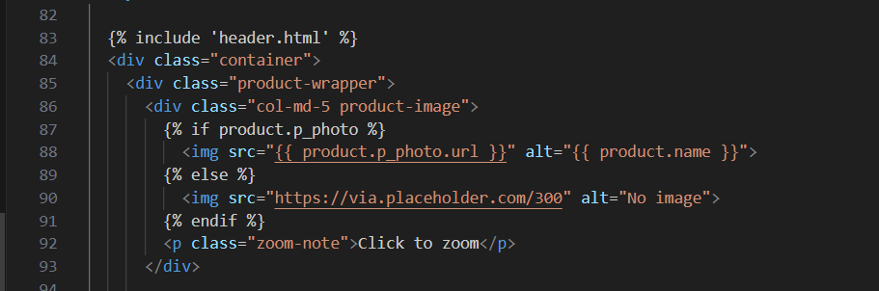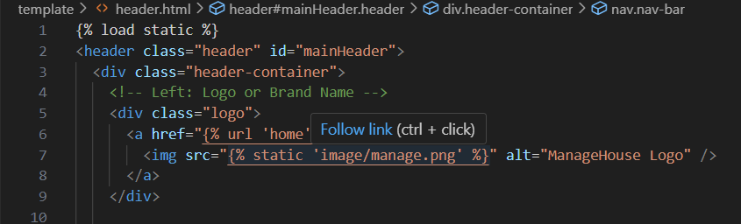
manage.py:
The manage.py file is a command-line utility that is included in every Django project by default. It acts as the central entry point for executing administrative tasks within the Django environment. This includes operations such as launching the development server using the runserver command, creating new applications, generating and applying database migrations via makemigrations and migrate, and interacting with the Django shell for testing and debugging. Overall, manage.py facilitates the management and execution of core Django functionalities throughout the development lifecycle.
settings.py:
The settings.py file contains the primary configuration for the Django project. It defines various project-wide settings, including database connection parameters, time zone and localization preferences, middleware stack configurations, static and media file directories, and template rendering settings. One of its most critical components is the INSTALLED_APPS list, which registers all Django and custom apps to be recognized and used by the framework. This file serves as the backbone of the project’s operational behavior.
admin.py:
The admin.py file allows Django models to be registered with the Django admin interface. By registering models such as Category, Product, C_profile, Portfolio, CartItem, Order, and OrderItem using admin.site.register(), administrative users can manage application data through a graphical interface provided by Django’s admin panel. This integration simplifies backend data management and provides a quick way to view, update, and delete records without needing custom dashboards.
forms.py:
The forms.py file defines Django form classes that are used for processing user input and validating submitted data. It contains the following key forms:
- ProductForm:
Type: ModelForm
Model: Product
Purpose: Enables vendors to add or update product listings.
Usage: Implemented in the add_product and update_product views.
- SignUpForm:
Type: Custom ModelForm
Model: User (with extended fields from C_profile)
Purpose: Manages user registration, including custom fields such as role, phone, profile picture, and bio.
Validation: Ensures unique usernames and matching passwords.
Effect: Simultaneously creates User and corresponding C_profile objects.
Usage: Used in the signup view.
- ProfilePictureForm:
Type: ModelForm
Model: C_profile
Field: profile_picture
Purpose: Designed to update a user’s profile image.
Validation: Restricts image size to a maximum of 5 MB.
Note: This form has not been integrated into views.py but can be used within the profile view to support image updates.
urls.py:
The urls.py file contains all the URL pattern definitions that connect frontend URLs to backend view logic. Each path specifies a route and links it to an appropriate view function. The following sections describe its structure:
- Admin Panel
/admin/: Provides access to Django’s built-in administrative interface.
- Homepage and Authentication
/: Loads the homepage via the home view.
/signup/: Handles user registration via the signup view.
/login/: Directs to the user login page.
/logout/: Logs out the currently authenticated user.
/profile/: Displays and allows updates to user profile details.
- Product Management
/product/: Displays a list of all available products.
/product/str:id/: Shows details of a specific product.
/product/add_product/: Allows vendors to add a new product.
/product/update_product/str:id/: Enables product updates.
/product/delete_product/str:id/: Facilitates product deletion.
- Team Profiles
/meet_the_team/: Shows the general team overview page.
Subroutes such as /meet_the_team/sajid/ and /meet_the_team/tanisha/ load individual team member profiles.
- Static Pages
/policy/: Loads the privacy policy page.
/help/: Loads the help and FAQ section.
- Event Section
/event_list/: Displays all portfolio events.
/event_list/int:pk/: Loads detailed information for a specific event.
- Shopping Cart and Orders
/cart/: Displays the current user’s cart contents.
/cart/add/int:product_id/: Adds a product to the cart.
/cart/remove/int:item_id/: Removes a product from the cart.
/checkout/: Finalizes the order and clears the cart.
/orders/: Displays the authenticated user’s past orders.
- Search and Vendors
/search/: Provides keyword search functionality for products.
/vendors/: Displays a list of all vendor profiles.
/vendor/int:user_id/: Loads the profile of a specific vendor.
- Media Handling
During development, static and media files (such as uploaded images) are served using the static () function with the MEDIA_URL setting from settings.py. This allows uploaded content to be displayed correctly in templates and user profiles.

3.2 ER Diagram
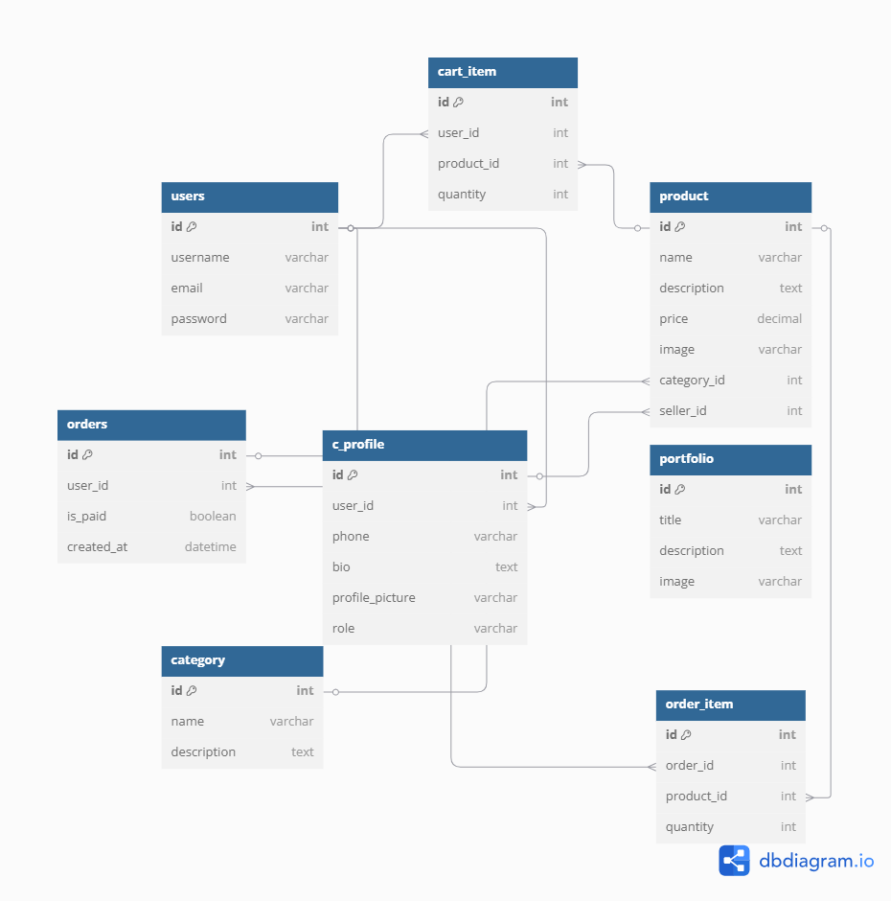

Project Implementation

4.1 Tools
We used many tools, languages, framework, and other things to develop this project and enhance our experience while also maintaining efficiency. The tools are:
VS Code:
In the context of our project, ManageHoise, an online event management website featuring event product buying, renting, and planning event Visual Studio Code (VS Code) emerges as a preferred development environment. Leveraging VS Code's lightweight design and powerful capabilities enhances the efficiency of our Django-based project. We used it’s extensions like:
HTML, CSS, Bootstrap:
For the frontend development of our ManageHoise? project, which focuses on providing comprehensive online event management services, HTML, CSS, and JavaScript play pivotal roles in creating a seamless and user-friendly interface.
HTML serves as the structural foundation, defining the layout and organization of various elements on our web pages.
CSS comes into play for styling, ensuring a visually appealing design and consistent branding across the site. We also use
Bootstrap is a CSS framework to work with many buttons and fonts to style elements
Python and Django:
In the backend development of our manageHoise? project, Python is the cornerstone, chosen for its suitability in creating a robust and scalable environment. Python, being a versatile and readable language, is instrumental in crafting the intricate logic that powers the backend functionalities of our online medical platform.
The Django framework, built on Python, provides a structured foundation that streamlines the development process, allowing us to efficiently manage various aspects of our project, such as product searching. Additionally, its extensive ecosystem and Django's built-in features simplify tasks such as database management, ensuring that our backend operations are not only powerful but also maintainable.
Database (SQLite3):
This is the default database of Django, and we used it to store all of the data. We can also update and delete the data from the database. We can use filters and queries to get the desired data from the database.

4.2 Example Walk-through

Team Contributions
Tasks | 22201169(Tanisha) | 22201186(Sajid) | 22201187(Sanjida) | 22101204(Emon)
HTML page creation
HTML page linking and URL mapping
Design with
CSS
Database
creation in (models.py) and
registration in (admin.py)
Backend logic handling (views.py, forms.py) and displaying data
Features and bug fixes
Version
control
Report
Writing

Conclusion and Future Work

Conclusion
The project successfully lays the groundwork for a dual-user event management platform, demonstrating the potential to evolve into a comprehensive event planning assistant. Built using Django’s MVT (Model-View-Template) architecture, the system currently supports core features including user registration and authentication, profile management, product listing and management by vendors, as well as browsing and purchasing by customers. A functional shopping cart and order processing system simulate a basic event-related marketplace, reflecting real-world workflows.
From a technical perspective, the system incorporates clean, modular architecture with scope for future expansion. The development process provided practical experience in full-stack web development with Django, encompassing user role management, form validation, dynamic URL routing, session handling, and secure file uploads. The project also demonstrated thoughtful UI design practices by integrating a modern, responsive interface.
Although core event planning tools—such as checklists, budgeting tools, and scheduling—have not yet been implemented, the current foundation is scalable and well-structured, allowing for the seamless addition of these features in subsequent phases.

Future Work
To evolve the system into a full-featured event planning assistant, several enhancements are planned:
- Checklist System: Users will be able to create, manage, and track task lists (e.g., "Book venue", "Send invitations"), improving event organization.
- Budget Tracker: A budgeting tool will allow users to plan and monitor expenses, comparing projected vs. actual costs.
- Scheduling with Calendar Integration: Event timelines, milestones, and automated reminders will be incorporated to help users stay on schedule.
- Notifications: In-app and email notifications will improve user engagement by alerting users to important updates, such as order confirmations or pending tasks.
From a user experience perspective:
- Responsive Design Improvements: Enhancements for mobile compatibility and accessibility will ensure a seamless experience across all devices.
- Role-Specific Dashboards: Customized interfaces for vendors and customers will provide a more intuitive and task-focused experience.
- Rating and Review System: Customers will be able to rate vendors and leave feedback, promoting trust and credibility within the platform.
- Payment Gateway Integration: Implementing services like SSLCommerz or Stripe will enable real-world financial transactions, making the platform deployment-ready.
By incorporating these features, the project will evolve from a basic product management platform into a user-friendly, feature-rich event planning assistant, capable of supporting users in organizing and managing memorable events with confidence and ease.

CEP Mapping
How K’s are addressed throughout the project:

Ks | Attribute | How Ps are addressed through the project
K3 | Engineering  fundamentals | The project uses web development fundamentals such as Django (MVT), authentication, and database modeling to build the core system.
K4 | Specialist knowledge | Django framework, form validation, admin panel, and file handling were applied to enable user roles, product uploads, and secure access.
K5 | Engineering design | An ER diagram and modular code structure were used to design the architecture of the two-user system and future event tools.
K6 | Engineering  practice | HTML, CSS, Django, Bootstrap, and JavaScript were used to build practical features like product listings, cart, and checkout.
K7 | Comprehension | The project promotes local vendor visibility and supports digital transformation in event planning, positively impacting society.

How P’s are addressed throughout the project:
Ps | Attribute | How Ps are addressed through the project
P1 | Depth of Knowledge Requirement | It required an understanding of frontend/backend development, database handling, user sessions, and form processing in Django.
P2 | Depth of analysis  required | User roles, data flows (products, cart, orders), and conditional logic (e.g., form validation and access control) were analyzed in depth.
P6 | Extent of Stakeholders | Vendors and customers are both essential stakeholders. The platform is designed to benefit both by streamlining communication and commerce.
P7 | Interdependence | The system involves interconnected modules: authentication, profile management, product system, cart/order logic, and templates.

How A’s are addressed throughout the project:

As | Attribute | How are as addressed through the project
A1 | Range of Resources | Used web development tools (HTML, CSS, Django, Bootstrap), Python libraries, and real-world knowledge of event organization.
A4 | Consequences for society and the environment | Encourages digitization of event planning, reduces paper use via digital checklists/reminders, and supports local vendors.

