
UGANDA INDUSTRIAL RESEARCH INSTITUTE
Namanve Industrial and Business Park, Mukono District, Uganda

SYSTEM DESIGN DIAGRAMS
FOR THE DESIGN AND DEVELOPMENT OF A WEB BASED
INVENTORY MANAGEMENT SYSTEM
FOR UGANDA INDUSTRIAL RESEARCH INSTITUTE (UIRI)
NAKAWA AND NAMANVE CAMPUSES
Name | Registration Number | Project Responsibility
Keith Paul Kato | 24/U/26593/EVE | Lead Reporter and Database Design
Komukama Tracy | 24/U/06151/EXT | Requirements and Documentation
Atuhiire Deo Kamate | 24/U/14365/PS | System Analysis and Testing
Programme | Bachelor of Science in Computer Science
Institution | Makerere University, Kampala and Jinja
Host Organisation | Uganda Industrial Research Institute (UIRI)
Department | Information and Communications Technology (ICT)
Field Supervisor | Mr. William Kakooza: IT Engineer at UIRI
Submitted to | ICT Team, UIRI Namanve
Submission Date | July-August 2026

Document Control
This document presents the system design diagrams for the UIRI Inventory Management System. It converts the approved proposal, SRS and database design into visual models that can guide implementation, testing and stakeholder review.
Table 1 Document Control Details
Document Title | System Design Diagrams for the UIRI Inventory Management System
Project | Design and Development of a Web Based Inventory Management System for UIRI
Version | 1.1
Prepared For | ICT Team, UIRI Namanve
Prepared By | Keith Paul Kato, Komukama Tracy and Atuhiire Deo Kamate
Document Status | Revised Landscape Version

Revision History
Table 2 Revision History
Version | Date | Description | Prepared By
1.0 | July-August 2026 | Initial system design diagrams prepared after database design approval | Project Team
1.1 | July-August 2026 | Reworked into landscape format with clearer figures, extended arrows, visible labels and linked contents | Project Team

Table of Contents
Document Control 2
Revision History 2
List of Figures 4
List of Tables 4
Abbreviations and Acronyms 4
1.0 Introduction 5
2.0 System Design Scope 5
3.0 System Context and Architecture 6
4.0 Actors and Use Case Model 8
5.0 Use Case Specifications 10
6.0 Activity Diagrams 11
7.0 UML Class Design 16
8.0 Design Traceability 18
9.0 Conclusion 19
10.0 References 19

List of Figures
Figure 1 System Architecture Context 7
Figure 2 Use Case Diagram for the UIRI Inventory Management System 9
Figure 3 Activity Diagram for Login and Role Based Access 12
Figure 4 Activity Diagram for Recording Stock Received 13
Figure 5 Activity Diagram for Requisition and Stock Issue 14
Figure 6 Activity Diagram for Dashboard and Report Generation 15
Figure 7 UML Class Diagram for the UIRI Inventory Management System 17

List of Tables
Table 1 Document Control Details 2
Table 2 Revision History 2
Table 3 Acronyms and Abbreviations 4
Table 4 Actor Summary 8
Table 5 Use Case Summary 10
Table 6 Core Use Case Specifications 10
Table 7 Class Responsibility Summary 18
Table 8 Design Traceability Matrix 18

Abbreviations and Acronyms
Table 3 Acronyms and Abbreviations
Acronym | Full Form
DBMS | Database Management System
ERD | Entity Relationship Diagram
ICT | Information and Communications Technology
IMS | Inventory Management System
RBAC | Role Based Access Control
SRS | Software Requirements Specification
UML | Unified Modeling Language
UIRI | Uganda Industrial Research Institute

1.0 Introduction
This document presents the system design diagrams for the proposed UIRI Inventory Management System. It follows the System Proposal, Software Requirements Specification and Database Design Document. The purpose is to show how users will interact with the system, how major workflows will proceed, and how the main software classes will support the database driven implementation.
The document focuses on the diagrams required in the project brief: Use Case Diagram, Activity Diagrams and Class Diagram. The diagrams are prepared in a Visio style so that they can be redrawn or refined in Microsoft Visio without changing the underlying design logic.

2.0 System Design Scope
The system design covers authentication, role based authorization, campus and department setup, inventory item registration, fixed asset tracking, consumable stock management, supplier records, stock receipt, stock issue, stock transfer, maintenance recording, dashboard reporting and audit logging.
The initial pilot is expected to run at UIRI Namanve, while the design remains capable of supporting both Nakawa and Namanve campuses. The diagrams separate user interaction design from database design. The ERDs define how tables relate, while the UML diagrams in this document define how actors, workflows and software classes cooperate during system use.
The design also preserves a distinction between durable assets and consumable stock. Durable assets such as computers, machines and laboratory instruments are traced individually by serial number, condition and custodian. Consumables such as stationery, reagents and workshop materials are tracked by quantity and reorder levels.

3.0 System Context and Architecture
The proposed IMS follows a simple three layer arrangement. Users interact with forms, dashboards and reports through a web browser. The application logic layer validates input, checks permissions and applies business rules. The database layer stores users, departments, items, assets, stock transactions, requisitions, maintenance records and audit logs.
Figure 1 shows the request path, database interaction and response path. The arrows have been extended and labelled to make the data movement clear. A user action begins in the browser, passes through the application layer, reaches the database through parameterized SQL, and returns results to the user interface.
Table 4 System Architecture Responsibilities
Layer | Responsibility
User and Browser Layer | Provides forms, dashboards, report views and authenticated user interaction
Application Logic Layer | Validates input, checks role permissions, applies inventory business rules and writes audit records
Database Layer | Stores master data, item records, fixed assets, stock balances, transactions, requisitions and logs
Security Controls | Protect login sessions, validate data, restrict unauthorized actions and preserve accountability

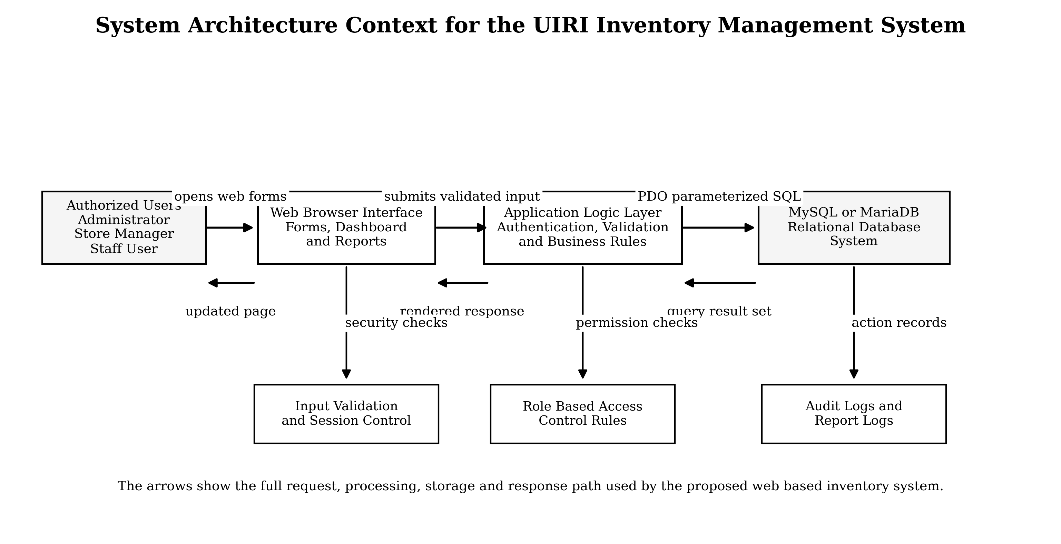
Figure 1 System Architecture Context

4.0 Actors and Use Case Model
The use case model identifies the external users of the system and the services each user expects from the IMS. These actors represent roles rather than individual people. A single physical person may perform more than one role only if the ICT Team grants the required permissions.
Table 5 Actor Summary
Actor | Description | Main Responsibilities
Administrator | Technical user with highest system privileges | Manage users, roles, campuses, departments, categories, system settings and audit review
Store Manager | Inventory custodian responsible for daily stock operations | Register items, receive stock, issue stock, transfer items, manage suppliers and maintain balances
Staff User | Departmental user who needs inventory information or items | View authorized records, submit requisitions and check request status
Department Head | Approving officer for departmental requests | Review, approve or reject requisitions and view departmental reports
Finance / Procurement | User concerned with suppliers and acquisition records | View supplier history, purchase references, batches and procurement related reports
ICT Supervisor | System owner or reviewer from the ICT function | Review dashboards, audit logs and technical accountability reports

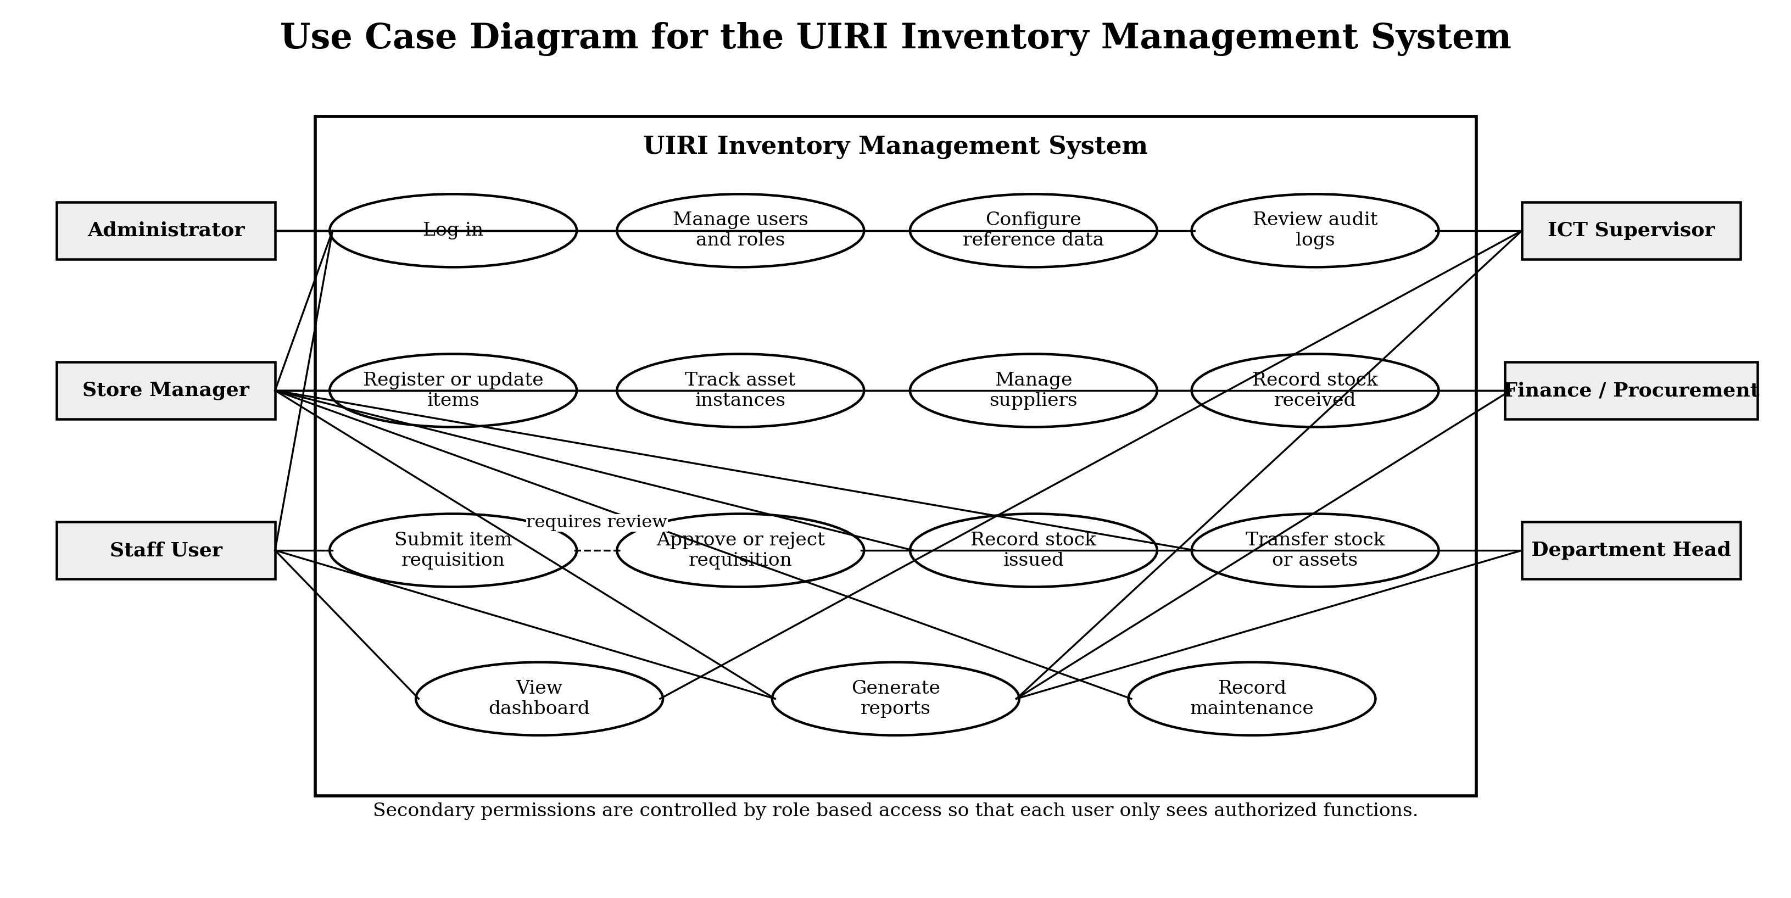
Figure 2 Use Case Diagram for the UIRI Inventory Management System

5.0 Use Case Specifications
The table below summarizes the main system use cases and provides a practical description for implementation and testing. More detailed use case narratives can be derived from these specifications during coding.
Table 6 Use Case Summary
Use Case | Primary Actor | Description | Expected Result
Log in | All users | User enters credentials and the system validates account status and role | Authenticated user is taken to the correct dashboard
Manage users and roles | Administrator | Administrator creates users, assigns roles and disables inactive accounts | Only authorized users can access the system
Register inventory item | Store Manager | Store Manager records item code, name, category, type, brand, model and reorder level | Item becomes available in the inventory catalogue
Track asset instance | Store Manager | Fixed assets are captured with serial number, location, status, purchase year and custodian | Each durable asset can be traced individually
Record stock received | Store Manager | Received quantity, supplier, batch and location are recorded | Stock balance increases and audit record is created
Record stock issued | Store Manager | Approved request is issued to a department or user | Stock balance decreases and issue history is saved
Generate reports | Authorized users | User selects report filters and report type | System displays or exports accurate filtered records
Review audit logs | Administrator or ICT Supervisor | System action history is reviewed for accountability | Sensitive actions can be traced to responsible users
Table 7 Core Use Case Specifications
Use Case | Precondition | Main Flow | Postcondition
Record Stock Received | User is logged in as Store Manager and item exists in catalogue | Select item, supplier, location and quantity. Enter batch and date. Save receipt. | Stock balance is increased and stock transaction is recorded
Record Stock Issued | Request is approved and stock is available | Select approved request or issue form. Confirm item and quantity. Save issue. | Stock balance is reduced, asset custodian may be updated and audit log is written
Generate Low Stock Report | User has report permission | Open reports, choose low stock report, apply campus or category filters. | System displays items whose available quantity is at or below reorder level
Update Asset Condition | Fixed asset exists in the system | Search asset, select condition and enter remarks. | Asset condition is updated and change is logged

6.0 Activity Diagrams
Activity diagrams show the flow of control for key system processes. They help the project team and stakeholders confirm that the proposed system supports practical inventory work before implementation begins.
The following diagrams are intentionally placed one per page so that each process flow remains visible when printed or reviewed on screen. Decision branches are labelled with Yes and No outcomes, while longer arrows show the direction of control between activities.
Table 8 Activity Diagram Summary
Activity Diagram | Purpose
Login and Role Based Access | Shows authentication, credential validation, active account checking and dashboard routing
Record Stock Received | Shows the process of receiving consumable stock or registering fixed asset instances
Requisition and Stock Issue | Shows request review, approval, stock availability checking and issue recording
Dashboard and Report Generation | Shows filtering, access checking, data retrieval and report output

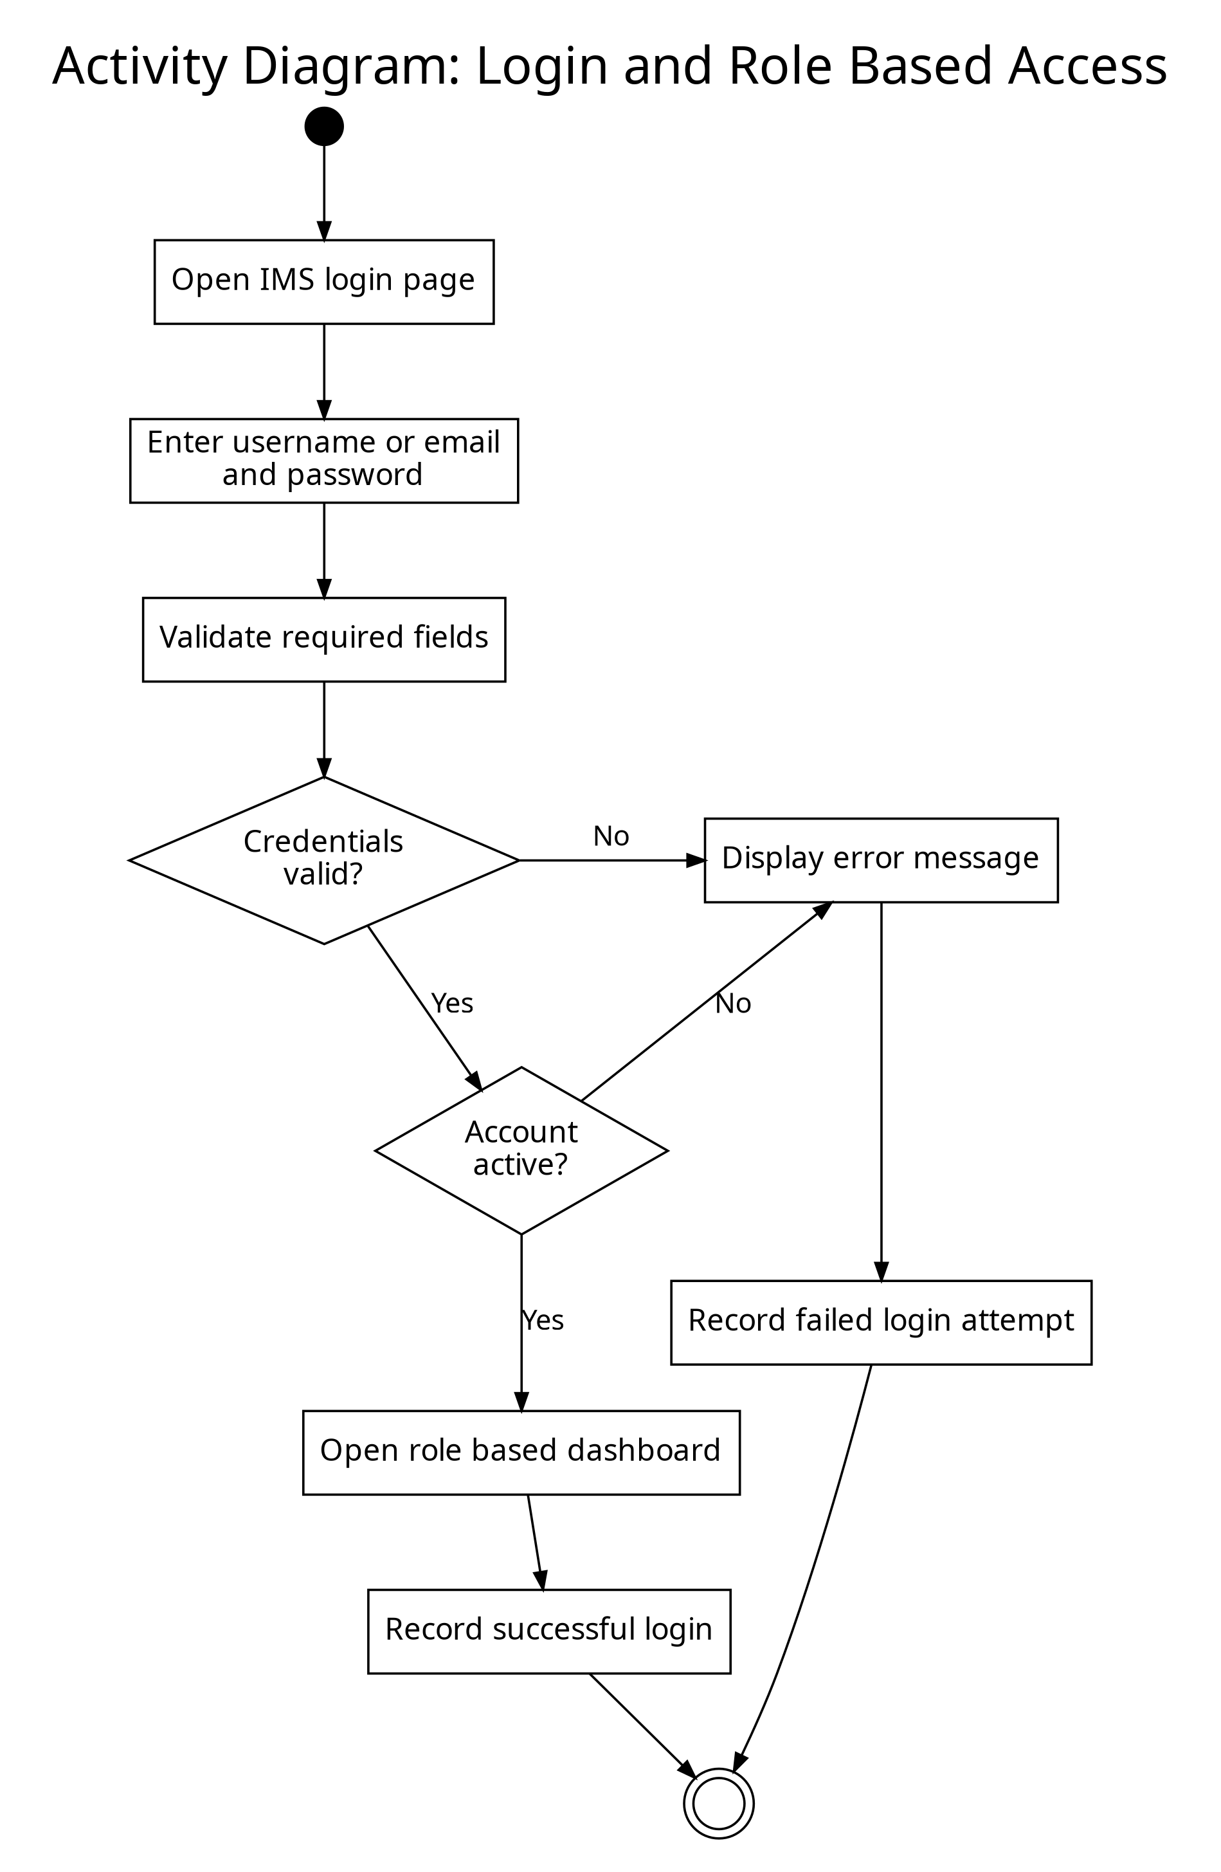
Figure 3 Activity Diagram for Login and Role Based Access

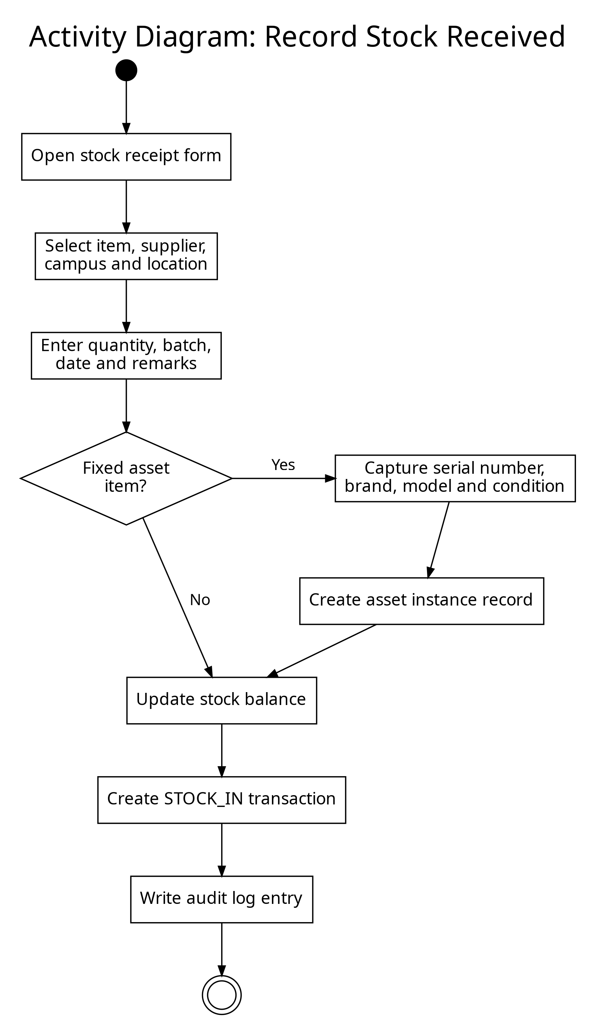
Figure 4 Activity Diagram for Recording Stock Received

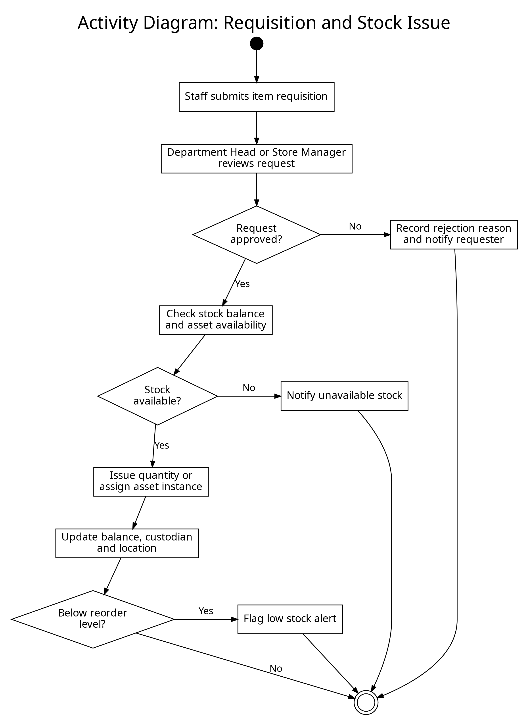
Figure 5 Activity Diagram for Requisition and Stock Issue

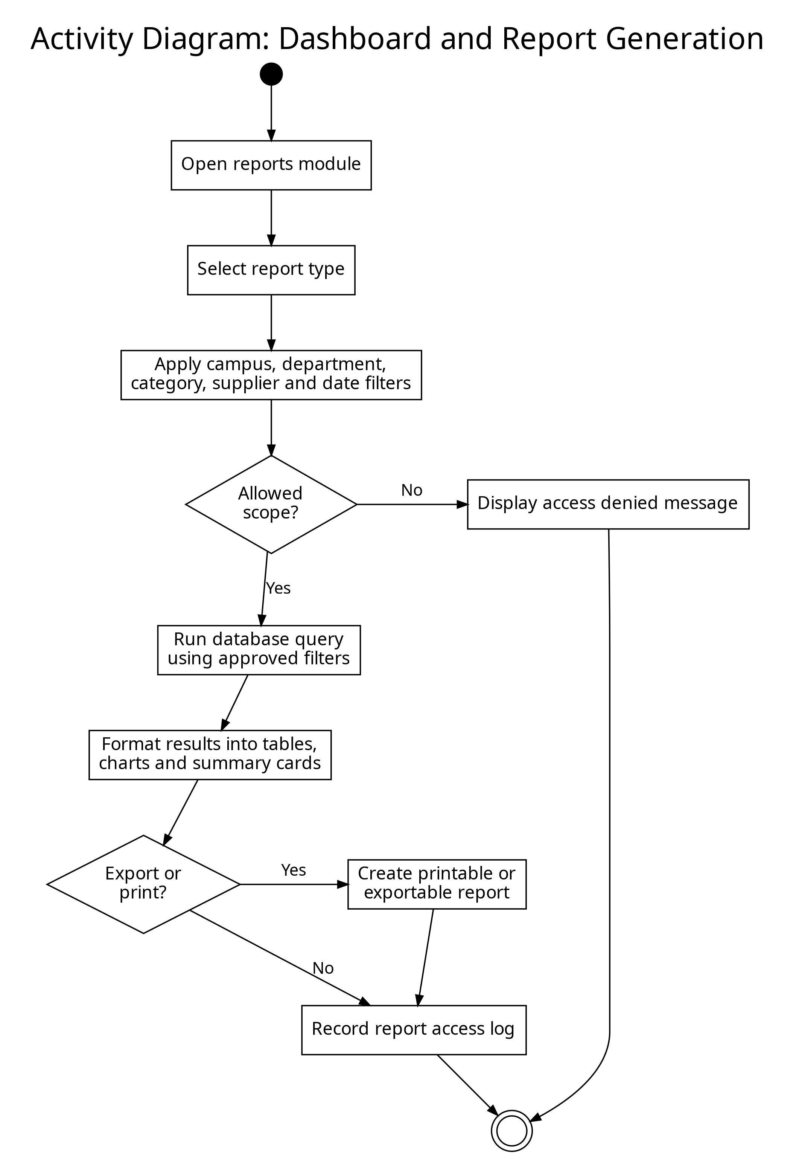
Figure 6 Activity Diagram for Dashboard and Report Generation

7.0 UML Class Design
The UML class diagram represents the main software objects that will support the inventory system. It mirrors the database model while adding behaviour such as login, item registration, stock movement, request approval, report access and audit logging.
The class diagram remains at system design level rather than replacing the detailed database design. Attributes and methods are summarized so that the figure can remain legible on one landscape page. The full table definitions are contained in the Database Design Document.
Table 9 Class Model Design Notes
Design Concern | How the Class Model Handles It
Users and Permissions | User is associated with Role so that access can be controlled by responsibility
Physical Organization | Campus, Department and Location represent where inventory is held
Item Catalogue | InventoryItem, ItemType and InventoryCategory describe item identity and tracking mode
Fixed Assets | AssetInstance separates individually traceable assets from general item definitions
Stock Control | StockBalance and StockTransaction maintain available quantities and movement history
Accountability | AuditLog records important user actions for later review

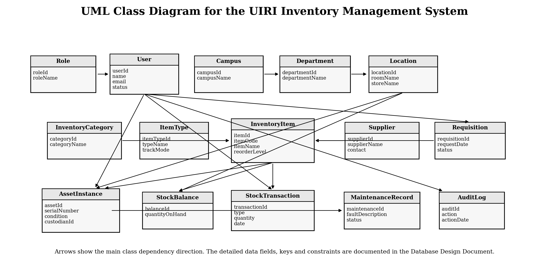
Figure 7 UML Class Diagram for the UIRI Inventory Management System

7.1 Class Responsibility Summary
Table 10 Class Responsibility Summary
Class | Main Responsibility
User and Role | Authenticate users and enforce role based permissions
Campus, Department and Location | Represent the organizational and physical placement of inventory
InventoryItem, ItemType and InventoryCategory | Represent the item catalogue and distinguish fixed assets from consumables
Supplier | Maintain supplier identity and contact details
AssetInstance | Track individual durable assets using serial number, location, status and custodian
StockBalance and StockTransaction | Maintain stock quantities and record all stock movement history
Requisition | Support departmental requests before stock is issued
MaintenanceRecord | Record faults, repairs and maintenance activities for assets
AuditLog | Preserve accountability for user actions

8.0 Design Traceability
Table 11 Design Traceability Matrix
Design Area | Relevant Diagram | Supported Requirement Area
Authentication and access control | Use case diagram, login activity diagram and class diagram | User login, role management, account security and session control
Inventory catalogue and assets | Use case diagram and class diagram | Item registration, category management, fixed asset tracking and condition updates
Stock movement | Stock receipt activity diagram, stock issue activity diagram and class diagram | Stock in, stock out, transfers, returns and stock balance updates
Supplier records | Use case diagram and class diagram | Supplier registration, supplier history and acquisition records
Reports and dashboard | Report generation activity diagram and use case diagram | Dashboard summaries, low stock reports, asset reports and filtered searches
Audit and accountability | Use case diagram and class diagram | Audit logs, report logs and traceability of sensitive user actions

9.0 Conclusion
This document has presented the system design diagrams for the UIRI Inventory Management System. The use case model identifies the actors and system services. The activity diagrams describe the main workflows for login, stock receipt, stock issue and reporting. The class diagram provides a structured object model that supports the database driven implementation.
The revised landscape layout improves figure visibility and makes each diagram easier to review, print and redraw in Microsoft Visio. The next deliverable in sequence is the source code and functional system prototype, unless the supervisor first requires the Visio versions of the diagrams to be refined separately.

10.0 References
[1] ICT Team, UIRI Namanve, "Internship Project Question: Design and Development of an Inventory Management System for Uganda Industrial Research Institute (UIRI)," Uganda Industrial Research Institute, Namanve, Uganda, Project Brief, 2026.
[2] K. P. Kato, K. Tracy and A. D. Kamate, "System Proposal: Design and Development of a Web Based Inventory Management System for UIRI," Uganda Industrial Research Institute, 2026.
[3] K. P. Kato, K. Tracy and A. D. Kamate, "Software Requirements Specification for the UIRI Inventory Management System," Uganda Industrial Research Institute, 2026.
[4] K. P. Kato, K. Tracy and A. D. Kamate, "Database Design Document for the UIRI Inventory Management System," Uganda Industrial Research Institute, 2026.
[5] I. Sommerville, Software Engineering, 10th ed. Boston, MA, USA: Pearson, 2016.
[6] Object Management Group, "Unified Modeling Language Specification," OMG, 2017.

