B U I L D P L A N
High-Traffic Utility
Tools Platform
A domain-first, profession-aware build plan for an online tools business
Prepared for: Founder (working blueprint)
Scope: 12 professional domains, 78-tool launch catalogue
Horizon: 6-month phased rollout
October 2026

Internal planning document October 2026

Table of Contents
Executive Summary
1. Product Vision and Strategic Positioning 1
2. Information Architecture: The Domain-First Structure 2
2.1 The twelve professional domains 2
2.2 The two-level system: domains, categories, tools 2
2.3 Tags and cross-listing 3
2.4 URL and navigation design 3
3. Site Experience Design 3
3.1 Landing page 3
3.2 Profession hubs: Tools for Your Profession 4
3.3 The standard tool page template 4
4. Launch Catalogue and Build Priorities 4
5. Technology Stack and Architecture 5
5.1 Core stack decisions 5
5.2 The tool registry: one template, 78 pages 5
5.3 Infrastructure cost by traffic tier 5
6. SEO and Traffic Growth Strategy 6
6.1 Keyword clusters by domain 6
6.2 Programmatic page patterns 6
6.3 Internal linking architecture 7
6.4 Technical SEO checklist and measurement 7
7. Monetization Plan 7
7.1 Stream one: display advertising 7
7.2 Stream two: affiliate recommendations 8
7.3 Stream three: premium subscription 8
8. Six-Month Build Roadmap 8
9. Illustrative Traffic and Revenue Model 9
9.1 Model assumptions 9
9.2 Outputs and sensitivity 10
10. Risk Analysis and Mitigation 10
11. Conclusions and Immediate Next Steps 11
Appendix A: The 78-Tool Launch Catalogue 12

Note: This Table of Contents is generated via field codes. To ensure page number accuracy after editing, please right-click the TOC and select "Update Field."

Executive Summary
This plan sets out the build of a high-traffic utility tools platform organised by professional domain rather than by tool function. Instead of a generic directory of calculators and converters, the site presents twelve professional domains, from Finance and Accounting to Everyday Utilities, each containing a curated set of tools, guides and related collections. A digital marketer visiting the Marketing section finds everything needed for SEO, advertising, social media, content and campaign analysis in one place; a business owner finds pricing, profitability and operations tools together. The positioning is deliberately professional: a tools platform for people at work, not another pile of random utilities.
The launch catalogue targets 78 tools across twelve domains, sequenced by commercial value: Finance and Accounting, Marketing and Growth, and Advertising and Media Buying launch first. The build starts with a 20-tool MVP in eight weeks, reaches 30 tools by month 4 and roughly 60 tools across nine domains by month 6, with the remaining catalogue items following as backlog. A two-level architecture (domain hubs above specialised categories above individual tool pages) plus a profession-based discovery layer gives every tool a dedicated, search-optimised landing page while preserving one coherent brand identity.
Traffic growth rests on programmatic SEO around high-intent calculator and converter queries, hub-and-spoke internal linking and fast static pages. Monetisation follows a three-stream ladder: display advertising from month 2, affiliate recommendations from month 4, and a $5 per month premium collection (ad-free, saved history, exports, embeds) from months 5 to 6. On the illustrative planning assumptions stated in Section 9, the platform reaches approximately 60,000 monthly sessions at month 6, 250,000 at month 12 and 750,000 at month 24, supporting an indicative revenue run-rate of roughly $20,000 per month at month 24. Those figures are sizing assumptions to be replaced with Search Console actuals from month 3 onward, not forecasts.

1. Product Vision and Strategic Positioning
Users do not wake up thinking in categories like calculators, converters or text tools. They arrive with a job: plan an ad budget, price a product, check a margin, prepare a quote. Organising the platform around professional domains matches that mental model. Someone working in digital marketing should be able to visit the Marketing section and find everything for SEO, advertising, social media, content creation and campaign analysis; someone running a business should find finance, operations, sales and administration tools together. This gives the platform a stronger identity than a function-first directory and creates room to expand into specialised, higher-value tools.
The domain-first structure has three strategic advantages. First, it attracts distinct professional audiences (accountants, digital marketers, advertising agencies, business owners, SEO specialists, designers, developers, students and freelancers) rather than a single undifferentiated calculator crowd. Each audience has different needs, different search behaviour and, importantly, different monetisation potential. Second, it creates topical authority: the Marketing and Growth section can become a substantial resource covering marketing calculations, campaign planning, customer acquisition and performance measurement, built from interconnected tools and educational guides. Search engines reward that coherence, and users return to the brand that covers their whole workflow. Third, it opens a natural path to premium subscriptions: a marketer can eventually pay for a campaign planning and reporting collection, an accountant for advanced financial calculators with export, an owner for pricing and profitability toolkits.
The recommended direction, carried through every later section of this plan, is therefore: build a domain-first, profession-aware global utilities platform. Primary navigation follows professional domains; secondary navigation follows specialised tool categories inside each domain; every tool gets its own page; a discovery layer organises tools by profession and use case; and monetisation combines advertising, affiliate recommendations and premium tool collections. Function-based categorisation is not abandoned, it is demoted to a secondary layer of tags and collections, so a user who specifically wants all converters can still find them in one view.

2. Information Architecture: The Domain-First Structure

2.1 The twelve professional domains
The platform starts with twelve major domains chosen to cover professional and everyday needs while keeping each hub commercially coherent. Five domains are commercial powerhouses (finance, marketing, advertising, business, SEO) where tool intent overlaps with buyer intent; four are broad utility domains (content, design, data, developer); three round out reach and habit (productivity, education, everyday). Table 1 shows the launch priority and catalogue sizing for each domain. The catalogue pool is the full list of candidate tools identified for this plan; the initial target is the subset that will exist when the catalogue is complete after the roadmap in Section 8.
Table 1: The twelve domains, launch priority and catalogue sizing
# | Domain | Launch priority | Catalogue pool (tools) | Initial target (tools)
1 | Finance & Accounting | 1 | 8 | 8
2 | Marketing & Growth | 2 | 8 | 8
3 | Advertising & Media Buying | 3 | 8 | 8
4 | Business & E-commerce | 4 | 8 | 8
5 | SEO & Website Management | 5 | 8 | 8
6 | Content & Writing | 6 | 8 | 6
7 | Design & Creative | 7 | 8 | 6
8 | Data & Analytics | 8 | 8 | 6
9 | Developer & Technology | 9 | 8 | 6
10 | Productivity & Project Management | 10 | 8 | 6
11 | Education & Research | 11 | 8 | 4
12 | Everyday Utilities | 12 | 8 | 4
 | Total |  | 96 | 78

2.2 The two-level system: domains, categories, tools
Function-based categorisation survives as a secondary layer. The primary layer is the professional domain: a central landing page introduces each domain and links to its specialised tool categories. Inside Marketing and Growth, for example, those categories are SEO Tools, Social Media Tools, Email Marketing, Marketing Analytics, Content Marketing and Marketing Planning. The third level is the individual tool, and every tool keeps its own URL, landing page, full functionality, explanation and related-tools block. This mirrors how specialists browse (by field first, by task second) while keeping every page individually rankable in search.

2.3 Tags and cross-listing
Every tool carries searchable tags such as calculator, free, marketing, analytics, online, ROI. Tags power the site search, the collection pages and the future recommendation engine. A tool belongs to one primary domain but can appear in other relevant collections: the ROAS calculator lives primarily in Advertising and Media Buying, yet also appears in the Marketing and Growth analytics collection. This one-primary-domain rule keeps URL structure and editorial ownership clean, while tags and collections give every tool multiple discovery paths without duplicating pages.

2.4 URL and navigation design
URLs follow the hierarchy and carry keywords: /marketing/ is the domain hub, /marketing/analytics/ the category page, /marketing/marketing-roi-calculator/ the tool page, and /professions/marketer/ the profession hub. The main navigation reads Home, Finance, Marketing, Advertising, Business, Design, Developers, More, with the More menu revealing the remaining domains; the footer lists all twelve domains plus the profession hubs. Breadcrumbs on every tool page reinforce the same hierarchy for users and for search engines.

3. Site Experience Design

3.1 Landing page
The landing page must communicate in seconds that this is a platform for professionals and everyday users, not a random collection of utilities. The main navigation (Home, Finance, Marketing, Advertising, Business, Design, Developers, More) is repeated in the page header, and the homepage itself is composed of eight blocks in a fixed order: a hero section with a prominent tool search; browse by professional domain; popular tools; tools for your profession; recently added tools; featured guides and tutorials; a premium subscription promotion; and a footer listing every tool domain. The hero search is the critical element: it queries the tool registry (names, tags, categories) and routes users to a tool in one keystroke-to-click interaction.

3.2 Profession hubs: Tools for Your Profession
Alongside the domain categories, the platform ships a section called Tools for Your Profession. Six hubs launch: for marketers (campaigns, SEO, advertising, analytics), accountants (finance, tax, budgets, profitability), business owners (pricing, sales, operations, planning), developers (coding, formatting, testing, conversion), designers (images, colours, dimensions, formats) and students (grades, research, calculations, study planning). Profession pages improve discovery for users who self-identify by occupation rather than by tool type, they create natural cross-links between domains, and they later support personalised tool recommendations once accounts exist. Each hub is also a compact SEO asset targeting phrases such as marketing tools for agencies or tools for small business owners.

3.3 The standard tool page template
Every one of the 78 tools ships on the same page skeleton, which is both a quality guarantee and the engine of the SEO strategy in Section 6. The template contains: an H1 with the tool name and a one-line value proposition; the working tool above the fold; a short how-it-works explanation; at least one worked example with realistic numbers; three to five FAQ entries; a related-tools block linking four to six sibling tools; and tags plus a breadcrumb back to the category and domain hubs. Users get orientation and depth; search engines get unique, structured content on every URL rather than a bare widget.

4. Launch Catalogue and Build Priorities
The 78-tool figure is a catalogue target for expansion, not a pre-launch obligation. The plan launches with the strongest 20 to 30 tools and expands from there. Phase 1 (the MVP, weeks 3 to 8) ships all eight finance tools, all eight marketing tools and the four headline advertising calculators (CPC, CPM, CTR, ROAS), because these combine high commercial intent with simple, fully client-side logic. Phase 2 (by month 4) adds the remaining four advertising tools and six business calculators. Phase 3 (by month 6) adds the business remainder plus eight SEO tools, six content tools, six design tools, six data tools and the first two developer tools. Phase 4 completes the 78-tool catalogue with the remaining developer tools, productivity, education and everyday utilities.
Figure 1 shows the resulting trajectory. The curve is deliberately steepest in months 1 and 2 (template building plus the finance and marketing batches) and again in months 5 and 6, when the registry-driven build process hits its stride and simple tools can be added in hours rather than days. Image-heavy design tools are scheduled into Phase 3 because they require more engineering (canvas and WebAssembly processing) than formula calculators.
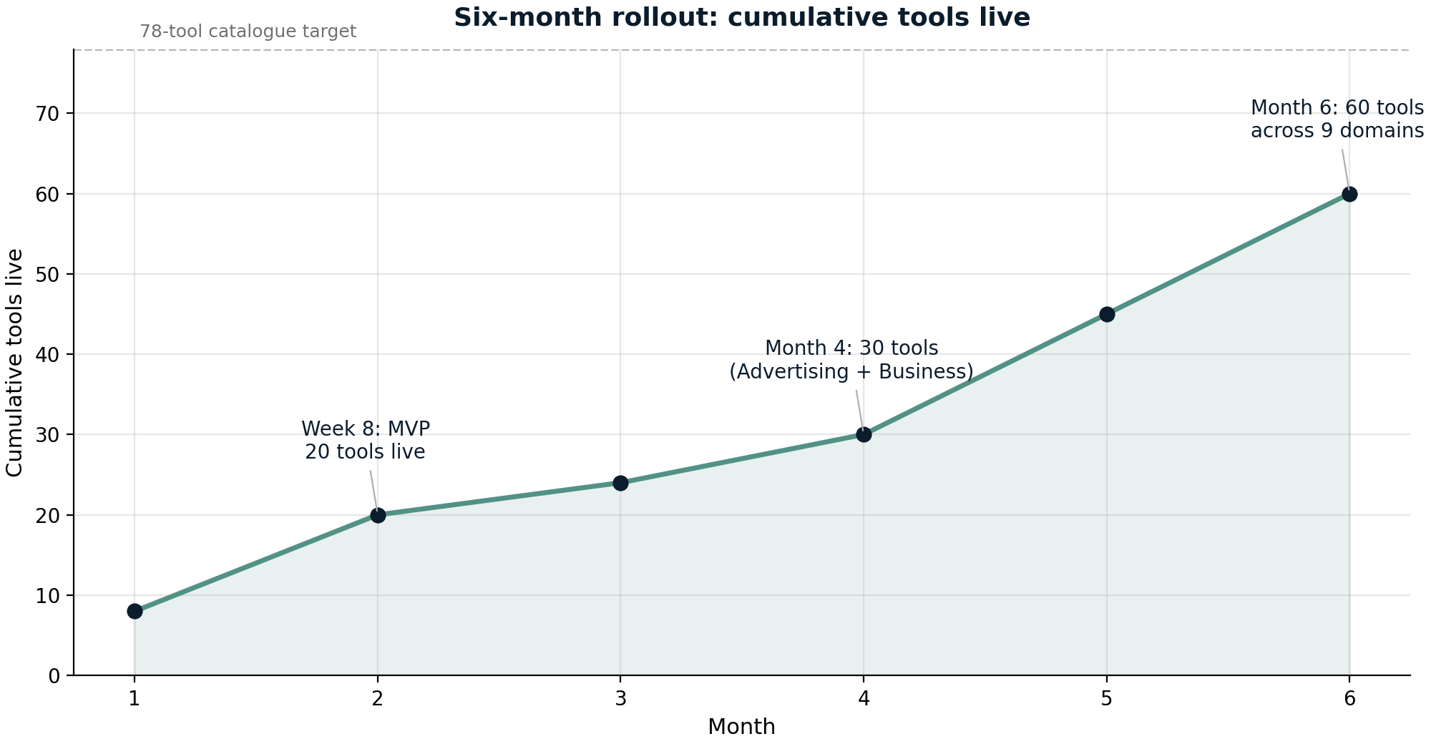
Figure 1: Six-month rollout, cumulative tools live by month

5. Technology Stack and Architecture

5.1 Core stack decisions
The recommended stack is Next.js (App Router) with static generation, TypeScript end to end and Tailwind CSS. Every tool page is pre-rendered at build time (with incremental regeneration for registry changes), which makes pages effectively instant, keeps Core Web Vitals comfortably green, and serves traffic from a CDN without origin load. All tool logic runs client-side in the browser: calculations never touch a server, which means zero marginal compute cost as traffic scales, privacy-friendly behaviour (user data never leaves the device), and resilience to traffic spikes. Image tools process files locally with canvas and WebAssembly, so images are never uploaded.

5.2 The tool registry: one template, 78 pages
The architectural centrepiece is a typed tool registry: a single configuration source that defines every tool (slug, domain, category, tags, component, description, how-it-works copy, worked example, FAQ entries, related tools). One ToolPage template renders all tool pages from the registry, and the domain hubs, category pages, sitemap and search index are generated from the same source. Adding a tool becomes adding a config entry and a component, which is what makes a 60-tool six-month roadmap realistic for a small team. The registry also enforces the SEO template of Section 3.3: no tool page can ship without an example and FAQ.
Supporting services stay boring and cheap: a managed Postgres (Neon or Supabase) for tool metadata, newsletter sign-ups and premium user data; Clerk or Auth.js for accounts; Stripe for subscriptions; Pagefind for fast client-side search over the registry; Plausible or GA4 plus Google Search Console for measurement; MDX for the guides layer. Hosting is Vercel (or Cloudflare Pages) fronted by Cloudflare DNS and CDN.

5.3 Infrastructure cost by traffic tier
Table 2 gives indicative monthly infrastructure costs at three traffic tiers, at current published list prices (to be verified at purchase time). The client-side architecture is the main cost shield: infrastructure spend grows with page views served by the CDN, not with calculations performed.
Table 2: Indicative monthly infrastructure cost by traffic tier
Tier | Monthly sessions | Stack at this tier | Indicative cost (per month)
Launch | Under 100,000 | Vercel Pro, Neon/Supabase free tier, Cloudflare free, analytics | $25 - $50
Growth | 100,000 - 1 million | Vercel Pro with usage overages, managed Postgres paid tier, Cloudflare free/pro | $100 - $300
Scale | 1 - 5 million | Usage-based hosting (Vercel enterprise or Cloudflare Workers paid), dedicated Postgres, cache layer | $500 - $1,500

6. SEO and Traffic Growth Strategy

6.1 Keyword clusters by domain
Utility tools win search when each tool page is the best answer for a specific high-intent query, and the domain-first structure adds the topical coherence that generic tool sites lack. Each domain maps to a cluster of head terms plus modifier patterns (formula, how to calculate, by country, by platform). Table 3 lists example clusters; exact volumes must be validated with a keyword research tool during Phase 0 and re-checked before each batch is built, so no figures are quoted here.
Table 3: Example keyword clusters and modifier patterns (volumes to be validated in Phase 0)
Domain | Example head terms | Modifier patterns
Finance & Accounting | compound interest calculator, mortgage calculator, VAT calculator | + country, + loan type, formula, how to calculate
Marketing & Growth | marketing ROI calculator, customer lifetime value calculator, conversion rate calculator | formula, benchmark, by industry, how to improve
Advertising & Media Buying | ROAS calculator, CPM calculator, CPC calculator, CTR calculator | + Google Ads, + Meta, formula, what is a good
Business & E-commerce | profit margin calculator, markup calculator, break-even calculator | vs markup, formula, by product
SEO & Website Management | meta title generator, schema markup generator, robots.txt generator | for WordPress, best practices, examples
Everyday Utilities | age calculator, date calculator, unit converter | in months, between dates, specific conversions

6.2 Programmatic page patterns
Four page patterns are generated from the registry and guide content. Tool pages are the primary assets and target the head terms. Formula explainers (a how-it-uses-the-math section on the same page, expanded for key tools) target informational queries such as how to calculate CAC without diluting the tool page across multiple URLs; where volume justifies it, a dedicated guide page is created instead. Comparison pages (markup versus margin, ROAS versus ROI) answer adjacent commercial queries and interlink both tools. Pillar guides per domain (for example, a guide to marketing metrics that embeds five tools) build the authority layer that search engines expect of a topical hub.

6.3 Internal linking architecture
Linking follows a strict hub-and-spoke model: domain hub to category to tool to related tools. Every tool links up to its parent category and domain, sideways to four to six related tools, and (where relevant) to its profession hub; every hub links down to everything beneath it. New tools therefore inherit internal links from established siblings on launch day, which accelerates indexation. This is only possible because the registry knows each tool's neighbours; the related-tools block is generated, not hand-maintained.

6.4 Technical SEO checklist and measurement
Technical fundamentals ship with the template: pre-rendered static pages (target LCP well under 2.5 seconds), WebApplication and FAQ schema generated from registry fields, an auto-generated XML sitemap per domain, canonical URLs, breadcrumbs, and clean keyword-bearing slugs. Measurement is part of the build plan rather than an afterthought: indexation coverage in Search Console is a phase gate (a batch is considered done when at least 85 percent of its pages are indexed), and per-domain counts of top-20 keywords and sessions per tool page are reviewed monthly to decide which clusters get the next batch of guides.

7. Monetization Plan
Monetisation uses three streams, deliberately sequenced so that each one starts only when the platform can support it: display advertising from month 2 (once a meaningful page count is indexed), affiliate recommendations from month 4 (once guides and commercial-adjacent tools exist), and the premium subscription from months 5 to 6 (once habitual users exist to convert). Over time the intended mix shifts from ad-dominated to subscription-dominated, which raises revenue per session and reduces exposure to advertising cycles.

7.1 Stream one: display advertising
Google AdSense is the starting network because approval is straightforward and it monetises from day one at any volume. The plan is to migrate to a premium network (Ezoic, Monumetric or a comparable managed partner) once traffic clears typical entry thresholds, which for the better networks sits around 50,000 sessions per month. Placement follows a strict rule: ads appear below the tool, between the result and the explanation, and beside the FAQ, never inside or above the working tool itself. Finance and advertising pages command the strongest RPMs of the catalogue, which is a further reason those domains launch first.

7.2 Stream two: affiliate recommendations
Affiliate income comes from contextual recommendations placed in tool results and guides: accounting software after the profit and loss calculator, email and marketing platforms after ROI and funnel tools, hosting and website builders after SEO utilities, design tools after image utilities. Two rules protect trust and compliance: recommendations must be genuinely relevant to the tool's outcome, and every affiliate placement carries a clear disclosure. Affiliate revenue is expected to stay the smallest stream; its real value is that it tests which commercial categories the audiences respond to, informing later premium bundles.

7.3 Stream three: premium subscription
The premium plan is priced at $5 per month or $48 per year and bundles the features that habitual users actually need: an ad-free experience; saved calculation history across devices; CSV and PDF export of results; batch mode for running multiple calculations at once; and embeddable widgets for the subscriber's own website or client reports. Launch bundles follow the personas: a Marketer pack (campaign and advertising collections with exports), an Accountant pack (the finance collection with exports and batch mode) and a Business pack (pricing, profitability and invoicing tools).
Two principles govern the whole plan. Free tools always stay fully functional, because free usage is the growth engine; and premium sells convenience, never captivity, because a paywalled calculator cannot compete in search. A business tier (white-label embeds and API access for agencies) is a deliberate later opportunity once premium proves demand for the underlying features.

8. Six-Month Build Roadmap
The roadmap is organised into four phases across six months, followed by the backlog that completes the 78-tool catalogue. Table 4 summarises scope, timing and the checkpoint that gates each phase. Tool count is not the only gate: a phase closes only when its indexation coverage reaches the target in Section 6.4 and Core Web Vitals stay green, because publishing more pages onto an unindexed or slow site compounds waste, not growth.
Table 4: Six-month phased roadmap
Phase | Weeks | Tools live | Domains covered | Key activities | Exit checkpoint
0 - Foundation | 1-2 | 0 | 0 | Domain and brand; stack setup; design system; tool registry and ToolPage template; analytics and Search Console | Template and registry ship; first page indexed
1 - MVP | 3-8 | 20 | 3 | Finance 8, Marketing 8, Advertising 4; three domain hubs; AdSense application at 20 indexed pages | MVP live in week 8; first rankings appearing
2 - Expansion | 9-16 | 30 | 4 | Advertising remainder 4, Business 6; profession hubs v1; affiliate links; first two pillar guides | 30 tools by month 4; indexation at 85 percent or higher
3 - Breadth | 17-24 | 60 | 9 | Business remainder 2, SEO 8, Content 6, Design 6, Data 6, Developer 2; premium beta then public launch; newsletter | 60 tools by month 6; premium revenue live
4 - Backlog | 25+ | 78 | 12 | Developer remainder 4, Productivity 6, Education 4, Everyday 4; B2B embed evaluation | Catalogue complete; scale decisions for year two
The binding constraint is solo-founder bandwidth, and the roadmap is engineered around it. The registry and template approach drives the average build time for a simple calculator down to a few hours once Phase 1 is complete; batches are ordered by commercial value so that any pause in the schedule still leaves the highest-value tools live; and every phase produces search assets (hubs, guides, interlinks) that compound even while the next batch is being built.

9. Illustrative Traffic and Revenue Model
The figures in this section are illustrative planning assumptions for sizing the opportunity, not forecasts. They exist to make the plan testable: from month 3 onward, Search Console and analytics actuals replace them, and the roadmap is re-planned against real growth. All arithmetic below follows from the stated assumptions.

9.1 Model assumptions
- Traffic. 60,000 monthly sessions at month 6, 250,000 at month 12 and 750,000 at month 24, driven by the expanding catalogue, indexation of tool and guide pages, and compounding internal linking (Figure 2).
- Display advertising. A blended ad RPM of $4.00 at month 6 rising to $5.50 at month 24 as the finance and advertising share of indexed pages grows; applied to sessions per thousand.
- Affiliate. A modest flat stream ($50 to $1,200 per month across the horizon) reflecting contextual placement only.
- Premium. Conversion of 0.10 percent of monthly sessions at month 6, 0.30 percent at month 12 and 0.40 percent at month 24, at $5 per month (60, 750 and 3,000 subscribers respectively); free tools stay free, so conversion depends on habit and export features.
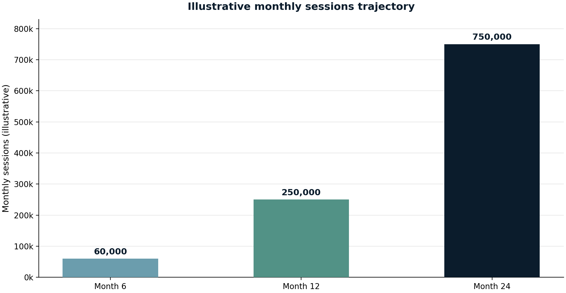
Figure 2: Illustrative monthly sessions trajectory at months 6, 12 and 24

9.2 Outputs and sensitivity
Table 5: Illustrative monthly revenue model (planning assumptions, not forecasts)
Line | Month 6 | Month 12 | Month 24
Monthly sessions | 60,000 | 250,000 | 750,000
Blended ad RPM | $4.00 | $5.00 | $5.50
Display advertising | $240 | $1,250 | $4,125
Affiliate revenue | $50 | $350 | $1,200
Premium subscribers | 60 | 750 | 3,000
Premium revenue | $300 | $3,750 | $15,000
Total revenue per month | $590 | $5,350 | $20,325
At month 24 the illustrative mix is 74 percent premium, 20 percent display and 6 percent affiliate (Figure 3), an annualised run-rate of roughly $244,000. The model is deliberately simple and its sensitivity is easy to read: revenue moves almost linearly with sessions, so halving traffic halves revenue; the largest swing factor is premium conversion, where the gap between 0.2 and 0.6 percent moves total month-24 revenue by roughly half. This is exactly why the roadmap instruments Search Console and premium beta metrics early rather than treating monetisation as a month-12 surprise.
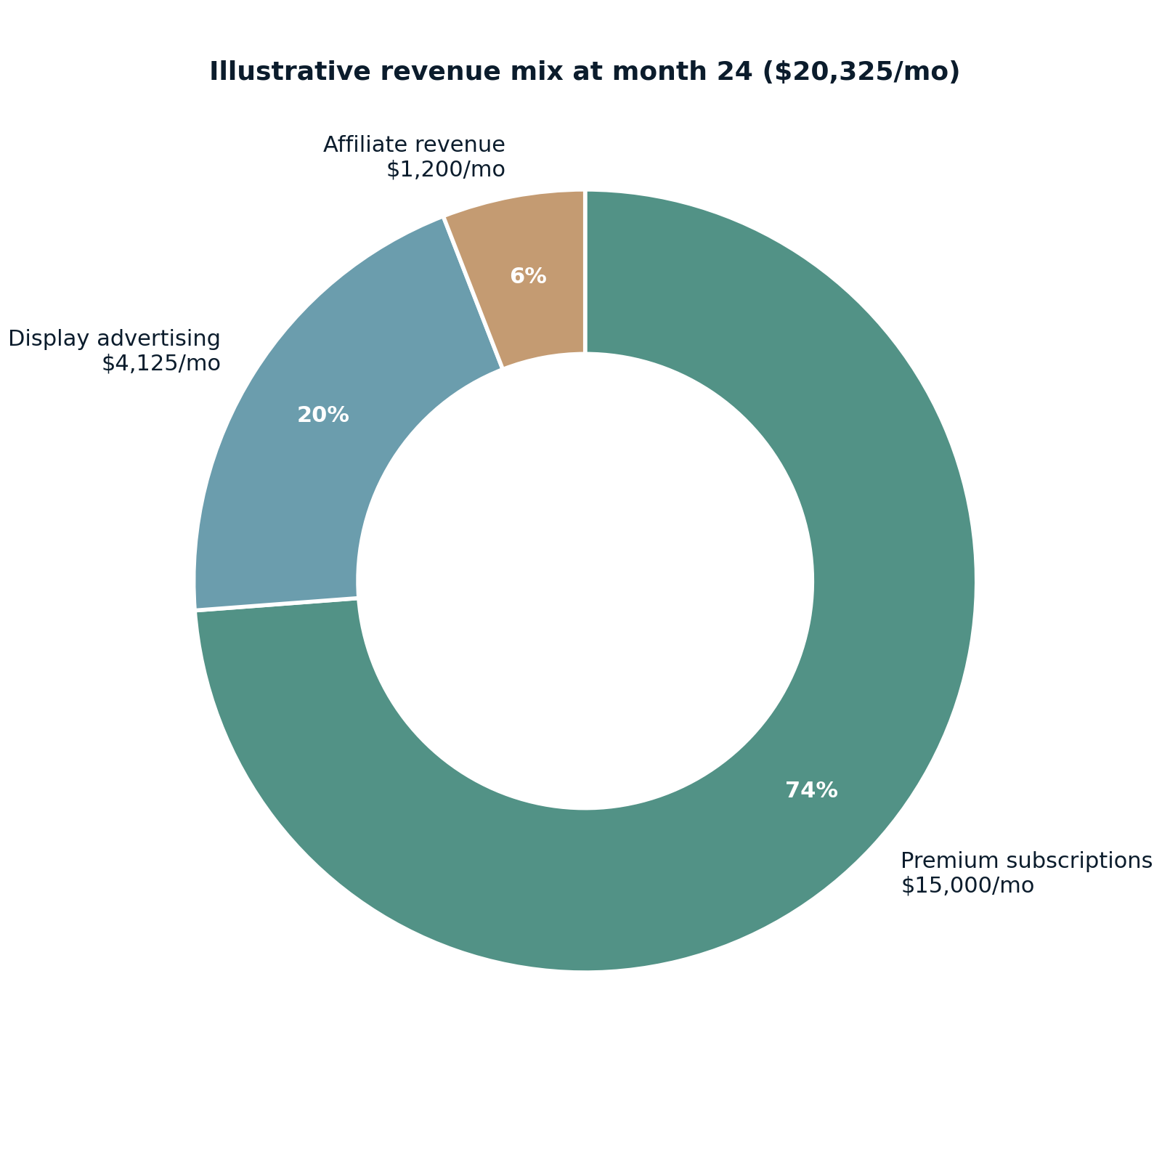
Figure 3: Illustrative revenue mix at month 24

10. Risk Analysis and Mitigation
The plan's main risks are external (search algorithms, advertising markets) and internal (bandwidth, quality at scale). Table 6 lists the six that matter most, with the mitigation already embedded in the preceding sections. The common thread is depth over volume: the registry enforces unique, useful content on every page, and the phase gates stop the catalogue from outrunning its own indexation.
Table 6: Principal risks and mitigations
Risk | Likelihood | Impact | Mitigation
Google core update hits thin tool pages | Medium | High | Unique example, FAQ and explanation on every page via the registry template; diversify traffic with newsletter, guides and brand direct visits
Tool pages judged as doorway pages | Low | High | No boilerplate-at-scale: one primary domain per tool, real functionality on every URL, hubs and categories carry editorial content
AdSense rejection or weak ad rates | Medium | Medium | Apply only after 20 substantial indexed pages; migrate to premium networks at threshold; affiliate and premium reduce ad dependence
Incumbent generic tool sites outrank launch pages | High | Medium | Profession-first identity, faster static pages, deeper per-domain clusters, and long-tail modifiers before head-term assaults
Solo-founder bandwidth slips the roadmap | Medium | Medium | Registry-driven builds (hours per tool after Phase 1), batches ordered by value, phase gates that protect quality over count
Abuse or cost spikes from bots | Low | Medium | Client-side computation, Cloudflare bot rules and caching, rate limits on the few server endpoints (accounts, payments)

11. Conclusions and Immediate Next Steps
The recommended direction is unchanged from the original thesis: build a domain-first, profession-aware global utilities platform, with primary navigation by professional domain, secondary navigation by specialised category, dedicated pages for individual tools, a discovery layer organised by profession, and monetisation through advertising, affiliate recommendations and premium collections. The twelve-domain structure and 78-tool catalogue give the platform room to grow for years; the two-level architecture keeps it coherent while it does.
The first thirty days determine whether the rest of the roadmap holds. The actions below correspond to Phases 0 and the start of Phase 1:
- Week 1: register the domain and brand, scaffold the Next.js project with the design system, and write the tool registry schema plus the ToolPage template.
- Week 2: build the first four finance tools on the template (compound interest, loan and mortgage, VAT, profit and loss), set up Google Search Console, sitemap and analytics, and validate the first keyword clusters with a research tool.
- Week 3: complete the finance batch of eight and the finance domain hub; start internal linking to the first guides.
- Week 4: start the marketing batch, prepare the AdSense application for submission once twenty pages are indexed, and review build time per tool against the roadmap assumption.
Three decisions are scheduled rather than open-ended: premium pricing is validated with the month 4 to 5 beta cohort; ad-network migration is evaluated when sessions cross roughly 50,000 per month; and contractor help is triggered if indexation consistently outpaces build capacity for two consecutive months. With those checkpoints in place, the plan converts the original strategic thesis into a buildable, measurable six-month programme.

Appendix A: The 78-Tool Launch Catalogue
Table A1 lists the full launch catalogue, sized to the per-domain targets in Table 1 (eight tools each for the five commercial domains, six each for the four broad utility domains, and four each for education and everyday utilities). Complexity reflects build effort on the ToolPage template: Low items are formula or string utilities deliverable in hours, Medium items need additional inputs, parsing or file handling, and High items involve heavy processing such as client-side image compression or document generation. Phase numbers correspond to the roadmap in Section 8.
Table A1: The 78-tool launch catalogue with complexity and launch phase
# | Domain | Tool | Complexity | Phase
1 | Finance & Accounting | Budget and expense calculator | Medium | 1
2 | Finance & Accounting | Loan and mortgage calculator | Low | 1
3 | Finance & Accounting | Compound interest calculator | Low | 1
4 | Finance & Accounting | Tax calculators | Medium | 1
5 | Finance & Accounting | VAT calculator | Low | 1
6 | Finance & Accounting | Profit and loss calculator | Low | 1
7 | Finance & Accounting | Currency converter | Medium | 1
8 | Finance & Accounting | Debt repayment calculator | Low | 1
9 | Marketing & Growth | Marketing ROI calculator | Low | 1
10 | Marketing & Growth | Campaign performance calculator | Low | 1
11 | Marketing & Growth | Customer acquisition cost calculator | Low | 1
12 | Marketing & Growth | Conversion rate calculator | Low | 1
13 | Marketing & Growth | Marketing budget planner | Medium | 1
14 | Marketing & Growth | Marketing funnel calculator | Low | 1
15 | Marketing & Growth | A/B test significance calculator | Medium | 1
16 | Marketing & Growth | Customer lifetime value calculator | Low | 1
17 | Advertising & Media Buying | CPC calculator | Low | 1
18 | Advertising & Media Buying | CPM calculator | Low | 1
19 | Advertising & Media Buying | CTR calculator | Low | 1
20 | Advertising & Media Buying | ROAS calculator | Low | 1
21 | Advertising & Media Buying | Ad budget calculator | Low | 2
22 | Advertising & Media Buying | Impression estimator | Low | 2
23 | Advertising & Media Buying | Reach and frequency calculator | Low | 2
24 | Advertising & Media Buying | Media planning calculator | Medium | 2
25 | Business & E-commerce | Profit margin calculator | Low | 2
26 | Business & E-commerce | Markup calculator | Low | 2
27 | Business & E-commerce | Break-even calculator | Low | 2
28 | Business & E-commerce | Pricing calculator | Low | 2
29 | Business & E-commerce | Discount calculator | Low | 2
30 | Business & E-commerce | Sales commission calculator | Low | 2
31 | Business & E-commerce | Shipping cost calculator | Medium | 3
32 | Business & E-commerce | Invoice generator | High | 3
33 | SEO & Website Management | Meta title generator | Low | 3
34 | SEO & Website Management | Meta description generator | Low | 3
35 | SEO & Website Management | SERP snippet preview | Low | 3
36 | SEO & Website Management | Keyword density checker | Low | 3
37 | SEO & Website Management | Robots.txt generator | Low | 3
38 | SEO & Website Management | XML sitemap generator | Medium | 3
39 | SEO & Website Management | URL slug generator | Low | 3
40 | SEO & Website Management | Schema markup generator | Medium | 3
41 | Content & Writing | Word counter | Low | 3
42 | Content & Writing | Character counter | Low | 3
43 | Content & Writing | Reading time calculator | Low | 3
44 | Content & Writing | Text case converter | Low | 3
45 | Content & Writing | Lorem Ipsum generator | Low | 3
46 | Content & Writing | Headline analyser | Medium | 3
47 | Design & Creative | Image compressor | High | 3
48 | Design & Creative | Image resizer | Medium | 3
49 | Design & Creative | Image cropper | Medium | 3
50 | Design & Creative | Colour palette generator | Low | 3
51 | Design & Creative | HEX to RGB converter | Low | 3
52 | Design & Creative | Aspect ratio calculator | Low | 3
53 | Data & Analytics | Percentage change calculator | Low | 3
54 | Data & Analytics | Data format converter | Medium | 3
55 | Data & Analytics | CSV viewer | Medium | 3
56 | Data & Analytics | JSON to CSV converter | Low | 3
57 | Data & Analytics | Average calculator | Low | 3
58 | Data & Analytics | Standard deviation calculator | Low | 3
59 | Developer & Technology | JSON formatter | Low | 3
60 | Developer & Technology | Regex tester | Medium | 3
61 | Developer & Technology | Base64 encoder/decoder | Low | 4
62 | Developer & Technology | URL encoder/decoder | Low | 4
63 | Developer & Technology | UUID generator | Low | 4
64 | Developer & Technology | Hash generator | Low | 4
65 | Productivity & Project Mgmt | Pomodoro timer | Low | 4
66 | Productivity & Project Mgmt | Meeting cost calculator | Low | 4
67 | Productivity & Project Mgmt | Working days calculator | Low | 4
68 | Productivity & Project Mgmt | Project cost calculator | Low | 4
69 | Productivity & Project Mgmt | Deadline calculator | Low | 4
70 | Productivity & Project Mgmt | Time zone converter | Medium | 4
71 | Education & Research | GPA calculator | Low | 4
72 | Education & Research | Grade calculator | Low | 4
73 | Education & Research | Percentage calculator | Low | 4
74 | Education & Research | Citation formatter | Medium | 4
75 | Everyday Utilities | Age calculator | Low | 4
76 | Everyday Utilities | Date calculator | Low | 4
77 | Everyday Utilities | Unit converter | Medium | 4
78 | Everyday Utilities | Temperature converter | Low | 4
Phase distribution: Phase 1 = 20 tools (MVP), Phase 2 = 10 (to 30 by month 4), Phase 3 = 30 (to 60 by month 6), Phase 4 = 18 (to 78). The remaining candidate tools from the original catalogue pool (grammar utilities, text comparison, image format converter, font pairing utilities, data comparison tool, chart and graph utilities, HTML formatter, CSS minifier, time tracker, task prioritisation tool, study time planner, research sample size calculator, scientific unit converter, exam countdown calculator, time calculator, distance converter, speed calculator and measurement converter) form the expansion backlog that follows the initial catalogue.

