The Toolbox by Minto Spatial Solutions:
User Guide

Version: Core Spatial Technology 4.2.0 (SWAF)

Updated: 2011/04/25

Copyright Information

Copyright © 2004-2011 Minto Spatial Solutions Ltd. All rights reserved.

Trademarks and Registered Trademarks

Smallworld is a registered trademark of General Electric Company

Table of Contents

1 Overview 4
1.1 Document History 4
2 User Interface 5
2.1 The Pointing Rule Toolbox 5
2.2 The Interaction Toolbar 6
2.3 The Options Dialog 6
2.4 The Attribute Prompter 8
3 Using Pointing Rules 9
3.1 Simple Pointing Rule 9
3.2 Trail-based Pointing Rule 9
3.3 Add Geometry Pointing Rule 10
3.4 Move / Rotate Geometry Pointing Rule 10
3.5 Move Vertex Pointing Rule 10
3.6 Action Pointing Rule 11
3.7 Compound Pointing Rule 11
4 Using Construction Functions 12
5 Related Tools 15

Overview
The Toolbox by Minto Spatial Solutions is a productivity tool that simplifies the process of creating and maintaining information in your Smallworld database. With a simple user interface, any object in your data model can be placed precisely with the click of a mouse, and extended editing tools enhance the capabilities of core Smallworld tools such as the trail and the transform toolbar.

The various functions described in this document are available when working with Smallworld Core Spatial Technology 4.2.0, using the Smallworld Application Framework (SWAF) environment.

Document History

Date | Name | Description
2007/02/20 | Tim Minto | - Created (from V4.0 version of document).
2008/08/16 | Tim Minto | - Added “Find” toolbar controls.
2008/05/31 | Tim Minto | - Updated to V4.1.1.
2011/04/25 | Tim Minto | - Updated to V4.2.0.

User Interface

The Pointing Rule Toolbox
Depending on how your system administrator has implemented the Pointing Rule Toolbox, it will be available as either a floating menu, or embedded in your application window:

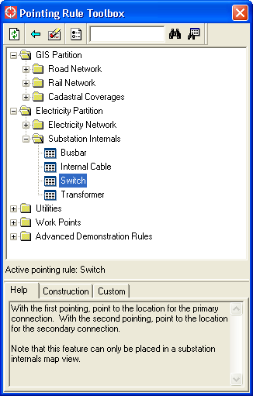

This menu consists of the following components:
- The Toolbar is at the top of the menu. All toolbar functions are described below.
- The main body of the menu is the Pointing rule list. A pointing rule is an action defined by your system administrator that allows you to create an object – or set of objects – with a combination of mouse clicks. These pointing rules are organized logically into folders to provide easy access.
- Below that, the Active pointing rule is displayed. Whenever you click on an entry in the Pointing rule list, that item becomes active. This means that any subsequent mouse clicks made in the map window will apply to this pointing rule. In this document, clicking on a pointing rule to make it active is commonly referred to as “launching” that pointing rule.
- At the bottom of the menu there are the following three tabs:
  - A Help tab displays a detailed description of the Active pointing rule.
  - A Construction tab allows the generation of construction lines for enhanced precision placement capability. This tab is described in detail in section 4.
  - A Custom tab allows additional input fields and controls prepared by your system administrator, which apply to the specific Active pointing rule that you have selected.

The Toolbar includes the following functions:

Refresh Pointing Rule List: this will refresh the contents of the Pointing rule list, based on the most recent configuration set up by your system administrator.
Terminate Active Pointing Rule: this ends the active pointing rule. When this is done, the pointing rule that was previously active once again becomes the active pointing rule. For example, suppose you launch a pole pointing rule to place several consecutive poles, and then follow that by launching a conductor pointing rule to place some conductor along those poles. When you terminate the conductor pointing rule, the pole pointing rule is once again the active pointing rule, so that subsequent pointings in the map window will cause more poles to be placed.

Up to 100 pointing rules can be stacked in this manner.
Terminate All Pointing Rules: this ends all pointing rules that you may have stacked up. After performing this action, there will be no active pointing rule.
Options…: this activates a dialog that allows various options to be set that affect the behavior of some pointing rules. Refer to section 2.3 for details.
Find By Name: this input field allows entry of a substring used for the find functions described below.
Find Next: this finds the next pointing rule with a name that matches the value entered in the Find By Name field.
Find All: this activates a dialog that displays all pointing rules with a name that matches the value entered in the Find By Name field.

Your system administrator may also place addition functions on the toolbar, depending on the details of your application and data model. For example, a Toggle Annotation button may be provided to enable or disable the automatic generation of annotation for any features that you create using this tool.

The Interaction Toolbar
Whenever a pointing rule is launched, the interaction mode of the active map view in your application is changed to Toolbox mode. The following screen shot shows the Toolbox mode as the current interaction mode:

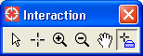

Note that you can change between Toolbox mode and any other interaction mode (such as Select or Trail mode) simply by pressing the corresponding button on the interaction toolbar. When in Toolbox mode, mouse pointings will be associated with the active pointing rule. When in other modes, mouse pointings will have their usual meanings – for example, in Select mode, mouse pointings are used to select geometries in the map view.

The Options Dialog
This dialog, which is activated from the Options toolbar icon, allows options to be specified that affect the behavior of various pointing rules. Here is a screen shot of this dialog:

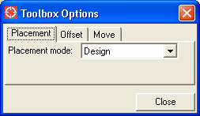

The Placement tab allows you to set the Placement mode option, which may be either Design or Data Maintenance. Your system administrator may use this setting to automatically set attributes of data that you create – for example, a value of Design may cause all newly-created features to have a status value of Proposed, while a value of Data Maintenance may cause all newly-created features to have a status value of Existing.

The Offset tab allows setting of options related to automatically offsetting trail-based pointing rules – see section 3.2 for details.

The Move tab allows setting of options related to move vertex pointing rules – see section 3.5 for details.

The Attribute Prompter
Many pointing rules will require that attributes be entered for the object that you are placing. The following dialog is used to allow you to enter these attributes:

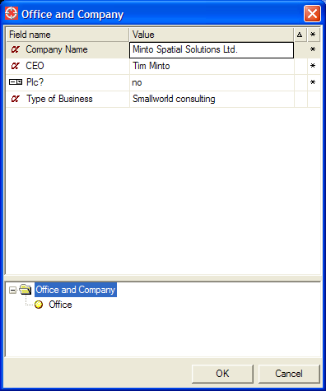

This dialog is used in a similar manner to the object editors that are part of the core Smallworld application. In cases where a compound pointing rule is used to place multiple records at once, the list at the bottom of the menu will show each record being placed. Selecting a record in the bottom list will cause the attribute display in the top list to show the proposed attributes for that record.

Using Pointing Rules
Each pointing rule can be configured by your system administrator to perform a set of actions that is specific to your data model. Therefore, detailed help information about the specific functionality of each pointing rule will be provided by your system administrator.

However, pointing rules will generally have the following characteristics:
- A central concept for a pointing rule is the Press-Drag-Release (PDR) sequence of actions that constitute a mouse pointing. Your system administrator can define specific actions to occur during each of the press, drag, and release phases.
  - Typically, when inserting a new object that requires you to enter attributes about that object, the dialog to prompt for attributes described in section 2.4 will be displayed after the release of the mouse pointing has been completed.
  - During the drag phase, special actions may also occur – for example, to verify that you are adding conductor to a pole in a valid manner, the pole may be highlighted as you drag the cursor over it.
- Hotkeys can be defined that perform additional actions – either while you are dragging the mouse during a PDR sequence, or after a PDR has been completed. For example, when placing a transformer that requires a parent pole to be identified, you may drag the mouse to the pole, press F6 to mark that pole as the parent, and then continue dragging to identify the location of the transformer.
- While dragging the mouse, geometry features will be snapped to in the same manner as occurs when working in Trail mode. This means that you can initiate the same one-shot probes to get a vertex probe or a free probe, and the “f” hotkey can be used while dragging to toggle a free probe on or off.
- While dragging the mouse, an outline image of the geometry (or geometries) you are about to place is dragged along with the cursor, to make it easy to visualize precisely the best location for the geometry being created.
  - For a trail-based pointing rule (described in section 3.2 below), this is only true if the offset distance is non-zero. Otherwise, the trail itself provides an outline image of the geometry being placed. Note that the offset distance is controlled using the Options dialog described in section 2.3.
- While dragging the mouse, you may hold down the Shift key to dynamically rotate the outline image of the geometry being placed. This is useful for orienting symbols and text with surrounding geometry.
  - This does not apply to a trail-based pointing rule (described in section 3.2 below).

The following sections define the common types of pointing rules provided with the Toolbox product:

Simple Pointing Rule
This pointing rule is typically used to create an object with a point or text geometry with a single pointing. It has no unique features beyond the general characteristics described above.

Trail-based Pointing Rule
This pointing rule is typically used to create an object with a chain or area geometry with a series of pointings. Pointing rules of this type actually build upon standard trail functionality available in Smallworld – however, they can also have custom actions which are executed as each trail point is placed (for example, the ability to highlight a correlated pole as you drag the mouse over it when placing a conductor using a trail-based pointing rule).

When you have completed defining the desired chain or area using the trail, press the F9 hotkey to complete the pointing rule. At this point, you will be prompted for attributes (if configured to do so by your system administrator).

Trail-based pointing rules use the offset distance and offset direction parameters specified on the Options dialog. If the offset distance is non-zero, a parallel line will be shown next to the trail to indicate where the offset geometry will be placed.
- Your system administrator may also configure these rules with a fixed offset distance, which may override the value that you enter on the Options dialog.

Add Geometry Pointing Rule
This pointing rule is typically used to add a point or text geometry to an existing object. It requires two pointings: the first to identify the feature to add the geometry to, and the second to identify the location of the geometry.

Your system administrator may configure an add geometry pointing rule to operate on a specific kind of object, or as a general-purpose rule that operates on various different objects in your data model. While dragging during the first pointing, any candidate objects for adding geometry to will be highlighted. If you drag the mouse over a candidate object and it does not highlight, this means that either:
- The object already has a geometry of the type that you are trying to add, or,
- Your system administrator has configured the add geometry pointing rule to only work with a specific object type, and you are pointing to a different type of object.

Move / Rotate Geometry Pointing Rule
This pointing rule is typically used to move and/or rotate a set of geometries.
- If you have one or more geometries selected in your map view, then you may simply press the mouse button anywhere, and as you drag the mouse, the selected geometries will drag as well. When you release the mouse button, the selected geometries will be moved to their new location.
- If you have no geometries selected in your map view, then you must press the mouse button so that it correlates on the geometry that you intend to move. Then, you may carry on with the drag and release of your mouse pointing (as described above).

Note that all geometries that are connected to the set you are moving will also be moved, in a similar manner to what is done when using the transform toolbar in the core Smallworld application,

While performing the drag phase of the move operation, you may press the Shift key at any time to rotate the geometries being moved. The center point for this rotation will be wherever you initially pressed the mouse button.

Move Vertex Pointing Rule
This pointing rule is typically used to adjust a single vertex of a chain or area geometry.
- If you have no geometries selected in your map view, then you must press the mouse button so that it correlates on a vertex of the geometry that you intend to adjust. As you drag the mouse, the selected vertex will drag as well. When you release the mouse button, the selected geometry will have the selected vertex adjusted to that location.
- If you have a single chain or area geometry selected in your map view, then you must press the mouse button so that it correlates on a vertex of the selected geometry. This allows you to specifically control which geometry will be updated in the case where multiple geometries meet at the vertex being manipulated.

Note that when you adjust a vertex for a connected chain or area (as opposed to a simple chain or simple area), its connectivity is affected as follows:
- If it was previously connected to other geometries at this vertex, those geometries may be dragged as well. This will depend on whether or not the “Disconnect before performing move vertex” option is selected in the Options dialog.
- After the vertex is moved, manifold interactions will be performed. This means that if the new vertex location snaps to other geometry in the same manifold, then these geometries may become connected (depending on the manifold rules established by your system administrator).

Action Pointing Rule
This pointing rule is typically used to perform custom actions on a specific feature or set of features. Examples of these actions include:
- Split chain: split a single chain into two pieces at the point that you specify.
- Abandon / remove facilities: select a set of facilities using standard Smallworld select functionality, and then use a hotkey associated with an action pointing rule to abandon or remove those facilities.

Compound Pointing Rule
Your system administrator may define compound pointing rules, which combine the behavior of two or more of the various pointing rules described above. For example:
- Two simple pointing rules can be combined to create a supply point record and a customer record in the same operation.
- A simple pointing rule and an add geometry pointing rule can be combined to create a road works location, and add an annotation to it at the same time.
- A trail-based pointing rule and a simple pointing rule can be combined to create a conductor, and automatically create a pole at each vertex.

In these complex cases, your system administrator will provide additional help information to specify the combination of mouse pointings and/or hotkeys required.

Using Construction Functions
The standard pointing rule functionality described above is a “point-and-click” interface, which allows features to be placed in a free-form manner. These functions will automatically take advantage of various data integrity rules that are defined in your current application – for example, when placing a valve in a free-form manner, your application will typically be configured to snap to the nearest pipe, and connect to that pipe. This will continue to be the case when using pointing rules.

However, there are situations where you may need to perform more precise placement. Examples of this include:
- Placing a series of poles all offset exactly 1.1 meters from a road line.
- Placing a customer vault exactly 3.5 meters from the property line and 1.2 meters from the road line.
- Tapping a new service pipe off of an existing main, such that the service is precisely parallel to an existing service pipe and 9.0 meters from that pipe.

To enable these capabilities, use the functions available on the Construction tab:

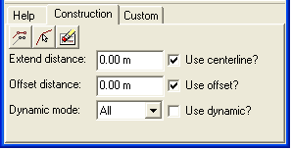

This menu consists of the following components:
- The Toolbar at the top of the tab includes these functions:

Set Construction From Trail: this creates construction lines from the active trail.
Set Construction From Selection: this creates construction lines from the selected chain and area geometries.
Clear: this clears all construction lines.

- Extend distance: this defines the length that a trail or chain geometry will be extended when creating construction lines.
- Offset distance: this defines the distance from a trail, chain, or area geometry where parallel construction lines will be created.
- Dynamic mode: this defines the criteria for which features will be considered when performing the creation of dynamic construction lines. This is described in more detail below.
- Use centerline?: if this is selected, then the route of the selected trail, chain, or area geometry will be used when creating construction lines.
- Use offset?: if this is selected, then two parallel offset geometries will be created from the selected trail, chain, or area geometry. Note that this can be combined with the Use Centerline? option – if both are selected, then three construction geometries will be created (two parallel, and one along the route of the selected trail, chain, or area geometry).
- Use dynamic?: if this is selected, then construction lines will be dynamically created as you drag the mouse during a Press-Drag-Release operation. This is described in more detail below.

The following example shows the use of the Set Construction From Selection function, with the following settings:
- Two roads selected.
- Extend distance: 30.0 m
- Offset distance: 15.0 m
- Use centerline?: yes
- Use offset?: yes

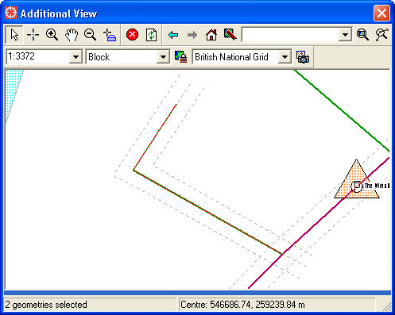

Once these construction lines have been set, it is simple to do any of the following:
- Place any feature offset precisely 15.0 meters from any selected road – as you drag the mouse near a construction line, it will be snapped to automatically.
- Place any feature exactly 15.0 meters from both roads – as long as the current trail snap settings have enabled the “Intersection” probe, the intersection point will be snapped to automatically.
- If you intend to use different offset distances for the two different roads, simply select them one at a time, and perform the Set Construction From Selection separately for each (with different offset distance values specified for each case).

When working with a very large number of construction lines (approximately 50 or more), system performance may decline due to the additional snapping computations that must be performed for all of these construction lines. Therefore, after creating several construction lines that are no longer required, use the Clear button to discard them.

By enabling the Use dynamic? checkbox, these construction lines will automatically be generated as you drag the mouse when in Trail or Toolbox mode:
- As you snap to a chain or area geometry: in addition to displaying probe text such as “Vertex” or “Segment”, dynamic construction lines will be created according to the various input values entered on this tab.
- As you drag the mouse away from that geometry, the dynamic construction lines associated with geometry will disappear. The distance that you must drag before this happens will depend on the Extend distance and Offset distance settings – it will be 2.5 times the larger of the settings. This will allow you to make use of these construction lines when continuing to work in the same vicinity, but once you have moved on to a different area where they are no longer needed, they will disappear.
- Your system administrator may configure additional options in the Dynamic mode pick-list, which are specific to your data model and application. Typical examples include the capability to only offset from mains and services; or to only offset from property lines and road lines. Using these options will limit the amount of screen clutter created as these construction lines are generated.

Related Tools
In order to enhance the capabilities of trail manipulation when using trail-based pointing rules, new trail manipulation tools been created. Your system administrator may choose to add this to any part of the GUI for your application: it is commonly placed on the trail toolbar, as shown here:

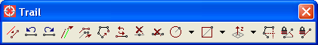

Extend Parallel by Dragging: in order to perform this function, you must do the following:
- Place one or more trail points.
- Select one or more chain or area geometries that form a continuous route.

Offset Parallel by Dragging: in order to perform this function, you must do the following:
- Place two or more trail points.

When the Extend Parallel by Dragging function is performed, a PDR is initiated that causes the trail to dynamically extend so that it is parallel to the selected geometries. This is a “one-shot” PDR, which means that after you have completed this operation, you will return to the standard trail interaction mode to allow placement of further trail points.

This function is useful for placing trenching, buried conductor, or gas mains parallel to a road line, or for placing services parallel to a property boundary – especially when that feature consists of arcs, splines, or complex sectors with a large number of vertices. For simpler parallel operations, consider using the Construction functions discussed in section 4.

The following features provide additional control over the parallel line:
- Holding the Ctrl key while dragging will cause the length of the current trail segment to be rounded to a multiple of a discrete spacing value that you specify. This discrete spacing defaults to 10.0 meters, and it can be changed on the Options dialog in your application window (shown below).
- Holding the Shift key while dragging will cause the length of the total trail to be rounded to that discrete spacing value.
- If you have the Intersection geometry snap enabled, the extend operation will snap to the precise intersection with any other linear feature that is near your cursor as you drag the mouse.

When the Offset Parallel by Dragging function is performed, a PDR is initiated that causes the trail to be dynamically offset as you drag the mouse. This is a “one-shot” PDR, which means that after you have completed this operation, you will return to the standard trail interaction mode to allow placement of further trail points.

The following features provide additional control over the parallel line:
- Holding the Ctrl key while dragging will cause the offset distance be rounded to a multiple of a discrete spacing value that you specify. This discrete spacing defaults to 1.0 meters, and it can be changed on the Options dialog in your application window (shown below).
Here is a screen-shot of the Options dialog showing how to change the values associated with these trail manipulation functions:

