CS1400 Assignment 4 Fall 2013
Art-o-mat Cigarette Vending Machine
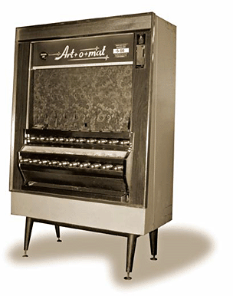
Ah, the days of automatically-dispensed tobacco products. Once a ubiquitous fixture of night clubs and bowling alleys, the Art-o-mat vending machine brought a touch of style and elegance to carcinogen-laced inhalant devices. You popped in your quarters, pulled the correct knob, and packet of Lucky Strikes slid down the polished stainless steel chute into your eagerly awaiting nicotine-stained fingers.
In this assignment, you are to write a menu-style program to simulate an updated Art-o-mat. You program should print the following menu:
s - report the machine status
d - drop in a quarter
1 - pull the 1st knob
2 - pull the 2nd knob
3 - pull the 3rd knob
4 - pull the 4th knob
r - restock the machine
q - quit
Any other input should be met with a "I do not understand" response.
Here is an example session (user responses shown in blue):
s - report the machine status
d - drop in a quarter
1 - pull the 1st knob
2 - pull the 2nd knob
3 - pull the 3rd knob
4 - pull the 4th knob
r - restock the machine
q - quit
> s
1: 5 packs of Lucky Strikes
2: 7 packs of Camels
3: 1 packs of Gauloises
4: 6 packs of Pall Malls
There is $24.50 in the machine
> d
ching
> d
ching
> 3
(nothing happens)
> d
ching
> 3
A pack of Gauloises slides into view. Gauloises? Really?
> d
ching
> d
ching
>d
ching
> 3
You hear mechanical clanking, but no cigarettes appear.
> 1
(nothing happens)
> s
1: 5 packs of Lucky Strikes
2: 7 packs of Camels
3: 0 packs of Gauloises
4: 6 packs of Pall Malls
There is $26.00 in the machine
> r
A grouchy-looking attendent shows up, opens the back, fiddles around a bit, closes it, and leaves.
> s
1: 10 packs of Lucky Strikes
2: 10 packs of Camels
3: 10 packs of Gauloises
4: 10 packs of Pall Malls
There is $0.00 in the machine
> q
So long!
You get the picture. You are allowed to be inventive in your text and actions, as long as it makes sense within the context of the story.
Turn in: a single .cpp file with your code in it.

