**CS5460 Assignment #1 Crypto Lab – Secret Key Encryption**

Austin Derbique A01967241 Fall 2017

https://github.com/aderbique/cs5460/tree/master/assn3

**3.1 Task 1: Encryption using different ciphers and modes**

During this task, I spent time getting familiarized with openssl and how to encrypt and decrypt files. I practiced on the README file that is found in the openssl directory on the seed image. These are a couple of the commands I used for this task. The files can be found in the Task 1 directory of the github repo.

seed@ubuntu:~/openssl-1.0.1$ sudo openssl enc -camellia-128-ecb -e -in README -out README_rc2-128-cfb -K 00112233445566778889aabbccddeeff -iv 0102030405060708

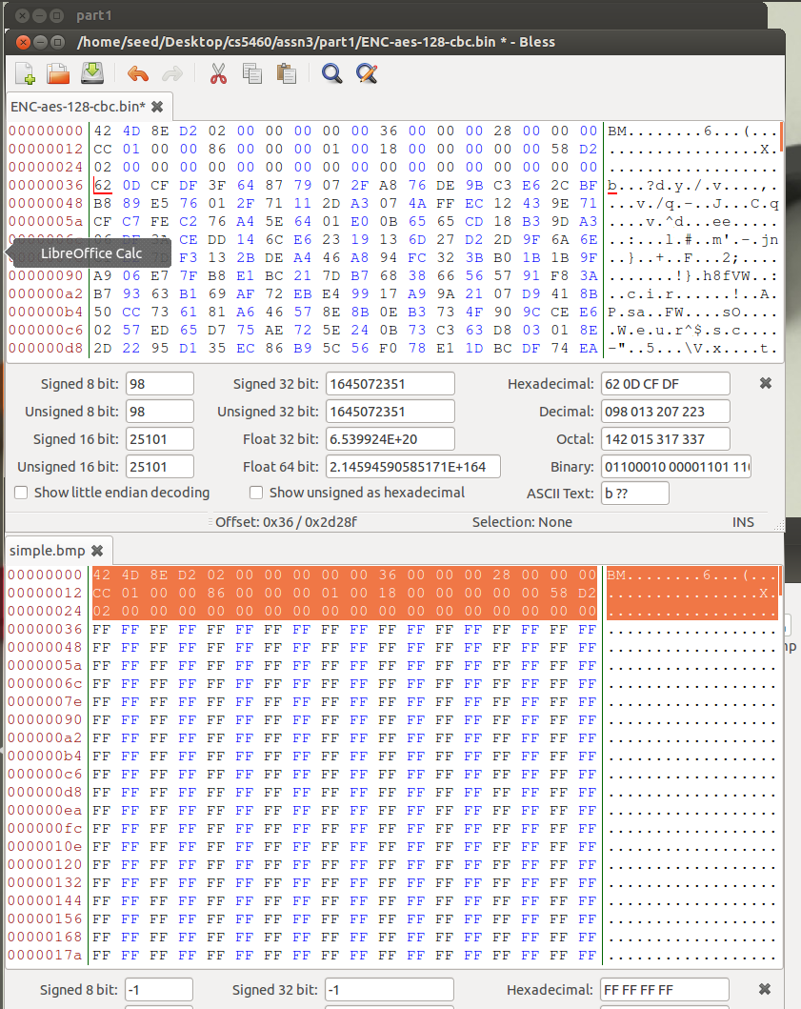seed@ubuntu:~/openssl-1.0.1$ sudo openssl enc -camellia-128-ecb -e -in README -out README_camellia-128-ecb -K 00112233445566778889aabbccddeeff -iv 0102030405060708

**3.2 Task 2: Encryption Mode – ECB vs. CBC**

1. This task consisted of encrypting a given simple.bmp image file using ECB and CBC ciphers. To do this, the following commands are used:

seed@ubuntu:~/Desktop/cs5460/assn3/part1$ sudo openssl enc -aes-128-ecb -in simple.bmp -out ENC-aes-128-ecb.bin -K 00112233445566778889aabbccddeeff -iv 0102030405060708

seed@ubuntu:~/Desktop/cs5460/assn3/part1$ sudo openssl enc -aes-128-cbc -in simple.bmp -out ENC-aes-128-ccb.bin -K 00112233445566778889aabbccddeeff -iv 0102030405060708

The resulting files are encrypted binary files that must have the headers changed for them to be recognized as an image file. To do this, the first 54 bytes of the files are replaced with the first 54 bytes of the original image file using Bless. These files are available in the Task 2 section of the github repo.

2. The CBC encryption completely scatters the image into a way that gives no information as to what the original image may have been. On the other hand, the ECB encryption shows a vague relation to the original image.

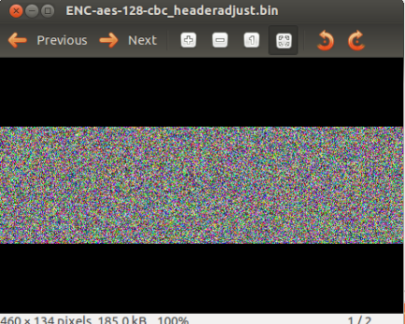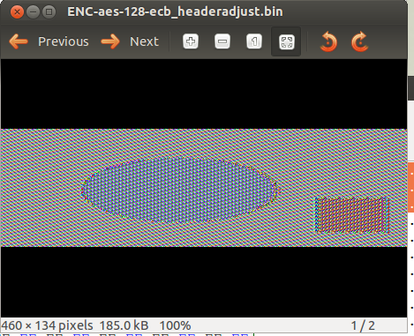

3. The task3.txt encrypted bmp image file is an encrypted version of the simple.bmp image using rc2-cbc cipher and a password of “cs5460”. This is available in the task 3 github repo.