Packet Sniffing and Spoofing Lab

CS5460 Assignment 7 Due: December 8 2017

Austin Derbique A01967241

2.1 Task 1: Writing Sniffing Program

Problem 1: Inside of sniffex.c are many different functions. The most important, however are the pcap library calls.
On Line 529: pcap_lookupdev: Finds default capture device
On Line 538: pcap_lookupnet: Gets net mask for device
On Line 551: pcap_open_live: Opens device and begins sniffing
On Line 558: pcap_datalink: Returns type of device that capture is happening on
On Line 564: pcap_compile: Creates filter of expression and parses filter
On Line 571: pcap_setfilter: Sets and installs filter
On Line 578: pcacp_loop: Loops for filtering packets
On Line 580: pcap_freecode: frees up code memory
On Line 581: pcpc_close: closes handle and session

Problem 2: You need root privilege in order to have full access to looking at network traffic. This can be promiscuous if you are not authorized to have root access. It is likely to fail when the program searches for the device. This is in the pcap_lookupdev function. Finding the capture device.
Problem 3: Promiscuous mode seems to show all the traffic not only going to the network controller but data flying past as well. When turned off, the only data seen is the data intended for your network controller This I found on line 551 of sniffex.c with the boolean expression to turn promiscuous mode on or off.

Task1.a: Understanding Sniffex. Downloading the sniffex.c file from: http://www.tcpdump.org/sniffex.c
Command used to compile: gcc -Wall -o sniffex sniffex.c -lpcap
Command used to execute: sudo ./sniffex

Output: Addiontally, piped txt output available in part2/task 1/sniffex_output.txt
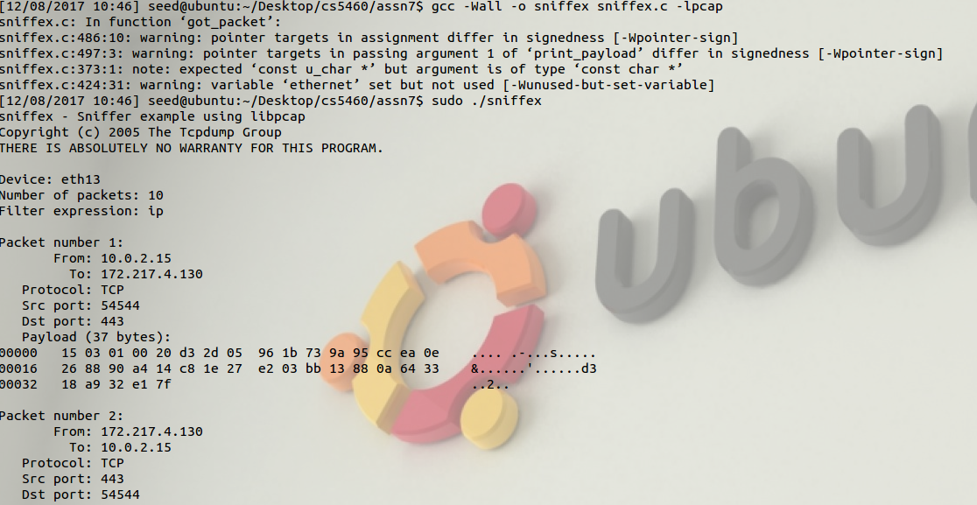

Task 1.b: Writing Filters. Using the help page on http://www.tcpdump.org/manpages/pcap-filter.7.html,

Capturing ICMP Packets between two Hosts:
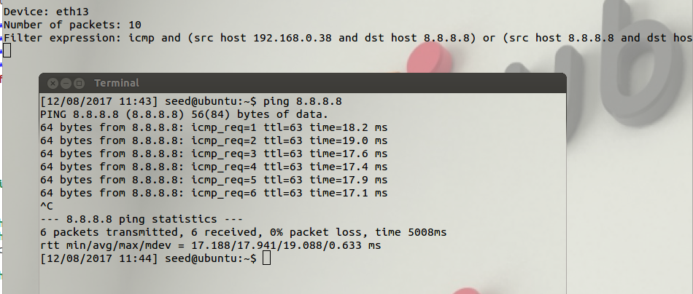

Capturing TCP packets that have destination port range from 10-100
Filter used: char filter_exp[] = "tcp dst portrange 10-100";

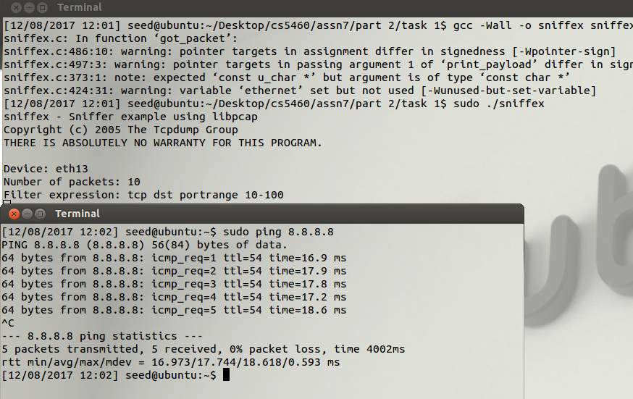

Task 1.c: Sniffing Passwords. Filter used: char filter_exp[] = "tcp port 23";
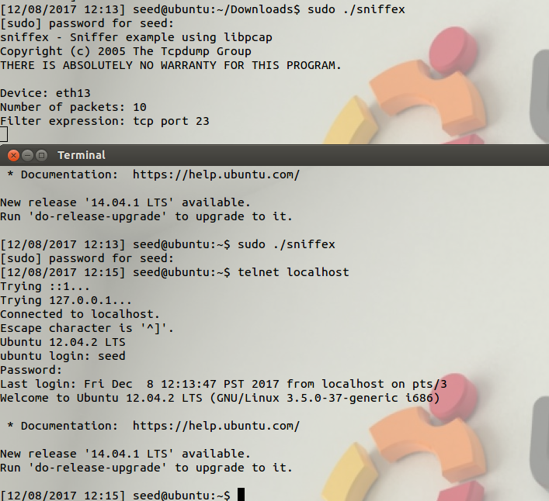

2.2 Task 2: Spoofing
Fot Task 2.a, Writing a spoofing program, the assignment description says a packet program can be downloaded. For this, I found the following code: https://github.com/andrewjkerr/seed-packet-sniffing/blob/master/src/part-2/spoofer.c . Using wireshark,

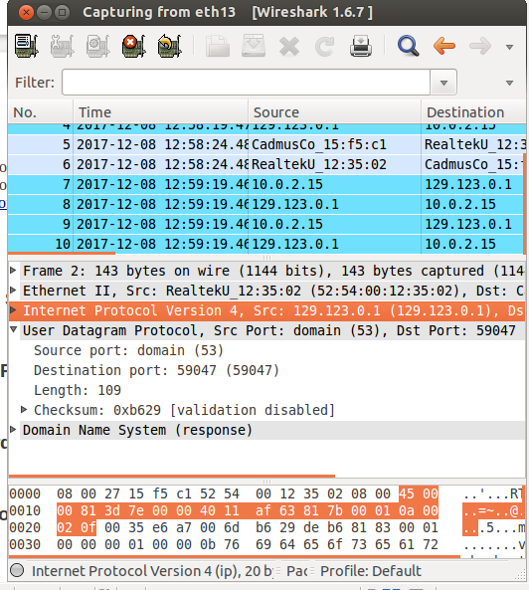

Task 2.b Spoof an ICMP Echo Request.
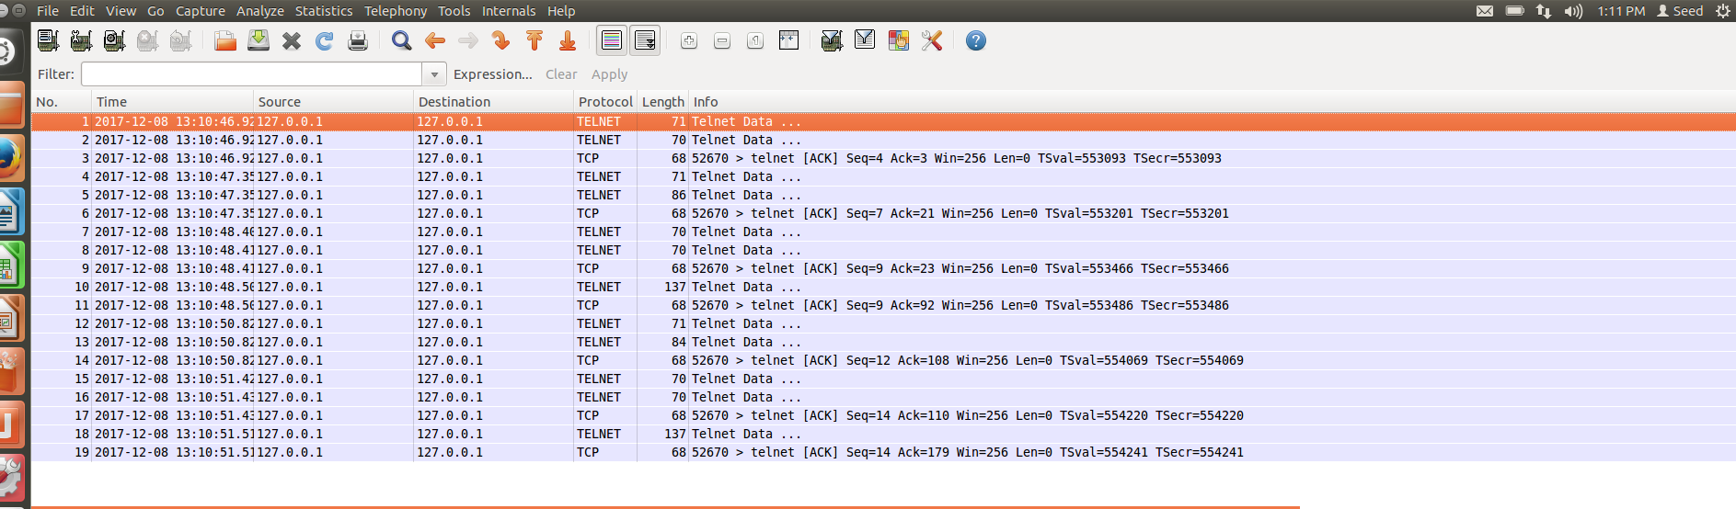
Task 2.c: Spoof an Ethernet Frame. For this part, I used a ethernet frame sender with code modified from https://gist.github.com/austinmarton/1922600. This allows an attacker to send the spoofed ethernet frame while haiving 01:02:03:04:05:06 as the source address.

Question 4. Can you set the IP packet length field to an arbitrary value, regardless of how big the actual packet is?
Not necessarily. This is because the program will error out if the packet length field is too large. It should just cut off the packet and send an incomplete packet.
Question 5. Using the raw socket programming, do you have to calculate the checksum for the IP header?
For raw socket programming, you do not need to calculate the checksum of the IP header because there are no checks. This would be a different story for regular sockets.
Question 6. Why do you need the root privilege to run the programs that use raw sockets? Where does the program fail if executed without the root privilege?
According to http://opensourceforu.com/2015/03/a-guide-to-using-raw-sockets/, it appears that you need root privilege to run programs on raw sockets because raw sockets require full access to the network controller.

2.3 Task 3: Sniff and then Spoof
For this task, I was unsuccessful in combining the sniffing and spoofing techniques to implement a sniff-and-then-spoof program. I successfully got the two Vms on the same LAN. This Is shown below in the following screenshot.

3.1 Filling in Data in Raw Packets
For this part I took the provided code and ran it. Files can be found in the 3.1 firectory of part 3.
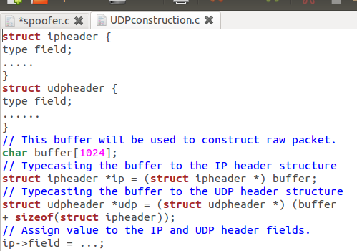

3.2 Network/Host Byte Order and the Conversions

Below is a picture of the Host VM and a secondary VM.
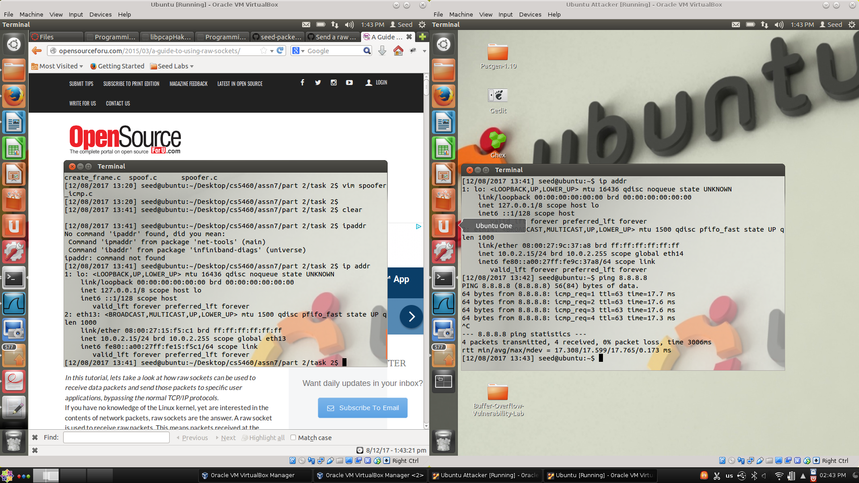
My CPU is a x64 so I believe it does not follow the Little Endian format. As for the packet buffer, I am unsure what this part of the assignment is asking. I am confident, however that whatever goes on on my machine is being converted properly to a network byte order format.

3.3 VirtualBox Network Configuration for Task 3

Attempted Ping:
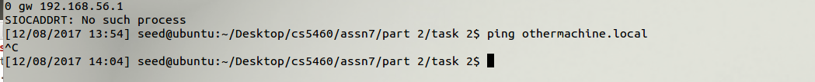
Adjust rules by spoofing MAC address.
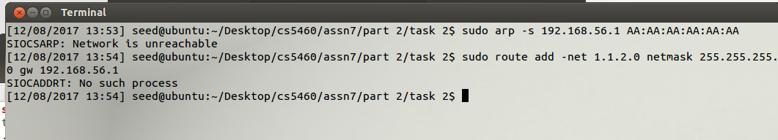
After this, I followed the directions in the assignment description of changing the VM's to be on a bridged network with promiscuous mode turnd on. After this, they were able to see each other.

