CS5680 – Fall Semester 2017
Final Project Proposal
Austin Derbique A01967241
1. Name of Paper: CrackTree: Automatic crack detection from pavement images
Authors: Qin Zou, Yu Cao, Qingquan Li, Qingzhou Mao, Song Wang
Publication Source: Science Direct, Available on Utah State University – University Libraries
Publication Year: 12 November 2011
# of Citations: 162
Paper URL: https://www-sciencedirect-com.dist.lib.usu.edu/science/article/pii/S0167865511003795
2. Cracks are common in places such as roads, sidewalks and structures. It is important to make sure our infrastructure is safe and in good, working condition. Crack detection is a difficult problem because of the low contrast between cracks and the surrounding material. There are added hurdles such as debris and shadows. This makes for a problem worth investigating as automated crack detection can greatly improve efficiency for conducting road condition evaluations.
3. The following are a few of the 200+ images used for testing the algorithm in the paper. Unfortunately, the images outside of those published in the paper are not available.
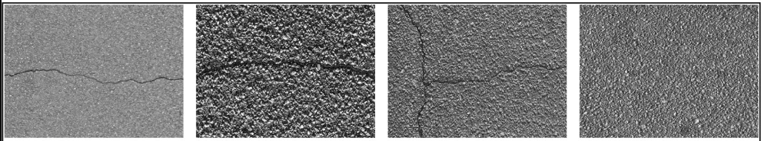
4. The algorithmic overview of the approach proposed in the paper for crack detection is the following:
A. Geodesic Shadow Removal – This step is essential as leaving the shadow in the image reduces accuracy of crack detection. By removing the shadow, the image is prepped for local intensity analysis.
B. Local Intensity-difference Analysis – Cracks may have similar intensity to surrounding areas. Therefore, local intensities are used to to identify incomplete, disjoint crack fragments.
C. Tensor Voting – Most pixels along desired crack curves stand out as local maxima in crack probability map.
D. Crack Seed Sampling – Identifying a set of crack seeds. These will later be connected to crack curves. This is used to construct the crack probability map which will help in determining local maxima.
E. Minimum Spanning Tree Construction and Edge Pruning
5. One of the assumptions made in the paper is that the algorithm will only be handling monochromatic pavement images. All images are 800x600 pixels. All are top down images of cracks.
6. The most important advantage to this paper presents is the ability to identify cracks even when the pixel intensities are very similar. Another advantage is an accurate way to identify cracks in images with significant shadowing.
7. The largest shortcoming is this paper only deals with monochromatic images. It is not capable of varying color images. This paper does not mention any future improvements.
8. The authors evaluated their results by performing various experiments. This included testing their implementation on 206 pavement images with various kinds of cracks. The results were computed using three measurements: Precision, Recall, and F-measure. Results are below:
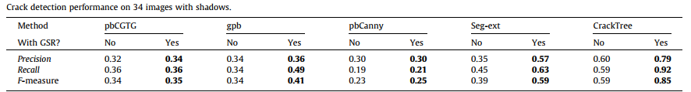
9. I plan on improving the approach by
10. Week 1: Nov. 19 – Nov. 25. Analyze paper and start design of improved implementation.
Week 2: Nov. 26 – Dec. 2 Begin implementation and trial proof of concept
Week 3: Dec. 3 – Dec. 9 Finish implementation and tune up algorithms. Evaluate implementation.
11. Additional Information: The images used in this paper are not publicly posted so I plan to go around and collect 50 images of my own to test on.

