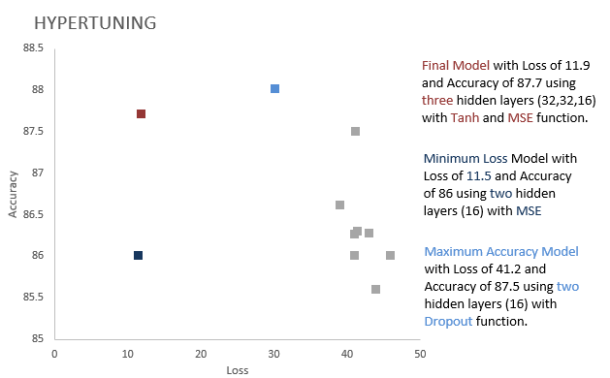

Summary:-

A hyperparameter tuning is a [parameter](https://en.wikipedia.org/wiki/Parameter) whose value is used to control the learning process. The above observation shows, the variations in the performance measure while hyper tuning. Below are the observations for each hyperparameter:

* The increase in the unit from 8, 16, 32, 64, 128, we could see that there is very minimal change in the accuracy whereas the loss function decreases. Also, the epoch values are generated at the early cycle as units increase.
* The increase in the number of hidden layers from 1 to 3, we observed there is no change in accuracy and deflection in the loss function.
* Using “mse” as loss function for IMDB dataset, loss value is low when compared to binary cross entropy.
* The accuracy of tanh activation function for the model is low and degrades the performance due to vanishing gradient problem.
* Regularization L-2 model shows loss is significantly low and less overfitting compared to initial model. Coming to the accuracy the L-2 model showing slightly better accuracy.
* The dropout also helps gain a lower loss function but does not affect accuracy.