ML ASSIGNMENT 3 REPORT

Part 1: Linear SVM:
Best C: 0.1
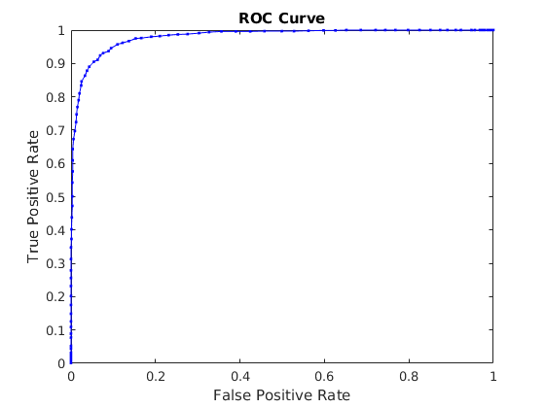
C vs Average Cross Validation:
Search space for C = [0.0001,0.001,0.1,1,10,100];

C | Accuracy(%)
0.0001 | 90.45
0.001 | 95.3
0.1 | 96.1
1 | 94.925
10 | 93.8
100 | 93.725

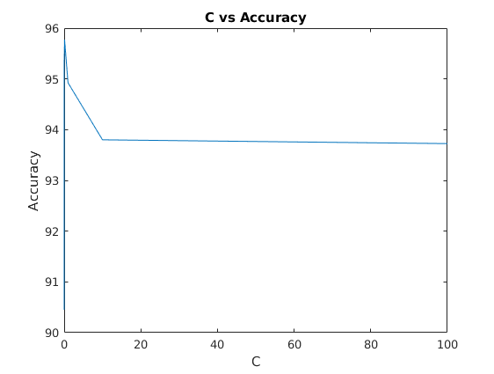
Part 2: Multiclass SVM:
Best C = 0.1
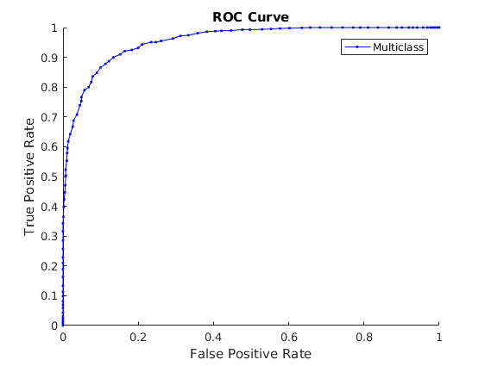

C vs Average Cross Validation:
Search space for C = [0.001,0.1,1,10,100];

C | Accuracy(%)
0.001 | 87.74
0.1 | 91.12
1 | 90.63
10 | 89.8
100 | 87.35

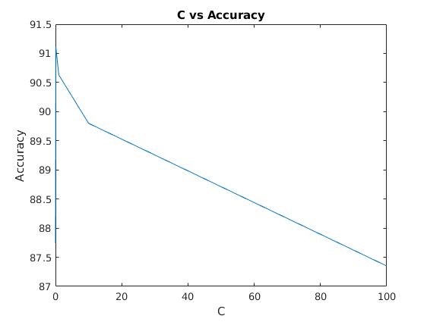

Part 3: RBF Kernel SVM: Accuracy = 94.1%
New one: Accuracy 90.08% C =10 gamma = 0.000001
Best C = 10, Gamma = 0.000001
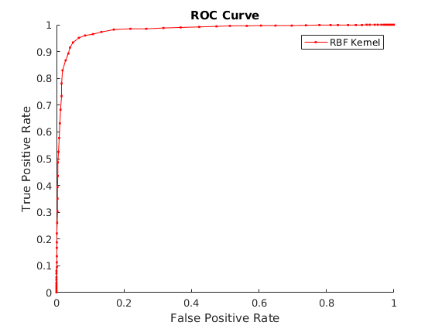
I could not complete cross validation since it was taking too long (I kept it running for 4 hours).

ROC Curve of Multiclass vs RBF Kernel:

