Ans 4. a.
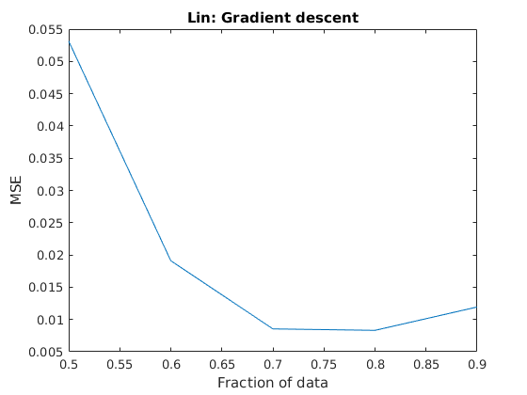
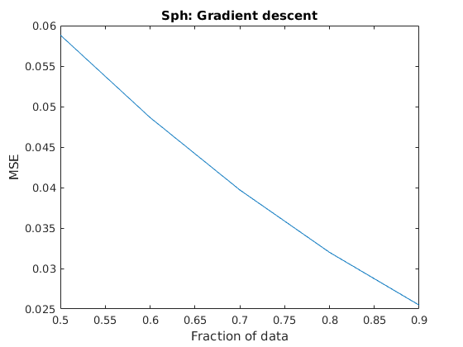
Ans 4. b.
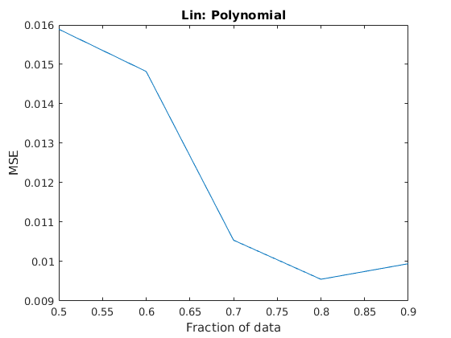
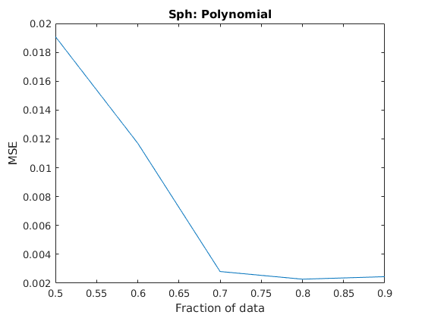
Ans 4. c.
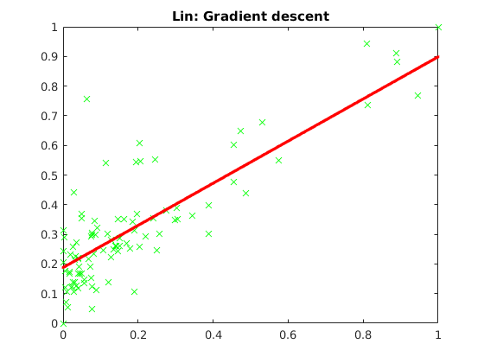
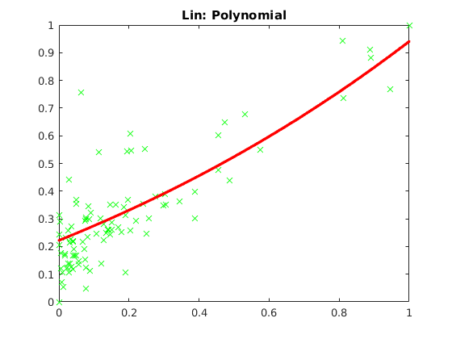
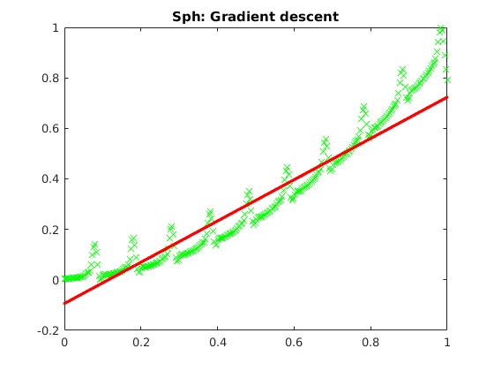
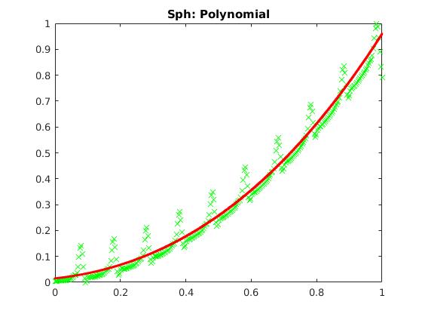

Ans 4. d.

Choosing the delta value:

Lin dataset:

 | 80 % training data + 20 % test data |  |  | 90 % training data + 10 % test data
 | Train Error | Test Error | Avg Error | Train Error | Test Error | Avg Error
0.1 | 0.062826 | 0.007193 | 0.035009 | 0.031174 | 0.018482 | 0.024828
0.5 | 0.050667 | 0.017297 | 0.033982 | 0.149542 | 0.014900 | 0.082221
1 | 0.346640 | 0.014163 | 0.180401 | 0.185215 | 0.013989 | 0.099602
10 | 2.208664 | 0.008807 | 1.108736 | 1.922445 | 0.009766 | 0.966106
50 | 3.498616 | 0.011004 | 1.754810 | 2.168872 | 0.014136 | 1.091504

For 90% training example the test error seems to be minimized for delta = 1. It performs not so great compared to delta = 0.1(best avg error) but that is majorly due to poor performance in train error.
Therefore, delta = 1

Sph dataset:

 | 80 % training data + 20 % test data |  |  | 90 % training data + 10 % test data
 | Train Error | Test Error | Avg Error | Train Error | Test Error | Avg Error
0.1 | 0.030096 | 0.002553 | 0.016325 | 0.031361 | 0.001729 | 0.016545
0.5 | 0.145685 | 0.005339 | 0.075512 | 0.153389 | 0.001715 | 0.077552
1 | 0.268837 | 0.003753 | 0.136295 | 0.293244 | 0.002082 | 0.147663
10 | 2.124107 | 0.024976 | 1.074542 | 2.301376 | 0.006795 | 1.154086
50 | 2.589090 | 0.020900 | 1.304995 | 13.872964 | 0.406893 | 7.139928

For 90% training example the test error seems to be minimized for delta = 0.5. It performs not so great compared to delta = 0.1(best avg error) but that is majorly due to poor performance in train error.
Therefore, delta = 0.5

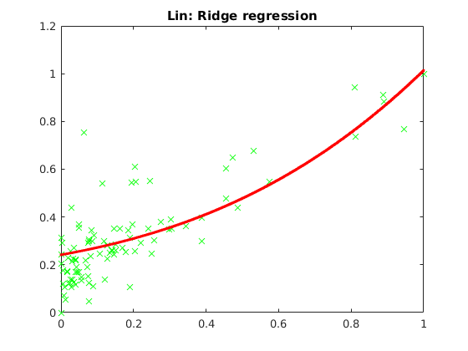
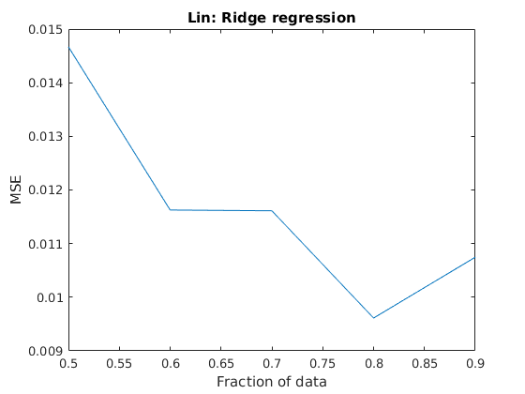

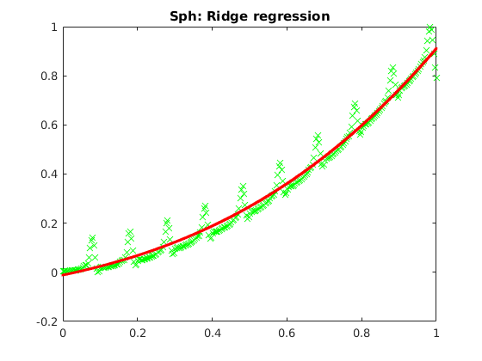
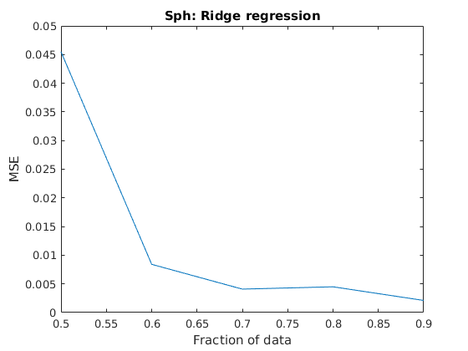

Ans 4. e.
