Product Requirement Document (PRD)

Project: Next.js H5 Game Portal (gamewhame.com)

1. Executive Summary & Objective
The goal of this project is to build a hyper-optimized, high-performance HTML5 gaming platform inspired by Poki.com. The application must act as a seamless front-end hub that handles route navigation, layout grid rendering, asset pre-fetching, and dynamic game viewport lifecycle tracking.
To offload processing pressure from the client's machine, the site will leverage Next.js to pre-render static assets, while heavy Unity WebGL engine files are loaded strictly on-demand via isolated edge environments.

2. Infrastructure & System Architecture Mandates
The architecture relies on complete separation of concerns between code deployment and game storage asset delivery.
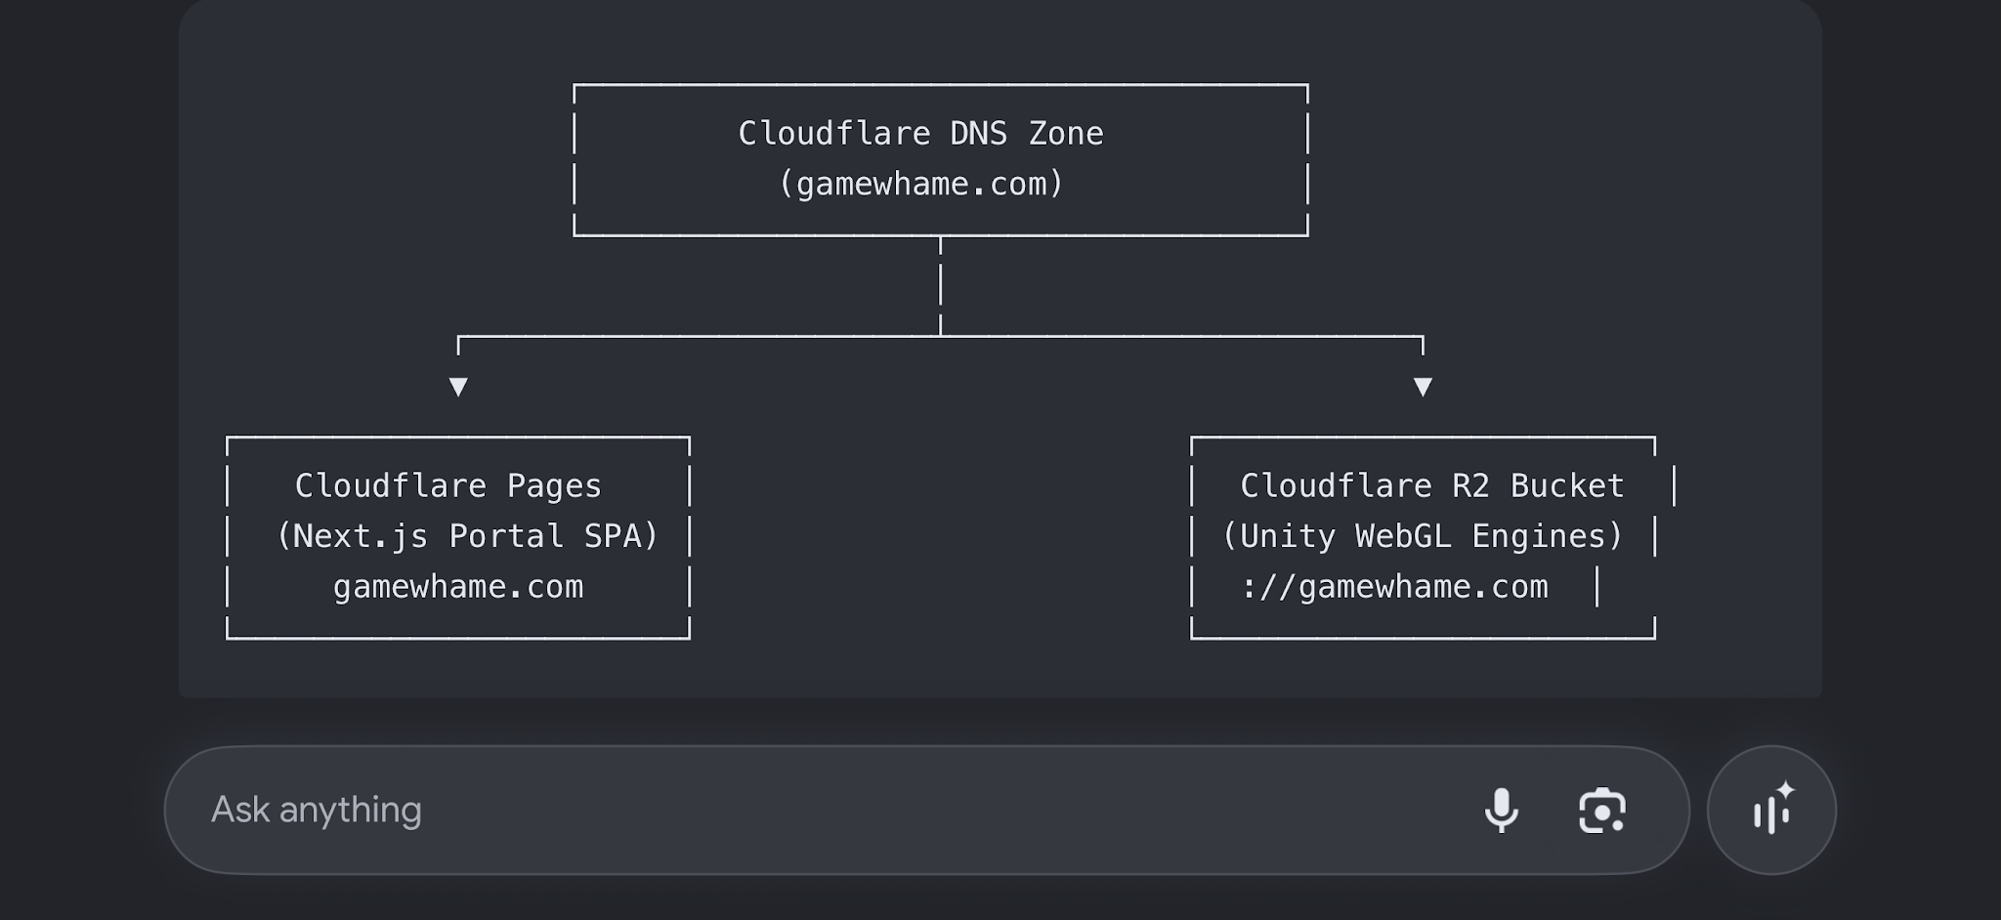

2.1 Web Application Hosting
- Framework: Next.js (Latest stable release using App Router layout configurations).
- Platform: Hosted on Cloudflare Pages utilizing @cloudflare/next-on-pages edge worker runtime adapters.
- Pipeline: Connected directly to the main production repository branch on GitHub for automated CI/CD builds.

2.2 Game Engine Storage & Delivery Architecture
- Storage Hub: Isolated Cloudflare R2 Object Storage bucket (gamewhame-files).
- Subdomain Mapping: Routed natively to https://gamewhame.com through Cloudflare DNS zones.
- Asset Directory Structure: Games are organized into flat, slugified directories containing static builds:
  - https://gamewhame.com{game-title-slug}/index.html
  - https://gamewhame.com{game-title-slug}/Build/

3. Detailed Functional Requirements

3.1 Portal Homepage & Game Grid
- Server-Driven Shell Layout: The home directory and navigation wrappers must be server-rendered (SSG or Server Components) to guarantee near-instant initial loads and search engine visibility.
- Poki-Style Elastic Responsive Grid: A CSS grid that maps varied-size visual tiles dynamically according to screen breakpoints (Desktop, Tablet, Mobile).
- Zero Cumulative Layout Shift (CLS): Game thumbnail cards must map precise pixel placeholders, explicit dimensions, or aspect ratios to eliminate page-jumping while dynamic content loads.
- Instant Filtering & Tags: Navigation options (e.g., /category/action, /category/puzzle) must update UI elements dynamically without hard-refreshing the global context.

3.2 Dynamic Search Engine
- Client-Side Fuzzy Filtering: A global navigation-bar search input that dynamically filters matching metadata fields across all available titles upon key-down inputs.
- Performance Control: The input handling loop must use proper debounce delays (e.g., 150ms) to avoid visual lagging on low-end machines.

3.3 The Game Isolation Viewport (Core Integration Point)
- Sandboxed Runtime Execution: The execution loop of any selected game must occur within an isolated <iframe> component to decouple heavy WebAssembly environments from the primary thread.
- Aspect Fluid Design: The frame container must scale contextually to enforce uniform asset layouts without layout overflow:
  - Desktop: Enforced 16:9 widescreen aspect ratio wrapper layout.
  - Mobile / Portrait: Automated adaptive scaling targeting a 9:16 bounding layout block.
- Immersion Overlay Control Layers: Custom UI element overlays positioned over the native frame canvas to manage global parameters:
  - Fullscreen Toggle: Triggering programmatic browser Fullscreen API layers over the target canvas object.
  - Share Action: Navigating native Clipboard sharing links for the active route URL.

4. Technical Non-Functional Requirements & Performance Targets

4.1 Strict Memory Leak Prevention
- Unmounting Lifecycle Execution: Upon changing portal routes away from an active game screen (e.g., navigating back to home), the system must programmatically terminate the game element link by assigning src="about:blank" and dropping it from the live DOM tree to force immediate browser garbage collection.

4.2 Resource Warming & Pre-fetching
- Intent-Driven Speculative Loading: Detect pointer hover interactions on any game grid tile exceeding 200ms. Upon firing, trigger background connection pre-warming policies to the game asset domain https://gamewhame.com.

