Bansilal Ramnath Agarwal Charitable Trust’s

**Vishwakarma Institute of Information Technology**

**Pune – 411048**



Preliminary Project Report

On

## Simon Game

Submitted By

Abbas Hashmi 17u096

Adesh Gaikwad 17u134

Burhanuddin J.G. 17u099

(*all* ***name in alphabetical order*)**

Department of Computer Engineering

Savitribai Phule Pune University, Pune

Year 2019-2020

# CERTIFICATE

This is to certify that the following students of T.Y. Computer, Vishwakarma Institute of Information Technology, Pune

Abbas Hashmi (17u096)

Adesh Gaikwad (17u134)

Burhanuddin J.G. (17u099)

have successfully completed the project report on

**Simon Game**

in the fulfilment of the requirements for the project completion of T.Y. Computer in the academic year 2019-2020.

#### **Project Guide HOD**

Table of Contents

1. Introduction

1.1 Purpose

1.2 Scope

1.3 Technologies to be used

2. Overall Description

2.1 Use-Case Model

2.2 Architecture diagram & database design

2.3 Assumptions and Dependencies

3. Specific Requirements

3.1 Hardware Requirement

3.2 Software Requirement

4. Conclusion

Software Requirements Specification

# 1. Introduction

Our ‘Simon Game’ project is basically an electronic game of memory skill invented by Ralph H. Baer and Howard J. Morrison. The device creates a series of tones and lights and requires a user to repeat the sequence.

## 1.1 Purpose

We analyze there are few websites allowing users to play Simon Game. But most of them have old school user interfaces and are also very buggy and full of distractions and ads. We aim to create a free basic and modern looking version of the simon game. Which can act as a time killer especially in situations like this (Lockdown). Apart from the game it's also a memory booster.

## 1.2 Scope

The website can be applicable as follows:

* Time Killer
* Memory Booster

## 1.3) Technologies to be used

* HTML, CSS, Bootstrap.
* Java Script
* Ajax

## 2. Overall Description

**Workflow:**

The system can be accessed by any user without registering or login. It's Free to use app/game.

After visiting the site, the user can start the game just by pressing any key.

Users will hear sound and light beeps and will have to remember the sequence throughout the game in order to move further the level.

As soon as the user presses the wrong tile(color) game is over. And can be restarted by pressing any key on the keyboard.

Users move further to the next level as soon as it finishes the sequence. But the sequence length becomes long as you move in levels and becomes harder to remember the sequence.

## 2.1 Use-Case Diagram

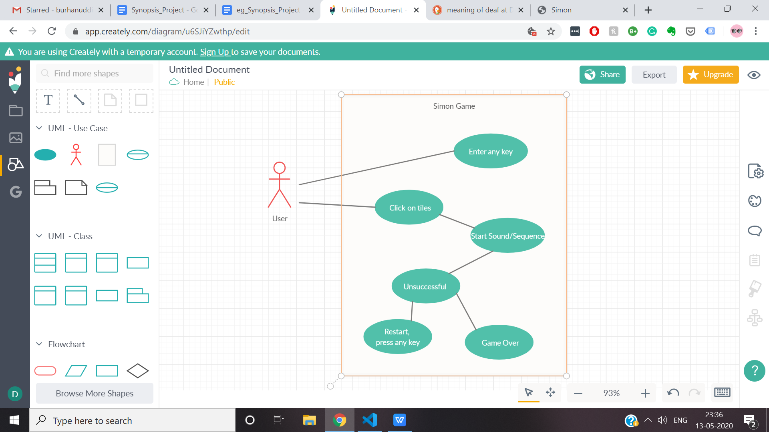

## Fig 1.0

## 2.2 Architecture and Database Schema:

The project uses javascript for creating the game logic.

## 

## 2.3 Assumptions and Dependencies:

1. Assuming that the user having some speaker for music output.
2. Assuming that the user is **not** color blind, deaf, and blind as the game is **dependent** on the ability of one's capabilities of identifying colors blinking, and hearing sounds of the tones.

**Screenshots:**

## Fig 2.0

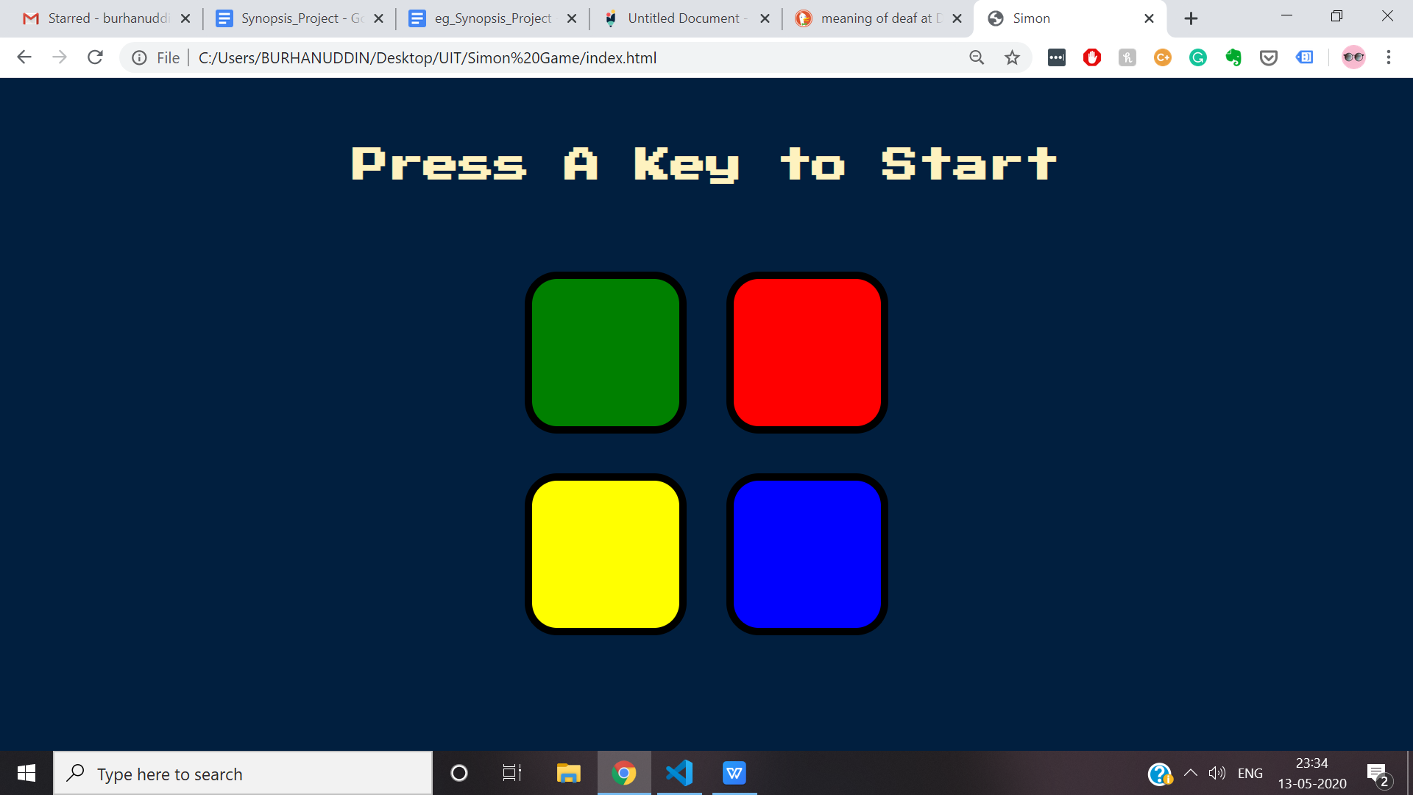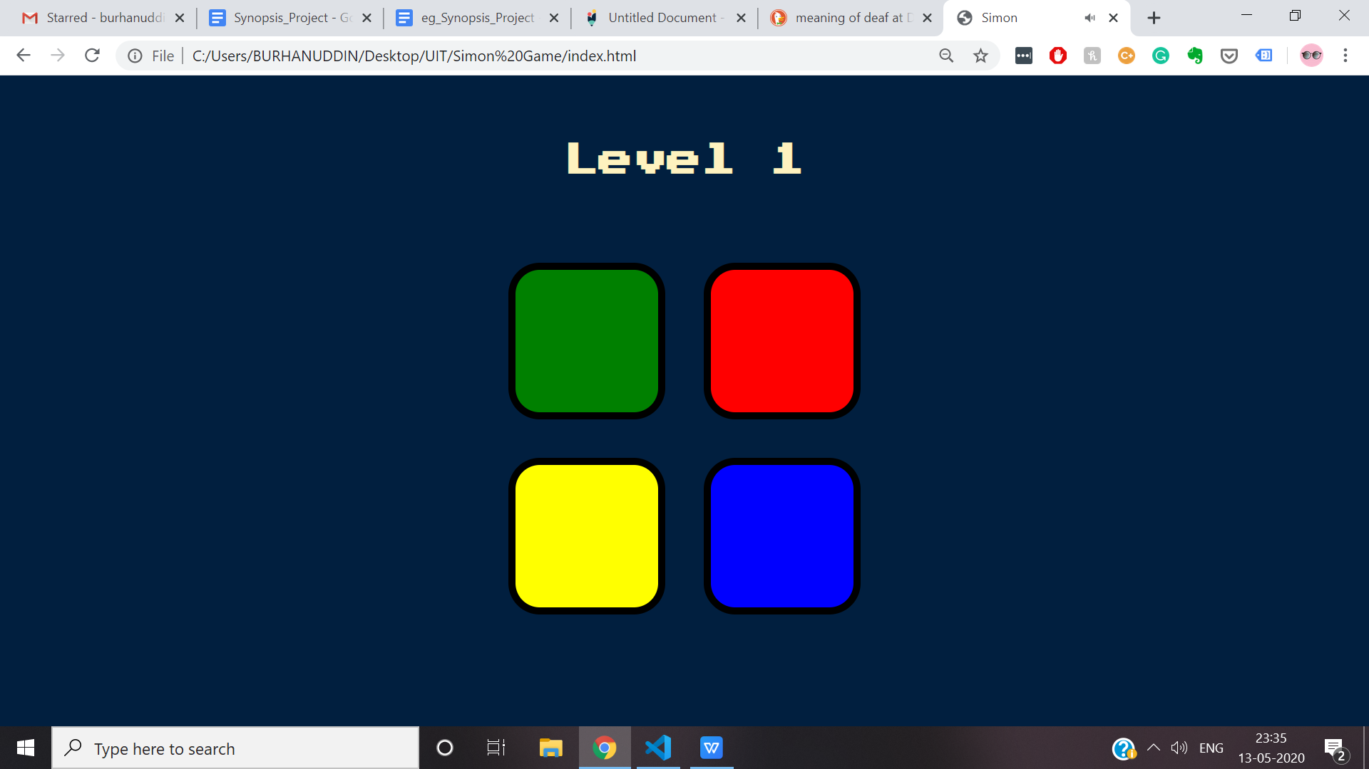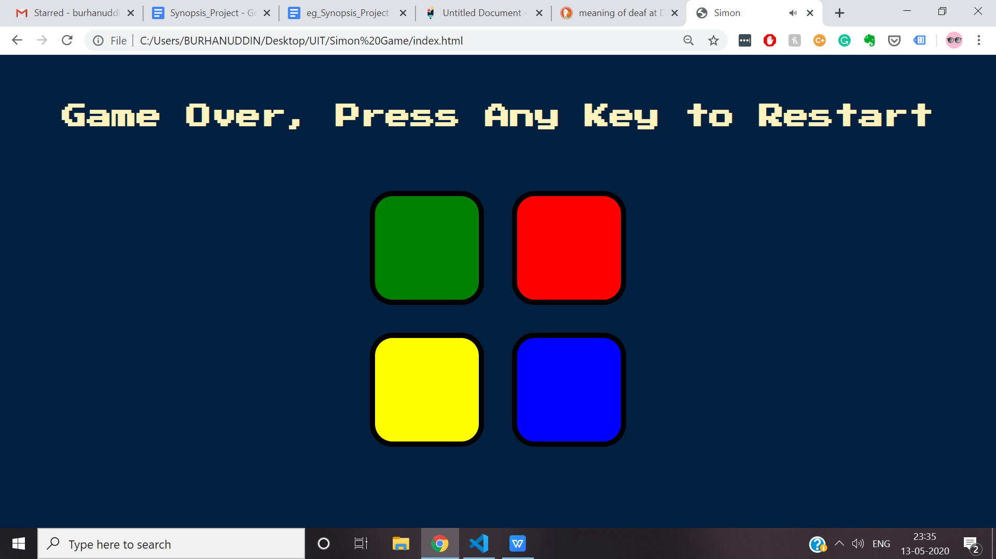

## Fig 3.0 & 4.0

# 3. Specific Requirements

**3.1 Hardware requirements:**

Any device with a speaker for sound output.

**3.2 Software requirements:**

- Updated browser

· - Chrome preferred

## 4. Conclusion:

## The main aim of developing Simon Game is to provide users of any age group especially kids who are spending most of the time online playing games which are not leading them into any constructive development, moreover it is leading to a violent nature into them.

## We wanted to create a time killer game which is also a memory booster and also wanted to give a glimpse to old era games and give them a break from modern age games.